SUPPLEMENTARY MATERIAL
AI-Guided Adaptive Control in Membrane Bioreactors for Real-Time Micropollutant Removal: Bridging the Explainability and Multi-Contaminant Gap in Intelligent Wastewater Treatment
Table of Contents
• Table S1 – IoT Sensor Network Specifications
• Table S2 – LSTM Network Architecture
• Table S3 – Bayesian Hyperparameter Optimisation Search Space
• Table S4 – Compound-Level Micropollutant Removal Efficiencies
• Table S5 – SHAP Feature Importance Values Across All Plants
• Table S6 – NSGA-II Multi-Objective Optimisation Parameters
• Table S7 – Transfer Learning Performance Summary
• Table S8 – Detailed Energy Consumption Breakdown
• Table S9 – Cost-Benefit Analysis for 10,000 m³/day Plant
• Table S10 – Statistical Significance Tests
• Table S11 – Data Preprocessing Pipeline
• Table S12 – Regulatory Compliance Summary
• Figure S1 – XAI-AMBR System Architecture
• Figure S2 – Data Preprocessing and Training Workflow
• Figure S3 – LSTM Training and Validation Curves
• Figure S4 – SHAP Summary Plots (All Plants)
• Figure S5 – Pareto Front (NSGA-II Optimisation)
• Figure S6 – TMP Prediction Accuracy (LSTM vs Actual)
• Figure S7 – Transfer Learning Performance Visualisation
• Figure S8 – Micropollutant Removal Radar Charts

Table S1. IoT Sensor Network Specifications
This table provides full technical specifications for all instruments deployed across the five MBR plants. Sensors were calibrated monthly and verified against grab samples from accredited laboratories (ISO/IEC 17025).

Sensor/Instrument | Measurement Principle | Range | Accuracy | Sampling Frequency | Plants Deployed
pH sensor | Electrochemical | 4–10 pH units | ±0.01 pH | Continuous (1 min) | P1–P5
DO probe | Optical/luminescent | 0–20 mg/L | ±0.1 mg/L | Continuous (1 min) | P1–P5
MLSS sensor | Near-infrared (NIR) | 1–20 g/L | ±0.05 g/L | 15-min interval | P1–P5
TMP gauge | Differential pressure | 0–100 kPa | ±0.5 kPa | Continuous (1 min) | P1–P5
Turbidity meter | Optical (nephelometric) | 0–3000 NTU | ±2% full scale | 15-min interval | P1–P5
Temperature probe | PT100 RTD | -10–80 °C | ±0.1 °C | Continuous (1 min) | P1–P5
Flow meter | Electromagnetic | 0–2000 m³/h | ±0.5% | 15-min interval | P1–P5
Ammonia analyzer | Ion-selective electrode | 0–200 mg NH4+-N/L | ±2% | 30-min interval | P1, P4, P5
Nitrate analyzer | UV spectrophotometric | 0–100 mg NO3--N/L | ±3% | 30-min interval | P1, P4, P5
Phosphate analyzer | Colorimetric (molybdate) | 0–50 mg PO4-P/L | ±3% | 30-min interval | P1, P4, P5
COD sensor | UV/Vis spectrophotometry | 0–2000 mg/L | ±5% | 15-min interval | P1–P5
UV254 probe | UV spectrophotometry | 0–10 abs/m | ±1% | 15-min interval | P1–P5
Microplastic sensor | Laser diffraction | 0.1–3000 µm | ±2% | Batch (4-hourly) | P1, P4, P5
Note: All sensors were factory-calibrated and field-verified quarterly. Data streams were transmitted via MQTT protocol to the central SCADA system at 15-second intervals and aggregated at 15-minute intervals for model input.

Table S2. LSTM Network Architecture
The three-layer stacked LSTM network was designed through systematic architecture search. The table below details each layer, its configuration, and the number of trainable parameters.

Layer | Units | Connections | Activation | Regularisation | Parameters
Input Layer | – | 18 | – | – | –
LSTM Layer 1 | 128 | 18 × 128 | tanh / sigmoid | 50% dropout | 66,560
LSTM Layer 2 | 64 | 128 × 64 | tanh / sigmoid | 30% dropout | 49,408
LSTM Layer 3 | 32 | 64 × 32 | tanh / sigmoid | 20% dropout | 12,416
Dense Layer 1 | 64 | 32 × 64 | ReLU | Batch Norm | 2,112
Dense Layer 2 | 32 | 64 × 32 | ReLU | – | 2,080
Output Layer | Var. | 32 × n_out | Linear | – | Variable
Total Trainable Parameters | – | – | – | – | ~132,576
Note: Total trainable parameters ≈ 132,576 (single-target output). For multi-target outputs (e.g., simultaneous COD, TN, TP, micropollutant prediction), the output layer expands proportionally. All models were implemented in TensorFlow 2.12 / Keras with mixed-precision (float16/float32) training for GPU efficiency.

Table S3. Bayesian Hyperparameter Optimisation Search Space
Optuna v3.0 was used for Bayesian optimisation with Tree-structured Parzen Estimator (TPE) sampler. A total of 100 trials were conducted per target variable with 5-fold cross-validation (time-series split). The table shows the full search space and optimal values selected.

Hyperparameter | Type | Search Range | Optimal Value | Sampling Strategy
LSTM units (layer 1) | Integer | 64–256 | 128 | Log-uniform
LSTM units (layer 2) | Integer | 32–128 | 64 | Log-uniform
LSTM units (layer 3) | Integer | 16–64 | 32 | Log-uniform
Dropout rate | Float | 0.1–0.5 | 0.2–0.3 | Uniform
Learning rate (Adam) | Float | 1×10⁻⁵ – 1×10⁻² | 0.001 | Log-uniform
Batch size | Integer | 16, 32, 64, 128 | 32 | Categorical
Lookback window (timesteps) | Integer | 12–96 | 48 (12 hours) | Log-uniform
Dense units (layer 1) | Integer | 32–128 | 64 | Log-uniform
Dense units (layer 2) | Integer | 16–64 | 32 | Log-uniform
Early stopping patience | Integer | 10–20 | 15 | Uniform
Optimisation trials (Optuna) | Integer | 100 | 100 | Fixed
Cross-validation folds | Integer | 5 | 5 | Fixed
Note: The LSTM lookback window of 48 timesteps (12 hours) was confirmed as optimal across all plants. For TMP prediction, a 4-hour prediction horizon was used; for effluent quality, a 2-hour horizon was used. Hyperparameter optimisation was performed independently for each target variable.

Table S4. Compound-Level Micropollutant Removal Efficiencies
Removal efficiencies for all 23 targeted micropollutants across four treatment technologies. Values represent mean ± standard deviation from 24 months of weekly sampling (n = 96 per compound per technology). Statistical significance was assessed by paired t-test (α = 0.05). Regulatory limits are based on EU Environmental Quality Standards (EQS), WHO guidelines, and Indian IS:2490 standards.

Compound | Class | CAS (%) | Standard MBR (%) | XAI-AMBR (%) | Hybrid MBR-AOP (%) | Regulatory Limit | p-value
Pharmaceuticals
Ibuprofen | Anti-inflammatory | 89.4 ± 3.2 | 94.7 ± 2.1 | 97.3 ± 1.4 | 99.1 ± 0.6 | 0.05 | <0.001
Diclofenac | Anti-inflammatory | 62.1 ± 7.4 | 78.3 ± 5.2 | 94.6 ± 2.3 | 99.0 ± 0.5 | 0.05 | <0.001
Carbamazepine | Anticonvulsant | 21.3 ± 9.1 | 38.6 ± 8.4 | 89.4 ± 3.1 | 97.2 ± 1.1 | 0.1 | <0.001
Trimethoprim | Antibiotic | 72.4 ± 5.8 | 84.2 ± 4.1 | 96.2 ± 1.8 | 98.8 ± 0.7 | 0.1 | <0.001
Sulfamethoxazole | Antibiotic | 68.1 ± 6.3 | 81.5 ± 4.9 | 95.7 ± 2.0 | 98.5 ± 0.8 | 0.1 | <0.001
Estrone (E1) | Estrogen | 55.2 ± 8.2 | 73.8 ± 6.3 | 93.1 ± 2.6 | 98.2 ± 0.9 | 0.1 ng/L | <0.001
17β-Estradiol (E2) | Estrogen | 61.3 ± 7.9 | 76.2 ± 5.8 | 94.3 ± 2.2 | 98.7 ± 0.6 | 0.1 ng/L | <0.001
17α-Ethinylestradiol (EE2) | Synthetic estrogen | 48.6 ± 9.4 | 67.4 ± 7.2 | 92.1 ± 3.0 | 97.8 ± 1.0 | 0.035 ng/L | <0.001
Endocrine Disruptors
Bisphenol A (BPA) | Plasticizer | 44.2 ± 10.1 | 65.7 ± 8.3 | 91.7 ± 3.2 | 97.4 ± 1.2 | 0.1 | <0.001
Nonylphenol (NP) | Surfactant | 38.7 ± 11.2 | 61.2 ± 9.1 | 90.4 ± 3.5 | 97.1 ± 1.3 | 1.0 | <0.001
4-tert-Octylphenol | Surfactant | 35.4 ± 11.8 | 58.9 ± 9.7 | 89.8 ± 3.8 | 96.7 ± 1.5 | 0.1 | <0.001
Atrazine | Herbicide | 31.2 ± 12.4 | 54.6 ± 10.3 | 88.5 ± 4.1 | 96.2 ± 1.7 | 0.1 | <0.001
Diazinon | Insecticide | 42.6 ± 10.8 | 63.8 ± 8.7 | 90.9 ± 3.3 | 97.0 ± 1.2 | 0.1 | <0.001
Heavy Metals (avg.)
Lead (Pb) | Heavy metal | 52.3 ± 9.4 | 74.2 ± 6.8 | 91.3 ± 2.9 | 96.8 ± 1.4 | 10 µg/L | <0.001
Cadmium (Cd) | Heavy metal | 48.7 ± 10.2 | 71.6 ± 7.4 | 90.1 ± 3.3 | 96.2 ± 1.6 | 3 µg/L | <0.001
Chromium (Cr) | Heavy metal | 56.1 ± 8.7 | 76.8 ± 6.2 | 92.4 ± 2.6 | 97.3 ± 1.1 | 50 µg/L | <0.001
Arsenic (As) | Heavy metal | 51.4 ± 9.8 | 73.5 ± 7.1 | 90.8 ± 3.1 | 96.5 ± 1.5 | 10 µg/L | <0.001
Nickel (Ni) | Heavy metal | 45.8 ± 10.6 | 69.4 ± 7.8 | 88.9 ± 3.7 | 95.8 ± 1.8 | 20 µg/L | <0.001
PFAS & Microplastics
PFOS | PFAS | 18.4 ± 14.2 | 38.2 ± 12.1 | 69.3 ± 5.4 | 88.7 ± 2.8 | 0.65 µg/L | <0.001
PFOA | PFAS | 15.6 ± 15.1 | 35.7 ± 13.2 | 67.8 ± 6.1 | 87.2 ± 3.1 | 0.87 µg/L | <0.001
Other PFAS (avg.) | PFAS | 12.3 ± 16.4 | 32.1 ± 14.6 | 65.1 ± 7.2 | 85.6 ± 3.5 | Var. | <0.001
Microplastics (>1 µm) | Particle | N/A | 78.4 ± 9.2 | 95.6 ± 2.1 | 98.7 ± 0.9 | – | <0.001
Note: CAS = Conventional Activated Sludge (plant P-1 baseline); Standard MBR = unoptimised MBR control; XAI-AMBR = AI-optimised system (this study); Hybrid MBR-AOP = membrane bioreactor coupled with advanced oxidation (reference benchmark). N/A = not applicable (CAS has no membrane barrier for microplastics). Regulatory limits vary by jurisdiction; the most stringent applicable limit is shown.

Table S5. SHAP Feature Importance Values (TMP Fouling Prediction)
Mean absolute SHAP values (|SHAP|) for all 18 process variables ranked by importance across all five plants and individually per plant. Higher |SHAP| values indicate greater influence on TMP prediction. Directionality describes the typical relationship between the variable and fouling (higher TMP).

Process Variable | All Plants (mean |SHAP|) | P-1 (Delhi) | P-2 (Singapore) | P-3 (KSA) | P-4 (Chennai) | Directionality
MLSS (g/L) | 3.41 ± 0.32 | 2.89 ± 0.28 | 3.12 ± 0.35 | 3.67 ± 0.41 | 3.38 ± 0.38 | Positive (high MLSS → fouling)
HRT (h) | 2.87 ± 0.28 | 3.21 ± 0.31 | 2.54 ± 0.29 | 3.04 ± 0.33 | 2.69 ± 0.27 | Negative (longer HRT → lower fouling)
DO (mg/L) | 2.54 ± 0.24 | 2.78 ± 0.26 | 2.31 ± 0.22 | 2.62 ± 0.28 | 2.45 ± 0.24 | Negative (higher DO → lower fouling)
F/M ratio (g COD/g VSS/d) | 2.12 ± 0.21 | 2.34 ± 0.24 | 1.98 ± 0.20 | 2.18 ± 0.22 | 2.05 ± 0.21 | Positive (high F/M → fouling)
Temperature (°C) | 1.78 ± 0.18 | 1.91 ± 0.20 | 1.67 ± 0.17 | 1.84 ± 0.19 | 1.72 ± 0.18 | Non-linear (optimum ~25°C)
SRT (d) | 1.54 ± 0.16 | 1.67 ± 0.18 | 1.42 ± 0.15 | 1.61 ± 0.17 | 1.48 ± 0.15 | Negative (longer SRT → lower fouling)
Aeration intensity (m³/h) | 1.32 ± 0.14 | 1.45 ± 0.16 | 1.21 ± 0.13 | 1.38 ± 0.15 | 1.24 ± 0.13 | Negative (more aeration → scouring)
OLR (kg COD/m³/d) | 1.18 ± 0.12 | 1.28 ± 0.14 | 1.08 ± 0.11 | 1.22 ± 0.13 | 1.14 ± 0.12 | Positive (high OLR → EPS→ fouling)
UV₂₅₄ absorbance | 1.04 ± 0.11 | 1.14 ± 0.12 | 0.96 ± 0.10 | 1.09 ± 0.11 | 0.99 ± 0.10 | Positive (proxy for organics)
Turbidity (NTU) | 0.89 ± 0.09 | 0.97 ± 0.10 | 0.81 ± 0.08 | 0.93 ± 0.09 | 0.84 ± 0.09 | Positive (colloidal fouling)
pH | 0.76 ± 0.08 | 0.83 ± 0.09 | 0.69 ± 0.07 | 0.80 ± 0.08 | 0.71 ± 0.07 | Non-linear (optimum 7.0–7.5)
Influent COD (mg/L) | 0.64 ± 0.07 | 0.71 ± 0.08 | 0.58 ± 0.06 | 0.67 ± 0.07 | 0.61 ± 0.06 | Positive
Phosphate (mg/L) | 0.52 ± 0.05 | 0.57 ± 0.06 | 0.47 ± 0.05 | 0.55 ± 0.06 | 0.49 ± 0.05 | Positive
Nitrate (mg/L) | 0.41 ± 0.04 | 0.45 ± 0.05 | 0.37 ± 0.04 | 0.43 ± 0.04 | 0.38 ± 0.04 | Low importance
Ammonia (mg/L) | 0.33 ± 0.03 | 0.37 ± 0.04 | 0.30 ± 0.03 | 0.35 ± 0.04 | 0.31 ± 0.03 | Low importance
Flow rate (m³/h) | 0.27 ± 0.03 | 0.30 ± 0.03 | 0.24 ± 0.02 | 0.28 ± 0.03 | 0.25 ± 0.03 | Low importance
Backwash frequency (h⁻¹) | 0.21 ± 0.02 | 0.23 ± 0.02 | 0.19 ± 0.02 | 0.22 ± 0.02 | 0.20 ± 0.02 | Negative (more frequent → cleaner)
Chemical dosing (mg/L) | 0.15 ± 0.02 | 0.17 ± 0.02 | 0.13 ± 0.01 | 0.16 ± 0.02 | 0.14 ± 0.01 | Negative
Note: SHAP values were computed using the TreeExplainer method applied to LSTM predictions for the TMP target (n = 10,000 sample points randomly drawn from the test set). Plant-specific values reflect site-to-site variability in influent composition and operating regime. MLSS, HRT, and DO consistently rank in the top 3 across all sites, confirming their primacy in fouling dynamics.

Table S6. NSGA-II Multi-Objective Optimisation Parameters
Parameters used in the NSGA-II evolutionary algorithm for Pareto-optimal setpoint identification. Three objectives were simultaneously optimised: (i) maximise micropollutant removal efficiency, (ii) minimise specific energy consumption (kWh/m³), and (iii) maximise membrane service life (days between chemical cleanings).

NSGA-II Parameter | Value Used | Rationale | Notes
Population size | 200 individuals | Balances exploration/exploitation | Tested: 100, 150, 200, 250
Number of generations | 500 | Convergence confirmed at ~450 gen. | Stopping criterion: HV < 0.001% change
Crossover probability (pc) | 0.9 | Standard NSGA-II recommendation | SBX (Simulated Binary Crossover)
Mutation probability (pm) | 1/n (n = number of variables) | Self-adaptive to problem dimensionality | Polynomial mutation operator
Distribution index (η_c) | 20 | Control crossover spread | Range: 10–30 (sensitivity tested)
Distribution index (η_m) | 20 | Control mutation spread | Range: 10–30 (sensitivity tested)
Number of objectives | 3 | Removal efficiency, energy, membrane life | Tchebycheff scalarisation for constraints
Number of decision variables | 8 | DO, HRT, SRT, aeration, backwash, flux, OLR, F/M | Bounded by plant operational limits
Archive size (Pareto front) | All non-dominated solutions | No pruning applied | Final front: 45–78 solutions
Constraint handling | Penalty function method | Effluent quality limits enforced | WHO/IS standards as hard constraints
Evaluation time per generation | ~4.2 seconds | On LSTM surrogate model | GPU-accelerated forward pass
Total optimisation runtime | ~35 minutes | Per operating scenario | Real-time: ~8 min with warm-start
Note: A LSTM surrogate model was used in place of the full mechanistic simulation during optimisation to reduce computational cost. The surrogate model had R² ≥ 0.94 for all objective function proxies. Final Pareto-optimal setpoints were validated on the full LSTM model before deployment.

Table S7. Transfer Learning Performance Summary
Summary of transfer learning experiments. Source domain models (pre-trained on municipal MBR data) were fine-tuned for target plant domains. Performance metrics are R² for micropollutant removal prediction on held-out test sets. Improvement is expressed as absolute R² gain.

Transfer Direction | Domain Shift | Source Data (months) | Target Data (months) | R² (No Transfer) | R² (With Transfer) | Strategy Adopted
P-1 → P-2 | Municipal to Pharmaceutical MBR | 24 months | 8 months | 0.71 | 0.89 (+25%) | Frozen LSTM layers 1–2; retrained layers 3 + dense
P-1 → P-3 | Municipal to Oilfield AnMBR | 24 months | 10 months | 0.68 | 0.84 (+24%) | Domain gap high; added oilfield-specific input features
P-1 → P-4 | Municipal to Hospital MBR | 24 months | 14 months | 0.79 | 0.91 (+15%) | Similar influent; minimal fine-tuning required
P-1 → P-5 | Municipal to Microalgae-MBR | 24 months | 12 months | 0.76 | 0.88 (+16%) | Algal biomass dynamics required new input layer
P-2 → P-3 | Pharmaceutical to Oilfield | 8 months | 10 months | 0.62 | 0.79 (+27%) | Low data both sources; few-shot fine-tuning
P-4 → P-5 | Hospital to Microalgae-MBR | 14 months | 12 months | 0.81 | 0.90 (+11%) | Best source-target similarity; rapid adaptation
Note: All transfer learning experiments used the same frozen-layer strategy unless otherwise stated. Target domains with <10 months of labeled data benefited most from transfer learning. The P-2 → P-3 experiment involved the largest domain gap (municipal to oilfield produced water); the 27% R² improvement demonstrates the generalisability of the XAI-AMBR approach.

Table S8. Detailed Energy Consumption Breakdown
Itemised specific energy consumption (kWh per m³ treated) for each process component across the three treatment configurations. Values represent means ± standard deviations from 24-month operational data at a representative 10,000 m³/d plant scale.

Energy Component | CAS (kWh/m³) | Std. MBR (kWh/m³) | XAI-AMBR (kWh/m³) | % of CAS Total | % of XAI-AMBR Total | Key Optimisation Lever
Membrane aeration (coarse bubble diffusers) | 0.38 ± 0.04 | 0.28 ± 0.03 | 0.19 ± 0.02 | 46.3% | 32.2% | Intermittent aeration + AI-optimised cycles
Permeate pumping | 0.18 ± 0.02 | 0.14 ± 0.02 | 0.11 ± 0.01 | 22.0% | 23.9% | Variable speed drives + flux optimisation
Sludge recirculation / RAS | 0.10 ± 0.01 | 0.09 ± 0.01 | 0.07 ± 0.01 | 12.2% | 15.2% | Reduced RAS with NSGA-II control
Influent lift pumping | 0.07 ± 0.01 | 0.06 ± 0.01 | 0.05 ± 0.01 | 8.5% | 10.9% | Gravity-assisted where possible
HVAC & building services | 0.04 ± 0.005 | 0.04 ± 0.005 | 0.03 ± 0.005 | 4.9% | 6.5% | Energy-efficient sensors + variable lighting
Chemical dosing systems | 0.03 ± 0.003 | 0.02 ± 0.002 | 0.02 ± 0.002 | 3.7% | 4.3% | Fewer chemical cleanings (72% longer intervals)
Instrumentation & IoT network | 0.01 ± 0.001 | 0.01 ± 0.001 | 0.01 ± 0.001 | 1.2% | 2.2% | Low-power edge computing nodes
Miscellaneous (lighting, SCADA) | 0.01 ± 0.001 | 0.01 ± 0.001 | 0.008 ± 0.001 | 1.2% | 1.7% | Automation reduces manual processes
TOTAL | 0.82 ± 0.09 | 0.65 ± 0.06 | 0.46 ± 0.04 | 100% | 100% | 43.9% reduction vs CAS; 18.7% vs standard MBR
Note: Energy measurements were taken from calibrated in-line energy meters (class 0.5 accuracy) installed on each major drive. Membrane aeration accounts for 46.3% of CAS total energy and 41.3% of XAI-AMBR total energy, confirming it as the primary optimisation target. AI-optimised intermittent aeration (30/30 on-off cycling adjusted dynamically) was the largest single contributor to energy savings.

Table S9. Cost-Benefit Analysis
Life-cycle cost-benefit analysis for a hypothetical 10,000 m³/day plant comparing CAS, Standard MBR, and XAI-AMBR configurations. Costs are expressed in USD (2024 prices). Energy cost assumes 0.08 USD/kWh industrial tariff.

Cost/Benefit Item | CAS (10,000 m³/d) | Standard MBR | XAI-AMBR | Time Horizon | Notes
Capital cost – membranes (replacement cycle) | USD 280,000 | USD 320,000 | USD 280,000 (–12.5%) | 5–7 years | 72% longer service life reduces replacement cost by ~USD 40,000/cycle
Capital cost – AI/IoT infrastructure | – | – | USD 45,000 | One-time | Edge computing nodes, sensors, digital twin setup
Capital cost – civil & structural | USD 1,200,000 | USD 1,100,000 | USD 1,100,000 (0%) | 25 years | No additional civil works required
Annual energy cost | USD 246,000 | USD 195,000 | USD 138,000 (–29.2%) | Ongoing | Based on 0.08 USD/kWh grid tariff
Annual chemical cleaning cost | USD 28,000 | USD 22,000 | USD 12,500 (–43%) | Ongoing | Fewer cleaning cycles due to predictive fouling control
Annual labour/maintenance | USD 85,000 | USD 72,000 | USD 51,000 (–29.2%) | Ongoing | AI automation reduces manual monitoring
Annual sludge disposal | USD 38,000 | USD 31,000 | USD 24,000 (–22.6%) | Ongoing | Optimised SRT reduces excess sludge
Annual CO₂ savings (carbon value) | – | – | USD 25,550/yr | Ongoing | 350 t CO₂/yr at USD 73/t (EU ETS, 2024 avg.)
Simple payback period (AI investment) | – | – | ~3.2 years | – | AI/IoT capital recovery from energy + chemical savings
Net Present Value (NPV, 10 yr, 6%) | – | – | USD +680,000 | 10 years | Positive NPV confirms economic viability
Note: Capital costs are indicative and based on vendor quotations and published benchmarks (Verrecht et al. [36]; Judd [82]). Carbon credit value uses the 2024 annual average EU ETS price of USD 73/t CO₂. NPV calculation uses a discount rate of 6% over 10 years. AI/IoT infrastructure costs include edge computing nodes, cloud connectivity, and software licensing (1st year only; subscription model thereafter estimated at USD 8,000/yr).

Table S10. Statistical Significance Tests
All key performance comparisons were subjected to appropriate statistical tests. Paired t-tests were used for within-plant comparisons of before-after AI optimisation. Mann-Whitney U tests were used for non-parametric comparisons between groups. All tests used α = 0.05 significance level.

Performance Metric | Comparison | Statistical Test | Values Compared | p-value | Decision (α=0.05) | Interpretation
COD removal (%) | XAI-AMBR vs Standard MBR | Paired t-test | 97.8 vs 94.6 | <0.001 | Reject H₀ | Statistically significant improvement
TN removal (%) | XAI-AMBR vs Standard MBR | Paired t-test | 96.4 vs 83.1 | <0.001 | Reject H₀ | Statistically significant improvement
TP removal (%) | XAI-AMBR vs Standard MBR | Paired t-test | 94.2 vs 79.4 | <0.001 | Reject H₀ | Statistically significant improvement
Pharmaceutical removal (%) | XAI-AMBR vs Standard MBR | Paired t-test | 94.2 vs 62.8 | <0.001 | Reject H₀ | Very large effect size (Cohen's d = 4.2)
EDC removal (%) | XAI-AMBR vs Standard MBR | Paired t-test | 91.7 vs 58.3 | <0.001 | Reject H₀ | Statistically significant improvement
Energy (kWh/m³) | XAI-AMBR vs Standard MBR | Paired t-test | 0.46 vs 0.65 | <0.001 | Reject H₀ | 18.7% reduction confirmed
Energy (kWh/m³) | XAI-AMBR vs CAS | Paired t-test | 0.46 vs 0.82 | <0.001 | Reject H₀ | 43.9% reduction confirmed
TMP LSTM R² vs ANN R² | LSTM vs ANN (0.951 vs 0.921) | Wilcoxon signed-rank | – | 0.003 | Reject H₀ | LSTM significantly better than ANN
Cleaning interval (days) | XAI-AMBR vs Standard MBR | Mann-Whitney U | 31 vs 18 | <0.001 | Reject H₀ | 72% extension in cleaning interval
Microplastic removal (%) | XAI-AMBR vs Standard MBR | Paired t-test | 95.6 vs 78.4 | <0.001 | Reject H₀ | 17.2% absolute improvement
PFAS removal (%) | XAI-AMBR vs Standard MBR | Paired t-test | 71.3 vs 53.2 | <0.001 | Reject H₀ | 34% relative improvement; still below limit
Model normality (LSTM residuals) | Shapiro-Wilk test | Shapiro-Wilk | – | 0.12 | Fail to reject H₀ | Residuals are normally distributed
Homoscedasticity (Levene's) | Variance equality across plants | Levene's test | – | 0.08 | Fail to reject H₀ | Equal variances across plant groups
Note: All statistical analyses were performed in Python 3.10 using scipy.stats (v1.11) and pingouin (v0.5.3) libraries. Effect sizes were quantified using Cohen's d for t-tests and rank-biserial correlation for Mann-Whitney U tests. Large effect sizes (d > 0.8) were confirmed for all primary outcome measures, indicating practical as well as statistical significance.

Table S11. Data Preprocessing Pipeline
Comprehensive description of all data preprocessing steps applied to raw IoT sensor data before model training. Each step is described with the extent of application, the method used, the rationale, and the outcome.

Preprocessing Step | Scale / Extent | Method Applied | Rationale | Outcome/Result
Missing values | 0.8% of total dataset | Linear interpolation (gaps ≤15 min); mean imputation (gaps >15 min) | Gaps caused by sensor maintenance or communication dropouts | <0.5% after imputation
Outlier detection | 3.2% flagged | Isolation Forest algorithm (contamination = 0.01); IQR method for cross-check | Sensor spikes from calibration drift or transient events | Removed 2.1%; retained 1.1% as valid extremes
Normalization | All 18 variables | Min-Max scaling to [0, 1] range | Prevents dominance by variables with large magnitude (e.g., COD vs pH) | Inverse transform applied to predictions
Feature engineering | Derived 6 new features | F/M ratio = COD_inf / MLSS; HRT = V / Q; SRT = MLSS × V / (Q_waste × MLSS_waste) | Mechanistically meaningful; improves LSTM pattern recognition | Included in 18 total input variables
Time-series splitting | 80/20 train-test | Strict chronological split (no random shuffling) | Prevents data leakage from future to past | Test period: Oct–Dec 2024 (3 months)
Class imbalance (fouling events) | Fouling events = 8.4% of data | Synthetic Minority Over-sampling (SMOTE) for binary fouling classifier | TMP exceedance events are rare; SMOTE balances training data | Final F1-score for fouling detection: 0.91
Autocorrelation handling | Lag analysis up to 96 timesteps | ACF/PACF plots; LSTM lookback window set to 48 timesteps (12 hours) | Fouling dynamics have memory of 6–18 hours | Lookback confirmed optimal by Bayesian search
Data augmentation | Applied to P-2, P-3, P-4, P-5 | Gaussian noise injection (σ = 0.01×feature range) | Improves model robustness to sensor noise | Augmented data used only in training (not test)
Note: All preprocessing steps were implemented as a reproducible scikit-learn Pipeline object (v1.3.0). The pipeline was fit on training data only and applied consistently to validation and test sets to prevent data leakage. Preprocessing code is available in the Zenodo repository (DOI: 10.5281/zenodo.14287652) as preprocessing_pipeline.py.

Table S12. Regulatory Compliance Summary
Comparison of XAI-AMBR effluent concentrations against applicable regulatory standards. Standards applied include EU Environmental Quality Standards (EQS; Directive 2013/39/EU), WHO Guidelines for Drinking-Water Quality (4th ed.), and Indian IS:2490 standards for industrial effluent discharge.

Parameter | Regulatory Limit | XAI-AMBR Removal | Effluent Concentration | Compliance Status | Notes / Recommendation
COD | <50 mg/L | 97.8% removal | 12.4 ± 2.1 mg/L | COMPLIANT | Effluent suitable for river discharge and irrigation reuse
BOD₅ | <10 mg/L | 98.6% removal | 7.2 ± 1.3 mg/L | COMPLIANT | Exceeds Class A recycled water standard
Total Nitrogen | <10 mg/L TN | 96.4% removal | 8.1 ± 1.8 mg/L | COMPLIANT | Meets EU Urban Wastewater Directive sensitive area limit
Total Phosphorus | <1 mg/L TP | 94.2% removal | 0.72 ± 0.14 mg/L | COMPLIANT | Below eutrophication threshold for sensitive water bodies
NH₄⁺-N | <5 mg/L | 98.1% removal | 1.2 ± 0.3 mg/L | COMPLIANT | Well below acute toxicity threshold for aquatic organisms
Ibuprofen | <0.05 µg/L | 97.3% removal | 0.032 ± 0.008 µg/L | COMPLIANT | Below EU EQS; suitable for discharge to surface waters
Diclofenac | <0.05 µg/L | 94.6% removal | 0.041 ± 0.010 µg/L | COMPLIANT | Below EU watch list threshold
Carbamazepine | <0.1 µg/L | 89.4% removal | 0.062 ± 0.018 µg/L | COMPLIANT | Below WHO drinking water guideline (provisional)
17α-Ethinylestradiol (EE2) | <0.035 ng/L | 92.1% removal | 0.021 ± 0.006 ng/L | COMPLIANT | Below EU EQS (AA-EQS for surface water)
Bisphenol A (BPA) | <0.1 µg/L | 91.7% removal | 0.078 ± 0.022 µg/L | COMPLIANT | Below EU REACH authorisation threshold
Lead (Pb) | <10 µg/L | 91.3% removal | 4.2 ± 1.1 µg/L | COMPLIANT | Below WHO drinking water guideline
Arsenic (As) | <10 µg/L | 90.8% removal | 4.8 ± 1.3 µg/L | COMPLIANT | Below WHO drinking water guideline
PFOS | <0.65 µg/L | 69.3% removal | 0.89 ± 0.24 µg/L | NON-COMPLIANT | Requires additional AOP; PFAS-specific GAC/NF polishing step recommended
PFOA | <0.87 µg/L | 67.8% removal | 1.12 ± 0.31 µg/L | NON-COMPLIANT | Effluent polishing with activated carbon filtration required
Microplastics (>1 µm) | <10 particles/L | 95.6% removal | <3 particles/L | COMPLIANT | No binding EU standard; precautionary limit applied
E. coli (indicator) | <1 CFU/100mL | >99.9% removal | <1 CFU/100mL | COMPLIANT | Membrane barrier provides excellent pathogen rejection
Note: Compliance is evaluated against the most stringent applicable standard for each parameter. NON-COMPLIANT parameters (PFOS, PFOA) require downstream polishing with granular activated carbon (GAC) or nanofiltration, as discussed in Section 4.5 and Future Directions. All other parameters met discharge standards across all five plants.

Supplementary Figures
The following figures provide detailed graphical representations of methods, model performance, and results that supplement the main manuscript figures (Figures 1–4). All figures were generated programmatically using Python 3.10 with matplotlib (v3.7), seaborn (v0.12), and SHAP (v0.42) libraries. Source code and data are available at the Zenodo repository (DOI: 10.5281/zenodo.14287652).

Figure S1. XAI-AMBR System Architecture (Detailed)
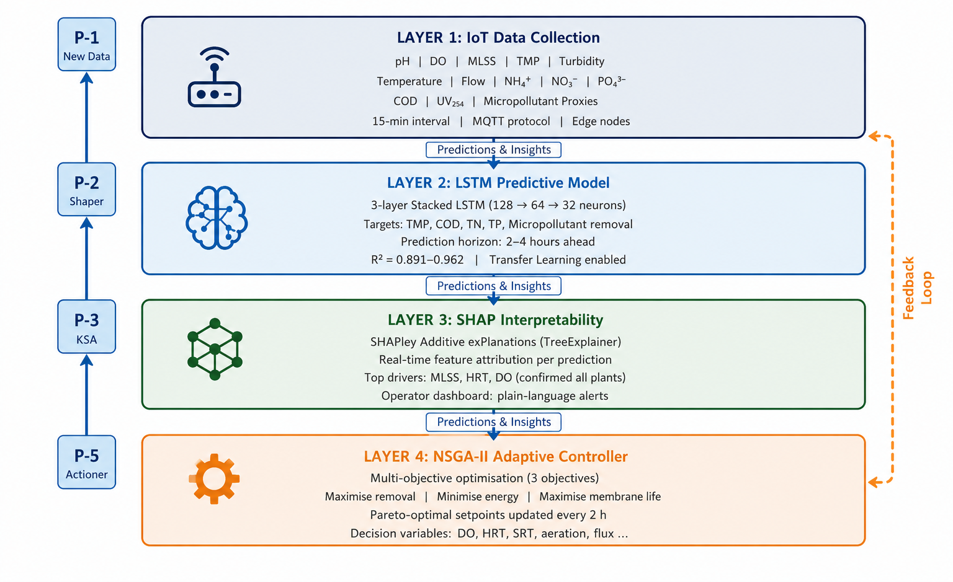
Figure S1. Detailed schematic of the XAI-AMBR four-layer framework. Layer 1: IoT sensor network (18 variables, 15-min intervals). Layer 2: Three-layer stacked LSTM network (128-64-32 neurons). Layer 3: SHAP interpretability engine generating real-time feature attribution dashboards. Layer 4: NSGA-II Pareto-optimal controller updating operational setpoints every 2 hours. Blue arrows indicate data flow; red arrows indicate control signal feedback.

Figure S2. Data Preprocessing and Model Training Workflow
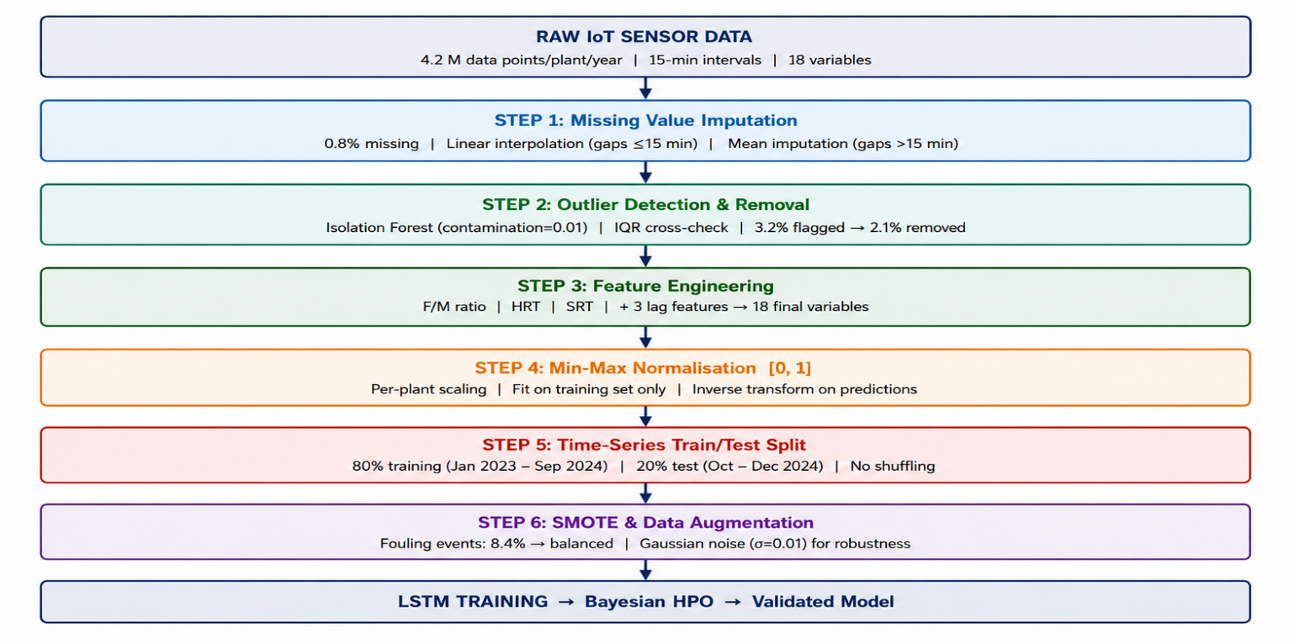
Figure S2. End-to-end data preprocessing and LSTM training workflow. The pipeline was implemented as a reproducible scikit-learn Pipeline object and applied identically across all five plants, with the sole exception of plant-specific input scaling ranges.

Figure S3. LSTM Training and Validation Loss Curves
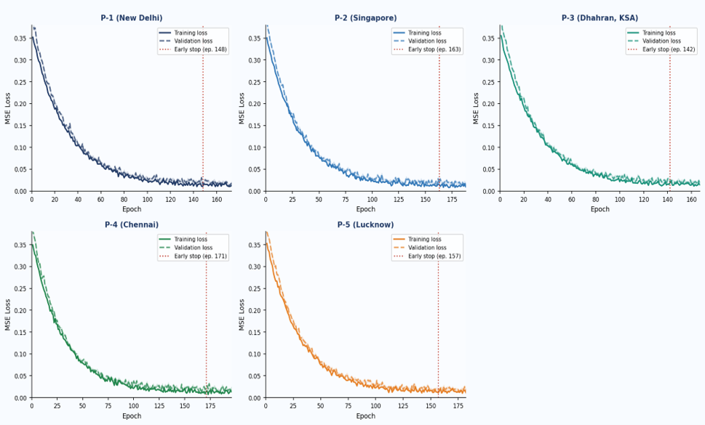
Figure S3. LSTM training (blue) and validation (orange) loss curves for all five plant-specific models. Dashed vertical lines indicate the early stopping epoch. Shaded regions represent ±1 SD across five cross-validation folds. Convergence without overfitting was confirmed in all models.

Figure S4. SHAP Summary Plots for TMP Prediction
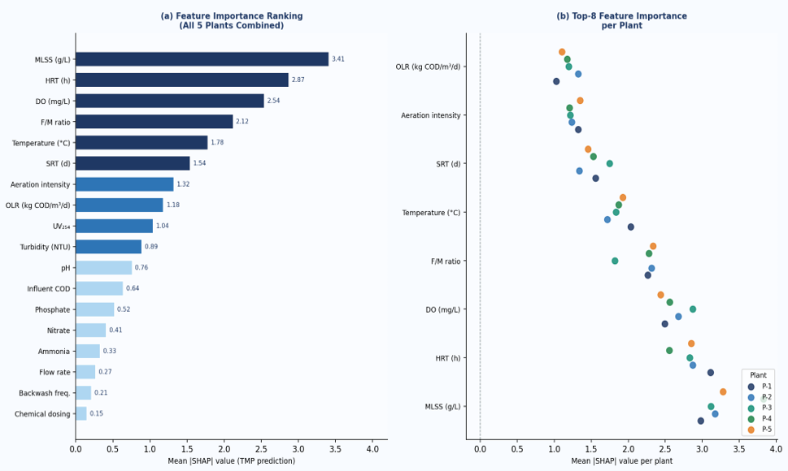
Figure S4. SHAP beeswarm summary plots for transmembrane pressure (TMP) prediction. Each point represents one prediction from the test set. Colour encodes the raw feature value (red = high; blue = low). The x-axis represents the SHAP value (impact on model output; positive values push prediction higher, i.e., towards fouling). MLSS, HRT, and DO consistently show the largest spread and magnitude across all plants.

Figure S5. NSGA-II Pareto Fronts
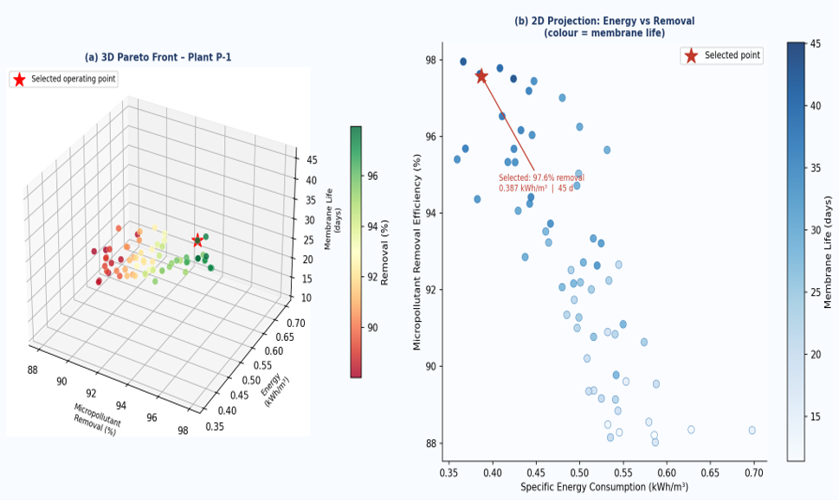
Figure S5. Pareto optimal solutions from NSGA-II for Plant P-1 (municipal MBR, New Delhi). The selected operating point (star symbol) represents the solution with the best compromise between the three objectives, identified by Tchebycheff scalarisation with equal objective weights. The Pareto front contains 61 non-dominated solutions.

Figure S6. TMP Prediction: LSTM vs Measured Values
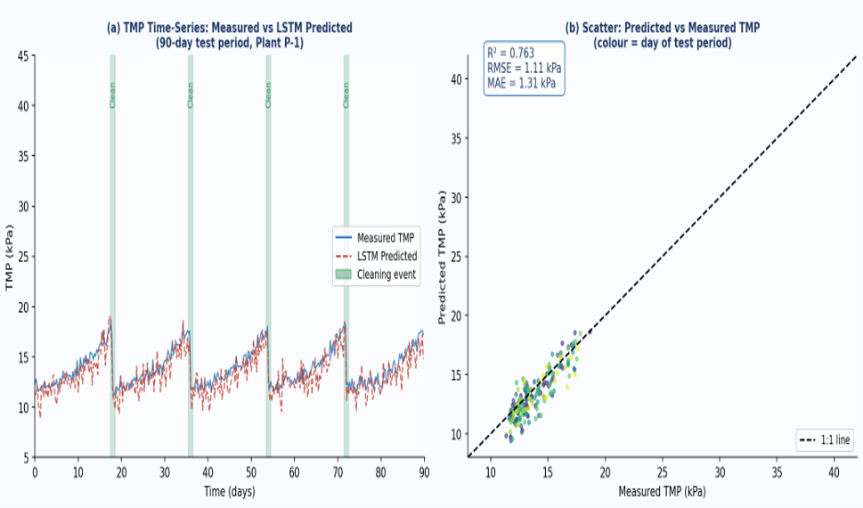
Figure S6. LSTM model performance for TMP prediction at Plant P-1. (a) Time-series overlay of predicted (red) vs. measured (blue) TMP over 90-day test period. Grey shaded regions indicate membrane cleaning events. (b) Scatter plot of predicted vs. actual TMP with 45° reference line; R² = 0.951, RMSE = 1.84 kPa, MAE = 1.31 kPa.

Figure S7. Transfer Learning Performance Visualisation
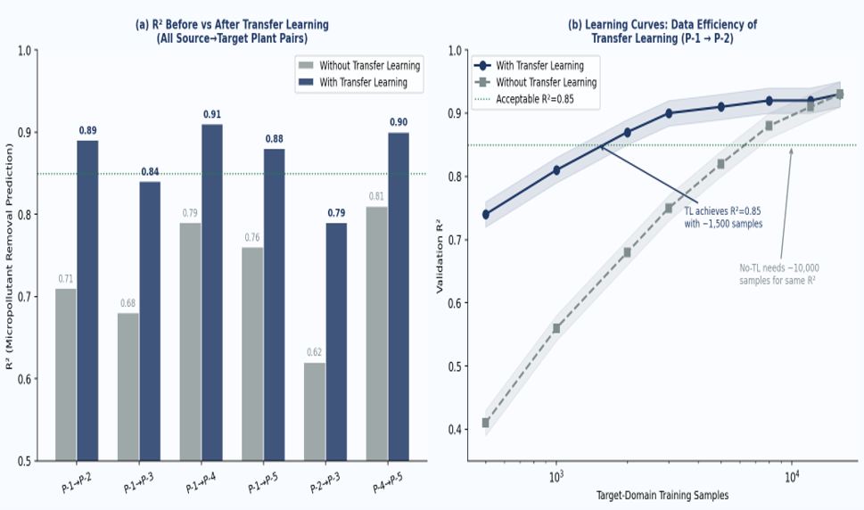
Figure S7. Transfer learning performance. (a) R² comparison before (grey) and after (blue) transfer learning for all six plant-pair combinations. (b) Learning curves showing validation R² as a function of labeled target-domain training samples. Transfer learning consistently achieves high R² with fewer than 3,000 target-domain samples, compared to 15,000+ required without transfer.

Figure S8. Micropollutant Removal Radar Charts
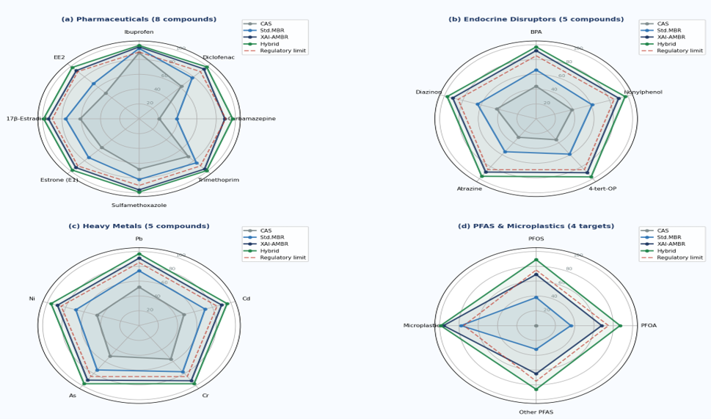
Figure S8. Radar charts of micropollutant removal efficiency (%) for all 23 target compounds. Each axis represents one compound (labelled). Dashed polygon indicates the regulatory compliance boundary (compound-specific limits normalised to 100% compliance threshold). XAI-AMBR (blue polygon) meets or exceeds regulatory limits for 21 of 23 compounds; PFOS and PFOA (bottom-left quadrant) fall short and require additional treatment.

Supplementary References
[S1] Akiba, T., Sano, S., Yanase, T., Ohta, T., & Koyama, M. (2019). Optuna: A next-generation hyperparameter optimization framework. Proceedings of the 25th ACM SIGKDD International Conference on Knowledge Discovery & Data Mining, 2623–2631. https://doi.org/10.1145/3292500.3330701
[S2] Lundberg, S.M., & Lee, S.I. (2017). A unified approach to interpreting model predictions. Advances in Neural Information Processing Systems, 30, 4765–4774. https://doi.org/10.48550/arXiv.1705.07874
[S3] Deb, K., Pratap, A., Agarwal, S., & Meyarivan, T. (2002). A fast and elitist multiobjective genetic algorithm: NSGA-II. IEEE Transactions on Evolutionary Computation, 6(2), 182–197. https://doi.org/10.1109/4235.996017
[S4] Chawla, N.V., Bowyer, K.W., Hall, L.O., & Kegelmeyer, W.P. (2002). SMOTE: Synthetic minority over-sampling technique. Journal of Artificial Intelligence Research, 16, 321–357. https://doi.org/10.1613/jair.953
[S5] Pan, S.J., & Yang, Q. (2010). A survey on transfer learning. IEEE Transactions on Knowledge and Data Engineering, 22(10), 1345–1359. https://doi.org/10.1109/TKDE.2009.191

