Supplementary material 5_HRQoL_model_justification and Sensitivity analysis

1. Aim
This appendix documents the distribution of the six WHOQOL domain scores and justifies the choice of regression model for the overlap-weighted between-arm comparison. Three candidate models were considered: a generalised linear model (GLM) with a Gamma distribution and a log link^{1,2}, ordinary least squares with robust variance (robust OLS)^{7,10}, and Beta regression^{5,6}. Each domain is expressed on the transformed 4–20 scale (the responses to its constituent Likert items, each scored 1–5, are averaged and multiplied by 4; theoretical range 4–20)^{13,14}. All models were fitted with overlap weights^{11,12} and a small-sample bias-corrected sandwich (robust) variance estimator^{9,10}.

2. Distribution of the domain scores
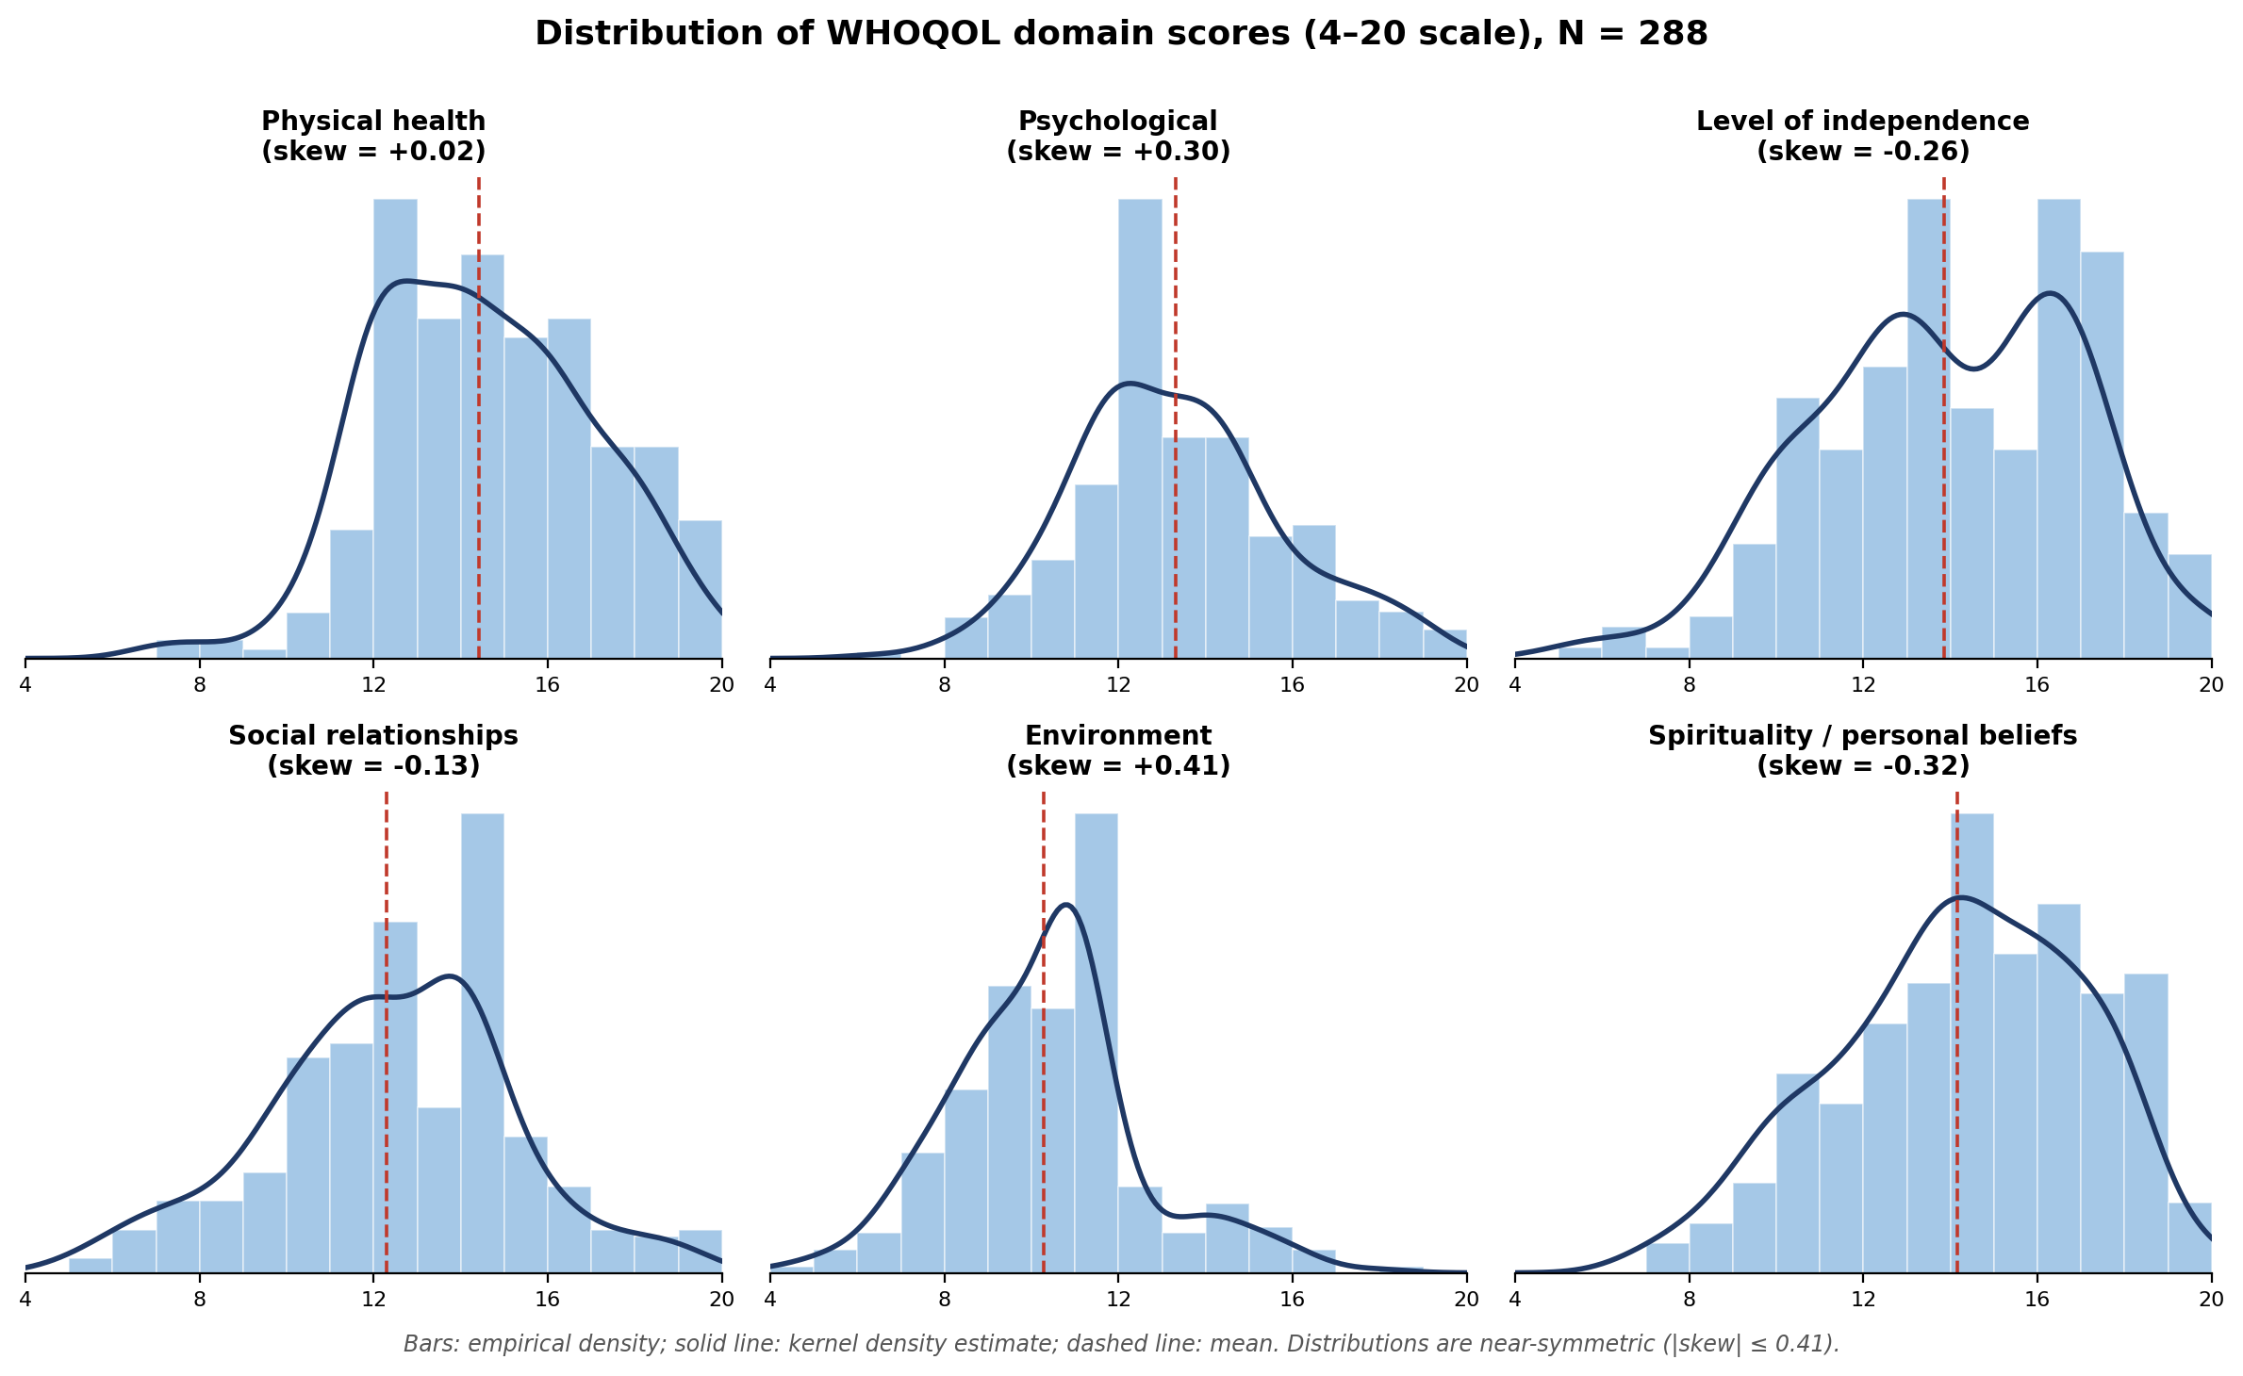
Figure S1. Histograms with kernel-density curves for the six WHOQOL domains (4–20 scale), N = 288. Dashed line: mean.
WHOQOL domain (4–20) | Mean (SD) | Median [IQR] | Min–Max | Skewness | At floor (4) / ceiling (20), n (%) | Score = 0, n
Physical health | 14.41 (2.48) | 14.0 [12.0–16.0] | 7.0–20.0 | +0.02 | 0 / 4 (1.4%) | 0
Psychological | 13.32 (2.39) | 12.8 [12.0–14.4] | 6.4–19.2 | +0.30 | 0 / 0 | 0
Level of independence | 13.85 (2.99) | 14.0 [12.0–16.0] | 5.0–20.0 | −0.26 | 0 / 6 (2.1%) | 0
Social relationships | 12.29 (2.80) | 12.0 [10.8–14.0] | 5.0–19.0 | −0.13 | 0 / 0 | 0
Environment | 10.28 (2.20) | 10.5 [9.0–11.0] | 4.0–18.0 | +0.41 | 1 (0.3%) / 0 | 0
Spirituality / personal beliefs | 14.15 (2.81) | 14.0 [12.0–16.0] | 7.0–20.0 | −0.32 | 0 / 3 (1.0%) | 0
Foot note: SD, standard deviation; IQR, interquartile range. Skewness was mild for every domain (−0.32 to +0.41), well below conventional thresholds for substantial asymmetry¹⁵; boundary mass was negligible (≤2.1% at any bound); no domain contained any value at or below zero.

3. Candidate models and their requirements
- Gamma GLM with log link. Support Y > 0; mean–variance Var(Y)=φ·μ²; suited to positive, continuous, right-skewed data^{1,2}. The log link gives multiplicative effects, so exp(β) is a ratio of mean scores². Does not impose an upper bound.
- Robust OLS (linear regression with sandwich variance). Models the mean on the identity scale, giving differences in mean scores; makes no positivity or boundedness assumption and is well suited to approximately symmetric continuous outcomes. The robust (sandwich) variance accommodates residual heteroscedasticity^{7,8}. It does not respect the bounds and yields additive (difference) rather than multiplicative effects.
- Beta regression. Support (0,1); bounded scores must be rescaled, e.g. Y*=(Y−4)/16. Explicitly models boundedness and the associated heteroscedasticity, and is the model of choice when observations cluster appreciably at the floor or ceiling⁵; it has been applied to bounded HRQoL indices⁴. It cannot accommodate exact 0 or 1; boundary values require the Smithson–Verkuilen transformation⁶ or a zero/one-inflated extension.

4. Decision criteria
Robust OLS suits continuous, approximately symmetric outcomes (mean differences); the Gamma–log model suits positive, right-skewed outcomes (ratios of means)²; Beta regression suits bounded outcomes with appreciable floor/ceiling clustering^{4,5}. As the six domains are strictly positive, continuous and near-symmetric, with negligible boundary mass, all three are applicable and are expected to yield consistent conclusions³. The Gamma–log model was retained as the primary specification for its directly interpretable ratios of mean scores — consistent with the risk-ratio framing used for the binary outcomes — while robust OLS and Beta regression were used as sensitivity analyses.

5. Choice of the 4–20 (rather than 0–100) scale
On the 0–100 transformation, the floor value of 4 maps to 0, since (4 − 4)/16 × 100 = 0¹⁴. The 0–100 version of the environment domain accordingly contained one value of exactly 0, which lies outside the support of the Gamma distribution and would prevent the model from being fitted¹. On the 4–20 scale, the same observation equals 4 (> 0). The 4–20 scale was therefore retained, so that the strict-positivity requirement of the Gamma distribution is met for all six domains.

6. Sensitivity analyses across models
To verify that the conclusions did not depend on the distributional assumption, the weighted between-arm effect was re-estimated under each candidate model³. Point estimates were consistent in direction and statistical significance across models: only the social-relationships domain differed materially between arms (lower in the intervention arm), under all three specifications, while the remaining domains showed no significant between-arm difference.
WHOQOL domain | Gamma–log: ratio of mean scores (RRw) [95% CI] | Robust OLS: mean difference [95% CI] | Beta: ratio of mean scores [95% CI]
Physical health | 1.00 [0.95–1.05] | −0.06 [−0.79, 0.66] | 0.99 [0.93–1.04]
Psychological | 0.97 [0.92–1.02] | −0.45 [−1.12, 0.22] | 0.96 [0.91–1.01]
Level of independence | 0.99 [0.92–1.06] | −0.19 [−1.12, 0.74] | 0.98 [0.91–1.05]
Social relationships | 0.82 [0.77–0.87] | −2.37 [−3.12, −1.61] | 0.81 [0.76–0.87]
Environment | 0.96 [0.90–1.03] | −0.40 [−1.11, 0.30] | 0.99 [0.91–1.06]
Spirituality / personal beliefs | 0.96 [0.90–1.02] | −0.58 [−1.43, 0.26] | 0.96 [0.91–1.02]
Overlap-weighted estimates. Confidence intervals use a small-sample bias-corrected sandwich estimator (HC3) for the Gamma and robust-OLS models^{9,10}, and a finite-sample-corrected robust sandwich (delta method) for the Beta model. Gamma and Beta give ratios of mean scores; robust OLS gives the mean difference. A ratio < 1 (or a negative difference) indicates a lower score in the intervention arm.

7. Statistical formulas
Gamma GLM. For domain score Yᵢ (i = 1, …, 288), Yᵢ > 0, with E(Yᵢ)=μᵢ and log(μᵢ)=β₀+β₁·armᵢ+…; Var(Yᵢ)=φ·μᵢ²¹. Estimating equations weighted by the overlap weights wᵢ¹¹. exp(β₁) is the weighted ratio of mean domain score (intervention vs control) in the overlap population.
Robust OLS. E(Yᵢ)=β₀+β₁·armᵢ+…; β₁ is the weighted mean difference; the variance is a small-sample bias-corrected (HC3) sandwich estimator^{7,9}.
Skewness. γ₁ = E[(Y−μ)³]/σ³¹⁵.
Beta rescaling. Y*=(Y−4)/16 ∈ (0,1); boundary correction Y**=[Y*(N−1)+0.5]/N⁶.

8. References
1. McCullagh P, Nelder JA. Generalized Linear Models. 2nd ed. London: Chapman & Hall; 1989.
2. Manning WG, Mullahy J. Estimating log models: to transform or not to transform? Journal of Health Economics. 2001;20(4):461–494.
3. Mihaylova B, Briggs A, O'Hagan A, Thompson SG. Review of statistical methods for analysing healthcare resources and costs. Health Economics. 2011;20(8):897–916.
4. Hunger M, Baumert J, Holle R. Analysis of SF-6D index data: is beta regression appropriate? Value in Health. 2011;14(5):759–767.
5. Ferrari SLP, Cribari-Neto F. Beta regression for modelling rates and proportions. Journal of Applied Statistics. 2004;31(7):799–815.
6. Smithson M, Verkuilen J. A better lemon squeezer? Maximum-likelihood regression with beta-distributed dependent variables. Psychological Methods. 2006;11(1):54–71.
7. White H. A heteroskedasticity-consistent covariance matrix estimator and a direct test for heteroskedasticity. Econometrica. 1980;48(4):817–838.
8. Huber PJ. The behavior of maximum likelihood estimates under nonstandard conditions. In: Proceedings of the Fifth Berkeley Symposium on Mathematical Statistics and Probability. Berkeley: University of California Press; 1967. p. 221–233.
9. MacKinnon JG, White H. Some heteroskedasticity-consistent covariance matrix estimators with improved finite sample properties. Journal of Econometrics. 1985;29(3):305–325.
10. Long JS, Ervin LH. Using heteroscedasticity consistent standard errors in the linear regression model. The American Statistician. 2000;54(3):217–224.
11. Li F, Morgan KL, Zaslavsky AM. Balancing covariates via propensity score weighting. Journal of the American Statistical Association. 2018;113(521):390–400.
12. Li F, Thomas LE, Li F. Addressing extreme propensity scores via the overlap weights. American Journal of Epidemiology. 2019;188(1):250–257.
13. The WHOQOL Group. The World Health Organization Quality of Life assessment (WHOQOL): development and general psychometric properties. Social Science & Medicine. 1998;46(12):1569–1585.
14. World Health Organization. WHOQOL User Manual. Geneva: World Health Organization; 1998 (WHO/HIS/HSI Rev.2012.03).
15. Bulmer MG. Principles of Statistics. New York: Dover Publications; 1979.

