Appendix

A1. Figures
Figure A1. Industrial Structure of Chinese Provinces (Source: National Bureau of Statistics of China, CEIC)
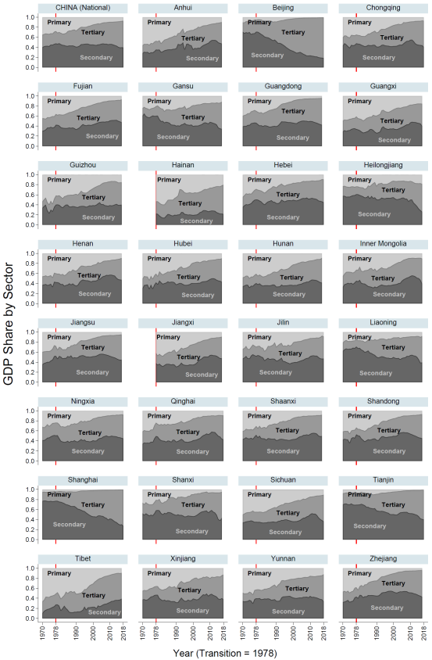
Figure A2. Productivity by Sector in Chinese Provinces (Source: Author’s Calculation (Raw Data from National Bureau of Statistics of China, CEIC))

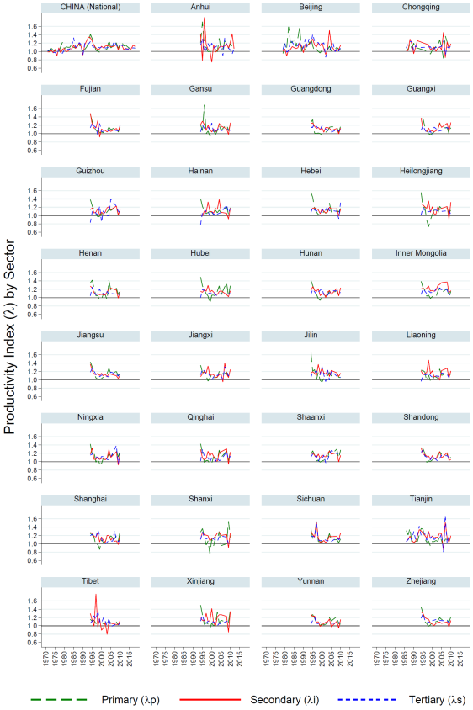
Figure A3. Productivity by Sector in FSU countries (Source: Author’s Calculation (Raw Data from WDI))

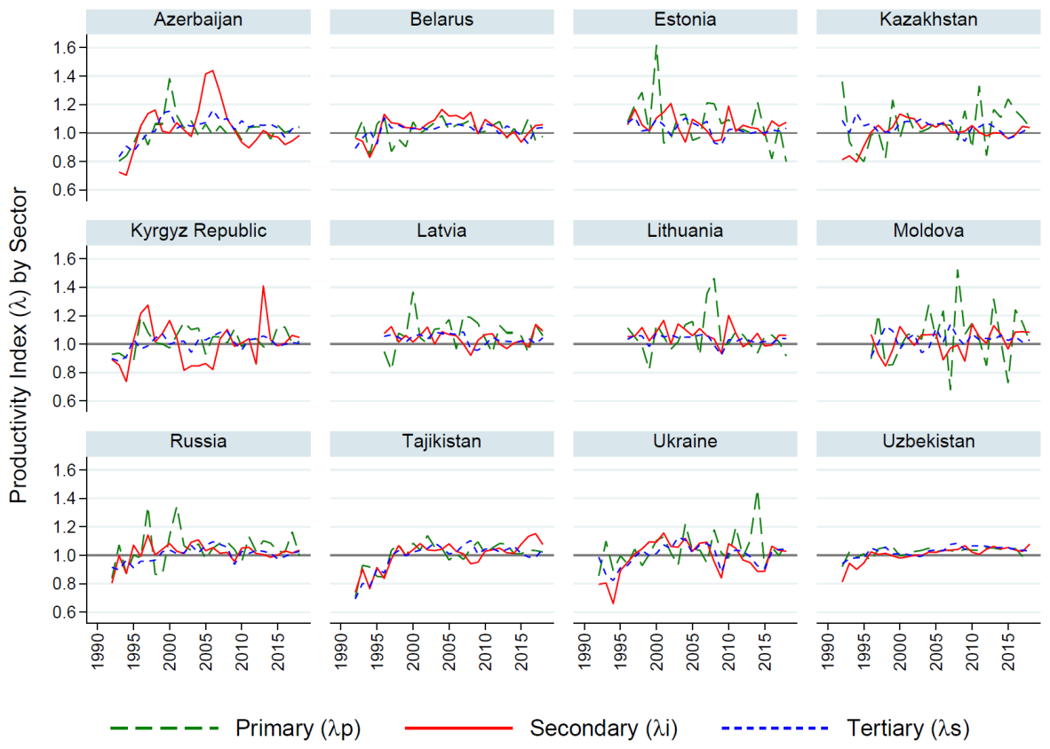

Figure A4. Sectoral Productivity in Chinese Provinces
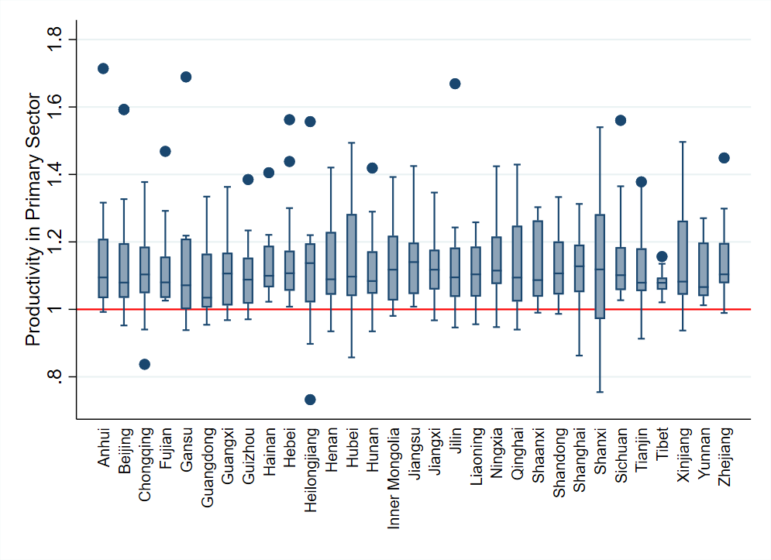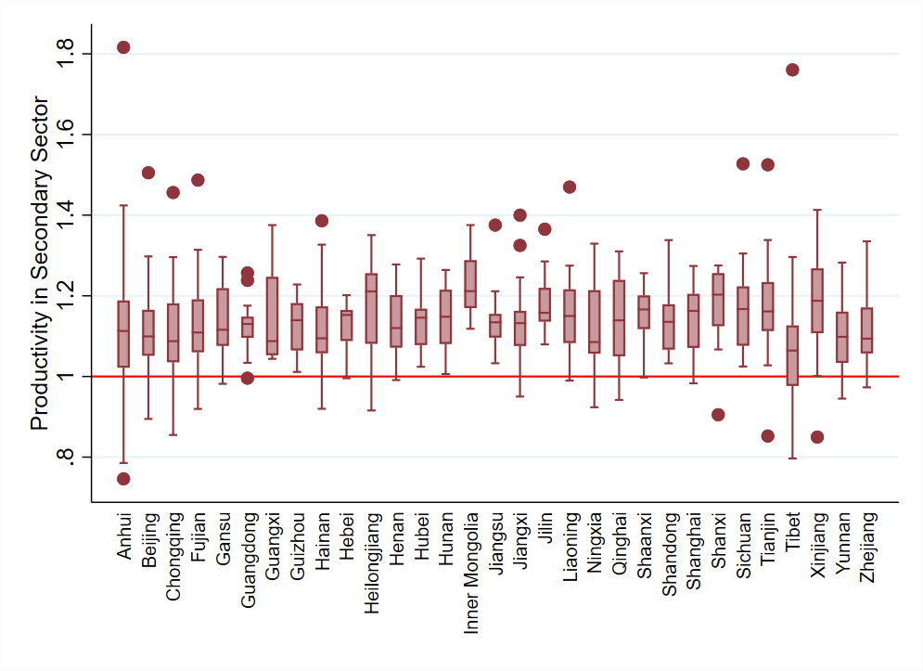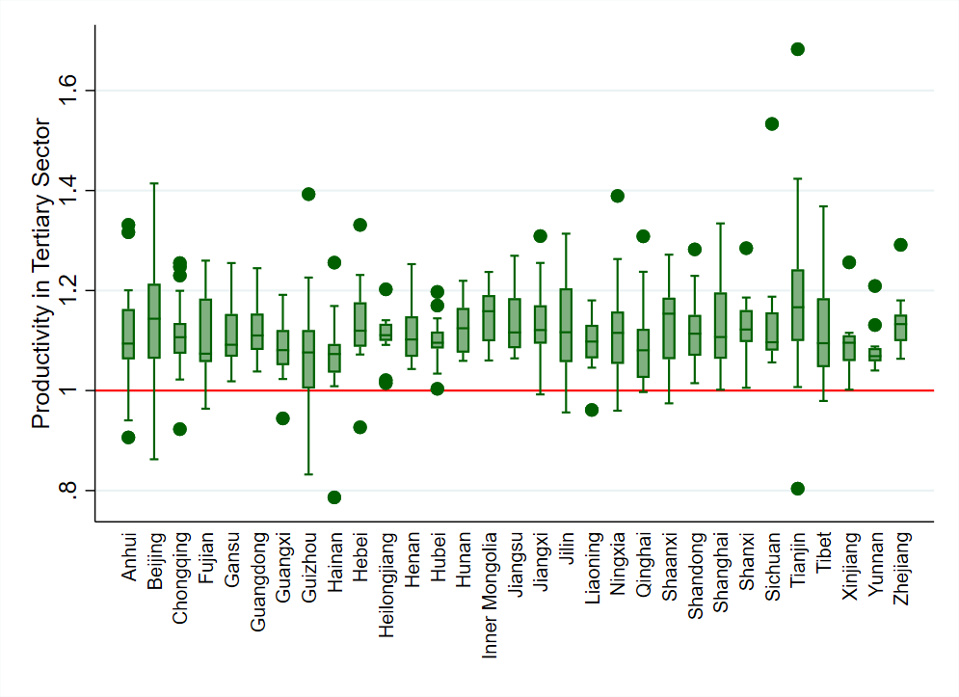

Figure A5. Sectoral Productivity in FSU countries
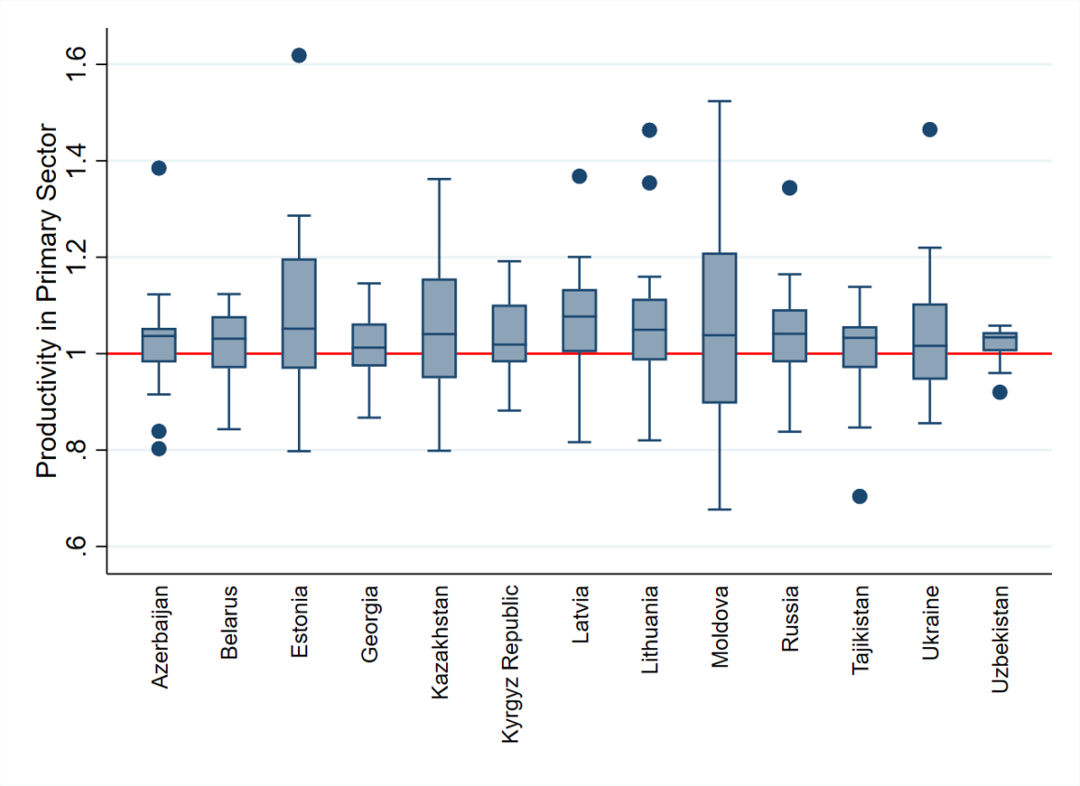
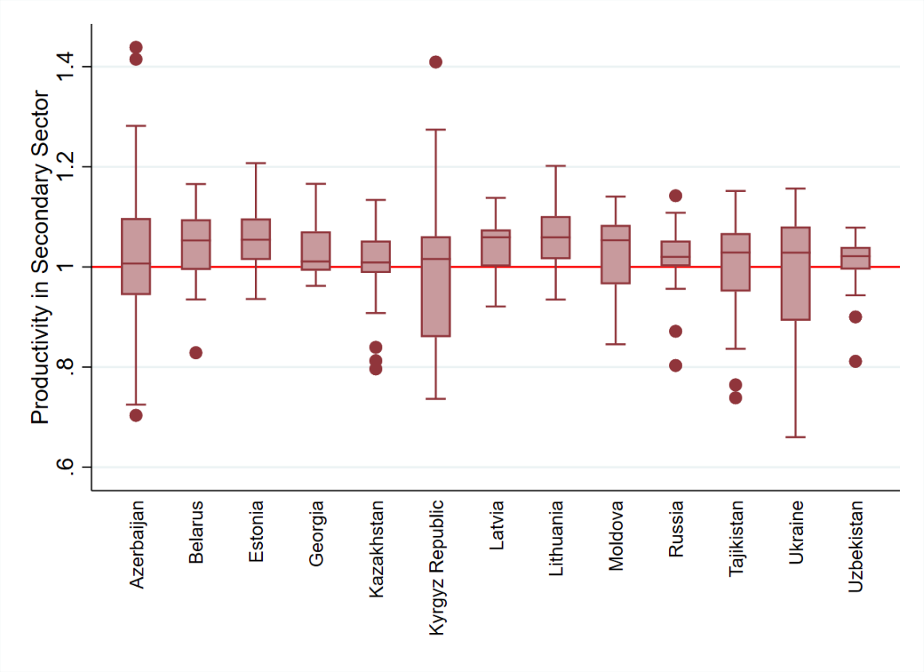
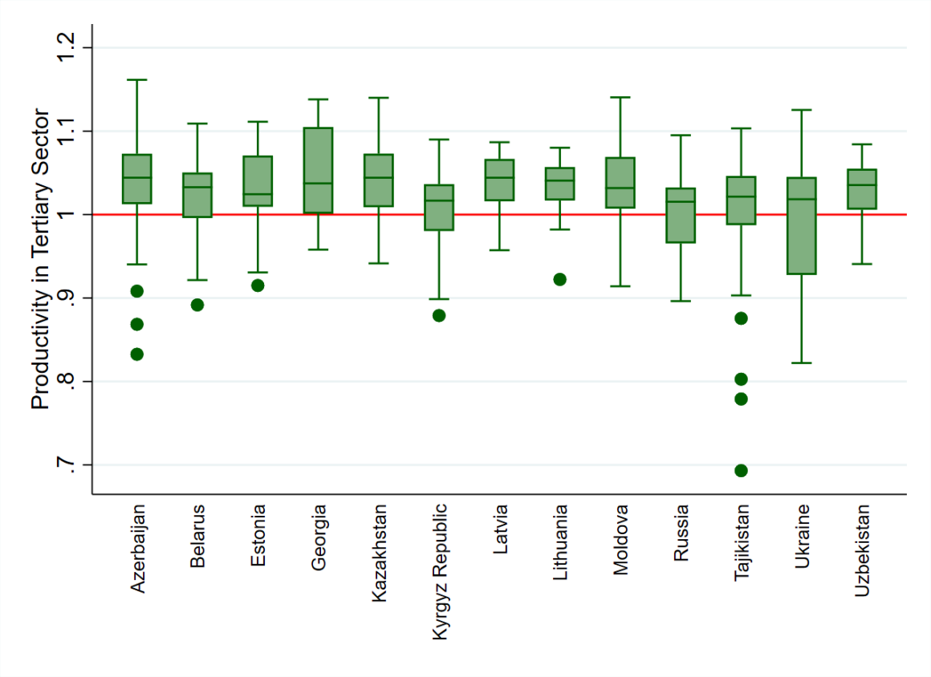

A2. Tables
Table A1. GDP Share of Secondary Sector in Chinese Provinces in 1978 and 2010

Province | 1978 | 2010
Anhui | 0.3558 | 0.5208
Beijing | 0.7114 | 0.2401
Chongqing | 0.4806 | 0.5500
Fujian | 0.4247 | 0.5105
Gansu | 0.6031 | 0.4817
Guangdong | 0.4661 | 0.5002
Guangxi | 0.3403 | 0.4714
Guizhou | 0.4018 | 0.3911
Hainan | 0.2256 | 0.2766
Hebei | 0.5046 | 0.5250
Heilongjiang | 0.6101 | 0.5019
Henan | 0.4263 | 0.5728
Hubei | 0.4219 | 0.4864
Hunan | 0.4070 | 0.4579
Inner Mongolia | 0.4543 | 0.5456
Jiangsu | 0.5260 | 0.5251
Jiangxi | 0.3802 | 0.5420
Jilin | 0.5240 | 0.5199
Liaoning | 0.7107 | 0.5405
Ningxia | 0.5082 | 0.4900
Qinghai | 0.4961 | 0.5514
Shaanxi | 0.5197 | 0.5380
Shandong | 0.5294 | 0.5422
Shanghai | 0.7736 | 0.4205
Shanxi | 0.5849 | 0.5689
Sichuan | 0.3551 | 0.5046
Tianjin | 0.6961 | 0.5247
Tibet | 0.2767 | 0.3230
Xinjiang | 0.4697 | 0.4767
Yunnan | 0.3994 | 0.4462
Zhejiang | 0.4326 | 0.5158

Table A2. Summary of theoretical models and estimation equations
Literature | Key Result | Estimation Equation
Rowthorn & Wells (1987); Rowthorn & Ramaswamy (1997) | • Productivity:  The average productivity growth of an economy converges to the productivity growth of the services sector (the least dynamic sector of the economy). (Baumol et al., 1991)  • Employment Share:  In the early stages of economic development, where the agricultural share of employment is large, the employment share in the industry sector increases, but as the economy grows, the share of agriculture in employment decreases and the industrial share of employment also starts to fall.  • Output Share:  The industrial share of output increases rapidly in the early stage of development, but it converges to the upper limit (1 − 𝜎) as an economy grows. | $$emp_ind_{it}= β_{0}+β_{1}ln_y_{it}+β_{2}{\left(ln_y_{it}\right)}^{2}+μ_{i}+η_{t}+ϵ_{it}$$
Rowthorn & Ramaswamy  (1999) | • Output Share with Consumption, Investment and Trade:  The industrial share of real output increases with 1) the share of industry in real consumption, 2) the investment share in output increases when investment is more industry intensive, and 3) the share of trade balance in the industry sector in output. | $$out_ind_{it}=β_{0}+β_{1}ln_y_{it}+β_{2}{\left(ln_y_{it}\right)}^{2}+β_{3}trd_bal_{it}+β_{4}inv_{it}+β_{5}unemp_{it}+β_{6}rel_pri_{it}+μ_{i}+η_{t}+ϵ_{it}$$  $$emp_ind_{it}=β_{0}+β_{1}ln_y_{it}+β_{2}{\left(ln_y_{it}\right)}^{2}+β_{3}trd_bal_{it}+β_{4}inv_{it}+β_{5}unemp_{it}+μ_{i}+η_{t}+ϵ_{it}$$
Mickiewicz & Zalewska  (2006) | • Employments share with Human and Physical Capital:  When the accumulated capital is below the threshold level ($\overline{k}$), the share of employment in the industrial sector increases with the increase in capital, but when the amount of accumulated capital is sufficiently large (over the threshold), the industrial employment share decreases. That is, an increase in capital leads to industrialisation in the early stages of economic development, and leads to a de-industrialisation in the mature stages of economic development. | $$emp_ind_{it}=β_{0}+β_{1}ln_y_{it}+β_{2}{\left(ln_y_{it}\right)}^{2}+β_{3}ex_man_{it}+β_{4}ex_fuel_{it}+β_{5}unemp_{it}+μ_{i}+η_{t}+ϵ_{it}$$
Mickiewicz & Zalewska  (2002) | • Post-transition share of employment in service sector will increase when productivity increases in both primary and industry sectors. Concentrating on increasing productivity in the industry sector does not sufficiently increase the share of employment in the industry and service sectors. | $$emp_ind_{it}=β_{0}+β_{1}ln_y_{i0}+β_{2}inv_{it}+β_{3}trd_share_{it}+β_{4}tr_{it}+β_{5}ref_{it}+μ_{i}+η_{t}+ϵ_{it}$$

Table A3. Descriptive Statistics
Variable | Obs. | Mean | Std. Dev. | Min | Max | Data Source
Chinese Provinces
Primary Sector | 1541 | 0.2337 | 0.1417 | 0.0030 | 0.7285
GDP Share in Secondary Sector | 1533 | 0.4390 | 0.1037 | 0.1030 | 0.7778
Tertiary Sector | 1541 | 0.3296 | 0.1131 | 0.1287 | 0.8074
Primary Sector | 614 | 0.4689 | 0.1715 | 0.0393 | 0.8077
Employment Secondary Sector | 614 | 0.2337 | 0.1037 | 0.0435 | 0.5598
Tertiary Sector | 614 | 0.2973 | 0.0953 | 0.0901 | 0.7413
Sectoral Primary Sector | 553 | 1.1230 | 0.1288 | 0.7323 | 1.7140 | CEIC Data
Productivity Secondary Sector | 553 | 1.1378 | 0.1133 | 0.7461 | 1.8160 | (Raw Data from
Index in Tertiary Sector | 553 | 1.1170 | 0.0881 | 0.7863 | 1.6826
GDP per capita (LN) | 1560 | 8.1169 | 1.8885 | 4.6151 | 11.8509 | Statistics of China)
GDP per capita2 (LN) | 1560 | 69.4483 | 31.0440 | 21.2993 | 140.4440
Capital Formation (LN) | 1490 | 3.8137 | 2.3649 | -1.2379 | 10.6031
Independent FDI (LN) | 733 | 7.2736 | 2.0462 | 0.0000 | 11.8128
Variables Education (%) | 589 | 72.1505 | 8.4377 | 39.7230 | 95.0443
Unemployment (%) | 974 | 3.3389 | 1.0951 | 0.2000 | 13.3000
Net Export | 1474 | 5.1664 | 203.9398 | -997.3560 | 2422.6768
FSU Countries
Primary Sector | 343 | 0.1115 | 0.0672 | 0.0197 | 0.2582
Value Added Secondary Sector | 343 | 0.3415 | 0.0855 | 0.2062 | 0.6464
Tertiary Sector | 343 | 0.547 | 0.1104 | 0.2854 | 0.7352
Primary Sector  Employment | 420 | 0.2858 | 0.1546 | 0.0349 | 0.5931
Share in Secondary Sector | 420 | 0.2314 | 0.0769 | 0.0822 | 0.3996 | (World Bank)
Tertiary Sector | 420 | 0.4828 | 0.1083 | 0.2436 | 0.7005
Sectoral Primary Sector | 322 | 1.039 | 0.1196 | 0.6766 | 1.6187
Productivity Secondary Sector | 322 | 1.0219 | 0.0977 | 0.66 | 1.4386
Index in Tertiary Sector | 322 | 1.0225 | 0.0601 | 0.6931 | 1.1615
GDP per capita (LN) | 407 | 8.7585 | 0.9254 | 6.6949 | 10.4582 | IMF
GDP per capita2 (LN) | 407 | 77.5649 | 16.1403 | 44.8214 | 109.3744 | IMF
Capital Formation (LN) | 380 | 3.1177 | 0.3457 | 0.9733 | 4.0554 | WDI
Independent FDI (LN) | 363 | 1.1622 | 1.1599 | -3.1921 | 4.0087 | WDI
Variables Openness (LN) | 375 | -2.1663 | 1.1103 | -10.6477 | -0.0977 | WDI
Human Capital (LN) | 250 | 1.1031 | 0.0728 | 0.8956 | 1.2678 | PWT 9.0
Fuel Export (LN) | 271 | 2.2892 | 1.7775 | -6.2601 | 4.5756 | WDI
Unemployment (%) | 299 | 9.0161 | 5.7216 | 0.1000 | 38.4000 | IMF
Inflation (%) | 395 | 181.9311 | 950.4341 | -71.3000 | 15616.50 | IMF
Transition Index | 375 | 0.0000 | 2.2308 | -4.3213 | 3.7956 | EBRD

Table A4. Correlation Matrix and Collinearity Diagnostics (Chinese Provinces)
 | Correlation Matrix |  |  |  |  |  |  |  |  | Collinearity Diagnostics
 | (1) | (2) | (3) | (4) | (5) | (6) | (7) | (8) | (9) | VIF | Tolerance
(1) Productivity in Primary Sector | 1.0000 |  |  |  |  |  |  |  |  | 1.45 | 0.6877
(2) Productivity in Secondary Sector | 0.2537 | 1.0000 |  |  |  |  |  |  |  | 1.19 | 0.8432
(3) Productivity in Tertiary Sector | 0.1402 | 0.3085 | 1.0000 |  |  |  |  |  |  | 1.12 | 0.8948
(4) GDP per capita (LN) | -0.0586 | 0.0426 | 0.0538 | 1.0000 |  |  |  |  |  | 2.57 | 0.3888
(5) Capital Formation (LN) | -0.0364 | -0.0275 | -0.0156 | 0.9077 | 1.0000 |  |  |  |  | 4.07 | 0.2456
(6) FDI (LN) | 0.0516 | -0.0552 | 0.0314 | 0.6423 | 0.8350 | 1.0000 |  |  |  | 3.69 | 0.2709
(7) Education (%) | 0.2652 | 0.0000 | -0.0237 | 0.3233 | 0.4202 | 0.2120 | 1.0000 |  |  | 1.30 | 0.7678
(8) Unemployment (%) | 0.0260 | -0.1128 | -0.1827 | 0.0030 | -0.0006 | -0.1874 | 0.0440 | 1.0000 |  | 1.18 | 0.8441
(9) Net Export | 0.0062 | -0.0652 | 0.0096 | 0.0294 | 0.1461 | 0.3349 | 0.0098 | 0.0230 | 1.0000 | 1.17 | 0.8517
Mean VIF |  |  |  |  |  |  |  |  |  | 1.97

Table A5. Correlation Matrix and Collinearity Diagnostics (Chinese Provinces)
 | Correlation Matrix |  |  |  |  |  |  |  |  |  |  |  | Collinearity Diagnostics
 | (1) | (2) | (3) | (4) | (5) | (6) | (7) | (8) | (9) | (10) | (11) | (12) | VIF | Tolerance
(1) Productivity in Primary Sector | 1.0000 |  |  |  |  |  |  |  |  |  |  |  | 1.12 | 0.8931
(2) Productivity in Secondary Sector | 0.1783 | 1.0000 |  |  |  |  |  |  |  |  |  |  | 1.17 | 0.8516
(3) Productivity in Tertiary Sector | 0.1659 | 0.4853 | 1.0000 |  |  |  |  |  |  |  |  |  | 1.31 | 0.7627
(4) GDP per capita (LN) | 0.1605 | 0.1760 | 0.1735 | 1.0000 |  |  |  |  |  |  |  |  | 4.47 | 0.2236
(5) Capital Formation (LN) | 0.0736 | 0.1037 | 0.2171 | 0.2919 | 1.0000 |  |  |  |  |  |  |  | 2.01 | 0.4965
(6) FDI (LN) | 0.0953 | 0.3397 | 0.3886 | 0.1905 | 0.2642 | 1.0000 |  |  |  |  |  |  | 1.56 | 0.6392
(7) Education (%) | 0.2654 | 0.3541 | 0.2904 | 0.7020 | 0.3177 | 0.2884 | 1.0000 |  |  |  |  |  | 6.47 | 0.1545
(8) Unemployment (%) | 0.1908 | 0.2421 | 0.1486 | 0.4044 | 0.1927 | 0.2815 | 0.4146 | 1.0000 |  |  |  |  | 2.61 | 0.3826
(9) Net Export | 0.0271 | 0.1087 | -0.0468 | 0.3604 | 0.0952 | 0.0000 | 0.2879 | 0.4004 | 1.0000 |  |  |  | 1.76 | 0.5687
(10) Unemployment (%) | 0.0076 | 0.0811 | 0.0234 | -0.0641 | -0.0282 | 0.1626 | -0.1235 | -0.0724 | -0.2233 | 1.0000 |  |  | 1.69 | 0.5926
(11) Inflation (%) | -0.1888 | -0.4340 | -0.4108 | -0.1937 | -0.3337 | -0.3670 | -0.5537 | -0.1943 | 0.0024 | -0.1495 | 1.0000 |  | 1.43 | 0.6982
(12) Transition Index | 0.2781 | 0.3352 | 0.3055 | 0.4225 | 0.0161 | 0.3491 | 0.5609 | 0.5992 | -0.2152 | 0.4763 | -0.3136 | 1.0000 | 3.58 | 0.2793
Mean VIF |  |  |  |  |  |  |  |  |  |  |  |  | 2.43

Table A6. Output Share by Sector of Chinese Provinces (Additional Controls)

Dependent Variable is GDP Share by Sector
Method | FGLS | FGLS | FGLS | FE | RE | FE | FE | SURE | SURE | SURE
 | (1) | (2) | (3) | (4) | (5) | (6) | (7) | (8) | (9) | (10)
Sector | Primary | Secondary | Tertiary | Primary | Primary | Secondary | Tertiary | Primary | Secondary | Tertiary
Productivity Index  in Primary Sector | 0.0414*** | -0.0280*** | -0.0109 | 0.0537*** | 0.0544*** | -0.0228 | -0.0309 | 0.0479*** | -0.0144 | -0.0336*
Productivity Index  in Primary Sector | (7.6787) | (-3.5789) | (-1.2196) | (4.4323) | (4.4758) | (-1.1180) | (-1.4731) | (5.0499) | (-0.7768) | (-1.7714)
Productivity Index  in Secondary Sector | 0.0010 | 0.0337*** | -0.0422*** | -0.0012 | -0.0009 | 0.0368* | -0.0356** | -0.0108 | 0.0509*** | -0.0401**
Productivity Index  in Secondary Sector | (0.2563) | (4.2963) | (-5.4374) | (-0.1264) | (-0.0945) | (1.9435) | (-2.0536) | (-1.3383) | (3.2284) | (-2.4807)
Productivity Index  in Tertiary Sector | -0.0003 | -0.0244*** | 0.0271*** | -0.0030 | -0.0031 | -0.0117 | 0.0147 | -0.0188** | 0.0115 | 0.0073
Productivity Index  in Tertiary Sector | (-0.0778) | (-3.4232) | (3.8731) | (-0.2974) | (-0.2998) | (-0.5941) | (0.8921) | (-2.1652) | (0.6809) | (0.4187)
GDP per capita | -0.3309*** | 0.3947*** | -0.1323* | -0.3743*** | -0.3769*** | 0.4358* | -0.0616 | 0.0810*** | -0.2339*** | 0.1529***
GDP per capita | (-10.4512) | (5.4604) | (-1.8347) | (-6.6170) | (-6.9963) | (1.9399) | (-0.2408) | (11.4356) | (-16.9297) | (10.7932)
GDP per capita  squared | 0.0112*** | -0.0186*** | 0.0075* | 0.0160*** | 0.0157*** | -0.0185* | 0.0025 | -0.0045*** | 0.0117*** | -0.0072***
GDP per capita  squared | (6.8747) | (-4.9489) | (1.9542) | (5.4147) | (5.4153) | (-1.8037) | (0.2152) | (-5.7813) | (7.6636) | (-4.5838)
Capital Formation | 0.0146*** | 0.0347*** | -0.0257*** | -0.0104 | -0.0055 | 0.0633* | -0.0529 | -0.0185*** | 0.0752*** | -0.0567***
Capital Formation | (4.5627) | (5.8844) | (-5.6294) | (-1.3193) | (-0.6883) | (1.7513) | (-1.3992) | (-2.6712) | (5.5771) | (-4.0990)
FDI | -0.0021** | -0.0036* | 0.0021 | -0.0037 | -0.0029* | 0.0091** | -0.0054 | -0.0058*** | 0.0122*** | -0.0064**
FDI | (-2.1717) | (-1.7998) | (1.2475) | (-1.4362) | (-1.2440) | (1.4971) | (-0.8659) | (-3.8827) | (4.1607) | (-2.1152)
Education | 0.0000 | 0.0002 | -0.0003* | 0.0004 | 0.0004 | 0.0001 | -0.0005 | -0.0005*** | 0.0015*** | -0.0010***
Education | (0.3610) | (0.8220) | (-1.6716) | (1.5239) | (1.5399) | (0.2818) | (-0.9908) | (-4.0029) | (5.6624) | (-3.5181)
Unemployment | 0.0026*** | -0.0001 | -0.0025 | 0.0054* | 0.0056* | -0.0007 | -0.0048 | 0.0086*** | -0.0053 | -0.0033
Unemployment | (2.7245) | (-0.0267) | (-1.1040) | (1.7820) | (1.7659) | (-0.1094) | (-0.6746) | (4.9917) | (-1.5709) | (-0.9639)
Net Export | -0.0000 | -0.0000 | 0.0000** | -0.0000** | -0.0000* | 0.0000 | -0.0000 | 0.0000** | -0.0001* | 0.0000
Net Export | (-0.3677) | (-1.4746) | (2.2411) | (-2.2588) | (-1.7309) | (1.1459) | (-0.3350) | (2.0703) | (-1.7169) | (0.6413)
Breusch-Pagan Test  for Heteroskedasticity | 12.79 | 17.57 | 15.74
Breusch-Pagan Test  for Heteroskedasticity | [0.0000] | [0.0000] | [0.0000]
Wooldridge Test  for Auto-correlation | 114.432 | 218.574 | 291.561
Wooldridge Test  for Auto-correlation | [0.0000] | [0.0001] | [0.0000]
Hausman Test |  |  |  | 16.30 |  | 47.15 | 55.64
Hausman Test |  |  |  | [0.3622] |  | [0.0000] | [0.0000]
Auto-correlation | PSAR1 | PSAR1 | PSAR1
Time Fixed Effects | Yes | Yes | Yes | Yes | Yes | Yes | Yes | Yes | Yes | Yes
Province Fixed Effects | Yes | Yes | Yes | Yes | Yes | Yes | Yes | Yes | Yes | Yes
N | 310 | 310 | 310 | 311 | 311 | 311 | 311 | 311 | 311 | 311
R squared |  |  |  | 0.8985 | 0.8982 | 0.7363 | 0.3940 | 0.9648 | 0.8977 | 0.9190
Note: 1. In parentheses: (robust t-statistics) with round bracket and [p-value] with squared bracket.
2. ***, **, and * in the cells indicate the levels of significance of 1%, 5% and 10% respectively.
3. F-statistics are reported in Heteroskedasticity test and Auto-correlation test, and Chi-squared statistics in Hausman test respectively.
Table A7. Output Share by Sector of Former Soviet Union Countries (Additional Controls)

Dependent Variable is Value Added Share by Sector
Method | FGLS | FGLS | FGLS | FE | FE | FE | SURE | SURE | SURE
 | (1) | (2) | (3) | (4) | (5) | (6) | (7) | (8) | (9)
Sector | Primary | Secondary | Tertiary | Primary | Secondary | Tertiary | Primary | Secondary | Tertiary
Productivity Index  in Primary Sector | 0.0191∗∗∗ | -0.0014 | -0.0210∗∗∗ | 0.0276∗∗∗ | 0.0037 | -0.0313∗∗∗ | 0.0248∗∗∗ | 0.0010 | -0.0258∗∗
Productivity Index  in Primary Sector | (6.6946) | (-0.2684) | (-3.4122) | (4.0610) | (0.6516) | (-5.7804) | (5.4775) | (0.0911) | (-2.2608)
Productivity Index  in Secondary Sector | -0.0185∗∗∗ | 0.0562∗∗∗ | -0.0442∗∗∗ | -0.0235∗∗ | 0.0859∗∗∗ | -0.0624∗∗∗ | -0.0275∗∗∗ | 0.0790∗∗∗ | -0.0515∗∗
Productivity Index  in Secondary Sector | (-2.6756) | (4.6873) | (-3.0586) | (-3.0841) | (4.6655) | (-3.7748) | (-3.1071) | (3.9809) | (-2.3555)
Productivity Index  in Tertiary Sector | -0.0081 | -0.0185 | 0.0317 | -0.0250 | -0.0673∗ | 0.0922∗∗ | -0.0335∗∗ | -0.0768∗∗ | 0.1101∗∗∗
Productivity Index  in Tertiary Sector | (-0.6205) | (-0.8221) | (1.1437) | (-1.3452) | (-1.9986) | (3.2430) | (-2.0513) | (-2.0241) | (2.6718)
GDP per capita | -0.3511∗∗∗ | -0.3594∗∗∗ | 0.7536∗∗∗ | -0.1275∗ | -0.1790 | 0.3064 | 0.0303∗∗ | -0.0062 | -0.0245
GDP per capita | (-10.0157) | (-5.3516) | (9.5570) | (-2.0501) | (-0.5987) | (0.9412) | (2.3710) | (-0.2618) | (-1.0269)
GDP per capita  squared | 0.0157∗∗∗ | 0.0218∗∗∗ | -0.0400∗∗∗ | 0.0054∗ | 0.0105 | -0.0159 | -0.0007 | 0.0040∗ | -0.0033
GDP per capita  squared | (7.8753) | (5.6332) | (-8.8343) | (2.1515) | (0.7804) | (-1.0872) | (-0.7113) | (1.9258) | (-1.4920)
Capital Formation | -0.0012∗∗∗ | 0.0017∗∗∗ | -0.0010∗∗∗ | -0.0018 | 0.0028∗ | -0.0012∗∗∗ | -0.0022∗∗∗ | 0.0034∗∗∗ | 0.0029∗∗∗
Capital Formation | (-0.6577) | (-2.9706) | (3.6723) | (-3.5209) | (-1.2598) | (2.0641) | (-5.6860) | (-4.6213) | (6.6907)
FDI | 0.0001 | 0.0015 | -0.0005 | 0.0001 | 0.0010 | -0.0010 | 0.0006 | 0.0017 | -0.0023
FDI | (0.0950) | (1.2025) | (-0.3296) | (0.0578) | (0.5657) | (-0.4687) | (0.6180) | (0.7159) | (-0.9019)
Openness | 0.0011 | -0.0072 | 0.0085 | 0.0052 | 0.0229 | -0.0281 | 0.0059 | 0.0225∗∗ | -0.0284∗∗
Openness | (0.3940) | (-0.8738) | (0.9487) | (0.8570) | (0.7301) | (-0.9611) | (1.2433) | (2.0940) | (-2.4397)
Human Capital | 0.0102 | 0.0063 | -0.0536 | -0.1017 | 0.0963 | 0.0055 | -0.1211∗∗∗ | 0.1212∗∗∗ | 0.0000
Human Capital | (0.5475) | (0.0915) | (-0.7864) | (-1.0173) | (0.3110) | (0.0166) | (-3.0625) | (3.0612) | (.)
Fuel Export | 0.0008 | 0.0055∗∗∗ | -0.0051∗∗∗ | -0.0045∗∗ | 0.0003 | 0.0041 | -0.0049∗∗∗ | -0.0001 | 0.0050∗
Fuel Export | (1.1764) | (3.9234) | (-3.0504) | (-2.4436) | (0.0845) | (0.9630) | (-4.6433) | (-0.0593) | (1.8926)
Unemployment | 0.0001 | -0.0029∗∗∗ | 0.0030∗∗∗ | 0.0002 | -0.0029∗ | 0.0028 | 0.0006∗ | -0.0025∗∗∗ | 0.0019∗∗
Unemployment | (0.3444) | (-4.7342) | (4.3236) | (0.3965) | (-1.9759) | (1.6105) | (1.7046) | (-2.9953) | (2.0825)
Inflation | 0.0002∗∗∗ | -0.0000 | -0.0002 | 0.0002∗ | -0.0000 | -0.0002 | 0.0002∗∗∗ | -0.0000 | -0.0002
Inflation | (3.5482) | (-0.0326) | (-1.5080) | (2.0886) | (-0.1138) | (-0.9279) | (3.9978) | (-0.3850) | (-1.2329)
Transition Index | -0.0050∗∗∗ | -0.0184∗∗∗ | 0.0226∗∗∗ | 0.0045 | -0.0082 | 0.0037 | 0.0060∗∗ | -0.0066 | 0.0006
Transition Index | (-2.6937) | (-4.1131) | (4.3696) | (1.2552) | (-0.4695) | (0.2168) | (2.5778) | (-1.2232) | (0.0993)
Breusch-Pagan Test  for Heteroskedasticity | 5.68 | 1.72 | 6.03
Breusch-Pagan Test  for Heteroskedasticity | [0.0000] | [0.0634] | [0.0000]
Wooldridge Test  for Auto-correlation | 138.399 | 60.791 | 67.457
Wooldridge Test  for Auto-correlation | [0.0000] | [0.0001] | [0.0001]
Hausman Test |  |  |  | 70.88 | 56.66 | 74.03
Hausman Test |  |  |  | [0.0000] | [0.0000] | [0.0000]
Auto-correlation | Yes | Yes | Yes | Yes | Yes | Yes | Yes | Yes | Yes
Time Fixed Effects | Yes | Yes | Yes | Yes | Yes | Yes | Yes | Yes | Yes
Province Fixed Effects | PSAR1 | PSAR1 | PSAR1
N | 145 | 145 | 145 | 146 | 146 | 146 | 146 | 146 | 146
R squared |  |  |  | 0.8051 | 0.6086 | 0.7153 | 0.9878 | 0.9114 | 0.9519
Note: 1. In parentheses: (robust t-statistics) with round bracket and [p-value] with squared bracket.
2. ***, **, and * in the cells indicate the levels of significance of 1%, 5% and 10% respectively.
3. F-statistics are reported in Heteroskedasticity test and Auto-correlation test, and Chi-squared statistics in Hausman test respectively.
Table A8. Employment Share by Sector of Chinese Provinces

Dependent Variable is Employment Share by Sector
Method | FGLS | FGLS | FGLS | FE | FE | FE | FGLS | FGLS | FGLS | FE | FE | FE
 | (1) | (2) | (3) | (4) | (5) | (6) | (7) | (8) | (9) | (10) | (11) | (12)
Sector | Primary | Secondary | Tertiary | Primary | Secondary | Tertiary | Primary | Secondary | Tertiary | Primary | Secondary | Tertiary
Productivity Index  in Primary Sector | 0.0072 | -0.0056 | 0.0003 | -0.0002 | -0.0130 | 0.0132 | -0.0084 | -0.0019 | 0.0085 | -0.0101 | 0.0021 | 0.0080
Productivity Index  in Primary Sector | (1.3512) | (-1.3258) | (0.0963) | (-0.0152) | (-0.8124) | (1.0075) | (-0.9239) | (-0.2827) | (1.3457) | (-0.4110) | (0.0924) | (0.4329)
Productivity Index  in Secondary Sector | 0.0276∗∗∗ | -0.0304∗∗∗ | 0.0030 | 0.0411∗∗ | -0.0395∗∗ | -0.0016 | 0.0362∗∗∗ | -0.0315∗∗∗ | 0.0045 | 0.0046 | -0.0024 | -0.0022
Productivity Index  in Secondary Sector | (5.8661) | (-8.3374) | (0.8638) | (2.6908) | (-2.3635) | (-0.2158) | (4.7841) | (-5.4354) | (0.8487) | (0.3454) | (-0.1149) | (-0.1663)
Productivity Index  in Tertiary Sector | 0.0380∗∗∗ | 0.0134∗∗∗ | -0.0491∗∗∗ | 0.0523∗∗∗ | 0.0173 | -0.0696∗∗∗ | 0.0416∗∗∗ | 0.0174∗∗ | -0.0565∗∗∗ | 0.0296∗ | 0.0281 | -0.0577∗∗∗
Productivity Index  in Tertiary Sector | (6.2391) | (2.9526) | (-11.8134) | (2.9777) | (0.7447) | (-3.0021) | (4.8835) | (2.5380) | (-9.7737) | (1.7571) | (1.2729) | (-3.9063)
GDP per capita | -0.3670∗∗∗ | 0.2991∗∗∗ | 0.1371∗∗∗ | -0.4280∗∗∗ | 0.4663∗∗∗ | -0.0384 | -0.1568∗∗ | 0.2097∗∗∗ | 0.1577∗∗∗ | -0.3856∗∗∗ | 0.4628∗∗ | -0.0772
GDP per capita | (-6.6933) | (7.1288) | (3.9425) | (-3.9099) | (3.1864) | (-0.2731) | (-1.9797) | (3.4552) | (2.6672) | (-3.4938) | (2.1626) | (-0.4303)
GDP per capita  squared | 0.0061∗∗ | -0.0084∗∗∗ | -0.0025 | 0.0201∗∗∗ | -0.0212∗∗∗ | 0.0011 | -0.0057 | -0.0041 | -0.0040 | 0.0176∗∗ | -0.0229∗ | 0.0053
GDP per capita  squared | (2.0598) | (-3.6902) | (-1.2778) | (3.2085) | (-2.7809) | (0.1513) | (-1.3970) | (-1.3066) | (-1.2106) | (2.6080) | (-1.9901) | (0.5551)
Capital Formation |  |  |  |  |  |  | 0.0175∗∗∗ | 0.0071∗∗ | -0.0171∗∗∗ | 0.0114 | 0.0523 | -0.0637∗∗
Capital Formation |  |  |  |  |  |  | (4.3013) | (2.0465) | (-4.4975) | (0.4509) | (1.2475) | (-2.2219)
FDI |  |  |  |  |  |  | -0.0057∗∗∗ | -0.0001 | -0.0029∗∗∗ | -0.0090 | 0.0048 | 0.0043
FDI |  |  |  |  |  |  | (-3.2536) | (-0.0399) | (2.6921) | (-1.2805) | (0.6371) | (1.0863)
Education |  |  |  |  |  |  | -0.0001 | -0.0000 | 0.0002 | 0.0003 | -0.0006 | 0.0003
Education |  |  |  |  |  |  | (-043750) | (-0.0038) | (1.6381) | (0.3901) | (-0.8331) | (0.6965)
Unemployment |  |  |  |  |  |  | 0.0049∗∗ | -0.0010 | -0.0034∗∗ | 0.0100 | -0.0026 | -0.0074
Unemployment |  |  |  |  |  |  | (2.1923) | (-0.5949) | (-2.0796) | (1.4174) | (-0.3489) | (-1.5598)
Net Export |  |  |  |  |  |  | -0.0000∗∗∗ | 0.0001∗∗∗ | 0.0000 | -0.0002∗∗ | 0.0002∗∗ | -0.0001
Net Export |  |  |  |  |  |  | (-3.4301) | (4.3191) | (0.8719) | (-2.4448) | (2.8039) | (-1.2927)
Breusch-Pagan Test  for Heteroskedasticity | 10.01 | 7.13 | 24.95 |  |  |  | 15.15 | 7.48 | 15.74
Breusch-Pagan Test  for Heteroskedasticity | [0.0000] | [0.0000] | [0.0000] |  |  |  | [0.0000] | [0.0000] | [0.0000]
Wooldridge Test  for Auto-correlation | 270.927 | 280.908 | 97.597 |  |  |  | 82.183 | 189.936 | 58.982
Wooldridge Test  for Auto-correlation | [0.0000] | [0.0000] | [0.0000] |  |  |  | [0.0000] | [0.0000] | [0.0000]
Hausman Test |  |  |  | 82.89 | 34.03 | 94.91 |  |  |  | 33.08 | 62.57 | 53.72
Hausman Test |  |  |  | [0.0000] | [0.0004] | [0.0000] |  |  |  | [0.0046] | [0.0000] | [0.0000]
Auto-correlation | Yes | Yes | Yes | Yes | Yes | Yes | Yes | Yes | Yes | Yes | Yes | Yes
Time Fixed Effects | Yes | Yes | Yes | Yes | Yes | Yes | Yes | Yes | Yes | Yes | Yes | Yes
Province Fixed Effects | PSAR1 | PSAR1 | PSAR1 |  |  |  | PSAR1 | PSAR1 | PSAR1
N | 505 | 505 | 505 | 505 | 505 | 505 | 310 | 310 | 310 | 311 | 311 | 311
R squared |  |  |  | 0.7751 | 0.5140 | 0.8556 |  |  |  | 0.8616 | 0.5691 | 0.7797
Note: 1. In parentheses: (robust t-statistics) with round bracket and [p-value] with squared bracket.
2. ***, **, and * in the cells indicate the levels of significance of 1%, 5% and 10% respectively.
3. F-statistics are reported in Heteroskedasticity test and Auto-correlation test, and Chi-squared statistics in Hausman test respectively.

Table A9. Employment Share by Sector of Former Soviet Union Countries

Dependent Variable is Employment Share by Sector
Method | FGLS | FGLS | FGLS | FE | FE | FE | FGLS | FGLS | FGLS | FE | FE | FE
 | (1) | (2) | (3) | (4) | (5) | (6) | (7) | (8) | (9) | (10) | (11) | (12)
Sector | Primary | Secondary | Tertiary | Primary | Secondary | Tertiary | Primary | Secondary | Tertiary | Primary | Secondary | Tertiary
Productivity Index  in Primary Sector | -0.0140∗∗∗ | 0.0090∗∗∗ | 0.0072∗ | -0.0047∗∗∗ | 0.0190∗∗ | 0.0287∗∗∗ | -0.0090 | 0.0044 | 0.0061 | -0.0165 | 0.0085 | 0.0080
Productivity Index  in Primary Sector | (-2.8679) | (2.9765) | (1.7704) | (-4.9146) | (2.3318) | (3.5968) | (-1.1174) | (1.0563) | (0.8815) | (-0.9685) | (1.3622) | (0.6057)
Productivity Index  in Secondary Sector | 0.0264∗∗∗ | -0.0229∗∗∗ | 0.0008 | 0.0077 | -0.0230 | 0.0153 | 0.0530∗∗∗ | -0.0464∗∗∗ | -0.0046 | 0.0516∗∗∗ | -0.0229∗∗∗ | -0.0287∗∗∗
Productivity Index  in Secondary Sector | (2.5949) | (-3.7956) | (0.1011) | (0.4533) | (-1.6188) | (0.7986) | (2.9376) | (-4.5961) | (-0.3347) | (1.7210) | (-1.7707) | (-0.9323)
Productivity Index  in Tertiary Sector | 0.0635∗∗∗ | -0.0059 | -0.0619∗∗∗ | 0.0880∗ | -0.0465 | -0.0416∗ | 0.0890∗∗∗ | -0.0077 | -0.0810∗∗∗ | -0.0159 | -0.0188 | 0.0347
Productivity Index  in Tertiary Sector | (3.8099) | (-0.6681) | (-4.8274) | (1.8729) | (-1.2938) | (-1.8888) | (2.6621) | (-0.4238) | (-3.0790) | (-0.2079) | (-0.4701) | (0.4879)
GDP per capita | -0.2607∗∗∗ | 0.0756∗∗∗ | 0.2705∗∗∗ | -0.0044 | 0.2217∗ | -0.2173∗ | -0.5762∗∗∗ | 0.4626∗∗∗ | 0.1004 | -0.4873 | 0.2269 | 0.2604
GDP per capita | (-4.1406) | (2.9737) | (4.1070) | (-0.0322) | (1.9267) | (-2.0604) | (-6.0809) | (7.2722) | (1.4845) | (-1.0845) | (0.8950) | (0.8156)
GDP per capita  squared | 0.0055 | -0.0019 | -0.0107∗∗∗ | 0.0023 | -0.0106 | 0.0083 | 0.0247∗∗∗ | -0.0236∗∗∗ | -0.0008 | 0.0216 | -0.0139 | -0.0077
GDP per capita  squared | (1.5339) | (-1.2548) | (-2.8206) | (0.2797) | (-1.6047) | (1.4760) | (4.5427) | (-6.5108) | (-0.2148) | (1.0914) | (-1.2562) | (-0.5127)
Capital Formation |  |  |  |  |  |  | -0.0007 | 0.0001 | -0.0002 | -0.0019 | 0.0011 | 0.0008
Capital Formation |  |  |  |  |  |  | (-1.3460) | (0.3249) | (-0.4550) | (-1.5088) | (1.5396) | (0.6717)
FDI |  |  |  |  |  |  | 0.0004 | 0.0012 | -0.0012 | 0.0044 | 0.0005 | -0.0049
FDI |  |  |  |  |  |  | (0.1997) | (1.1497) | (-0.7385) | (0.6584) | (0.1437) | (-1.2992)
Openness |  |  |  |  |  |  | 0.0471∗∗∗ | -0.0147∗∗ | -0.0261∗∗∗ | 0.0310 | -0.0112 | -0.0198
Openness |  |  |  |  |  |  | (4.6184) | (-2.4263) | (-2.8531) | (1.2199) | (-0.5874) | (-0.8121)
Human Capital |  |  |  |  |  |  | -0.6810∗∗∗ | 0.3944∗∗∗ | 0.3054∗∗∗ | -0.4135 | 0.1816 | 0.2320
Human Capital |  |  |  |  |  |  | (-9.6990) | (9.3766) | (4.5684) | (-0.7954) | (0.7701) | (0.7127)
Fuel Export |  |  |  |  |  |  | 0.0030 | 0.0016 | -0.0032∗ | -0.0064 | -0.0011 | 0.0074
Fuel Export |  |  |  |  |  |  | (1.4284) | (1.2380) | (-1.9272) | (-0.6831) | (-0.2701) | (1.1443)
Unemployment |  |  |  |  |  |  | -0.0040∗∗∗ | -0.0020∗∗∗ | 0.0052∗∗∗ | -0.0033∗∗∗ | -0.0022∗∗ | 0.0054∗∗∗
Unemployment |  |  |  |  |  |  | (-4.8466) | (-4.3921) | (7.2600) | (-3.6068) | (-2.3988) | (7.5452)
Inflation |  |  |  |  |  |  | 0.0001 | 0.0000 | -0.0000 | 0.0001 | -0.0001 | -0.0000
Inflation |  |  |  |  |  |  | (0.5144) | (0.6495) | (-0.2479) | (0.7526) | (-0.6296) | (-0.0631)
Transition Index |  |  |  |  |  |  | -0.0206∗∗∗ | 0.0166∗∗∗ | 0.0074 | 0.0065 | -0.0115 | 0.0050
Transition Index |  |  |  |  |  |  | (-3.1644) | (4.6012) | (1.5066) | (0.4897) | (-1.0165) | (0.3853)
Breusch-Pagan Test  for Heteroskedasticity | 6.78 | 7.08 | 9.05 |  |  |  | 6.35 | 3.50 | 3.79
Breusch-Pagan Test  for Heteroskedasticity | [0.0000] | [0.0000] | [0.0000] |  |  |  | [0.0000] | [0.0001] | [0.0000]
Wooldridge Test  for Auto-correlation | 97.439 | 33.266 | 196.412 |  |  |  | 80.806 | 24.624 | 71.128
Wooldridge Test  for Auto-correlation | [0.0000] | [0.0001] | [0.0000] |  |  |  | [0.0000] | [0.0016] | [0.0001]
Hausman Test |  |  |  | 119.83 | 13.91 | 96.40 |  |  |  | 80.87 | 88.41 | 45.15
Hausman Test |  |  |  | [0.0000] | [0.0842] | [0.0000] |  |  |  | [0.0000] | [0.0000] | [0.0000]
Auto-correlation | Yes | Yes | Yes | Yes | Yes | Yes | Yes | Yes | Yes | Yes | Yes | Yes
Time Fixed Effects | Yes | Yes | Yes | Yes | Yes | Yes | Yes | Yes | Yes | Yes | Yes | Yes
Province Fixed Effects | PSAR1 | PSAR1 | PSAR1 |  |  |  | PSAR1 | PSAR1 | PSAR1
N | 322 | 322 | 322 | 322 | 322 | 322 | 145 | 145 | 145 | 146 | 146 | 146
R squared |  |  |  | 0.6445 | 0.2806 | 0.7293 |  |  |  | 0.8253 | 0.6440 | 0.8550
Note: 1. In parentheses: (robust t-statistics) with round bracket and [p-value] with squared bracket.
2. ***, **, and * in the cells indicate the levels of significance of 1%, 5% and 10% respectively.
3. F-statistics are reported in Heteroskedasticity test and Auto-correlation test, and Chi-squared statistics in Hausman test respectively.

A3. Derivations

A3.1. Derivation of $\frac{∂E_{i }}{∂k}$(adapted from Mickiewicz & Zalewska (2006))
 | $$E_{i}=\frac{L_{i}}{L}=\frac{μ\left[ν\left(1-e^{k\left(1-λ_{a}\right)}\right)+fe^{k}\right]}{f\left[\left(1-μ\right)e^{λ_{i}k}+μe^{k}\right]}$$ | (A1)

 | $$\frac{∂E_{i}}{∂k}=\frac{μ}{f}⋅\frac{1}{{\left[\left(1-μ\right)e^{λ_{i}k}+μe^{k}\right]}^{2}}⋅\left[ν\left(\frac{∂}{∂k}\left[-e^{\left(1-λ_{a}\right)k}\right]\right)+f⋅\frac{∂}{∂k}\left[e^{k}\right]\right]⋅\left[\left(1-μ\right)e^{λ_{i}k}+μe^{k}\right]-\left[\left(1-μ\right)\frac{∂}{∂k}\left[e^{λ_{i}k}\right]+μ\frac{∂}{∂k}\left[e^{k}\right]\right]⋅\left[ν\left(1-e^{\left(1-λ_{a}\right)k}\right)+fe^{k}\right]$$ | (A2a)
 | $$=\frac{μ}{f}⋅\frac{1}{{\left[\left(1-μ\right)e^{λ_{i}k}+μe^{k}\right]}^{2}}⋅\left[ν\left(-\frac{∂}{∂k}\left[e^{\left(1-λ_{a}\right)k}\right]\right)+fe^{k}\right]⋅\left[\left(1-μ\right)e^{λ_{i}k}+μe^{k}\right]-\left[\left(1-μ\right)e^{λ_{i}k}\frac{∂}{∂k}\left[λ_{i}k\right]+μe^{k}\right]⋅\left[ν\left(1-e^{\left(1-λ_{a}\right)k}\right)+fe^{k}\right]$$ | (A2b)
 | $$=\frac{μ}{f}⋅\frac{1}{{\left[\left(1-μ\right)e^{λ_{i}k}+μe^{k}\right]}^{2}}\left[-νe^{\left(1-λ_{a}\right)k}\left(1-λ_{a}\right)+fe^{k}\right]⋅\left[g\left(1-μ\right)e^{λ_{i}k}+μe^{k}\right]-\left[\left(1-μ\right)λ_{i}e^{λ_{i}k}+μe^{k}\right]⋅\left[ν\left(1-e^{\left(1-λ_{a}\right)k}\right)+fe^{k}\right]$$ | (A2c)
 | $$=\frac{μ}{f}⋅\frac{1}{{\left[\left(1-μ\right)e^{λ_{i}k}+μe^{k}\right]}^{2}}⋅\left[fe^{k}-\left(1-λ_{a}\right)νe^{\left(1-λ_{a}\right)k}\right]⋅\left[\left(1-μ\right)e^{λ_{i}k}+μe^{k}\right]-\left[ν\left(1-e^{\left(1-λ_{a}\right)k}\right)+fe^{k}\right]⋅\left[λ_{i}\left(1-μ\right)e^{λ_{i}k}+μe^{k}\right]$$ | (A2d)

After rearrangements, this can be simplified to
 | $$\frac{∂E_{i}}{∂k}=\frac{μ}{f}⋅\frac{1}{{\left[\left(1-μ\right)e^{λ_{i}k}+μe^{k}\right]}^{2}}⋅Λ$$ | (A3)
where
 | $$Λ=μνe^{k}\left(λ_{a}e^{\left(1-λ_{a}\right)k}-1\right)+\left[\left(1-μ\right)e^{λ_{i}k}\right]⋅\left[f\left(1-λ_{i}\right)e^{k}+ν\left(λ_{a}-1\right)e^{\left(1-λ_{a}\right)k}+νλ_{i}\left(e^{\left(1-λ_{a}\right)k}-1\right)\right]$$ | (A4)

Therefore, the sign of A3a depends on the sign of $Λ$.

i) For big value of $k$
The first term is negative when $k≥\frac{\ln{λ_{a}}}{λ_{a}-1}$ and, from the assumptions that $λ_{a}$ and $λ_{i}$are greater than one, the terms ${1-λ}_{i}$and $e^{\left(1-λ_{a}\right)k}-1$ are negative. Then, $λ_{a}$is negative when the below inequality holds.
 | $$f\left(1-λ_{i}\right)e^{k}+ν\left(λ_{a}-1\right)e^{\left(1-λ_{a}\right)k}≤0$$  $$ν\left(λ_{a}-1\right)e^{-λ_{a}k}≤f\left(λ_{i}-1\right)$$ | (A5a)  (A5b)
As $k$ increases, the value of the left hand side of the inequality gradually decreases, and this inequality sign holds. That is, when the value of $k$ is large, $E_{i}$ is a decreasing function of $k$.

ii) For small value of $k$
After rearrangements, Λ is positive when the below inequality holds.
 | $$ν\left\{μg\left(λ_{a}e^{\left(1-λ_{a}\right)k}\right)-e^{λ_{i}k}\left(1-μ\right)\left[λ_{i}e^{-k}-e^{-λ_{a}k}\left(λ_{i}+λ_{a}-1\right)\right]\right\}>e^{λ_{i}k}\left(1-μ\right)f\left(λ_{i}-1\right)$$ | (A6)
The first term of the left hand side is positive when $k$ is very small, specifically when $k<\frac{\ln{λ_{a}}}{λ_{a}-1}$ . Also, the second term of the left hand side is negative when $e^{λ_{i}k}\left(1-μ\right)\left[λ_{i}e^{-k}-e^{-λ_{a}k}\left(λ_{i}+λ_{a}-1\right)\right] < 0$, that is, $k<\frac{\ln\left(λ_{a}-λ_{i}-1\right)-\ln\left(λ_{i}\right)}{λ_{a}-1}$. Since $\ln\left(λ_{a}-λ_{i}-1\right)-\ln\left(λ_{i}\right)>0$, from the assumption that $λ_{i}$is greater than one, and the right hand side is positive, this inequality hold, which means $E_{i}$ is an increasing function of $k$ when $k$ is at a lower level.

A3.2. Derivation of $\frac{∂E_{s}}{∂k}$ (adapted from Mickiewicz & Zalewska (2006))
 | $$E_{s}=1-E_{a}-E_{i}=1-\frac{νe^{-λ_{a}k}}{f}-\frac{μ\left[ν\left(1-e^{k\left(1-λ_{a}\right)}\right)+fe^{k}\right]}{f\left[\left(1-μ\right)e^{λ_{i}k}+μe^{k}\right]}$$ | (A7)

 | $$\frac{∂E_{s}}{∂k}=-\frac{∂E_{a}}{∂k}-\frac{∂E_{i}}{∂k}=\frac{λ_{a}νe^{-λ_{a}k}}{f}-\frac{μ}{f{\left[\left(1-μ\right)e^{λ_{i}k}+μe^{k}\right]}^{2}}⋅\left\{\left[-\frac{∂}{∂k}\left(e^{\left(1-λ_{a}\right)k}\right)+f\frac{∂}{∂k}\left(e^{k}\right)\right]⋅\left[\left(1-μ\right)e^{λ_{i}k}+μe^{k}\right]-\left[\left(1-μ\right)\frac{∂}{∂k}\left(e^{λ_{i}k}\right)+μ\frac{∂}{∂k}\left(e^{k}\right)\right]⋅\left[-e^{\left(1-λ_{a}\right)k}+fe^{k}+1\right]\right\}$$ | (A8a)
 | $$=\frac{λ_{a}νe^{-λ_{a}k}}{f}-\frac{μ}{f{\left[\left(1-μ\right)e^{λ_{i}k}+μe^{k}\right]}^{2}}⋅\left[-e^{\left(1-λ_{a}\right)k}\left(1-λ_{a}\right)+fe^{k}\right]⋅\left[\left(1-μ\right)e^{λ_{i}k}+μe^{k}\right]-\left[\left(1-μ\right)e^{λ_{i}k}λ_{i}+μe^{k}\right]⋅\left[-e^{\left(1-λ_{a}\right)k}+fe^{k}+1\right]$$ | (A8b)
 | $$=\frac{λ_{a}νe^{-λ_{a}k}}{f}-\frac{μ}{f{\left[\left(1-μ\right)e^{λ_{i}k}+μe^{k}\right]}^{2}}⋅\left[fe^{k}-e^{\left(1-λ_{a}\right)k}\right]⋅\left[\left(1-μ\right)e^{λ_{i}k}+μe^{k}\right]-\left[-e^{\left(1-λ_{a}\right)k}+fe^{k}+1\right]⋅\left[λ_{i}\left(1-μ\right)e^{λ_{i}k}+μe^{k}\right]$$ | (A8c)

 | $$\frac{∂E_{s}}{∂k}=\frac{1}{f{\left[\left(1-μ\right)e^{λ_{i}k}+μe^{k}\right]}^{2}}⋅Ω$$ | (A9)
where
 | $$Ω=νλ_{a}e^{-λ_{a}k}{\left[e^{λ_{i}k}\left(1-μ\right)-μe^{k}\right]}^{2}-μ\left[fe^{k}-ν\left(1-λ_{a}\right)e^{\left(1-λ_{a}\right)k}\right]⋅\left[e^{λ_{i}k}\left(1-μ\right)+μe^{k}\right]+μ\left[ν+fe^{k}-νe^{\left(1-λ_{a}\right)k}\right]⋅\left[\left(1-μ\right)e^{λ_{i}k}+μe^{k}\right]$$ | (A10)
This can be simplified to
 | $$Ω=\left[νλ_{a}e^{\left(λ_{i}-λ_{a}\right)k}\left(1-μ\right)+μν\right]⋅\left[\left(1-μ\right)e^{λ_{i}k}+μe^{k}\right]$$ | (A11)
Since $Ω$ is positive then $\frac{∂E_{s}}{∂k}$ is also positive, which means $E_{s}$ is an increasing function of $k$.

A3.3. Derivation of $\frac{∂E_{i}}{∂λ_{i}}$
 | $$E_{i}=\frac{μ}{f}⋅\frac{\left[ν\left(1-e^{k\left(λ_{s}-λ_{a}\right)}\right)+fe^{λ_{s}k}\right]}{\left[\left(1-μ\backslash big\right)e^{λ_{i}k}+μe^{λ_{s}k}\right]}$$ | (A12)
 | $$\frac{∂E_{i}}{∂λ_{i}}=\frac{μ}{f}⋅\left[ν\left(1-e^{k\left(λ_{s}-λ_{a}\right)}\right)+fe^{λ_{s}k}\right]⋅\frac{∂}{∂λ_{i}}\left[\frac{1}{\left(1-μ\right)e^{λ_{i}k}+μe^{λ_{s}k}}\right]$$ | (A13a)
 | $$=-\frac{μ}{f}⋅\left[ν\left(1-e^{k\left(λ_{s}-λ_{a}\right)}\right)+fe^{λ_{s}k}\right]⋅\frac{\frac{∂}{∂λ_{i}}\left[\left(1-μ\right)e^{λ_{i}k}+μe^{λ_{s}k}\right]}{{\left[\left(1-μ\right)e^{λ_{i}k}+μe^{λ_{s}k}\right]}^{2}}$$ | (A13b)
 | $$=-\frac{μ\left[ν\left(1-e^{k\left(λ_{s}-λ_{a}\right)}\right)+fe^{λ_{s}k}\right]}{f{\left[\left(1-μ\right)e^{λ_{i}k}+μe^{λ_{s}k}\right]}^{2}}⋅\left[\left(1-μ\right)e^{λ_{i}k}k\right]$$ | (A13c)

A3.4. Derivation of $\frac{∂E_{s}}{∂λ_{s}}$
 | $$E_{s}=1-E_{a}-E_{i}$$ | (A14a)
 | $$\frac{∂E_{s}}{∂λ_{s}}=-\frac{∂E_{a}}{∂λ_{s}}-\frac{∂E_{i}}{∂λ_{s}}=-\frac{∂E_{i}}{∂λ_{s}}$$ | (A14b)
 | $$\frac{∂E_{s}}{∂λ_{s}}=-\frac{μ}{f{\left[\left(1-μ\backslash big\right)e^{λ_{i}k}+μe^{λ_{s}k}\right]}^{2}}⋅\frac{∂}{∂λ_{s}}\left[ν\left(1-e^{k\left(λ_{s}-λ_{a}\right)}\right)+fe^{λ_{s}k}\right]⋅\left[\left(1-μ\right)e^{λ_{i}k}+μe^{λ_{s}k}\right]-\left[ν\left(1-e^{k\left(λ_{s}-λ_{a}\right)}\right)+fe^{λ_{s}k}\right]⋅\frac{∂}{∂λ_{s}}\left[\left(1-μ\right)e^{λ_{i}k}+μe^{λ_{s}k}\right]$$ | (A15a)
 | $$=-\frac{μ}{f{\left[\left(1-μ\right)e^{λ_{i}k}+μe^{λ_{s}k}\right]}^{2}}⋅\left[ν\left(-\frac{∂}{∂λ_{s}}\left[e^{k\left(λ_{s}-λ_{a}\right)}\right]\right)+fe^{λ_{s}k}\frac{∂}{∂λ_{s}}\left[λ_{s}k\right]\right]⋅\left[\left(1-μ\right)e^{λ_{i}k}+μe^{λ_{s}k}\right]-\left[ν\left(1-e^{k\left(λ_{s}-λ_{a}\right)}\right)+fe^{λ_{s}k}\right]⋅\left[μe^{λ_{s}k}\frac{∂}{∂λ_{s}}\left[λ_{s}k\right]\right]$$ | (A15b)
 | $$=-\frac{μ}{f{\left[\left(1-μ\right)e^{λ_{i}k}+μe^{λ_{s}k}\right]}^{2}}⋅\left[fe^{λ_{s}k}k-νe^{k\left(λ_{s}-λ_{a}\right)}k\right]⋅\left[\left(1-μ\right)e^{λ_{i}k}+μe^{λ_{s}k}\right]-\left[ν\left(1-e^{k\left(λ_{s}-λ_{a}\right)}\right)+fe^{λ_{s}k}\right]⋅μe^{λ_{s}k}k$$ | (A15c)

