Supplementary Information: Beyond 50 Gbit/s Wireless Transmission Using a Directly Modulated 2.54 THz Quantum Cascade Laser and Adaptive OFDM
Sanchit S. Kondawar1, ∗, Mohamed Nihal Munshi1, ∗, Martyn Fice1, James Seddon1, Mohammed Salih2, Cyril C. Renaud1, Feng Liu1, Lianhe Li2, Joshua R. Freeman2, Jayaprasath Elumalai2, Edmund H. Linfield2, Alexander Giles Davies2, and Alwyn J. Seeds1
1Department of Electronic and Electrical Engineering, University College London, Torrington Place, London, WC1E 7JE, UK
2School of Electronic and Electrical Engineering, University of Leeds, Leeds, LS2 9JT, UK.
*Corresponding author(s). E-mail(s): sanchit.kondawar.18@ucl.ac.uk ; m.naziruddin@ucl.ac.uk

Supplementary information Note 1: Intensity Modulation/Direct Detection based on Optical OFDM framework
Note 1a. Intensity Modulation/ Direct Detection:
Intensity Modulation and Direct Detection (IM/DD) is one of the most widely adopted transmission techniques in optical wireless communication systems due to its simplicity, low implementation cost and compatibility with a wide range of optical sources and photodetectors ¹. In an IM/DD system, information is transmitted through variations in the emitted optical intensity and recovered directly by a photodetector at the receiver. Unlike coherent optical communication systems, IM/DD architectures do not require local oscillators, phase recovery circuits, or complex carrier synchronization algorithms, making them particularly attractive for short-range and high-speed optical wireless links.
A typical IM/DD system consists of an optical transmitter, a wireless optical channel, and an optical receiver. The electrical information signal is first converted into an optical signal by modulating the intensity of a light source which in our case is a quantum cascade laser (QCL). After propagating through the optical wireless channel, the received optical signal is converted back into an electrical signal by a Schottky diode and subsequently processed to recover the transmitted information. The received signal can be expressed as
$$r(t)=h(t)*s(t)+n(t)$$where $s(t)$is the transmitted signal, $h(t)$is the channel impulse response, $*$denotes convolution, and $n(t)$represents the additive noise component.
Although IM/DD systems provide a simple and cost-effective solution for optical wireless communication, they impose two important constraints on the transmitted waveform. First, the transmitted signal must be real valued since only the optical intensity is modulated and detected. Second, the optical waveform must remain non-negative because negative optical power cannot be physically generated. These constraints have motivated the development of optical variants of Orthogonal Frequency Division Multiplexing (OFDM).
Note 1b. Digital signal processing framework of Optical Orthogonal Frequency Division Multiplexing based on fixed QAM and adaptive QAM:
OFDM is a multicarrier modulation technique that divides a high-speed serial data stream into multiple low-rate parallel streams that are transmitted simultaneously over a large number of orthogonal subcarriers. The orthogonality between adjacent subcarriers allows significant spectral overlap while avoiding inter-carrier interference, resulting in high spectral efficiency and robustness against frequency-selective channel impairments. For an OFDM system employing $N$subcarriers, the time-domain OFDM signal is generated using an inverse fast Fourier transform (IFFT) according to
$$x[n]=\frac{1}{N}\sum_{k=0}^{N-1}{X[k]}e^{j2πkn/N}$$where $X[k]$denotes the modulation symbol assigned to the $k^{th}$subcarrier.
Since conventional RF-OFDM produces complex-valued bipolar waveforms, additional processing is required before transmission through an IM/DD optical channel ^{2,3}. The real-valued requirement is achieved by imposing Hermitian symmetry on the frequency-domain subcarriers
$$X[k]=X^{*}[N-k]$$where $X^{*}$denotes the complex conjugate. This operation ensures that the output of the IFFT is purely real-valued. To satisfy the non-negativity requirement, a constant DC bias is added to the OFDM waveform, resulting in Direct Current Biased Optical OFDM (DCO-OFDM). The transmitted optical signal can therefore be expressed as
$$x_{DCO}(t)=x_{OFDM}(t)+B_{DC}$$where $B_{DC}$represents the applied DC bias.
The complete DCO-OFDM transmission chain used in this work is illustrated in Fig. 1. At the transmitter, binary data are first converted from serial to parallel format and subsequently mapped onto an M-QAM constellation. An IFFT operation is then performed to generate the time-domain OFDM waveform. A cyclic prefix (CP) is added to mitigate inter-symbol interference and preserve subcarrier orthogonality in the presence of channel dispersion. Following digital-to-analog conversion and DC bias addition, the resulting electrical signal drives the optical transmitter.
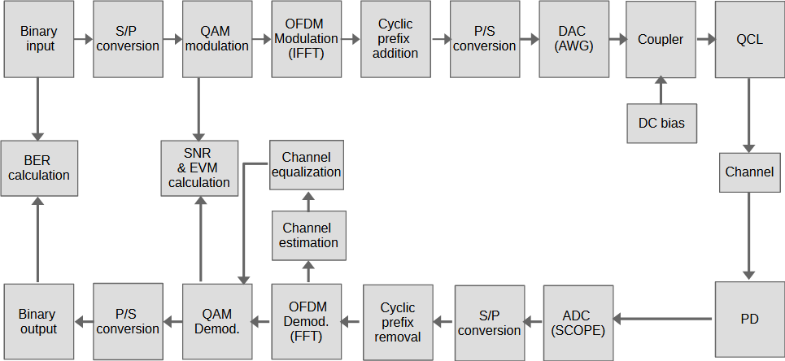
Figure S1. Framework of Direct Current Optical – Orthogonal Frequency Division Multiplexing
At the receiver, the optical signal is converted back into an electrical signal using a photodiode and digitized using an analog-to-digital converter (ADC). Following cyclic prefix removal, an FFT operation is performed to recover the frequency-domain subcarriers. Channel estimation and equalization are then applied to compensate for channel distortions prior to QAM demodulation and symbol decoding.
Channel estimation is performed using repeated training OFDM symbols transmitted at the beginning of each data block. The same known training symbol is transmitted multiple times and the corresponding received symbols are averaged in the frequency domain in order to improve the estimation accuracy and reduce the influence of noise. The estimated channel frequency response can therefore be expressed as
$$\hat{H}(f)=\frac{\sum_{i=1}^{N_{tr}}{R_{i}}(f)}{N_{tr}S(f)}$$where $N_{tr}$denotes the number of training symbols used for averaging, $S(f)$is the known transmitted training symbol in the frequency domain, and $R_{i}(f)$is the corresponding received symbol. By averaging multiple received copies of the same training symbol, the random noise contribution is reduced while preserving the channel response.
Following channel estimation, frequency-domain equalization is applied using a zero-forcing equalizer. The equalization coefficient associated with the $k^{th}$subcarrier is given by
$$G_{k}=\frac{1}{{\hat{H}}_{k}}$$and the equalized symbol is obtained as
$${\hat{X}}_{k}=G_{k}R_{k}$$where $R_{k}$denotes the received symbol on the $k^{th}$subcarrier.
It should be noted that two different transmission strategies are employed in this work. For the fixed-modulation OFDM experiments, only a single transmission is performed using a predetermined modulation format such as BPSK, QAM-4, QAM-8, QAM-16 or so on across all active subcarriers. The received signal is subsequently used to evaluate the system performance in terms of SNR, EVM, BER, and achievable data rate. Since the frequency response of the optical wireless channel is generally non-uniform across the transmission bandwidth, different subcarriers experience different channel conditions. Consequently, assigning identical modulation formats and power levels to all subcarriers does not fully exploit the available channel capacity. Hence, both fixed modulation formats and adaptive modulation format is implemented.
In contrast, the adaptive OFDM implementation consists of two transmission stages. During the first transmission, a low-order modulation format, typically QPSK or 4-QAM, is employed across all active subcarriers. The received signal is then used to estimate the channel response and determine the SNR distribution across the OFDM spectrum. Based on this information, adaptive bit-loading and power-loading masks are generated. Furthermore, a second transmission is performed based on the computed bit and power loading masks in which the modulation order and power allocation of each subcarrier are adjusted according to the estimated channel conditions. This adaptive procedure enables a more efficient utilization of the available DAC dynamic range and channel capacity, allowing higher-order modulation formats to be assigned to favourable subcarriers while maintaining reliable communication on weaker subcarriers. Consequently, the adaptive OFDM approach achieves higher spectral efficiency and data throughput compared to fixed-modulation OFDM. To maximize the achievable throughput while maintaining reliable communication performance, a practical block-based adaptive bit and power loading algorithm is employed. The estimated SNR profile is first smoothed to reduce the influence of local fluctuations and estimation noise. The available subcarriers are then grouped into blocks consisting of neighbouring subcarriers, and a representative SNR value is determined for each block. Based on the estimated block SNR, an appropriate modulation order is assigned to all subcarriers within the corresponding block. Subcarriers operating under favourable channel conditions are allocated higher-order modulation formats, whereas subcarriers experiencing lower SNR values are assigned smaller constellation sizes. The allocated power profile is subsequently stabilized through smoothing to improve loading robustness and reduce abrupt variations between neighbouring subcarriers.
The theoretical channel capacity is bounded by Shannon's theorem
$$C=BW{log⁡}_{2}(1+SNR)$$where $C$is the channel capacity, $BW$is the modulation bandwidth, and $SNR$is the signal-to-noise ratio.
The number of bits assigned to each block is determined using an SNR-gap formulation associated with a predefined BER target and can be approximated by
$$b_{k}={log⁡}_{2}\left(1 + \frac{γ_{k}}{Γ}\right)$$where $b_{k}$denotes the number of bits allocated to block $k$, $γ_{k}$is the estimated block SNR, and $Γ$is the SNR gap corresponding to the target BER ^{4–6}.
For square M-QAM modulation, the BER can be approximated as
$$P_{b}(M_{k},γ_{k})=\frac{4}{{log⁡}_{2}(M_{k})}\left(1 − \frac{1}{\sqrt{M_{k}}}\right)Q\left(\sqrt{\frac{3γ_{k}}{M_{k}-1}}\right)$$where $M_{k}$is the constellation size assigned to block $k$, $γ_{k}$is the corresponding SNR, and $Q\left(⋅\right)$ denotes the Gaussian Q-function.
The resulting spectral efficiency can be expressed as
$$η=\frac{\sum_{k=1}^{N_{active}}{{log⁡}_{2}}(M_{k})}{N_{FFT}+N_{CP}}$$where $N_{active}$is the number of active subcarriers, $N_{FFT}$is the FFT size, and $N_{CP}$is the cyclic prefix length.
The performance of the optical OFDM system is evaluated using signal-to-noise ratio (SNR), error vector magnitude (EVM), bit error rate (BER), spectral efficiency, and achievable data rate. The SNR of the $k^{th}$subcarrier is calculated as
$$SNR_{k}=\frac{E[∣X_{k}∣^{2}]}{E[∣X_{k}-{\hat{X}}_{k}∣^{2}]}$$where $X_{k}$and ${\hat{X}}_{k}$represent the transmitted and equalized symbols, respectively.
Similarly, the EVM is calculated as
$$EVM=\sqrt{\frac{∑∣X_{k}-{\hat{X}}_{k}∣^{2}}{∑∣X_{k}∣^{2}}}×100\%$$A lower EVM corresponds to improved transmission quality and more accurate symbol detection.
Finally, the BER is obtained by comparing the transmitted and recovered bit streams according to
$$BER=\frac{N_{error}}{N_{total}}$$where $N_{error}$is the number of erroneous bits and $N_{total}$is the total number of transmitted bits.
The achievable gross data rate is then determined from
$$R_{b}=BW×η$$where $BW$is the modulation bandwidth and $η$is the spectral efficiency. Together, these metrics provide a comprehensive assessment of the performance of the optical DCO-OFDM transmission system

Supplementary information Note 2. Modulation Behaviour under Single-Tone and OFDM Excitation
The estimated modulation current swing derived from the experimentally determined minimum operating current is shown in Supplementary Figure S2. Under single-tone excitation, the available current swing decreases rapidly with increasing modulation frequency, and the instantaneous current approaches the DC bias current above approximately 7 GHz. In contrast, OFDM excitation maintains a substantially larger current excursion over the entire occupied bandwidth, indicating that useful modulation persists well beyond the measured small-signal bandwidth.
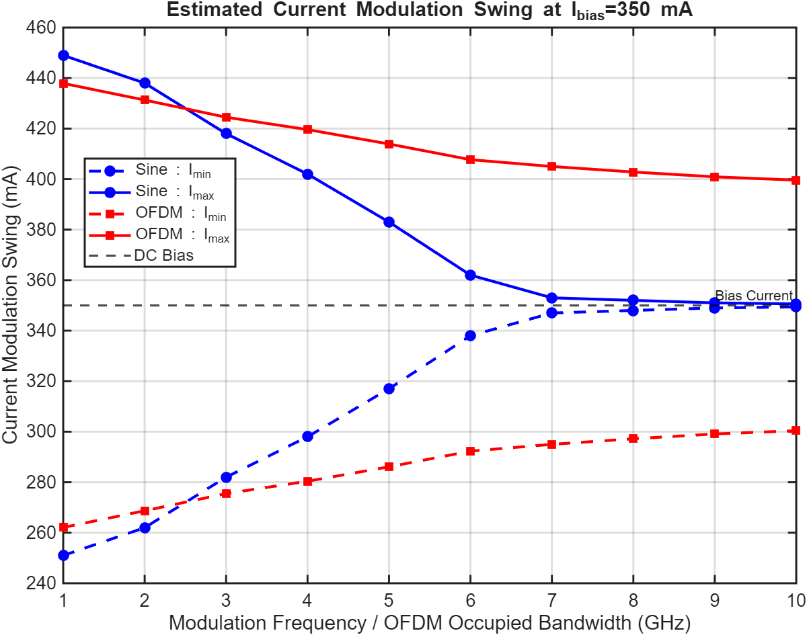
Figure S2. Estimated current modulation swing under single-tone and OFDM excitation. Estimated minimum and maximum instantaneous currents at a fixed QCL bias current of 350 mA as a function of modulation frequency for single-tone excitation and occupied bandwidth for OFDM operation. The dashed horizontal line indicates the DC bias current. Under single-tone modulation, the available current swing decreases rapidly with increasing frequency, approaching the bias current above approximately 7 GHz. In contrast, OFDM excitation maintains a substantially larger modulation swing over the entire bandwidth range, with the estimated current varying between approximately 300 and 400 mA at 10 GHz. These results indicate that OFDM preserves effective large-signal modulation over bandwidths considerably exceeding the measured small-signal modulation bandwidth.
The communication experiments presented in this work were performed using direct modulation of the 2.54 THz quantum cascade laser (QCL) operated at a fixed bias current of 350 mA. The purpose of these measurements was to investigate how the modulation waveform influences the effective modulation behaviour of the device and to provide physical insight into the successful demonstration of adaptive OFDM transmission beyond the measured small-signal modulation bandwidth.
The static threshold current of the QCL was determined from the continuous-wave LIV characteristics and was measured to be
$$\begin{matrix} & I_{th,0}=200 mA & & \end{matrix}$$
while all communication measurements were performed at a fixed operating current of
$$\begin{matrix} & I_{bias}=350 mA & & \end{matrix}$$These equations are directly connected to your measurements.
The modulation behaviour of the device was investigated experimentally using both single-tone excitation and broadband OFDM signals. For each modulation frequency, or for each occupied OFDM bandwidth, the QCL bias current was gradually reduced while maintaining a constant RF drive voltage of approximately 10 V (peak to peak). The received electrical spectrum was monitored using a Rohde & Schwarz FSW spectrum analyser operating with a resolution bandwidth of 10 kHz.
The minimum operating current was defined as the lowest bias current at which the modulation signal remained detectable above the measurement noise floor. The experimentally determined minimum operating current is denoted by
$$\begin{matrix} & I_{min}(f) & & \end{matrix}$$where $(f)$ represents either the single-tone modulation frequency or the maximum occupied OFDM frequency. The difference between the operating current and the minimum operating current provides a measure of the current excursion associated with the modulation process and may therefore be written as
$$\begin{matrix} & ΔI(f)=I_{bias}-I_{min}(f) & & \end{matrix}$$
Larger values of $ΔI(f)$ indicate that a greater fraction of the modulation current contributes to the optical response of the device, whereas smaller values correspond to reduced modulation efficiency.
Under single-tone excitation, the measured minimum operating current increases from approximately 101 mA at 1 GHz to approximately 199 mA at 10 GHz. Consequently, the available modulation swing decreases substantially with increasing modulation frequency. At low frequencies the device can sustain a large current excursion, whereas at high frequencies the modulation swing becomes progressively smaller.
The normalized modulation efficiency may therefore be expressed as
$$\begin{matrix} & η(f)=\frac{ΔI(f)}{ΔI_{max}} & & \end{matrix}$$where $ΔI_{max}$ represents the maximum measured modulation swing.
The measured modulation efficiency decreases rapidly above approximately 4 GHz and approaches zero near 10 GHz. This behaviour is consistent with the measured small-signal frequency response and indicates that the carrier population cannot efficiently follow rapidly varying high-frequency modulation. In contrast, the OFDM measurements exhibit a considerably smaller increase in the minimum operating current as the occupied bandwidth is increased. The measured minimum operating current increases only from approximately 112 mA to 150 mA over the full occupied bandwidth. Consequently, a substantially larger modulation swing is maintained under OFDM excitation than under equivalent single-tone excitation. The directly modulated QCL exhibits a measured small-signal modulation bandwidth of approximately 3.27 GHz. However, adaptive OFDM transmission is experimentally demonstrated over occupied bandwidths substantially exceeding this value. The present measurements provide a physical explanation for this apparent discrepancy. The small-signal bandwidth characterizes the response of the device to a single-frequency excitation. Under OFDM operation, however, the transmitted RF energy is distributed among many subcarriers spanning the available transmission bandwidth. Although the highest-frequency components experience reduced modulation efficiency, lower-frequency subcarriers continue to contribute to the modulation process. Consequently, a substantial modulation swing is maintained over the entire OFDM bandwidth, allowing useful optical modulation to persist beyond the measured small-signal bandwidth. The modulation waveform therefore plays an important role in determining the effective large-signal response of directly modulated THz quantum cascade lasers.
These results demonstrate that OFDM excitation preserves significantly greater modulation capability than single-tone excitation and provide a physical explanation for the successful demonstration of high-capacity OFDM transmission beyond the measured small-signal modulation bandwidth.
Supplementary information Note 3. Statistical Sampling and Constellation Coverage in High-Order OFDM Transmission
Supplementary Figure S3 compares the received 128-QAM constellations obtained for a representative OFDM subcarrier (SC274) using 100 and 750 transmitted OFDM symbols. The measurements were performed using fixed 128-QAM modulation on all 2047 active OFDM subcarriers over a 5 GHz transmission bandwidth using direct modulation of the 2.54 THz quantum cascade laser.
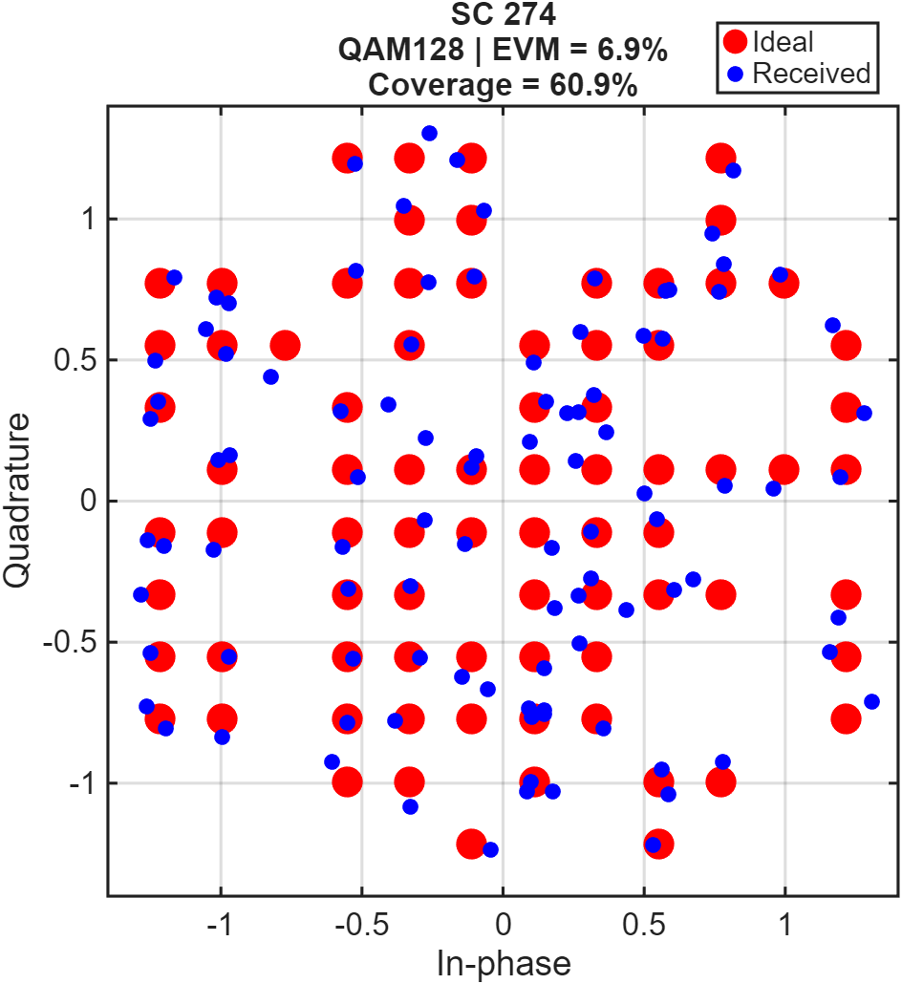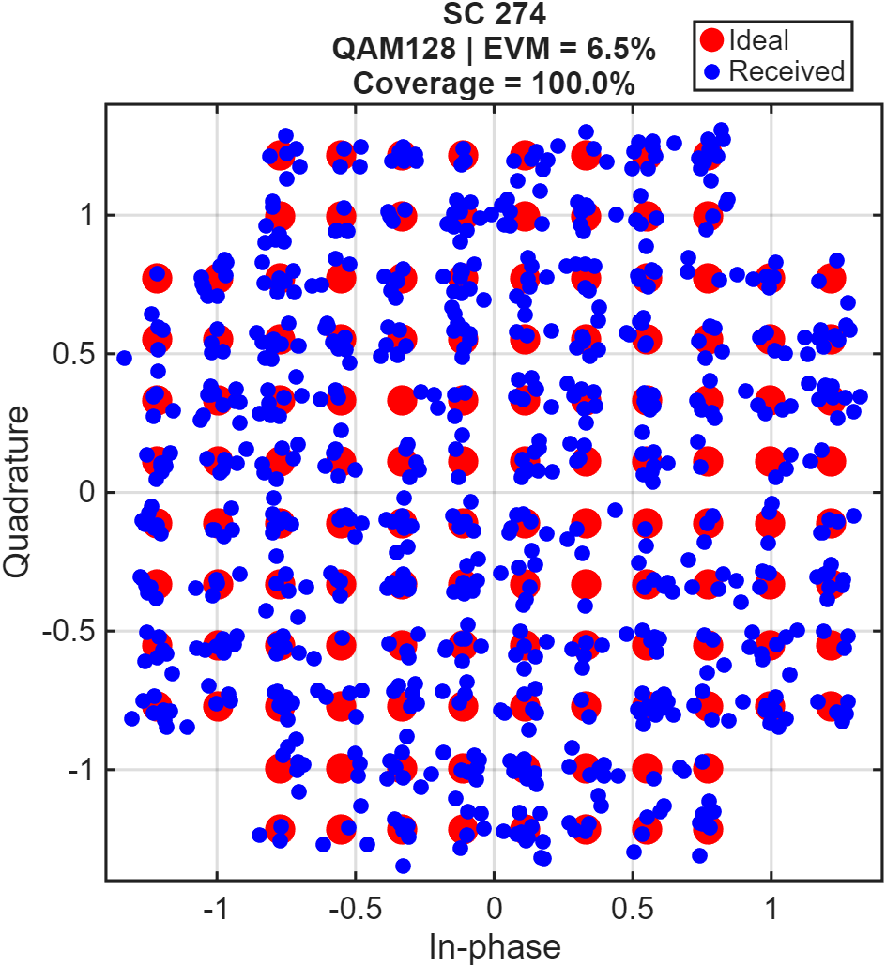
Figure S3: Supplementary Fig. S6 | Effect of the number of OFDM symbols on the measured 128-QAM constellation. (Left) Measured 128-QAM constellation for representative subcarrier SC274 obtained using 100 transmitted OFDM symbols. Only a fraction of the available constellation states is populated owing to the limited statistical sampling associated with the finite number of transmitted symbols. The measured constellation coverage is approximately 60.9%.
(Right) Measured 128-QAM constellation for the same subcarrier obtained using 750 transmitted OFDM symbols. The larger number of transmitted symbols substantially improves the sampling of the 128-QAM symbol alphabet, resulting in complete occupation of the available constellation states. The measured SNR, EVM and BER remain essentially unchanged, indicating that the underlying communication performance is unaffected by the number of transmitted OFDM symbols.
Red squares indicate the ideal transmitted symbol locations, while blue points represent the received symbols after equalization.
The constellation shown in Supplementary Figure S3 (Left) was obtained using 100 transmitted OFDM symbols. Although the received symbols are clearly clustered around the ideal 128-QAM positions, only a fraction of the available constellation states is populated. This behaviour originates from the finite statistical sampling associated with the limited number of transmitted OFDM symbols.
For an M-ary modulation format containing $M$ possible symbol states, the probability that a particular constellation point is not transmitted after $N$independent symbol realisations are given by
$$\begin{matrix} & P_{miss}={\left(1 − \frac{1}{M}\right)}^{N} & & \end{matrix}$$For the present measurements,
$$\begin{matrix} & M=128. & & \end{matrix}$$For $N=100$transmitted OFDM symbols, the probability that an individual constellation state remains unoccupied is
$$\begin{matrix} & P_{miss}={\left(\frac{127}{128}\right)}^{100}=0.456 & & \end{matrix}$$The expected constellation coverage may therefore be written as
$$\begin{matrix} & C=1-P_{miss} & & \end{matrix}$$which predicts a theoretical constellation coverage of approximately 54.4%. Experimentally, the measured coverage for SC274 was approximately 60.9%, in good agreement with the statistical prediction.
Increasing the number of transmitted OFDM symbols, improves the statistical sampling of the symbol alphabet. For the measurement using 750 OFDM symbols, the probability that a particular symbol remains unoccupied becomes
$$\begin{matrix} & P_{miss}={\left(\frac{127}{128}\right)}^{750}=2.8×{10}^{-3} & & \end{matrix}$$which corresponds to a theoretical coverage of
$$\begin{matrix} & C=99.7\% & & \end{matrix}$$As shown in Supplementary Figure S3 (Right), all 128 constellation states become populated, resulting in a fully occupied 128-QAM constellation.
Importantly, the increase in the number of transmitted OFDM symbols does not alter the underlying communication performance. The measured average signal-to-noise ratio remains approximately 21 dB for both measurements, while the measured error vector magnitude changes only slightly from 9.0% for the 100-symbol acquisition to 9.7% for the 750-symbol acquisition. Similarly, the measured bit-error rate remains essentially unchanged, with values of approximately $1.8×{10}^{-2}$obtained for both acquisitions. These results demonstrate that increasing the number of transmitted OFDM symbols does not improve the communication channel itself but rather improves the statistical representation of the received constellation.
An additional benefit of longer acquisitions is the improvement in BER resolution. The minimum measurable BER is determined by the total number of transmitted bits and may be expressed as
$$\begin{matrix} & BER_{res}=\frac{1}{N_{bits}} & & \end{matrix}$$where
$$\begin{matrix} & N_{bits}=N_{sym}N_{ind}b & & \end{matrix}$$with $N_{sym}$denoting the number of transmitted OFDM symbols.
For the 100-symbol measurement, approximately
$$\begin{matrix} & N_{bits}=1.43×{10}^{6} & & \end{matrix}$$bits were transmitted, corresponding to a BER resolution of
$$\begin{matrix} & BER_{res}=6.98×{10}^{-7} & & \end{matrix}$$For the 750-symbol measurement, the total number of transmitted bits increased to
$$\begin{matrix} & N_{bits}=1.07×{10}^{7} & & \end{matrix}$$resulting in
$$\begin{matrix} & BER_{res}=9.31×{10}^{-8} & & \end{matrix}$$The larger acquisition therefore improves the BER resolution by approximately one order of magnitude. The measurements were performed using a 50 GSa/s real-time oscilloscope. The 100-symbol acquisition used an acquisition length of approximately $2.0×{10}^{7}$samples, while the 750-symbol acquisition required approximately $6.25×{10}^{7}$samples. Increasing the number of OFDM symbols further would require substantially larger oscilloscope memory depth, longer acquisition windows, increased data transfer times, and significantly longer offline digital signal processing. The experimental acquisition time increased from approximately 58 s for the 100-symbol measurement to approximately 220 s for the 750-symbol measurement. Consequently, the maximum practical number of transmitted OFDM symbols is primarily constrained by instrumentation memory and processing requirements rather than by the THz communication system itself.
The partially occupied constellations observed for short acquisition sequences therefore do not indicate incomplete modulation, missing symbol states, or degradation of the THz communication link. Instead, they arise from the finite statistical sampling associated with a limited number of transmitted OFDM symbols. The fully populated constellation obtained using longer acquisition sequences confirms that the directly modulated THz QCL communication link successfully supports the complete 128-QAM symbol alphabet while maintaining essentially unchanged SNR, EVM, and BER performance.
Supplementary Information Note 4: Initial QPSK Probing Transmission for Adaptive OFDM Channel Characterization
Adaptive bit- and power-loading requires accurate knowledge of the frequency-dependent channel quality prior to data transmission. Consequently, the adaptive OFDM implementation used in this work begins with an initial probing transmission in which all active OFDM subcarriers are assigned the same low-order modulation format. A uniform QPSK constellation (2 bits per subcarrier) was selected for this purpose because of its low signal-to-noise ratio (SNR) requirement and high robustness against channel impairments. The objective of this first transmission is therefore not to maximize the achievable data rate, but rather to characterize the frequency response of the THz communication channel.
For the 10 GHz occupied modulation bandwidth, the OFDM signal consisted of 2047 active positive-frequency subcarriers. After direct modulation of the 2.54 THz quantum cascade laser and free-space transmission, the received OFDM symbols were processed using the digital signal processing framework described in Supplementary Note 1. Following synchronization, cyclic-prefix removal, FFT operation, channel estimation, and frequency-domain equalization, the received QPSK symbols on each subcarrier were used to estimate the communication quality across the transmission band.
For every subcarrier, the receiver calculates the corresponding signal-to-noise ratio (SNR), and error vector magnitude (EVM). These quantities provide a direct measurement of the available channel quality as a function of frequency. Since the frequency response of the directly modulated THz link is not uniform over the entire 10 GHz bandwidth, the measured SNR gradually decreases towards higher frequencies, while the EVM exhibits a corresponding increase. Consequently, different subcarriers possess substantially different transmission capabilities.
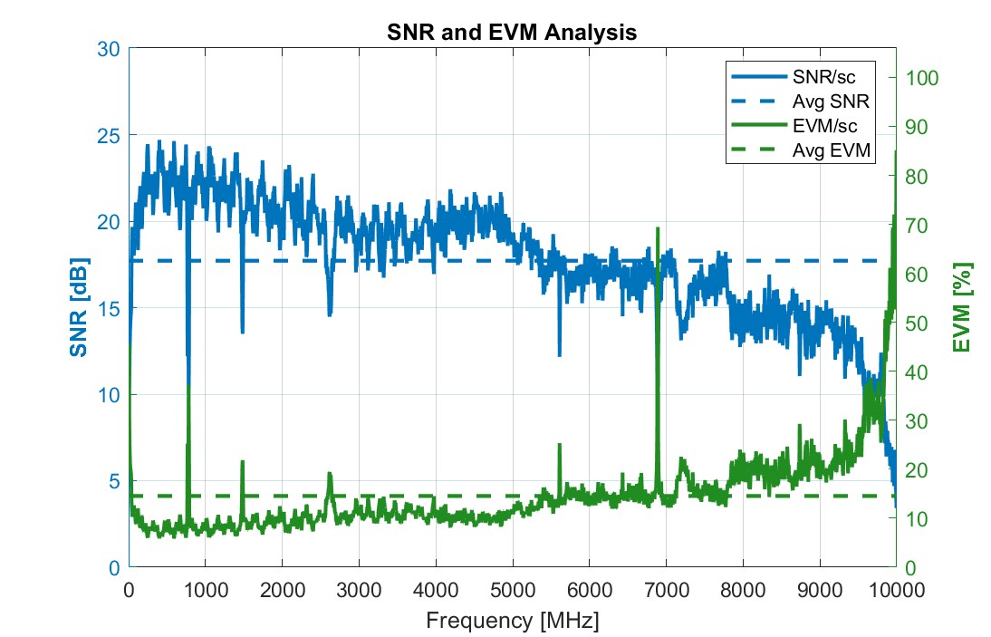
Figure S4. Measured signal-to-noise ratio (SNR, blue) and error vector magnitude (EVM, green) as a function of transmission frequency for the initial uniform QPSK probing transmission.
Supplementary Figure S4 shows the measured SNR and EVM obtained from the initial QPSK probing transmission. The dashed horizontal lines indicate the average SNR and EVM across all active subcarriers. Figures S5 illustrate the corresponding uniform bit-loading profile of 2 bits per subcarrier as a function of subcarrier index and transmission frequency, respectively. Since identical QPSK symbols are transmitted on every active subcarrier during this initial probing stage, the bit-loading profile remains constant across the entire occupied bandwidth.
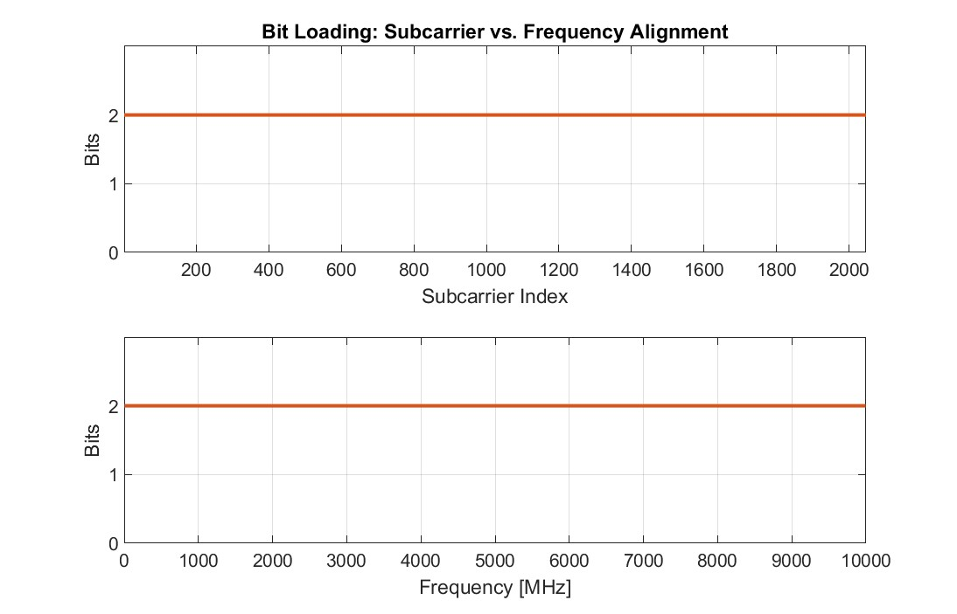
Figure S5. (Top) Uniform bit-loading profile as a function of OFDM subcarrier index during the initial probing transmission. All 2047 active positive-frequency subcarriers are assigned QPSK (2 bits per subcarrier) to enable accurate channel characterization. (Bottom) Uniform bit-loading profile as a function of transmission frequency corresponding to the initial QPSK probing transmission. Since identical QPSK symbols are transmitted on every active subcarrier, the bit allocation remains constant over the entire 10 GHz occupied bandwidth.
The measured SNR profile obtained from this first transmission serves as the input to the adaptive loading algorithm. Based on the estimated channel quality, a bit-loading mask is generated that assigns an appropriate modulation order to each subcarrier, while a corresponding power-loading mask adjusts the transmitted electrical power according to the measured channel response. Subcarriers exhibiting high SNR are subsequently assigned higher-order QAM constellations to maximize spectral efficiency, whereas subcarriers with reduced SNR employ lower-order modulation formats to maintain reliable communication. The resulting adaptive loading profiles are then applied during the second transmission stage to maximize the overall achievable data rate while satisfying the target BER requirement. The overall adaptive transmission procedure can therefore be summarized as in Figure S6
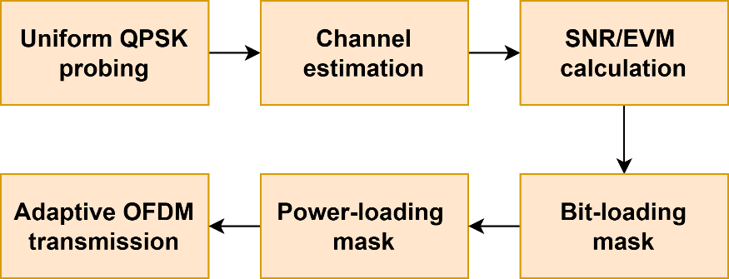
Figure S6. Schematic illustration of the adaptive OFDM transmission procedure. The first-stage uniform QPSK probing transmission provides per-subcarrier channel quality information through channel estimation and SNR/EVM evaluation. The measured channel characteristics are subsequently used to derive adaptive bit-loading and power-loading masks, which are applied during the second-stage adaptive OFDM transmission to improve spectral efficiency and overall throughput.
This two-stage approach enables the transmitter to exploit the available channel capacity more efficiently than fixed-modulation OFDM by matching the modulation order and transmitted power to the measured quality of each individual OFDM subcarrier.
References:
1. Cox, C., Ackerman, E., Helkey, R. & Betts, G. E. Techniques and Performance of Intensity-Modulation Direct-Detection Analog Optical Links. IEEE Trans. Microw. Theory Tech. 45, 1375–1383 (1997).
2. Armstrong, J. OFDM for Optical Communications. J. Light. Technol. 27, 189–204 (2009).
3. Dissanayake, S. D. & Armstrong, J. Comparison of ACO-OFDM, DCO-OFDM and ADO-OFDM in IM/DD Systems. J. Light. Technol. 31, 1063–1072 (2013).
4. Leke, A. & Cioffi, J. M. A maximum rate loading algorithm for discrete multitone modulation systems. in GLOBECOM 97. IEEE Global Telecommunications Conference. Conference Record vol. 3 1514–1518 vol.3 (1997).
5. Proakis, J. G. & Salehi, M. Digital Communications. (McGraw-Hill, Boston, 2008).
6. Munshi, M. N. et al. 2.85-Gb/s Organic Light Communication With a 459-MHz Micro-OLED. IEEE Photonics Technol. Lett. 35, 1399–1402 (2023).

