Appendix A. Additional diagnostics
The following VIF diagnostics are from the Python fixed-effects design matrix and should not be interpreted as SmartPLS indicator VIFs. They are reported to document collinearity in the panel-regression robustness checks.
Table A1. VIF diagnostics for the fixed-effects robustness design matrix.
Variable | VIF
Debt maturity | 2.618
Cash holding ratio | 3.039
Net working capital ratio | 1.460
Firm size | 5.004
Tobin-Q | 1.362
Leverage | 2.045
Effective tax rate | 1.577
Dividend | 1.843
Net debt issuance | 5.532
L1_ndts | 3.035
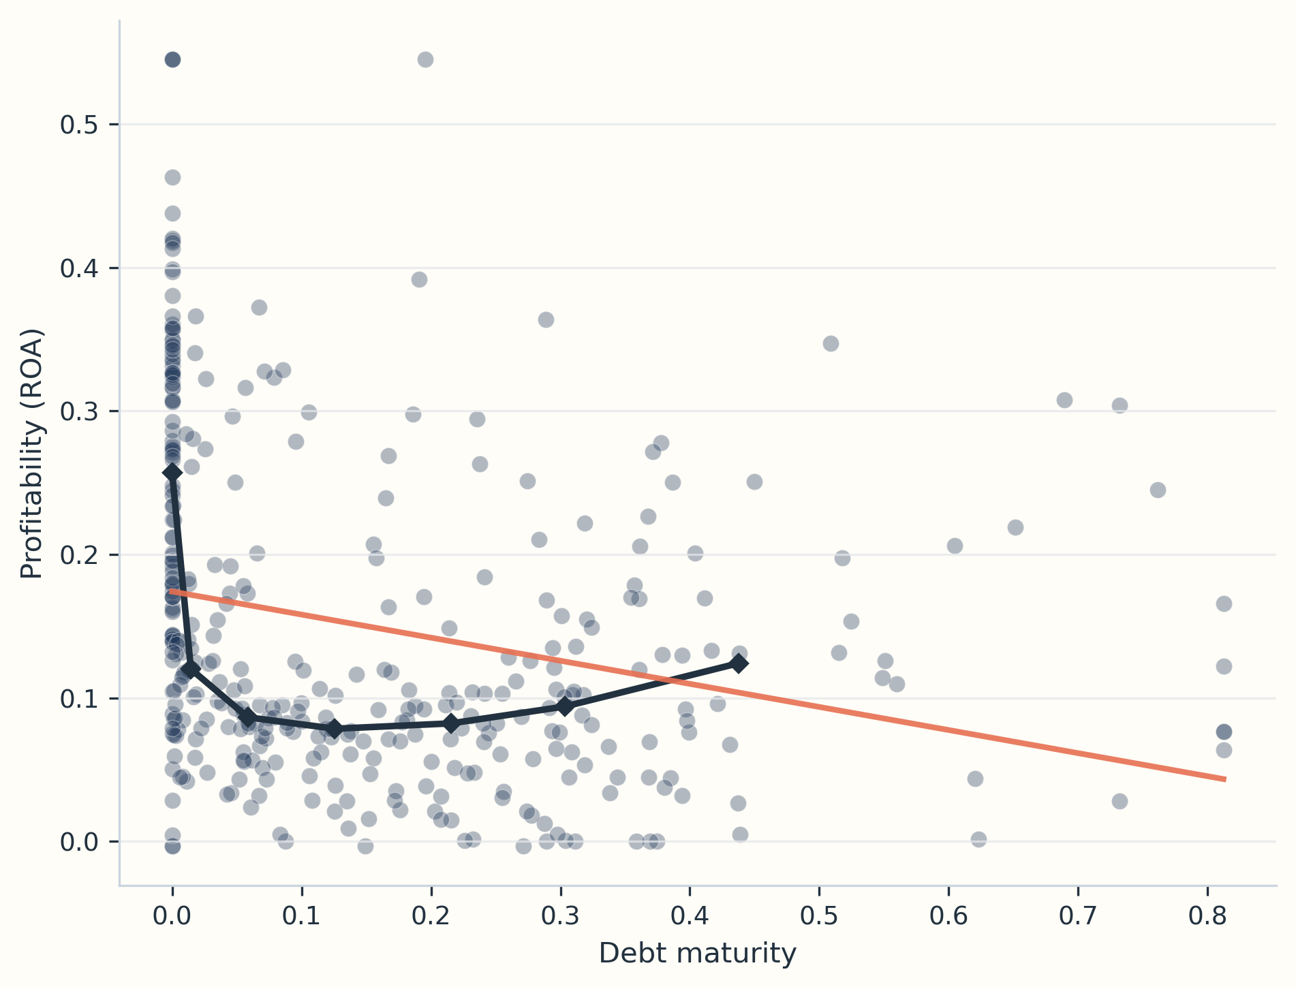
Figure A1. Debt maturity and profitability with binned median trend.
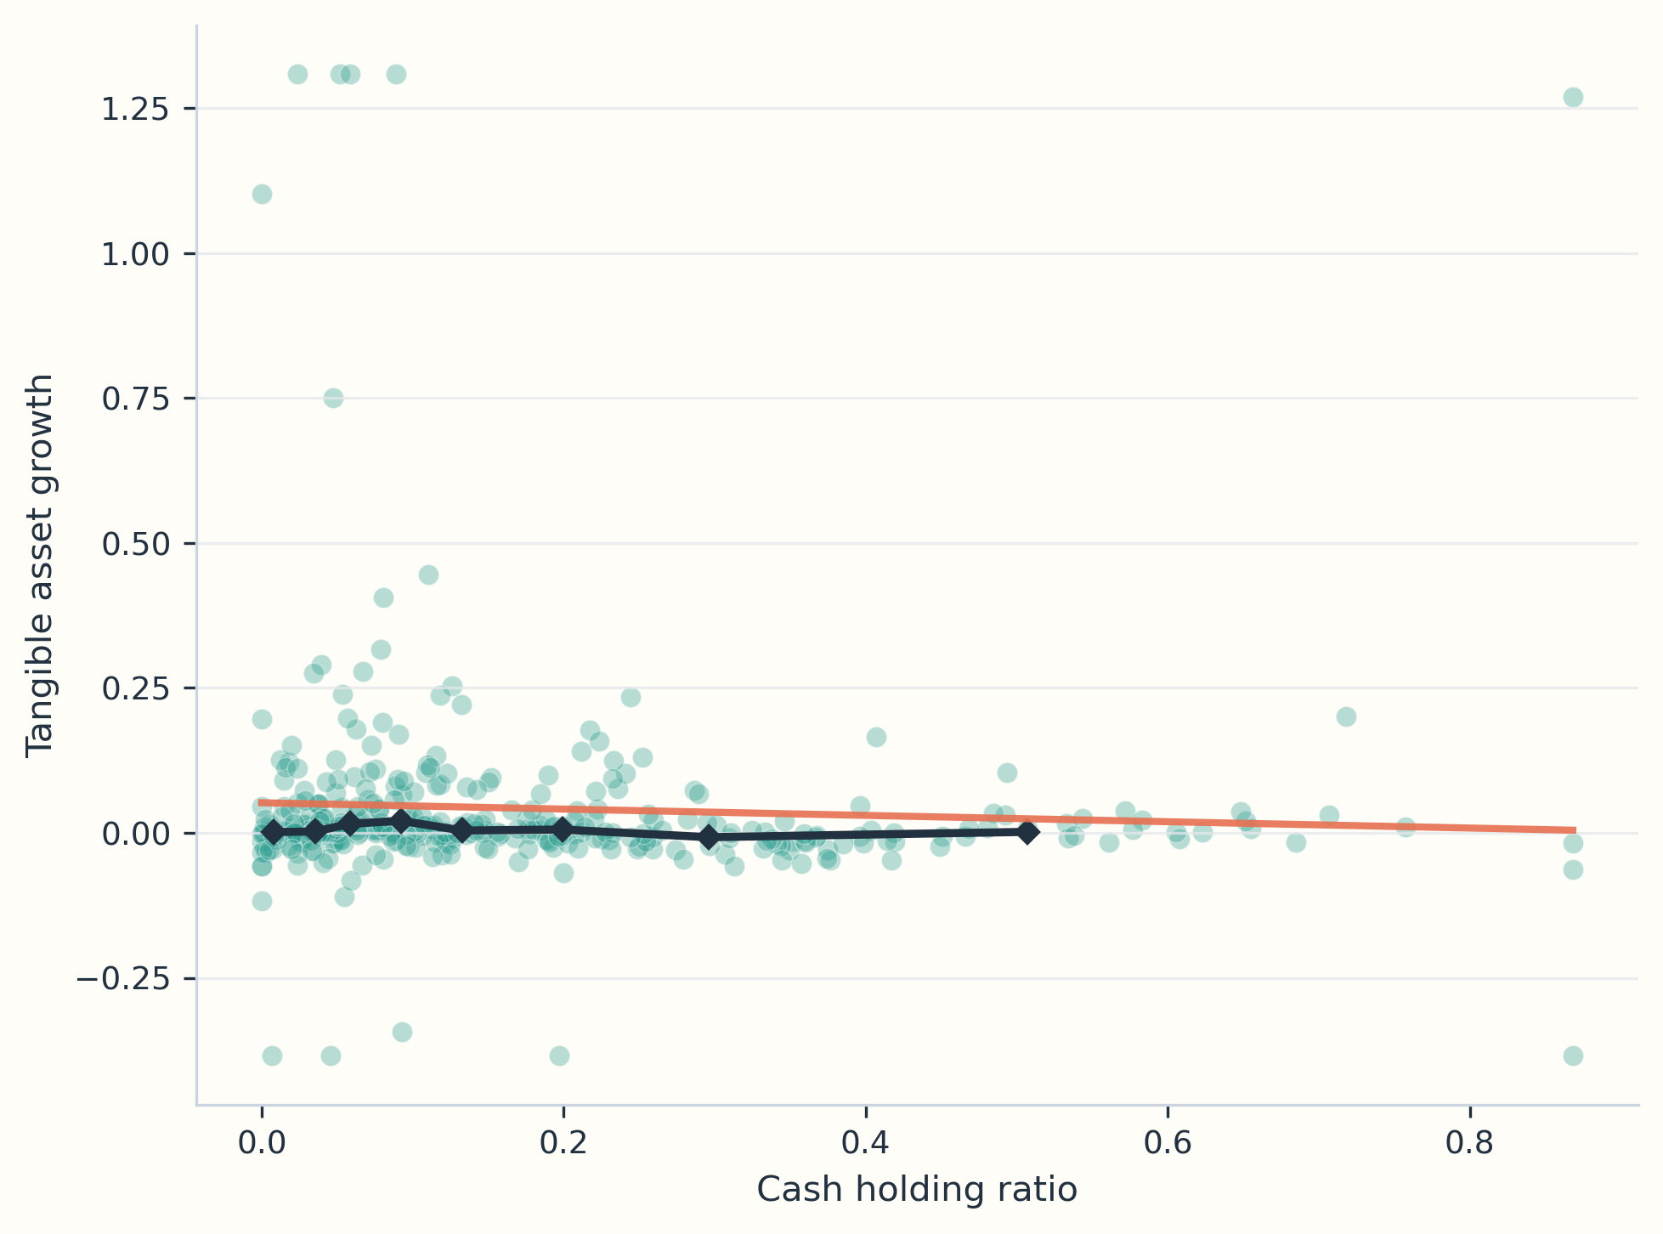
Figure A2. Cash holding ratio and tangible asset growth.
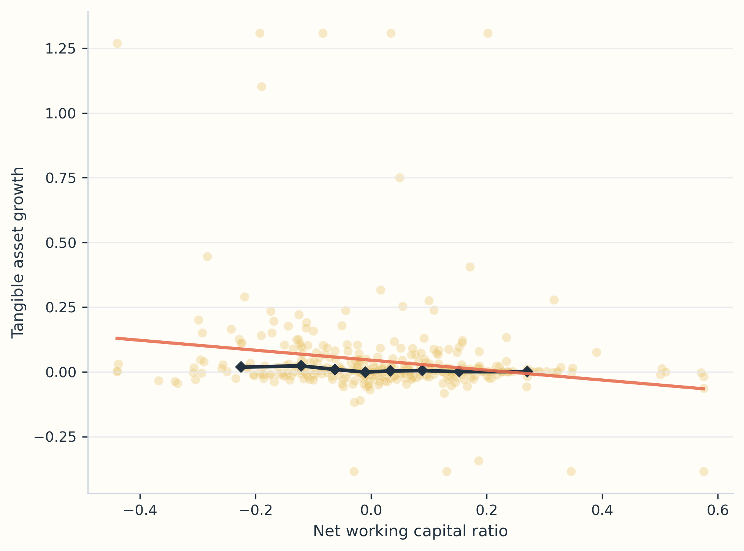
Figure A3. Net working capital ratio and tangible asset growth.
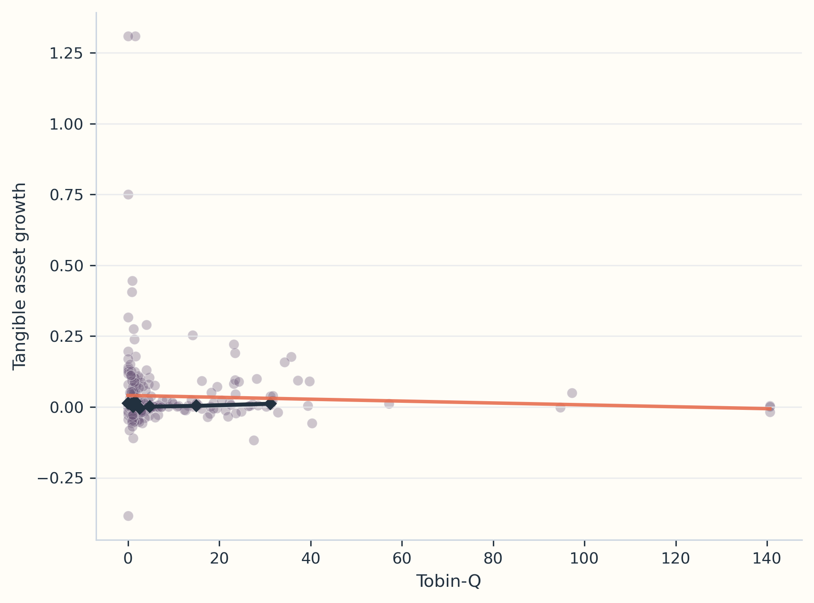
Figure A4. Tobin-Q and tangible asset growth.
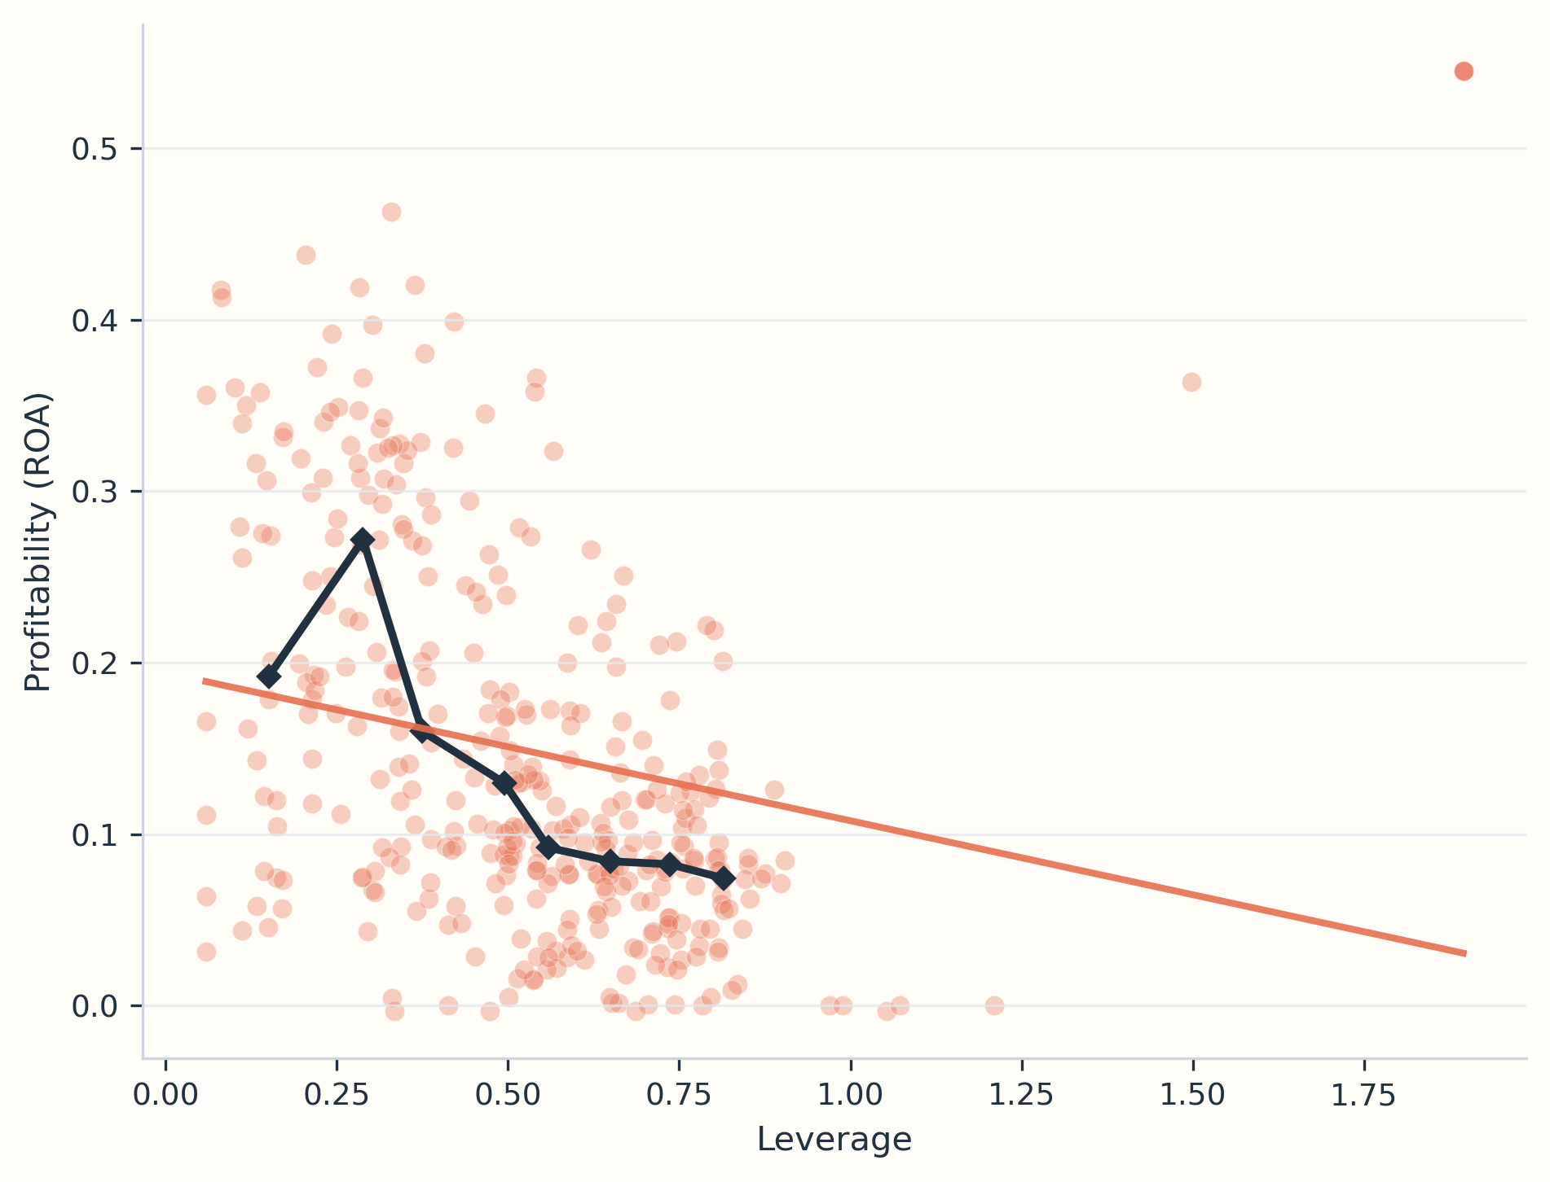
Figure A5. Leverage and profitability.
Appendix B. Full SmartPLS interaction tables
Table B1. Full interaction effects in the asset-growth SmartPLS model.
Pathway | Coefficient | t-statistic | p-value
CHR x Dmaturity -> CAPEX | 0.039 | 2.341 | 0.022
NWC x Dmaturity -> CAPEX | 0.126 | 2.763 | 0.013
CHR x Dmaturity -> TAR | -0.531 | 4.046 | 0.001
NWC x Dmaturity -> TAR | -0.608 | 4.163 | 0.001
CHR x TERMS -> CAPEX | -0.039 | 3.031 | 0.009
NWC x TERMS -> CAPEX | -0.027 | 2.362 | 0.022
CHR x TERMS -> TAR | 0.210 | 3.644 | 0.003
NWC x TERMS -> TAR | -0.221 | 4.302 | 0.001
CHR x ETR -> CAPEX | 0.230 | 2.030 | 0.029
NWC x ETR -> CAPEX | -0.018 | 2.004 | 0.030
CHR x ETR -> TAR | 0.495 | 2.082 | 0.028
NWC x ETR -> TAR | 0.253 | 2.125 | 0.027
CHR x size -> CAPEX | 0.364 | 3.768 | 0.002
NWC x size -> CAPEX | -0.148 | 2.821 | 0.012
CHR x size -> TAR | -0.362 | 3.647 | 0.003
NWC x size -> TAR | -0.446 | 4.188 | 0.001
CHR x Dividend -> CAPEX | 0.064 | 2.495 | 0.019
CHR x Dividend -> TAR | 0.110 | 2.563 | 0.017
CHR x Tobin-Q -> CAPEX | 0.003 | 2.013 | 0.030
CHR x Tobin-Q -> TAR | 0.932 | 4.099 | 0.001
NWC x Tobin-Q -> CAPEX | 0.003 | 2.013 | 0.030
NWC x Tobin-Q -> TAR | -0.474 | 3.569 | 0.003
NWC x Dividend -> CAPEX | -0.001 | 2.010 | 0.030
NWC x Dividend -> TAR | -0.015 | 2.874 | 0.021

Table B2. Full interaction effects in the profit-growth SmartPLS model.
Pathway | Coefficient | t-statistic | p-value
CHR x Dmaturity -> EARQ | 0.171 | 2.887 | 0.011
NWC x Dmaturity -> EARQ | 0.218 | 3.294 | 0.006
CHR x Dmaturity -> EARV | 0.052 | 2.836 | 0.012
NWC x Dmaturity -> EARV | 0.062 | 2.829 | 0.012
CHR x Dmaturity -> Profitability | -0.001 | 2.010 | 0.030
NWC x Dmaturity -> Profitability | -0.139 | 3.568 | 0.004
CHR x TERMS -> EARQ | -0.119 | 3.677 | 0.003
NWC x TERMS -> EARQ | -0.170 | 4.191 | 0.001
CHR x TERMS -> EARV | 0.084 | 2.899 | 0.011
NWC x TERMS -> EARV | -0.117 | 3.376 | 0.005
CHR x TERMS -> Profitability | 0.361 | 3.751 | 0.002
NWC x TERMS -> Profitability | -0.205 | 3.776 | 0.002
CHR x ETR -> EARQ | -1.073 | 2.149 | 0.026
NWC x ETR -> EARQ | -0.151 | 2.024 | 0.029
CHR x ETR -> EARV | -1.065 | 2.291 | 0.023
NWC x ETR -> EARV | 0.040 | 2.020 | 0.030
CHR x ETR -> Profitability | 0.318 | 2.097 | 0.028
NWC x ETR -> Profitability | 0.042 | 2.049 | 0.029
CHR x size -> EARQ | -0.163 | 2.635 | 0.016
NWC x size -> EARQ | 0.200 | 3.291 | 0.006
CHR x size -> EARV | -0.262 | 4.141 | 0.001
NWC x size -> EARV | 0.178 | 3.466 | 0.004
CHR x size -> Profitability | -0.496 | 5.146 | 0.000
NWC x size -> Profitability | -0.152 | 2.936 | 0.010
CHR x Dividend -> EARQ | 0.000 | 2.000 | 0.030
NWC x Dividend -> EARQ | -0.448 | 3.836 | 0.002
CHR x Dividend -> EARV | -0.177 | 3.540 | 0.004
NWC x Dividend -> EARV | -0.108 | 2.555 | 0.017
CHR x Dividend -> Profitability | 0.037 | 2.233 | 0.024
NWC x Dividend -> Profitability | 0.374 | 3.295 | 0.006
CHR x Tobin-Q -> EARQ | 0.980 | 3.307 | 0.006
NWC x Tobin-Q -> EARQ | -1.298 | 4.005 | 0.001
CHR x Tobin-Q -> EARV | -0.162 | 3.004 | 0.009
NWC x Tobin-Q -> EARV | 0.128 | 3.016 | 0.009
CHR x Tobin-Q -> Profitability | 0.050 | 2.263 | 0.024
NWC x Tobin-Q -> Profitability | -0.018 | 2.121 | 0.027

