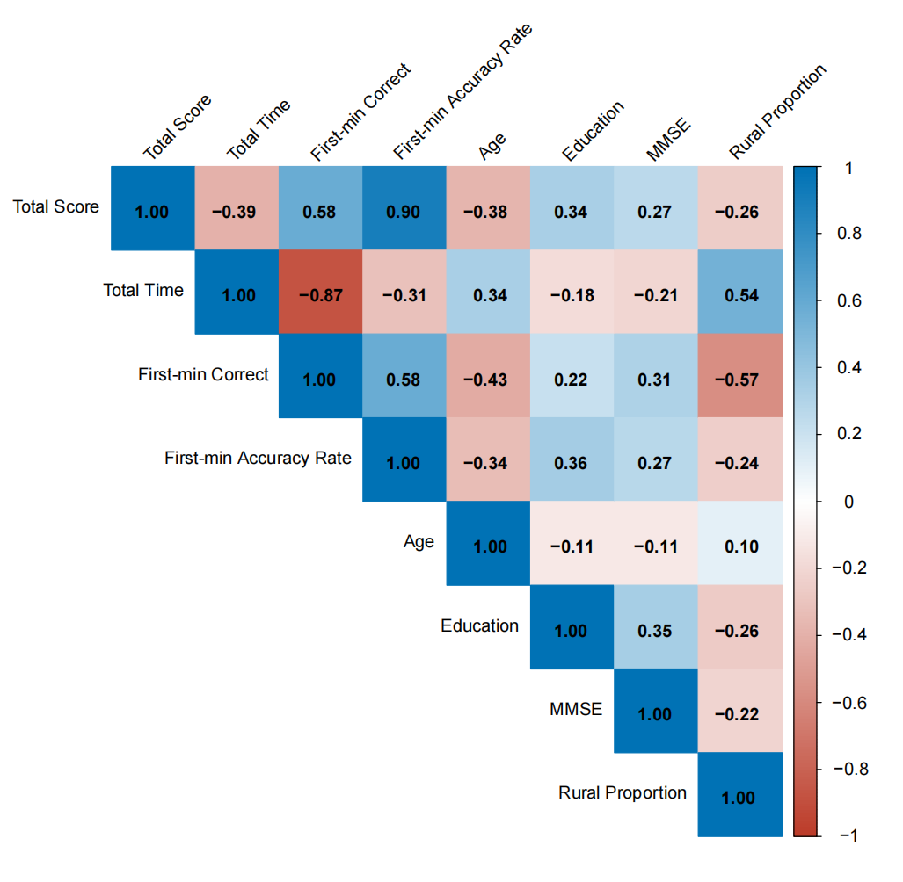
Figure S2. Correlation matrix of RNT-C outcome measures and participant characteristics. Heatmap displaying pairwise Spearman rank correlation coefficients (ρ) among eight variables in 93 cognitively normal adults. Color intensity reflects the direction and magnitude of each correlation, with blue indicating positive and red indicating negative associations (scale: −1 to 1); ρ values are annotated within each cell. Only the lower triangle is displayed.

