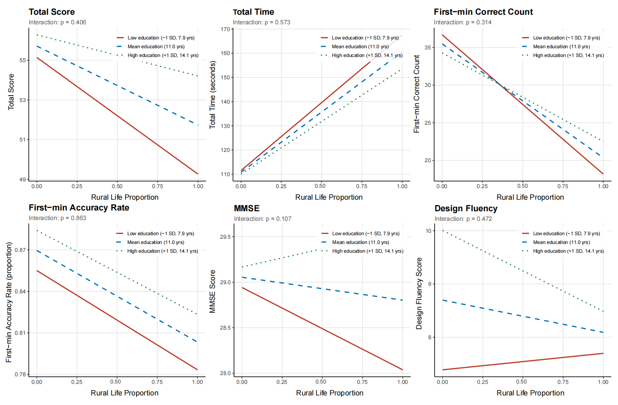
Figure S3. Moderation analysis: simple slopes of rural life proportion on cognitive outcomes at three levels of education.
Each panel displays predicted values from the moderation model at −1 SD (7.9 years, red solid line), mean (11.0 years, blue dashed line), and +1 SD (14.1 years, green dotted line) of years of education. Outcomes shown are (a) naming total score, (b) total completion time, (c) first-minute correct count, (d) first-minute naming accuracy rate, (e) MMSE score, and (f) Design Fluency score. The interaction p-value for each model is annotated in the upper left of each panel. No significant education × rural life proportion interaction was observed for any outcome (all p > 0.10).

