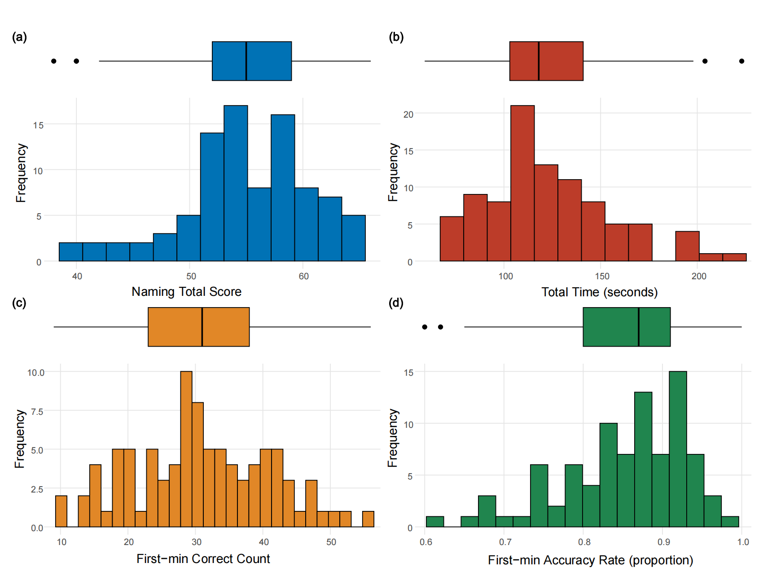
Figure S1. Distribution of RNT-C outcome measures in cognitively healthy individuals (n = 93).
Each panel shows a boxplot (upper) and histogram (lower) for one outcome measure. (a) Naming total score (range 38–66); (b) total completion time (seconds; range 59–223); (c) first-minute correct count (range 9–56); (d) first-minute naming accuracy rate (proportion; range 0.60–1.00). In the boxplot, the central line represents the median, box edges represent the 25th and 75th percentiles, whiskers extend to 1.5 times the interquartile range, and filled circles denote outliers. Histogram bin width was set to capture the overall shape of each distribution.

