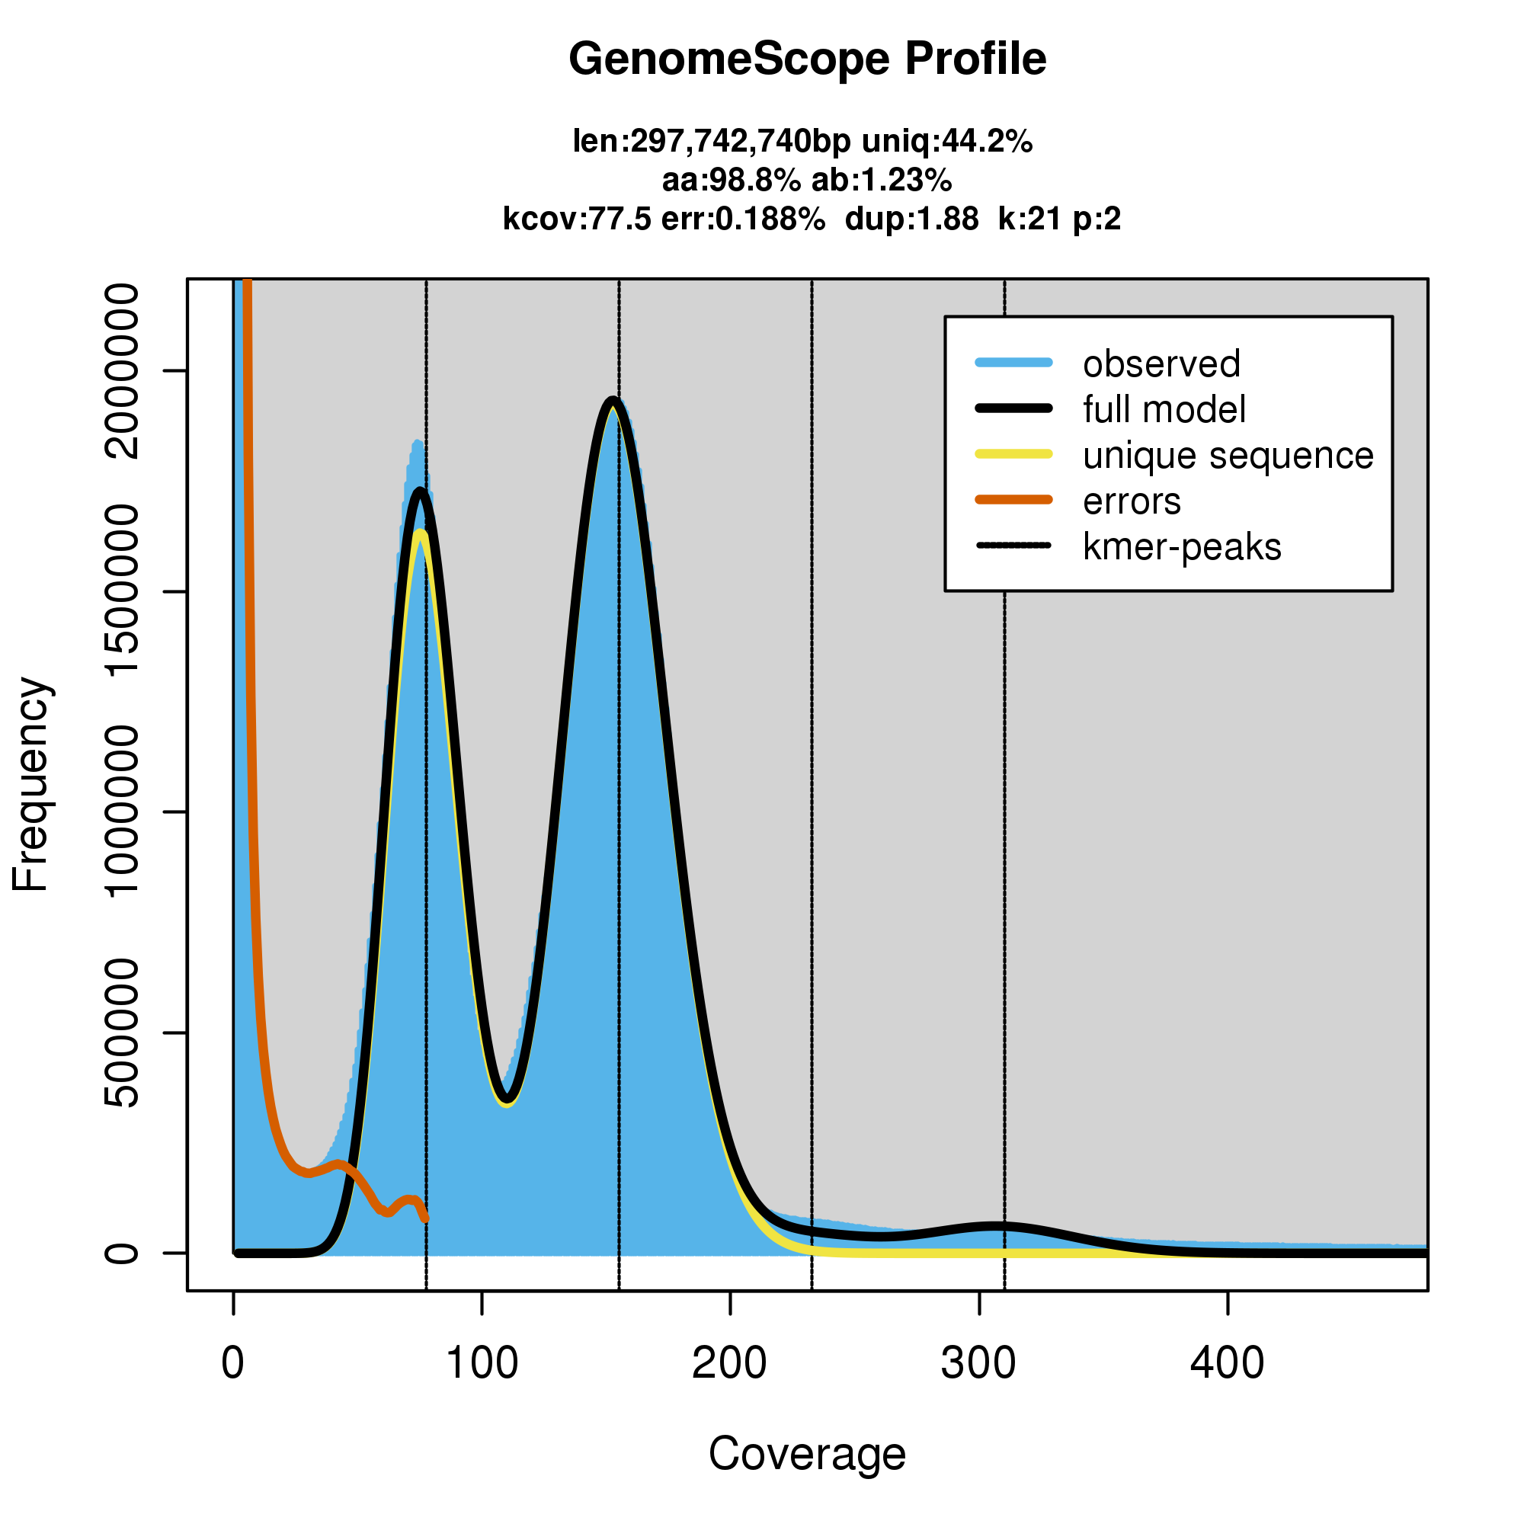Figure S1. GenomeScope k-mer frequency distribution profile of E. splendens genome using 21-mer.

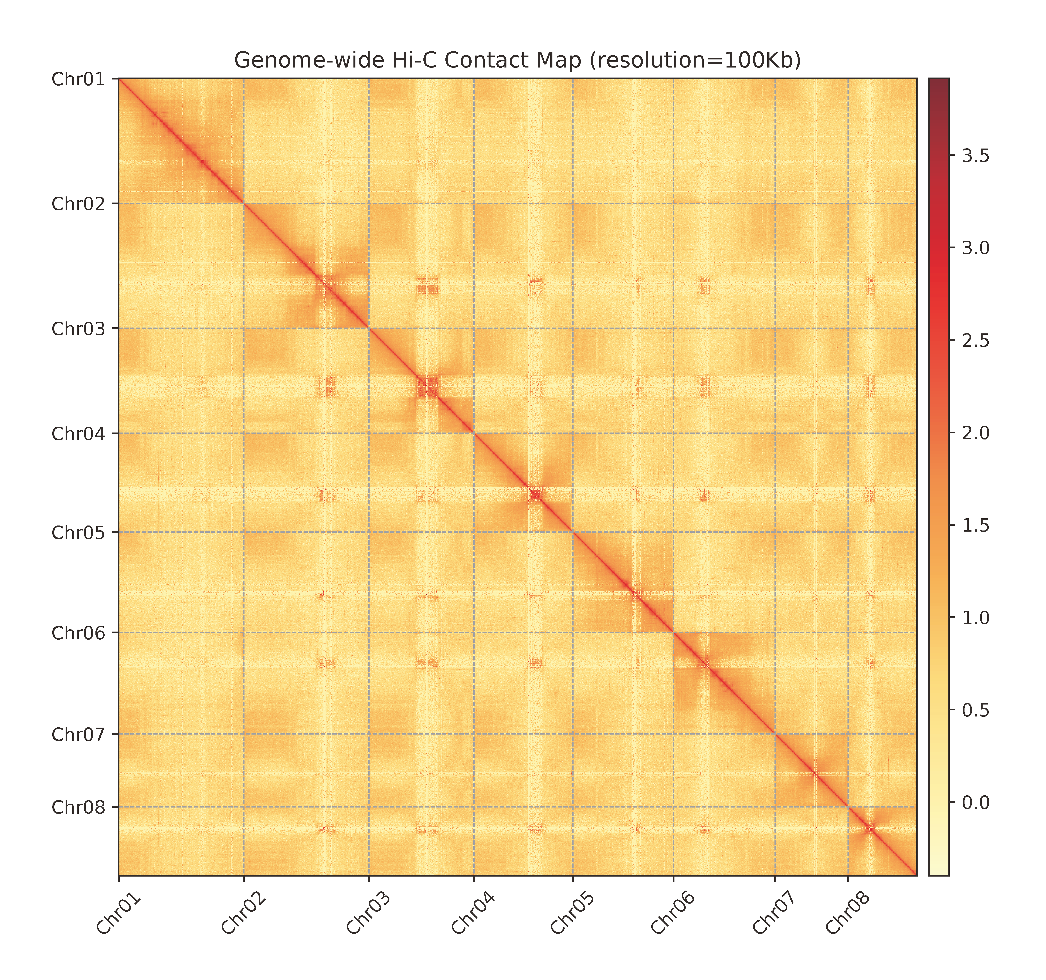Figure S2. Genome-wide Hi-C contact map of E. splendens at 100 kb resolution.

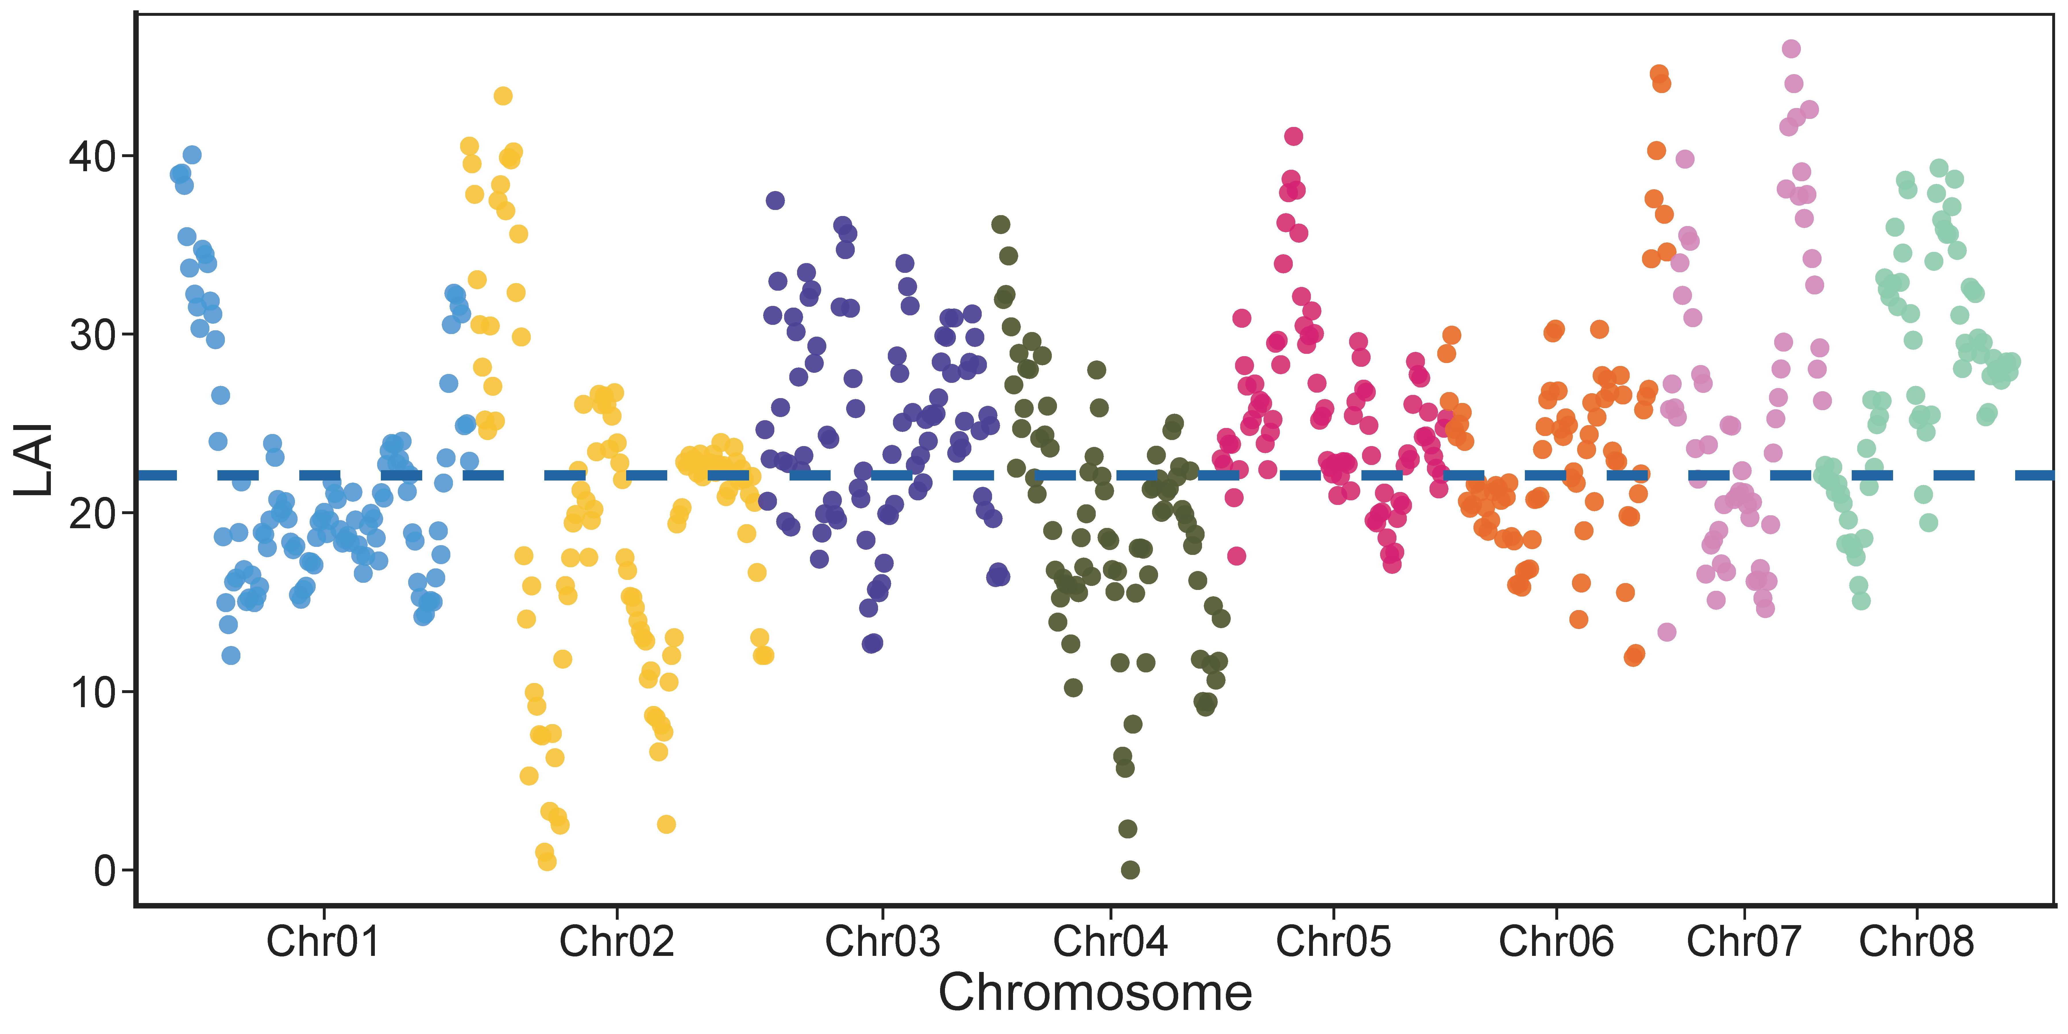Figure S3. Chromosome-wise LAI distribution of the E. splendens genome.

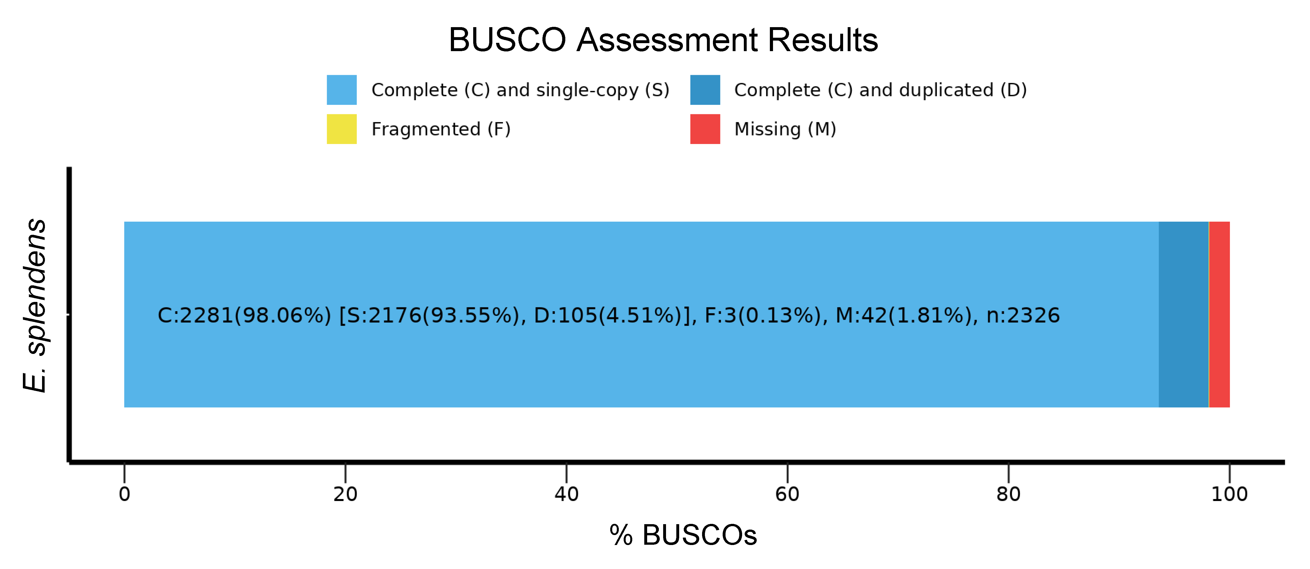Figure S4. BUSCO completeness assessment for the E. splendens genome

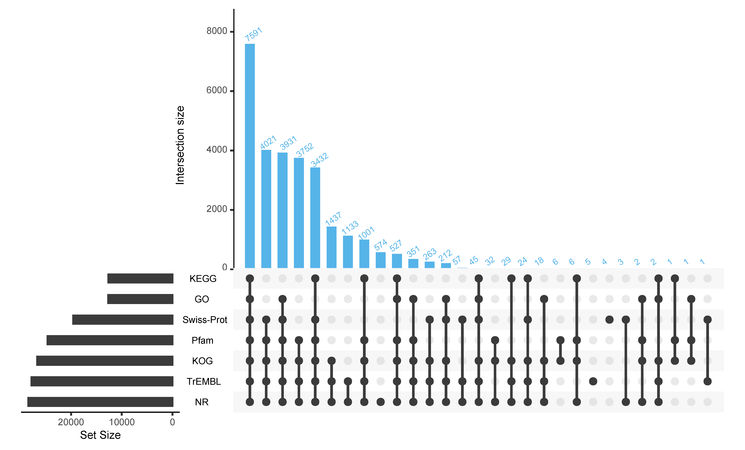Figure S5. UpSet plot of gene functional annotation results across seven public databases for E. splendens.

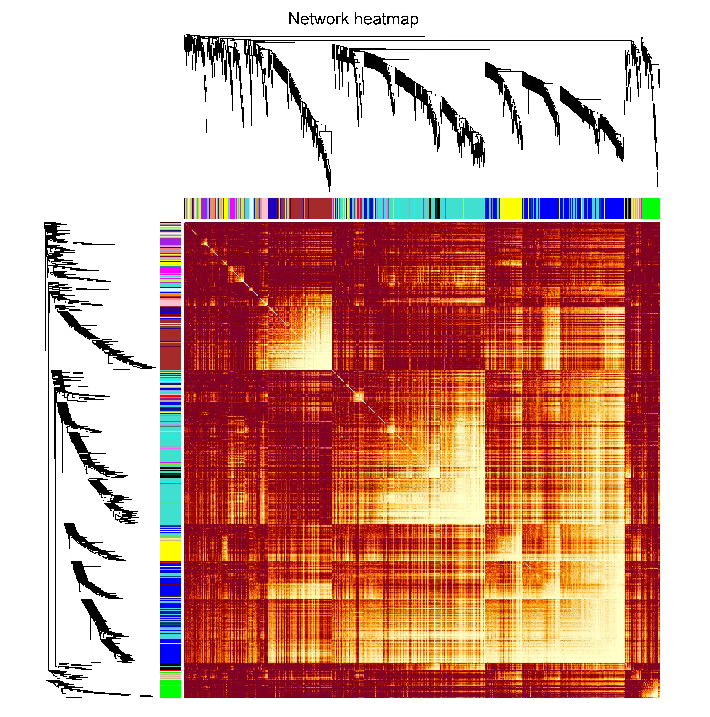
Figure S6. WGCNA network heatmap of E. splendens transcriptomes under copper stress.

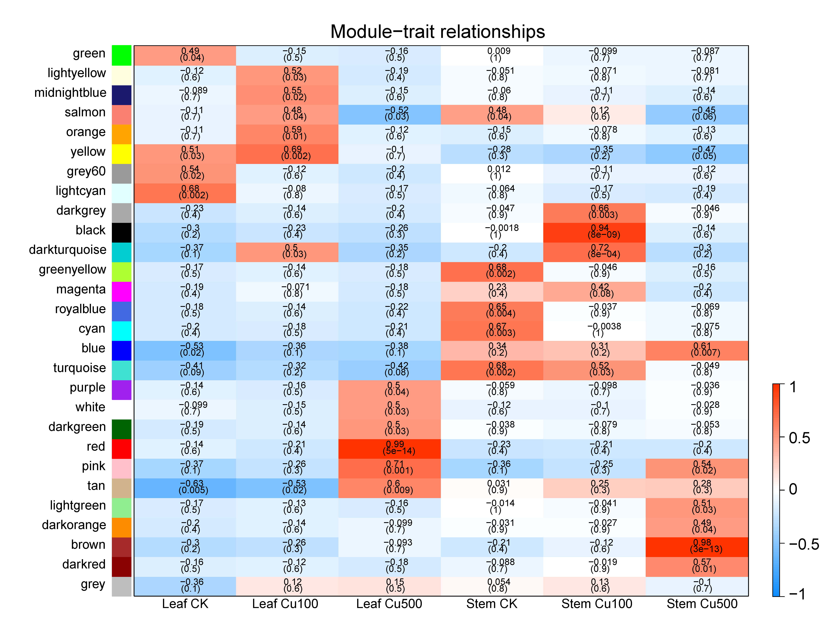
Figure S7. WGCNA modules–traits relationship in E. splendens under copper stress.

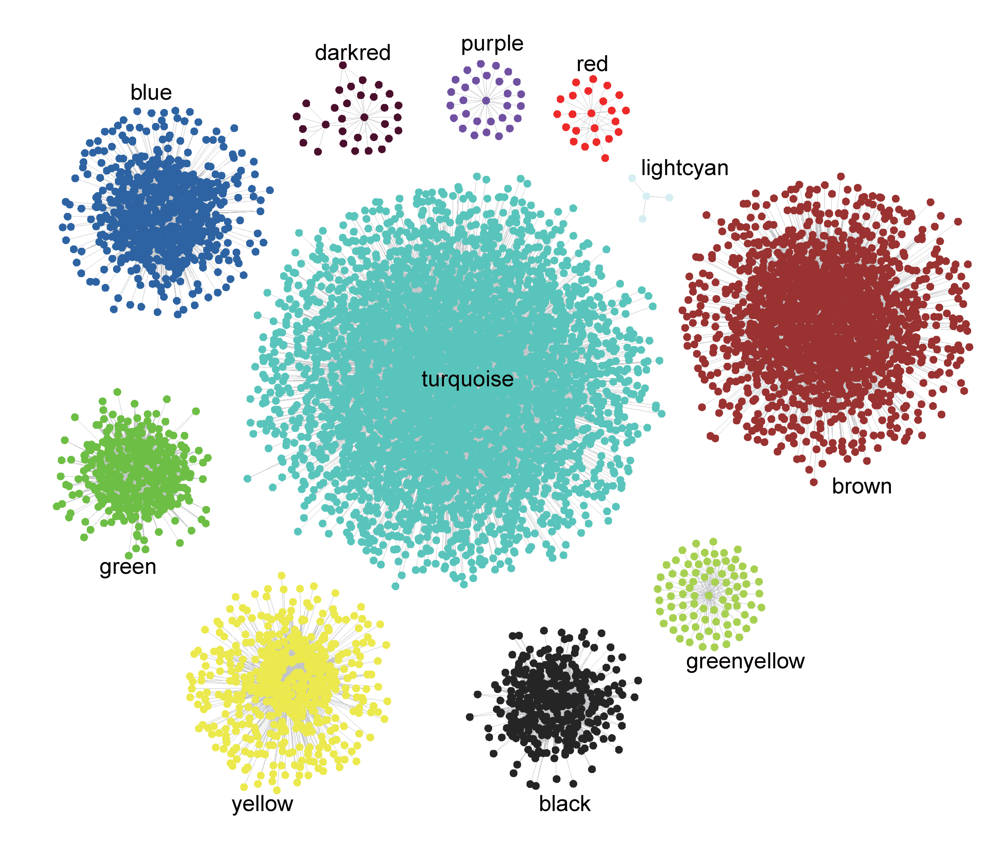 Figure S8. Cytoscape visualization of hub gene co-expression relationships with other genes in E. splendens under copper stress.

