Experiment 1

RT effects
A 2 × (2 × 2 × 8) mixed ANOVA was conducted on main RT with group (conflict vs. response expectancy) as a between-subjects factor, conflict (congruent vs. incongruent) and rating (no-rating vs. rating) as within-subjects factor, and run length of congruent/incongruent trials as a repeated-measures factor. Supplementary Table S1 outlines the results of the ANOVA, and Supplementary Figure S1 depicts the mean RT as a function of run length, split by group, conflict, and rating.

Supplementary Table S1

ANOVA on Flanker Task Response Time (RT) with Group, Congruent/Incongruent Run Length, Conflict, and Rating as Factors
Effect |  | df | MSE | F | p | η_{p}²
Between-subjects
 | Rate group | 1,127 | 79555.41 | 0.01 | .934 | <.001
Within-subjects
 | Run length | 7,889 | 670.17 | 6.32 | <.001*** | .047
 | Run length x Rate group | 7,889 | 670.17 | 1.21 | .293 | .009
 | Conflict | 1,127 | 3987.58 | 2002.61 | <.001*** | .940
 | Conflict x Rate group | 1,127 | 3987.58 | 0.63 | .430 | .005
 | Rating | 1,127 | 3323.48 | 60.31 | <.001*** | .322
 | Rating x Rate group | 1,127 | 3323.48 | 0.00 | .944 | <.001
 | Run length x Conflict | 7,889 | 750.54 | 37.72 | <.001*** | .229
 | Run length x Conflict x Rate group | 7,889 | 750.54 | 0.94 | .478 | .007
 | Run length x Rating | 7,889 | 655.81 | 1.14 | .336 | .009
 | Run length x Rating x Rate group | 7,889 | 655.81 | 0.64 | .727 | .005
 | Conflict x Rating | 1,127 | 906.11 | 19.62 | <.001*** | .134
 | Conflict x Rating x Rate group | 1,127 | 906.11 | 0.27 | .605 | .002
 | Run length x Conflict x Rating | 7,889 | 669.85 | 0.62 | .739 | .005
 | Run length x Conflict x Rating x Rate group | 7,889 | 669.85 | 1.57 | .140 | .012
Note. Type III tests. *** p < .001

Supplementary Figure S1

Flanker Task Response Time (RT) by Congruent/Incongruent Run Length, split by Group, Conflict, and Rating
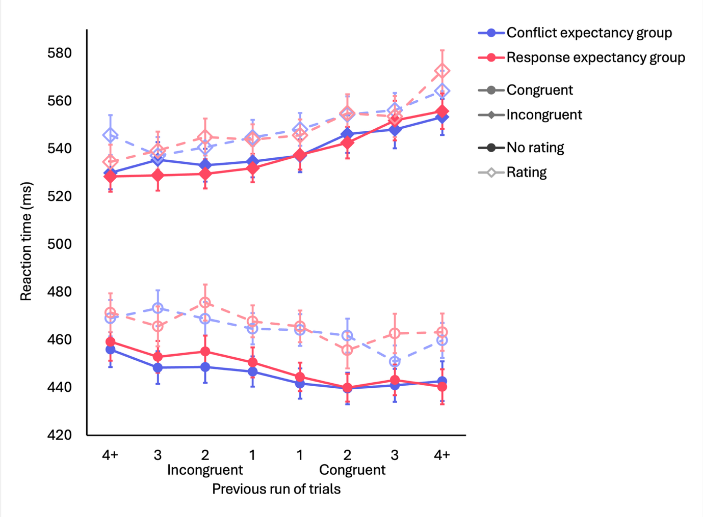
Note. RTs of incongruent trials lie around the 520–580 ms range and represented by diamond points, while those of congruent trials lie around the 430–480 ms range and represented by circle points. Dark solid lines denote trials without an expectancy rating, while light dashed lines are trials with expectancy ratings. The blue lines represent the conflict expectancy group, while the red lines represent the response expectancy group. Error bars correspond to one standard error of the mean (SEM).

PCSE
Supplementary Table S2 outlines the full ANOVA on flanker RT, with group (conflict vs. response expectancy) as a between-subjects factor, rating (rating vs. no-rating) as a within-subjects factor, and congruent/incongruent run length as a repeated-measures factor.

Supplementary Table S2

ANOVA on Flanker RT with Group, Congruent/Incongruent Run Length, and Rating as Factors
Effect |  | df | MSE | F | p | η_{p}²
Between-subjects
 | Rate group | 1,127 | 7975.16 | 0.63 | .430 | .005
Within-subjects
 | Run length | 7,889 | 1501.07 | 37.72 | <.001*** | .229
 | Run length x Rate group | 7,889 | 1501.07 | 0.94 | .478 | .007
 | Rating | 1,127 | 1812.22 | 19.62 | <.001*** | . 134
 | Rating x Rate group | 1,127 | 1812.22 | 0.27 | .605 | .002
 | Run length x Rating | 7,889 | 1339.71 | 0.62 | .739 | .005
 | Run length x Rating x Rate group | 7,889 | 1339.71 | 1.57 | .140 | .012
Note. Type III tests. *** p < .001
A repeated-measures (8) ANOVA was run on flanker RT with run length as a repeated-measures factor for each trial type (rating vs. no rating) in each group (conflict vs. response expectancy). Linear contrasts were used to investigate the linear trend across run length. Supplementary Table S3 outlines the results of the linear contrast analyses for the PCSE for each trial type.

Supplementary Table S3

Summary of Linear Contrasts of PCSE for Each Trial Type
Rate Group | Trial type | ∆ estimate | SE | df | t | p | η_{p}²
Conflict Expectancy group | No rating | 431.0 | 72.8 | 64 | 5.920 | <.001*** | .35
Conflict Expectancy group | Rating | 468.30 | 76.8 | 64 | 6.101 | <.001*** | .37
Response Expectancy group | No rating | 583.7 | 81.1 | 63 | 7.196 | <.001*** | .45
Response Expectancy group | Rating | 504.5 | 92.5 | 63 | 5.456 | <.001*** | .32

Note. * p < .05, ** p < .01, *** p < .001

RT effects by left/right response runs
We ran the mixed ANOVA on RT with the same factors (group, conflict, rating, and run length), except here, we used run length with respect to the sequence of left/right responses. Supplementary Table S4 outlines the results of the ANOVA, and Supplementary Figure S2 depicts the mean RT across left/right response runs, split by group, conflict, and rating. Supplementary Table S5 summarises the linear contrast analyses of RT across left/right response run length, along with the interactions between the linear trends with group, conflict, and rating.

Supplementary Table S4

ANOVA on Flanker Task Response Time (RT) with Group, Left/Right Response Run Length, Conflict, and Rating as Factors
Effect |  | df | MSE | F | p | η_{p}²
Between-subjects
 | Rate group | 1,127 | 78997.81 | 0.01 | .913 | <.001
Within-subjects
 | Run length | 7,889 | 880.90 | 14.26 | <.001*** | .101
 | Run length x Rate group | 7,889 | 880.90 | 0.51 | .825 | .004
 | Conflict | 1,127 | 4146.62 | 1866.27 | <.001*** | .936
 | Conflict x Rate group | 1,127 | 4146.62 | 1.18 | .280 | .009
 | Rating | 1,127 | 3137.00 | 65.15 | <.001*** | .339
 | Rating x Rate group | 1,127 | 3137.00 | 0.15 | .703 | .001
 | Run length x Conflict | 7,889 | 735.16 | 2.01 | .052 | .016
 | Run length x Conflict x Rate group | 7,889 | 735.16 | 1.72 | .100 | .013
 | Run length x Rating | 7,889 | 714.56 | 2.76 | .008** | .021
 | Run length x Rating x Rate group | 7,889 | 714.56 | 2.26 | .027* | .018
 | Conflict x Rating | 1,127 | 731.28 | 37.25 | <.001*** | .227
 | Conflict x Rating x Rate group | 1,127 | 731.28 | 0.17 | .682 | .001
 | Run length x Conflict x Rating | 7,889 | 699.87 | 0.83 | .565 | .006
 | Run length x Conflict x Rating x Rate group | 7,889 | 699.87 | 1.30 | .246 | .010
Note. Type III tests. * p < .05, ** p < .01, *** p < .001

Supplementary Figure S2

Flanker Task Response Time (RT) by Left/Right Response Run Length, split by Group, Conflict, and Rating
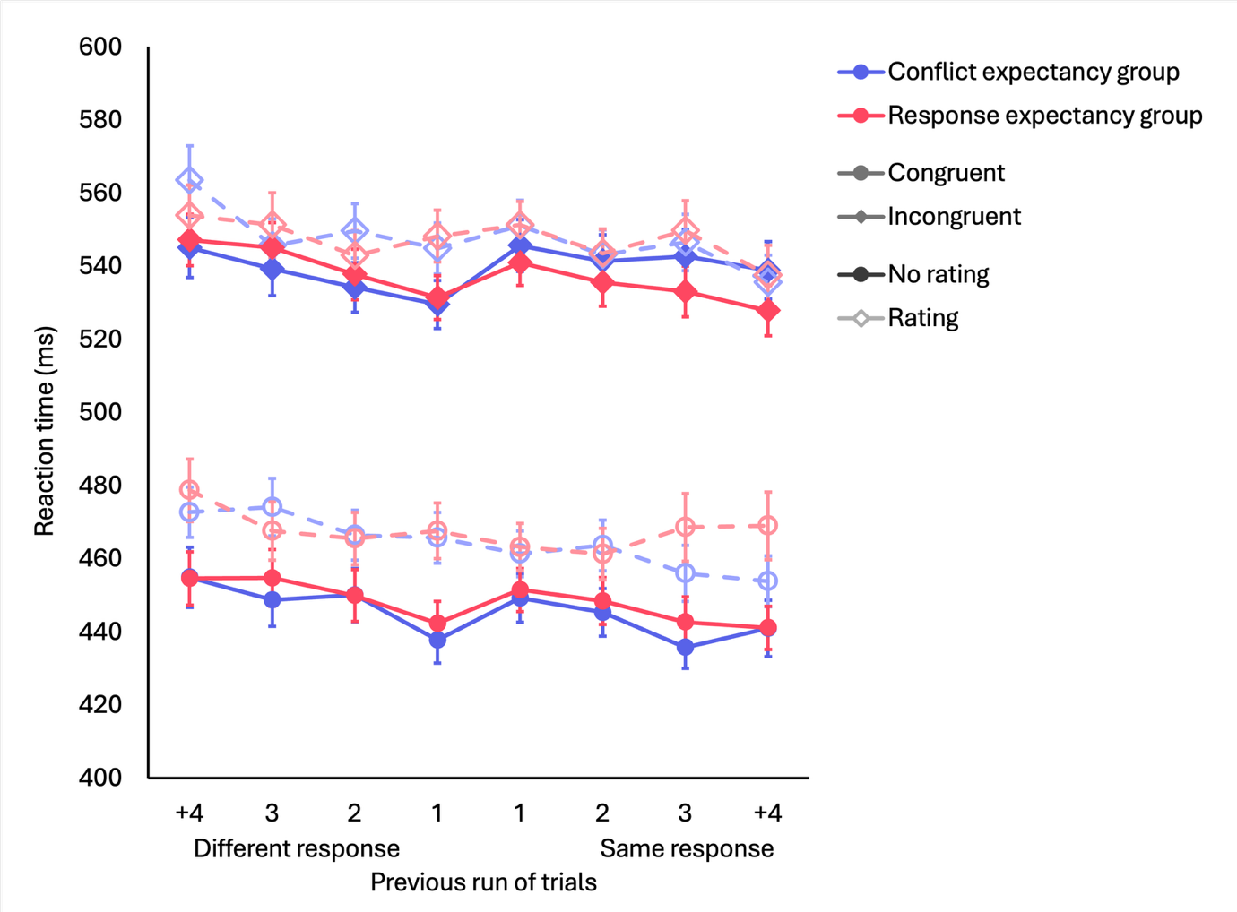
Note. RTs of incongruent trials lie around the 520–580 ms range and represented with diamond points, while those of congruent trials lie around the 430–480 ms range and represented with circle points. Dark solid lines denote trials without an expectancy rating, while light dashed lines are trials with expectancy ratings. The blue lines represent the conflict expectancy group, while the red lines represent the response expectancy group. Error bars correspond to one standard error of the mean (SEM).

Supplementary Table S5

Summary of Interaction between Linear Contrasts by Effect — Left/Right Runs
Effect | ∆ estimate | SE | df | t | p | η_{p}²
(Main) | -141.89 | 26.1 | 127 | -5.442 | <.001*** | 0.08
Conflict | 31.9 | 38.8 | 127 | 0.823 | .412 | <.001
Rating | -35.4237 | 40.5 | 127 | -0.875 | .383 | .006
Rate group | 13.51 | 52.2 | 127 | 0.259 | .796 | <.001
Conflict x Rating | -70.6 | 75.9 | 127 | -0.930 | .354 | .006
Conflict x Rate group | 144.01 | 77.5 | 127 | -1.858 | .066 | .003
Rating x Rate group | 215.5 | 81.0 | 127 | 2.661 | .009** | .05
Conflict x Rating x Rate group | 150.7 | 152 | 127 | 0.993 | .323 | .008

Note. * p < .05, ** p < .01, *** p < .001

Error rates
The original mixed ANOVA on RT was run with error rates. Supplementary Table S6 outlines the results of this ANOVA, and Supplementary Figure S3 depicts the average error rate as a function of congruent/incongruent run length, split by group, conflict, and rating. Supplementary Table S7 summarises the linear contrast analyses on these means across run length, as well as the interactions effects.

Supplementary Table S6

ANOVA on Error Rate with Group, Congruent/Incongruent Run Length, Conflict, and Rating as Factors
Effect |  | df | MSE | F | p | η_{p}²
Between-subjects
 | Rate group | 1,127 | 0.04 | 8.24 | .005** | <.001
Within-subjects
 | Run length | 7,889 | 0.00 | 4.93 | <.001*** | .101
 | Run length x Rate group | 7,889 | 0.00 | 0.60 | .759 | .004
 | Conflict | 1,127 | 0.02 | 128.05 | <.001*** | .936
 | Conflict x Rate group | 1,127 | 0.02 | 4.12 | .045* | .009
 | Rating | 1,127 | 0.01 | 32.39 | <.001*** | .339
 | Rating x Rate group | 1,127 | 0.01 | 4.00 | .048* | .001
 | Run length x Conflict | 7,889 | 0.00 | 4.35 | <.001*** | .016
 | Run length x Conflict x Rate group | 7,889 | 0.00 | 1.03 | .409 | .013
 | Run length x Rating | 7,889 | 0.00 | 1.44 | .187 | .021
 | Run length x Rating x Rate group | 7,889 | 0.00 | 0.12 | .997 | .018
 | Conflict x Rating | 1,127 | 0.01 | 2.02 | .158 | .227
 | Conflict x Rating x Rate group | 1,127 | 0.01 | 0.80 | .374 | .001
 | Run length x Conflict x Rating | 7,889 | 0.00 | 1.15 | .329 | .006
 | Run length x Conflict x Rating x Rate group | 7,889 | 0.00 | 1.25 | .272 | .010
Note. Type III tests. * p < .05, ** p < .01, *** p < .001

Supplementary Figure S3

Error Rate by Congruent/Incongruent Run Length, split by Group, Conflict, and Rating
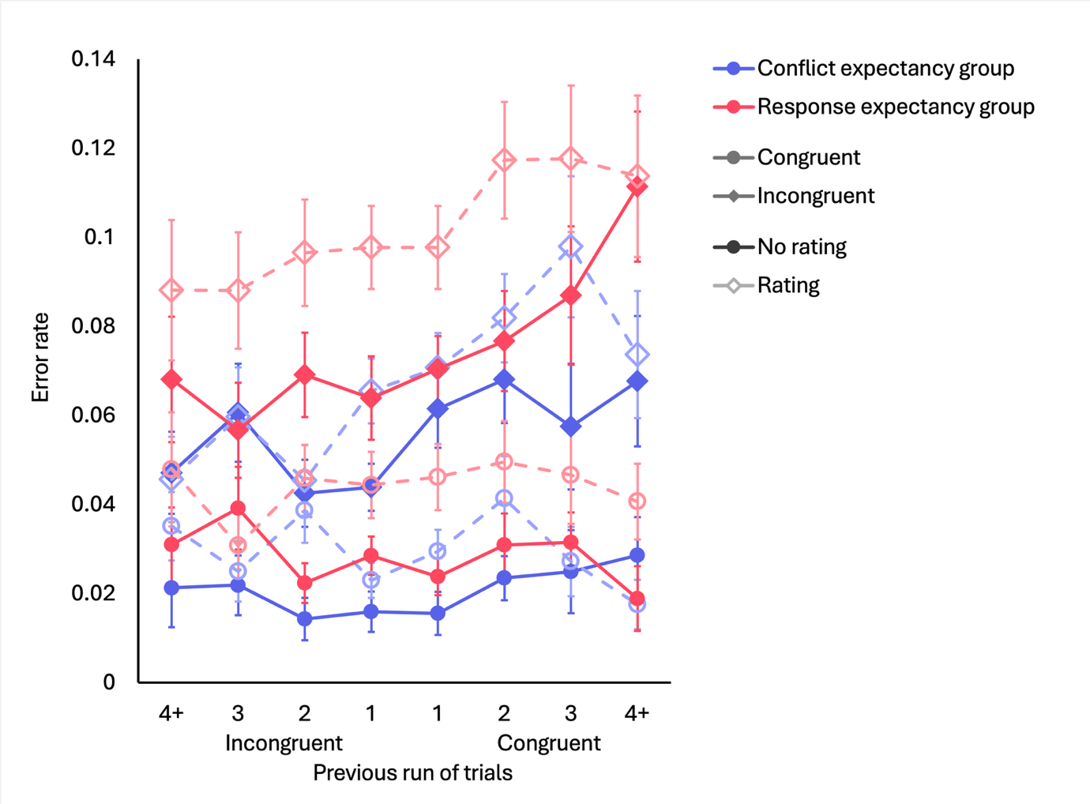
Note. Error rates denote proportion of incorrect trials out of one. Error rates of incongruent trials lie around the 0.04–0.12 range and are represented with diamond points, while those of congruent trials lie around the 0.02–0.06 ms range and are represented with circle points. Dark solid lines denote trials without an expectancy rating, while light dashed lines are trials with expectancy ratings. The blue lines represent the conflict expectancy group, while the red lines represent the response expectancy group. Error bars correspond to one standard error of the mean (SEM).

Supplementary Table S7

Summary of Interaction between Linear Contrasts by Effect — Error Rates
Effect | ∆ estimate | SE | df | t | p | η_{p}²
(Main) | 0.1917 | 0.0483 | 127 | 3.971 | <.001*** | .11
Conflict | 0.4158 | 0.1070 | 127 | 3.882 | <.001*** | .001
Rating | 0.0345 | 0.0968 | 127 | 0.357 | .722 | .920
Rate group | 0.0226 | 0.0965 | 127 | 0.234 | .815 | <.001
Conflict x Rating | 0.1166 | 0.180 | 127 | 0.647 | .519 | .003
Conflict x Rate group | 0.102 | 0.214 | 127 | 0.478 | .634 | .002
Rating x Rate group | -0.0197 | 0.194 | 127 | -0.102 | .919 | <.001
Conflict x Rating x Rate group | -0.7081 | 0.360 | 127 | -1.965 | .052 | .03
Note. * p < .05, ** p < .01, *** p < .001

Experiment 2

RT effects
We ran a 2 × (2 × 2 × 8) mixed ANOVA with group as a between-subjects factor, conflict and rating as a within-subjects factor, and congruent/incongruent run length as a repeated-measures factor. Supplementary Table S8 outlines the results of this ANOVA, and Supplementary Figure S4 plots the average RT across run length, split by group, conflict, and rating trials.

Supplementary Table S8

ANOVA on Flanker Task Response Time (RT) with Group, Congruent/Incongruent Run Length, Conflict, and Rating as Factors
Effect |  | df | MSE | F | p | η_{p}²
Between-subjects
 | Group | 1, 145 | 108830.65 | 3.95 | .049* | .026
Within-subjects
 | Run length | 7, 1015 | 853.47 | 2.23 | .030* | .015
 | Run length x Group | 7, 1015 | 853.47 | 0.76 | .618 | .005
 | Conflict | 1, 145 | 7959.19 | 1186.53 | <.001*** | .891
 | Conflict x Group | 1, 145 | 7959.19 | 10.93 | .001** | .070
 | Rating | 1, 145 | 2542.37 | 26.84 | <.001*** | .156
 | Rating x Group | 1, 145 | 2542.37 | 11.87 | <.001*** | .076
 | Run length x Conflict | 7, 1015 | 863.16 | 28.07 | <.001*** | .162
 | Run length x Conflict x Group | 7, 1015 | 863.16 | 0.36 | .926 | .002
 | Run length x Rating | 7, 1015 | 838.88 | 0.36 | .925 | .002
 | Run length x Rating x Group | 7, 1015 | 838.88 | 0.76 | .623 | .005
 | Conflict x Rating | 1, 145 | 1031.98 | 3.82 | .052 | .026
 | Conflict x Rating x Group | 1, 145 | 1031.98 | 6.15 | .014* | .041
 | Run length x Conflict x Rating | 7, 1015 | 787.99 | 2.39 | .020* | .016
 | Run length x Conflict x Rating x Group | 7, 1015 | 787.99 | 0.66 | .704 | .005
Note. Type III tests. * p < .05, ** p < .01, *** p < .001

Supplementary Figure S4

Flanker Task Response Time (RT) by Congruent/Incongruent Run Length, split by Group, Conflict, and Rating
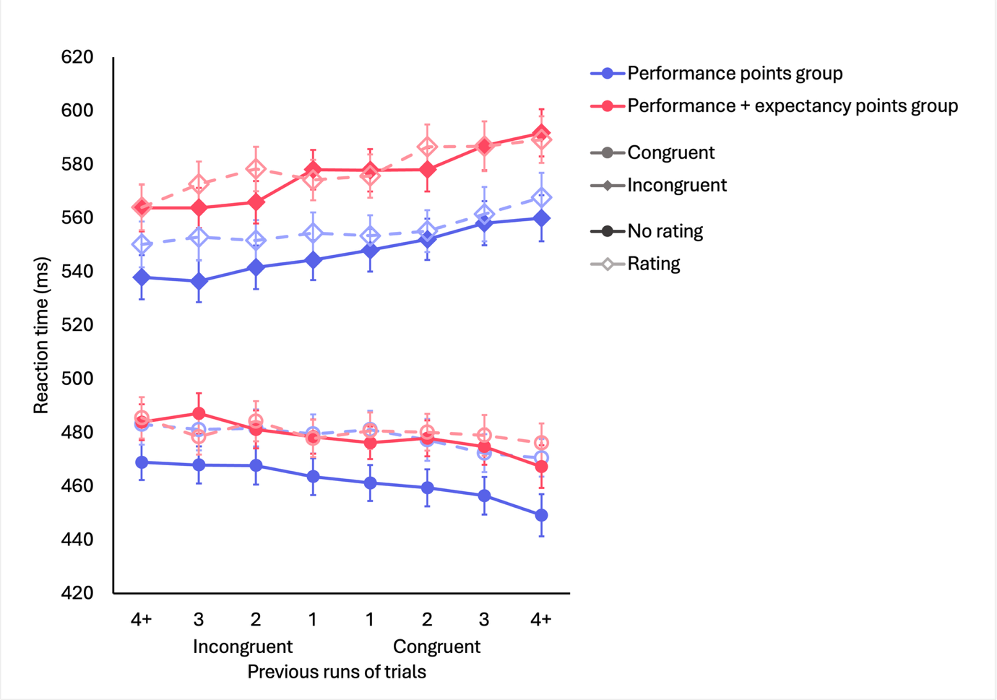
Note. Incongruent trial RT is depicted around the 520–600 ms range and represented with diamond points, while congruent trial RT is around the 440–500 ms range and depicted by circle points. Dark solid lines represent no rating trials, and light dashed lines correspond to trials with expectancy ratings. Blue lines refer to the performance points group, while red lines depict the performance + expectancy points group. Standard error bars represent one SEM.

PCSE
Supplementary Table S9 outlines the results of the ANOVA on flanker RT with group (performance points group vs. performance + expectancy points group), rating, and run length as factors.

Supplementary Table S9

ANOVA on Flanker RT with Group, Congruent/Incongruent Run Length, and Rating as Factors
Effect |  | df | MSE | F | p | η_{p}²
Between-subjects
 | Group | 1,145 | 15918.38 | 10.93 | .001** | .070
Within-subjects
 | Run length | 7,1015 | 1726.33 | 28.07 | <.001*** | .162
 | Run length x Group | 7,1015 | 1726.33 | 0.36 | .926 | .002
 | Rating | 1,145 | 2063.96 | 3.82 | .052 | .026
 | Rating x Group | 1,145 | 2063.96 | 6.15 | .014* | .041
 | Run length x Rating | 7,1015 | 1575.98 | 2.39 | .020* | .016
 | Run length x Rating x Group | 7,1015 | 1575.98 | 0.66 | .704 | .005
Note. Type III tests. *** p < .001
We ran an ANOVA on flanker RT using run length as a factor on each trial type (rating vs. no rating) for each group, to assess the individual linear trends. Supplementary Table S10 summarises these analyses.

Supplementary Table S10

Summary of Linear Contrasts of PCSE for Each Trial Type
Group | Trial type | ∆ estimate | SE | df | t | p | η_{p}²
Performance points | No rating | 502.5 | 70.0 | 73 | 7.178 | <.001*** | .41
Performance points | Rating | 317.5 | 76.7 | 74 | 4.141 | <.001*** | .19
Performance + Expectancy points | No rating | 539.0 | 85.0 | 73 | 6.344 | <.001*** | .36
Performance + Expectancy points | Rating | 358.0 | 77.1 | 74 | 4.644 | <.001*** | .23
Note. * p < .05, ** p < .01, *** p < .001

Error rates
The ANOVA on RT was rerun with error rate as the dependent variable. Supplementary Table S11 outlines the results from this ANOVA, and Supplementary Figure S5 depicts the mean error rates across run length, split by group, conflict, and rating. Supplementary Table S12 summarises the linear contrast analyses ran on the ANOVA.

Supplementary Table S11

ANOVA on Error Rate with Group, Congruent/Incongruent Run Length, Conflict, and Rating as Factors
Effect |  | df | MSE | F | p | η_{p}²
Between-subjects
 | Group | 1,148 | 0.05 | 3.50 | .063 | .023
Within-subjects
 | Run length | 7,1036 | 0.01 | 5.74 | <.001*** | .037
 | Run length x Group | 7,1036 | 0.01 | 1.02 | .417 | .007
 | Conflict | 1,148 | 0.02 | 247.09 | <.001*** | .625
 | Conflict x Group | 1,148 | 0.02 | 2.28 | .133 | .015
 | Rating | 1,148 | 0.01 | 28.48 | <.001*** | .161
 | Rating x Group | 1,148 | 0.01 | 0.05 | .830 | <.001
 | Run length x Conflict | 7,1036 | 0.01 | 5.14 | <.001*** | .034
 | Run length x Conflict x Group | 7,1036 | 0.01 | 0.72 | .654 | .005
 | Run length x Rating | 7,1036 | 0.01 | 1.40 | .201 | .009
 | Run length x Rating x Group | 7,1036 | 0.01 | 1.59 | .133 | .011
 | Conflict x Rating | 1,148 | 0.01 | 0.06 | .803 | <.001
 | Conflict x Rating x Group | 1,148 | 0.01 | 0.63 | .430 | .004
 | Run length x Conflict x Rating | 7,1036 | 0.01 | 0.37 | .920 | .002
 | Run length x Conflict x Rating x Group | 7,1036 | 0.01 | 0.93 | .480 | .006
Note. Type III tests. * p < .05, ** p < .01, *** p < .001

Supplementary Figure S5

Error Rate by Congruent/Incongruent Run Length, split by Group, Conflict, and Rating
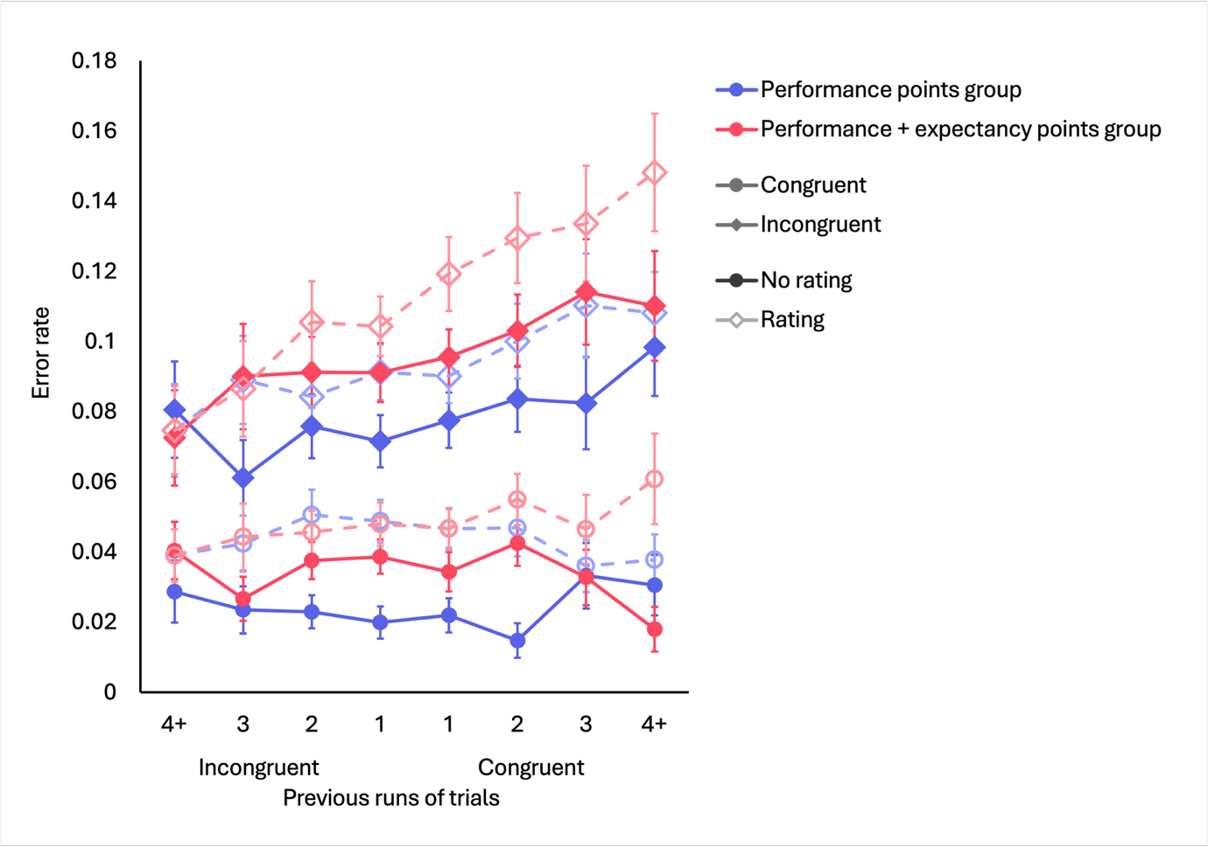
Note. Error rates denote proportion of incorrect trials out of one. Error rates of incongruent trials lie around the 0.06–0.16 range and are represented with diamond points, while those of congruent trials lie around the 0.02–0.06 ms range and are represented with circle points. Dark solid lines denote trials without an expectancy rating, while light dashed lines are trials with expectancy ratings. The blue lines represent the conflict expectancy group, while the red lines represent the response expectancy group. Error bars correspond to one standard error of the mean (SEM).

Supplementary Table S12

Summary of Interaction between Linear Contrasts by Effect — error rates
Effect | ∆ estimate | SE | df | t | p | η_{p}²
(Main) | 0.2458 | 0.0513 | 148 | 4.794 | <.001*** | .13
Conflict | 0.4617 | 0.0911 | 148 | 5.067 | <.001*** | .15
Rating | 0.1883 | 0.0854 | 148 | 2.204 | .029* | .03
Rate group | 0.1761 | 0.1030 | 148 | 1.717 | .088 | .02
Conflict x Rating | 0.1636 | 0.182 | 148 | 0.864 | .389 | .005
Conflict x Rate group | 0.2613 | 0.214 | 148 | 1.434 | .154 | .01
Rating x Rate group | 0.3433 | 0.171 | 148 | 2.009 | .046* | .03
Conflict x Rating x Rate group | -0.114 | 0.379 | 148 | -0.300 | .765 | <.001
Note. * p < .05, ** p < .01, *** p < .001

Experiment 3

RT effects
A (2 × 2 × 8) ANOVA was run on main RT with conflict and rating as within-subjects factors, and congruent/incongruent run length as a repeated-measures factor. Supplementary Table S13 outlines the results of the ANOVA, and Supplementary Figure S6 plots the mean RT across run length, split by conflict and rating.

Supplementary Table S13

ANOVA on Flanker Task Response Time (RT) with Congruent/Incongruent Run Length, Conflict, and Rating as Factors
Effect | df | MSE | F | p | η_{p}²
Run length | 7, 518 | 834.88 | 2.83 | . 007** | .037
Conflict | 1, 74 | 5799.83 | 850.32 | <.001*** | .920
Rating | 1, 74 | 2588.80 | 7.44 | .008** | .091
Run length x Conflict | 7, 518 | 818.73 | 12.15 | <.001*** | .141
Run length x Rating | 7, 518 | 821.11 | 0.55 | .798 | .007
Conflict x Rating | 1, 74 | 1367.43 | 0.46 | .499 | .006
Run length x Conflict x Rating | 7, 518 | 997.47 | 1.44 | .188 | .019
Note. Type III tests. * p < .05, ** p < .01, *** p < .001

Supplementary Figure S6

Flanker Task Response Time (RT) by Congruent/Incongruent Run Length, split by Conflict and Rating
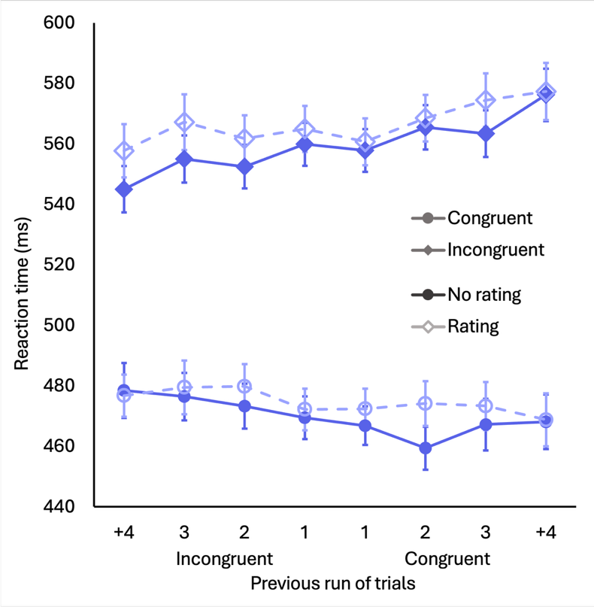
Note. Incongruent trial RT is depicted around the 540–580 ms range and represented with diamond points, while congruent trial RT is around the 460–480 ms range and depicted by circle points. Dark solid lines represent no rating trials, and light dashed lines correspond to trials with expectancy ratings. Standard error bars represent one SEM.

PCSE
The full ANOVA on flanker RT with rating and run length as factors is summarised in Supplementary Table S14.

Supplementary Table S14

ANOVA on Flanker RT with Group, Congruent/Incongruent Run Length, and Rating as Factors
Effect | df | MSE | F | p | η_{p}²
Run length | 7,518 | 1637.46 | 12.15 | <.001*** | .141
Rating | 1,74 | 2734.85 | 0.46 | .499 | .006
Run length x Rating | 7,518 | 1994.94 | 1.44 | .188 | .019
Note. Type III tests. *** p < .001
An ANOVA was run on flanker RT with run length as a factor for each trial type (rating vs. no rating). Supplementary Table S15 summarises the linear contrast analyses run on the specific linear trends.

Supplementary Table S15

Summary of Linear Contrasts of PCSE for Each Trial Type
Trial type | ∆ estimate | SE | df | t | p | η_{p}²
No rating | 460.2 | 81.6 | 75 | 5.637 | <.001*** | .30
Rating | 277.6 | 70.5 | 74 | 3.935 | <.001*** | .17
Note. * p < .05, ** p < .01, *** p < .001

RT effects with attention group as a factor
We reran the ANOVA on main RT, with the addition of attention group (chance vs. above chance) as a between-subjects factor. Supplementary Table S16 outlines the full results of the ANOVA, and Supplementary Figure S7 depicts the mean RT across run length, with group, rating, and conflict as factors.

Supplementary Table S16

ANOVA on Flanker Task Response Time (RT) with Attention, Congruent/Incongruent Run Length, Conflict, and Rating as Factors
Effect |  | df | MSE | F | p | η_{p}²
Between-subjects
 | Attention | 1, 73 | 118299.66 | 0.92 | .340 | . 012
Within-subjects
 | Run length | 7, 511 | 839.33 | 2.32 | .024* | .031
 | Run length x Attention | 7, 511 | 839.33 | 0.61 | .750 | .008
 | Conflict | 1, 73 | 5736.43 | 484.20 | <.001*** | .869
 | Conflict x Attention | 1, 73 | 5736.43 | 1.82 | .182 | .024
 | Rating | 1, 73 | 2398.42 | 14.83 | <.001*** | .169
 | Rating x Attention | 1, 73 | 2398.42 | 6.87 | .011* | .086
 | Run length x Conflict | 7, 511 | 802.33 | 9.29 | <.001*** | .113
 | Run length x Conflict x Attention | 7, 511 | 802.33 | 2.51 | .015* | .033
 | Run length x Rating | 7, 511 | 813.91 | 1.68 | .111 | .023
 | Run length x Rating x Attention | 7, 511 | 813.91 | 1.65 | .118 | .022
 | Conflict x Rating | 1, 73 | 1379.62 | 0.80 | .373 | .011
 | Conflict x Rating x Attention | 1, 73 | 1379.62 | 0.35 | .558 | .005
 | Run length x Conflict x Rating | 7, 511 | 1000.25 | 0.53 | .809 | .007
 | Run length x Conflict x Rating x Attention | 7, 511 | 1000.25 | 0.79 | .592 | .011
Note. Type III tests. * p < .05, ** p < .01, *** p < .001

Supplementary Figure S7

Flanker Task Response Time (RT) by Congruent/Incongruent Run Length, split by Attention Check, Conflict, and Rating
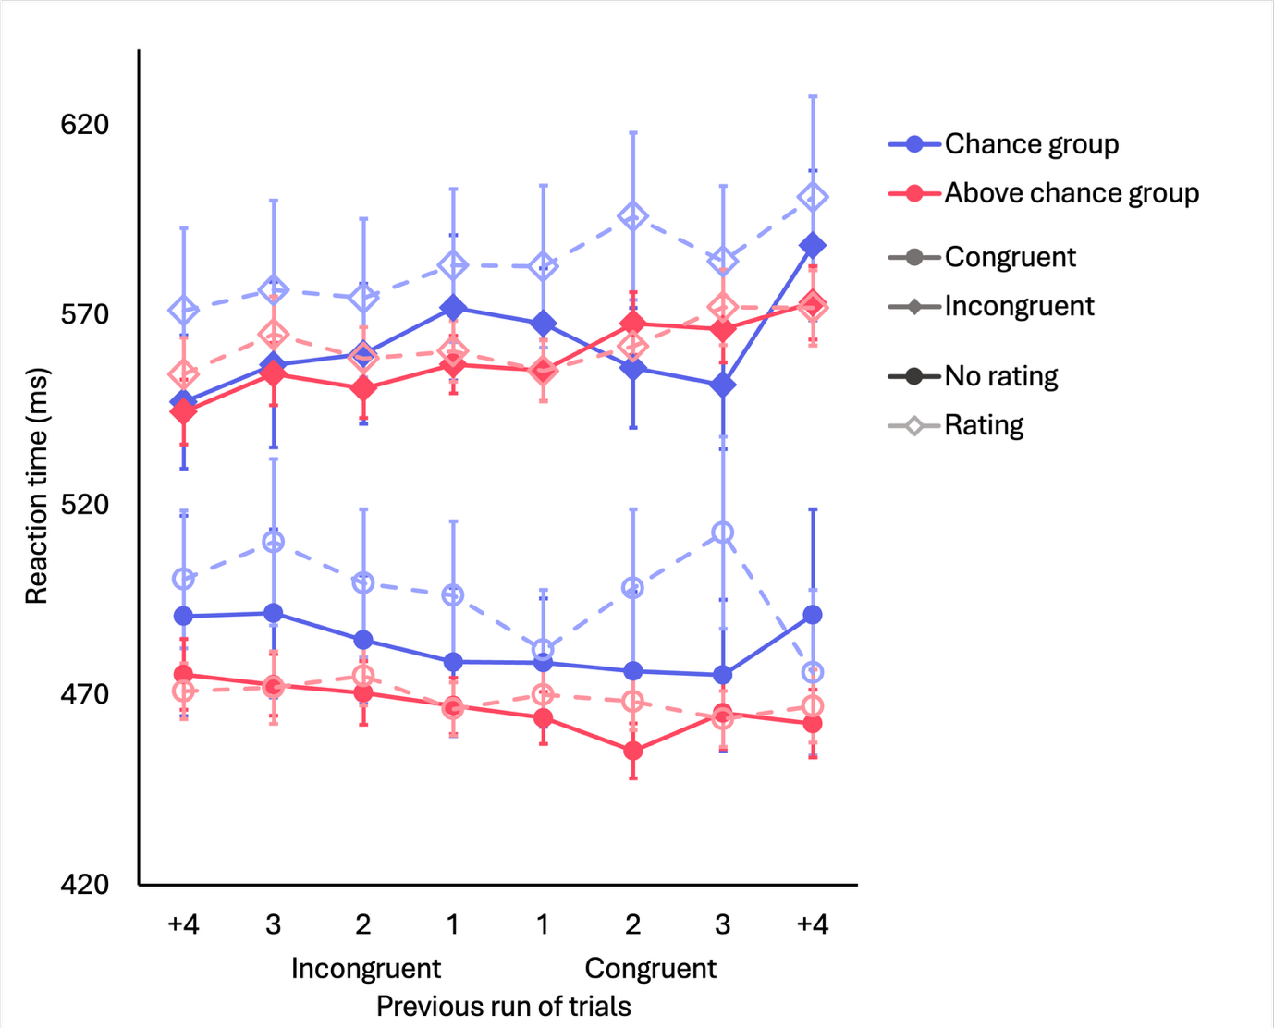
Note. Incongruent trial RT is depicted around the 540–580 ms range and represented with diamond points, while congruent trial RT is around the 460–480 ms range and depicted by circle points. Dark solid lines represent no rating trials, and light dashed lines correspond to trials with expectancy ratings. Blue lines refer to those performing at chance in the attention check questions, while red lines refer to those performing above chance. Standard error bars represent one SEM.

PCSE with attention group as a factor
Supplementary Table S17 outlines the ANOVA on flanker RT with attention group (at chance vs. above chance), rating, and run length as factors. Supplementary Table S18 summarises the individual linear contrast analyses run for each trial type in each group.

Supplementary Table S17

ANOVA on Flanker RT with Attention Group, Congruent/Incongruent Run Length, and Rating as Factors
Effect |  | df | MSE | F | p | η_{p}²
Between-subjects
 | Attention group | 1,73 | 11472.86 | 1.82 | .182 | .024
Within-subjects
 | Run length | 7,511 | 1604.65 | 9.29 | <.001*** | .113
 | Run length x Attention group | 7,511 | 1604.65 | 2.51 | .015* | .033
 | Rating | 1,73 | 2759.24 | 0.80 | .373 | .011
 | Rating x Attention group | 1,73 | 2759.24 | 0.35 | .558 | .005
 | Run length x Rating | 7,511 | 2000.49 | 0.53 | .809 | .007
 | Run length x Rating x Attention group | 7,511 | 2000.49 | 0.79 | .592 | .011
Note. Type III tests. *** p < .001

Supplementary Table S18

Summary of Linear Contrasts of PCSE for Each Trial Type, Split by Attention Check
Attention Group | Trial type | ∆ estimate | SE | df | t | p | η_{p}²
At chance | No rating | 351.3 | 199 | 14 | 1.763 | .100 | .18
At chance | Rating | 407.6 | 192 | 13 | 2.123 | .054 | .26
Above chance | No rating | 487.0 | 89.7 | 60 | 5.431 | <.001*** | .33
Above chance | Rating | 247.7 | 75.0 | 60 | 3.301 | .002** | .15
Note. * p < .05, ** p < .01, *** p < .001

Error rates
The ANOVA on main RT was rerun with error rates as the dependent variable. Table Supplementary S19 outlines the results of this ANOVA, and Supplementary Figure S8 plots the average error rate across run length, split by conflict, rating, and attention group. The summary of linear contrast analyses are outlined in Supplementary Table S20.

Supplementary Table S19

ANOVA on Error Rate with Attention Check, Congruent/Incongruent Run Length, Conflict, and Rating as Factors
Effect |  | df | MSE | F | p | η_{p}²
Between-subjects
 | Attention group | 1, 74 | 0.06 | 3.92 | .051 | .050
Within-subjects
 | Run length | 7, 518 | 0.01 | 1.78 | .088 | .024
 | Run length x Attention group | 7, 518 | 0.01 | 1.18 | .311 | .016
 | Conflict | 1, 74 | 0.02 | 53.73 | <.001*** | .421
 | Conflict x Attention group | 1, 74 | 0.02 | 1.27 | .263 | .017
 | Rating | 1, 74 | 0.02 | 22.06 | <.001*** | .230
 | Rating x Attention group | 1, 74 | 0.02 | 5.03 | .028* | .064
 | Run length x Conflict | 7, 518 | 0.01 | 2.36 | .022* | .031
 | Run length x Conflict x Attention group | 7, 518 | 0.01 | 1.34 | .229 | .018
 | Run length x Rating | 7, 518 | 0.01 | 2.54 | .014* | .033
 | Run length x Rating x Attention group | 7, 518 | 0.01 | 1.00 | .430 | .013
 | Conflict x Rating | 1, 74 | 0.00 | 1.71 | .195 | .023
 | Conflict x Rating x Attention group | 1, 74 | 0.00 | 3.72 | .057 | .048
 | Run length x Conflict x Rating | 7, 518 | 0.01 | 1.11 | .353 | .015
 | Run length x Conflict x Rating x Attention group | 7, 518 | 0.01 | 1.46 | .179 | .019
Note. * p < .05, ** p < .01, *** p < .001

Supplementary Figure S8

Error Rate by Congruent/Incongruent Run Length, split by Attention Check, Conflict, and Rating
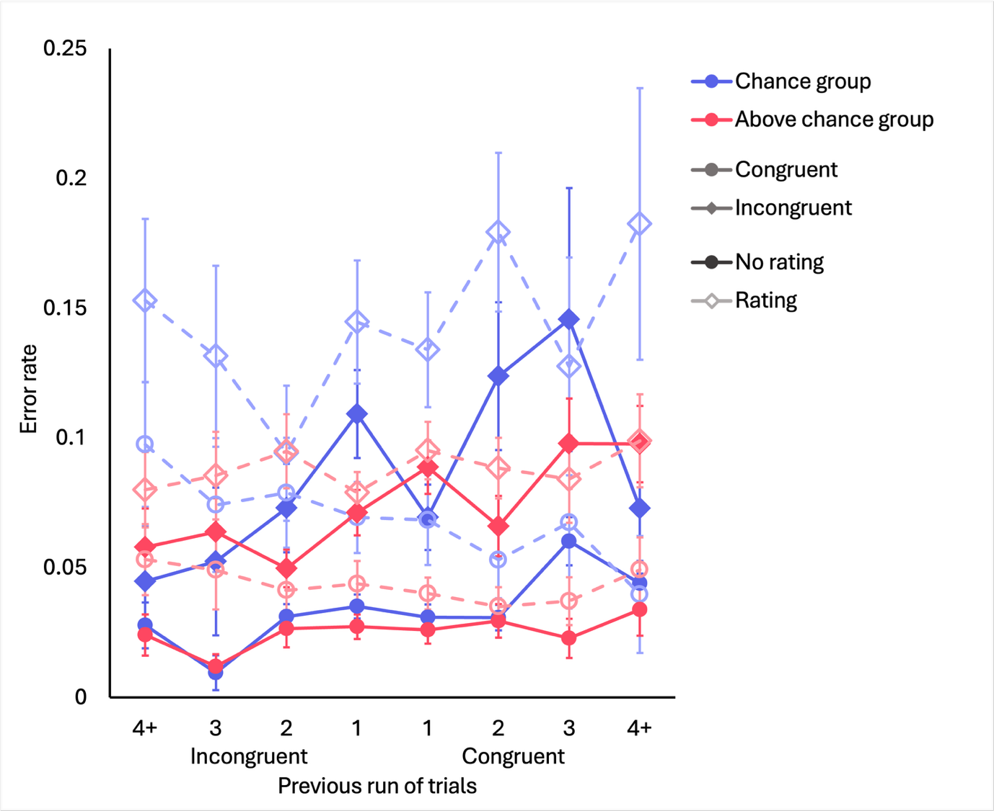
Note. Error rates denote proportion of incorrect trials out of one. Error rates of incongruent trials lie around the 0.05–0.20 range and are represented with diamond points, while those of congruent trials lie around the 0.01–0.10 ms range and are represented with circle points. Dark solid lines denote trials without an expectancy rating, while light dashed lines are trials with expectancy ratings. The blue lines represent the conflict expectancy group, while the red lines represent the response expectancy group. Error bars correspond to one standard error of the mean (SEM).

Supplementary Table S20

Summary of Interaction between Linear Contrasts by Effect — Error Rates
Effect | ∆ estimate | SE | df | t | p | η_{p}²
(Main) | 0.2136 | 0.0836 | 74 | 2.555 | .013* | .08
Conflict | 0.4948 | 0.153 | 74 | 3.227 | .002** | .12
Rating | -0.4634 | 0.167 | 74 | -2.776 | .007** | .09
Attention group | -0.0988 | 0.167 | 74 | -0.591 | .556 | .005
Conflict x Rating | 0.191 | 0.358 | 74 | 0.532 | . 596 | .004
Conflict x Attention group | -0.3738 | 0.307 | 74 | -1.219 | .227 | .002
Rating x Attention group | 0.2945 | 0.334 | 74 | 0.882 | .381 | .001
Conflict x Rating x Attention group | -0.686 | 0.716 | 74 | -0.957 | . 342 | .01
Note. * p < .05, ** p < .01, *** p < .001

Pregistered analysis
Our preregistration includes an analysis on the subset of participants who scored a minimum criterion of 80% accuracy on the attention check questions. We used the 80% threshold to split participants into two groups (N(below 80%) = 30; N(80% and above) = 46), and ran the same analyses as in the main paper. Mean expectancy ratings against run length for each group are plotted in Supplementary Figure S9A. A repeated-measures ANOVA was run on expectancy with attention group and run length as factors, and linear contrasts were run with the results from the ANOVA. Expectancy ratings, on average, did not interact with run length linearly, t(74) = -0.479, p = .633, but its interaction with attention group was significant, t(74) = -2.417, p = .018, η_{p}² = .07. Running the ANOVA and linear contrast analyses on each group reveals that the group who scored below 80% did not exhibit a significant linear trend, t(29) = 1.337, p = .192. On the other hand, the group scoring at least 80% on the attention check questions exhibited a significant negative recency trend, t(74) = -2.212, p = .032, η_{p}² = .10, with ratings for conflict (i.e., “hard”) being strongest following longer runs of congruent trials, and closer to 0 following longer runs of incongruent trials.
Supplementary Figure S9

Flanker Effect and Expectancy by Previous Trial Runs in Subset of Participants
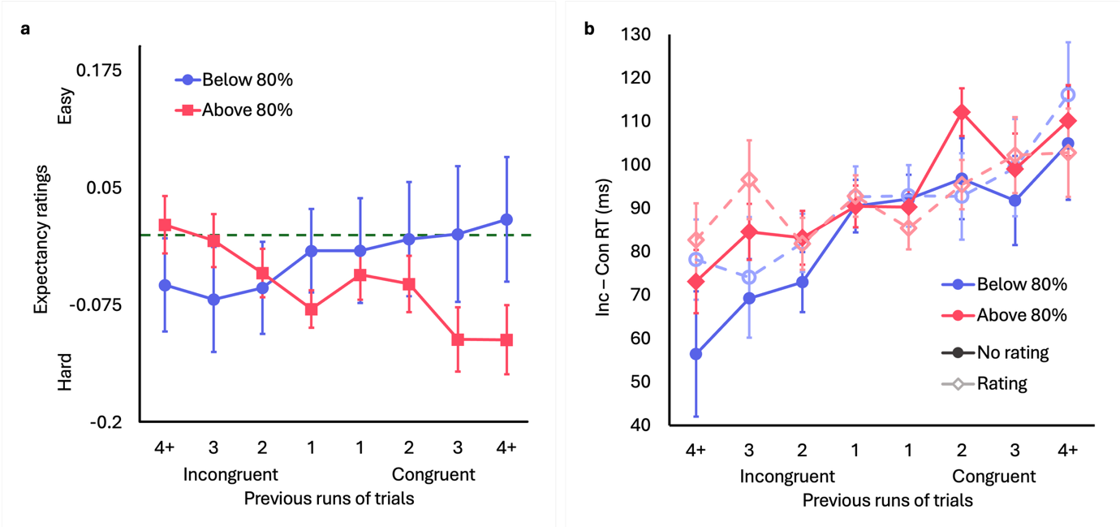Note. a) Mean expectancy ratings for each run length, split by attention group. Standard error bars represent one SEM. b) Mean flanker effect (i.e. the difference between incongruent and congruent trial RT) for each run length, split by trial type. Dark solid lines represent no-rating trials, while light dashed lines represent rating trials. Standard error bars represent one SEM.
A 2 × (2 × 8) ANOVA on flanker effect was run with attention group (below 80% vs. 80% and above) as a between-subjects factor, trial type (no-rating vs. rating) as a within-subjects factor and run length as a repeated-measures factor. Figure S9B depicts the mean flanker effect across run length for each trial type and attention group. There was a significant main effect of run length, and an analysis of linear contrasts revealed that the trend across run length was significant, demonstrating the PCSE, t(74) = 7.398, p < .001, η_{p}² = .43. There was no main effect of rating, nor were the PCSE trends between rating and no-rating trials significantly different, t(74) = -1.778, p = .080. There was also no effect of attention group, and no interaction between attention group and the PCSE trend, t(74) = -1.639, p = .106. The three way interaction between rating, group, and the linear PCSE trend was also not significant, t(74) = -0.156, p = .876. Analyses run on individual groups revealed that the PCSE trend was significant both for the 80% and above group, t(45) = 4.448, p < .001, η_{p}² = .31, and the below 80% group, t(28) = 6.203, p < .001, η_{p}² = .58. Neither of these trends interacted with rating significantly, p > .05.

