Sample Size Calculation
S1. Design
The sample size for this single-arm, single-centre, exploratory phase II study was determined using A'Hern's single-stage exact binomial design (A'Hern RP. Sample size tables for exact single-stage phase II designs. Stat Med. 2001;20(6):859–866), an exact refinement of Fleming's single-stage design appropriate for a binary primary endpoint (R0 resection: yes/no) in a single-arm setting.
S2. Parameters and hypotheses
The primary endpoint was the intention-to-treat (ITT) R0 resection rate.
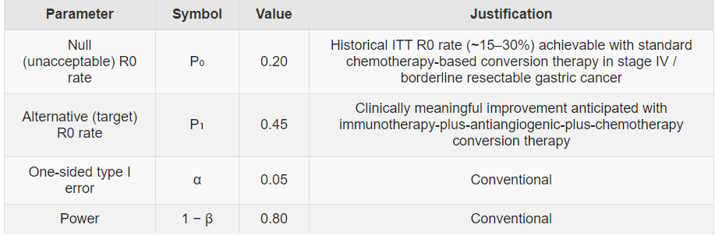
- H₀: p ≤ P₀ = 0.20 (regimen not worthy of further study)
- H₁: p ≥ P₁ = 0.45 (regimen warrants further study)
S3. Method
A'Hern's design identifies the smallest sample size n and critical value r (minimum number of R0 resections to reject H₀) satisfying both exact binomial constraints:
Type I error: Σ[x=r→n] C(n,x) P₀ˣ (1−P₀)ⁿ⁻ˣ ≤ α
Power: Σ[x=r→n] C(n,x) P₁ˣ (1−P₁)ⁿ⁻ˣ ≥ 1 − β
S4. Result
The design requires n = 21 evaluable patients with a critical value r = 7. If ≥ 7 of 21 evaluable patients achieve R0 resection, H₀ is rejected.
- Exact one-sided α = 0.043 (≤ 0.05)
- Exact power = 0.803 (≥ 0.80)
Allowing for approximately 10% attrition, the planned enrolment was 24 (21 / 0.90 ≈ 23.3, rounded up). The study ultimately enrolled 31 patients, providing additional power. Among all enrolled patients, 11 achieved R0 resection, exceeding the prespecified threshold (≥ 7); the primary endpoint was therefore met.
S5. Software and verification
Calculations were performed in R 4.3.0 using the clinfun package (ph2single) and confirmed by independent exact-binomial computation.
library(clinfun)
# A'Hern single-stage exact binomial design
ph2single(pu = 0.20, pa = 0.45, ep1 = 0.05, ep2 = 0.20, nsoln = 3)
# -> optimal design: n = 21, r = 7 (Type I error 0.0431; Type II error 0.1971)

# Exact verification of n = 21, r = 7
n <- 21; r <- 7; P0 <- 0.20; P1 <- 0.45
typeI <- 1 - pbinom(r - 1, n, P0) # 0.0431
power <- 1 - pbinom(r - 1, n, P1) # 0.8029
c(alpha = round(typeI, 4), power = round(power, 4))
Output
n = 21, r = 7; exact one-sided alpha = 0.0431; exact power = 0.8029

