Title: Global warming increases lightning activity over Brazil regardless of cloud ice content trends in a GCM

Supplementary Material

Summary
- Supplementary Introduction
- Supplementary Methods
- Supplementary Results
- Supplementary References

- Supplementary Introduction
Lightning is an atmospheric phenomenon driven by an electric field generated by charge separation in cumulonimbus clouds. The noninductive theory of cloud electrification is based on elastic collisions between ice crystals and graupel in the mixed-phase regions of clouds (Takahashi 1978; Takahashi et al. 1999). Graupel grows through riming, a process where supercooled water droplets freeze upon impact with an ice particle. This environment depends on updrafts to suspend hydrometeors and on moisture transport to supply liquid water. During riming, the release of latent heat warms the graupel surface. In subsequent collisions, this temperature difference, or the presence of a liquid water film at high cloud water contents, drives ion transfer between the particles (Baker et al. 1987; Baker and Dash 1994). Consequently, rebounding ice crystals change the net charge of the rimed particles. While the non-inductive mechanism is considered the primary driver of the charge separation, inductive charging processes can act concurrently to further intensify this electrification (Shi et al. 2016).
- Supplementary Methods
All datasets were harmonized to a common monthly temporal resolution and mapped onto a 1° × 1° terrestrial grid over Brazil (EPSG:4326, WGS84). The grid was defined as a regular geographic mesh and intersected with the 10 m resolution Natural Earth land mask for Brazil, using level-0 administrative boundaries. Only the land fraction of each grid cell was retained. Grid-cell areas were calculated from geometries clipped by the land mask using an Albers equal-area projection, and entirely oceanic cells were excluded.
For the lightning data, WWLLN records underwent quality control by removing entries with missing or invalid geographic coordinates and were then filtered to the Brazilian domain. Each lightning stroke was assigned to a land-clipped grid cell using a spatial join, ensuring that only lightning occurring within the land fraction of each cell was retained. Monthly lightning counts were aggregated by grid cell, and a complete cell-month matrix was constructed to preserve temporal continuity, including months with zero lightning. Lightning density was calculated as the monthly number of lightning strokes divided by the land area of each grid cell, yielding values in strokes km⁻² month⁻¹. The resulting density estimates were corrected using monthly averaged RDE maps.
The analysis period covers 2013-2025. This interval was selected to avoid the rapid increase in WWLLN Relative Detection Efficiency observed between 2004 and 2012, after which detection efficiency stabilized close to 100% (Hutchins et al. 2012). The training period was defined as 2013-2022, and the validation period as 2023–2025.
Monthly ERA5 pressure-level and single-level variables were aggregated onto the target grid using precomputed area-weighted mapping. In this procedure, the contribution of each source grid cell was proportional to its geometric overlap with the land fraction of each target cell. This approach accounts for latitudinal variations in grid-cell area and improves the representation of coastal regions. For EC-Earth3-Veg, predictor fields were extracted using the same grid structure and the same set of variables, ensuring consistency between the reanalysis-based relationships and future projections.
The derived variables were computed from the ERA5 pressure-level and single-level fields. See Supplementary Table 1 for the variable’s identification used here. PB was estimated from moist static energy differences between a near-surface parcel and the saturated environment at 850 hPa (Beucler et al. 2024). WS was calculated as the vector difference between horizontal winds at 850 and 500 hPa. The CSP was defined as the difference between saturated θₑ at 700 hPa and θₑ at 850 hPa, representing a measure of conditional stability in the lower to mid-troposphere, where positive values indicate greater inhibition to deep convection and negative values indicate enhanced convective potential (Finney et al. 2020). CRH was obtained as the ratio between vertically integrated water vapor and its saturation equivalent (Kalashnikov et al. 2024), while the MHD was defined as one minus the mean relative humidity between 700 and 500 hPa. The MLD was estimated as the vertical distance between the 0 °C and −40 °C isotherms. The CAPE, CINE, and others were directly extracted from ERA5 fields. Additionally, an EEF was defined as the ratio between CAPE and the sum of CAPE and the absolute value of CINE.
For Ec-Earth3-Veg, CAPE and CINE were computed from vertical thermodynamic profiles using a surface parcel defined by near-surface temperature and humidity (2 m fields), with buoyancy integrated on a refined vertical grid (~700 Pa resolution) from the surface to the equilibrium level. CAPE corresponds to the vertical integral of positive buoyancy, while CINE represents the integral of negative buoyancy below the level of free convection.
To the initial selection of ERA5 atmospheric proxies, spatial correlation analyses were performed between each candidate variable and lightning density at the grid-cell level. Three spatial metrics were computed: (i) the mean absolute correlation, representing the average strength of association across all valid cells; (ii) the spatial standard deviation of correlations, used to assess the consistency of the relationship across regions; and (iii) the fraction of statistically significant cells (p < 0.05), representing the spatial robustness of the association. These metrics were normalized to a 0-1 range (min-max transformation), with positive orientation for mean correlation and fraction of significant cells, and inverse orientation for spatial variability. A composite spatial score was then defined as a weighted combination of these metrics (Equation 1) and computed separately for Pearson and Spearman correlations.
$S_{P/S} = 0.5M + 0.3F +O.2H,$ Equation 1
where M is the normalized mean correlation of all cells, F is the normalized fraction of significant cells, and H is the normalized spatial mean standard deviation.
In addition, the ability of each variable to reproduce the seasonal cycle of lightning was evaluated using monthly climatologies. For each grid cell, 12-point climatological series were constructed for both the atmospheric variable and lightning density, and Pearson and Spearman correlations were computed between them. The spatial mean of the absolute values of these correlations was calculated and normalized, and the resulting average was used as a seasonal skill score. The final ranking of variables was obtained by combining the Pearson-based spatial score ($S_{Pearson})$, the Spearman-based spatial score ($S_{Spearman}$), and the seasonal skill score ($S_{cycle}$), as described in Equation 2.
$S_{final} = 0.4S_{Pearson} + 0.3S_{Spearman} +O.2S_{cycle},$ Equation 2
This approach assigns equal importance to linear and monotonic relationships while incorporating the ability to capture the climatological seasonal cycle. Variables were then ranked in descending order of the final score, defining the hierarchy of atmospheric proxies for subsequent modeling. We excluded variables with a final score lower than 0.4.
The performance analysis of the MLR models was conducted using combinations of predictors, starting with the highest-ranked variables (see Supplementary Table 1). Model performance was evaluated at the grid-cell level using both the training and validation periods. For each cell, the coefficient of determination (R²) from the training period was summarized through its mean, median, and standard deviation, while predictive performance in the validation period was assessed using the mean and standard deviation of the root mean squared error (RMSE) and the mean bias.
Model statistical significance was evaluated using the F-statistics, summarized by its mean and standard deviation across cells, along with the percentage of cells presenting statistically significant F-tests (p < 0.05). Multicollinearity was assessed using the variance inflation factor (VIF), and the percentage of cells with VIF values lower than 5 was reported.
In addition to cell-level diagnostics, domain-level metrics were computed to assess large-scale model performance. Domain-mean time series were constructed by averaging predictions across all valid grid cells and were generated using a single domain-level MLR. From these domain-level MLR simulations, the R² from the training period, RMSE, bias, and Pearson correlation coefficient (r) and its associated p-value were calculated from the validation period. These domain metrics are commonly reported in the literature (e.g., Romps et al. 2014; Finney et al. 2018) and provide a more robust assessment of model performance, since cell-level R² values tend to be lower due to local variability and GCM noise.
The prior ranking of individual variables guided the model selection strategy. The analysis started with the highest-ranked variable and progressively incorporated additional predictors representing distinct physical processes, provided they also ranked highly. A full combinatorial exploration of all possible predictor sets was therefore not performed. Interaction terms between variables were explicitly tested to account for coupling between processes.

- Supplementary Results
Supplementary Table 1. Atmospheric variables used in subsequent analysis and their identification.
Variable | ID | Measurement Unit
Plume buoyance | PB | $$m s^{-2}$$
Convective precipitation rate | CPR | $$kg m^{-2} s^{-1}$$
Potential temperature equivalent (θₑ) at 850 hPa | ThetaE | K
Vertical velocity (ω) at 500 hPa | Omega500 | $$Pa s^{-1}$$
Mid-level humidity deficit  (700-500 hPa) | MHD | Dimensionless (0-1)
Total column ice | ICE | $$kg m^{-2}$$
Convective Available Potential Energy | CAPE | $$J {kg}^{-1}$$
Convective Inhibition Energy | CINE | $$J {kg}^{-1}$$
Conditional stability proxy (Δθₑ) | CSP | K
Mean sea level pressure | MSLP | hPa
Column relative humidity | CRH | Dimensionless (0-1)
Effective energy fraction | EEF | Dimensionless (0-1)
Mixed-phase layer depth  (0ºC to –40ºC) | MLD | m
Wind Shear (850 hPa – 500 hPa) | WS | $$m s^{-2}$$

Supplementary Table 2. Summary of the RLM models analyzed based on performance and global significance. Cell-averaged metrics represent the mean values computed across all individual RLMs fitted at each grid cell over the domain (Brazil), whereas domain-level metrics correspond to those obtained from a single RLM fitted using predictor variables spatially averaged over the entire domain. [Only the Excel file is available due to the table dimension.]
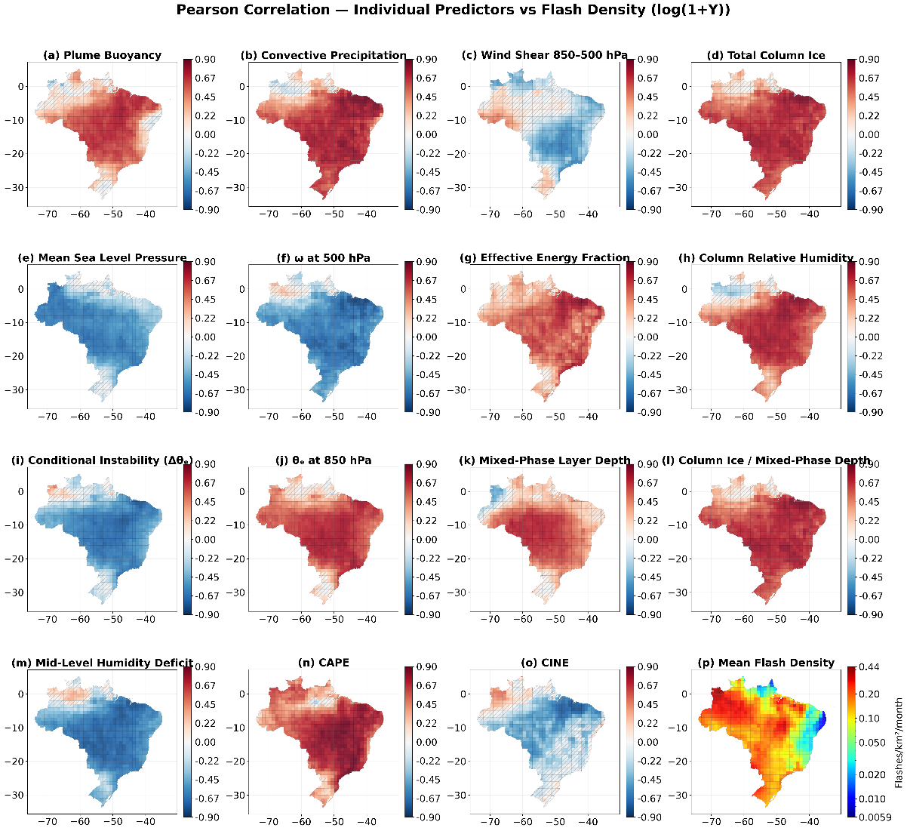
Supplementary Figure 1. Pearson correlation between atmospheric variables and lightning density. Lightning density was normalized using log(1+Y), and dashed cells indicate non-significant correlations (p>0.05).
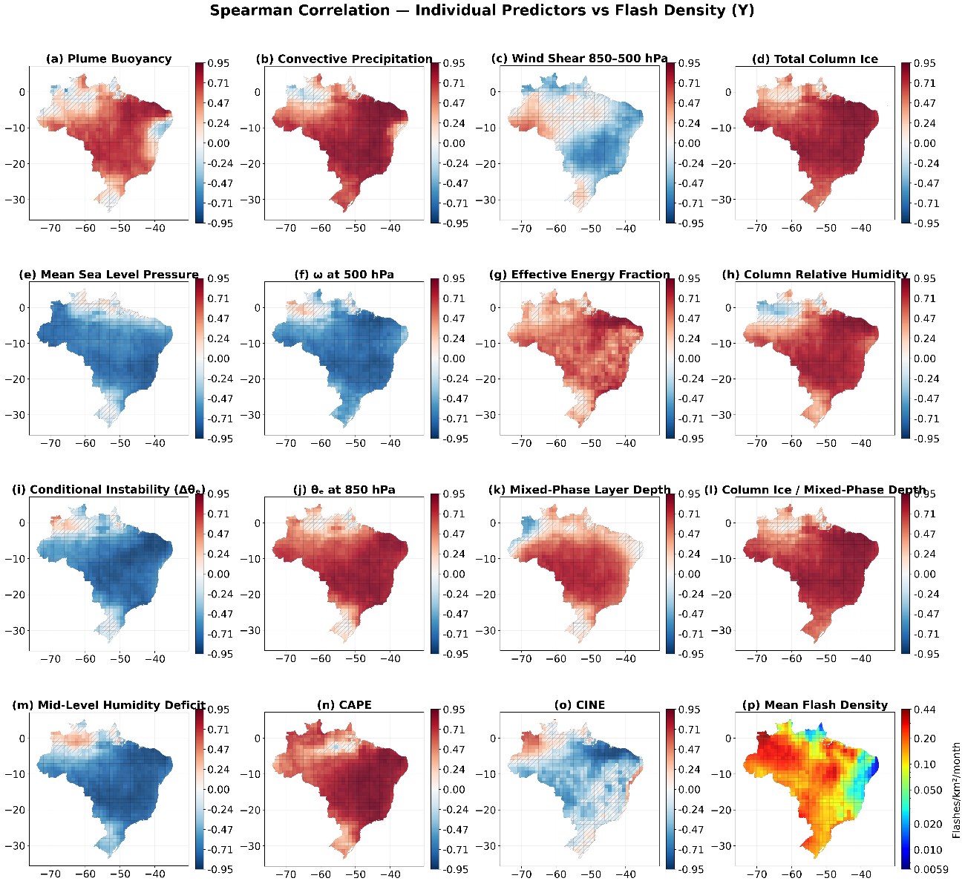
Supplementary Figure 2. Pearson correlation between atmospheric variables and lightning density. The dashed cells indicate non-significant correlations (p>0.05).

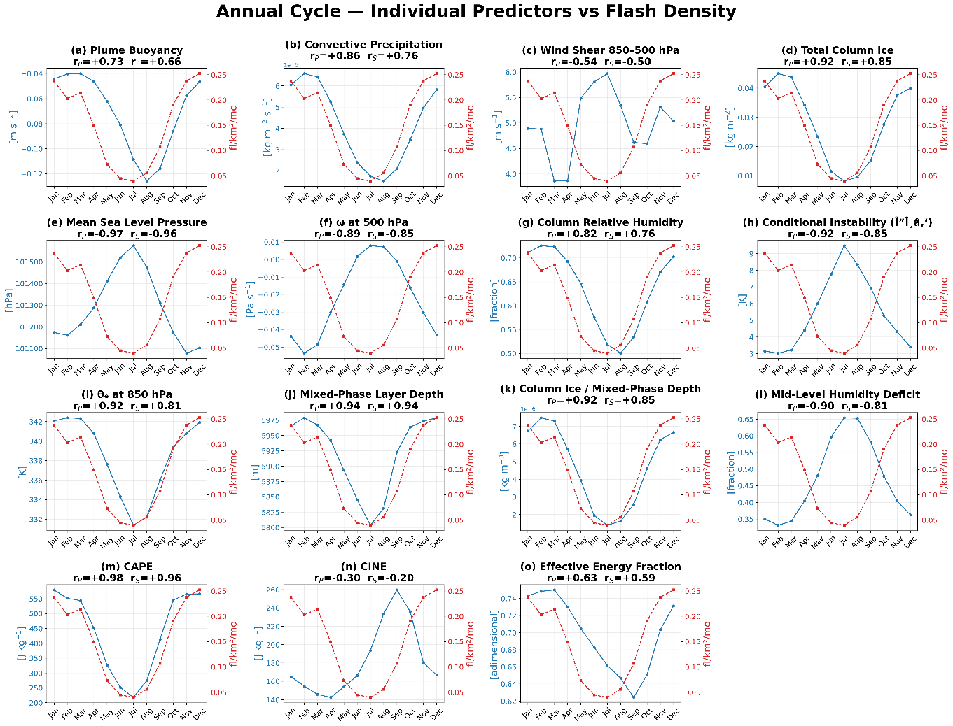
Supplementary Figure 3. Annual Cycle of each atmospheric variable (blue) and lightning density (red). Pearson and Spearman correlation (r) between the time series is also reported.

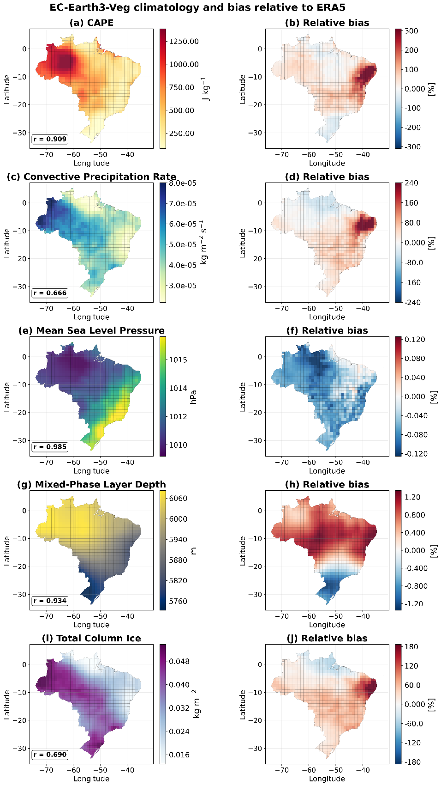
Supplementary Figure 4. Left panels (a, c, e, g, i) show climatological mean values from EC-Earth3-Veg over the reference period 2013–2025 for the predictor variables. Right panels (b, d, f, h, j) show the relative bias, calculated as [(EC-Earth3-Veg - ERA5) / ERA5] × 100%. Positive values (warm colors) indicate model overestimation, while negative values (cool colors) indicate underestimation. From top to bottom: (a, b) Convective Available Potential Energy (CAPE, J kg⁻¹); (c, d) convective precipitation rate (kg m⁻² s⁻¹); (e, f) mean sea level pressure (hPa); (g, h) mixed-phase layer depth (m); (i, j) total column ice (kg m⁻²).

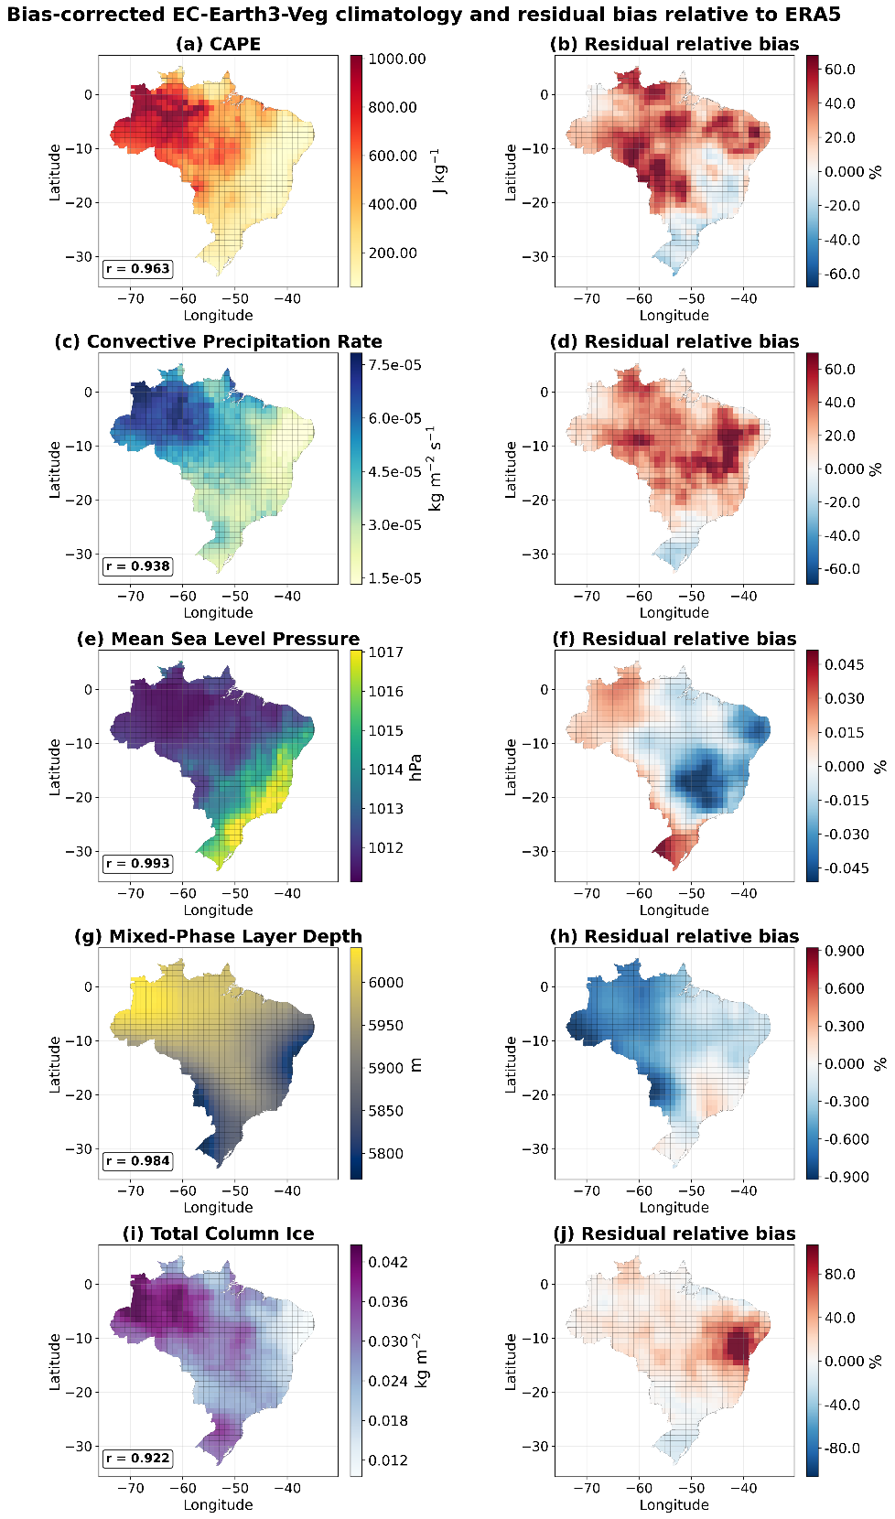
Supplementary Figure 5. Left panels (a, c, e, g, i) show bias-corrected climatological mean values from EC-Earth3-Veg over the validation period 2023–2025. Bias-correction parameters were derived from the training period 2013-2022 and applied independently to 2023-2025 data (out-of-sample validation). Right panels (b, d, f, h, j) show residual relative bias after correction. Warm colors indicate remaining model overestimation; cool colors indicate underestimation. From top to bottom: (a, b) Convective Available Potential Energy (CAPE, J kg⁻¹); (c, d) convective precipitation rate (kg m⁻² s⁻¹); (e, f) mean sea level pressure (hPa); (g, h) mixed-phase layer depth (m); (i, j) total column ice (kg m⁻²). The out-of-sample test demonstrates the robustness of the bias-correction method when applied to independent data.

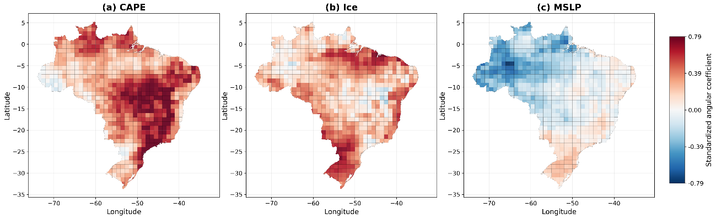
Supplementary Figure 6. Standardized angular coefficients of the multiple linear regression model linking lightning activity to atmospheric predictors over Brazil for (a) convective available potential energy, (b) total column ice water, and (c) mean sea level pressure. Coefficients are normalized by the standard deviation of lightning density at each grid cell. Red and blue shades indicate positive and negative relationships, respectively.

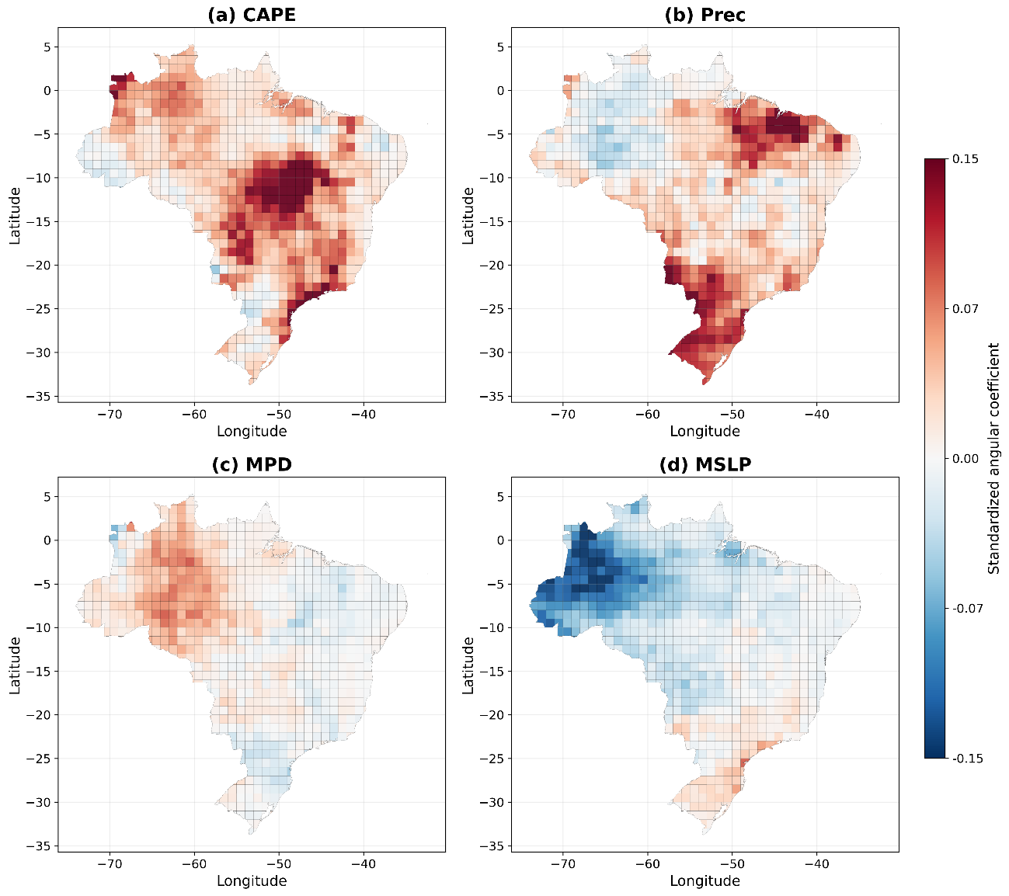
Supplementary Figure 7. Standardized angular coefficients of the multiple linear regression model linking lightning activity to atmospheric predictors over Brazil for (a) convective available potential energy, (b) convective precipitation rate, (c) mixed-phase layer depth, and (d) mean sea level pressure. Coefficients are normalized by the standard deviation of lightning density at each grid cell. Red and blue shades indicate positive and negative relationships, respectively.

- Supplementary References
Baker B, Baker MB, Jayaratne ER, Latham J, Saunders CPR (1987) The Influence of Diffusional Growth Rates On the Charge Transfer Accompanying Rebounding Collisions Between Ice Crystals and Soft Hailstones. Quarterly Journal of the Royal Meteorological Society 113:1193–1215. https://doi.org/10.1002/qj.49711347807
Baker MB, Dash JG (1994) Mechanism of charge transfer between colliding ice particles in thunderstorms. Journal of Geophysical Research: Atmospheres 99:10621–10626. https://doi.org/https://doi.org/10.1029/93JD01633
Beucler T, Gentine P, Yuval J, Gupta A, Peng L, Lin J, Yu S, Rasp S, Ahmed F, O’Gorman PA, Neelin JD, Lutsko NJ, Pritchard M (2024) Climate-invariant machine learning. Sci Adv 10. https://doi.org/10.1126/sciadv.adj7250
Finney DL, Doherty RM, Wild O, Stevenson DS, MacKenzie IA, Blyth AM (2018) A projected decrease in lightning under climate change. Nat Clim Chang 8:210–213
Finney DL, Marsham JH, Wilkinson JM, Field PR, Blyth AM, Jackson LS, Kendon EJ, Tucker SO, Stratton RA (2020) African lightning and its relation to rainfall and climate change in a convection‐permitting model. Geophys Res Lett 47. https://doi.org/10.1029/2020GL088163
Hutchins ML, Holzworth RH, Brundell JB, Rodger CJ (2012) Relative detection efficiency of the World Wide Lightning Location Network. Radio Sci 47. https://doi.org/10.1029/2012RS005049
Kalashnikov DA, Davenport F V., Labe ZM, Loikith PC, Abatzoglou JT, Singh D (2024) Predicting Cloud‐To‐Ground Lightning in the Western United States From the Large‐Scale Environment Using Explainable Neural Networks. Journal of Geophysical Research: Atmospheres 129. https://doi.org/10.1029/2024JD042147
Romps DM, Seeley JT, Vollaro D, Molinari J (2014) Projected increase in lightning strikes in the United States due to global warming. Science (1979) 346:851–854. https://doi.org/10.1126/science.1259100
Shi Z, Tang H-Q, Tan Y-B (2016) Effects of the Inductive Charging on the Electrification and Lightning Discharges in Thunderstorms. Terrestrial, Atmospheric and Oceanic Sciences 27:241–251. https://doi.org/10.3319/TAO.2015.12.10.01(A)
Takahashi T (1978) Riming Electrification as a Charge Generation Mechanism in Thunderstorms. J Atmos Sci 35:1536–1548. https://doi.org/10.1175/1520-0469(1978)035<1536:REAACG>2.0.CO;2
Takahashi T, Tajiri T, Sonoi Y (1999) Charges on Graupel and Snow Crystals and the Electrical Structure of Winter Thunderstorms. J Atmos Sci 56:1561–1578. https://doi.org/10.1175/1520-0469(1999)056<1561:COGASC>2.0.CO;2

