Supplementary Material
Supplementary Figure S1. Representative fieldwork settings during data collection in government schools across Ladakh, illustrating school premises and waste-bin provision. No individuals are identifiable.
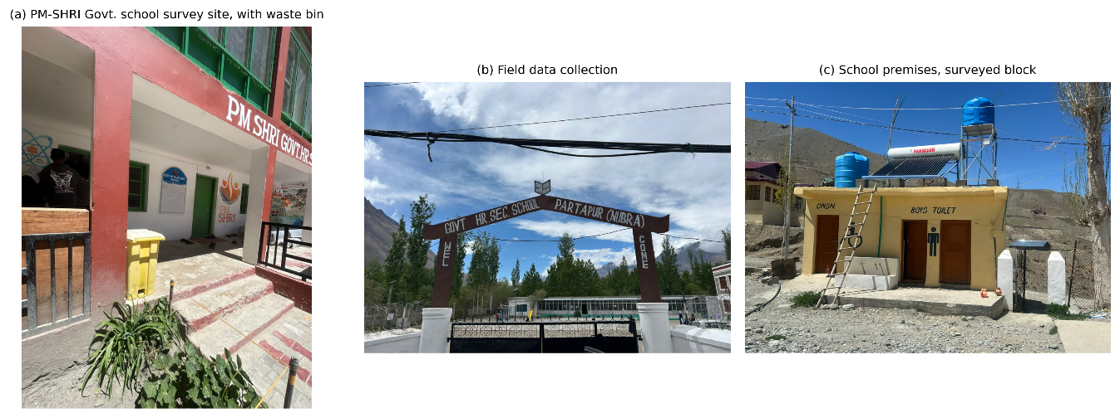
Supplementary Table S1 (variable dictionary). A full coding scheme for all questionnaire items (Parts I-IX and the attitude/Likert module) is available from the corresponding author and was used to derive the composite knowledge, practice and period-poverty indices described in the Methods.

