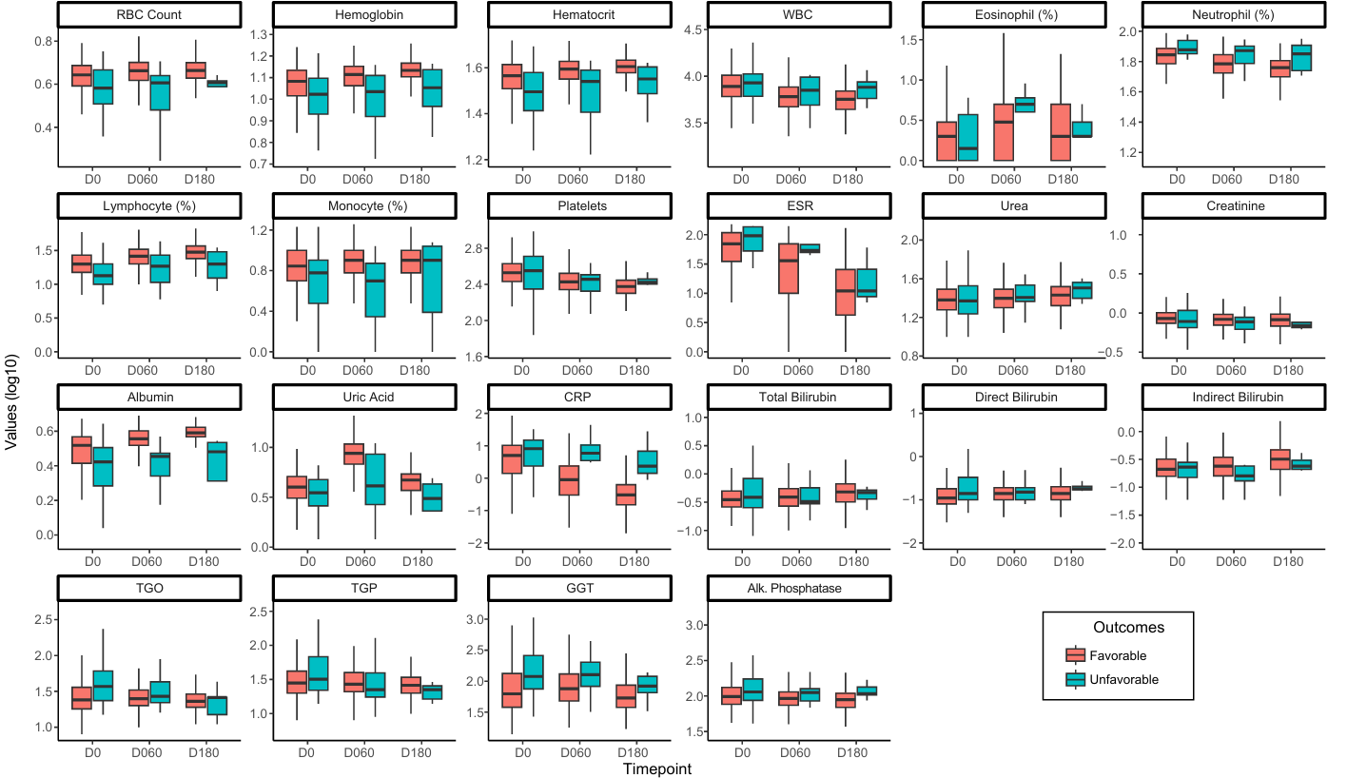
Supplementary Figure. Longitudinal assessment of laboratory tests in patients with favorable and unfavorable tuberculosis treatment outcomes. Boxplots show the distribution (log10-transformed) of 22 routine laboratory tests measured at baseline (D0), Day 60 (D60), and Day 180 (D180) in patients with favorable (salmon) and unfavorable (teal) outcomes. Tests include hematological parameters (e.g., RBC, hemoglobin, hematocrit, WBC subtypes), inflammatory markers (e.g., CRP, ESR), renal/liver function tests (e.g., urea, creatinine, bilirubin, transaminases), and others (albumin, uric acid). P-values comparing favorable versus unfavorable outcomes at each time point are provided in Supplementary Table 2. Abbreviations: RBC (red blood cell); WBC (white blood cell); ESR (erythrocyte sedimentation rate); CRP (C-reactive protein); AST (aspartate aminotransferase); ALT (alanine aminotransferase); GGT (gamma-glutamyl transferase).

