Supplementary material

Table S1 Days where PM events originated partially from a source
 | 0% | 10% | 20% | 25% | 40% | 50% | 60% | 75% | 80% | 90% | 100%
Traffic | 3910 | 6 | 6 | 16 | 1 | 13 |  | 4 | 5 | 4 | 52
Resuspension | 3925 | 5 | 5 | 5 |  | 15 | 1 | 12 | 5 | 5 | 36
Volcanic ash | 4008 |  |  |  |  | 1 |  |  |  |  | 8
Sand storm | 3980 |  |  | 1 |  | 2 |  | 4 | 1 | 1 | 28

Table S2 Correlation matrix for exposure variables during the study period (same day, or lag0 values Pearson correlation coefficient).
 | PM₁₀ | NO₂ | SO₂ | H₂S | O₃ | Pollen | Temperature | Relative Humidity
PM₁₀ | 1.00
NO₂ | 0.07* | 1.00
SO₂ | 0.01 | 0.01 | 1.00
H₂S | 0.01 | 0.34* | 0.10* | 1.00
O₃ | 0.11* | -0.38* | -0.23* | -0.21* | 1.00
Pollen | -0.03* | -0.17* | -0.03 | -0.10* | -0.12* | 1.00
Temperature | -0.20* | -0.46* | -0.05* | -0.28* | -0.06* | 0.40* | 1.00
Relative humidity | -0.22* | 0.09* | -0.04* | 0.03 | -0.06* | -0.19* | 0.08* | 1.00
*p-value is less than 0.05

Table S3 PM event sources and their association with dispensing of asthma drugs in models adjusted for SO₂, NO₂, PM₁₀ (3622 observations)
 | Short-acting |  |  |  | Long-acting
 | RR | 95% CI |  |  |  | RR |  | 95% CI
Traffic | 1.26 | 1.05– 1.52 |  |  |  | 1.34 | 1.04 – 1.72
Resuspension | 0.87 | 0.72 – 1.07 |  |  |  | 1.00 | 0.77 – 1.30
Volcanic | 1.09 | 0.74 – 1.63 |  |  |  | 2.81 | 1.76 – 4.50
Dust storm | 0.99 | 0.74 – 1.31 |  |  |  | 0.41 | 0.28 – 0.62
NO₂ | 1.01 | 1.00 – 1.03 |  |  |  | 1.01 | 0.99 – 1.03
SO₂ | 1.00 | 1.00 – 1.00 |  |  |  | 1.00 | 1.00 – 1.00
PM₁₀ | 1.00 | 0.99 – 1.01 |  |  |  | 1.02 | 1.00 – 1.03
RR associated with air pollutants NO₂, SO₂, PM₁₀, O₃ and H₂S are presented per IQR.
Models are adjusted for pollen, temperature, flu season, and odd holidays, day of week, and season and time trend splines.

Table S4 PM event sources and their association with dispensing of asthma drugs in models adjusted for SO₂, NO₂, PM₁₀, H₂S and O₃ (1234 days with observations)
 | Short-acting |  |  |  |  |  |  | Long-acting
 | RR | 95% CI |  |  |  |  |  |  | RR | 95% CI
Traffic | 1.11 | 0.98–1.26 |  |  |  |  | 0.72 |  |  |  | 0.49–1.06
Resuspension | 1.17 | 1.03–1.32 |  |  |  |  | 1.03 |  |  |  | 0.69–1.55
Volcanic* | – | – |  |  |  |  | – |  |  |  | –
Dust storm | 1.03 | 0.84–1.26 |  |  |  |  | 1.11 |  |  |  | 0.65–1.91
NO₂ | 1.03 | 0.99–1.07 |  |  |  |  | 1.02 |  |  |  | 1.00–1.05
SO₂ | 0.96 | 0.93–0.99 |  |  |  |  | 0.98 |  |  |  | 0.94–1.02
PM₁₀ | 1.02 | 0.99–1.04 |  |  |  |  | 1.06 |  |  |  | 1.03–1.08
H₂S | 1.03 | 1.01–1.04 |  |  |  |  | 0.93 |  |  |  | 0.89–0.96
O₃ | 1.06 | 1.03–1.09 |  |  |  |  | 0.99 |  |  |  | 0.98–1.01
Short-acting drugs: ATC code R03A, Long acting drugs: ATC code R03B.RR associated with air pollutants NO₂, SO₂, PM₁₀, O₃ and H₂S are presented per IQR.
Models are adjusted for pollen, temperature, flu season, and odd holidays, day of week, and season and time trend splines.
*No volcanic events occurred on days with exposure data on all these pollutants.

Figure S1 Time series plots of 24-hour means of exposure variables with a 30 day moving average.

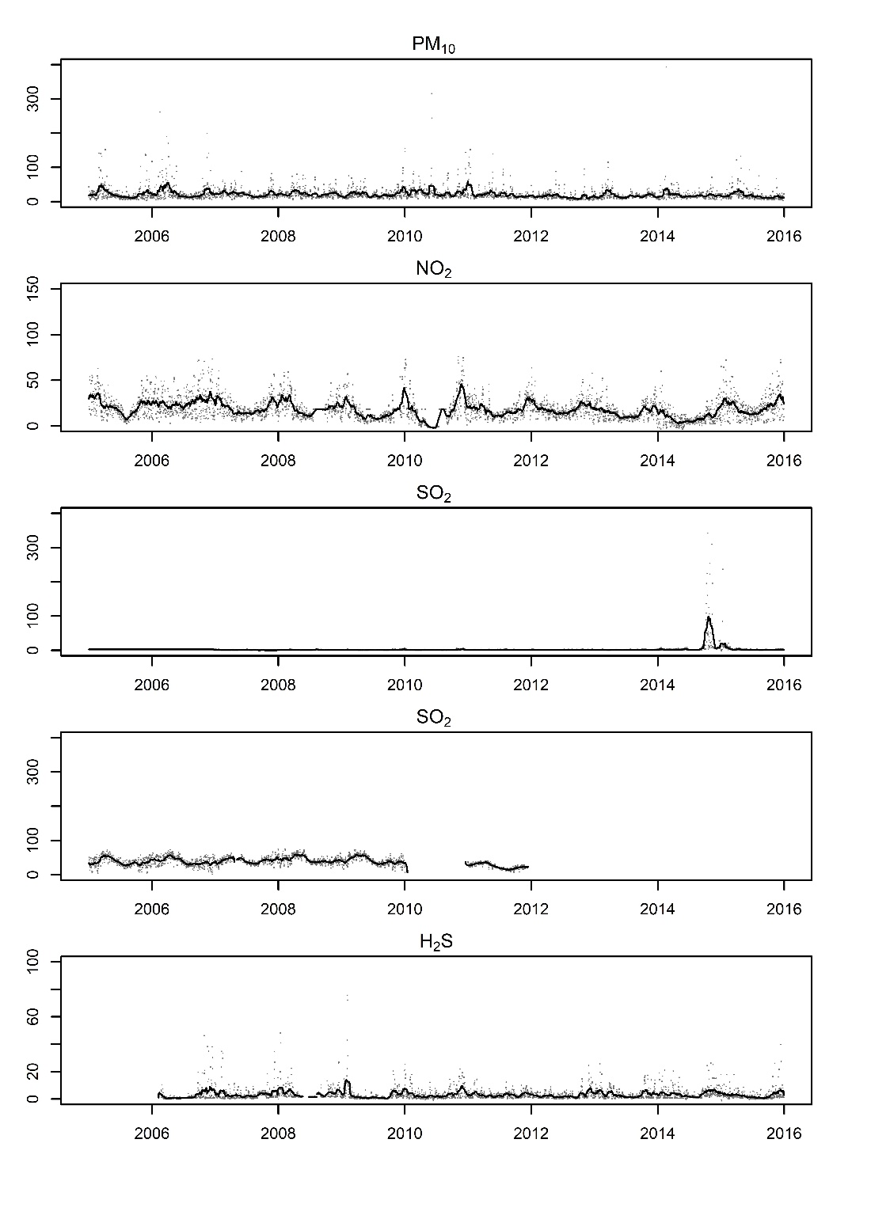

Figure S2 Lag-effects plot of the effect of temperature on long-acting drug dispensing at selected values above and below 0°C

R code
#packageurl <- "https://cran.r-project.org/src/contrib/Archive/mgcv/mgcv_1.8-27.tar.gz"
#install.packages(packageurl, repos=NULL, type="source")

#this generates the plots Jan 2021 version
#load data5_15
library(Hmisc)

#libraries
library(gplots)
library(gnm)
library(stats)
library(dlnm)
library(splines)

#pharma dispensings
load("C:/Users/xkraha/Documents/C_ash time/Data/data5_15_mor.Rdata")
##DLNM for plot
#specify the crossbasis so give splines some wiggle room
data5_15 <- dat_mor
cb.pm<- crossbasis(data5_15$pm10_mean, lag=7
, argvar=(list(fun="ns"))
, arglag=(list(fun="poly", degree=3)))
cb.no2<- crossbasis(data5_15$no2_mean, lag=7
, argvar=(list(fun="ns"))
, arglag=(list(fun="poly", degree=3)))
cb.so2<- crossbasis(data5_15$so2, lag=7
, argvar=(list(fun="ns"))
, arglag=(list(fun="poly", degree=3)))
cb.O3<- crossbasis(data5_15$o3_mean, lag=7
, argvar=(list(fun="ns"))
, arglag=(list(fun="poly", degree=3)))
cb.H2S<- crossbasis(data5_15$h2s, lag=7
, argvar=(list(fun="ns"))
, arglag=(list(fun="poly", degree=3)))
#pollen
cb.pollen<- crossbasis(data5_15$all, lag=7
, argvar=(list(fun="ns"))
, arglag=(list(fun="poly", degree=3)))
cb.temp<- crossbasis(data5_15$TEMP, lag=7 #temp
, argvar=(list(fun="ns"))
, arglag=(list(fun="poly", degree=3)))

# SO NO source adjusted ####

mod.bas <- gnm( data5_15$mor_adult~
cb.temp
+cb.no2 + cb.so2 + cb.pm
+cb.pollen
+rh_l07
+as.factor(dow)
+ns(nday)
+flu +ns(doy3)
,data=data5_15, family=quasipoisson())

#no2 and so2 coefficients+ cb.no2+cb.so2####
#IQR change

#Effekt of no in adjusted models per IQR
pred.no2<- crosspred(cb.no2, mod.bas, cumul=TRUE, by=1, at=22.984, cen = 10.064)
res_no2 <- with(pred.no2_adjv,cbind(allRRfit,allRRlow,allRRhigh))

#per lag
pcum.no2 <- crosspred(cb.no2,mod.bas, lag=7, at=22.984, cen = 10.064, cumul = T)#
pcum.no2 <- with(pcum.no2,cbind(cumRRfit,cumRRlow,cumRRhigh))

#Effekt of SO2 in adjusted models per IQR
pred.so2 <- crosspred(cb.so2, mod.bas, cumul=TRUE, by=1, at=2.5285, cen = 0.7732)
res_so2 <- with(pred.so2,cbind(allRRfit,allRRlow,allRRhigh))

##per lag
pcum.so2 <- crosspred(cb.so2,mod.bas, lag=7, at=2.5285, cen = 0.7732, cumul = T)#
res_so2 <- with(pred.so2,cbind(cumRRfit,cumRRlow,cumRRhigh))

#effect of PM10 in adjusted models per IQR
pred.pm <- crosspred(cb.pm, mod.bas, cumul=TRUE, by=1, at=25.724, cen = 12.524)
res_pm <- with(pred.pm,cbind(allRRfit,allRRlow,allRRhigh))

##per lag
pcum.pm <- crosspred(cb.pm,mod.bas, lag=7, at=25.724, cen = 12.524, cumul = T)#
res_pm <- with(pred.pm,cbind(cumRRfit,cumRRlow,cumRRhigh))

#effect of temperature adjusted models per IQR####
pred.temp <- crosspred(cb.temp, mod.bas, by=1, at=10, cen = 0)
pred.temp_15 <- crosspred(cb.temp, mod.bas, cumul=TRUE, by=1, at=15, cen = 0)
pred.temp_5 <- crosspred(cb.temp, mod.bas, cumul=TRUE, by=1, at=5, cen = 0)

pred.temp_neg10 <- crosspred(cb.temp, mod.bas, cumul=TRUE, by=1, at=-10, cen = 0)
pred.temp_neg15 <- crosspred(cb.temp, mod.bas, cumul=TRUE, by=1, at=-15, cen = 0)
pred.temp_neg5 <- crosspred(cb.temp, mod.bas, cumul=TRUE, by=1, at=-5, cen = 0)

res_temp <- with(pred.temp,cbind(allRRfit,allRRlow,allRRhigh))

write.csv2(res_pm, file="./output/standard/mortality/temp_10 coefs.csv")

##per lag

pcum.temp <- crosspred(cb.temp,mod.bas, lag=7, at=10, cen = 0, cumul = T)#
res_temp <- with(pred.temp,cbind(cumRRfit,cumRRlow,cumRRhigh))

write.csv2(res_so2, file="./output/standard/mortality/temp_10 coefs-cum.csv")

plot(pcum.temp, "slices", var=10)
lines(pred.temp_15, "slices", var=15, lty=2)
lines(pred.temp_5, "slices", var=5, lty=3)

#effect of temperature

cb.temp<- crossbasis(data5_15$TEMP,lag=7 #temp
, argvar=(list(fun="ns"))
, arglag=(list(fun="poly", degree=3)))

mod.basb <- gnm( data5_15$ind_b~
cb.temp
+cb.no2 + cb.so2
+cb.pollen
+as.factor(dow)
+ns(nday)
+flu +ns(doy3)
,data=data5_15, family=quasipoisson())
pred.temp_b<- crosspred(cb.temp,mod.basb , cumul=TRUE, by=1, cen=0)

par(mfrow=c(1,2))
plot(pred.temp_a,"slices", var=-2,
main=expression('Temperatures below 0')
, ylab="Relative risk"
,ylim=c(0.95 , 1.05)
, type="l", lty=1, ci="n", xlab="Lag",xlim=c(0,7) ) #a
lines(pred.temp_a, "slices", var=-5, col="gray44", lty=2,lwd=1
,ci.level=0.95)#
lines(pred.temp_a, "slices", var=-7, col="gray66", ci="n", lty=3,lwd=1
,ci.level=0.95)#
grcol <- c("black", "gray22", "gray44")
legtxt <- c("-2°C","-5°C", "-10°C")
legend("top", legtxt, col=grcol, lty=1:3, ncol=3, bty="n")

plot(pred.temp_a,"slices", var=1,
main=expression('Temperatures above 0')
, ylab="Relative risk"
,ylim=c(0.95 , 1.05)
, type="l", lty=1, ci="n", xlab="Lag", xlim=c(0,7) ) #
lines(pred.temp_a, "slices", var=5, col="gray44", lty=2
,lwd=1, ci.arg=list(density=40,col=grey(0.7))
,ci.level=0.95)#
lines(pred.temp_a, "slices", var=10, col="gray66", lty=3, lwd=1
,ci.level=0.95)#
legtxt <- c("2°C","5°C", "10°C")
legend("top", legtxt, col=grcol, lty=1:3, ncol=3, bty="n")

