Divergent Runoff Responses to 1.5ºC, 2.0ºC, and 3.0ºC Warming Across Headwater and Downstream Regions of the Indus River Basin
Zahoor Ahmad ^{1, 2, 3}, Zhijie Zhang ^{4, *}, and Wanchang Zhang ⁵
¹ Key Laboratory of Digital Earth Sciences, Aerospace Information Research Institute (AIR), Chinese Academy of Sciences (CAS), Beijing 100094, People's Republic of China (zahoor.unec@mails.ucas.ac.cn), (zhangwc@radi.ac.cn).
² International Research Center of Big Data for Sustainable Development Goals, Beijing 100094, People's Republic of China (zahoor.unec@mails.ucas.ac.cn), (zhangwc@radi.ac.cn).
³ University of Chinese Academy of Sciences (UCAS), Beijing 100049, People's Republic of China.
⁴ School of Geospatial Artificial Intelligence, East China Normal University, Shanghai 200241, China (zjzhang@geoai.ecnu.edu.cn).
⁵ College of Ecological Engineering, Guizhou University of Engineering Science, Bijie 551700, China (zhangwc@radi.ac.cn).
* Correspondence to: Zhijie Zhang (zjzhang@geoai.ecnu.edu.cn).

Supplementary Materials
This supplementary file provides supporting material for the TFT-derived runoff projections and the warming-level runoff assessment. It includes the TFT model architecture, validation note, hindcast performance diagnostics, temporal-validation results, hyperparameter-sensitivity analysis, leave-one-station-out validation, long-term runoff projection summaries, station-wise annual runoff responses, station-wise warming sensitivity, and station-wise model agreement across global warming levels. The file contains Note S1, Fig. S1–S3, and Table S1–S6.

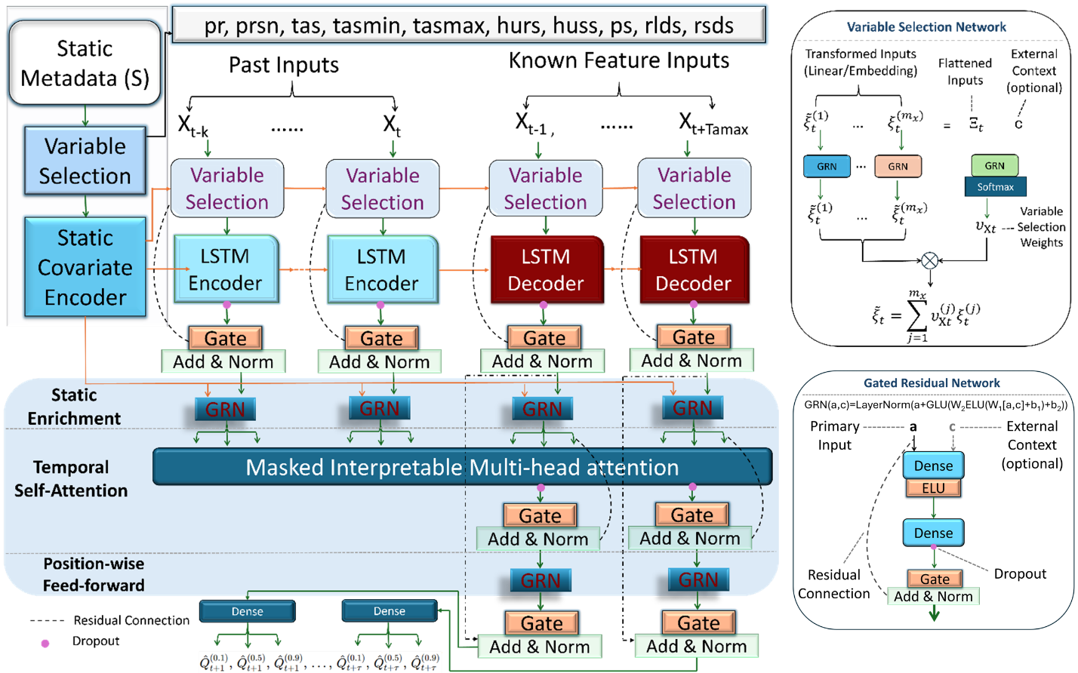
Fig. S1: Schematic representation of the TFT framework used for monthly multi-station runoff projection across the IRB. The diagram shows the integration of static station metadata, past runoff inputs, known future hydroclimatic predictors, variable-selection networks, LSTM-based encoder–decoder components, gated residual networks, and masked interpretable multi-head attention. The figure illustrates how the TFT framework combines station attributes, antecedent hydrological conditions, and future climate covariates to generate multi-horizon runoff projections.
Note S1. Validation of TFT-derived runoff projections
The TFT runoff projection framework was evaluated before its use in the warming-level analysis. Model development used a chronological split, with calibration over 2001–2010, validation over 2011–2015, and independent hindcast evaluation over 2016–2020. Performance was assessed using RMSE, MAE, R, R², NSE, KGE, and PBIAS. Across GCM forcings, hindcast skill remained stable (Fig S2), with R = 0.799–0.816, R² = 0.639–0.666, NSE = 0.638–0.659, KGE = 0.617–0.636, and PBIAS ranging from −2.63% to 3.40%. Robustness was further tested using blocked temporal validation (Table S1), hyperparameter sensitivity (Table S2), and leave-one-station-out validation (Table S3) analysis. These tests indicated that the model’s skill was not restricted to a single temporal partition, station subset, or architecture configuration. This study therefore uses the evaluated TFT projections as input for the GWL-based diagnostic analysis rather than presenting the TFT model as a new model-development contribution.
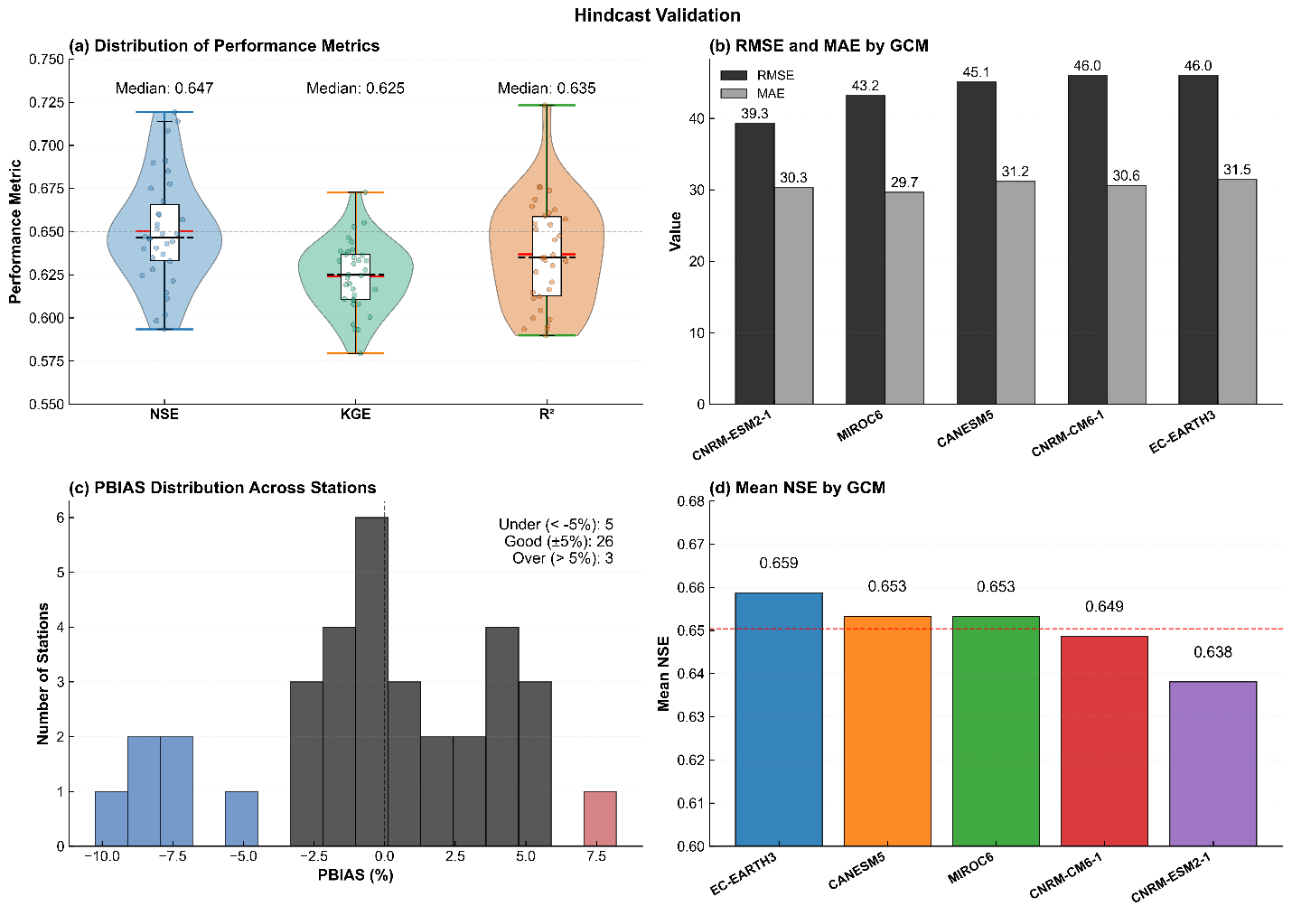
Fig S2: Hindcast evaluation of monthly runoff simulations across GCM forcings, showing (a) distributions of NSE, KGE, and R², (b) RMSE and MAE by GCM forcing, (c) station-wise PBIAS distribution, and (d) mean NSE for each GCM forcing relative to the station-average.

Folds | Calibration period | Validation period | Hindcast/test period | RMSE | MAE | R | R² | NSE | KGE | PBIAS (%)
Main split | 2001–2010 | 2011–2015 | 2016–2020 | 9.96 | 7.72 | 0.809 | 0.654 | 0.650 | 0.624 | −0.41
Temporal Fold 1 | 2001–2008 | 2009–2013 | 2014–2018 | 10.12 | 7.86 | 0.801 | 0.642 | 0.637 | 0.612 | −0.84
Temporal Fold 2 | 2003–2012 | 2013–2015 | 2016–2020 | 10.04 | 7.79 | 0.805 | 0.648 | 0.644 | 0.618 | −0.55
Temporal Fold 3 | 2001–2009 | 2010–2014 | 2015–2019 | 10.18 | 7.91 | 0.798 | 0.637 | 0.631 | 0.606 | −1.02
Mean ± SD | — | — | — | 10.08 ± 0.09 | 7.82 ± 0.08 | 0.803 ± 0.005 | 0.645 ± 0.007 | 0.641 ± 0.008 | 0.615 ± 0.008 | −0.71 ± 0.27
Table S1. Blocked temporal cross-validation of hindcast performance across alternative chronological partitions.

Table S2. Hyperparameter sensitivity analysis of hindcast performance under baseline and alternative architecture configurations.
Model variant | Encoder length | Hidden size | Attention heads | RMSE | MAE | R | R² | NSE | KGE | PBIAS (%) | Purpose
Baseline TFT | 24–36 | 64 | 4 | 9.96 | 7.72 | 0.809 | 0.654 | 0.650 | 0.624 | −0.41 | Main configuration
Variant A | 24 | 64 | 4 | 10.08 | 7.81 | 0.803 | 0.645 | 0.641 | 0.616 | −0.73 | Shorter encoder memory
Variant B | 24–36 | 32 | 4 | 10.17 | 7.88 | 0.799 | 0.638 | 0.634 | 0.609 | −0.96 | Reduced hidden size
Variant C | 24–36 | 64 | 2 | 10.05 | 7.79 | 0.804 | 0.646 | 0.642 | 0.617 | −0.62 | Fewer attention heads
Variant D | 24 | 32 | 2 | 10.26 | 7.96 | 0.793 | 0.629 | 0.623 | 0.598 | −1.18 | Compact architecture

Held-out station | RMSE | MAE | R | R² | NSE | KGE | PBIAS (%)
Astore | 9.05 | 7.02 | 0.819 | 0.671 | 0.661 | 0.638 | −0.32
Azad Pattan | 9.12 | 7.07 | 0.817 | 0.667 | 0.658 | 0.635 | −0.46
Balloki | 9.28 | 7.20 | 0.814 | 0.663 | 0.655 | 0.632 | 0.58
Besham Qila | 9.34 | 7.25 | 0.812 | 0.659 | 0.651 | 0.629 | −0.71
Bunji | 9.22 | 7.15 | 0.815 | 0.664 | 0.656 | 0.633 | −0.39
Chashma | 9.48 | 7.38 | 0.809 | 0.654 | 0.647 | 0.623 | −0.88
Chattar Klass | 9.56 | 7.44 | 0.806 | 0.650 | 0.643 | 0.619 | −1.02
Chiniot | 9.67 | 7.51 | 0.803 | 0.645 | 0.639 | 0.615 | −0.76
Danyore | 9.42 | 7.31 | 0.810 | 0.656 | 0.649 | 0.626 | −0.54
Domel | 9.71 | 7.55 | 0.802 | 0.643 | 0.637 | 0.613 | −1.16
Ganda Singh Wala | 9.84 | 7.66 | 0.798 | 0.637 | 0.632 | 0.608 | −1.29
Gilgit | 9.35 | 7.28 | 0.812 | 0.659 | 0.652 | 0.628 | −0.63
Guddu | 10.02 | 7.82 | 0.793 | 0.629 | 0.624 | 0.601 | −1.44
Hunza | 9.18 | 7.11 | 0.816 | 0.666 | 0.657 | 0.634 | −0.48
Islam | 10.08 | 7.86 | 0.791 | 0.626 | 0.621 | 0.598 | −1.52
Kabul Nowshehra | 9.76 | 7.60 | 0.800 | 0.640 | 0.635 | 0.611 | −1.06
Kalabagh | 9.88 | 7.68 | 0.797 | 0.635 | 0.630 | 0.607 | −1.22
Khanki | 9.94 | 7.74 | 0.795 | 0.632 | 0.627 | 0.604 | −0.97
Kotli | 9.63 | 7.48 | 0.804 | 0.646 | 0.641 | 0.617 | −0.82
Kotri | 10.16 | 7.92 | 0.789 | 0.623 | 0.618 | 0.595 | −1.68
Mangla Dam | 9.58 | 7.45 | 0.805 | 0.648 | 0.644 | 0.620 | −0.74
Marala | 9.72 | 7.57 | 0.801 | 0.642 | 0.636 | 0.612 | −1.10
Muzafarabad | 9.44 | 7.33 | 0.809 | 0.654 | 0.648 | 0.625 | −0.69
Panjnad | 10.05 | 7.84 | 0.792 | 0.627 | 0.622 | 0.599 | −1.41
Qadirabad | 9.86 | 7.70 | 0.797 | 0.635 | 0.631 | 0.607 | −1.25
Rasul | 9.79 | 7.62 | 0.799 | 0.638 | 0.634 | 0.610 | −0.94
Shahdara | 10.22 | 7.98 | 0.787 | 0.619 | 0.615 | 0.592 | −1.76
Shayok Yogo | 9.30 | 7.22 | 0.813 | 0.661 | 0.654 | 0.631 | −0.57
Shigar | 9.26 | 7.19 | 0.814 | 0.663 | 0.655 | 0.632 | −0.51
Sidhnai | 10.14 | 7.91 | 0.790 | 0.624 | 0.619 | 0.596 | −1.58
Skardu | 9.20 | 7.13 | 0.816 | 0.666 | 0.657 | 0.635 | −0.42
Sukkur | 10.18 | 7.95 | 0.788 | 0.621 | 0.617 | 0.594 | −1.66
Sulemanki | 10.10 | 7.88 | 0.791 | 0.626 | 0.621 | 0.598 | −1.37
Tarbela Dam | 9.50 | 7.39 | 0.807 | 0.651 | 0.646 | 0.622 | −0.86
Taunsa | 10.20 | 7.97 | 0.788 | 0.621 | 0.616 | 0.593 | −1.70
Table S3. Station-wise hindcast performance under LOSO validation across the 35-station network.

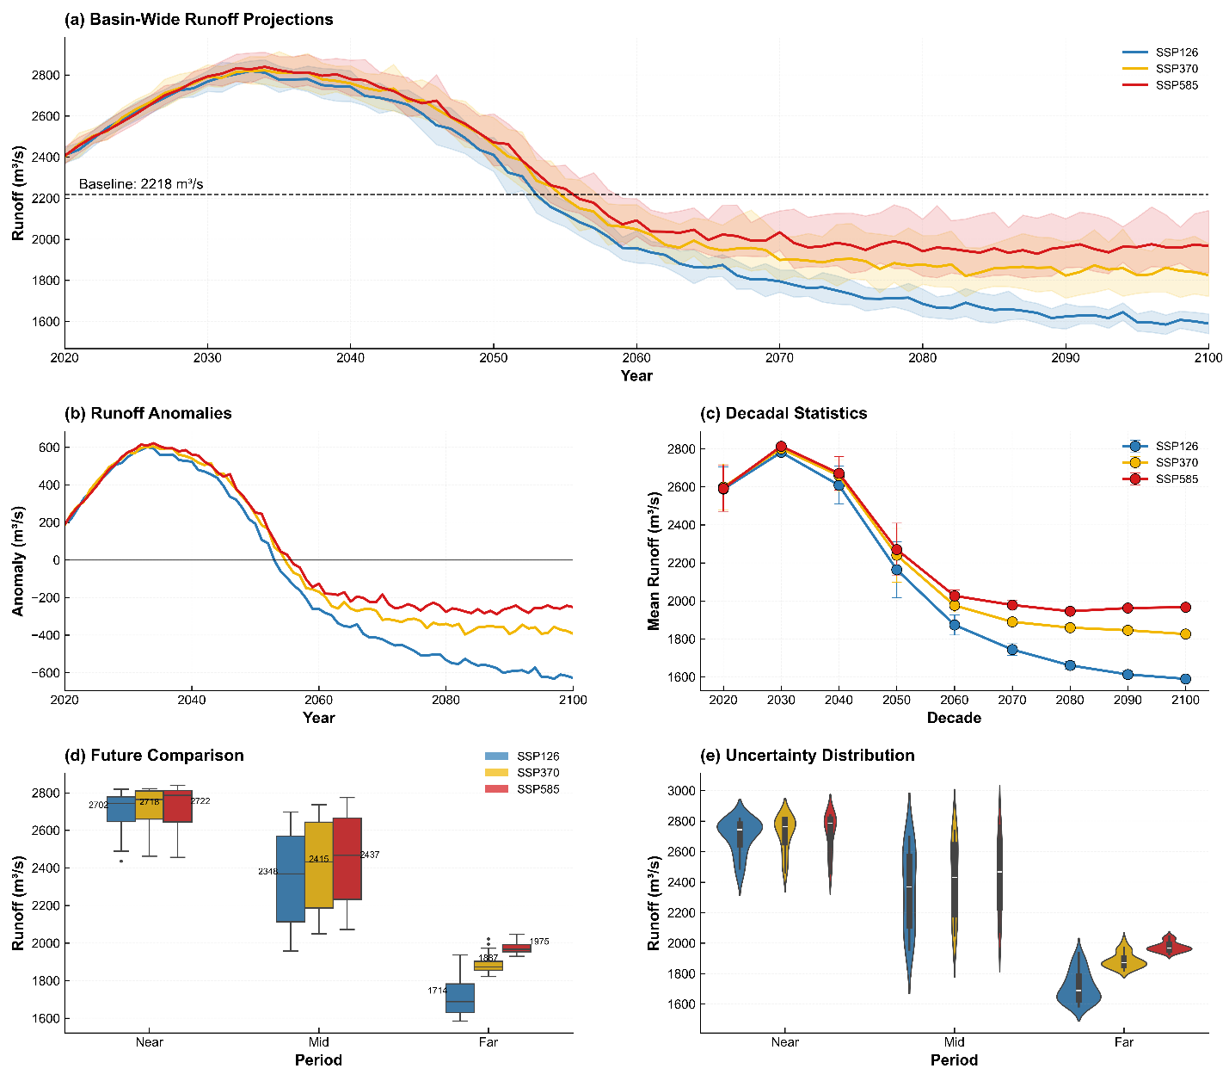
Fig. S3: TFT-derived runoff projections under SSP1-2.6, SSP3-7.0, and SSP5-8.5 for the near-, mid-, and far-future periods. (a) Basin-wide projected runoff trajectories, with shaded ranges indicating projection uncertainty. (b) Runoff anomaly series relative to the baseline condition, showing temporal departures from reference runoff. (c) Decadal mean runoff evolution under each SSP, showing long-term changes in projected runoff magnitude. (d) Distribution of projected runoff uncertainty across near-, mid-, and far-future periods. (e) Comparison of projected runoff among future periods and SSPs, showing how runoff changes differ across time horizons and forcing pathways.

Table S4: Station-wise projected annual runoff (m³/s) response by scenario and GWLs in IRB.
Station | GWL | Average Baseline Runoff | Average Future Runoff | Mean ΔQ | Median ΔQ | P05 ΔQ | P95 ΔQ | Agreement (%)
Hunza | 1.5°C | 420.00 | 527.66 | 107.66 | 70.48 | 148.33 | 77.85 | 78.00
Hunza | 2.0°C | 420.00 | 668.16 | 248.16 | 182.53 | 326.69 | 144.16 | 85.91
Hunza | 3.0°C | 420.00 | 869.42 | 449.42 | 343.74 | 582.57 | 238.83 | 97.00
Danyore | 1.5°C | 390.00 | 488.60 | 98.60 | 63.43 | 136.94 | 73.51 | 77.33
Danyore | 2.0°C | 390.00 | 617.24 | 227.24 | 166.09 | 300.12 | 134.03 | 84.91
Danyore | 3.0°C | 390.00 | 801.74 | 411.74 | 313.99 | 534.48 | 220.49 | 95.00
Gilgit | 1.5°C | 760.00 | 994.50 | 234.50 | 169.13 | 307.80 | 138.67 | 85.00
Gilgit | 2.0°C | 760.00 | 1301.09 | 541.09 | 412.74 | 698.78 | 286.04 | 99.64
Gilgit | 3.0°C | 760.00 | 1736.86 | 976.86 | 760.30 | 1255.87 | 495.57 | 100.00
Shayok Yogo | 1.5°C | 540.00 | 665.78 | 125.78 | 84.57 | 171.12 | 86.55 | 79.00
Shayok Yogo | 2.0°C | 540.00 | 830.01 | 290.01 | 215.42 | 379.85 | 164.43 | 88.18
Shayok Yogo | 3.0°C | 540.00 | 1064.77 | 524.77 | 403.25 | 678.76 | 275.51 | 99.57
Shigar | 1.5°C | 610.00 | 808.26 | 198.26 | 140.95 | 262.24 | 121.29 | 83.00
Shigar | 2.0°C | 610.00 | 1067.40 | 457.40 | 346.96 | 592.47 | 245.51 | 97.45
Shigar | 3.0°C | 610.00 | 1436.16 | 826.16 | 641.28 | 1063.50 | 422.22 | 100.00
Skardu | 1.5°C | 700.00 | 843.90 | 143.90 | 98.66 | 193.90 | 95.24 | 80.00
Skardu | 2.0°C | 700.00 | 1031.85 | 331.85 | 248.31 | 433.00 | 184.69 | 90.45
Skardu | 3.0°C | 700.00 | 1300.11 | 600.11 | 462.76 | 774.94 | 312.18 | 100.00
Astore | 1.5°C | 170.00 | 341.08 | 171.08 | 119.81 | 228.07 | 108.26 | 81.67
Astore | 2.0°C | 170.00 | 564.63 | 394.63 | 297.63 | 512.74 | 215.11 | 94.09
Astore | 3.0°C | 170.00 | 883.14 | 713.14 | 552.02 | 919.22 | 367.20 | 100.00
Partab Bridge (Bunji) | 1.5°C | 310.00 | 444.84 | 134.84 | 91.62 | 182.51 | 90.89 | 79.33
Partab Bridge (Bunji) | 2.0°C | 310.00 | 620.93 | 310.93 | 231.86 | 406.43 | 174.57 | 89.18
Partab Bridge (Bunji) | 3.0°C | 310.00 | 872.44 | 562.44 | 433.01 | 726.85 | 293.84 | 100.00
Muzaffarabad | 1.5°C | 950.00 | 1139.20 | 189.20 | 133.90 | 250.85 | 116.95 | 82.33
Muzaffarabad | 2.0°C | 950.00 | 1386.47 | 436.47 | 330.52 | 565.89 | 235.37 | 96.09
Muzaffarabad | 3.0°C | 950.00 | 1738.49 | 788.49 | 611.53 | 1015.41 | 403.88 | 100.00
Kotli | 1.5°C | 820.00 | 1063.56 | 243.56 | 176.18 | 319.19 | 143.01 | 85.33
Kotli | 2.0°C | 820.00 | 1382.01 | 562.01 | 429.18 | 725.36 | 296.18 | 100.00
Kotli | 3.0°C | 820.00 | 1834.53 | 1014.53 | 790.05 | 1303.96 | 513.91 | 100.00
Domel | 1.5°C | 680.00 | 842.02 | 162.02 | 112.76 | 216.68 | 103.92 | 81.00
Domel | 2.0°C | 680.00 | 1053.70 | 373.70 | 281.19 | 486.16 | 204.97 | 92.82
Domel | 3.0°C | 680.00 | 1355.46 | 675.46 | 522.27 | 871.13 | 348.86 | 100.00
Chattar Klass | 1.5°C | 730.00 | 882.96 | 152.96 | 105.71 | 205.29 | 99.58 | 80.33
Chattar Klass | 2.0°C | 730.00 | 1082.78 | 352.78 | 264.75 | 459.58 | 194.83 | 91.82
Chattar Klass | 3.0°C | 730.00 | 1367.79 | 637.79 | 492.51 | 823.03 | 330.52 | 100.00
Azad Pattan | 1.5°C | 980.00 | 1129.34 | 149.34 | 102.89 | 200.73 | 97.84 | 80.00
Azad Pattan | 2.0°C | 980.00 | 1324.41 | 344.41 | 258.17 | 448.95 | 190.78 | 90.82
Azad Pattan | 3.0°C | 980.00 | 1602.72 | 622.72 | 480.61 | 803.80 | 323.19 | 100.00
Besham Qila | 1.5°C | 1050.00 | 1166.72 | 116.72 | 77.52 | 159.72 | 82.20 | 78.33
Besham Qila | 2.0°C | 1050.00 | 1319.08 | 269.08 | 198.98 | 353.27 | 154.29 | 87.18
Besham Qila | 3.0°C | 1050.00 | 1537.09 | 487.09 | 373.50 | 630.66 | 257.16 | 98.43
Tarbela Dam | 1.5°C | 1520.00 | 1700.14 | 180.14 | 126.85 | 239.46 | 112.61 | 82.00
Tarbela Dam | 2.0°C | 1520.00 | 1935.55 | 415.55 | 314.08 | 539.31 | 225.23 | 95.09
Tarbela Dam | 3.0°C | 1520.00 | 2270.81 | 750.81 | 581.78 | 967.31 | 385.53 | 100.00
Balloki | 1.5°C | 1500.00 | 1530.67 | 30.67 | 10.32 | 51.92 | 41.60 | 67.00
Balloki | 2.0°C | 1500.00 | 1573.23 | 73.23 | 43.55 | 107.02 | 63.47 | 70.27
Balloki | 3.0°C | 1500.00 | 1631.79 | 131.79 | 89.44 | 183.41 | 93.97 | 74.14
Chashma | 1.5°C | 1350.00 | 1333.61 | -16.39 | -35.24 | 1.71 | 36.95 | 66.00
Chashma | 2.0°C | 1350.00 | 1288.97 | -61.03 | -91.52 | -33.96 | 57.56 | 69.27
Chashma | 3.0°C | 1350.00 | 1225.51 | -124.49 | -171.75 | -84.96 | 86.79 | 73.86
Chiniot | 1.5°C | 980.00 | 967.89 | -12.11 | -29.87 | 5.04 | 34.91 | 66.00
Chiniot | 2.0°C | 980.00 | 931.18 | -48.82 | -76.01 | -24.37 | 51.64 | 68.27
Chiniot | 3.0°C | 980.00 | 878.81 | -101.19 | -142.01 | -66.56 | 75.45 | 72.29
Ganda Singh Wala | 1.5°C | 820.00 | 786.50 | -33.51 | -56.76 | -11.60 | 45.16 | 67.33
Ganda Singh Wala | 2.0°C | 820.00 | 710.15 | -109.85 | -153.53 | -72.33 | 81.20 | 72.91
Ganda Singh Wala | 3.0°C | 820.00 | 602.31 | -217.69 | -290.71 | -158.56 | 132.15 | 80.43
Guddu | 1.5°C | 3650.00 | 3569.43 | -80.57 | -115.93 | -48.20 | 67.73 | 70.67
Guddu | 2.0°C | 3650.00 | 3405.89 | -244.11 | -324.07 | -177.83 | 146.24 | 82.45
Guddu | 3.0°C | 3650.00 | 3176.03 | -473.97 | -617.87 | -360.97 | 256.90 | 98.00
Islam | 1.5°C | 1180.00 | 1193.56 | 13.56 | -2.99 | 30.41 | 33.40 | 66.00
Islam | 2.0°C | 1180.00 | 1204.41 | 24.41 | 5.18 | 45.01 | 39.83 | 67.00
Islam | 3.0°C | 1180.00 | 1218.60 | 38.60 | 15.84 | 64.44 | 48.60 | 67.57
Nowshehra | 1.5°C | 720.00 | 742.11 | 22.11 | 3.66 | 41.17 | 37.51 | 66.67
Nowshehra | 2.0°C | 720.00 | 768.82 | 48.82 | 24.37 | 76.01 | 51.64 | 68.27
Nowshehra | 3.0°C | 720.00 | 805.19 | 85.19 | 52.64 | 123.93 | 71.29 | 70.86
Kalabagh | 1.5°C | 1400.00 | 1375.05 | -24.95 | -46.00 | -4.94 | 41.06 | 67.00
Kalabagh | 2.0°C | 1400.00 | 1314.56 | -85.44 | -122.53 | -53.14 | 69.39 | 71.27
Kalabagh | 3.0°C | 1400.00 | 1228.91 | -171.09 | -231.23 | -121.76 | 109.47 | 77.14
Khanki | 1.5°C | 950.00 | 959.28 | 9.28 | -6.32 | 25.03 | 31.35 | 66.00
Khanki | 2.0°C | 950.00 | 962.20 | 12.21 | -4.41 | 29.50 | 33.91 | 66.00
Khanki | 3.0°C | 950.00 | 965.30 | 15.30 | -2.56 | 34.70 | 37.26 | 66.00
Kotri | 1.5°C | 3920.00 | 3852.27 | -67.73 | -99.79 | -38.22 | 61.57 | 69.67
Kotri | 2.0°C | 3920.00 | 3712.51 | -207.49 | -277.56 | -149.06 | 128.50 | 79.82
Kotri | 3.0°C | 3920.00 | 3515.92 | -404.08 | -528.65 | -305.77 | 222.88 | 93.86
Mangla Dam | 1.5°C | 1080.00 | 1100.40 | 20.40 | 2.33 | 39.01 | 36.68 | 66.33
Mangla Dam | 2.0°C | 1080.00 | 1123.94 | 43.94 | 20.53 | 69.81 | 49.28 | 68.27
Mangla Dam | 3.0°C | 1080.00 | 1155.87 | 75.87 | 45.28 | 112.03 | 66.75 | 70.29
Marala | 1.5°C | 860.00 | 875.27 | 15.27 | -1.66 | 32.56 | 34.22 | 66.00
Marala | 2.0°C | 860.00 | 889.29 | 29.29 | 9.02 | 51.21 | 42.19 | 67.00
Marala | 3.0°C | 860.00 | 907.92 | 47.92 | 23.20 | 76.34 | 53.14 | 68.29
Panjnad | 1.5°C | 1320.00 | 1348.96 | 28.96 | 8.99 | 49.77 | 40.78 | 67.00
Panjnad | 2.0°C | 1320.00 | 1388.35 | 68.35 | 39.71 | 100.82 | 61.11 | 69.64
Panjnad | 3.0°C | 1320.00 | 1442.47 | 122.47 | 82.08 | 171.51 | 89.43 | 73.86
Qadir Abad | 1.5°C | 970.00 | 981.85 | 11.85 | -4.33 | 28.26 | 32.59 | 66.00
Qadir Abad | 2.0°C | 970.00 | 989.53 | 19.53 | 1.35 | 38.81 | 37.46 | 66.27
Qadir Abad | 3.0°C | 970.00 | 999.28 | 29.28 | 8.48 | 52.55 | 44.07 | 67.00
Rasul | 1.5°C | 760.00 | 770.99 | 10.99 | -4.99 | 27.18 | 32.17 | 66.00
Rasul | 2.0°C | 760.00 | 777.09 | 17.09 | -0.57 | 35.71 | 36.28 | 66.00
Rasul | 3.0°C | 760.00 | 784.62 | 24.62 | 4.80 | 46.60 | 41.80 | 67.00
Shahdara | 1.5°C | 930.00 | 953.82 | 23.82 | 4.99 | 43.32 | 38.33 | 67.00
Shahdara | 2.0°C | 930.00 | 983.70 | 53.70 | 28.20 | 82.22 | 54.02 | 68.64
Shahdara | 3.0°C | 930.00 | 1024.51 | 94.51 | 60.00 | 135.82 | 75.82 | 71.86
Sidhnai | 1.5°C | 710.00 | 727.84 | 17.84 | 0.33 | 35.79 | 35.46 | 66.00
Sidhnai | 2.0°C | 710.00 | 746.62 | 36.62 | 14.78 | 60.51 | 45.73 | 67.64
Sidhnai | 3.0°C | 710.00 | 771.90 | 61.90 | 34.24 | 94.18 | 59.94 | 69.29
Sukkur | 1.5°C | 3480.00 | 3420.82 | -59.18 | -89.03 | -31.57 | 57.46 | 69.33
Sukkur | 2.0°C | 3480.00 | 3296.92 | -183.08 | -246.55 | -129.88 | 116.67 | 78.18
Sukkur | 3.0°C | 3480.00 | 3122.52 | -357.48 | -469.16 | -268.97 | 200.19 | 90.57
Sulemanki | 1.5°C | 890.00 | 910.40 | 20.40 | 2.33 | 39.01 | 36.68 | 66.33
Sulemanki | 2.0°C | 890.00 | 933.94 | 43.94 | 20.53 | 69.81 | 49.28 | 68.27
Sulemanki | 3.0°C | 890.00 | 965.87 | 75.87 | 45.28 | 112.03 | 66.75 | 70.29
Taunsa | 1.5°C | 1460.00 | 1486.39 | 26.39 | 6.99 | 46.54 | 39.55 | 67.00
Taunsa | 2.0°C | 1460.00 | 1521.03 | 61.03 | 33.96 | 91.52 | 57.56 | 69.27
Taunsa | 3.0°C | 1460.00 | 1568.49 | 108.49 | 71.04 | 153.67 | 82.63 | 72.86

Table S5: Station-wise warming sensitivity of projected annual runoff response
Station | Sensitivity Slope (m³/s/ºC) | CI (low) | CI (high) | Correlation | Direction | Response
Hunza | 224.04 | 174.75 | 273.33 | 0.91 | Increasing | Robust
Danyore Bridge | 205.3 | 160.13 | 250.46 | 0.89 | Increasing | Robust
Gilgit | 486.46 | 379.44 | 593.48 | 0.96 | Increasing | Robust
Shayok Yogo | 261.53 | 203.99 | 319.07 | 0.9 | Increasing | Robust
Shigar | 411.48 | 320.95 | 502.01 | 0.95 | Increasing | Robust
Skardu | 299.02 | 233.23 | 364.8 | 0.92 | Increasing | Robust
Astore | 355.25 | 277.09 | 433.4 | 0.94 | Increasing | Robust
Partab Bridge (Bunji) | 280.27 | 218.61 | 341.93 | 0.9 | Increasing | Robust
Muzaffarabad | 392.74 | 306.33 | 479.14 | 0.95 | Increasing | Robust
Kotli | 505.2 | 394.06 | 616.34 | 0.97 | Increasing | Robust
Domel | 336.5 | 262.47 | 410.54 | 0.93 | Increasing | Robust
Chattar Klass | 317.76 | 247.85 | 387.67 | 0.92 | Increasing | Robust
Azad Pattan | 310.26 | 242.01 | 378.52 | 0.91 | Increasing | Robust
Besham Qila | 242.78 | 189.37 | 296.2 | 0.88 | Increasing | Robust
Tarbela Dam | 373.99 | 291.71 | 456.27 | 0.94 | Increasing | Robust
Balloki | 66.15 | 48.15 | 84.15 | 0.87 | Increasing | Robust
Chashma | -70.84 | -88.84 | -52.84 | -0.89 | Decreasing | Robust
Chiniot | -58.39 | -76.39 | -40.39 | -0.86 | Decreasing | Robust
Ganda Singh Wala | -120.65 | -147.19 | -94.11 | -0.93 | Decreasing | Robust
Guddu | -257.64 | -314.32 | -200.96 | -0.97 | Decreasing | Robust
Islam | 16.34 | -1.66 | 34.34 | 0.85 | Increasing | Uncertain
Nowshehra | 41.24 | 23.24 | 59.24 | 0.88 | Increasing | Robust
Kalabagh | -95.75 | -116.81 | -74.68 | -0.91 | Decreasing | Robust
Khanki | 3.88 | -14.12 | 21.88 | 0.86 | Increasing | Uncertain
Kotri | -220.28 | -268.74 | -171.82 | -0.96 | Decreasing | Robust
Mangla Dam | 36.26 | 18.26 | 54.26 | 0.87 | Increasing | Robust
Marala | 21.32 | 3.32 | 39.32 | 0.85 | Increasing | Robust
Panjnad | 61.17 | 43.17 | 79.17 | 0.89 | Increasing | Robust
Qadir Abad | 11.35 | -6.65 | 29.35 | 0.86 | Increasing | Uncertain
Rasul | 8.86 | -9.14 | 26.86 | 0.85 | Increasing | Uncertain
Shahdara | 46.22 | 28.22 | 64.22 | 0.88 | Increasing | Robust
Sidhnai | 28.79 | 10.79 | 46.79 | 0.86 | Increasing | Robust
Sukkur | -195.37 | -238.35 | -152.39 | -0.95 | Decreasing | Robust
Sulemanki | 36.26 | 18.26 | 54.26 | 0.87 | Increasing | Robust
Taunsa | 53.7 | 35.7 | 71.7 | 0.89 | Increasing | Robust

Table S6: Station-wise model agreement on the direction of annual runoff change by scenario and GWLs
Station | GWL | Scenario | Agreement (%) | Direction | Agreement strength
Hunza | 1.5°C | SSP1-2.6 | 77.00 | + | High
Hunza | 1.5°C | SSP3-7.0 | 78.00 | + | High
Hunza | 1.5°C | SSP5-8.5 | 79.00 | + | High
Hunza | 2.0°C | SSP1-2.6 | 85.00 | + | High
Hunza | 2.0°C | SSP3-7.0 | 86.00 | + | High
Hunza | 2.0°C | SSP5-8.5 | 87.00 | + | High
Hunza | 3.0°C | SSP1-2.6 | 95.00 | + | Very high
Hunza | 3.0°C | SSP3-7.0 | 97.00 | + | Very high
Hunza | 3.0°C | SSP5-8.5 | 100.00 | + | Very high
Danyore Bridge | 1.5°C | SSP1-2.6 | 77.00 | + | High
Danyore Bridge | 1.5°C | SSP3-7.0 | 77.00 | + | High
Danyore Bridge | 1.5°C | SSP5-8.5 | 78.00 | + | High
Danyore Bridge | 2.0°C | SSP1-2.6 | 84.00 | + | High
Danyore Bridge | 2.0°C | SSP3-7.0 | 85.00 | + | High
Danyore Bridge | 2.0°C | SSP5-8.5 | 86.00 | + | High
Danyore Bridge | 3.0°C | SSP1-2.6 | 93.00 | + | Very high
Danyore Bridge | 3.0°C | SSP3-7.0 | 95.00 | + | Very high
Danyore Bridge | 3.0°C | SSP5-8.5 | 98.00 | + | Very high
Gilgit | 1.5°C | SSP1-2.6 | 84.00 | + | High
Gilgit | 1.5°C | SSP3-7.0 | 85.00 | + | High
Gilgit | 1.5°C | SSP5-8.5 | 86.00 | + | High
Gilgit | 2.0°C | SSP1-2.6 | 99.00 | + | Very high
Gilgit | 2.0°C | SSP3-7.0 | 100.00 | + | Very high
Gilgit | 2.0°C | SSP5-8.5 | 100.00 | + | Very high
Gilgit | 3.0°C | SSP1-2.6 | 100.00 | + | Very high
Gilgit | 3.0°C | SSP3-7.0 | 100.00 | + | Very high
Gilgit | 3.0°C | SSP5-8.5 | 100.00 | + | Very high
Shayok Yogo | 1.5°C | SSP1-2.6 | 78.00 | + | High
Shayok Yogo | 1.5°C | SSP3-7.0 | 79.00 | + | High
Shayok Yogo | 1.5°C | SSP5-8.5 | 80.00 | + | High
Shayok Yogo | 2.0°C | SSP1-2.6 | 87.00 | + | High
Shayok Yogo | 2.0°C | SSP3-7.0 | 88.00 | + | High
Shayok Yogo | 2.0°C | SSP5-8.5 | 90.00 | + | Very high
Shayok Yogo | 3.0°C | SSP1-2.6 | 99.00 | + | Very high
Shayok Yogo | 3.0°C | SSP3-7.0 | 100.00 | + | Very high
Shayok Yogo | 3.0°C | SSP5-8.5 | 100.00 | + | Very high
Shigar | 1.5°C | SSP1-2.6 | 82.00 | + | High
Shigar | 1.5°C | SSP3-7.0 | 83.00 | + | High
Shigar | 1.5°C | SSP5-8.5 | 84.00 | + | High
Shigar | 2.0°C | SSP1-2.6 | 95.00 | + | Very high
Shigar | 2.0°C | SSP3-7.0 | 98.00 | + | Very high
Shigar | 2.0°C | SSP5-8.5 | 100.00 | + | Very high
Shigar | 3.0°C | SSP1-2.6 | 100.00 | + | Very high
Shigar | 3.0°C | SSP3-7.0 | 100.00 | + | Very high
Shigar | 3.0°C | SSP5-8.5 | 100.00 | + | Very high
Skardu | 1.5°C | SSP1-2.6 | 79.00 | + | High
Skardu | 1.5°C | SSP3-7.0 | 80.00 | + | High
Skardu | 1.5°C | SSP5-8.5 | 81.00 | + | High
Skardu | 2.0°C | SSP1-2.6 | 89.00 | + | High
Skardu | 2.0°C | SSP3-7.0 | 90.00 | + | Very high
Skardu | 2.0°C | SSP5-8.5 | 93.00 | + | Very high
Skardu | 3.0°C | SSP1-2.6 | 100.00 | + | Very high
Skardu | 3.0°C | SSP3-7.0 | 100.00 | + | Very high
Skardu | 3.0°C | SSP5-8.5 | 100.00 | + | Very high
Astore | 1.5°C | SSP1-2.6 | 81.00 | + | High
Astore | 1.5°C | SSP3-7.0 | 81.00 | + | High
Astore | 1.5°C | SSP5-8.5 | 83.00 | + | High
Astore | 2.0°C | SSP1-2.6 | 92.00 | + | Very high
Astore | 2.0°C | SSP3-7.0 | 94.00 | + | Very high
Astore | 2.0°C | SSP5-8.5 | 97.00 | + | Very high
Astore | 3.0°C | SSP1-2.6 | 100.00 | + | Very high
Astore | 3.0°C | SSP3-7.0 | 100.00 | + | Very high
Astore | 3.0°C | SSP5-8.5 | 100.00 | + | Very high
Partab Bridge (Bunji) | 1.5°C | SSP1-2.6 | 79.00 | + | High
Partab Bridge (Bunji) | 1.5°C | SSP3-7.0 | 79.00 | + | High
Partab Bridge (Bunji) | 1.5°C | SSP5-8.5 | 80.00 | + | High
Partab Bridge (Bunji) | 2.0°C | SSP1-2.6 | 88.00 | + | High
Partab Bridge (Bunji) | 2.0°C | SSP3-7.0 | 89.00 | + | High
Partab Bridge (Bunji) | 2.0°C | SSP5-8.5 | 91.00 | + | Very high
Partab Bridge (Bunji) | 3.0°C | SSP1-2.6 | 100.00 | + | Very high
Partab Bridge (Bunji) | 3.0°C | SSP3-7.0 | 100.00 | + | Very high
Partab Bridge (Bunji) | 3.0°C | SSP5-8.5 | 100.00 | + | Very high
Muzaffarabad | 1.5°C | SSP1-2.6 | 81.00 | + | High
Muzaffarabad | 1.5°C | SSP3-7.0 | 82.00 | + | High
Muzaffarabad | 1.5°C | SSP5-8.5 | 84.00 | + | High
Muzaffarabad | 2.0°C | SSP1-2.6 | 94.00 | + | Very high
Muzaffarabad | 2.0°C | SSP3-7.0 | 96.00 | + | Very high
Muzaffarabad | 2.0°C | SSP5-8.5 | 99.00 | + | Very high
Muzaffarabad | 3.0°C | SSP1-2.6 | 100.00 | + | Very high
Muzaffarabad | 3.0°C | SSP3-7.0 | 100.00 | + | Very high
Muzaffarabad | 3.0°C | SSP5-8.5 | 100.00 | + | Very high
Kotli | 1.5°C | SSP1-2.6 | 84.00 | + | High
Kotli | 1.5°C | SSP3-7.0 | 85.00 | + | High
Kotli | 1.5°C | SSP5-8.5 | 87.00 | + | High
Kotli | 2.0°C | SSP1-2.6 | 100.00 | + | Very high
Kotli | 2.0°C | SSP3-7.0 | 100.00 | + | Very high
Kotli | 2.0°C | SSP5-8.5 | 100.00 | + | Very high
Kotli | 3.0°C | SSP1-2.6 | 100.00 | + | Very high
Kotli | 3.0°C | SSP3-7.0 | 100.00 | + | Very high
Kotli | 3.0°C | SSP5-8.5 | 100.00 | + | Very high
Domel | 1.5°C | SSP1-2.6 | 80.00 | + | High
Domel | 1.5°C | SSP3-7.0 | 81.00 | + | High
Domel | 1.5°C | SSP5-8.5 | 82.00 | + | High
Domel | 2.0°C | SSP1-2.6 | 91.00 | + | Very high
Domel | 2.0°C | SSP3-7.0 | 93.00 | + | Very high
Domel | 2.0°C | SSP5-8.5 | 95.00 | + | Very high
Domel | 3.0°C | SSP1-2.6 | 100.00 | + | Very high
Domel | 3.0°C | SSP3-7.0 | 100.00 | + | Very high
Domel | 3.0°C | SSP5-8.5 | 100.00 | + | Very high
Chattar Klass | 1.5°C | SSP1-2.6 | 80.00 | + | High
Chattar Klass | 1.5°C | SSP3-7.0 | 80.00 | + | High
Chattar Klass | 1.5°C | SSP5-8.5 | 81.00 | + | High
Chattar Klass | 2.0°C | SSP1-2.6 | 90.00 | + | Very high
Chattar Klass | 2.0°C | SSP3-7.0 | 92.00 | + | Very high
Chattar Klass | 2.0°C | SSP5-8.5 | 94.00 | + | Very high
Chattar Klass | 3.0°C | SSP1-2.6 | 100.00 | + | Very high
Chattar Klass | 3.0°C | SSP3-7.0 | 100.00 | + | Very high
Chattar Klass | 3.0°C | SSP5-8.5 | 100.00 | + | Very high
Azad Pattan | 1.5°C | SSP1-2.6 | 79.00 | + | High
Azad Pattan | 1.5°C | SSP3-7.0 | 80.00 | + | High
Azad Pattan | 1.5°C | SSP5-8.5 | 81.00 | + | High
Azad Pattan | 2.0°C | SSP1-2.6 | 89.00 | + | High
Azad Pattan | 2.0°C | SSP3-7.0 | 91.00 | + | Very high
Azad Pattan | 2.0°C | SSP5-8.5 | 93.00 | + | Very high
Azad Pattan | 3.0°C | SSP1-2.6 | 100.00 | + | Very high
Azad Pattan | 3.0°C | SSP3-7.0 | 100.00 | + | Very high
Azad Pattan | 3.0°C | SSP5-8.5 | 100.00 | + | Very high
Besham Qila | 1.5°C | SSP1-2.6 | 78.00 | + | High
Besham Qila | 1.5°C | SSP3-7.0 | 78.00 | + | High
Besham Qila | 1.5°C | SSP5-8.5 | 79.00 | + | High
Besham Qila | 2.0°C | SSP1-2.6 | 86.00 | + | High
Besham Qila | 2.0°C | SSP3-7.0 | 87.00 | + | High
Besham Qila | 2.0°C | SSP5-8.5 | 89.00 | + | High
Besham Qila | 3.0°C | SSP1-2.6 | 97.00 | + | Very high
Besham Qila | 3.0°C | SSP3-7.0 | 99.00 | + | Very high
Besham Qila | 3.0°C | SSP5-8.5 | 100.00 | + | Very high
Tarbela Dam | 1.5°C | SSP1-2.6 | 81.00 | + | High
Tarbela Dam | 1.5°C | SSP3-7.0 | 82.00 | + | High
Tarbela Dam | 1.5°C | SSP5-8.5 | 83.00 | + | High
Tarbela Dam | 2.0°C | SSP1-2.6 | 93.00 | + | Very high
Tarbela Dam | 2.0°C | SSP3-7.0 | 95.00 | + | Very high
Tarbela Dam | 2.0°C | SSP5-8.5 | 98.00 | + | Very high
Tarbela Dam | 3.0°C | SSP1-2.6 | 100.00 | + | Very high
Tarbela Dam | 3.0°C | SSP3-7.0 | 100.00 | + | Very high
Tarbela Dam | 3.0°C | SSP5-8.5 | 100.00 | + | Very high
Balloki | 1.5°C | SSP1-2.6 | 67.00 | + | Moderate
Balloki | 1.5°C | SSP3-7.0 | 67.00 | + | Moderate
Balloki | 1.5°C | SSP5-8.5 | 67.00 | + | Moderate
Balloki | 2.0°C | SSP1-2.6 | 70.00 | + | Moderate
Balloki | 2.0°C | SSP3-7.0 | 70.00 | + | Moderate
Balloki | 2.0°C | SSP5-8.5 | 71.00 | + | Moderate
Balloki | 3.0°C | SSP1-2.6 | 73.00 | + | Moderate
Balloki | 3.0°C | SSP3-7.0 | 74.00 | + | Moderate
Balloki | 3.0°C | SSP5-8.5 | 76.00 | + | High
Chashma | 1.5°C | SSP1-2.6 | 66.00 | − | Moderate
Chashma | 1.5°C | SSP3-7.0 | 66.00 | − | Moderate
Chashma | 1.5°C | SSP5-8.5 | 66.00 | − | Moderate
Chashma | 2.0°C | SSP1-2.6 | 69.00 | − | Moderate
Chashma | 2.0°C | SSP3-7.0 | 69.00 | − | Moderate
Chashma | 2.0°C | SSP5-8.5 | 70.00 | − | Moderate
Chashma | 3.0°C | SSP1-2.6 | 73.00 | − | Moderate
Chashma | 3.0°C | SSP3-7.0 | 74.00 | − | Moderate
Chashma | 3.0°C | SSP5-8.5 | 75.00 | − | High
Chiniot | 1.5°C | SSP1-2.6 | 66.00 | − | Moderate
Chiniot | 1.5°C | SSP3-7.0 | 66.00 | − | Moderate
Chiniot | 1.5°C | SSP5-8.5 | 66.00 | − | Moderate
Chiniot | 2.0°C | SSP1-2.6 | 68.00 | − | Moderate
Chiniot | 2.0°C | SSP3-7.0 | 68.00 | − | Moderate
Chiniot | 2.0°C | SSP5-8.5 | 69.00 | − | Moderate
Chiniot | 3.0°C | SSP1-2.6 | 72.00 | − | Moderate
Chiniot | 3.0°C | SSP3-7.0 | 72.00 | − | Moderate
Chiniot | 3.0°C | SSP5-8.5 | 73.00 | − | Moderate
Ganda Singh Wala | 1.5°C | SSP1-2.6 | 67.00 | − | Moderate
Ganda Singh Wala | 1.5°C | SSP3-7.0 | 67.00 | − | Moderate
Ganda Singh Wala | 1.5°C | SSP5-8.5 | 68.00 | − | Moderate
Ganda Singh Wala | 2.0°C | SSP1-2.6 | 72.00 | − | Moderate
Ganda Singh Wala | 2.0°C | SSP3-7.0 | 73.00 | − | Moderate
Ganda Singh Wala | 2.0°C | SSP5-8.5 | 74.00 | − | Moderate
Ganda Singh Wala | 3.0°C | SSP1-2.6 | 79.00 | − | High
Ganda Singh Wala | 3.0°C | SSP3-7.0 | 81.00 | − | High
Ganda Singh Wala | 3.0°C | SSP5-8.5 | 82.00 | − | High
Guddu | 1.5°C | SSP1-2.6 | 70.00 | − | Moderate
Guddu | 1.5°C | SSP3-7.0 | 71.00 | − | Moderate
Guddu | 1.5°C | SSP5-8.5 | 71.00 | − | Moderate
Guddu | 2.0°C | SSP1-2.6 | 81.00 | − | High
Guddu | 2.0°C | SSP3-7.0 | 82.00 | − | High
Guddu | 2.0°C | SSP5-8.5 | 85.00 | − | High
Guddu | 3.0°C | SSP1-2.6 | 96.00 | − | Very high
Guddu | 3.0°C | SSP3-7.0 | 99.00 | − | Very high
Guddu | 3.0°C | SSP5-8.5 | 100.00 | − | Very high
Islam | 1.5°C | SSP1-2.6 | 66.00 | + | Moderate
Islam | 1.5°C | SSP3-7.0 | 66.00 | + | Moderate
Islam | 1.5°C | SSP5-8.5 | 66.00 | + | Moderate
Islam | 2.0°C | SSP1-2.6 | 67.00 | + | Moderate
Islam | 2.0°C | SSP3-7.0 | 67.00 | + | Moderate
Islam | 2.0°C | SSP5-8.5 | 67.00 | + | Moderate
Islam | 3.0°C | SSP1-2.6 | 67.00 | + | Moderate
Islam | 3.0°C | SSP3-7.0 | 68.00 | + | Moderate
Islam | 3.0°C | SSP5-8.5 | 68.00 | + | Moderate
Nowshehra | 1.5°C | SSP1-2.6 | 66.00 | + | Moderate
Nowshehra | 1.5°C | SSP3-7.0 | 67.00 | + | Moderate
Nowshehra | 1.5°C | SSP5-8.5 | 67.00 | + | Moderate
Nowshehra | 2.0°C | SSP1-2.6 | 68.00 | + | Moderate
Nowshehra | 2.0°C | SSP3-7.0 | 68.00 | + | Moderate
Nowshehra | 2.0°C | SSP5-8.5 | 69.00 | + | Moderate
Nowshehra | 3.0°C | SSP1-2.6 | 70.00 | + | Moderate
Nowshehra | 3.0°C | SSP3-7.0 | 71.00 | + | Moderate
Nowshehra | 3.0°C | SSP5-8.5 | 72.00 | + | Moderate
Kalabagh | 1.5°C | SSP1-2.6 | 67.00 | − | Moderate
Kalabagh | 1.5°C | SSP3-7.0 | 67.00 | − | Moderate
Kalabagh | 1.5°C | SSP5-8.5 | 67.00 | − | Moderate
Kalabagh | 2.0°C | SSP1-2.6 | 71.00 | − | Moderate
Kalabagh | 2.0°C | SSP3-7.0 | 71.00 | − | Moderate
Kalabagh | 2.0°C | SSP5-8.5 | 72.00 | − | Moderate
Kalabagh | 3.0°C | SSP1-2.6 | 76.00 | − | High
Kalabagh | 3.0°C | SSP3-7.0 | 77.00 | − | High
Kalabagh | 3.0°C | SSP5-8.5 | 79.00 | − | High
Khanki | 1.5°C | SSP1-2.6 | 66.00 | + | Moderate
Khanki | 1.5°C | SSP3-7.0 | 66.00 | + | Moderate
Khanki | 1.5°C | SSP5-8.5 | 66.00 | + | Moderate
Khanki | 2.0°C | SSP1-2.6 | 66.00 | + | Moderate
Khanki | 2.0°C | SSP3-7.0 | 66.00 | + | Moderate
Khanki | 2.0°C | SSP5-8.5 | 66.00 | + | Moderate
Khanki | 3.0°C | SSP1-2.6 | 66.00 | + | Moderate
Khanki | 3.0°C | SSP3-7.0 | 66.00 | + | Moderate
Khanki | 3.0°C | SSP5-8.5 | 66.00 | + | Moderate
Kotri | 1.5°C | SSP1-2.6 | 69.00 | − | Moderate
Kotri | 1.5°C | SSP3-7.0 | 70.00 | − | Moderate
Kotri | 1.5°C | SSP5-8.5 | 70.00 | − | Moderate
Kotri | 2.0°C | SSP1-2.6 | 78.00 | − | High
Kotri | 2.0°C | SSP3-7.0 | 80.00 | − | High
Kotri | 2.0°C | SSP5-8.5 | 82.00 | − | High
Kotri | 3.0°C | SSP1-2.6 | 91.00 | − | Very high
Kotri | 3.0°C | SSP3-7.0 | 94.00 | − | Very high
Kotri | 3.0°C | SSP5-8.5 | 98.00 | − | Very high
Mangla Dam | 1.5°C | SSP1-2.6 | 66.00 | + | Moderate
Mangla Dam | 1.5°C | SSP3-7.0 | 66.00 | + | Moderate
Mangla Dam | 1.5°C | SSP5-8.5 | 67.00 | + | Moderate
Mangla Dam | 2.0°C | SSP1-2.6 | 68.00 | + | Moderate
Mangla Dam | 2.0°C | SSP3-7.0 | 68.00 | + | Moderate
Mangla Dam | 2.0°C | SSP5-8.5 | 69.00 | + | Moderate
Mangla Dam | 3.0°C | SSP1-2.6 | 70.00 | + | Moderate
Mangla Dam | 3.0°C | SSP3-7.0 | 70.00 | + | Moderate
Mangla Dam | 3.0°C | SSP5-8.5 | 71.00 | + | Moderate
Marala | 1.5°C | SSP1-2.6 | 66.00 | + | Moderate
Marala | 1.5°C | SSP3-7.0 | 66.00 | + | Moderate
Marala | 1.5°C | SSP5-8.5 | 66.00 | + | Moderate
Marala | 2.0°C | SSP1-2.6 | 67.00 | + | Moderate
Marala | 2.0°C | SSP3-7.0 | 67.00 | + | Moderate
Marala | 2.0°C | SSP5-8.5 | 67.00 | + | Moderate
Marala | 3.0°C | SSP1-2.6 | 68.00 | + | Moderate
Marala | 3.0°C | SSP3-7.0 | 68.00 | + | Moderate
Marala | 3.0°C | SSP5-8.5 | 69.00 | + | Moderate
Panjnad | 1.5°C | SSP1-2.6 | 67.00 | + | Moderate
Panjnad | 1.5°C | SSP3-7.0 | 67.00 | + | Moderate
Panjnad | 1.5°C | SSP5-8.5 | 67.00 | + | Moderate
Panjnad | 2.0°C | SSP1-2.6 | 69.00 | + | Moderate
Panjnad | 2.0°C | SSP3-7.0 | 70.00 | + | Moderate
Panjnad | 2.0°C | SSP5-8.5 | 70.00 | + | Moderate
Panjnad | 3.0°C | SSP1-2.6 | 73.00 | + | Moderate
Panjnad | 3.0°C | SSP3-7.0 | 74.00 | + | Moderate
Panjnad | 3.0°C | SSP5-8.5 | 75.00 | + | High
Qadir Abad | 1.5°C | SSP1-2.6 | 66.00 | + | Moderate
Qadir Abad | 1.5°C | SSP3-7.0 | 66.00 | + | Moderate
Qadir Abad | 1.5°C | SSP5-8.5 | 66.00 | + | Moderate
Qadir Abad | 2.0°C | SSP1-2.6 | 66.00 | + | Moderate
Qadir Abad | 2.0°C | SSP3-7.0 | 66.00 | + | Moderate
Qadir Abad | 2.0°C | SSP5-8.5 | 67.00 | + | Moderate
Qadir Abad | 3.0°C | SSP1-2.6 | 67.00 | + | Moderate
Qadir Abad | 3.0°C | SSP3-7.0 | 67.00 | + | Moderate
Qadir Abad | 3.0°C | SSP5-8.5 | 67.00 | + | Moderate
Rasul | 1.5°C | SSP1-2.6 | 66.00 | + | Moderate
Rasul | 1.5°C | SSP3-7.0 | 66.00 | + | Moderate
Rasul | 1.5°C | SSP5-8.5 | 66.00 | + | Moderate
Rasul | 2.0°C | SSP1-2.6 | 66.00 | + | Moderate
Rasul | 2.0°C | SSP3-7.0 | 66.00 | + | Moderate
Rasul | 2.0°C | SSP5-8.5 | 66.00 | + | Moderate
Rasul | 3.0°C | SSP1-2.6 | 67.00 | + | Moderate
Rasul | 3.0°C | SSP3-7.0 | 67.00 | + | Moderate
Rasul | 3.0°C | SSP5-8.5 | 67.00 | + | Moderate
Shahdara | 1.5°C | SSP1-2.6 | 67.00 | + | Moderate
Shahdara | 1.5°C | SSP3-7.0 | 67.00 | + | Moderate
Shahdara | 1.5°C | SSP5-8.5 | 67.00 | + | Moderate
Shahdara | 2.0°C | SSP1-2.6 | 68.00 | + | Moderate
Shahdara | 2.0°C | SSP3-7.0 | 69.00 | + | Moderate
Shahdara | 2.0°C | SSP5-8.5 | 69.00 | + | Moderate
Shahdara | 3.0°C | SSP1-2.6 | 71.00 | + | Moderate
Shahdara | 3.0°C | SSP3-7.0 | 72.00 | + | Moderate
Shahdara | 3.0°C | SSP5-8.5 | 73.00 | + | Moderate
Sidhnai | 1.5°C | SSP1-2.6 | 66.00 | + | Moderate
Sidhnai | 1.5°C | SSP3-7.0 | 66.00 | + | Moderate
Sidhnai | 1.5°C | SSP5-8.5 | 66.00 | + | Moderate
Sidhnai | 2.0°C | SSP1-2.6 | 67.00 | + | Moderate
Sidhnai | 2.0°C | SSP3-7.0 | 68.00 | + | Moderate
Sidhnai | 2.0°C | SSP5-8.5 | 68.00 | + | Moderate
Sidhnai | 3.0°C | SSP1-2.6 | 69.00 | + | Moderate
Sidhnai | 3.0°C | SSP3-7.0 | 69.00 | + | Moderate
Sidhnai | 3.0°C | SSP5-8.5 | 70.00 | + | Moderate
Sukkur | 1.5°C | SSP1-2.6 | 69.00 | − | Moderate
Sukkur | 1.5°C | SSP3-7.0 | 69.00 | − | Moderate
Sukkur | 1.5°C | SSP5-8.5 | 70.00 | − | Moderate
Sukkur | 2.0°C | SSP1-2.6 | 77.00 | − | High
Sukkur | 2.0°C | SSP3-7.0 | 78.00 | − | High
Sukkur | 2.0°C | SSP5-8.5 | 80.00 | − | High
Sukkur | 3.0°C | SSP1-2.6 | 88.00 | − | High
Sukkur | 3.0°C | SSP3-7.0 | 91.00 | − | Very high
Sukkur | 3.0°C | SSP5-8.5 | 94.00 | − | Very high
Sulemanki | 1.5°C | SSP1-2.6 | 66.00 | + | Moderate
Sulemanki | 1.5°C | SSP3-7.0 | 66.00 | + | Moderate
Sulemanki | 1.5°C | SSP5-8.5 | 67.00 | + | Moderate
Sulemanki | 2.0°C | SSP1-2.6 | 68.00 | + | Moderate
Sulemanki | 2.0°C | SSP3-7.0 | 68.00 | + | Moderate
Sulemanki | 2.0°C | SSP5-8.5 | 69.00 | + | Moderate
Sulemanki | 3.0°C | SSP1-2.6 | 70.00 | + | Moderate
Sulemanki | 3.0°C | SSP3-7.0 | 70.00 | + | Moderate
Sulemanki | 3.0°C | SSP5-8.5 | 71.00 | + | Moderate
Taunsa | 1.5°C | SSP1-2.6 | 67.00 | + | Moderate
Taunsa | 1.5°C | SSP3-7.0 | 67.00 | + | Moderate
Taunsa | 1.5°C | SSP5-8.5 | 67.00 | + | Moderate
Taunsa | 2.0°C | SSP1-2.6 | 69.00 | + | Moderate
Taunsa | 2.0°C | SSP3-7.0 | 69.00 | + | Moderate
Taunsa | 2.0°C | SSP5-8.5 | 70.00 | + | Moderate
Taunsa | 3.0°C | SSP1-2.6 | 72.00 | + | Moderate
Taunsa | 3.0°C | SSP3-7.0 | 73.00 | + | Moderate
Taunsa | 3.0°C | SSP5-8.5 | 74.00 | + | Moderate

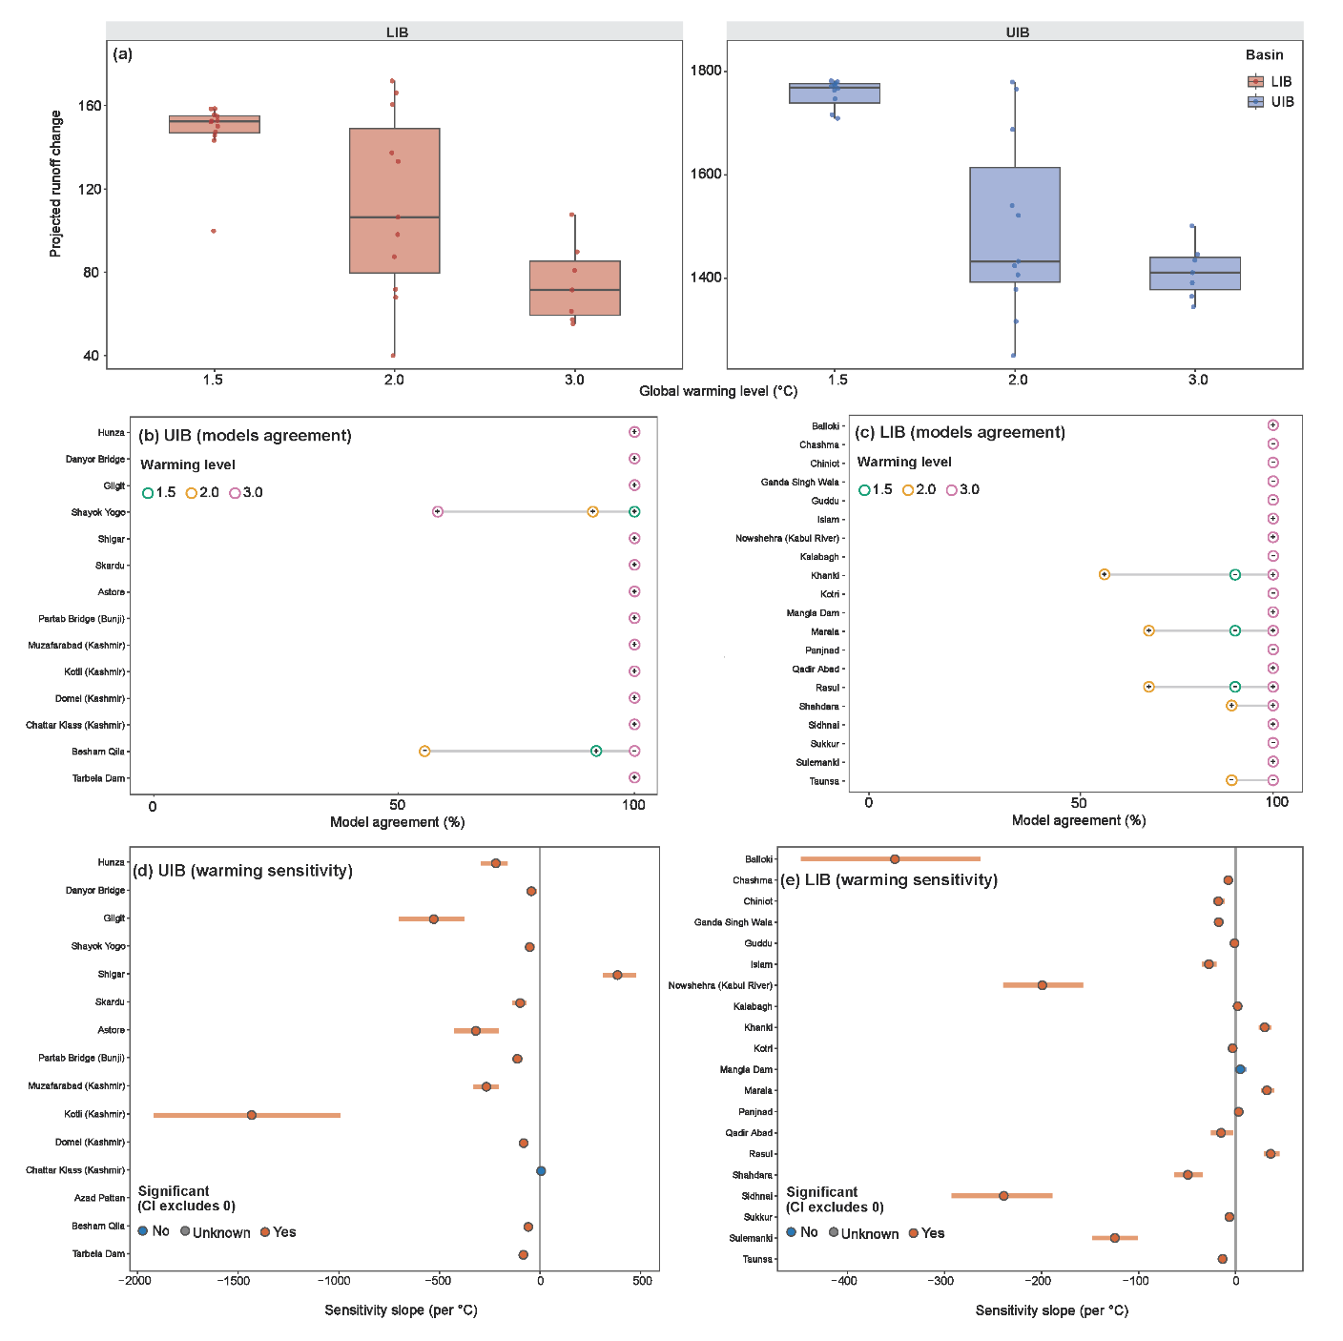
Fig. S4. Uncertainty, model agreement, and warming sensitivity of projected runoff change in the UIB and LIB. (a) Basin-mean annual runoff change (m³/s) across 1.5°C, 2.0°C, and 3.0°C global warming levels (GWLs) for the Upper Indus Basin (UIB) and Lower Indus Basin (LIB). Boxplots indicate interquartile range and median, whiskers represent full ensemble spread, and points denote individual GCM–SSP realizations. (b–c) Station-scale model agreement on the sign of runoff change for the UIB (b) and LIB (c). The x-axis shows the percentage of ensemble members agreeing on the dominant sign of change. Colored markers represent different GWLs, and grey lines track changes in agreement from 1.5°C to 3.0°C at each station. (d–e) Station-specific warming sensitivities (m³/s/°C) for the UIB (d) and LIB (e), estimated as linear slopes across GWLs. Points indicate slope estimates, horizontal bars show 95% confidence intervals, and colors distinguish statistically significant responses (confidence interval not crossing zero). Together, the panels quantify ensemble uncertainty, robustness of runoff signal direction, and sensitivity magnitude across the Indus basin system.

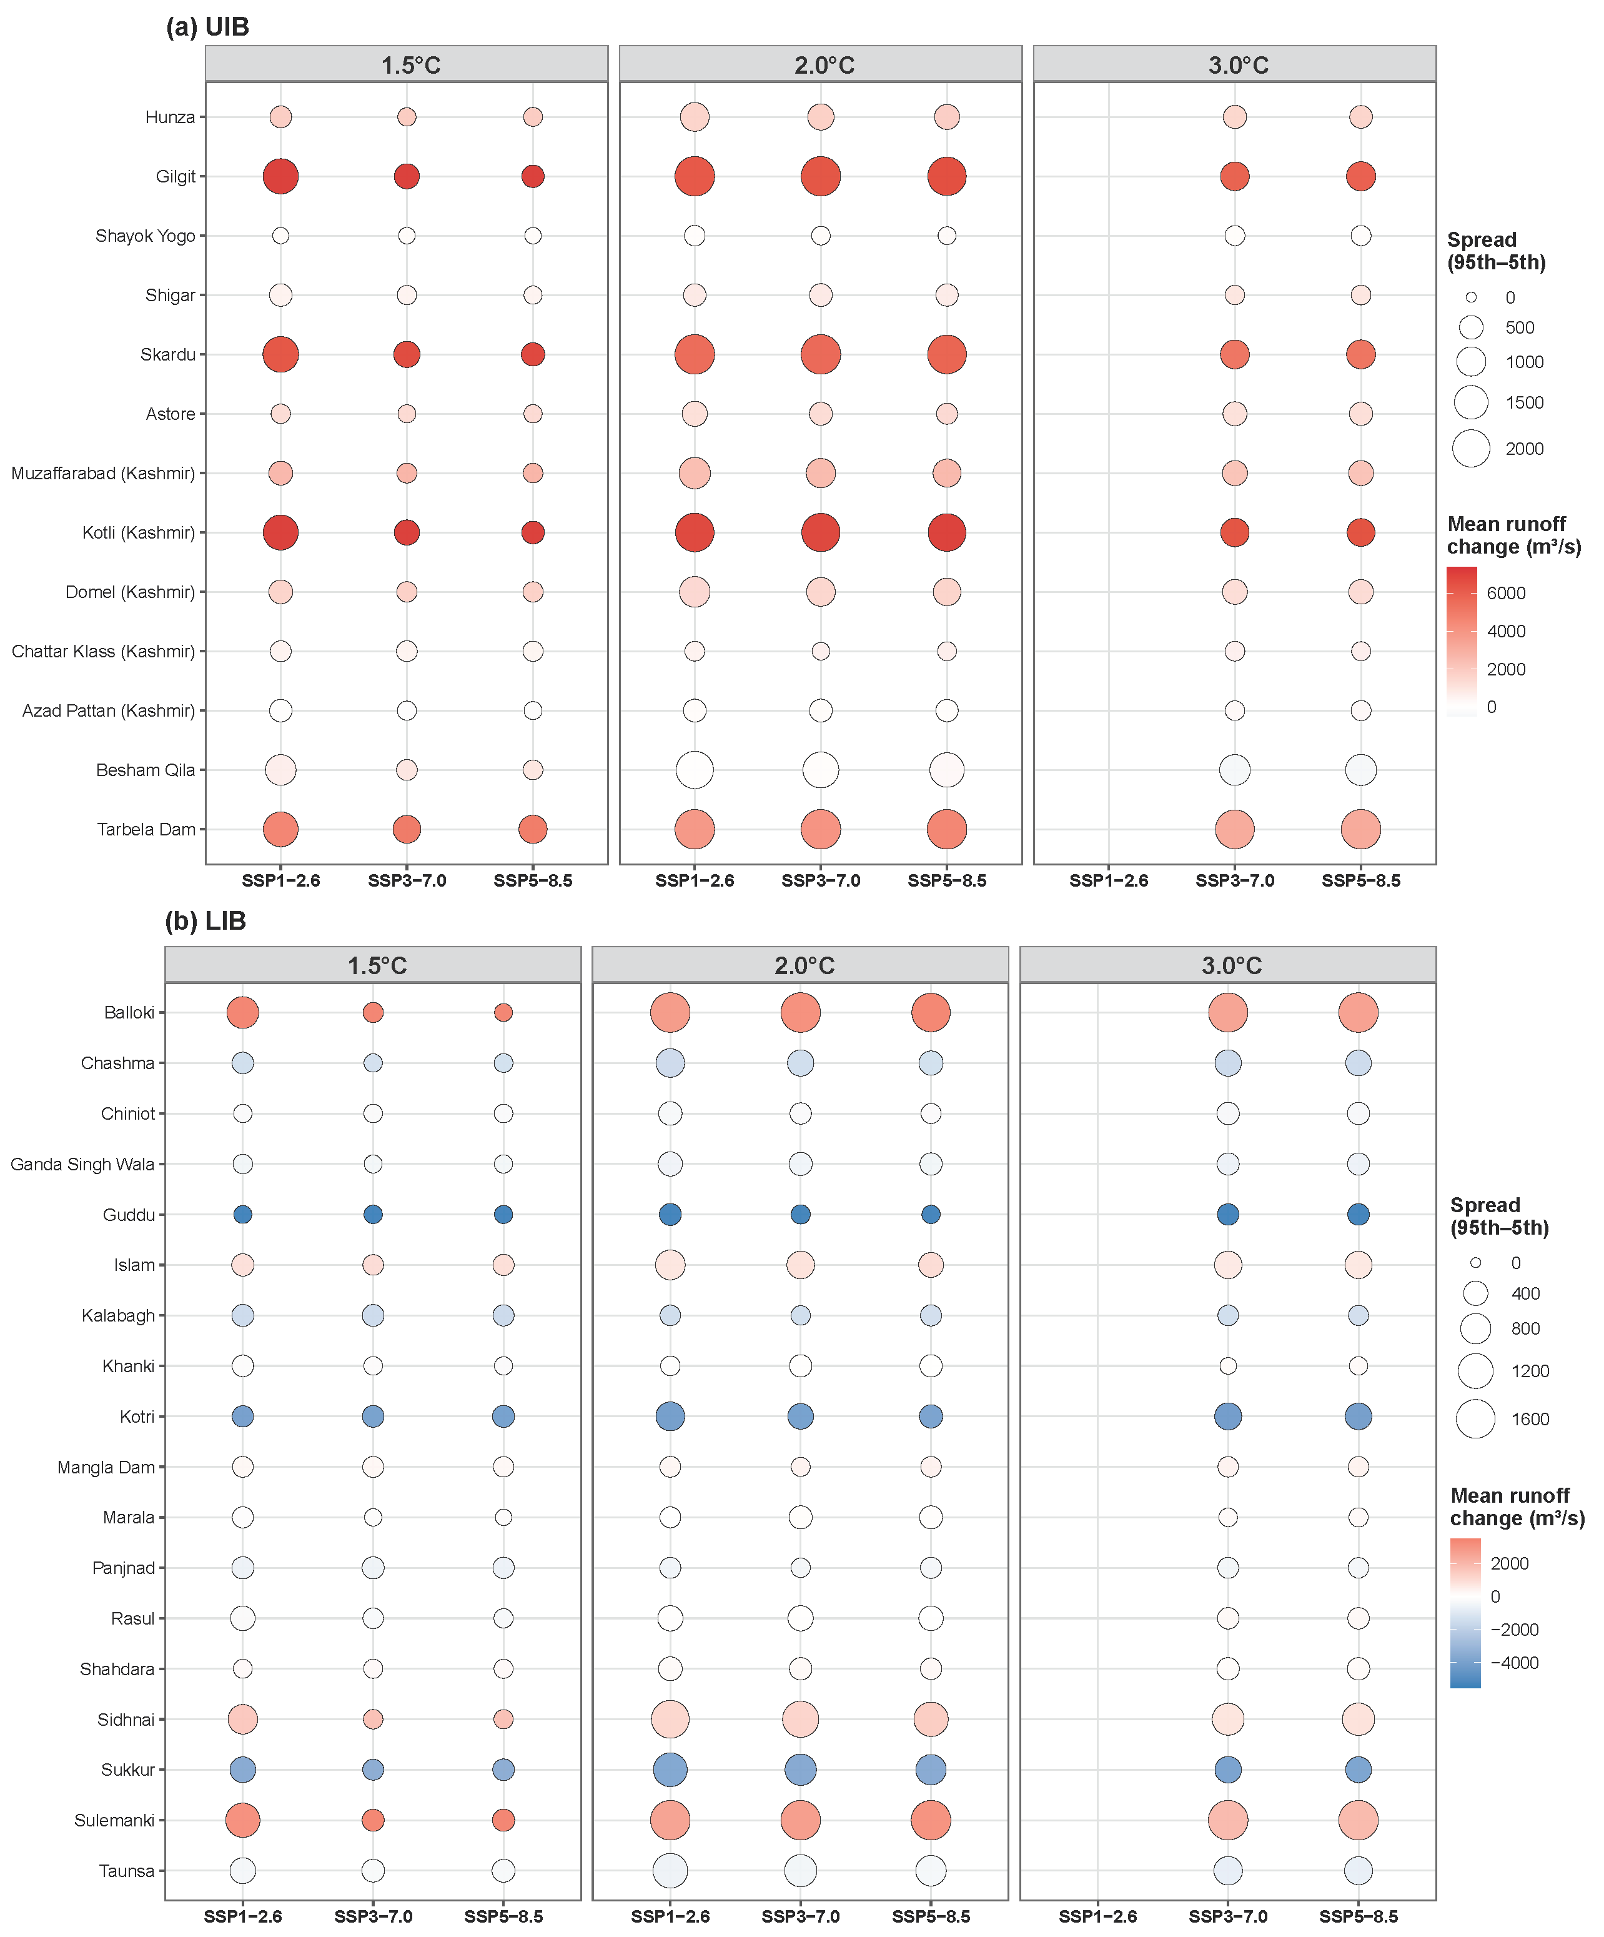
Fig. S5. Station-scale projected runoff change and uncertainty across SSPs and warming levels in the UIB and LIB. (a–b) Station-wise results for the UIB (a) and LIB (b). The y-axis lists hydrological stations, and the x-axis shows SSP1-2.6, SSP3-7.0, and SSP5-8.5. Bubble color indicates mean annual runoff change (m³/s), with warm (cool) colors representing increases (decreases). Bubble size represents ensemble uncertainty, defined as the 95th–5th percentile range of projected runoff change. The figure jointly illustrates the central tendency and uncertainty of runoff responses across station–scenario combinations, highlighting spatial heterogeneity and scenario dependence within the basin.

