Table 4 Comparison of the learning process of the two proposed and supervised models during the training process
proposed model |  |  | supervised model
model output | mape | epoch | model output | mape | epoch
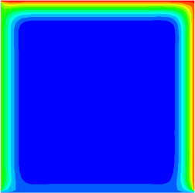 | 82.64 | 50 | 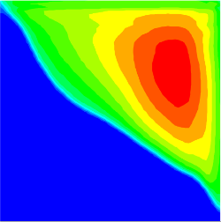 | 65.98 | 25
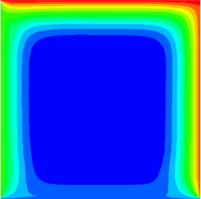 | 74.54 | 100 | 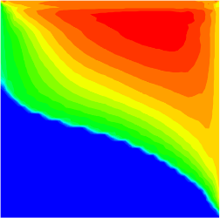 | 55.12 | 50
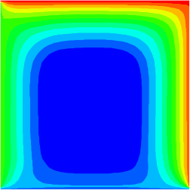 | 60.2 | 200 | 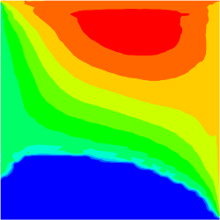 | 37.51 | 75
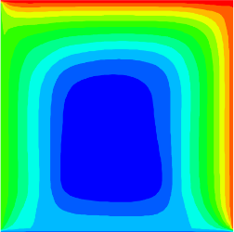 | 58.67 | 300 | 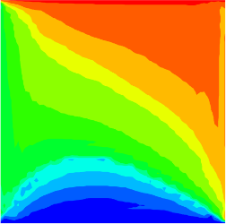 | 22.08 | 100
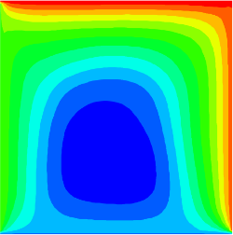 | 49.28 | 500 |  | 19.30 | 125
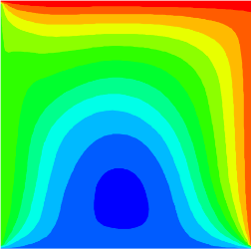 | 37.70 | 900 |  | 10.13 | 175
 | 29.52 | 1100 |  | 7.30 | 250
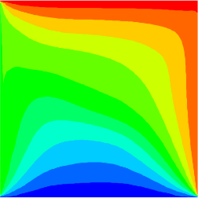 | 15.74 | 1300 | 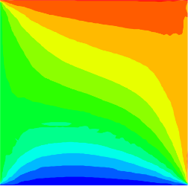 | 4.17 | 2000
 | 6.61 | 1600 |  | 2.41 | 3000
 | 0.68 | 2400 |  | 1.53 | 4000

