Supplementary Information
Clamp-like side-arm-functionalized calixarenes reinforce molecular cage confinement for damp-heat operationally durable perovskite photovoltaics
Bowen Li^{1, #}, Mingyu Wang^{1, #}, Haichao Yang^{1,} *, Kunyuan Zheng¹, Haiyun Li⁴, Cheng Gong⁵, Huān Bì⁶, Danqing Ma⁷, Siyu Wang¹, Xinyu Tan^{1, 8,} *, Baibai Liu^{2, *}, Weijie Ding², Ruize Hu², Jiangzhao Chen^{3,} *, Qian Zhou^{1,} *
¹ Hubei Provincial Engineering Research Center for Solar Energy High-value Utilization and Green Conversion, College of Materials and Chemical Engineering, China Three Gorges University, Yichang, 443002, China.
² School of Materials Science and Engineering, Zhejiang Key Laboratory for Island Green Energy and New Materials, Taizhou University, Jiaojiang, 318000, China.
³ Faculty of Materials Science and Engineering, Kunming University of Science and Technology, Kunming, 650093, China.
⁴ Laboratory of Photonics and Interfaces, École Polytechnique Fédérale de Lausanne, Lausanne 1015, Switzerland.
⁵ School of Energy and Mechanical Engineering, Jiangxi University of Science and Technology, Nanchang, 330013, China.
⁶ i-Powered Energy System Research Center (i-PERC), Faculty of Informatics and Engineering, The University of Electro-Communications, Tokyo, 1828585, Japan.
⁷ Key Laboratory of Optoelectronic Technology & Systems, College of Optoelectronic Engineering, Chongqing University, Chongqing, 400044, China.
⁸ School of New Energy, Jingchu University of Technology, Jingmen, 448000, China.
#These authors contributed equally to this work.
*Corresponding Authors
yanghc@ctgu.edu.cn (Haichao Yang); tanxin@ctgu.edu.cn (Xinyu Tan); bbl@tzc.edu.cn (Baibai Liu); jzchen@kust.edu.cn (Jiangzhao Chen); zhouqian@ctgu.edu.cn (Qian Zhou)
The PDF file includes:
Supplementary Notes 1-3
Supplementary Figs. 1-25
Supplementary Tables 1-4
Supplementary References 1-15

Supplementary Note 1 | Computational details for host–guest coordination and binding-energy calculations
The DFT calculations were used to compare relative host–guest coordination preferences within one internally consistent molecular-model framework rather than to report absolute solvation thermodynamics. Isolated BC4A EE4, BC4A, POAE and PTBP hosts, together with the corresponding Li⁺- or Ag-related complexes, were fully relaxed before electronic-structure, electrostatic-potential and binding-energy comparisons. The same spin-polarized PBE-GGA treatment, 449 eV cutoff energy, 5 × 10⁻⁵ eV electronic convergence criterion and 0.005 eV Å⁻¹ force-convergence criterion were used for all models, so the trends in Figs. 1b–e and Supplementary Fig. 1 can be compared within a single computational protocol.
The host–guest binding energy was calculated from the total energy of the optimized host–guest complex, the total energy of the relaxed isolated host and the energy of the isolated guest species:
$E_{bind}=E_{complex}-\left(E_{host}+E_{guest}\right)$ (S1)
Here, E_{complex}, E_{host} and E_{guest} denote the optimized complex, isolated host and isolated guest energies, respectively. A more negative value denotes a more favorable association under the same model and convergence settings. For the BC4A control in Fig. 1b, Li⁺ was placed at the central cavity-associated site corresponding to the Li-O@4 position in BC4A EE4; this comparison isolates the effect of the lower-rim ester side arms rather than mixing the side-arm effect with a different initial Li⁺ location.
Electrostatic-potential maps were used to compare the local electrostatic environments of the host frameworks. Identical isosurface and color-scale settings were applied within each comparison group, allowing direct comparison of the potential distributions. Combined with the optimized coordination geometries and binding-energy trends, the results indicate that the lower-rim, cavity-associated region of BC4A EE4 provides a favorable coordination environment for Li⁺. These calculations were used to compare relative coordination preferences within a consistent electronic-structure framework.

Supplementary Note 2 | Calculation of conductivity and SCLC mobility values in Fig. 3h
The conductivity values in Fig. 3h were calculated from the ohmic region of the I–V curves in Supplementary Fig. 10. The linear slope gives conductance and resistance as follows:
$G=\frac{dI}{dV}, R=\frac{1}{G}$ (S2)
For a film with thickness L and electrode area A, the conductivity was calculated from the measured resistance or conductance:
$σ=\frac{L}{RA}=\frac{GL}{A}$ (S3)
Equivalently, when the measurement is expressed as current density J and electric field E, the same conductivity can be written as:
$σ=\frac{J}{E}=\frac{JL}{V}$ (S4)
The same film-thickness and electrode-area definitions were used for Spiro@Li, Spiro@Li-POAE and Spiro@Li-BC4A EE4, so the relative trend is not affected by geometric normalization.
The hole mobility values in Fig. 3h were extracted from hole-only SCLC devices using the trap-free Mott–Gurney relation:^{1,2}
$J=\frac{9}{8}ε_{0}ε_{r}μ\frac{V_{eff}^{2}}{L^{3}}$ (S5)
Here, ε₀ is the vacuum permittivity, εᵣ is the relative dielectric constant used for the transport layer, μ is the hole mobility, L is the active-layer thickness and V_{eff} is the effective voltage. When built-in-voltage or series-voltage corrections were required, the effective voltage was defined as:
$V_{eff}=V_{appl}-V_{bi}-V_{s}$ (S6)
Otherwise, the applied voltage was used consistently for all samples in the high-voltage SCLC region. Rearranging the Mott–Gurney relation gives:
$μ=\frac{8JL^{3}}{9ε_{0}ε_{r}V_{eff}^{2}}$ (S7)
When a trap-filled-limit transition is resolved, the trap density can be estimated from the trap-filled-limit voltage:
$V_{TFL}=\frac{eN_{t}L^{2}}{2ε_{0}ε_{r}}$ (S8)
Here, e is the elementary charge and N_{t} is the trap density. This parameter was not used as the primary metric in Fig. 3h; the figure reports conductivity and hole mobility because these quantities directly describe the transport ability of the doped Spiro-OMeTAD HTL. The extracted hole mobilities are 1.62 × 10⁻⁴ cm² V⁻¹ s⁻¹ for Spiro@Li, 1.23 × 10⁻³ cm² V⁻¹ s⁻¹ for Spiro@Li-POAE and 2.23 × 10⁻³ cm² V⁻¹ s⁻¹ for Spiro@Li-BC4A EE4.

Supplementary Note 3 | TRPL fitting and boundary of the p–i–n device extension
Representative TRPL decay curves, including those used for the fitting parameters in Supplementary Table 2, were fitted with a bi-exponential function, and the amplitude-weighted average lifetime was calculated as follows:
$I\left(t\right)=A_{1}exp\left(-t/τ_{1}\right)+A_{2}exp\left(-t/τ_{2}\right)$ (S9)
$τ_{avg}=\frac{A_{1}τ_{1}^{2}+A_{2}τ_{2}^{2}}{A_{1}τ_{1}+A_{2}τ_{2}}$ (S10)
For TRPL mapping, each pixel-resolved decay trace was fitted with a three-exponential function. The amplitude-weighted average lifetime from this fit was then used to construct the TRPL lifetime maps in Fig. 3f and Supplementary Figs. 8 and 19:
$I\left(t\right)=A_{1}exp\left(-t/τ_{1}\right)+A_{2}exp\left(-t/τ_{2}\right)+A_{3}exp\left(-t/τ_{3}\right)$ (S11)
$τ_{avg,map}=\frac{A_{1}τ_{1}^{2}+A_{2}τ_{2}^{2}+A_{3}τ_{3}^{2}}{A_{1}τ_{1}+A_{2}τ_{2}+A_{3}τ_{3}}$ (S12)
Here, A₁–A₃ and τ₁–τ₃ are the fitted amplitudes and decay components, respectively. The three-exponential model was used only for TRPL mapping because each pixel contains spatially heterogeneous decay contributions; the representative TRPL decay curves and the values summarized in Supplementary Table 2 remain based on the bi-exponential fitting protocol.
The p–i–n implementation is used to test architectural compatibility of the BC4A EE4 scaffold in an inverted interfacial environment rather than to reproduce the n–i–p Spiro/LiTFSI/tBP co-doping mechanism.³ The device in Fig. 5b uses BC4A EE4 as an upper-interface treatment and does not contain the LiTFSI/tBP-doped Spiro-OMeTAD HTL used for the n–i–p mechanistic study.⁴⁻⁷ The steady-state PL spectra and three-exponential TRPL mapping results in Supplementary Figs. 18, 19 are therefore interpreted as photophysical evidence that BC4A EE4 upper-interface treatment improves carrier extraction in the inverted device stack. The p–i–n EQE spectra in Supplementary Fig. 20 provide the corresponding photocurrent cross-check. These measurements support architectural compatibility of the polar calixarene scaffold, but they do not extend the Li⁺ coordination-confinement mechanism beyond the n–i–p Spiro/LiTFSI/tBP chemistry.
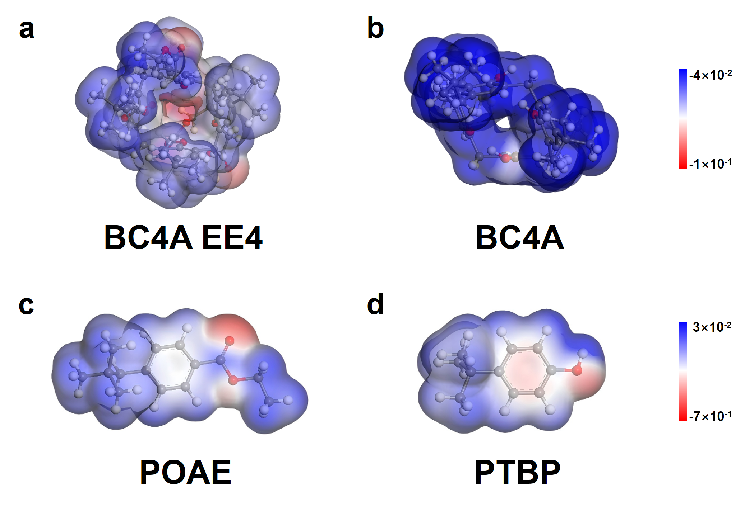
Supplementary Fig. 1. ESP maps of the model host molecules. a–d, Electrostatic-potential maps of (a) BC4A EE4, (b) BC4A, (c) POAE and (d) PTBP. BC4A retains the calixarene scaffold but lacks the ester-functionalized lower-rim side arms, whereas POAE and PTBP contain local oxygen-donor units without a preorganized cyclic cavity. This comparison separates the contribution of the macrocyclic cage from that of isolated oxygen-donor sites.
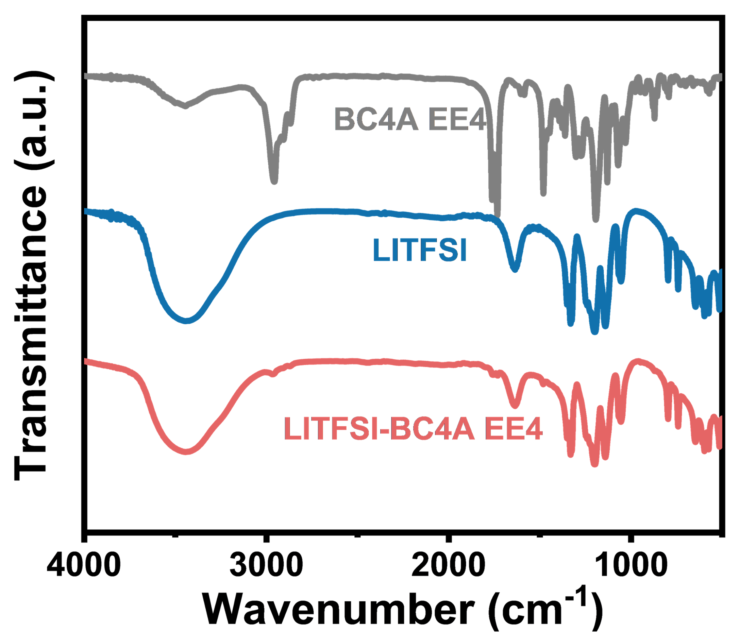
Supplementary Fig. 2. Full FTIR spectra of BC4A EE4, LiTFSI and the LiTFSI-BC4A EE4 mixture in the range of 4000–500 cm⁻¹. The full spectra provide the vibrational context for the C=O and C–O regions highlighted in Fig. 1i, j.
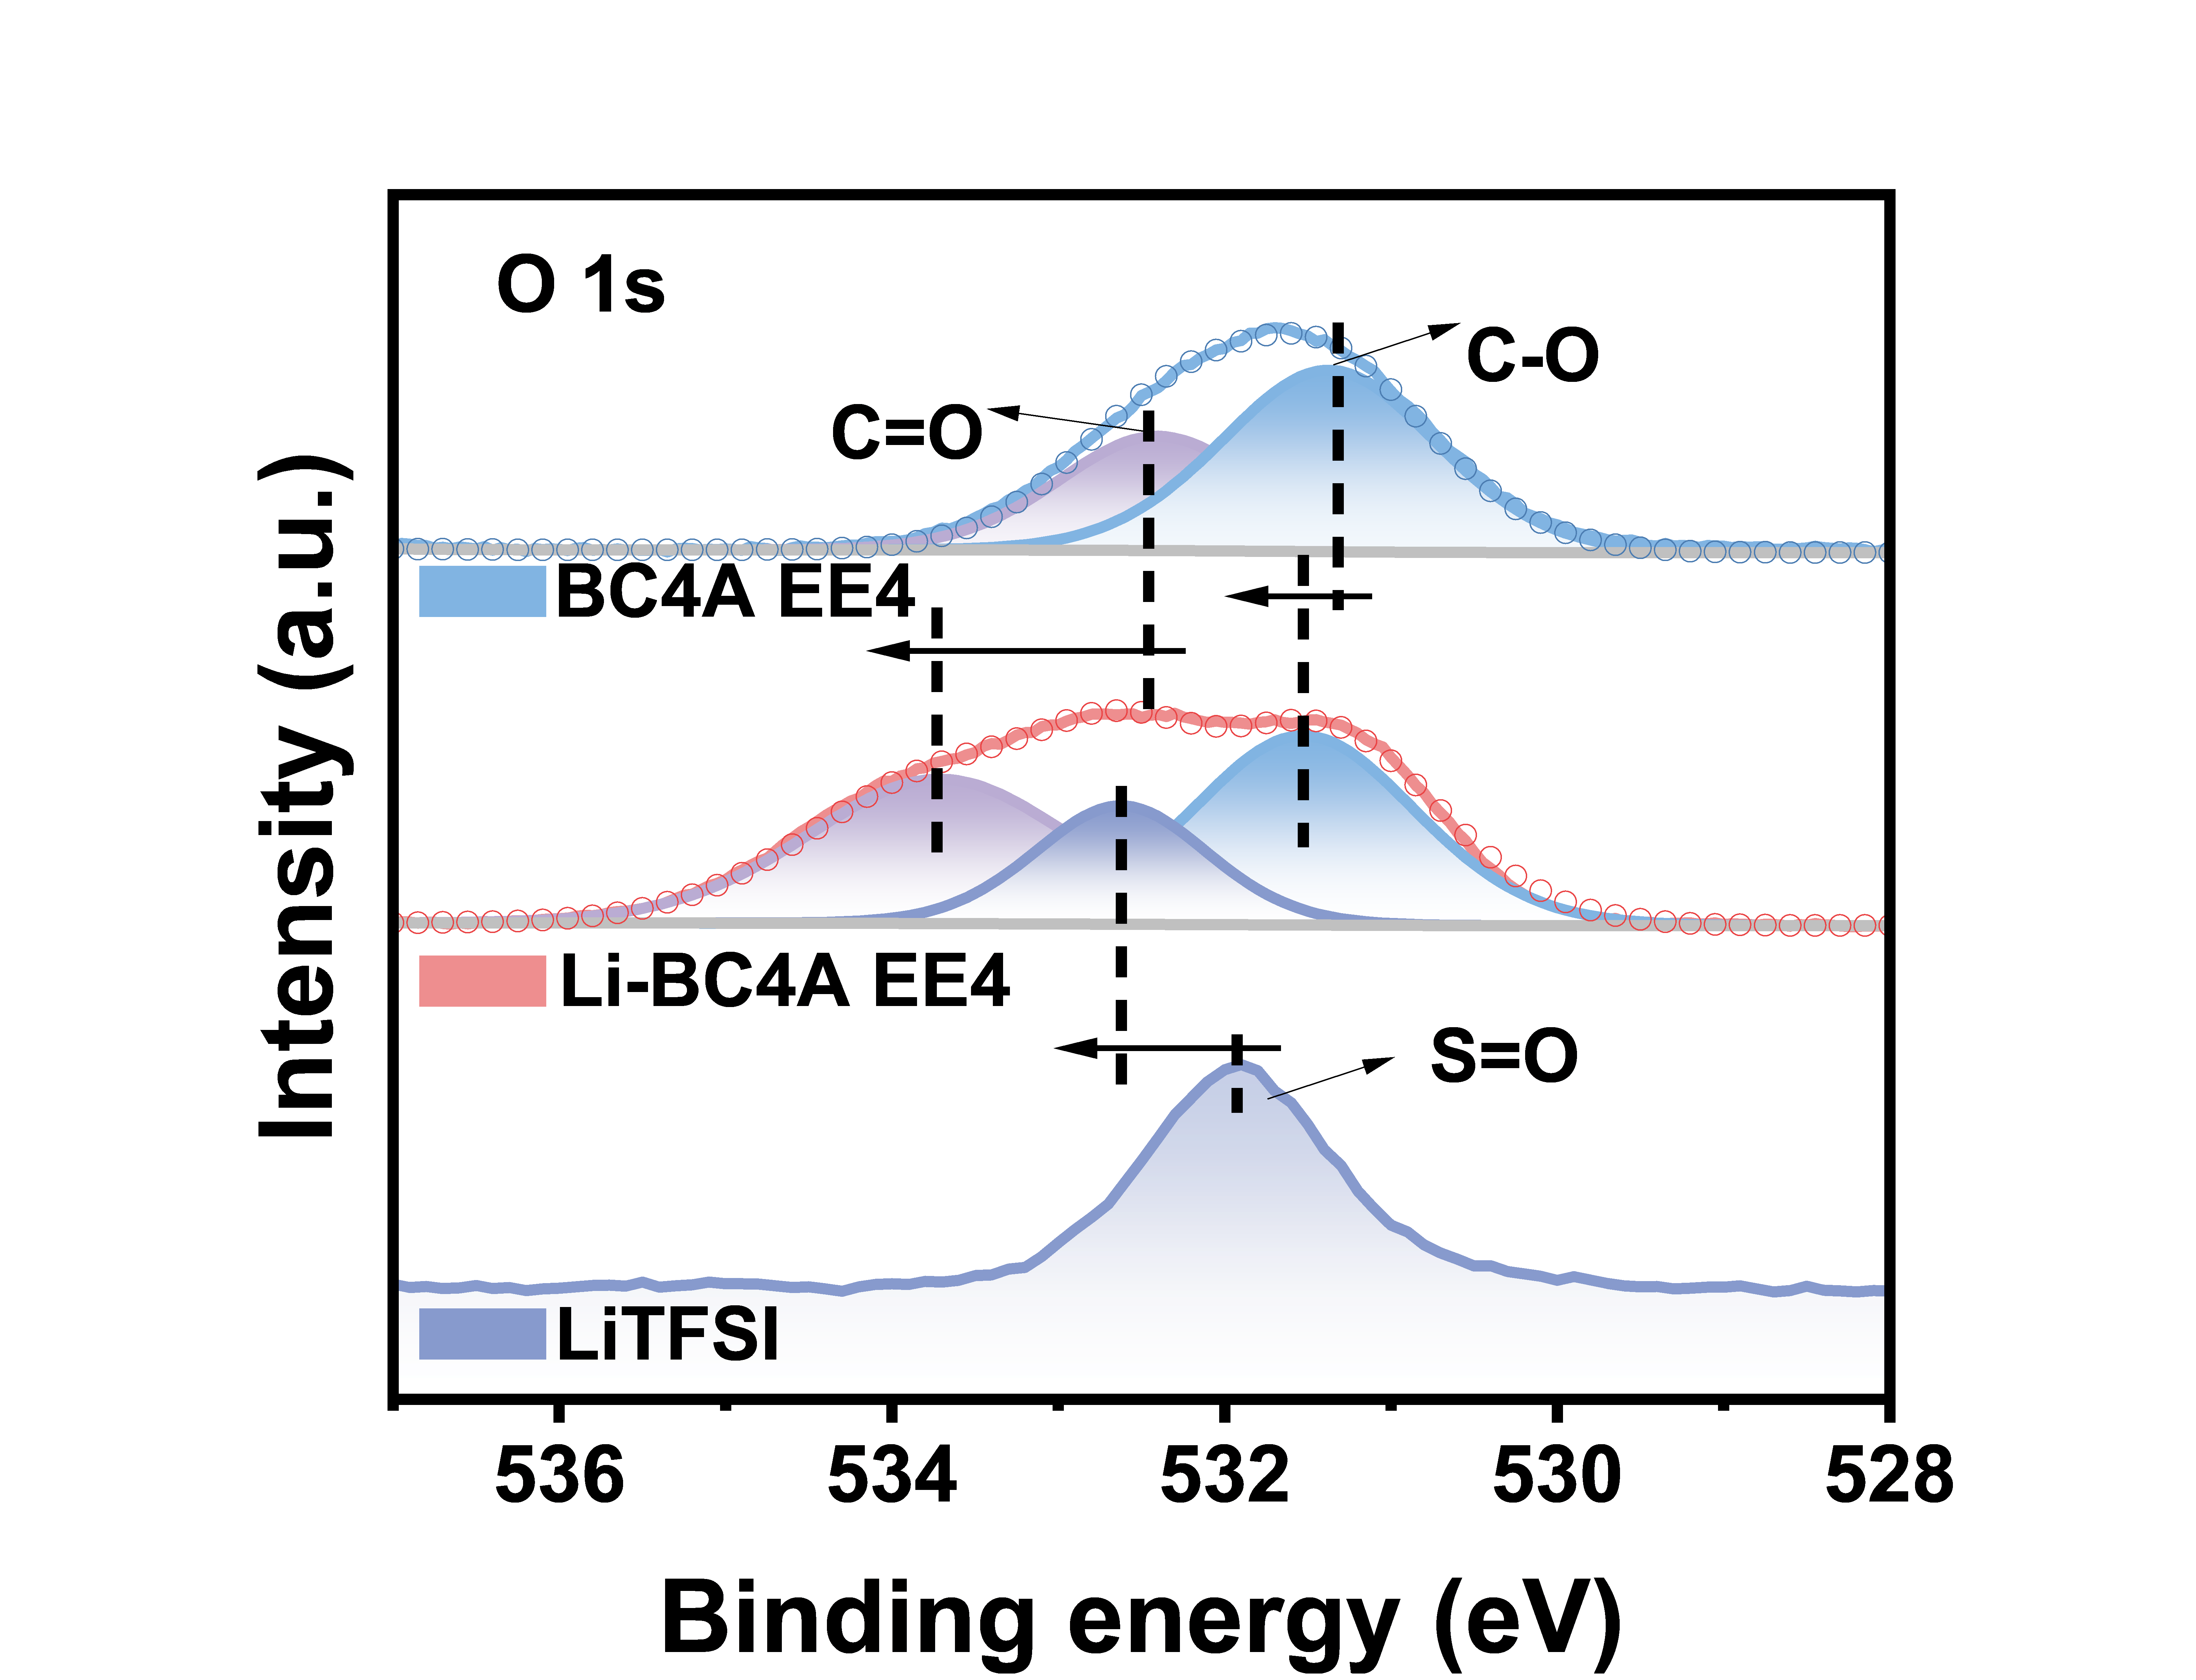
Supplementary Fig. 3. O1s XPS spectra of LiTFSI, BC4A EE4, and the LiTFSI/BC4A EE4 sample. The O 1s shift after mixing with BC4A EE4 supports a changed coordination environment, consistent with the Li 1s XPS evidence in Fig. 1k.^{4,5}
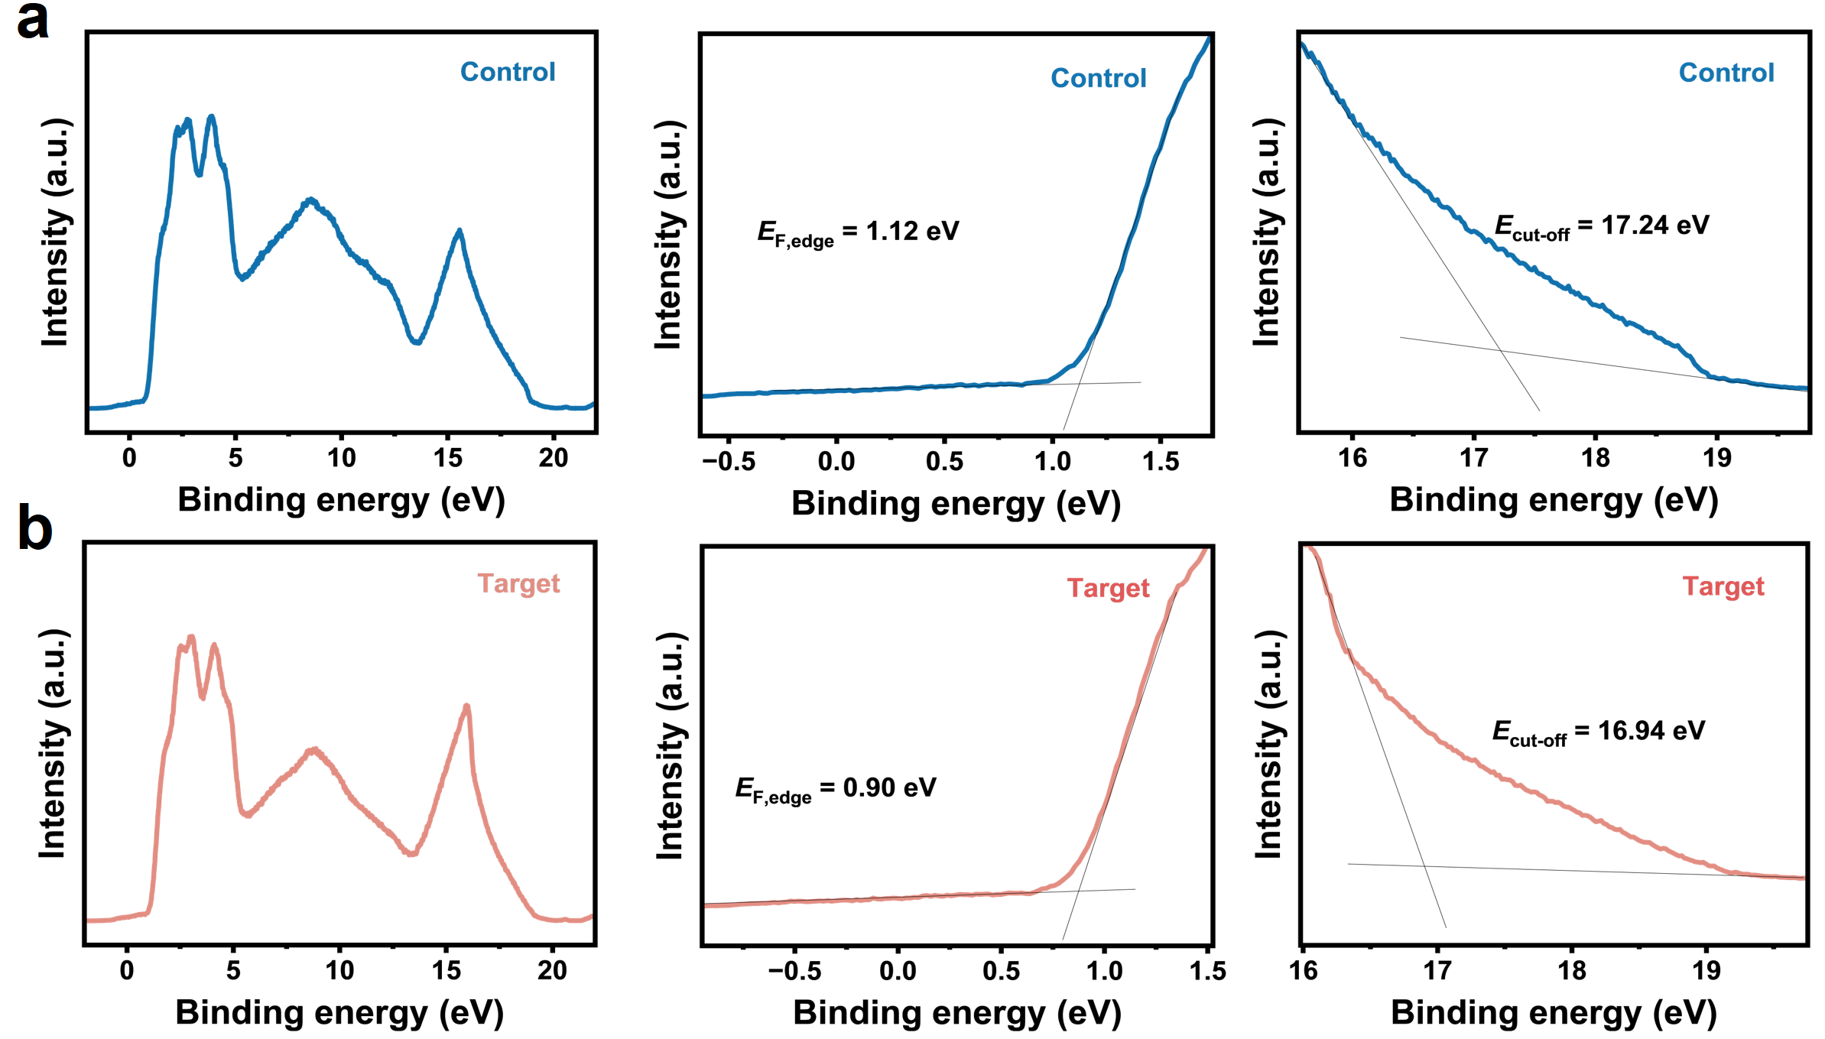
Supplementary Fig. 4. Raw UPS spectra and cutoff analyses of control and BC4A EE4-modified Spiro-OMeTAD films. a, UPS spectra, valence-band-edge region and secondary-electron cutoff of the Spiro@Li control film. b, Corresponding UPS analyses of the Spiro@Li-BC4A EE4 film. These spectra support the work-function increase from 3.98 to 4.28 eV and the reduction in E_{F} − E_{VBM} from 1.12 to 0.90 eV shown in Fig. 2e.
Supplementary Fig. 5. Tauc analysis of the Spiro-OMeTAD films without and with BC4A EE4 doping. The optical gap remains near 3.00 eV after BC4A EE4 incorporation, indicating that the energy-level shift is not caused by an additional low-bandgap absorbing component.
Supplementary Fig. 6. UV–vis absorption spectra of the Spiro@Li, Spiro@Li-POAE, and Spiro@Li-BC4A EE4 solutions. The spectra compare the conventional Spiro@Li solution, the monomer-control solution and the Spiro@Li-BC4A EE4 solution, with the neutral Spiro-OMeTAD and Spiro-OMeTAD•⁺ absorption regions labelled in the plot. The stronger Spiro-OMeTAD•⁺ absorption feature in the BC4A EE4-containing solution supports the film-state oxidation evidence in Fig. 3d.^{5,8}
Supplementary Fig. 7. Steady-state PL spectra of perovskite/HTL stacks. The PVSK/Spiro@Li-BC4A EE4 stack shows lower PL intensity than the PVSK/Spiro@Li stack, consistent with more efficient hole extraction from perovskite into the modified Spiro-OMeTAD layer.
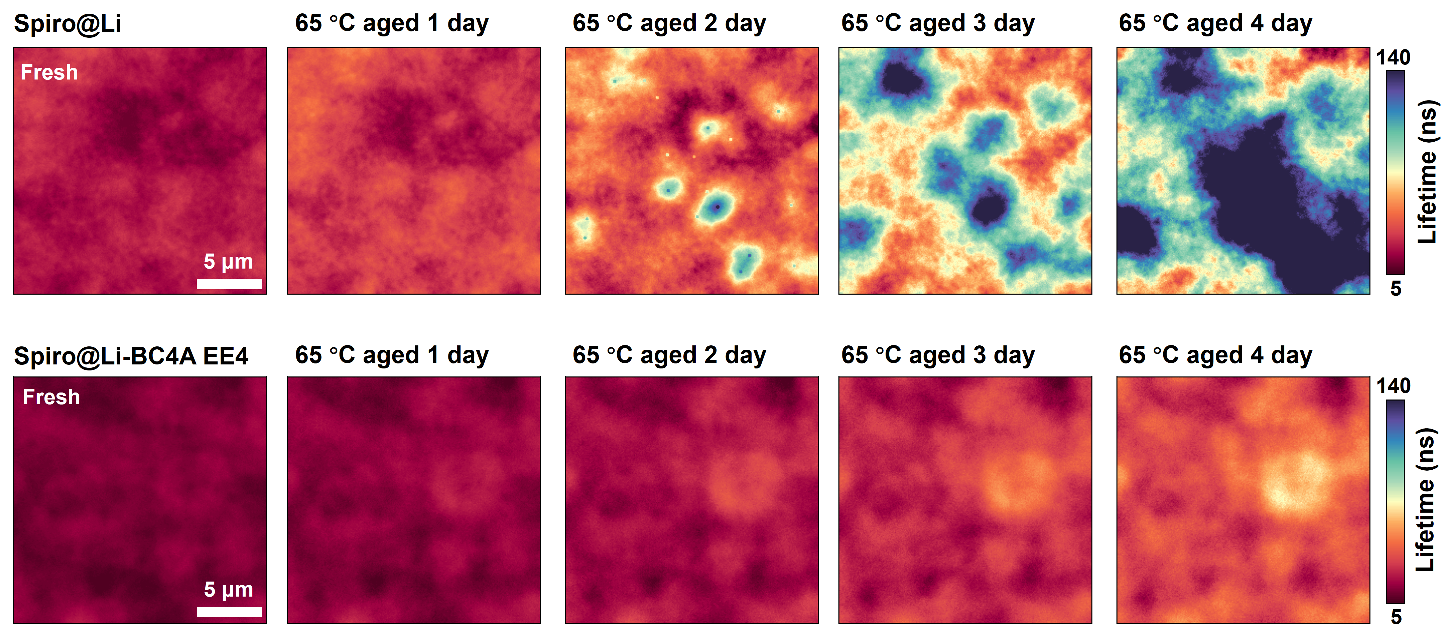
Supplementary Fig. 8. TRPL lifetime mapping sequence of perovskite/HTL stacks during 65 °C aging in air. Pixel-resolved lifetime maps were obtained using a three-exponential fitting model. The Spiro@Li stack develops progressively stronger lifetime heterogeneity from the fresh state to 4 days of aging, whereas the Spiro@Li-BC4A EE4 stack maintains a more spatially uniform lifetime distribution, indicating delayed aging-induced deterioration in interfacial carrier transport.
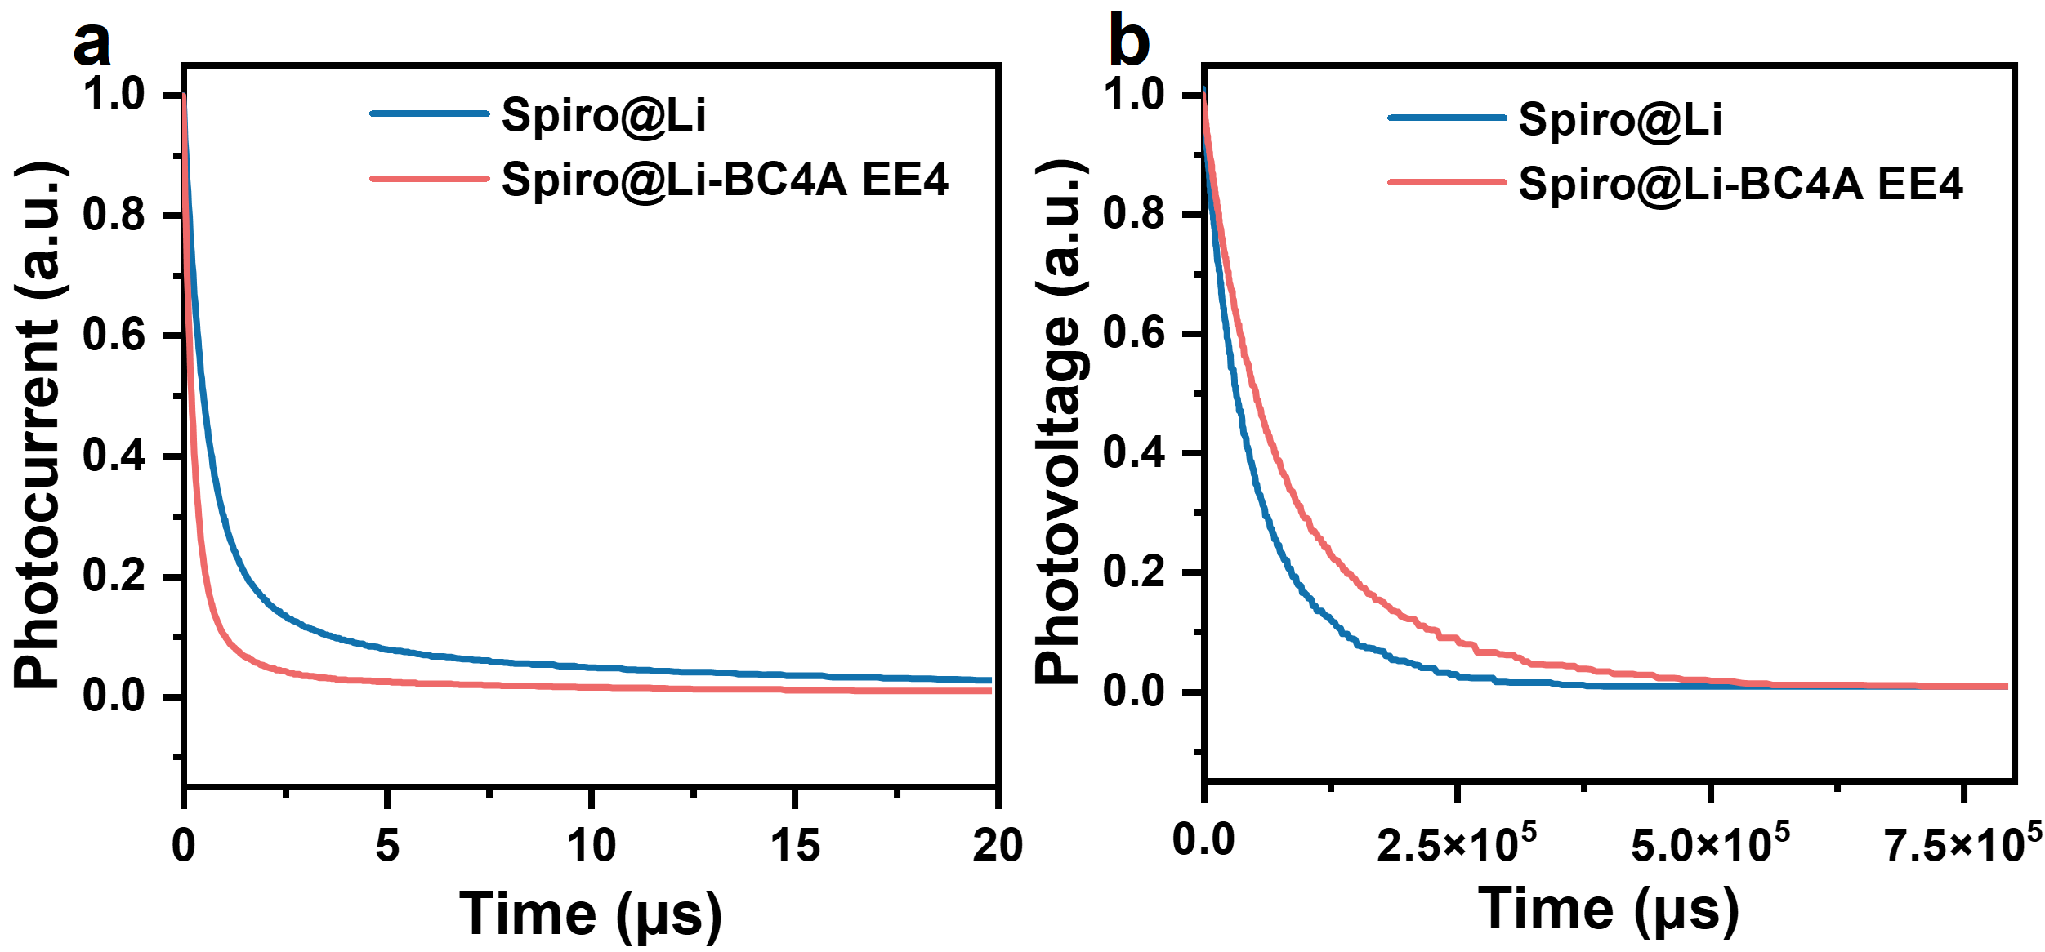
Supplementary Fig. 9. a,b, TPC and TPV of control and BC4A EE4-modified devices. The faster TPC decay and longer TPV decay of the BC4A EE4-modified device indicate accelerated carrier extraction and suppressed recombination.^{9,10}
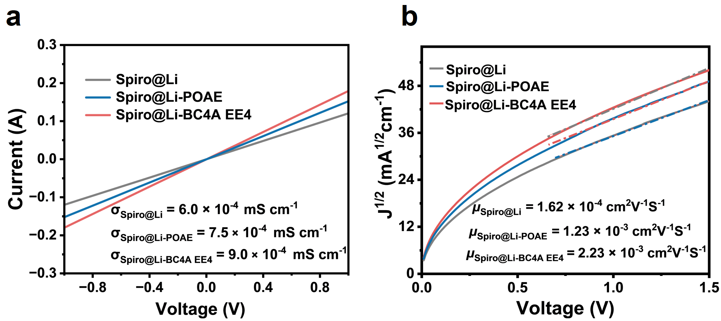
Supplementary Fig. 10. Raw conductivity and SCLC curves used to extract the electrical parameters summarized in Fig. 3h. a, Current–voltage curves in the ohmic region used for conductivity extraction for Spiro@Li, Spiro@Li-POAE and Spiro@Li-BC4A EE4 films. b, SCLC fitting curves used to extract the hole mobility of Spiro@Li, Spiro@Li-POAE and Spiro@Li-BC4A EE4 films.^{1,2,11}
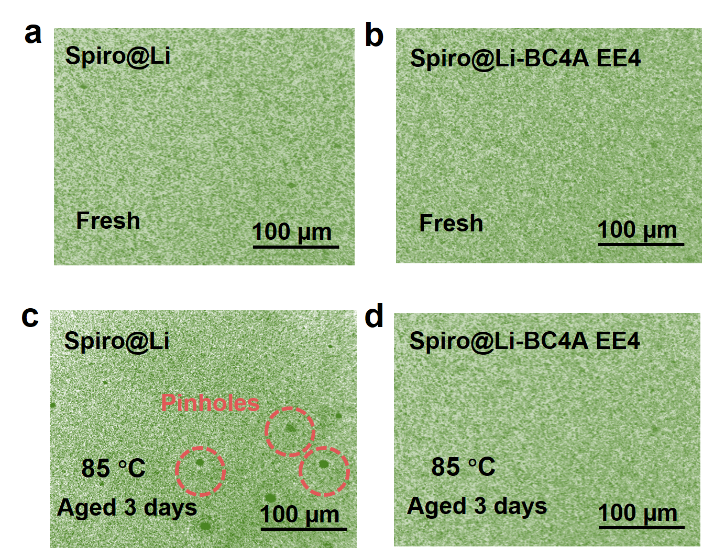
Supplementary Fig. 11. a,b, Optical microscopy images of fresh (a) Spiro@Li and (b) Spiro@Li-BC4A EE4 films. c,d, Optical microscopy images of (c) Spiro@Li and (d) Spiro@Li-BC4A EE4 films after aging at 85 °C for 3 days.
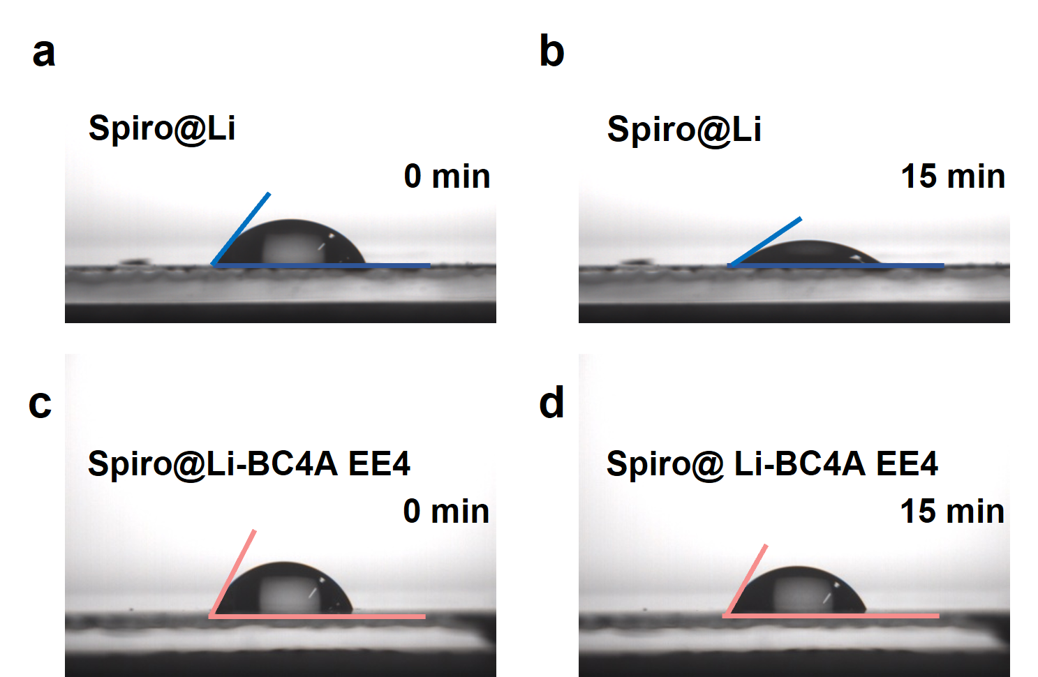
Supplementary Fig. 12. a,b, Contact-angle images of the Spiro@Li film at (a) 0 and (b) 15 min. c,d, Contact-angle images of the Spiro@Li-BC4A EE4 film at (c) 0 and (d) 15 min.
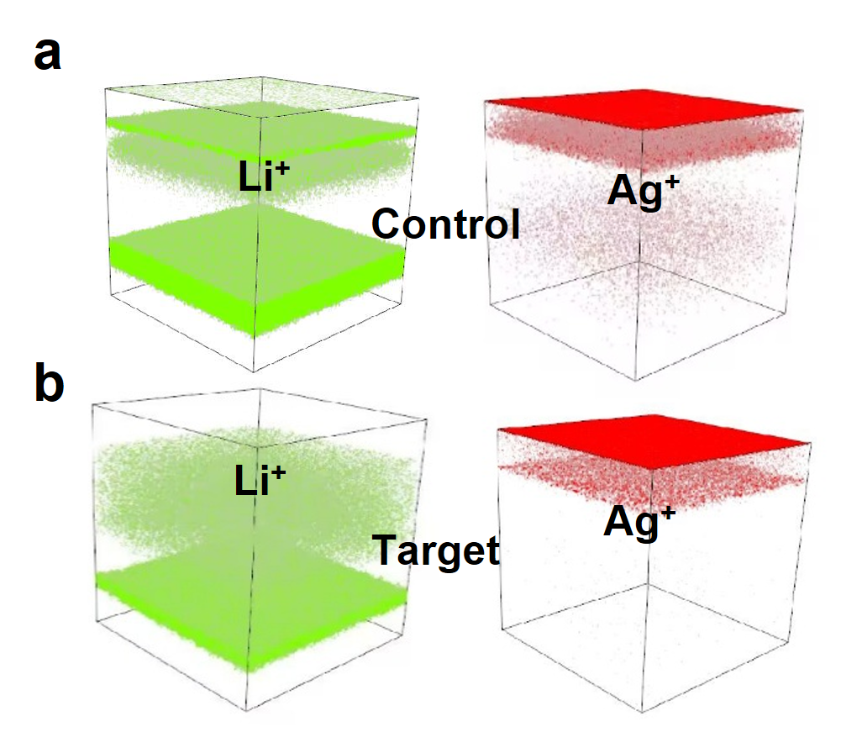
Supplementary Fig. 13. Three-dimensional ToF-SIMS reconstructions of ion distributions in aged devices. a, b, Three-dimensional Li⁺ and Ag⁺ distributions in aged (a) Spiro@Li control and (b) Spiro@Li-BC4A EE4 devices. Compared with the control device, the BC4A EE4-modified device shows more spatially confined Li⁺ and Ag⁺ signals, supporting suppressed ion redistribution during aging.
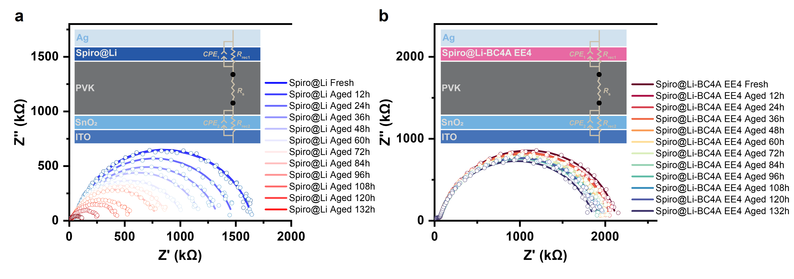
Supplementary Fig. 14. a, Impedance spectra of the Spiro@Li control device during aging. b, Impedance spectra of the Spiro@Li-BC4A EE4 device during aging. The raw spectra support the fitted resistance trends summarized in Fig. 4i, j.^{9,12,13}
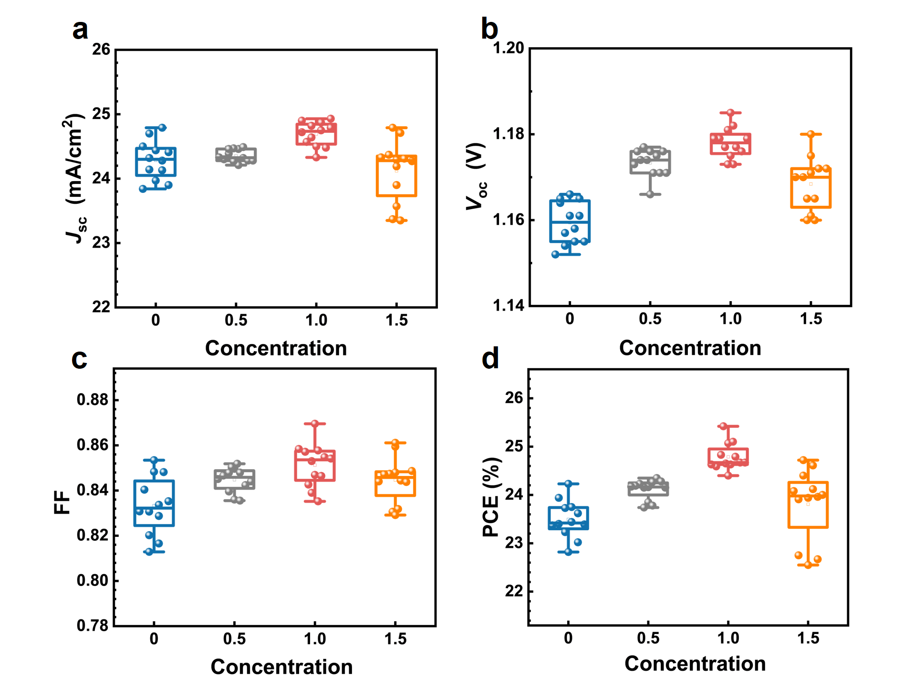
Supplementary Fig. 15.a–d, Statistical distributions of (a) J_{SC}, (b) V_{OC}, (c) FF and (d) PCE for n-i-p devices modified with different concentrations of POAE.
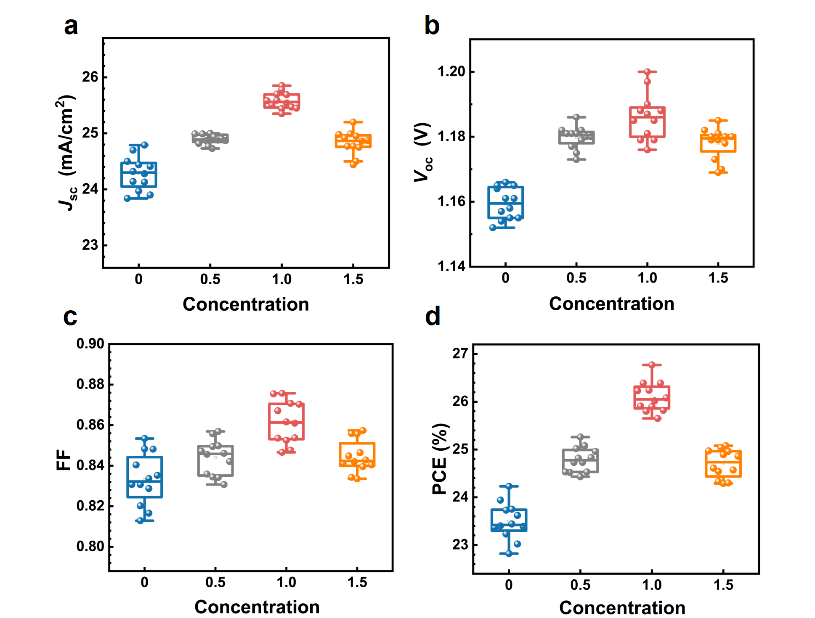
Supplementary Fig. 16. a–d, Statistical distributions of (a) J_{SC}, (b) V_{OC}, (c) FF and (d) PCE for n-i-p devices modified with different concentrations of BC4A EE4.
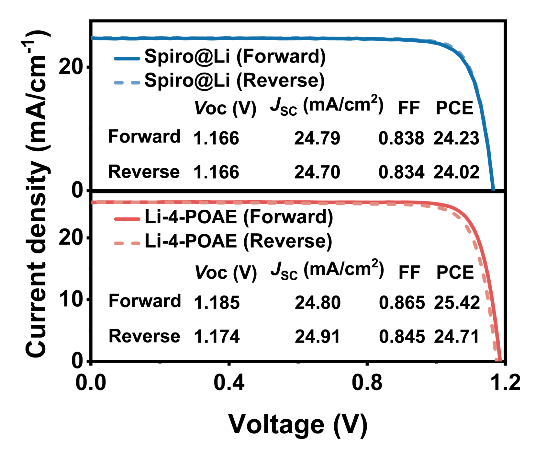
Supplementary Fig. 17. Forward and reverse J–V curves of the optimized control and POAE-modified n–i–p devices.
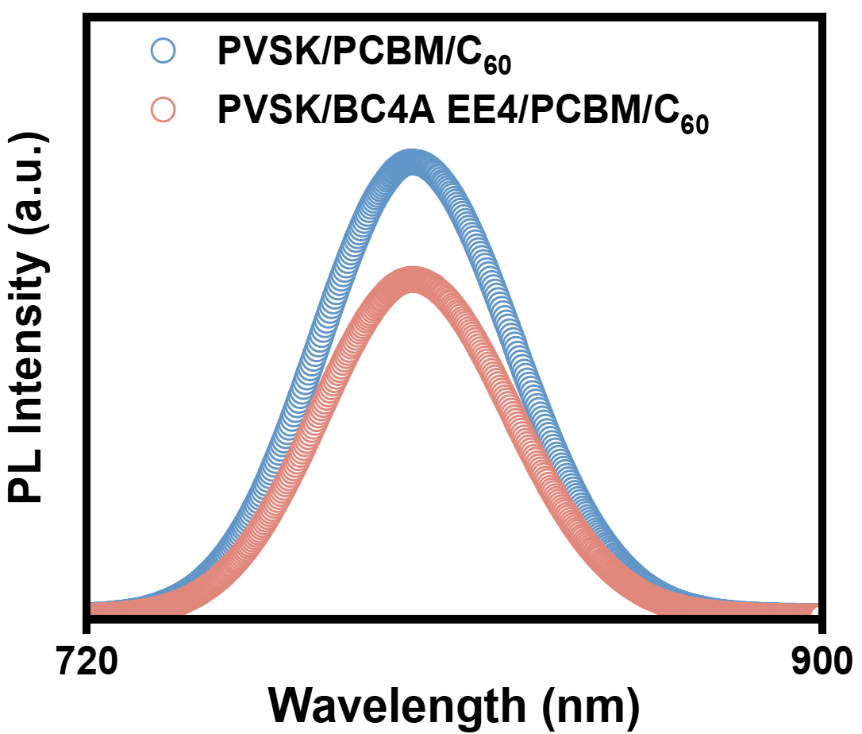
Supplementary Fig. 18. Steady-state PL spectra of PVSK/PC₆₁BM/C₆₀ and PVSK/BC4A EE4/PC₆₁BM/C₆₀ stack samples measured from ETL side. The reduced PL intensity after BC4A EE4 treatment supports enhanced carrier extraction in the inverted stack.
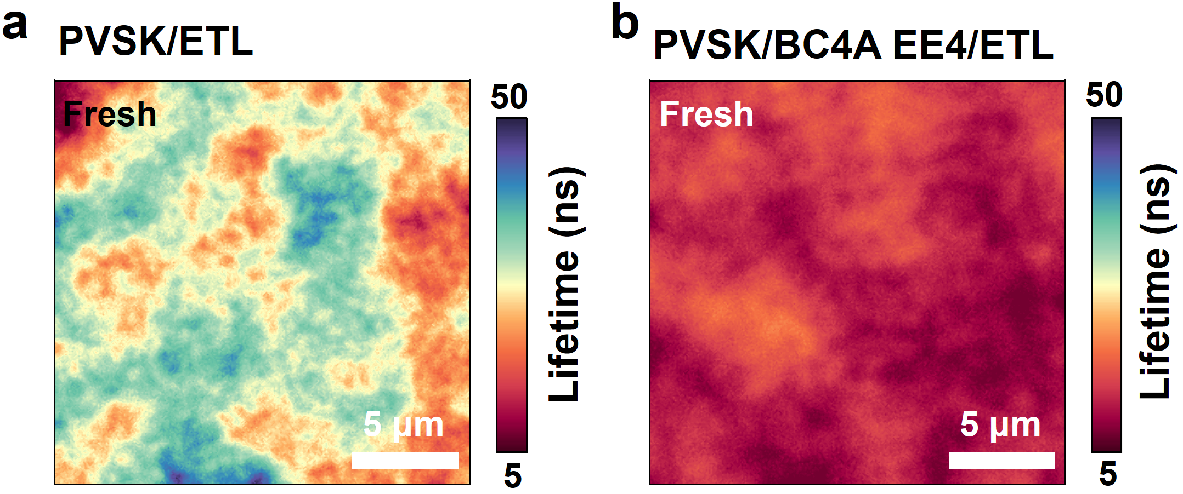
Supplementary Fig. 19. a,b, TRPL lifetime maps of (a) PVSK/ETL and (b) PVSK/BC4A EE4/ETL stack samples. The lifetime maps were obtained using a three-exponential pixel-resolved fitting model.
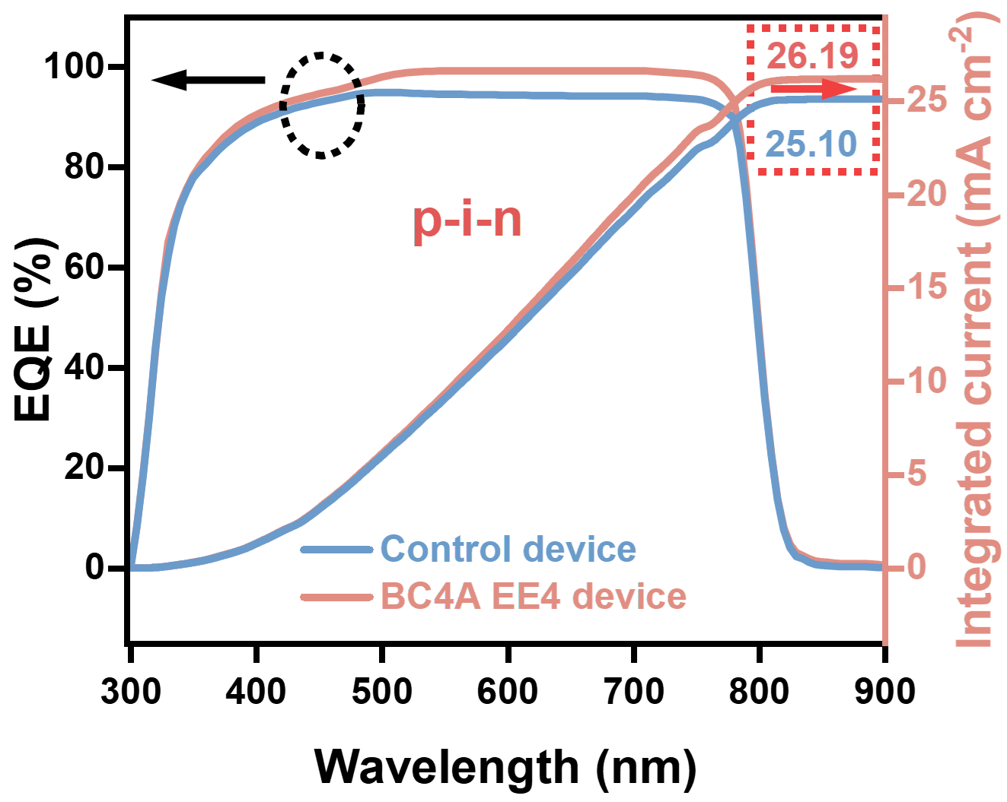
Supplementary Fig. 20. EQE spectra of inverted p–i–n devices without and with BC4A EE4 upper-interface treatment. The integrated current density increases from 25.10 to 26.19 mA cm⁻² after BC4A EE4 treatment, consistent with the enhanced J_{SC} in the corresponding J–V curves.
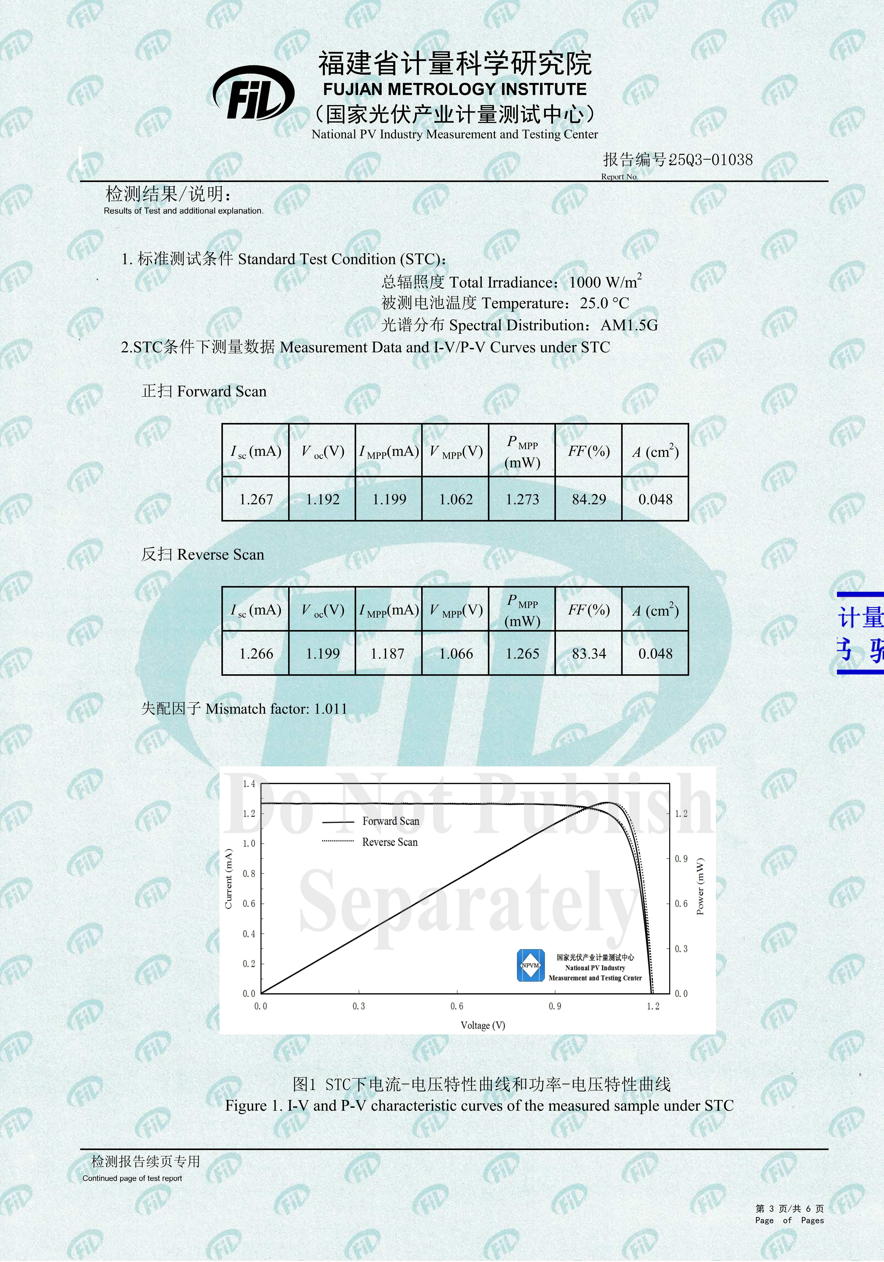
Supplementary Fig. 21. Certification report for the BC4A EE4-modified n-i-p PSCs obtained from Fujian Metrology Institute.
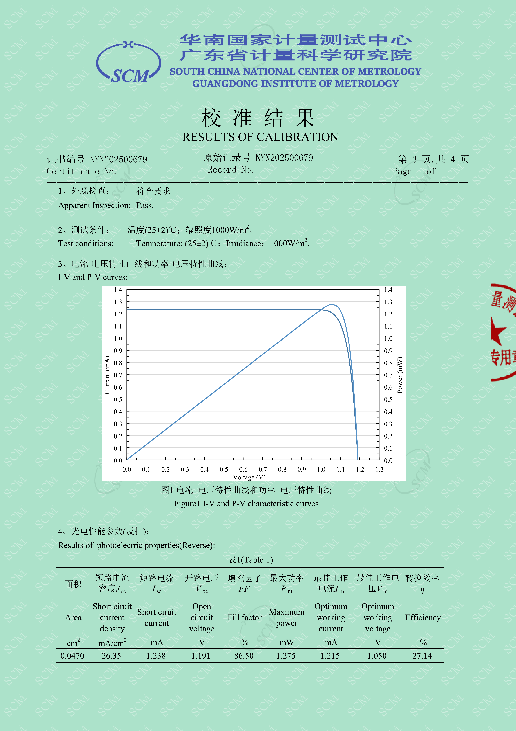
Supplementary Fig. 22. Certification report for the BC4A EE4-modified p-i-n PSCs obtained from South China National Center of Metrology.
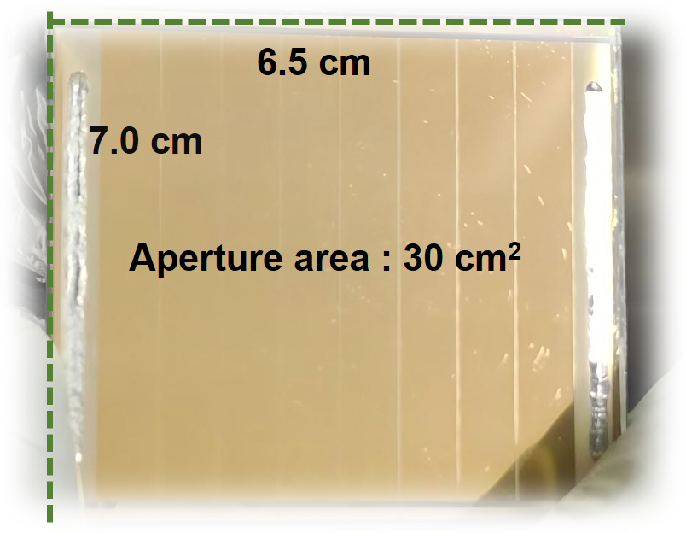
Supplementary Fig. 23. Photograph and aperture-area information of the 30 cm² mini-module. The image shows the module configuration and aperture-area definition used for the large-area photovoltaic measurement.
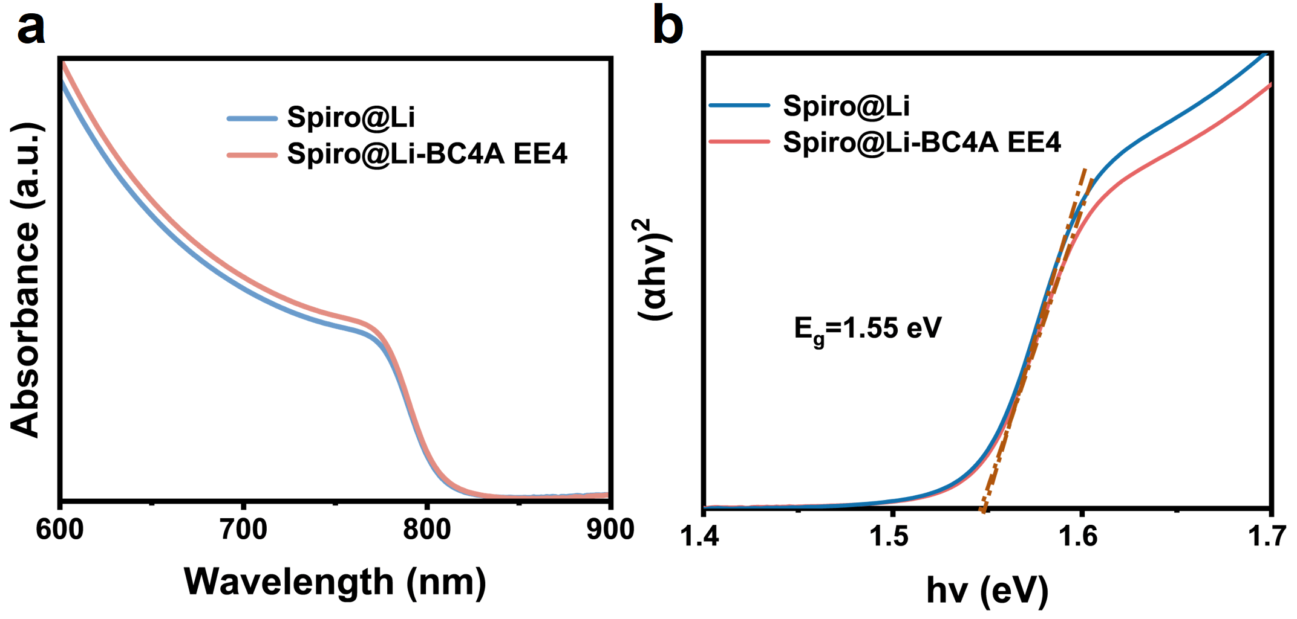
Supplementary Fig. 24. a, Absorption spectra of the control and target perovskite films in the band-edge region. b, Corresponding Tauc plots used to estimate the optical bandgap. Both samples show similar absorption edges and an optical bandgap close to 1.55 eV, indicating that the increased EQE-derived current is not caused by bandgap variation but mainly originates from improved carrier collection.
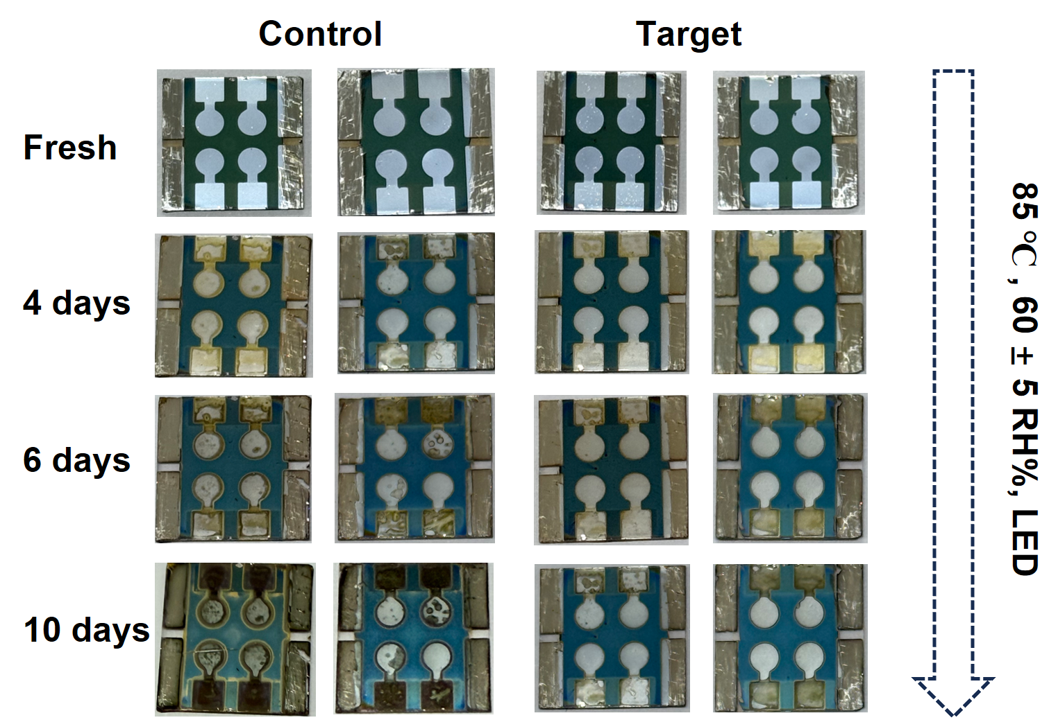
Supplementary Fig. 25. Time-sequential photographs of unencapsulated devices under LED aging at 85 ℃ and 60 ± 5% RH.^{14,15} Photographs were taken in the fresh state and after 4, 6 and 10 days of aging. The control devices show stronger macroscopic discoloration and electrode degradation, whereas the BC4A EE4-containing devices remain visually more intact.
Supplementary Table 1. Calculated valence band (E_{VB}) and conduction band (E_{CB}) from Ecut-off, E_{F,edge} and E_{g} for control and modified Spiro films.
Films | E_{cut-off} (eV) | E_{F} (eV) | E_{F,edge} (eV) | E_{VB} (eV) | E_{g} (eV) | E_{CB} (eV)
Spiro@Li | 17.24 | -3.98 | 1.12 | -5.10 | 3.00 | -2.10
Spiro@Li-BC4A EE4 | 16.94 | -4.28 | 0.90 | -5.18 | 3.00 | -2.18

Supplementary Table 2. Fitted results of TRPL curves of the perovskite films deposited on glass substrates with or without modifiers measured from glass side. The PVSK represents the perovskite layer.
Samples | τ₁ (ns) | A₁ | τ₂ (ns) | A₂ | τ_{ave} (ns)
Glass/PVSK/Spiro@Li | 24.422 | 0.41 | 1992.07 | 0.59 | 1975.45
Glass/PVSK/Spiro@Li-BC4A EE4 | 37.50 | 0.25 | 988.52 | 0.75 | 976.64

Supplementary Table 3. Photovoltaic parameters of the PSCs based on Spiro films modified by different concentrations of POAE in the range of 0 to 1.5 mg mL⁻¹. J–V curves were measured with a scan rate of 100 mV s⁻¹ under AM 1.5G illumination.
Devices | Statistic | J_{SC} (mA cm⁻²) | V_{OC} (V) | FF | PCE (%)
Control | Average | 24.29 ± 0.302 | 1.159 ± 0.0049 | 0.833 ± 0.0128 | 23.49 ± 0.388
Control | Champion | 24.79 | 1.166 | 0.838 | 24.23
0.5 mg mL⁻¹ | Average | 24.36 ± 0.094 | 1.174 ± 0.0031 | 0.847 ± 0.0054 | 24.11 ± 0.204
0.5 mg mL⁻¹ | Champion | 24.39 | 1.174 | 0.850 | 24.35
1.0 mg mL⁻¹ | Average | 24.69 ± 0.188 | 1.178 ± 0.0036 | 0.851 ± 0.0097 | 24.79 ± 0.280
1.0 mg mL⁻¹ | Champion | 24.80 | 1.185 | 0.865 | 25.42
1.5 mg mL⁻¹ | Average | 24.12 ± 0.477 | 1.168 ± 0.0063 | 0.845 ± 0.010 | 23.81 ± 0.744
1.5 mg mL⁻¹ | Champion | 24.79 | 1.175 | 0.849 | 24.72

Supplementary Table 4. Photovoltaic parameters of the PSCs based on Spiro films modified by different concentrations of BC4A EE4 in the range of 0 to 1.5 mg mL⁻¹. J–V curves were measured with a scan rate of 100 mV s⁻¹ under AM 1.5G illumination.
Devices | Statistic | J_{SC} (mA cm⁻²) | V_{OC} (V) | FF | PCE (%)
Control | Average | 24.29 ± 0.302 | 1.159 ± 0.0049 | 0.833 ± 0.0128 | 23.49 ± 0.388
Control | Champion | 24.79 | 1.166 | 0.838 | 24.23
0.5 mg mL⁻¹ | Average | 24.89 ± 0.088 | 1.179 ± 0.0034 | 0.844 ± 0.0086 | 24.79 ± 0.258
0.5 mg mL⁻¹ | Champion | 24.96 | 1.181 | 0.856 | 25.26
1.0 mg mL⁻¹ | Average | 25.58 ± 0.150 | 1.186 ± 0.0072 | 0.861 ± 0.0105 | 26.07 ± 0.265
1.0 mg mL⁻¹ | Champion | 25.82 | 1.190 | 0.872 | 26.77
1.5 mg mL⁻¹ | Average | 24.83 ± 0.210 | 1.178 ± 0.0048 | 0.845 ± 0.0080 | 24.70 ± 0.298
1.5 mg mL⁻¹ | Champion | 24.86 | 1.179 | 0.856 | 25.08

Supplementary Table 5. Summary of photovoltaic parameters (V_{OC}, J_{SC}, FF, PCE) for different devices in Figs. 5a-c. J–V curves were measured with a scan rate of 100 mV s⁻¹ under AM 1.5G illumination.
Devices | Figure |  | J_{SC} (mA cm⁻²) | V_{OC} (V) | FF | PCE (%)
Spiro@Li | Fig.5a | Forward | 24.79 | 1.166 | 0.838 | 24.23
Spiro@Li | Fig.5a | Reverse | 24.70 | 1.166 | 0.834 | 24.02
Li-BC4A EE4 | Fig.5a | Forward | 25.82 | 1.190 | 0.872 | 26.77
Li-BC4A EE4 | Fig.5a | Reverse | 25.81 | 1.189 | 0.867 | 26.61
Control | Fig.5b | Forward | 25.25 | 1.185 | 0.853 | 25.53
Control | Fig.5b | Reverse | 25.40 | 1.173 | 0.852 | 25.38
Target | Fig.5b | Forward | 26.40 | 1.198 | 0.871 | 27.55
Target | Fig.5b | Reverse | 26.32 | 1.204 | 0.863 | 27.35
Control | Fig.5c | Forward | 2.91 | 9.219 | 0.779 | 20.90
Control | Fig.5c | Reverse | 2.95 | 9.268 | 0.792 | 21.65
Target | Fig.5c | Forward | 3.02 | 9.473 | 0.816 | 23.34
Target | Fig.5c | Reverse | 3.04 | 9.486 | 0.822 | 23.70

Supplementary References
1 Lampert, M. A. Simplified Theory of Space-Charge-Limited Currents in an Insulator with Traps. Phys. Rev. 103, 1648-1656, doi:10.1103/PhysRev.103.1648 (1956).
2 Murgatroyd, P. N. Theory of space-charge-limited current enhanced by Frenkel effect. J. Phys. D: Appl. Phys. 3, 151-156, doi:10.1088/0022-3727/3/2/308 (1970).
3 Yuan, M. et al. Redox-Improved Self-Assembled Monolayers for Inverted Perovskite Solar Cells. Nat. Commun. 16, 11330, doi:10.1038/s41467-025-66421-4 (2025).
4 Wang, S. et al. Unveiling the Role of tBP-LiTFSI Complexes in Perovskite Solar Cells. J. Am. Chem. Soc. 140, 16720-16730, doi:10.1021/jacs.8b09809 (2018).
5 Zhang, T. et al. Ion-modulated radical doping of spiro-OMeTAD for more efficient and stable perovskite solar cells. Science 377, 495-501, doi:10.1126/science.abo2757 (2022).
6 Pan, T. et al. Stabilizing doped Spiro-OMeTAD with an organic molten salt for efficient and stable perovskite solar cells. Energy Environ. Sci. 17, 9548-9554, doi:10.1039/d4ee04310c (2024).
7 Niu, G. et al. Overcoming stability challenges in perovskite solar cells: Addressing Li ions movement in Spiro-OMeTAD layer through nano-graphdiyne incorporation. Nano Energy 129, 110017, doi:10.1016/j.nanoen.2024.110017 (2024).
8 Shin, Y. S. et al. Intrinsic and Extrinsic Determinants of Stability in Spiro-OMeTAD-Based Hole-Transporting Layers in Perovskite Solar Cells: Mechanistic Insights and Strategic Perspectives. Adv. Mater. 37, e13270, doi:10.1002/adma.202513270 (2025).
9 Bisquert, J. & Janssen, M. From Frequency Domain to Time Transient Methods for Halide Perovskite Solar Cells: The Connections of IMPS, IMVS, TPC, and TPV. J. Phys. Chem. Lett. 12, 7964-7971, doi:10.1021/acs.jpclett.1c02065 (2021).
10 Chen, X., Kamat, P. V., Janaky, C. & Samu, G. F. Charge Transfer Kinetics in Halide Perovskites: On the Constraints of Time-Resolved Spectroscopy Measurements. ACS Energy Lett. 9, 3187-3203, doi:10.1021/acsenergylett.4c00736 (2024).
11 Wang, S. et al. Self-cleaning Spiro-OMeTAD via multimetal doping for perovskite photovoltaics. Nat. Commun. 16, 4167, doi:10.1038/s41467-025-59350-9 (2025).
12 Yoo, S.-M. et al. An Equivalent Circuit for Perovskite Solar Cell Bridging Sensitized to Thin Film Architectures. Joule 3, 2535-2549, doi:10.1016/j.joule.2019.07.014 (2019).
13 Zarazua, I. et al. Surface Recombination and Collection Efficiency in Perovskite Solar Cells from Impedance Analysis. J. Phys. Chem. Lett. 7, 5105-5113, doi:10.1021/acs.jpclett.6b02193 (2016).
14 Khenkin, M. V. et al. Consensus statement for stability assessment and reporting for perovskite photovoltaics based on ISOS procedures. Nat. Energy 5, 35-49, doi:10.1038/s41560-019-0529-5 (2020).
15 Silverman, T. J. et al. Durability research is pivotal for perovskite photovoltaics. Nat. Energy 10, 934-940, doi:10.1038/s41560-025-01786-w (2025).

