Supplementary Information
Assessing the Credibility of Corporate SDG Claims: An Agentic AI Framework for Sustainability Report Analysis
This Supplementary Information contains the sector- and claim-type-level analyses summarised in §4.5 and the retrieval-validation detail summarised in §4.2–4.3, the SMTEC scoring rubric (§3.3.4), and the per-goal self-declared-versus-substantive comparison (§5.5) of the main text. Tables and figures use the S-prefix and are cited from the main text as Table S1–S7 and Fig. S1. S6 reproduces the SMTEC scoring rubric with worked examples and grounding (§3.3.4); S7 reports the per-goal self-declared-versus-substantive comparison (§5.5).

S1. Sector-level analysis
Table S1 reports per-sector credibility means and tier distributions across the corpus; sector labels follow the Stock Exchange of Thailand classification (SET, 2021).
Table S1. Sector-level credibility means and tier distribution.
Sector | N firms | N claims | Composite | Sym% | Part% | Sub% | S M T E C
Property Development | 4 | 1,027 | 1.44 | 5.3 | 72.2 | 22.5 | 1.74 0.64 0.94 1.14 2.75
Banking & Finance | 4 | 990 | 1.37 | 9.4 | 73.6 | 17.0 | 1.62 0.58 0.87 1.11 2.66
Energy & Utilities | 6 | 986 | 1.41 | 10.5 | 67.4 | 22.0 | 1.65 0.65 0.98 1.15 2.64
Agribusiness & Food | 4 | 913 | 1.44 | 9.3 | 66.7 | 24.0 | 1.73 0.71 0.87 1.20 2.66
Commerce | 3 | 722 | 1.42 | 9.0 | 69.7 | 21.3 | 1.72 0.84 0.93 1.11 2.49
Construction Materials | 3 | 623 | 1.51 | 6.9 | 64.0 | 29.1 | 1.75 0.86 1.02 1.25 2.64
Transportation | 2 | 353 | 1.47 | 8.2 | 66.9 | 24.9 | 1.78 0.66 1.10 1.14 2.67
ICT | 2 | 326 | 1.47 | 11.7 | 62.0 | 26.4 | 1.83 0.88 1.04 1.14 2.47
Health Care | 1 | 220 | 1.37 | 10.0 | 68.6 | 21.4 | 1.64 0.70 0.83 1.11 2.58
Electronic Components | 1 | 165 | 1.50 | 9.7 | 60.6 | 29.7 | 1.76 0.72 1.33 1.24 2.46
Fig. S1 renders the sector-by-dimension SMTEC means as a heatmap.
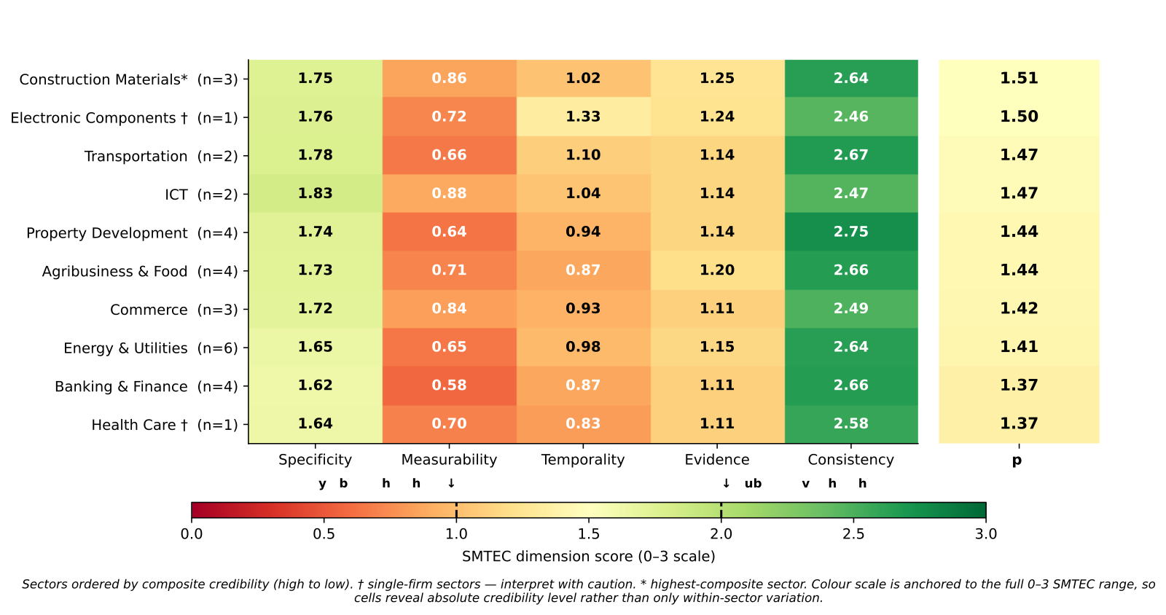
Fig. S1 Sector × SMTEC dimensional heatmap
Three observations follow. First, cross-sector variation in mean composite is modest (1.37 in Banking & Finance and Health Care to 1.51 in Construction Materials — a 0.14 spread), consistent with the legitimacy-theory prediction that firms converge on common norms once a regulatory floor is set (Wuttichindanon, 2017). Second, the dimensional fingerprint differs more across sectors than the composite does: ICT shows the highest Specificity (1.83) but the lowest Consistency among larger sectors (2.47); Construction Materials shows higher Measurability (0.86) and Evidence (1.25); Property Development has the highest Consistency (2.75). Third, no sector reaches a majority-substantive profile — even Construction Materials classifies only 29.1% of claims as Substantive — so the modal pattern is mid-quality reporting rather than symbolic-versus-substantive bimodality.

S2. Claim-type analysis
Table S2 reports credibility means and tier distributions for the six claim types with n ≥ 100.
Table S2. Claim-type-level credibility means and tier distribution.
Claim type | N claims | Composite | Sym% | Part% | Sub% | S M T E C
commitment | 2,964 | 1.26 | 11.8 | 77.0 | 11.2 | 1.52 0.32 0.70 1.06 2.69
achievement | 1,260 | 1.69 | 3.9 | 58.7 | 37.4 | 1.98 0.91 1.41 1.41 2.72
metric | 1,019 | 1.84 | 1.1 | 46.0 | 52.9 | 2.13 2.04 1.54 1.13 2.36
policy | 667 | 1.16 | 12.3 | 84.9 | 2.8 | 1.50 0.09 0.46 1.08 2.70
alignment | 284 | 1.13 | 19.4 | 76.1 | 4.6 | 1.35 0.04 0.46 1.29 2.52
target | 103 | 1.87 | 1.0 | 38.8 | 60.2 | 2.08 2.06 1.60 1.05 2.57
Three findings stand out. First, metric and target claims dominate the Substantive tier (53% and 60%) because both carry quantitative content (Measurability ≈ 2.04 and 2.06) and bundle period references (Temporality 1.54 and 1.60), clearing the Substantive boundary almost by construction. Second, commitment, policy, and alignment claims are structurally Partially Substantive: all show negligible Measurability (0.32, 0.09, 0.04) and low Temporality, because they describe intent, principles, or programmatic association rather than numerical content — the framework faithfully measures an inherent quality ceiling rather than failing on these types. Third, Consistency is uniformly high across all claim types (2.36–2.72); metric claims show the lowest, since a single numerical fact is harder to corroborate cross-section than a rhetorical commitment that can be paraphrased many ways. The SMTEC profile therefore separates quantitative claim types (metric, target, achievement) from qualitative ones (commitment, policy, alignment), refining the symbolic-versus-substantive distinction (Lodhia et al., 2022; Heras-Saizarbitoria et al., 2022): the meaningful question is a report’s claim-type mix and how it distributes across the dimensions.

S3. Retrieval robustness
Table S3 reports pairwise agreement across the three retrieval pipelines applied to the 63-claim validation sample (§4.2): OpenAI embeddings (production), Nomic-Embed-Text-v1.5 (open-source local), and Qwen3-32B-Instruct as a relevance judge.
Table S3. Pairwise retrieval agreement across the three pipelines.
Pair | Mean top-5 Jaccard | Section-diversity flag agreement
OpenAI vs Nomic | 0.591 | 100.0%
OpenAI vs Qwen-judge | 0.326 | 98.4%
Nomic vs Qwen-judge | 0.306 | 98.4%
Existence-of-evidence judgements converge (98.4–100%; method-invariant for 62 of 63 claims), while specific top-K item selection diverges (Jaccard 0.31–0.59), most so on metric and target claims where the judge locates the exact figure and embeddings rank topically similar passages.

S4. Retrieval sensitivity — per-dimension shift
Table S4 reports the per-dimension mean-score shift when switching from same-section claims-only retrieval to the production chunk-aware retrieval, holding prompt and model constant (§4.3).
Table S4. Per-dimension mean-score shift: claims-only vs. chunk-aware retrieval.
Dimension | Mean (claims-only) | Mean (chunk-aware) | Δ
Specificity | 1.78 | 1.90 | +0.13
Measurability | 0.73 | 0.73 | 0.00
Temporality | 0.86 | 0.86 | 0.00
Evidence | 1.35 | 1.32 | −0.03
Consistency | 2.43 | 2.76 | +0.33
The effect concentrates in the context-dependent dimensions (Consistency +0.33, Specificity +0.13); Measurability and Temporality are formally invariant, confirming the prediction that retrieval quality affects dimensions scored from cross-section context more than those scored from claim text alone.

S5. Retrieval sensitivity — tier shift
Table S5 reports the credibility-tier distribution shift under chunk-aware retrieval for the 63-claim sample (§4.3): 25 of 63 claims (40%) cross a tier boundary, 18 upward and 7 downward.
Table S5. Credibility-tier shift under chunk-aware retrieval (63-claim sample).
Tier | Old retrieval | New retrieval | Δ
Symbolic | 21 | 3 | −18
Partially Substantive | 20 | 44 | +24
Substantive | 22 | 16 | −6
Upward shifts are predominantly out of the Symbolic tier (claims previously under-scored because the old retrieval surfaced no cross-section evidence); downward shifts are predominantly out of the Substantive tier (claims previously over-scored because same-section paraphrases were mistaken for corroboration). Both corrections are addressed by the production chunk-aware retrieval.

S6. SMTEC scoring rubric — definitions and worked examples
The Scorer Agent applies the five-dimensional SMTEC rubric below (production prompt, Version 3). Each dimension is scored 0–3 independently, and the composite Credibility Score is the arithmetic mean. Table S6 gives the score anchors with worked examples.
Table S6. SMTEC scoring rubric: score anchors (0–3) with worked examples.
Dimension | 0 | 1 | 2 | 3
Specificity | No specific claim (“We support sustainable development”) | Vague theme; no concrete initiative (“We invest in community programmes”) | Specific programme/target area or quantified target (“Solar Rooftop Programme at 12 facilities”) | Named initiative + scope + quantified target (“Solar Rooftop Programme: 4.2 MW across 12 facilities in Rayong and Chonburi, FY2023”)
Measurability | No metrics; directional verbs without numbers (“enhance”, “reduce”) | Comparative/directional with rough magnitude (“significantly reduced”) | A specific number but missing baseline or target (“reduced water by 15%”) | KPI with baseline and target/units (“Water intensity 4.2→3.6 m³/tonne, −14.3% vs FY2020”)
Temporality | No temporal reference (“we are committed to…”) | Vague timing, or past-tense achievement marker without a date (“have completed”) | One specific time point (“by 2030”, “in FY2024”) | ≥2 time points / interim milestones (“Net zero by 2030: 25% by FY2023, 50% by 2026”)
Evidence | No supporting evidence | Self-reported only, no methodology | Internal data with methodology, or a partial external reference (“aligned with GRI 305”) | Third-party verified — external assurance, audit, or recognised certification
Consistency | Direct contradiction with other report content | No cross-section corroboration | One INDIRECT cross-section reference | One DIRECT cross-section reference, or ≥2 cross-section references of any classification
Worked example. A claim scored S = 2 (names a programme, lacks location), M = 1 (directional, no numbers), T = 2 (cites FY2023, no interim milestone), E = 1 (self-reported, no methodology), C = 3 (one DIRECT plus one INDIRECT cross-section reference) yields a composite of 1.8 — Partially Substantive: a real programme with cross-report corroboration but lacking the baselines and verification needed for full substantiation.
Grounding. Specificity, Measurability, and Temporality operationalise the SMART goal-setting criteria (Doran, 1981) and the GRI reporting-quality principles (Global Reporting Initiative, 2021). Evidence operationalises accountability theory’s information-sufficiency requirement (Gray et al., 1996; Unerman and O’Dwyer, 2007), rewarding independently verifiable substantiation. Consistency operationalises the legitimacy-theory distinction between substantive and symbolic disclosure (Suchman, 1995) by testing cross-section corroboration. Signalling theory (Connelly et al., 2011) motivates the rubric as a whole: claims that are specific, measurable, time-bound, evidenced, and internally consistent function as costly signals that are difficult to fabricate without genuine action.

S7. Self-declared versus substantive SDG engagement (per goal)
Across the corpus, firms declared a mean of 4.2 SDGs each (range 1–15) but engaged substantively with 15.1 on average. Only one over-claim appears (CP ALL declaring SDG 1 without sufficient corroboration), against 326 instances (72.1%) of substantive-but-undeclared engagement and 126 (27.8%) aligned declarations (main-text Table 10). Table S7 tabulates the goals with the largest declaration gaps (the goals shown in Fig. 5): the number of firms (of 30) engaging substantively with each goal versus the number declaring it as a strategic priority.
Table S7. Self-declared versus substantive engagement for the most under-reported SDGs (firms, of 30).
SDG goal | Substantive engagement | Declared
SDG 11 Sustainable Cities | 28 | 1
SDG 17 Partnerships | 29 | 2
SDG 4 Quality Education | 30 | 4
SDG 16 Peace, Justice, Strong Institutions | 30 | 5
SDG 9 Industry, Innovation, Infrastructure | 29 | 6
SDG 8 Decent Work | 30 | 8
SDG 12 Responsible Consumption | 30 | 19
SDG 13 Climate Action | 30 | 26
SDG 11 is the most under-reported goal in the corpus — operationally present in 28 of 30 reports yet declared by a single firm — while SDG 13 (Climate) shows the closest alignment between substantive engagement and strategic declaration.

