Supplementary Materials
Risk Factors and Screening Model for Sarcopenia among Community-Dwelling Older Adults: Development and Internal Validation with a WeChat Mini-Program Tool
Table S1. Comparison of baseline characteristics between the development cohort and the internal validation cohort.
Variable | Development cohort  (n = 438) | Validation cohort  (n = 188) | Statistic | P
Age (years), mean ± SD | 71.47 ± 5.31 | 72.33 ± 5.50 | t = −1.845 | 0.066
Sex, n (%)
Male | 182 (41.6) | 76 (40.4)
Female | 256 (58.4) | 112 (59.6) | χ² = 0.069 | 0.793
Ethnicity, n (%)
Han | 285 (65.1) | 109 (58.0)
Bai | 122 (27.9) | 65 (34.6)
Other | 31 (7.0) | 14 (7.4) | χ² = 3.064 | 0.216
Former occupation, n (%)
Public-sector / enterprise managers | 9 (2.1) | 7 (3.7)
Professional / technical staff | 44 (10.0) | 16 (8.5)
Clerical staff | 51 (11.6) | 18 (9.6)
Commerce / service industries | 52 (11.9) | 30 (16.0)
Agriculture / forestry / animal husbandry / fishery | 214 (48.9) | 83 (44.1)
Production / transport equipment operators | 53 (12.1) | 26 (13.8)
Military | 0 (0) | 0 (0)
Unclassified | 4 (0.9) | 1 (0.5)
Unemployed | 11 (2.5) | 7 (3.7) | χ² = 5.781 | 0.565
Education, n (%)
Postgraduate | 0 (0) | 0 (0)
Bachelor’s | 4 (0.9) | 1 (0.5)
Junior college | 11 (2.5) | 2 (1.1)
Secondary specialised school | 44 (10.0) | 14 (7.4)
Technical school | 6 (1.4) | 2 (1.1)
Senior high school | 47 (10.7) | 13 (6.9)
Junior high school | 94 (21.5) | 36 (19.1)
Primary school | 187 (42.7) | 90 (47.9)
Illiterate / semi-illiterate | 45 (10.3) | 30 (16.0) | χ² = 9.303 | 0.232
Marital status, n (%)
Unmarried | 0 (0) | 0 (0)
Married | 374 (85.4) | 160 (85.1)
Divorced | 30 (6.8) | 9 (4.8)
Widowed | 34 (7.8) | 19 (10.1)
Not specified | 0 (0) | 0 (0) | χ² = 1.753 | 0.416
Comparisons used the independent-samples t-test for normally distributed continuous variables and the χ² test for categorical variables. SD, standard deviation.

Table S2. Univariate analysis of factors associated with sarcopenia in the development cohort.
Variable | Sarcopenia  (n = 71) | Non-sarcopenia  (n = 367) | Statistic | P
Age (years), mean ± SD | 76.34 ± 3.65 | 70.52 ± 5.07 | t = 11.640 | <0.001
Sex, n (%)
Male | 20 (28.2) | 162 (44.1)
Female | 51 (71.8) | 205 (55.9) | χ² = 6.249 | 0.013
Ethnicity, n (%)
Han | 43 (60.6) | 242 (65.9)
Bai | 26 (36.6) | 96 (26.2)
Other | 2 (2.8) | 29 (7.9) | χ² = 4.775 | 0.092
Former occupation, n (%)
Public-sector / enterprise managers | 0 (0) | 9 (2.5)
Professional / technical staff | 4 (5.6) | 40 (10.9)
Clerical staff | 7 (9.9) | 44 (12.0)
Commerce / service industries | 3 (4.2) | 49 (13.4)
Agriculture / forestry / animal husbandry / fishery | 46 (64.8) | 168 (45.8)
Production / transport equipment operators | 8 (11.3) | 45 (12.3)
Military | 0 (0) | 0 (0)
Unclassified | 1 (1.4) | 3 (0.8)
Unemployed | 2 (2.8) | 9 (2.5) | χ² = 12.497 | 0.085
Education, n (%)
Postgraduate | 0 (0) | 0 (0)
Bachelor’s | 1 (1.4) | 3 (0.8)
Junior college | 2 (2.8) | 9 (2.5)
Secondary specialised school | 3 (4.2) | 41 (11.2)
Technical school | 3 (4.2) | 3 (0.8)
Senior high school | 7 (9.9) | 40 (10.9)
Junior high school | 12 (16.9) | 82 (22.3)
Primary school | 31 (43.7) | 156 (42.5)
Illiterate / semi-illiterate | 12 (16.9) | 33 (9.0) | χ² = 12.682 | 0.080
Marital status, n (%)
Unmarried | 0 (0) | 0 (0)
Married | 59 (83.1) | 315 (85.8)
Divorced | 4 (5.6) | 26 (7.1)
Widowed | 8 (11.3) | 26 (7.1)
Not specified | 0 (0) | 0 (0) | χ² = 1.576 | 0.455
BMI (kg/m²), mean ± SD | 19.39 ± 2.45 | 24.09 ± 2.90 | t = −12.818 | <0.001
Waist circumference (cm), mean ± SD | 72.55 ± 9.76 | 79.92 ± 8.53 | t = −6.507 | <0.001
Systolic blood pressure (mmHg), mean ± SD | 136.49 ± 14.06 | 133.80 ± 13.17 | t = 1.558 | 0.120
Diastolic blood pressure (mmHg), mean ± SD | 82.04 ± 12.98 | 79.89 ± 10.28 | t = 1.546 | 0.123
Pulse rate (beats/min), mean ± SD | 73.72 ± 6.94 | 72.81 ± 11.38 | t = 0.890 | 0.375
Self-rated health, n (%)
Satisfied | 32 (45.1) | 176 (48.0)
Mostly satisfied | 25 (35.2) | 145 (39.5)
Unsure | 7 (9.9) | 31 (8.4)
Dissatisfied | 7 (9.9) | 15 (4.1) | χ² = 4.470 | 0.215
Self-rated capacity for daily living, n (%)
Fully independent | 68 (95.8) | 358 (97.5)
Moderately dependent | 3 (4.2) | 9 (2.5)
Severely dependent | 0 (0) | 0 (0)
Unable to care for self | 0 (0) | 0 (0) | χ² = 0.702 | 0.305
Emotional status, n (%)
Negative | 70 (98.6) | 362 (98.6)
Positive | 1 (1.4) | 5 (1.4) | χ² = 0.001 | 0.976
Dentition status, n (%)
Normal | 18 (25.4) | 181 (49.3)
Missing teeth | 18 (25.4) | 53 (14.4)
Dental caries | 26 (36.6) | 93 (25.3)
Dentures | 9 (12.7) | 40 (10.9) | χ² = 14.844 | 0.002
Frequency of physical exercise, n (%)
Occasional | 25 (35.2) | 6 (1.6)
≥1 time per week | 25 (35.2) | 23 (6.3)
Daily | 21 (29.6) | 338 (92.1) | χ² = 162.489 | <0.001
Mode of exercise, n (%)
Walking | 60 (84.5) | 229 (62.4)
Brisk walking | 3 (4.2) | 58 (15.8)
Running | 6 (8.5) | 49 (13.4)
Other | 2 (2.8) | 31 (8.4) | χ² = 13.775 | 0.003
Duration of each exercise session (min), median (P25, P75) | 30 (20, 50) | 78 (72, 83) | Z = −7.516 | <0.001
Duration of sustained exercise (years), median (P25, P75) | 5 (3, 8) | 8 (4, 12) | Z = −3.889 | <0.001
Dietary habits, n (%)
Balanced (meat and vegetables) | 39 (54.9) | 310 (84.5)
Predominantly meat | 1 (1.4) | 25 (6.8)
Predominantly vegetarian | 26 (36.6) | 15 (4.1)
High-salt preference | 3 (4.2) | 10 (2.7)
High-oil preference | 1 (1.4) | 5 (1.4)
High-sugar preference | 1 (1.4) | 2 (0.5) | χ² = 77.804 | <0.001
Smoking status, n (%)
Never smoker | 61 (85.9) | 284 (77.4)
Current smoker | 9 (12.7) | 30 (8.2)
Former smoker | 1 (1.4) | 53 (14.4) | χ² = 10.10 | 0.006
Frequency of alcohol use, n (%)
Not in recent years | 6 (8.5) | 69 (18.8)
Occasional | 64 (90.1) | 288 (78.2)
Frequent | 1 (1.4) | 10 (2.7)
Daily | 0 (0) | 1 (0.3) | χ² = 5.384 | 0.146
Haemoglobin (g/L), median (P25, P75) | 111 (102, 121) | 136 (124, 146) | Z = −9.279 | <0.001
White blood cell count (×10⁹/L), median (P25, P75) | 5.34 (4.85, 6.17) | 5.38 (4.34, 6.50) | Z = −0.767 | 0.443
Platelet count (×10⁹/L), median (P25, P75) | 157 (129, 202) | 172 (141, 215) | Z = −1.721 | 0.085
Fasting plasma glucose (mmol/L), mean ± SD | 6.17 ± 2.38 | 6.22 ± 2.22 | t = −0.152 | 0.879
Alanine aminotransferase (U/L), median (P25, P75) | 18 (15, 36) | 21 (15, 29) | Z = −1.399 | 0.162
Aspartate aminotransferase (U/L), median (P25, P75) | 22 (17, 29) | 23 (18, 27) | Z = −0.239 | 0.811
Serum albumin (g/L), median (P25, P75) | 34.7 (31.7, 42.0) | 49.5 (42.2, 52.4) | Z = −9.520 | <0.001
Total bilirubin (μmol/L), median (P25, P75) | 11.9 (6.6, 15.1) | 12.0 (7.4, 15.8) | Z = −1.099 | 0.272
Direct bilirubin (μmol/L), median (P25, P75) | 3.4 (2.4, 5.3) | 3.7 (2.3, 6.6) | Z = −0.240 | 0.811
Serum creatinine (μmol/L), median (P25, P75) | 80.0 (68.0, 85.0) | 76.0 (65.0, 90.4) | Z = −1.150 | 0.250
Blood urea (mmol/L), median (P25, P75) | 5.1 (4.2, 7.4) | 5.5 (4.5, 6.4) | Z = −0.037 | 0.971
Total cholesterol (mmol/L), mean ± SD | 4.09 ± 0.91 | 5.02 ± 1.21 | t = −7.491 | <0.001
Triglycerides (mmol/L), median (P25, P75) | 1.34 (0.84, 1.73) | 1.27 (0.84, 2.00) | Z = −0.484 | 0.628
Serum low-density lipoprotein cholesterol (mmol/L), mean ± SD | 2.89 ± 1.43 | 3.09 ± 1.01 | t = −1.379 | 0.169
Serum high-density lipoprotein cholesterol (mmol/L), mean ± SD | 1.67 ± 0.51 | 1.58 ± 0.501 | t = 1.238 | 0.217
Continuous variables with a normal distribution are presented as mean ± SD and compared with the independent-samples t-test; continuous variables not normally distributed are presented as median (P25, P75) and compared with the Mann–Whitney U test; categorical variables are presented as n (%) and compared with the χ² test. BMI, body mass index; SD, standard deviation; P25, 25th percentile; P75, 75th percentile.

Table S3. Coding of independent variables for the binary logistic regression model.
Independent variable | Coding
Sarcopenia (dependent variable) | No = 0, Yes = 1
Age | Original value
Sex | Female = 0, Male = 1
BMI | Original value
Waist circumference | Original value
Frequency of physical exercise | Occasional = 1, ≥1 time per week = 2, Daily = 3
Mode of exercise | Walking = 1, Brisk walking = 2, Running = 3, Other = 4
Duration of each exercise session | Original value
Duration of sustained exercise | Original value
Dietary habits | Balanced (meat and vegetables): X1 = 1, X2 = 0, X3 = 0, X4 = 0, X5 = 0, X6 = 0  Predominantly meat: X1 = 0, X2 = 1, X3 = 0, X4 = 0, X5 = 0, X6 = 0  Predominantly vegetarian: X1 = 0, X2 = 0, X3 = 1, X4 = 0, X5 = 0, X6 = 0  High-salt preference: X1 = 0, X2 = 0, X3 = 0, X4 = 1, X5 = 0, X6 = 0  High-oil preference: X1 = 0, X2 = 0, X3 = 0, X4 = 0, X5 = 1, X6 = 0  High-sugar preference: X1 = 0, X2 = 0, X3 = 0, X4 = 0, X5 = 0, X6 = 1
Smoking status | Never smoker: X1 = 1, X2 = 0, X3 = 0  Current smoker: X1 = 0, X2 = 1, X3 = 0  Former smoker: X1 = 0, X2 = 0, X3 = 1
Haemoglobin | Original value
Serum albumin | Original value
Total cholesterol | Original value
Dentition status | Normal: X1 = 1, X2 = 0, X3 = 0, X4 = 0  Missing teeth: X1 = 0, X2 = 1, X3 = 0, X4 = 0  Dental caries: X1 = 0, X2 = 0, X3 = 1, X4 = 0  Dentures: X1 = 0, X2 = 0, X3 = 0, X4 = 1
Note: For categorical variables with more than two levels (dietary habits, smoking status, dentition status), dummy variables (X1, X2, …) were created using the reference category coded as all zeros and entered into the model together. The reference categories were: balanced diet (for dietary habits), never smoker (for smoking status) and normal dentition (for dentition status). BMI, body mass index.

Supplementary Figures
Figure S1. Calibration plot of the logistic regression model in the internal validation cohort. The horizontal axis shows the model-predicted probability of sarcopenia and the vertical axis shows the observed proportion of sarcopenia. The diagonal line represents perfect calibration; the solid line represents the model performance in the validation cohort. The close agreement between the two lines indicates satisfactory calibration.
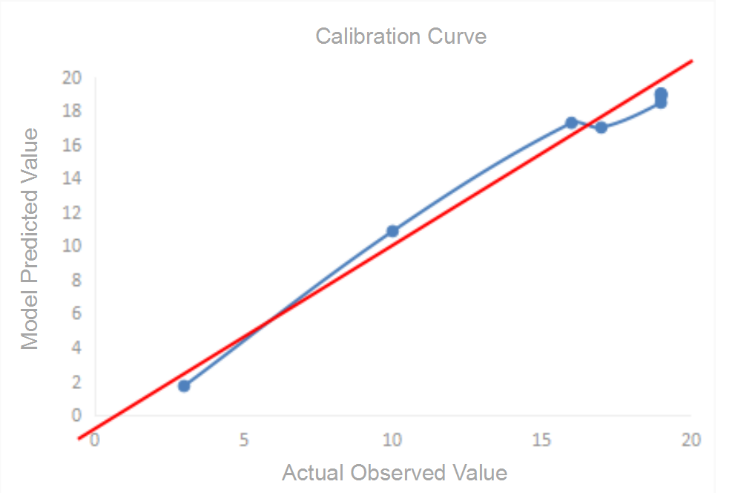
Figure S2. Screenshot of the WeChat mini-program for sarcopenia risk screening in community-dwelling older adults. After the user enters the six input variables (sex, BMI, frequency of physical exercise, duration of each exercise session, serum albumin and total cholesterol), the mini-program automatically computes the individual risk probability of sarcopenia and indicates whether the individual is at high risk (P > 45.22%).
Figure S3. QR code for the WeChat mini-program for sarcopenia risk screening in community-dwelling older adults. Users may scan this QR code with the WeChat application to access the mini-program.

