Supplementary Materials for “DeepMicrobeFinder sorts metagenomes into prokaryotes, eukaryotes and viruses, with marine applications”
Shengwei Hou^{1¶$*}, Siliangyu Cheng^{2$}, Ting Chen³, Jed A. Fuhrman¹, Fengzhu Sun^{2*}

¹ Quantitative and Computational Biology Program, University of Southern California, Los Angeles, CA 90089, USA
² Department of Biological Sciences, University of Southern California, Los Angeles, CA 90089, USA
³ Department of Computer Science and Technology, Institute of Artificial Intelligence & BNRist,
Tsinghua University, Beijing 100084, China
¶ Current address: Department of Ocean Science and Engineering, Southern University of Science and Technology, Shenzhen 518055, China

$ These authors contributed equally as co-first authors
* Correspondence: shengwei@usc.edu (S. Hou) and fsun@usc.edu (F. Sun)

Supplemental Tables

Test Dataset  No. | File Name | PROK:EUK | Prok:ProkVir:Plas | Euk:EukVir | Prokaryote | ProkVirus | Plasmid | Eukaryote | EukVirus | PROK | EUK
0 | 642_128_128_83_16_test.fasta | 9:1 | 5:1:1 | 5:1 | 642 | 128 | 128 | 83 | 16 | 898 | 99
1 | 600_150_150_79_19_test.fasta | 9:1 | 4:1:1 | 4:1 | 600 | 150 | 150 | 79 | 19 | 900 | 98
2 | 540_180_180_74_24_test.fasta | 9:1 | 3:1:1 | 3:1 | 540 | 180 | 180 | 74 | 24 | 900 | 98
3 | 450_225_225_66_33_test.fasta | 9:1 | 2:1:1 | 2:1 | 450 | 225 | 225 | 66 | 33 | 900 | 99
4 | 500_99_99_250_50_test.fasta | 7:3 | 5:1:1 | 5:1 | 500 | 99 | 99 | 250 | 50 | 698 | 300
5 | 466_116_116_240_60_test.fasta | 7:3 | 4:1:1 | 4:1 | 466 | 116 | 116 | 240 | 60 | 698 | 300
6 | 419_139_139_225_75_test.fasta | 7:3 | 3:1:1 | 3:1 | 419 | 139 | 139 | 225 | 75 | 697 | 300
7 | 350_175_175_200_100_test.fasta | 7:3 | 2:1:1 | 2:1 | 350 | 175 | 175 | 200 | 100 | 700 | 300
8 | 357_71_71_416_83_test.fasta | 5:5 | 5:1:1 | 5:1 | 357 | 71 | 71 | 416 | 83 | 499 | 499
9 | 333_83_83_400_100_test.fasta | 5:5 | 4:1:1 | 4:1 | 333 | 83 | 83 | 400 | 100 | 499 | 500
10 | 300_100_100_375_125_test.fasta | 5:5 | 3:1:1 | 3:1 | 300 | 100 | 100 | 375 | 125 | 500 | 500
11 | 250_125_125_333_166_test.fasta | 5:5 | 2:1:1 | 2:1 | 250 | 125 | 125 | 333 | 166 | 500 | 499
12 | 214_42_42_583_116_test.fasta | 3:7 | 5:1:1 | 5:1 | 214 | 42 | 42 | 583 | 116 | 298 | 699
13 | 199_49_49_559_139_test.fasta | 3:7 | 4:1:1 | 4:1 | 199 | 49 | 49 | 559 | 139 | 297 | 698
14 | 180_60_60_524_175_test.fasta | 3:7 | 3:1:1 | 3:1 | 180 | 60 | 60 | 524 | 175 | 300 | 699
15 | 150_75_75_466_233_test.fasta | 3:7 | 2:1:1 | 2:1 | 150 | 75 | 75 | 466 | 233 | 300 | 699
16 | 71_14_14_750_150_test.fasta | 1:9 | 5:1:1 | 5:1 | 71 | 14 | 14 | 750 | 150 | 99 | 900
17 | 66_16_16_720_180_test.fasta | 1:9 | 4:1:1 | 4:1 | 66 | 16 | 16 | 720 | 180 | 98 | 900
18 | 60_20_20_675_225_test.fasta | 1:9 | 3:1:1 | 3:1 | 60 | 20 | 20 | 675 | 225 | 100 | 900
19 | 50_25_25_600_300_test.fasta | 1:9 | 2:1:1 | 2:1 | 50 | 25 | 25 | 600 | 300 | 100 | 900
Supplemental Table S1. The composition of test datasets used in this study for benchmarking different tools. PROK includes prokaryotic genomes, plasmids and prokaryotic viruses; EUK includes eukaryotic genomes and viruses. Prok: prokaryotic genomes, ProkVir: prokaryotic viruses/phages, Plas: plasmids, Euk: eukaryotic genomes, EukVir: eukaryotic viruses. Test files were named using the number of sampled sequences from each sequence class following the rule: Prok_ProkVir_Plas_Euk_EukVir_test.fasta, which can be found at dx.doi.org/10.6084/m9.figshare.14576193.

Supplemental Figures
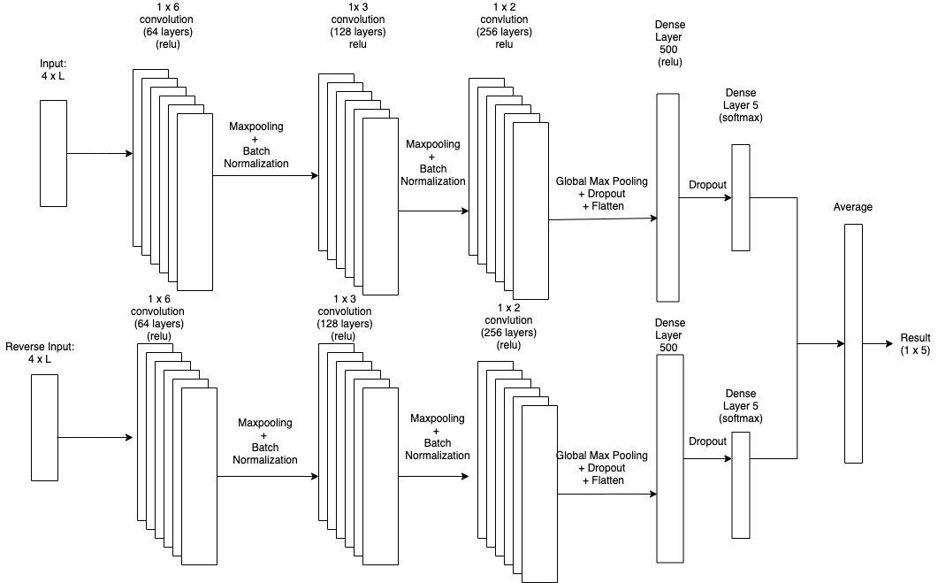
Supplemental Figure S1. Schematic representation of the multi-class CNN structure used in this study. The hyperparameters used for each layer are: a) 64 filters with a kernel size of 6 were used for convolution layer 1, followed by relu activation, b) the stride and pooling size were set to 2 for max pooling layer 1, c) 128 filters with a kernel size of 3 were used for convolution layer 2, followed by relu activation, d) the stride was set to 1 and the pooling size was set to 2 for max pooling layer 2, e) 256 filters with a kernel size of 2 were used for convolution layer 3, followed by relu activation, f) a dropout threshold of 0.1 was used for drop out layers, g) 500 hidden units were chosen for the first dense layer, followed by relu activation, h) 5 hidden units were chosen for the last dense layer, followed by softmax activation.

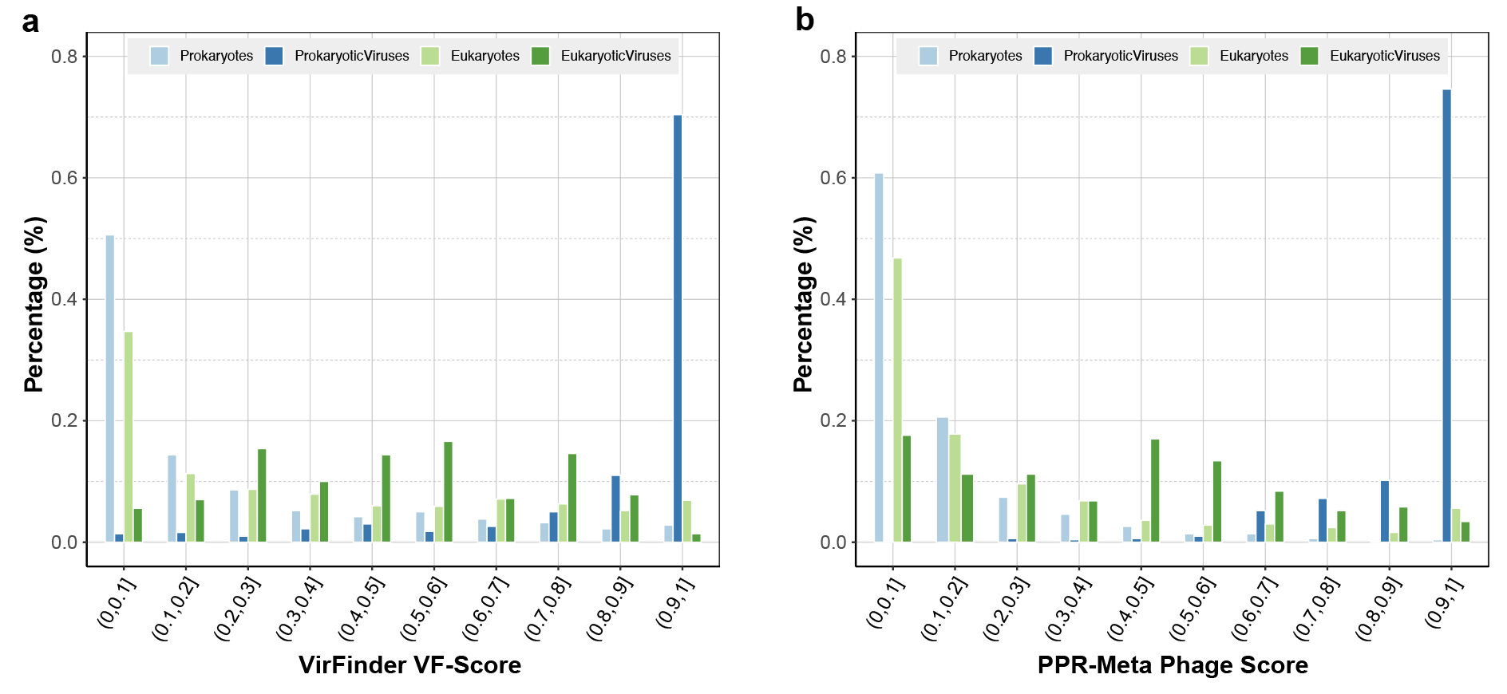
Supplemental Figure S2. The distribution of viral confidence scores for (a) VirFinder and (b) PPR-Meta. For both predictors, the same dataset was used and the predictions were performed with default parameters. VirFinder uses VF-Scores to determine the likelihood of input sequences to be viral or not, and PPR-Meta uses phage scores to discern viruses from host chromosomes and plasmids. Both predictors achieved a high recall for prokaryotic viruses, while the confidence scores of eukaryotic viruses were more evenly spreaded across all confidence regions. Besides, both predictors achieved a high performance in distinguishing prokaryotic host sequences from prokaryotic viruses, but less so for eukaryotic host sequences.

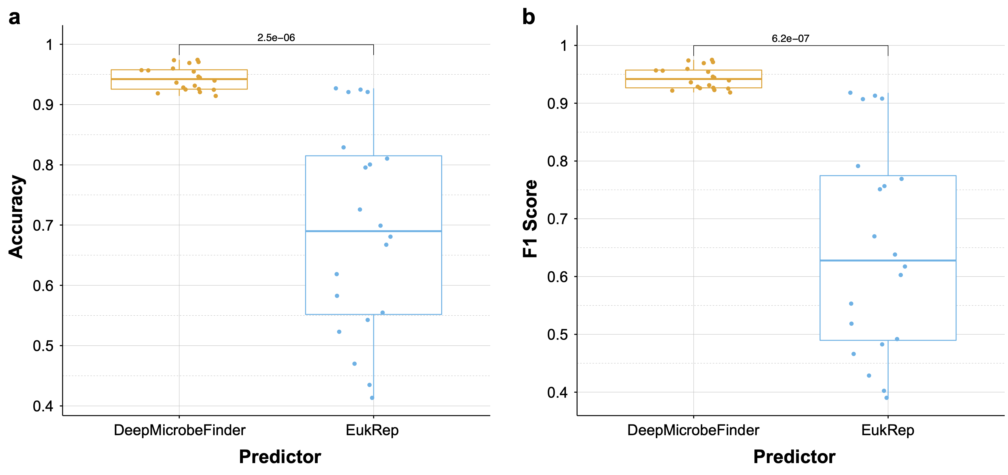
Supplemental Figure S3. Performance of DeepMicrobeFinder and EukRep on eukaryotic sequence classification. Both the accuracy (a) and F1 score (b) were compared based on 20 designed test datasets. The sequence class composition of the 20 test datasets can be found in supplemental table 1. Values on top of the pairwise comparisons are Bonferroni adjusted t-test p-values.
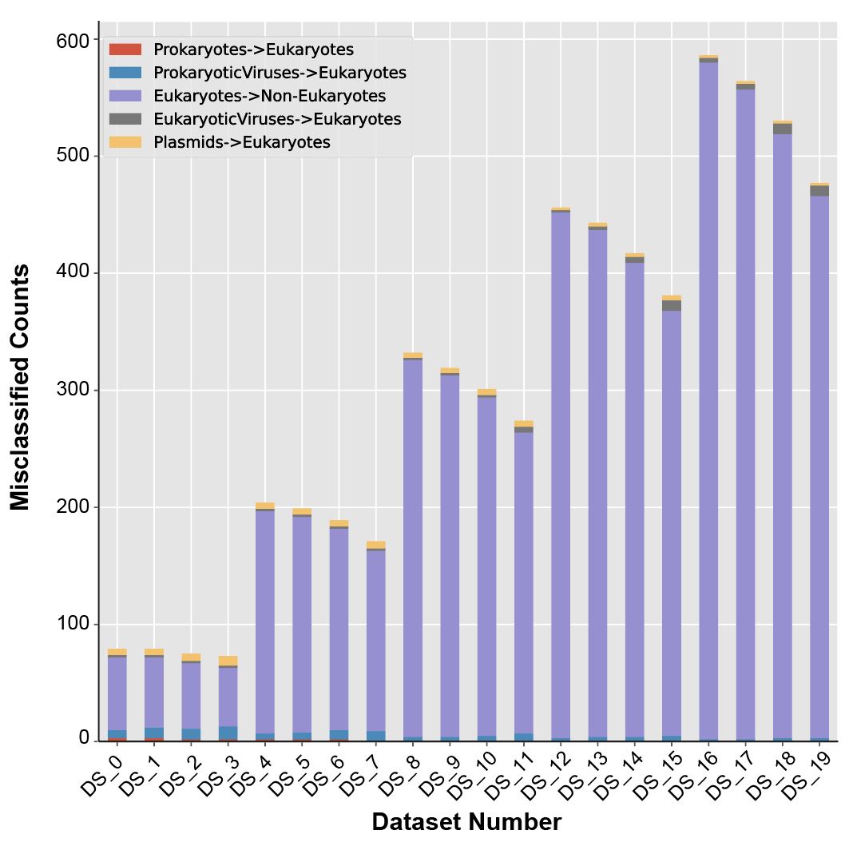
Supplemental Figure S4. The distribution of misclassified sequence types by EukRep. The sequence composition of these datasets can be found in supplementary table S1.
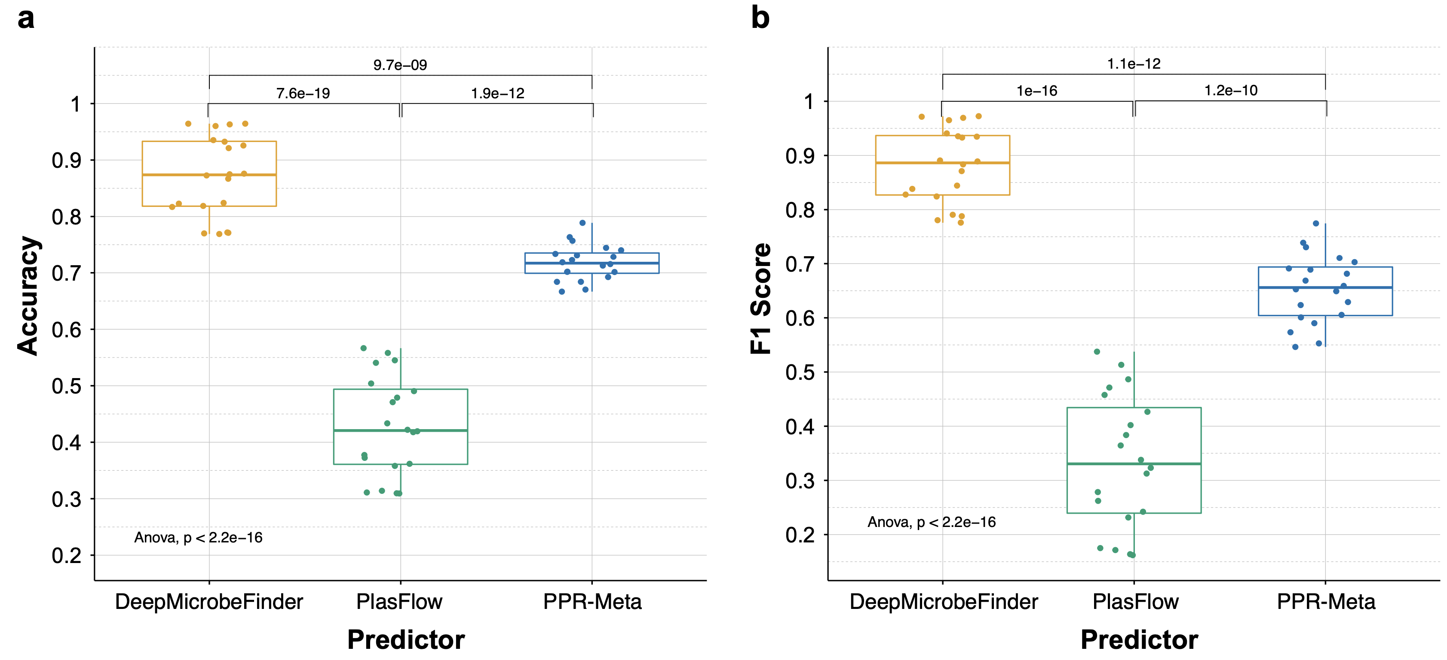
Supplemental Figure S5. Performance of DeepMicrobeFinder, PlasFlow, and PPR-Meta on plasmid sequence classification. Both the accuracy (a) and F1 score (b) were compared based on 20 designed test datasets. The sequence class composition of the 20 test datasets can be found in supplemental table 1. Values on top of the pairwise comparisons are Bonferroni adjusted t-test p-values. The significance of the overall ANOVA test was shown on the bottom left corner.
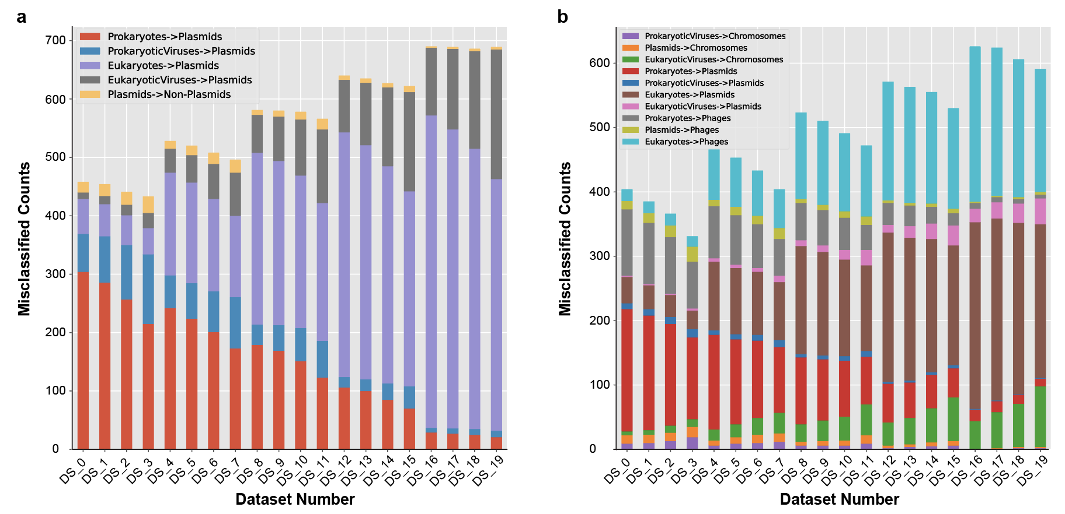
Supplemental Figure S6. The distribution of misclassified sequence types by PlasFlow (a) and PPR-Meta (b). The sequence composition of these datasets can be found in supplementary table S1. For each dataset, the total number of test sequences is 1000.

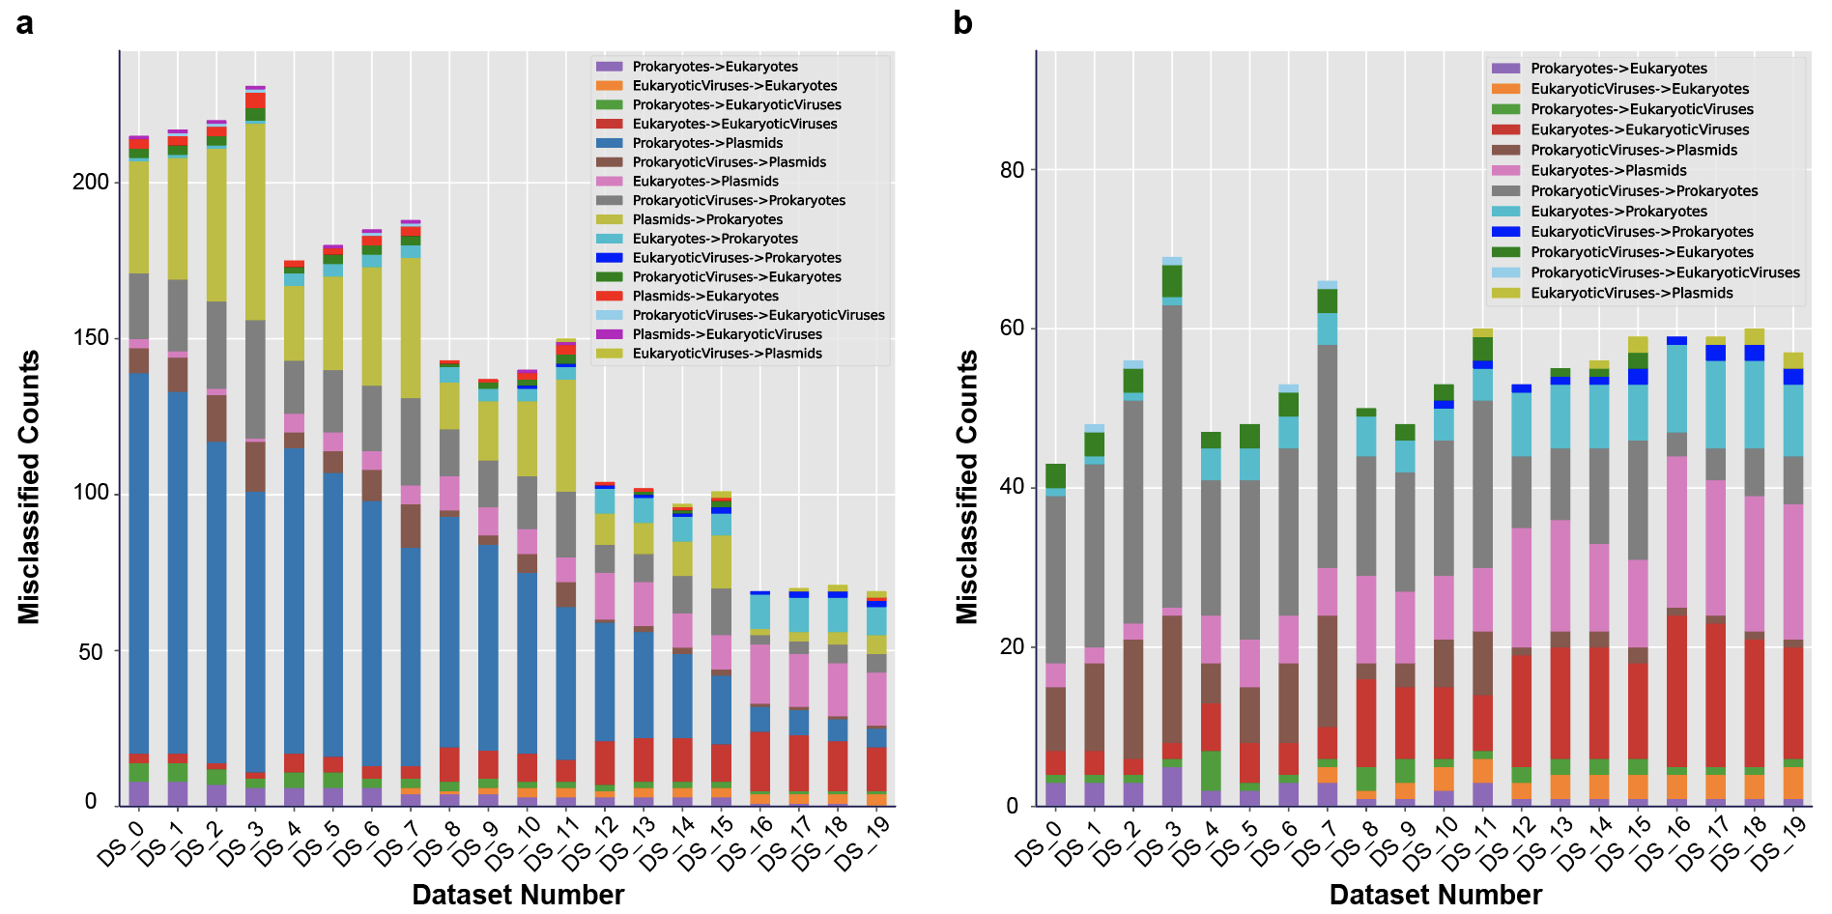
Supplemental Figure S7. The distribution of misclassified sequence types by DeepMicrobeFinder. Sequences were classified into 5 classes (a) or 4 classes by collapsing prokaryotic hosts and plasmids into prokaryotes (b). The sequence composition of these datasets can be found in supplementary table S1. For each dataset, the total number of test sequences is 1000.
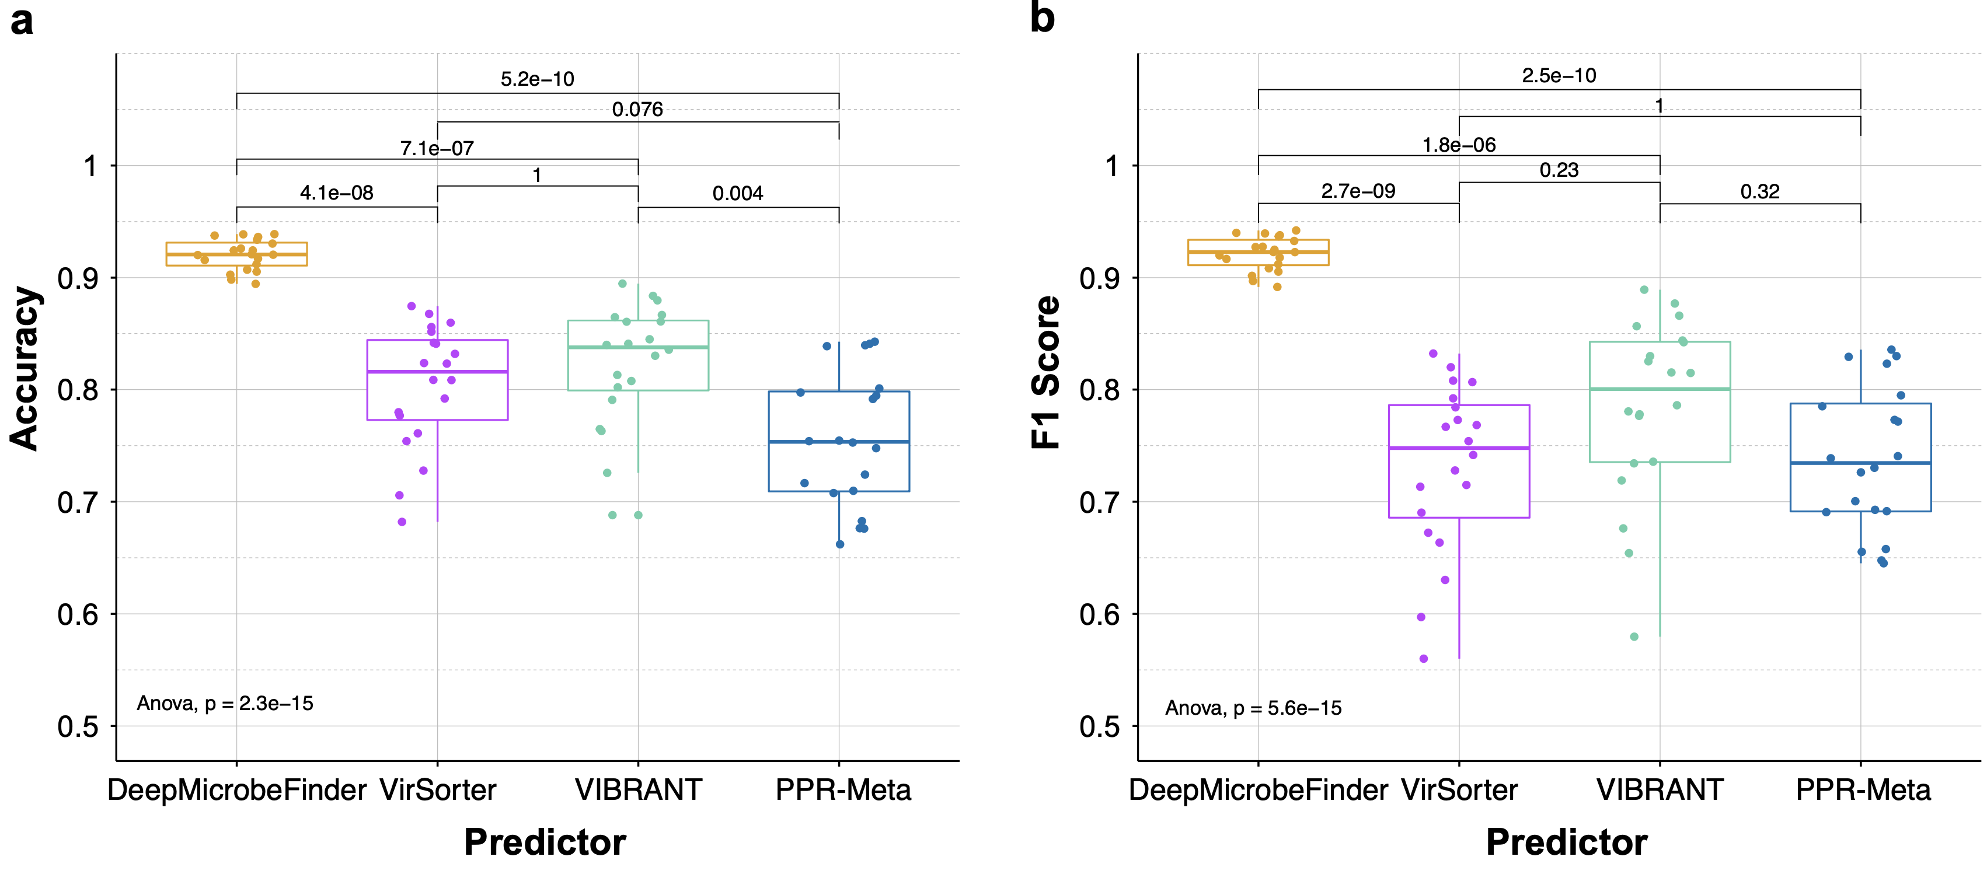
Supplemental Figure S8. Performance of DeepMicrobeFinder, VirSorter, VIBRANT, and PPR-Meta on viral sequence classification. Both the accuracy (a) and F1 score (b) were compared based on 20 designed test datasets. The sequence class composition of the 20 test datasets can be found in supplemental table 1. Values on top of the pairwise comparisons are Bonferroni adjusted t-test p-values. The significance of the overall ANOVA test was shown on the bottom left corner.

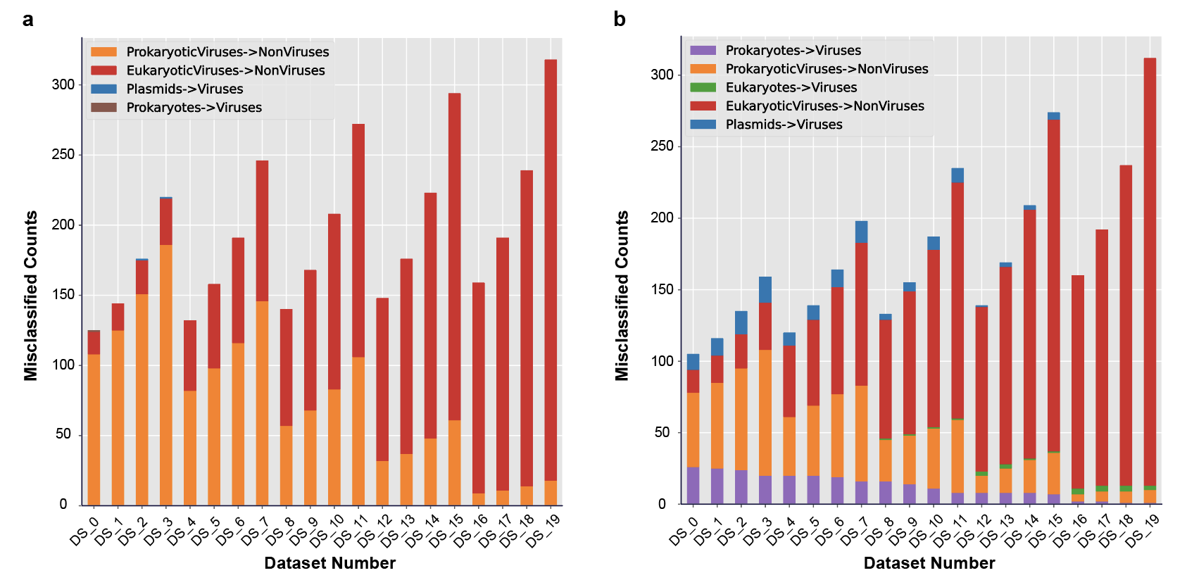
Supplemental Figure S9. The distribution of misclassified sequence types by VirSorter (a) and VIBRABT (b). The sequence composition of these datasets can be found in supplementary table S1. For each dataset, the total number of test sequences is 1000.
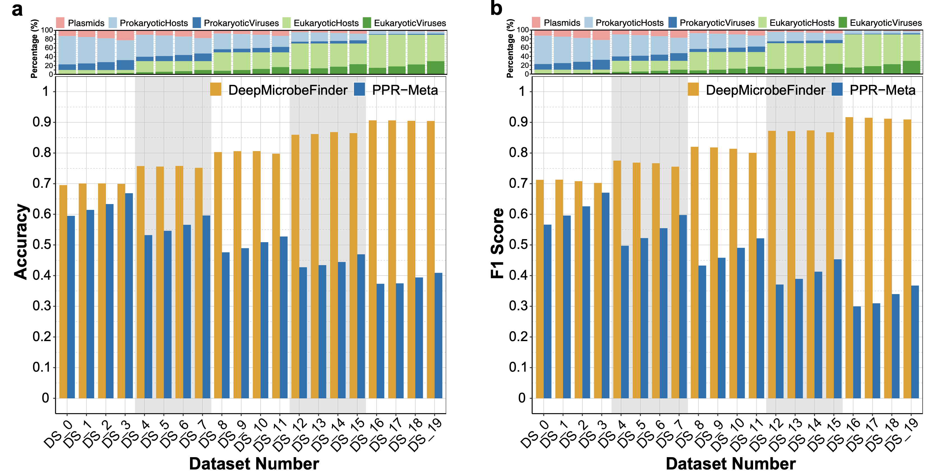

Figure 10. Distribution of (a) accuracy and (b) F1 scores across 20 test datasets for DeepMicrobeFinder and PPR-Meta on multiclass contig classification. DeepMicrobeFinder received higher scores in both accuracy and F1 score in all tested scenarios compared to PPR-Meta. DeepMicrobeFinder showed improved performance with increasing fractions of eukaryotic related sequences, while the performance of PPR-Meta severely degraded.
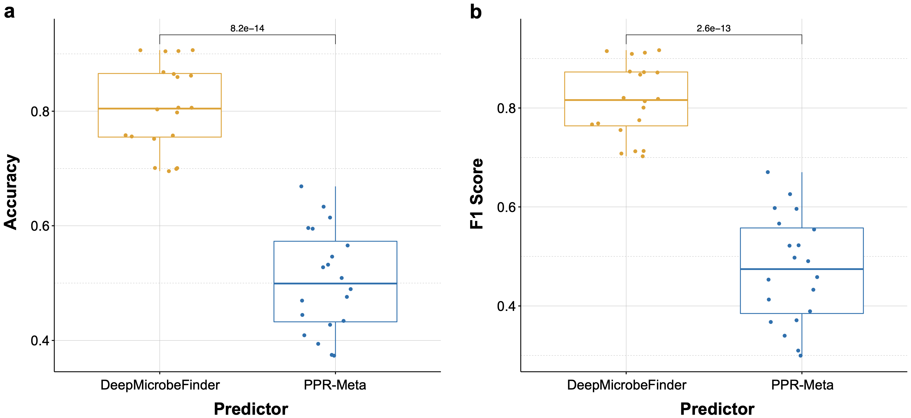
Supplemental Figure S11. Performance of DeepMicrobeFinder and PPR-Meta on multiclass sequence classification. Both the accuracy (a) and F1 score (b) were compared based on 20 designed test datasets. The sequence class composition of the 20 test datasets can be found in supplemental table 1.

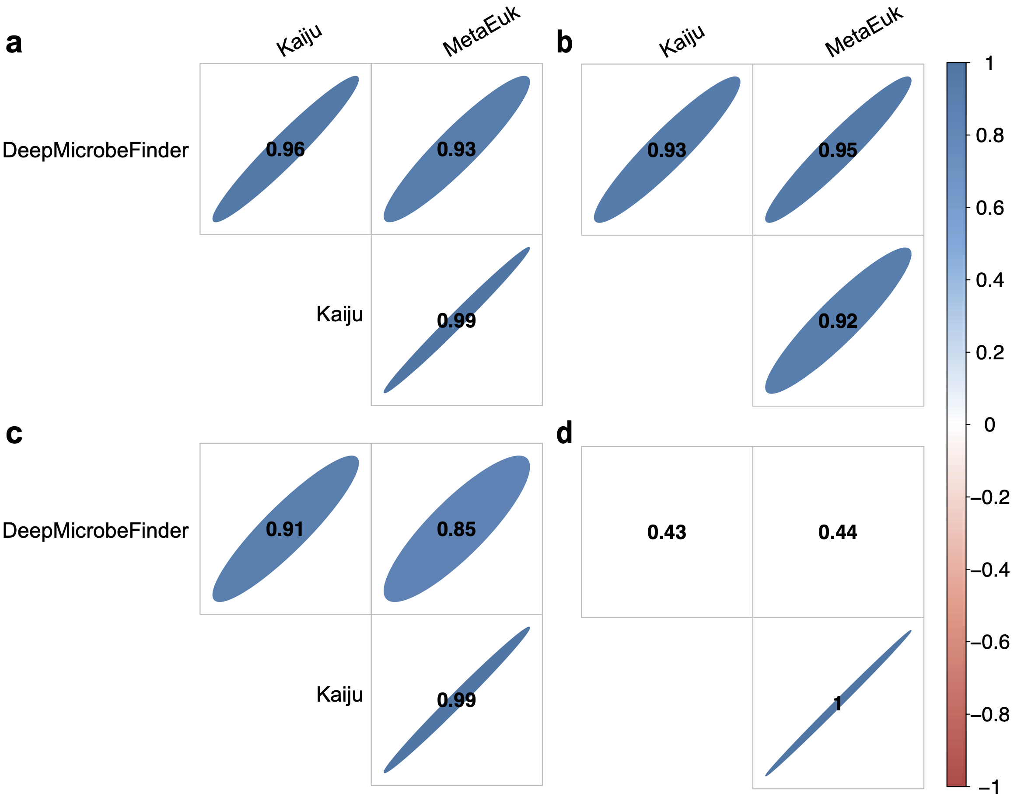
Supplemental Figure S12. Correlation coefficients of Prokaryotic (a), Eukaryotic (b), ProkaryoticViral (c), and EukaryoticViral (d) sequence relative abundances of different sequence classifiers. Coefficients highlighted in colors are significant ones (p-value < 0.01).

