Supplementary material

Mutagenic Potential of Lead Nitrate and Cadmium Nitrate for Generating Genetic Variability in Grain Amaranth (Amaranthus hypochondriacus L.)

Dinesh Chandra Joshi*, Nazarul Hasan*, Mahendar Singh Bhinda, Ramesh Singh Pal, Nirmal Kumar Hedau & Lakshmi Kant
ICAR-Vivekananda Institute of Hill Agriculture, Almora, Uttarakhand, India-263601

Correspondence: Dr. Dinesh Chandra Joshi
Authors for Correspondence: dinesh.pbl@gmail.com , dinesh.joshi@icar.org.in & nazarulpasha143@gmail.com

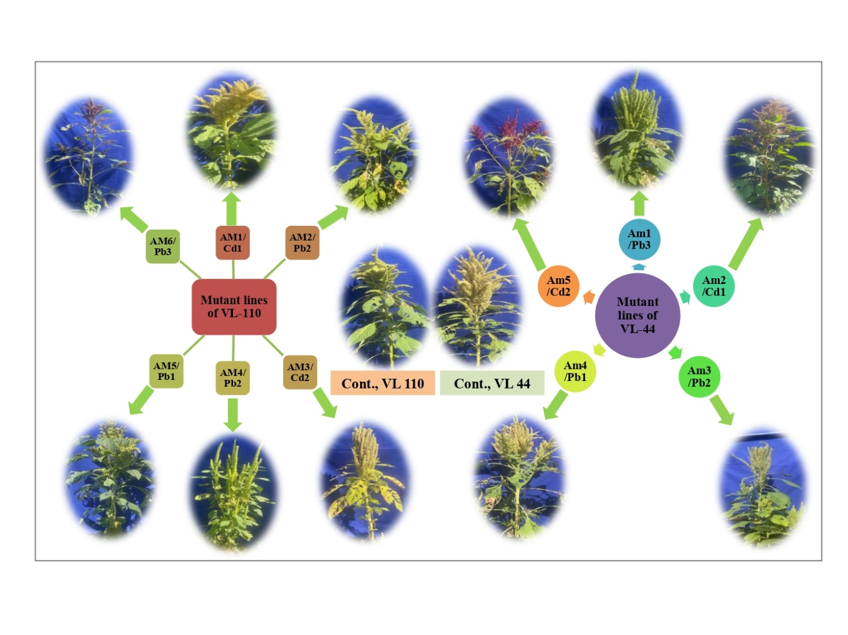
Figure S1: Mutants of grain amaranth with significant morphological variations selected from effective doses of Cd(NO₃)₂ and Pb(NO₃)₂ mutagens.
Effective doses: Cd1/Pb1: 10ppm, Cd2/Pb2: 20ppm and Cd3/Pb3: 30ppm

Supplementary table S1: Description of mutant lines grown/selected from M₁ to M₃ generation in Var. VL-44 and Var. VL-110 varieties.
Mutagen  Cd(NO₃)₂/  Pb(NO₃)₂ | M₁ |  |  | M₂ |  |  |  | M₃
Mutagen  Cd(NO₃)₂/  Pb(NO₃)₂ | Seed Treated | Seeds Germinated | Fertile Plants | M₂ Lines | Total M₂ Seeds | Seeds Germinated | Fertile Plants | M₃ Lines | Total M₃  Seeds | Seeds Germinated | Fertile Plants
Var. VL-44
Control* | 250 | 249 | 249 | 249 | 7145 | 7016 | 6984 | 600 | 610 | 604 | 604
 | Lead Nitrate [Pb(NO₃)₂]
10ppm | 250 | 247 | 245 | 245 | 7345 | 7125 | 7065 | 582 | 512 | 503 | 501
20ppm | 250 | 245 | 242 | 242 | 7212 | 6934 | 6815 | 546 | 505 | 500 | 495
30ppm | 250 | 242 | 238 | 238 | 7102 | 6718 | 6600 | 500 | 495 | 489 | 482
40ppm | 250 | 238 | 233 | 233 | 6934 | 6538 | 6385 | 425 | 488 | 482 | 476
50ppm | 250 | 232 | 227 | 227 | 6712 | 6294 | 6127 | 340 | 480 | 473 | 465
 | Cadmium Nitrate [Cd(NO₃)₂]
10ppm | 250 | 245 | 242 | 242 | 7214 | 7016 | 6974 | 580 | 508 | 500 | 496
20ppm | 250 | 237 | 233 | 233 | 7156 | 6800 | 6692 | 535 | 500 | 494 | 492
30ppm | 250 | 231 | 227 | 227 | 7067 | 6528 | 6348 | 486 | 488 | 482 | 476
40ppm | 250 | 224 | 219 | 219 | 6852 | 6210 | 6000 | 414 | 480 | 472 | 469
50ppm | 250 | 215 | 209 | 209 | 6612 | 5944 | 5728 | 335 | 471 | 463 | 458
Var. VL-110
 | Lead Nitrate [Pb(NO₃)₂]
10ppm | 250 | 242 | 238 | 238 | 7508 | 7365 | 7270 | 592 | 504 | 490 | 490
20ppm | 250 | 236 | 231 | 231 | 7458 | 7212 | 7100 | 565 | 497 | 484 | 483
30ppm | 250 | 227 | 221 | 221 | 7306 | 7002 | 6842 | 516 | 486 | 471 | 466
40ppm | 250 | 216 | 210 | 210 | 7130 | 6842 | 6586 | 453 | 475 | 460 | 453
50ppm | 250 | 204 | 198 | 198 | 6810 | 6560 | 6215 | 398 | 462 | 448 | 438
 | Cadmium Nitrate [Cd(NO₃)₂]
10ppm | 250 | 232 | 227 | 227 | 7414 | 7248 | 7165 | 585 | 500 | 482 | 472
20ppm | 250 | 226 | 218 | 218 | 7250 | 7008 | 6892 | 552 | 491 | 472 | 463
30ppm | 250 | 211 | 202 | 202 | 7136 | 6814 | 6647 | 502 | 476 | 459 | 446
40ppm | 250 | 195 | 186 | 186 | 7090 | 6523 | 6423 | 434 | 462 | 442 | 433
50ppm | 250 | 182 | 171 | 171 | 6815 | 6216 | 6142 | 376 | 448 | 431 | 418
Pooled total | 5,250 | 4,776 | 4,666 | 4,666 | 1,42,123 | 1,34897 | 1,25,174 | 9,264 | 10,338 | 10,101 | 9,976
*for control set, 250 seeds were sown in same field.
Supplementary table S2: Frequency of chlorophyll mutants in M₁ and M₂ populations of Var. VL-44 and Var. VL-110.
Mutagen/  Dose | Var. VL-44 |  |  |  |  |  | Var. VL-110
Mutagen/  Dose | No of M₁ progeny |  | No. of M₂ seedling |  | Mutation frequency |  | No of M₁ progeny |  | No. of M₂ seedling |  | Mutation frequency
Mutagen/  Dose | Scored | Segregated | Scored | Segregated | Per 100 M₁ plants | Per 100 M₂ plants | Scored | Segregated | Scored | Segregated | Per 100 M₁ plants | Per 100 M₂ plants
Control | - | - | - | - | - | - | - | - | - | - | - | -
Cadmium Nitrate [Cd(NO₃)₂]
10ppm | 20 | 4 | 840 | 22 | 20.00 | 2.62 | 20 | 5 | 845 | 23 | 25.00 | 2.72
20ppm | 20 | 5 | 840 | 27 | 25.00 | 3.21 | 20 | 8 | 845 | 29 | 40.00 | 3.43
30ppm | 20 | 7 | 840 | 24 | 35.00 | 2.86 | 20 | 7 | 820 | 26 | 35.00 | 3.17
40ppm | 20 | 4 | 825 | 25 | 20.00 | 3.03 | 20 | 6 | 820 | 25 | 30.00 | 3.05
50ppm | 20 | 6 | 768 | 23 | 30.00 | 2.99 | 20 | 6 | 780 | 23 | 30.00 | 2.95
Lead Nitrate [Pb(NO₃)₂]
10ppm | 20 | 5 | 840 | 24 | 25.00 | 2.86 | 20 | 6 | 850 | 25 | 30.00 | 2.94
20ppm | 20 | 7 | 840 | 28 | 35.00 | 3.33 | 20 | 9 | 850 | 30 | 45.00 | 3.53
30ppm | 20 | 6 | 850 | 26 | 30.00 | 3.06 | 20 | 8 | 835 | 28 | 40.00 | 3.35
40ppm | 20 | 4 | 834 | 25 | 20.00 | 3.00 | 20 | 6 | 820 | 27 | 30.00 | 3.29
50ppm | 20 | 5 | 780 | 24 | 25.00 | 3.08 | 20 | 6 | 800 | 26 | 30.00 | 3.25

Supplementary table S3: Frequency and relative percentage M₁ plant progenies segregating for single and multiple chlorophyll mutants in M₂ populations of Var. VL-44 and Var. VL-110.
Mutagen/  dose | Var. VL-44 |  |  |  |  |  |  | Var. VL-110
Mutagen/  dose | M₁ plant progeny segregating | Frequency |  |  | Relative percent |  |  | M₁ plant progeny segregating | Frequency |  |  | Relative percent
Mutagen/  dose | M₁ plant progeny segregating | One types | Two types | Three  types | One types | Two types | Three  types | M₁ plant progeny segregating | One types | Two types | Three  types | One types | Two types |  | Three  types
Control | - | - | - | - | - | - | - | - | - | - | - | - | - |  | -
Cadmium Nitrate [Cd(NO₃)₂]
10ppm | 4 | 1 | 2 | 1 | 25.00 | 50.00 | 25.00 | 5 | 2 | 3 | - | 40.00 | 60.00 |  | -
20ppm | 5 | 1 | 3 | 1 | 20.00 | 60.00 | 20.00 | 8 | 3 | 2 | 3 | 37.50 | 25.00 |  | 37.50
30ppm | 7 | 3 | 2 | 2 | 42.86 | 28.57 | 28.57 | 7 | 1 | 4 | 2 | 14.29 | 57.14 |  | 28.57
40ppm | 4 | 2 | - | 2 | 50.00 | 0.00 | 50.00 | 6 | 2 | 4 | - | 33.33 | 66.66 |  | -
50ppm | 6 | - | 1 | - | - | 100.00 | - | 6 | 1 | - | 5 | 16.66 | - |  | 83.33
Lead Nitrate [Pb(NO₃)₂]
10ppm | 5 | 2 | 3 | - | 40.00 | 60.00 | - | 6 | 3 | 2 | 1 | 50.00 | 33.33 | 16.67
20ppm | 7 | 3 | 1 | 3 | 42.86 | 14.29 | 42.86 | 9 | 2 | 4 | 3 | 22.22 | 44.44 | 33.33
30ppm | 6 | 2 | 3 | 1 | 33.33 | 50.00 | 16.67 | 8 | - | 5 | 3 | - | 62.50 | 37.50
40ppm | 4 | - | 2 | 2 | - | 50.00 | 50.00 | 6 | 4 | 2 | - | 66.66 | 33.33 | -
50ppm | 5 | 3 | - | 2 | - | 60.00 | 40.00 | 7 | 2 | - | 5 | 28.57 | - | 71.42

