Supplementary Figures
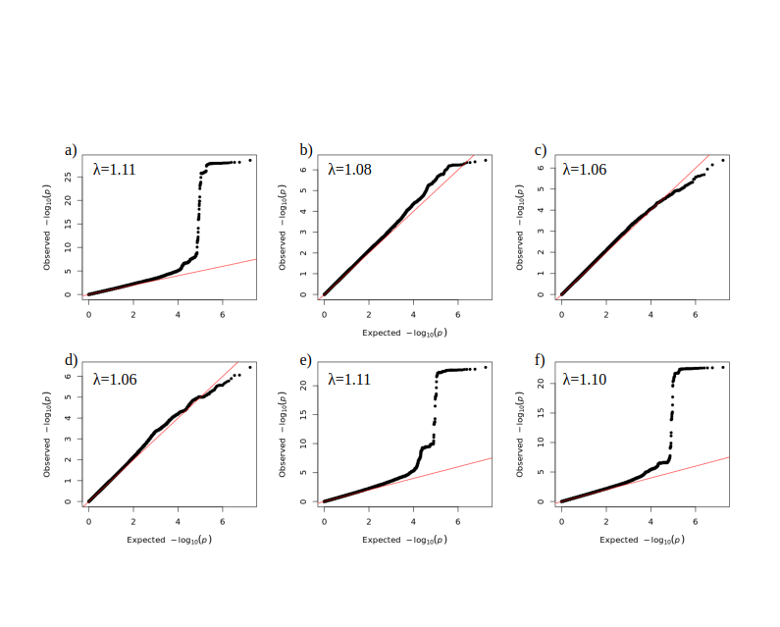
Supplementary Figure S1. GWAS analyses Quantile-Quantile plots and Lambda (λ) values for a) Higher ED risk b) Make yourself sick c) Lost > 6 kg d) Feel fat e) Lost control f) Food dominates.

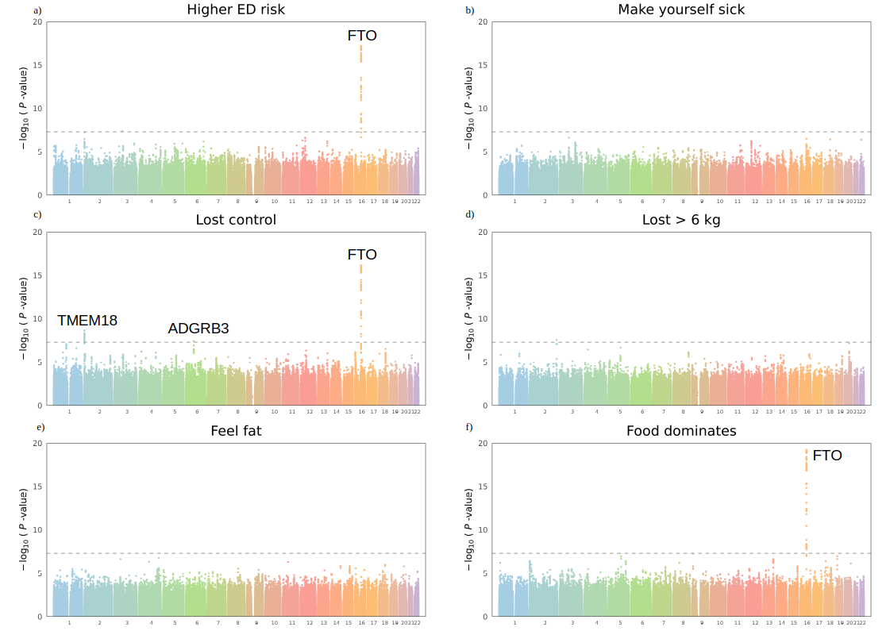
Supplementary Figure S2. Manhattan plots for higher ED risk and five SCOFF item based GWASs among females. The x-axis represents chromosomes 1 to 22, the y-axis shows –log10(P-value) for the association of genetic variants detected in GWAS. The gray dashed line is a genome-wide significance threshold of p-value of <5×10⁻⁸. For each lead SNP in genetic risk loci above GWAS threshold, the nearest genes were prioritized (marked on the figure).

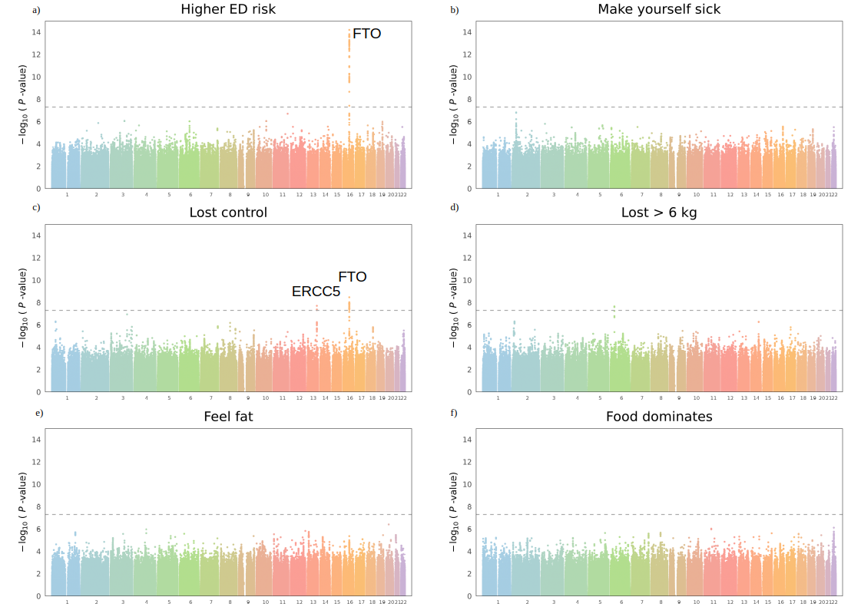
Supplementary Figure S3. Manhattan plots for higher ED risk and five SCOFF item based GWASs among males. The x-axis represents chromosomes 1 to 22, the y-axis shows –log10(P-value) for the association of genetic variants detected in GWAS. The gray dashed line is a genome-wide significance threshold of p-value of <5×10⁻⁸. For each lead SNP in genetic risk loci above GWAS threshold, the nearest genes are marked.

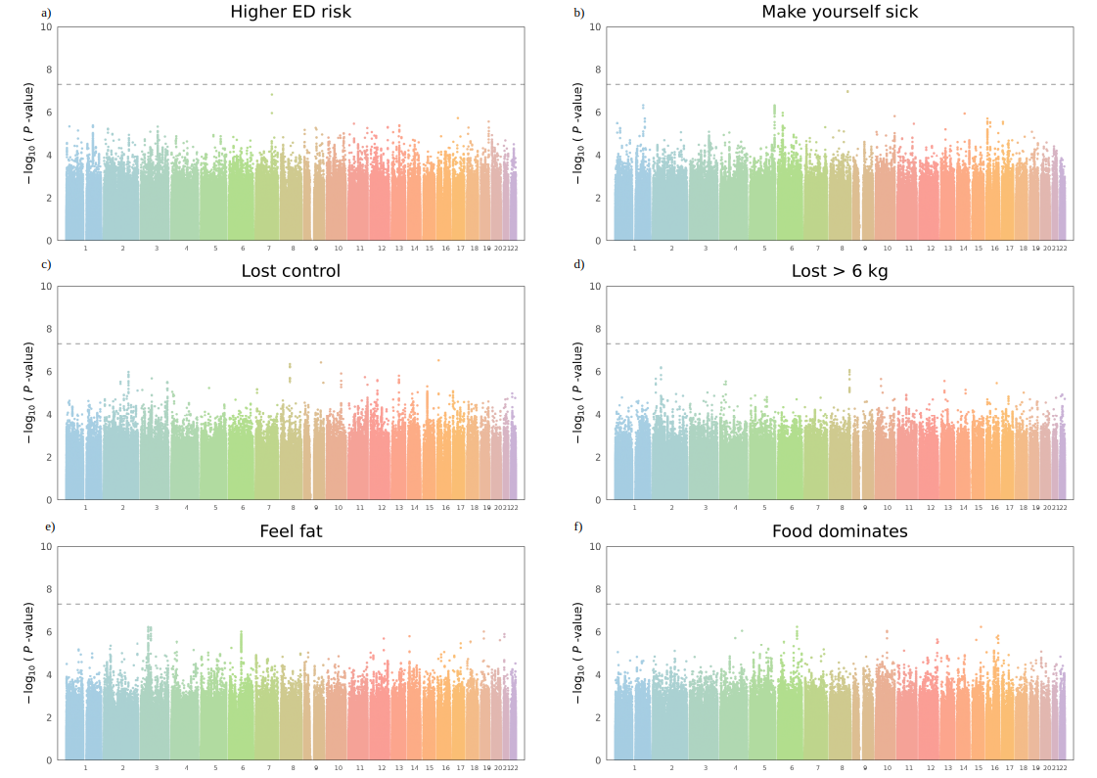
Supplementary Figure S4. Manhattan plots for higher ED risk and five SCOFF item based GWASs among underweight/normal BMI (<25 kg/m²). The x-axis represents chromosomes 1 to 22, the y-axis shows –log10(P-values) for the association of genetic variants detected in GWAS. The gray dashed line is a genome-wide significance threshold of p-value of <5×10⁻⁸. For each lead SNP in genetic risk loci above GWAS threshold, the nearest genes are marked.

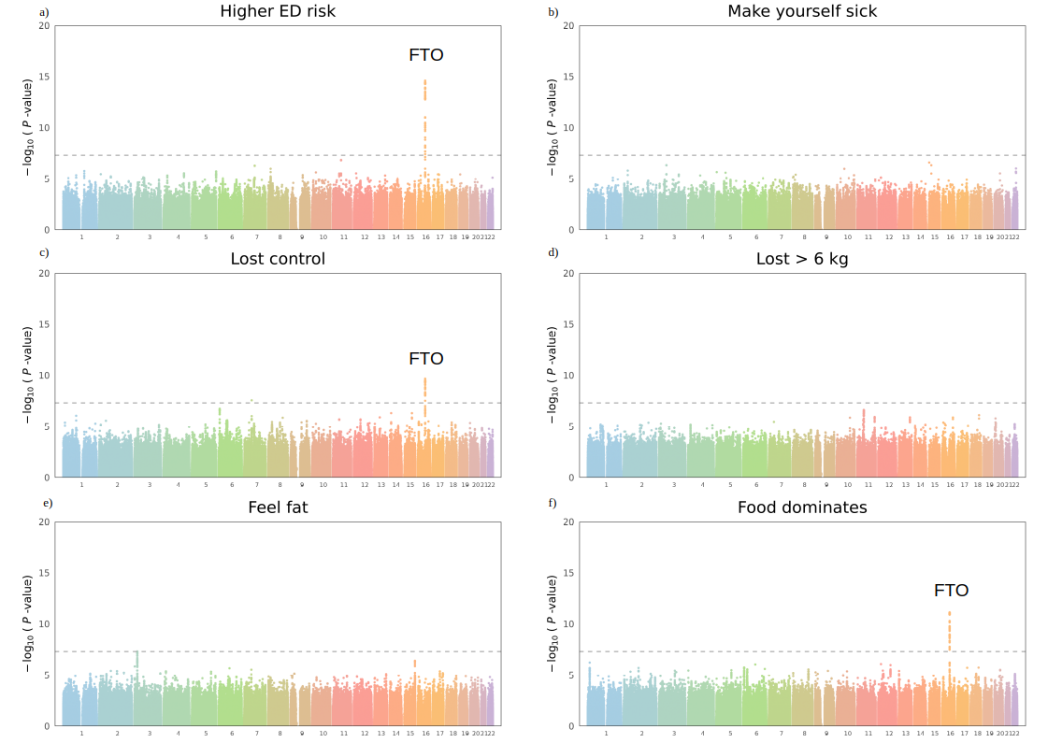
Supplementary Figure S5. Manhattan plots for higher ED risk and five SCOFF item based GWASs among overweight/obese BMI (≥25 kg/m²) group. The x-axis represents chromosomes 1 to 22, the y-axis shows –log10(P-values) for the association of genetic variants detected in GWAS. The gray dashed line is a genome-wide significance threshold of p-value of <5×10⁻⁸. For each lead SNP in genetic risk loci above GWAS threshold, the nearest genes are marked.

