Supplementary Information

Microplastics as carrier for polycyclic aromatic hydrocarbons? A case study investigating the relevance of the carrier effect for human health.

Amelie Vogel^{a,b}, Lauren Greenª, Martin Wiemann^{c}, Alexander Roloffª, Mario Pinkª, Holger Sieg^{d}, Wendel Wohlleben^{e,f}, Andrea Haase^{a,g,h}

ªGerman Federal Institute for Risk Assessment, Department of Chemical and Product Safety, Berlin, Germany
^{b}Technische Universität Berlin, Food Chemistry and Toxicology, Berlin, Germany
^{c}IBR R&D Institute for Lung Health gGmbH, Muenster, Germany
^{d}German Federal Institute for Risk Assessment, Department of Food and Feed Safety in the Food Chain
^{e}BASF SE, Dept. Chemical, Material and Regulatory Sciences, Ludwigshafen, Germany
^{f}current address: German Federal Institute for Occupational Safety and Health (BAuA), Berlin, Germany
^{g}Freie Universität Berlin, Institute of Pharmacy, Berlin, Germany
^{h}University of the Western Cape (UWC), Department of Chemical Sciences, Bellville, Cape Town, South Africa

Corresponding author:
Andrea Haase, andrea.haase@bfr.bund.de

Number of pages: 9
Number of figures: 10
Number of tables: 4

1. Verifying the fluorescence labelling stability of PA-6 particles with Alexa Fluor™ 633
To verify the labelling stability of fluorescently Alexa Fluor™ 633-dyed PA-6_{7µm}, particles were incubated for 24 h in complete cell culture medium (CCM) at a concentration of 100 µg/mL. Subsequently, the particles were pelleted by centrifugation (30 min, 14,000 × g), and the resulting supernatant was transferred to CaCo-2 cells, without particles. Cells were exposed to the supernatant for 24 h. In the event of dye leaching, free Alexa Fluor™ 633 present in the CCM supernatant would have been internalized by the cells and accumulated in liposomes. To assess this, single-cell fluorescence was analysed by flow cytometry using the same instrument settings (e.g., voltages and gates) as applied for the cell culture experiments. Percentage of positive cells was 0.24%, confirming that no significant amounts of Alexa dye leached from PA-6_{7µm} particles during incubation (s. Fig. S1).

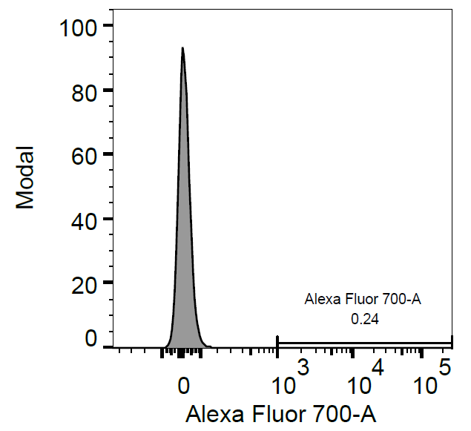
Figure S1: Verification of the labelling stability of PA-6 particles with Alexa Fluor™ 633 using flow cytometry.

2. Investigations on cytochrome P450 1A1 (CYP1A1) induction
Table S1: Primers used for quantitative Real-Time-PCR
Primer | Sequence
CYP1A1 forward | 5’-CCA AGA GTC CAC CCT TCC CAG CT -3’
CYP1A1 reverse | 5’-GAG GCC AGA AGA AAC TCC GTG GC -3’
HPRT forward | 5’-GTT CTG TGG CCA TCT GCT TAG -3’
HPRT reverse | 5’-GCC CAA AGG GAA CTG ATA GTC-3’

3. Quantification of benzo(a)pyrene (B(a)P) by GC-MS
Table S2: Conversion of GC-MS calibration concentrations (ng/mL) into absolute B(a)P amounts in CCM and cell pellets
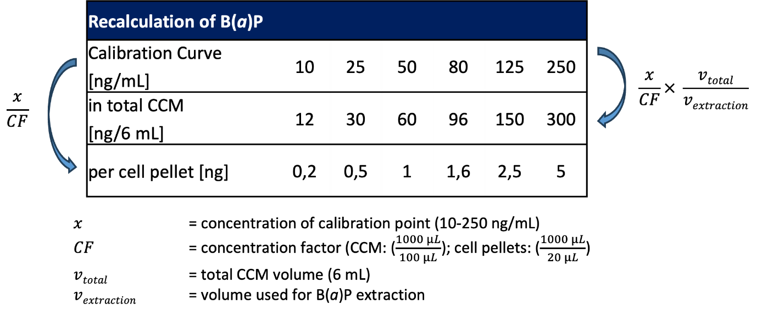
Table S3: Quantifier and qualifier mass-to-charge ratio (m/z) of the analytes and their corresponding internal standards
 | Quantifier [m/z] | Qualifier [m/z] | Qualifier Ratio
Benzo(a)pyrene | 252 | 250 | 22.1
Benzo(a)pyrene-d12 | 264 | 260 | 17.5
*range was calculated by MassHunter software (V. B.06.00)
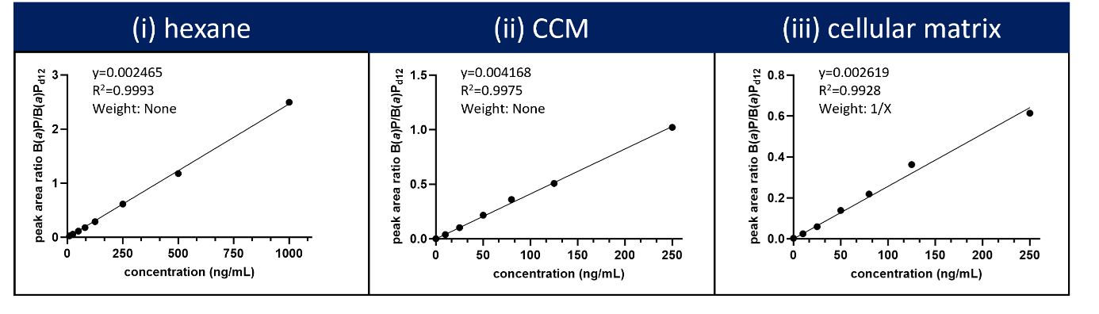
Figure S2: Representative GC-MS calibration curves for benzo(a)pyrene (B(a)P) in (i) hexane, (ii) cell culture medium (CCM) and (iii) cellular matrix. The peak area ratios of B(a)P and B(a)P_{d12} are plotted as a function of the analyte concentration in ng/mL. Calibration curves were analyzed using MassHunter software (version B.06.00).

4. Initial screening of different environmental relevant MNPs

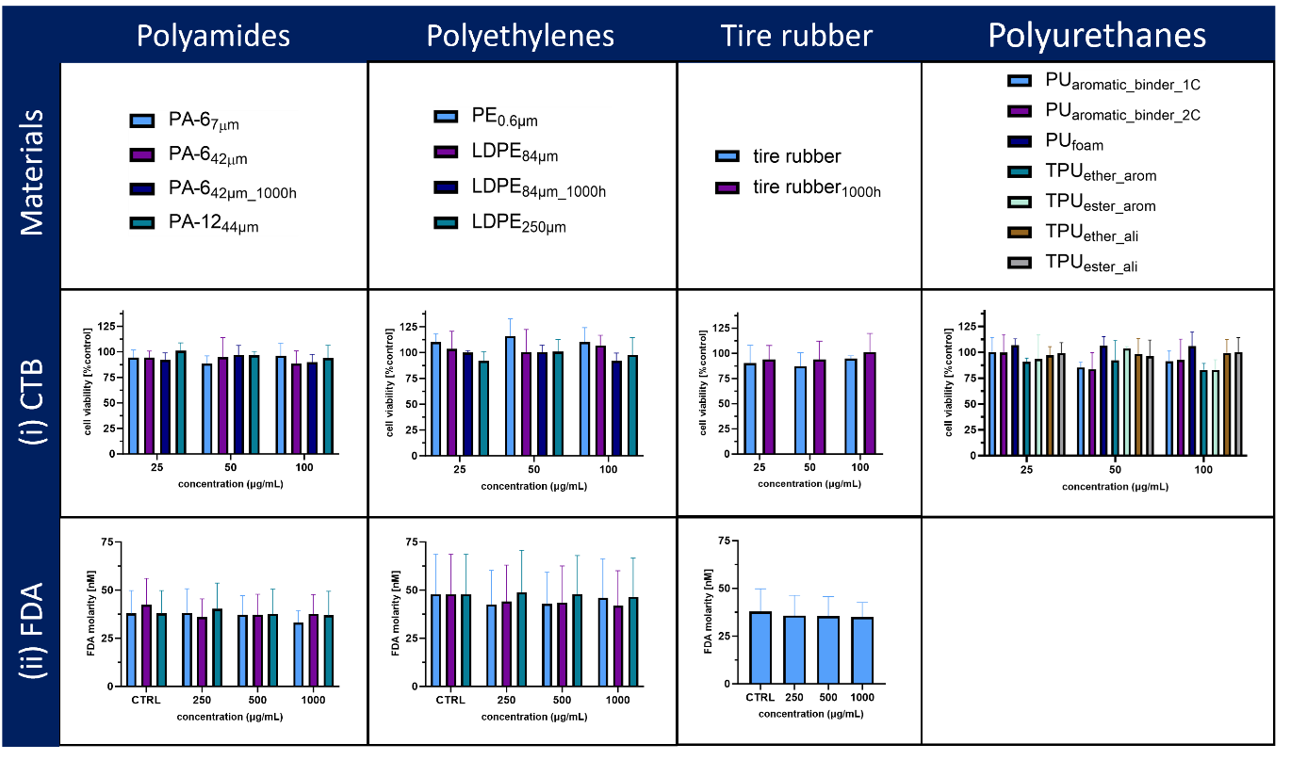
Figure S3: (i) Effects on cell viability of CaCo-2 cells after 24 h exposure to different MNPs as assessed by the CTB assay. (ii) Generation of reactive oxygen species (acellular).

5. Investigating the carrier effect of B(a)P for PA-6 particles

Internalization of PA-6 and PE MPs by CaCo-2 cells
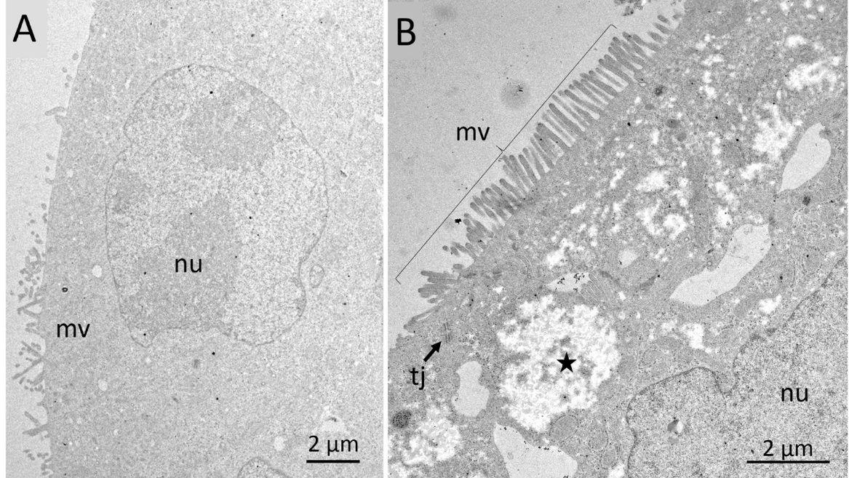
Figure S4: Ultrastructure of CaCo-2 cells. (A) Undifferentiated CaCo-2 cells (early state of cultivation) characterized by a compact nucleus (nu) and few microvilli structures at the surface (mv). (B) Fully differentiated CaCo-2 cells characterized fully developed fields of microvilli (mv), a lobed nucleus (nu), characteristic electron lucent areas (asterisk in B), and tight junctions among adjacent cells (tj).
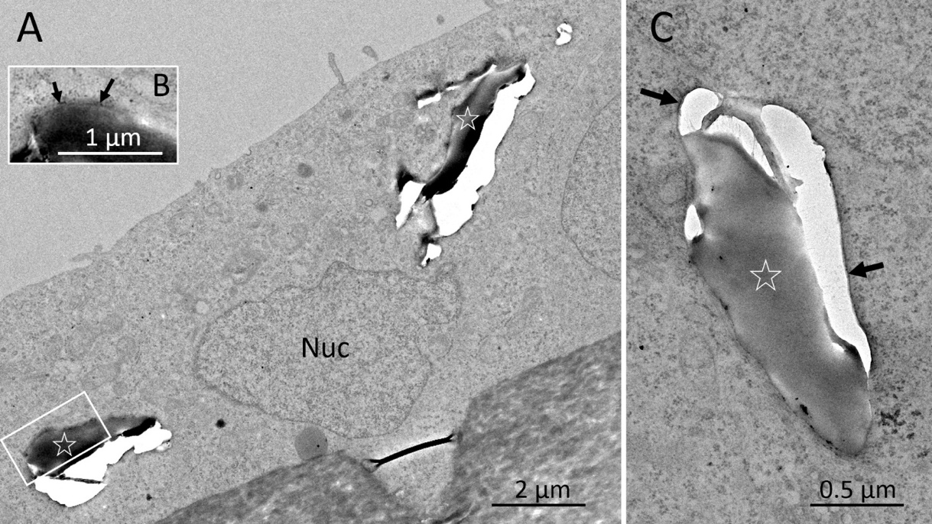
Figure S5: Uptake of microplastic particles by CaCo-2 cells into membrane bound vacuoles. (A-C) are deformed and partially detached from surrounding membrane structures, which is interpreted as an embedding/sectioning artefact. Adjacent osmiophilic structures (arrows) in (B) and (C) are interpreted as enclosing membranes. (B) Shows another sectioning plane of the inclusion marked by the white box in (A).

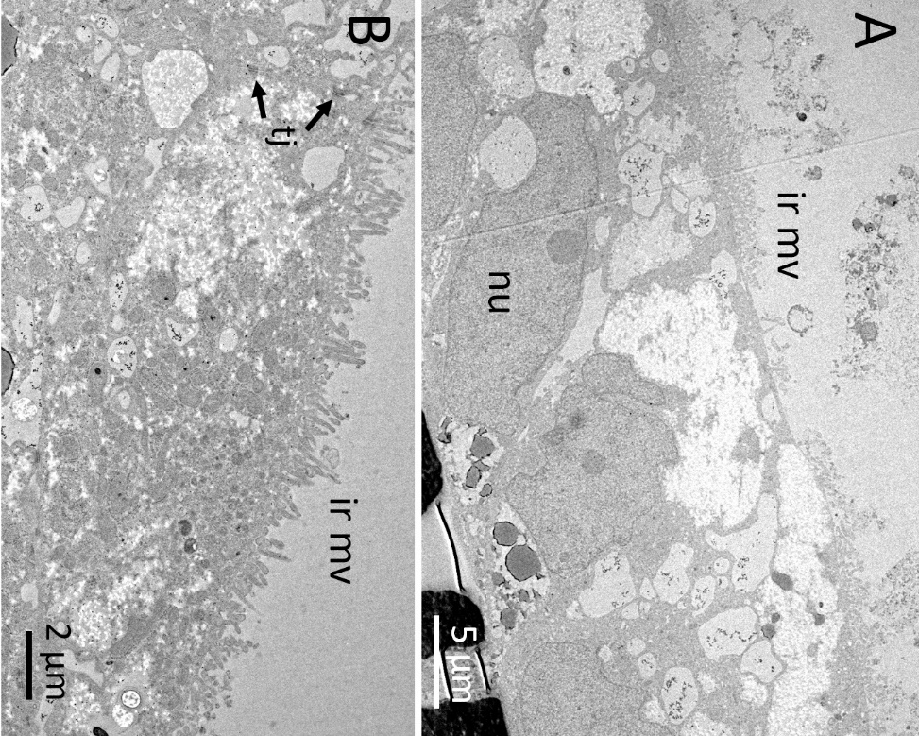
Figure S6. Treatment with microplastic particles partially alters the outer structure of differentiated CaCo-2 cells. (A) Treatment with polyamide particles (PA-6_{7µm}). In the lower right corner, some structures of the filter carrier were sectioned. (B) Treatment with polyethylene (PE) particles. Both treatments caused areas where microvilli appeared irregular or damaged (ir mv); local extracellular debris was also found on top of the cells (A). nu: nucleus, tj: tight junction structures.

Cell viability testing in undifferentiated CaCo-2 cells
For cell viability testing in undifferentiated CaCo-2 cells, cells were seeded in 96-well plates with a density of 5,000 cells/well. Cells were let attached for 24 h and subsequently treated with B(a)P at concentrations ranging between 1.01-22.63 µM for 24 h and PA-6_{7µm} at concentrations of 25, 50 and 100 µg/mL for 24 h.

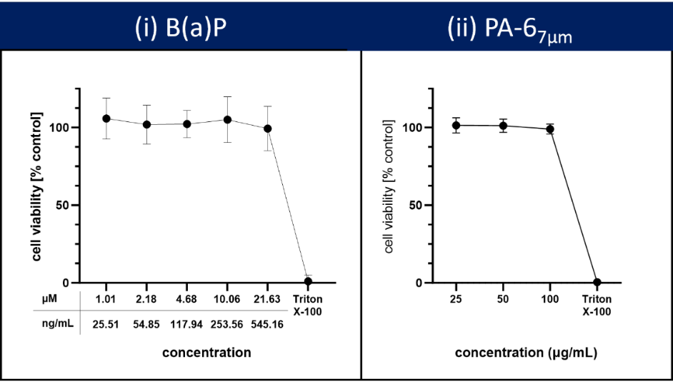
Figure S7: Effects of (i) benzo(a)pyrene (B(a)P) and (ii) PA-6_{7µm} on cell viability of undifferentiated CaCo-2 cells. Results are represented as mean values ± standard deviation from at least three independent biological replicates.

Quantification of sorbed B(a)P on PA-6 to align exposure conditions
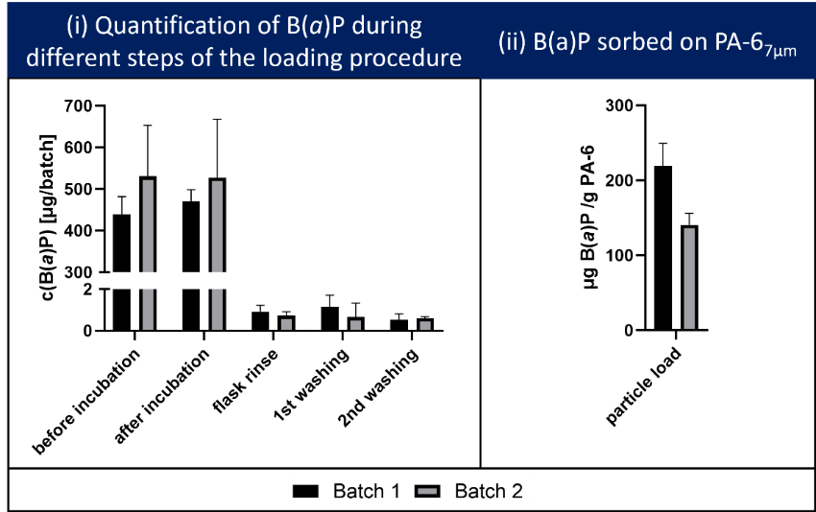
Figure S8: Verification of PA-6 loading with benzo(a)pyrene (B(a)P) using GC-MS. (i) Quantification of B(a)P during the different steps of the loading procedure. The recovery for B(a)P in the initial stock solution was found to be 88.0% ± 8.4% for Batch 1 (n= 4) and 106% ± 17.4% for Batch 2 (n = 2) relative to the initial applied concentration (500 µg B(a)P/100 mL/batch). After three days of incubation, B(a)P concentration in the solution was found to be 94.2% ± 5.5% for Batch 1 (n= 4) and 105.5% ± 19.9% for Batch 2 (n = 2) relative to the initial concentration. The B(a)P concentration in the different washing solutions was <0.25%. Results are represented as mean values ± standard deviation from four independent replicates. (ii) Quantification of B(a)P sorbed on PA-6 particles. The dried particles from each technical batch replicate were combined before the determination of sorbed B(a)P. Results are represented as mean values ± standard deviation from three technical replicates for both batches.

Identification of non-cell-associated PA-6 residues
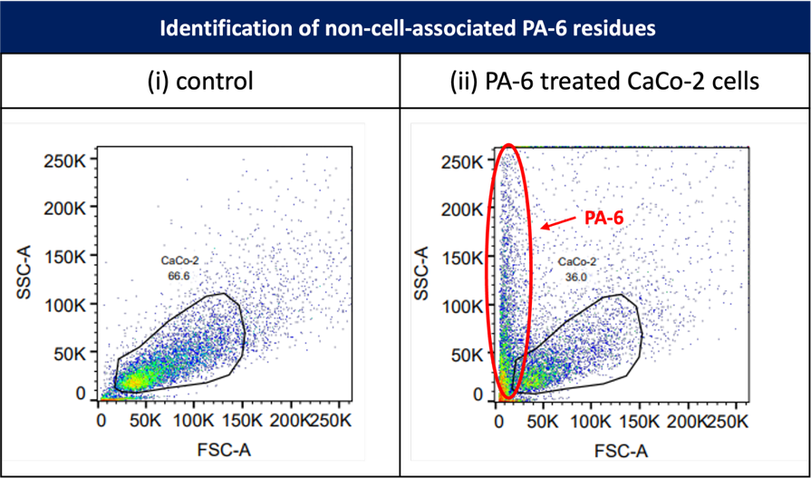
Figure S9: SSC-A/FSC-A dot plots of control and PA-6 treated, undifferentiated CaCo-2 cells as measured by flow cytometry. In PA-6 exposed samples, a high SSC, low FSC population is visible (red ellipse), which represents non-cell-associated particles that are clearly separated from the gated CaCo-2 cell population.

Quantification of cell-associated B(a)P and B(a)P in cell culture medium
The limits of detection (LOD) and quantification (LOQ) were determined for each respective matrix (hexane, cell culture medium, and cell pellets) based on calibration curves measured in the range of 1–15 ng/mL B(a)P. LOD and LOQ and results are presented in Table S3.

Table S4: The limit of detection (LOD) and limit of detection (LOQ) as analyzed for different matrices. Formulas for back calculation are depicted in Table S3.
 | matrix free | matrix-matched
 | hexane | cell culture medium |  | cell pellets
 | as measured | as measured | absolute (ng/6 mL) | as measured | absolute (ng/pellet)
LOD | 3.6 | 3.8 | 4.6 | 4.5 | 0.09
LOQ | 11.0 | 11.6 | 13.9 | 13.1 | 0.3

Figure S10: Quantification of B(a)P in acellular controls and cellular samples after 24 h incubation with B(a)P-loaded PA-6 particles. The acellular control was treated identically to the cellular samples but without cells, confirming that particles cannot be completely removed after 24 h of incubation. B(a)P may desorb from particles during liquid-liquid extraction, potentially leading to an overestimation of B(a)P in the cellular samples. Please note that a direct comparison of peak areas between cellular and acellular samples is not feasible, as B(a)P can bind to cellular components. This figure is intended to demonstrate that particle-associated B(a)P can be co-extracted during the analytical workflow. A ratio of B(a)P to B(a)P_{d12} could not be determined, as peak areas of the IS B(a)P_{d12} differed significantly between acellular controls and cellular samples.

