Supplementary Material
of
Evidence of rapid formation of non-crystalline secondary phases in an enhanced rock weathering field trial.

Emma Bonvin^{1,2#*}, Xavier Dupla ^{#1,2}, Stéphanie Grand¹
¹ Institute of Earth Surface Dynamics, University of Lausanne, 1015 Lausanne, Switzerland
² Department of Earth and Planetary Sciences, ETH Zurich, Zurich, Switzerland
* Corresponding author: embonvin@ethz.ch

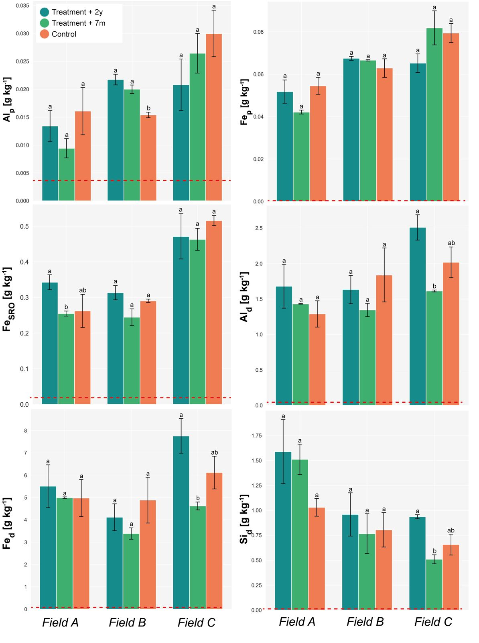
Figure S1 Selective dissolution results. Na-pyrophosphate–extractable Al (Al_{p}) and Fe (Fe_{p}) bound in organo-metal complexes. Fe_{SRO} denotes ammonium-oxalate–extractable Fe (SRO). Al_{d}, Fe_{d} and Si_{d} denote citrate–bicarbonate–dithionite–extractable Al, Fe and Si (pedogenic oxides). Treatments correspond to 2 years (+2y) and 7 months (+7m) after basanite rock powder application, and an unamended control. Error bars represent the standard error of the mean. Statistically significant differences (p-value < 0.005) are represented using compact letter display. The red dashed line corresponds to the amount extracted on the fresh rock powder and brought to a soil equivalent.
Table S1 ANOVAs. All the p-values resulting from the two-way ANOVAs are < 0.05, indicating that the ‘Treatment’ and the ‘Field’ variables are significantly impacting Al_{SRO} and Si_{SRO}.
 | p-values
Soil variable | Field | Treatment | Interaction
Al_{SRO}, g kg⁻¹  (0-3 cm) | 0.042962 | 0.000236 | 0.025385
Si_{SRO}, g kg⁻¹  (0-3 cm) | 0.007835 | 0.000008 | 0.010749

Table S2 Pedogenic indicators. Al_{SRO}/Si_{SRO}, Al_{p}/Al_{SRO} and (Al_{p}+0.5Fe_{p})/C_{p} recorded for each field between 0-3 cm.
 |  | Means + standard deviation
Soil variable | Field | Treatment + 2y | Treatment + 7m | Control
Al_{SRO}/Si_{SRO} | Field A | 0.961 ± 0.018 | 1.086 ± 0.043 | 4.733 ± 0.331
Al_{SRO}/Si_{SRO} | Field B | 1.795 ± 0.173 | 1.2956 ± 0.241 | 8.550 ± 1.058
Al_{SRO}/Si_{SRO} | Field C | 3.503 ± 2.616 | 1.872 ± 0.305 | 6.170 ± 3.485
Al_{p}/Al_{SRO} | Field A | 0.026 ± 0.006 | 0.025 ± 0.001 | 0.102 ± 0.052
Al_{p}/Al_{SRO} | Field B | 0.086 ± 0.017 | 0.066 ± 0.040 | 0.115 ± 0.013
Al_{p}/Al_{SRO} | Field C | 0.065 ± 0.019 | 0.082 ± 0.029 | 0.115 ± 0.025
(Al_{p} + 0.5 Fe_{p})/C_{p} | Field A | 0.219 ± 0.013 | 0.208 ± 0.003 | 0.233 ± 0.053
(Al_{p} + 0.5 Fe_{p})/C_{p} | Field B | 0.245 ± 0.020 | 0.236 ± 0.013 | 0.227 ± 0.019
(Al_{p} + 0.5 Fe_{p})/C_{p} | Field C | 0.232 ± 0.019 | 0.275 ± 0.031 | 0.263 ± 0.011

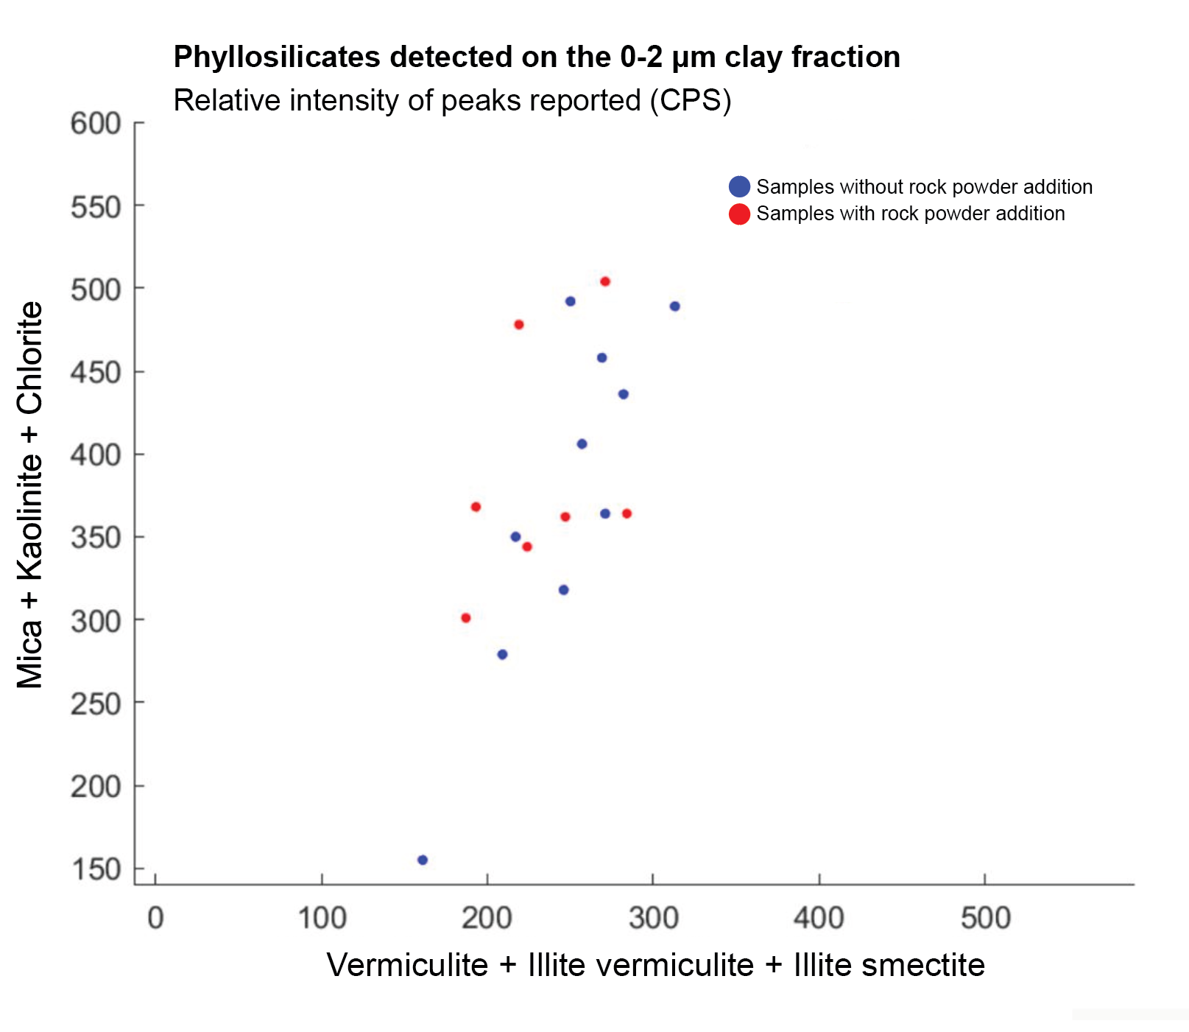
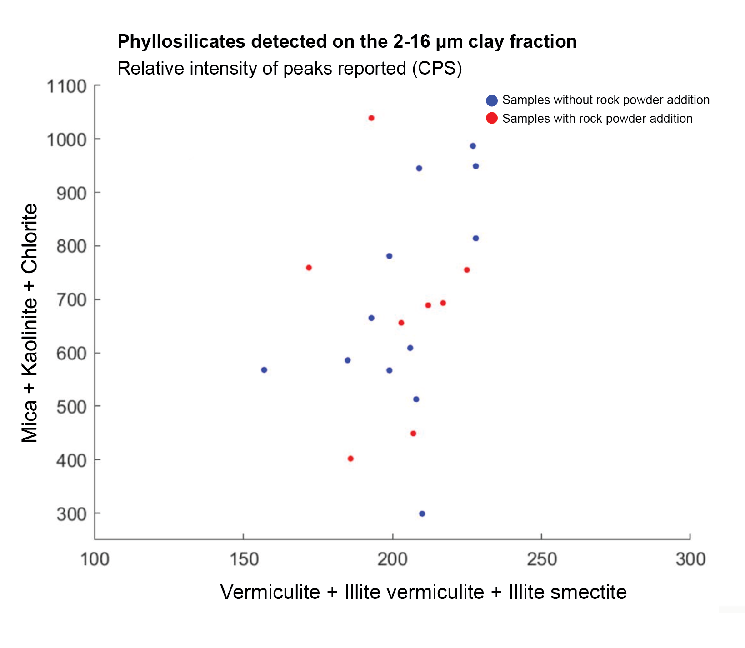
Figure S2 XRD patterns of the field clay fraction. The rock powder amendment does not indicate any trend toward enhanced secondary clay formation in either analysed size fraction (0-2 µm and 2-16 µm).

Table S3 Key soil properties. SOC refers to soil organic carbon and CEC to cation exchange capacity. Soil textural class was defined according to the USDA texture triangle.
 | Soil parameters (0-10 cm)
Field | pH H₂O | SOC  wt % | CEC  Cmol_{c} kg⁻¹ | Texture
Field A | 7.54 | 3.12 | 28.86 | loam
Field B | 6.36 | 3.04 | 26.98 | loam
Field C | 6.21 | 2.81 | 22.53 | loam

Table S4 Mineralogical composition. Basanite composition obtained by XRD. Details can be found in ref ⁷⁴
.
Mineralogical family | Mineral | Content (%)
Pyroxene | Augite | 48.4
Olivine | Forsterite (Fo₇₅) | 19.8
Plagioclase | Labradorite (An₅₅) | 10.0
Feldspathoid | Leucite | 9.1
Fe-Ti Oxide | Hematite, Ilmenite | 10.3
Mica | Phlogopite | 2.5
Total mineralogical content |  | 100.1
Estimated amorphous/glass content (%) |  | 8

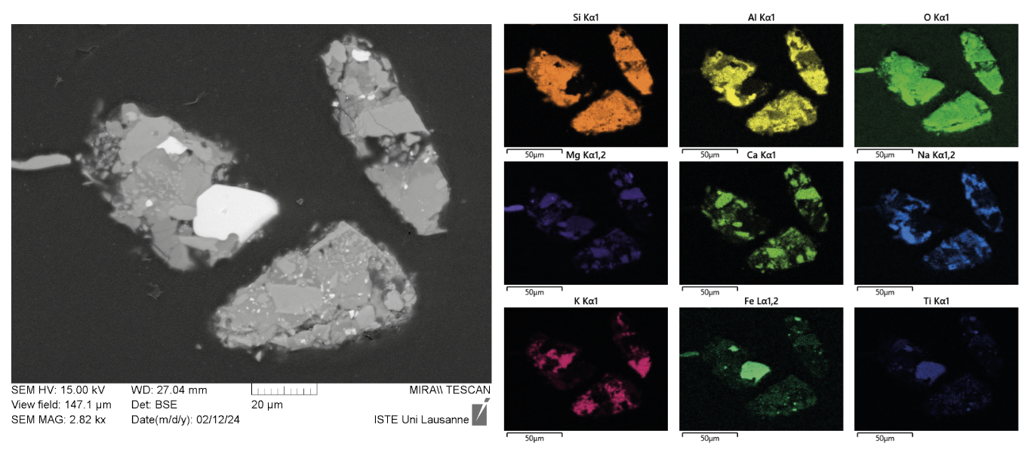
Figure S3 Rock powder texture. Basanite texture as revealed by SEM observations (left) and EDS elemental mapping results (right).

