Systemic responses to oral hyaluronic acid: A clinical randomized placebo-controlled study of plasma immune and metabolomic responses
Romana Šínová, Vratislav Berka, Lukáš Kubala, Petra Ovesná, Iva Dolečková, Vladimír Velebný, Matěj Šimek*

Supplementary materials

SUPPLEMENTARY METHODS
Malondialdehyde analysis
Malondialdehyde was quantified according to the modified method developed by [47]. The samples were derivatized with 2-thiobarbituric acid, chloroform:methanol (4:1) was added, and the mixture was vortexed (5 min), centrifuged (10 min), and the upper layer was filtered through a 0.22 μm PVDF filter. The analysis was performed on Acquity H-class UPLC system with a fluorometric detector and Acquity BEH C18 (1.7 μm, 2.1 × 50 mm, Waters) column with corresponding pre-column. The FL detector wavelengths were set for excitation at 527 nm and emission at 551 nm.

SUPPLEMENTARY RESULTS
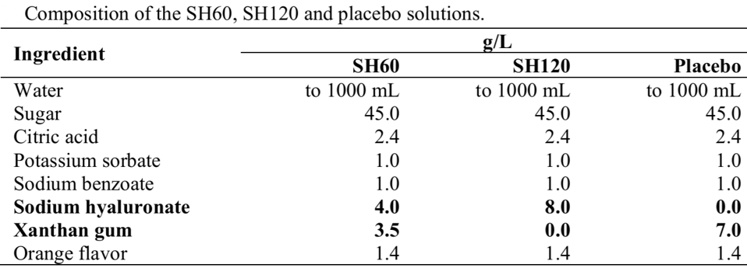
Figure S1: Composition of the SH60, SH120, and placebo solutions.
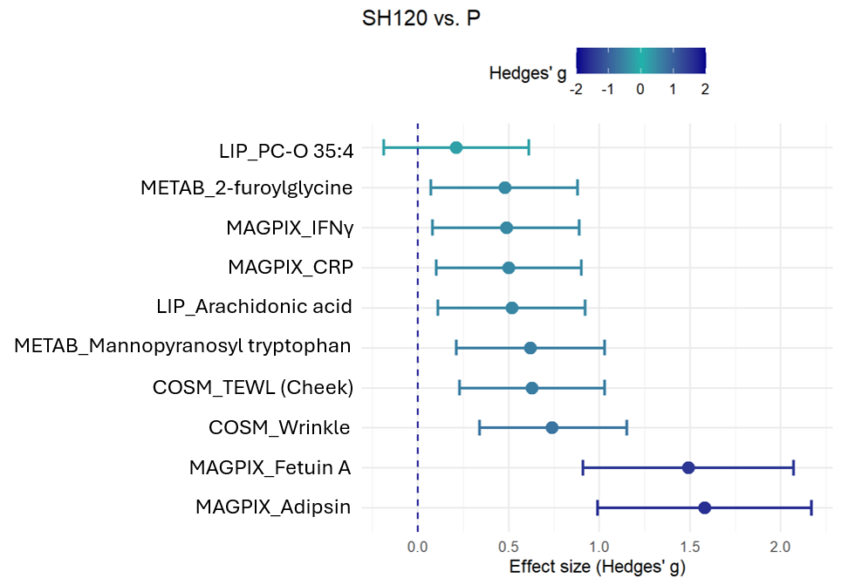
Figure S2: Effect sizes of HA supplementation on selected plasma and clinical parameters. The forest plot visualizes the magnitude of the treatment effect for the SH120 group compared to the placebo group. Effect sizes were quantified using Hedges' g to provide a standardized measure of the differences between the groups, underscoring the clinical and biological relevance of the statistically significant changes. The analysis encompasses selected immune and metabolic markers (MAGPIX), metabolites (METAB), lipids (LIP), and cosmetic outcomes (COSM). Data are presented as the Hedges' g point estimates along with their corresponding 95% confidence intervals.
Figure S3: The levels of selected metabolic analytes in human plasma for SH120. C peptide, interleukine-6 (IL-6), leptin, Monocyte Chemoattractant Protein-1 (MCP-1), and adropin were analysed only in the SH120 group in 0 and 3 months using multiplex assay analysis or ELISA (in case of adropin). The data are presented as the median, 25th, 75th percentile, min, max; statistical differences were tested using the Wilcoxon test; n = 50 per group and time point, *p < 0.05, **p < 0.01, ***p < 0.001 compared to the hypothetical value 1.

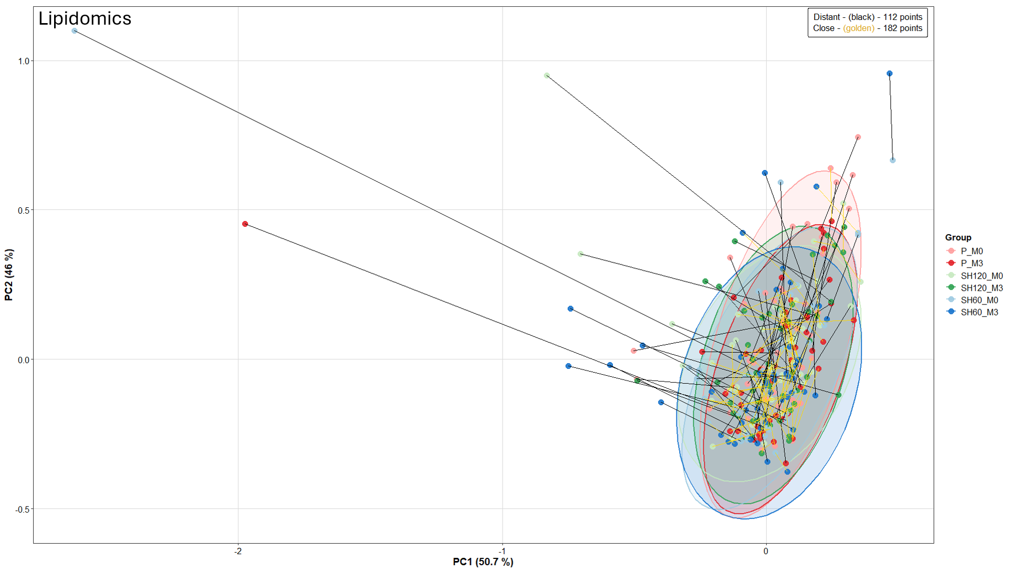
Figure S4: The main lipidomics driver are the individuals Lines connect paired samples from the same subject at timepoints M0 and M3. The magnitude of shift for each subject was quantified using the Euclidean distance between their M0 and M3 coordinates in the PC1/PC2 space. Trajectories are colored based on the mean distance across all subjects: golden lines indicate a shift less than or equal to the mean (Close), while black lines indicate a shift greater than the mean (Distant).
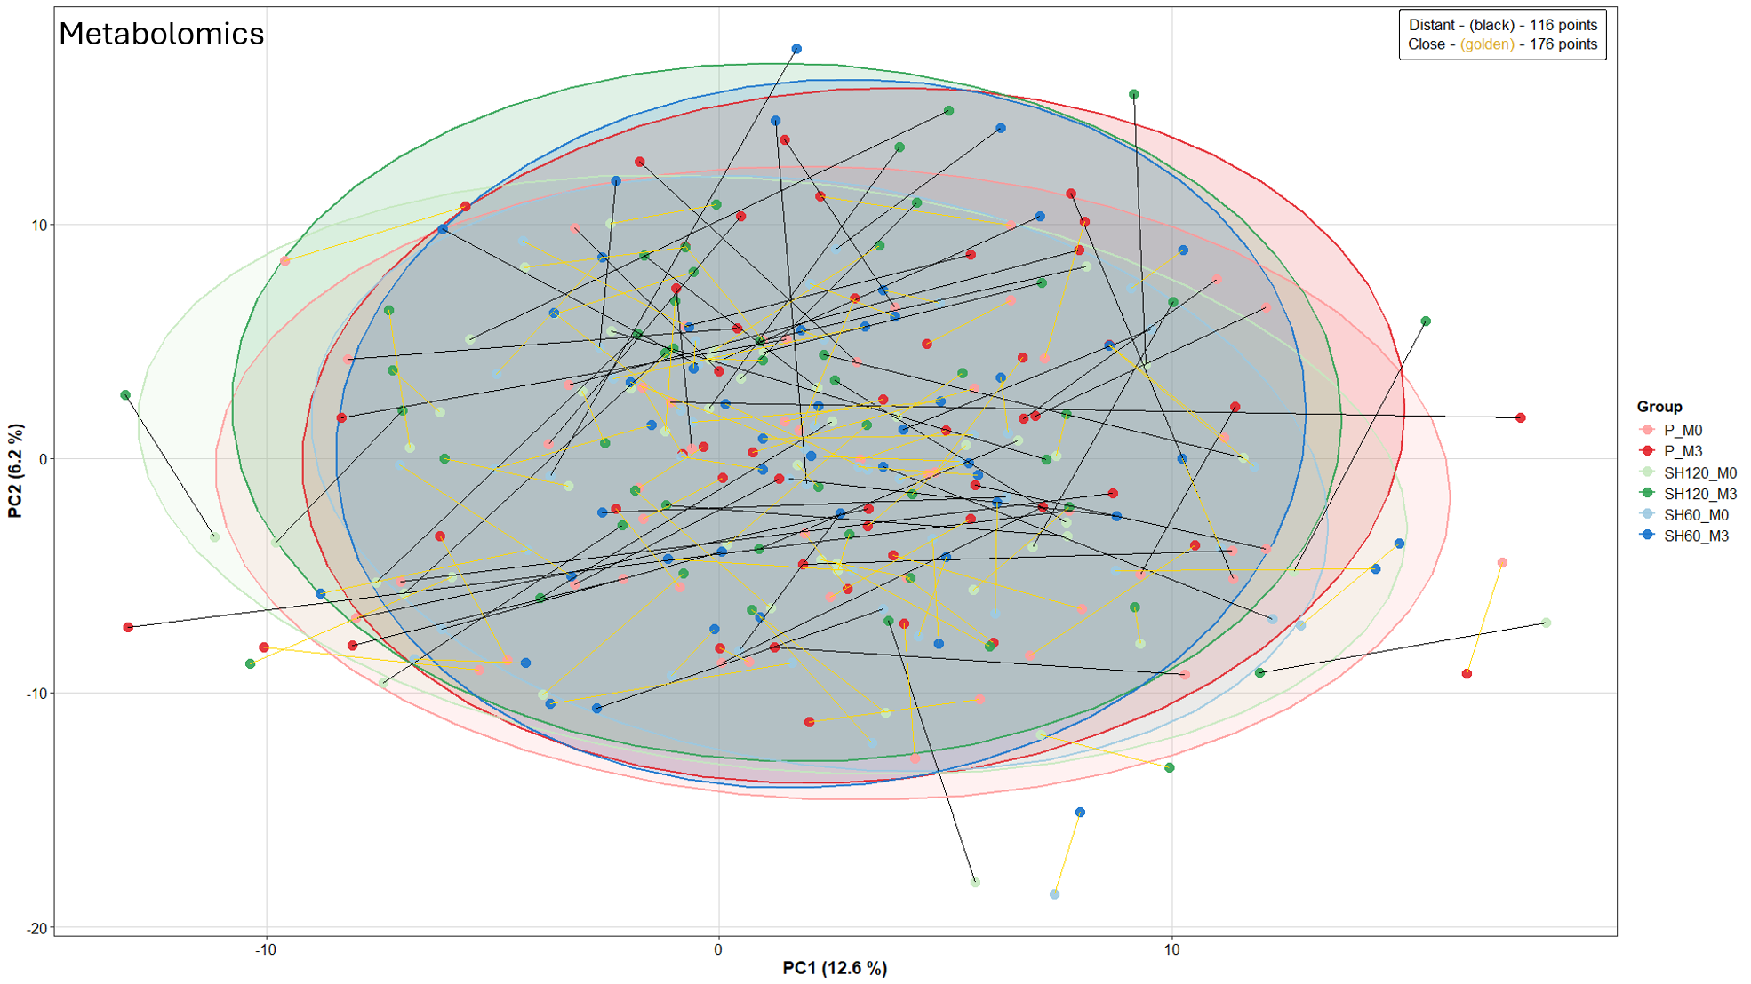
Figure S5: The main metabolomics drivers are the individuals - Lines connect paired samples from the same subject at timepoints M0 and M3. The magnitude of shift for each subject was quantified using the Euclidean distance between their M0 and M3 coordinates in the PC1/PC2 space. Trajectories are colored based on the mean distance across all subjects: golden lines indicate a shift less than or equal to the mean (Close), while black lines indicate a shift greater than the mean (Distant).
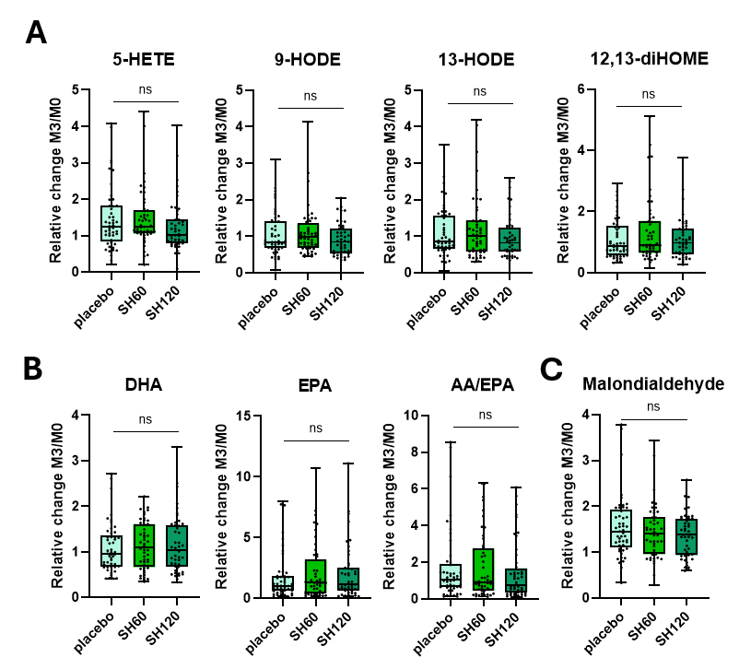
Figure S6: Impact of oral HA supplementation on the oxylipins and malondialdehyde in healthy human plasma. The box plots represent M3/M0 ratios calculated from analyses performed at month 0 (M0) and at month 3 (M3). A) 5-HETE, 9-HODE, 13-HODE, 12,13-diHOME were detected in the oxylipin analysis. B) DHA, EPA, and AA/EPA ratio are fatty acids. C) The M3/M0 malondialdehyde ratio calculated from the concentration in plasma samples. The data are presented as the median, 25th, 75th percentile, min, max. Statistical differences were tested using the Kruskal-Wallis test; n = 50 per group and time point. The results are not significant (ns) compared to the placebo group. Abbreviations: Hydroxyeicosatetraenoic acid (HETE), Hydroxyoctadecadienoic acid (HODE), Dihydroxyoctadecenoic acid (12, 13-diHOME), Docosahexaenoic acid (DHA), Eicosapentaenoic acid (EPA), Arachidonic acid (AA).

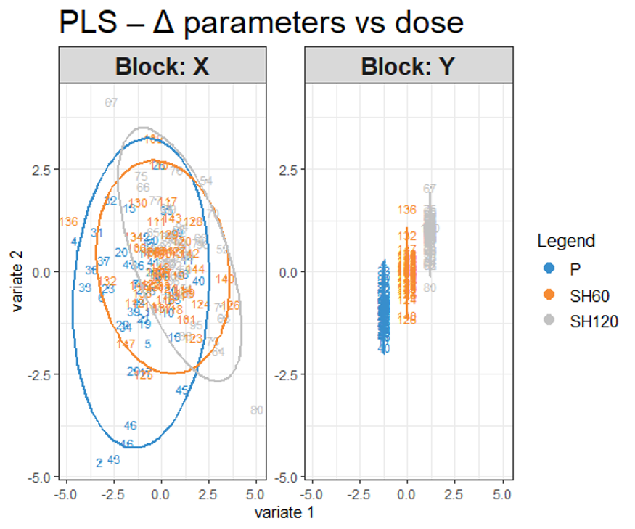
Figure S7: Partial Least Squares (PLS) score plot illustrating the dose-dependent effects of HA supplementation for metabolomics and lipidomics analytes. The multi-variable PLS score plot visualizes the global separation of the experimental groups (Placebo, SH60, and SH120) based on their integrated metabolomic and lipidomic profiles. The plot displays the projection of individual samples onto the first two latent components (variate 1 and variate 2). Ellipses represent the 95% confidence regions for each treatment group. The progressive shift of the group clusters along the components demonstrates a continuous dose-response trend, visually confirming that the selected signature captures a shared underlying biological effect rather than random intergroup variability.
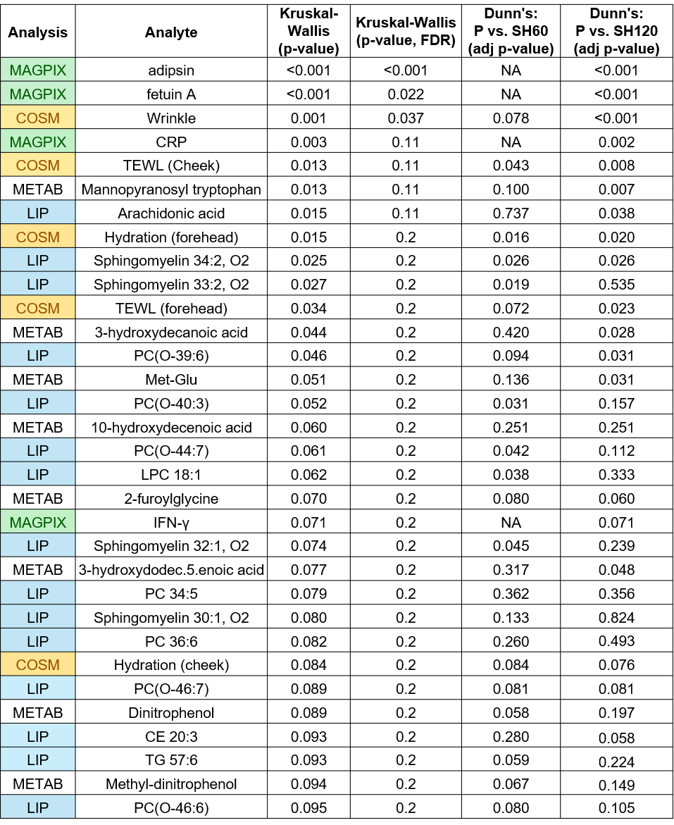
Figure S8: Table of the most significant analytes after oral HA supplementation. The Kruskal-Wallis test was used as a screening step to identify parameters potentially sensitive to treatment; only analytes with a crude p-value below 0.1 are displayed. False discovery rate (FDR) correction was applied to all analytes. For the pre-selected parameters, a subsequent Dunn's post-hoc test was performed to evaluate specific pairwise comparisons against the placebo group, with resulting post-hoc p-values adjusted using the Benjamini-Hochberg FDR correction. Abbreviations: adjusted (adj), cholesteryl ester (CE), cosmetics parameters (COSM), C-reactive protein (CRP), false discovery rate (FDR), interferon-gamma (IFN-γ), lipidomics and oxylipin parameters (LIP), lysophosphatidylcholine (LPC), metabolomics parameters (METAB), not applicable (NA), phosphatidylcholine (PC), transepidermal water loss (TEWL), triglycerides (TG).
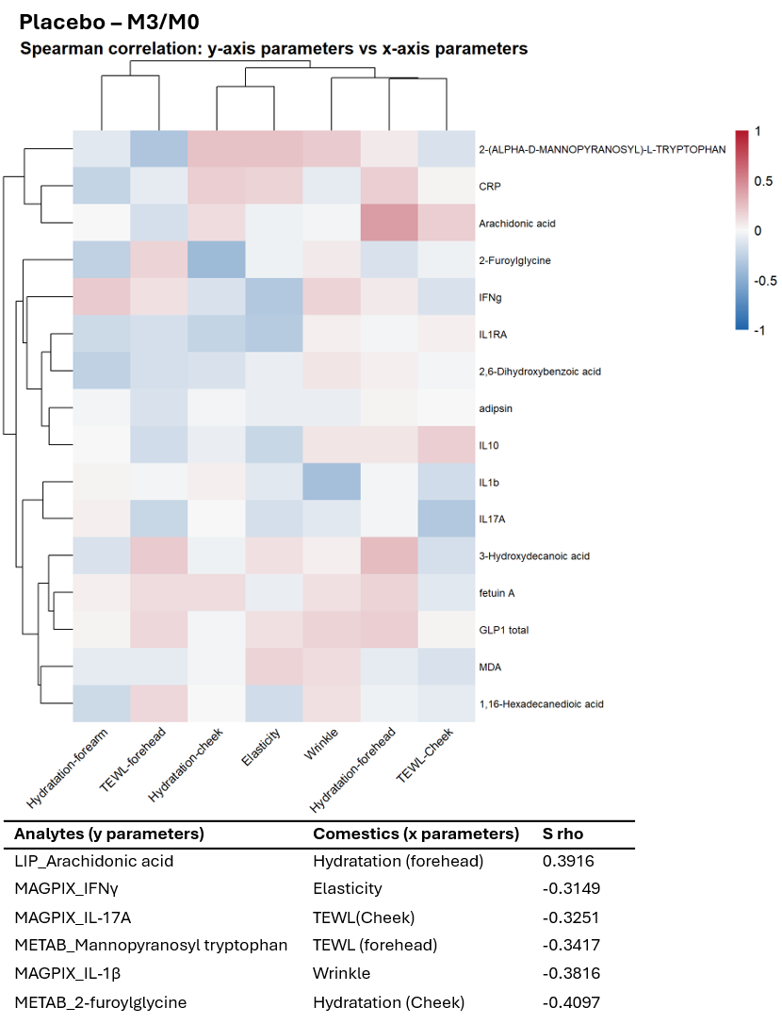
Figure S9: Associations between cosmetic parameters and plasma analytes for the placebo group. Heatmap based on Spearman’s rank correlation (details in 2.8) using hierarchical clustering for cosmetic parameters comparing selected analytes in plasma. Spearman’s Rank Order Correlation was performed from M3/M0 ratios calculated from analyses at month 0 (M0) and at month 3 (M3). The strongest correlations are listed in the table below the heatmap.

