Supplementary material for

Biofilm induction and tolerance to invasion of marine bacterial communities

Nan Yang¹, Amanda Sofie Seger Jakobsen¹, Fábio Pretti¹, Mette Burmølle¹* and Cristina I. Amador¹*
¹ Section of Microbiology, Department of Biology, University of Copenhagen, Copenhagen, Denmark
* Shared corresponding authors:
Mette Burmølle (burmolle@bio.ku.dk); Cristina I. Amador (chierro@bio.ku.dk)

Contains:
7 supplementary figures
2 supplementary tables

Supplementary Figures

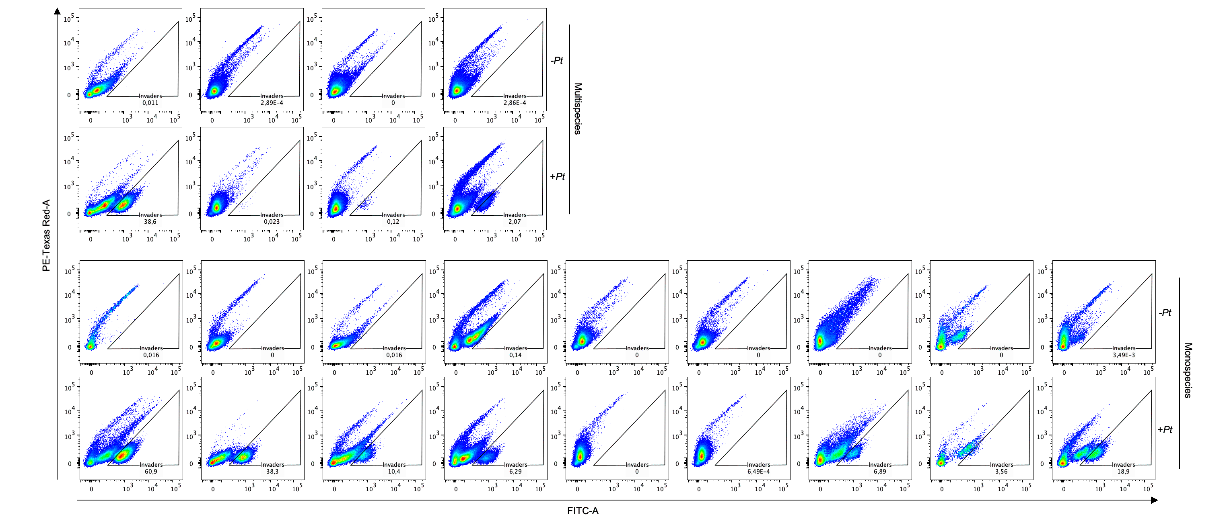
All biofilm cells stained with SYTO60 (red)
Invader expresses green fluorescence but also stains in red
Gating strategy in flow cytometry
PE-Texas Red
(SYTO60, area)
FITC (Gfp, area)
PE-Texas Red
(SYTO60, area)
FITC (Gfp, area)
Supplementary Figure 1. Overview of the flow cytometry gating strategy used to identify invader populations (P. tunicata, GFP-tagged). All biofilm-associated cells were stained with SYTO60. Non-invaded biofilms served as controls (left panel; FITC vs. PE–Texas Red–A), establishing the fixed gating region used to detect P. tunicata GFP cells in invaded samples (right panel; FITC vs. PE–Texas Red–A).

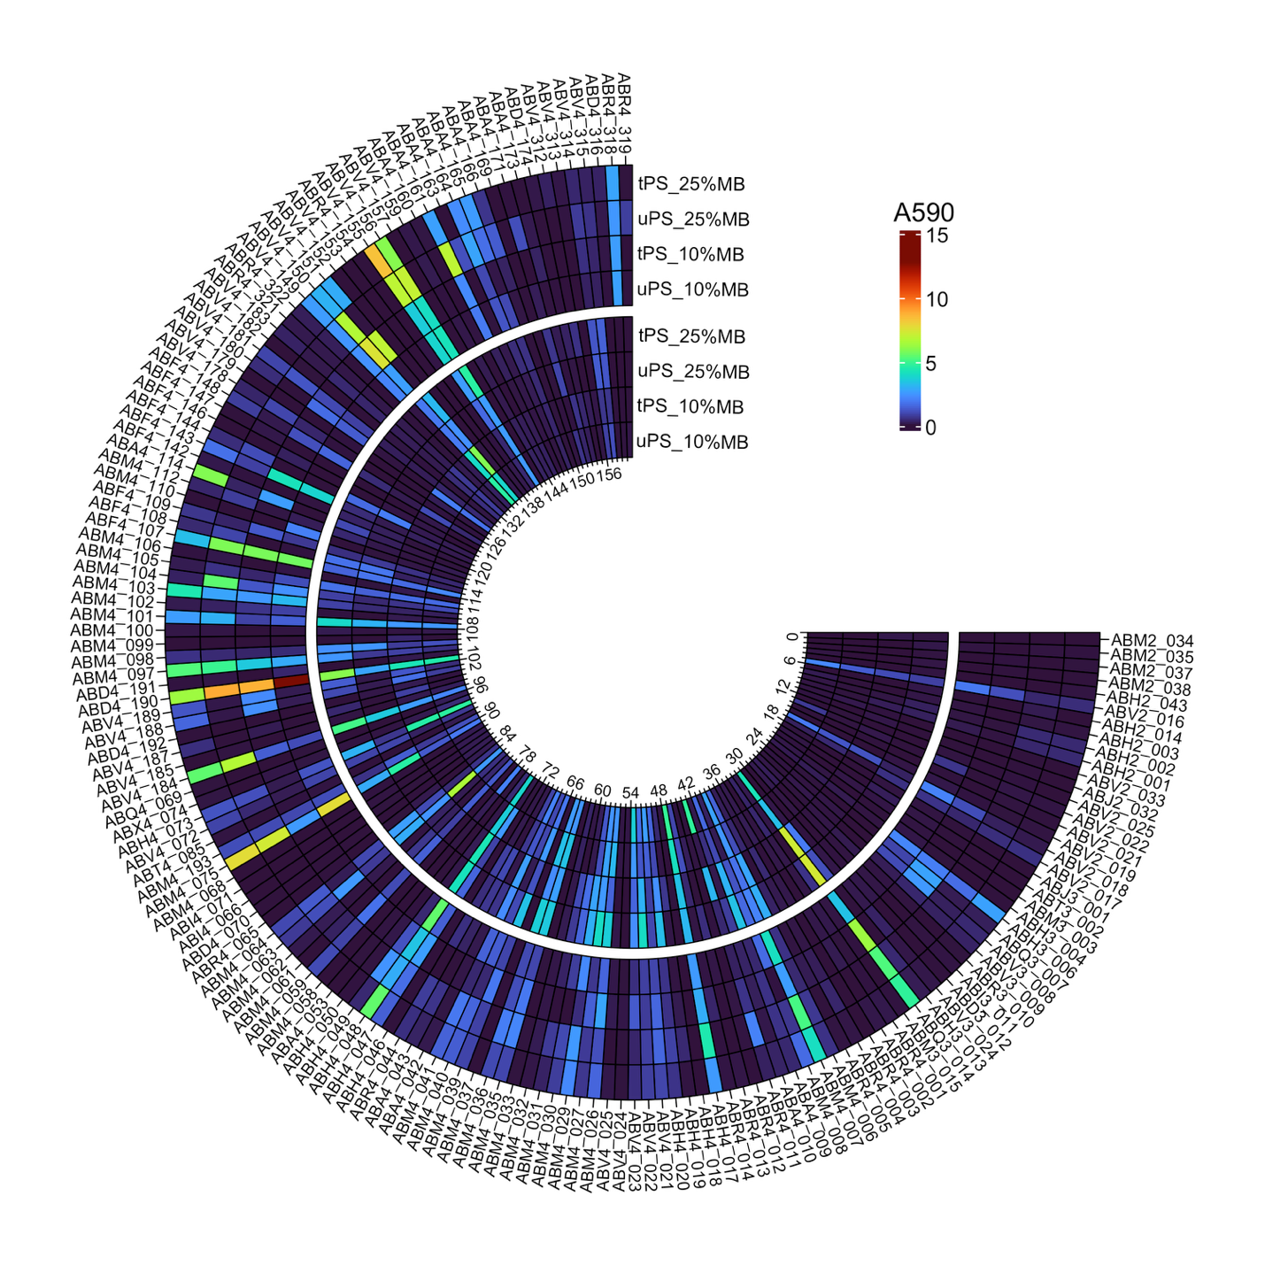
Supplementary Figure 2. Second independent experiment on screening of the 161 marine isolates on different materials, media and incubation times. The biofilm biomass (A590) of all 161 isolates screened in untreated polystyrene (uPS, hydrophobic) and tissue-culture treated polystyrene (tPS, hydrophilic) microtiter plates, tested in two different marine broth with dilutions of 10% and 25% strength in buffered, supplemented ASW (artificial sea water), and two time points: 24 and 72 hours (n = 3).

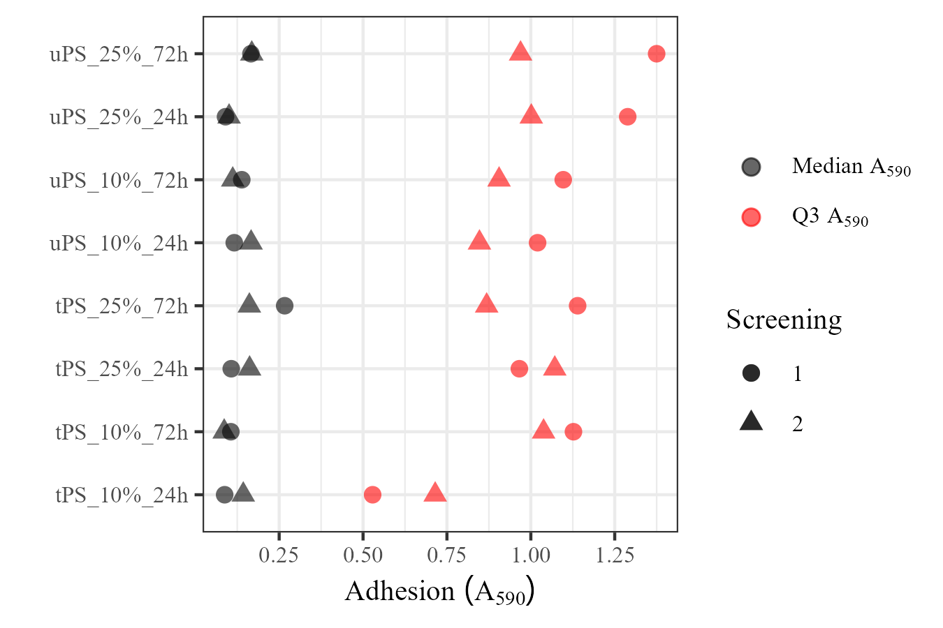
Supplementary Figure 3. Biofilm biomass (A₅₉₀) of the marine isolate population (n = 161). The dot plot compares median and third quartile (Q3) biofilm formation in untreated and treated polystyrene (uPS, tPS, respectively), 10 % or 25 % marine broth (MB) and 72 and 48 h. Median: median biofilm biomass of the population. The third quartile (Q3) biofilm biomass: top 25% biofilm biomass of the population. Point shape represents the media or third quartile for independent screening assays (1 and 2).

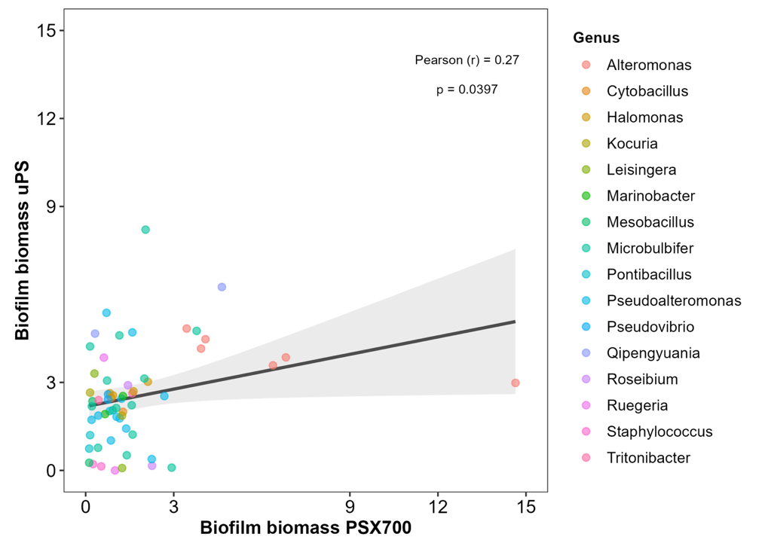
Supplementary Figure 4. Correlation of biofilm biomass produced by the top 30 isolates on uPS and PSX700-coated surfaces. Linear regression lines with confidence intervals illustrate correlation of biofilm biomass between uPS and PSX700 materials for top 30 isolates, with Pearson correlation coefficients (r) and p value provided in the plot.

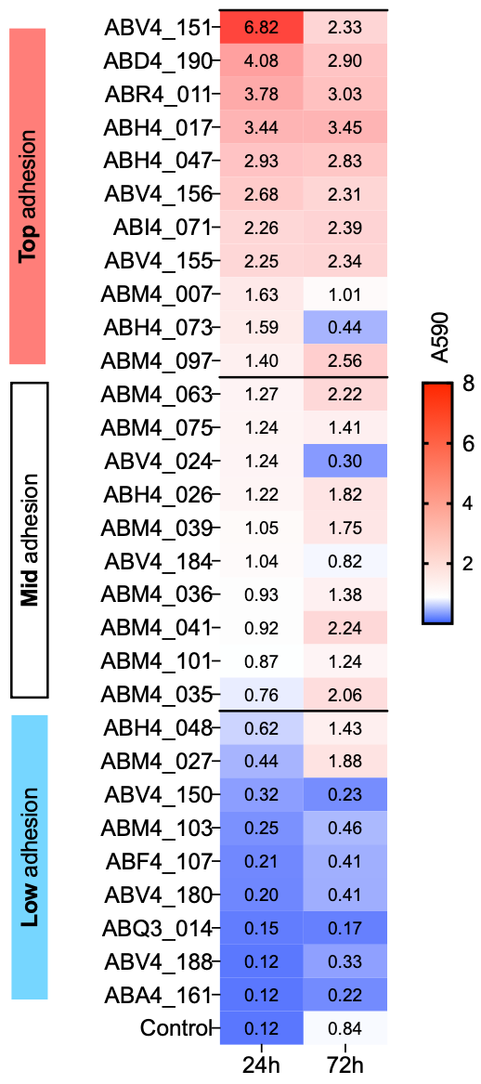
Supplementary Figure 5. Heatmap of biofilm biomass of top 30 biofilm formers on PSX700-coated plates. Biofilm biomass (A₅₉₀) was measured at 24 and 72 h (n = 3) in the second independent experiment. These 30 isolates were grouped into three categories (Top, Mid, and Low adhesion), each with 10 isolates. Data from three biological replicates, each with three technical replicates.

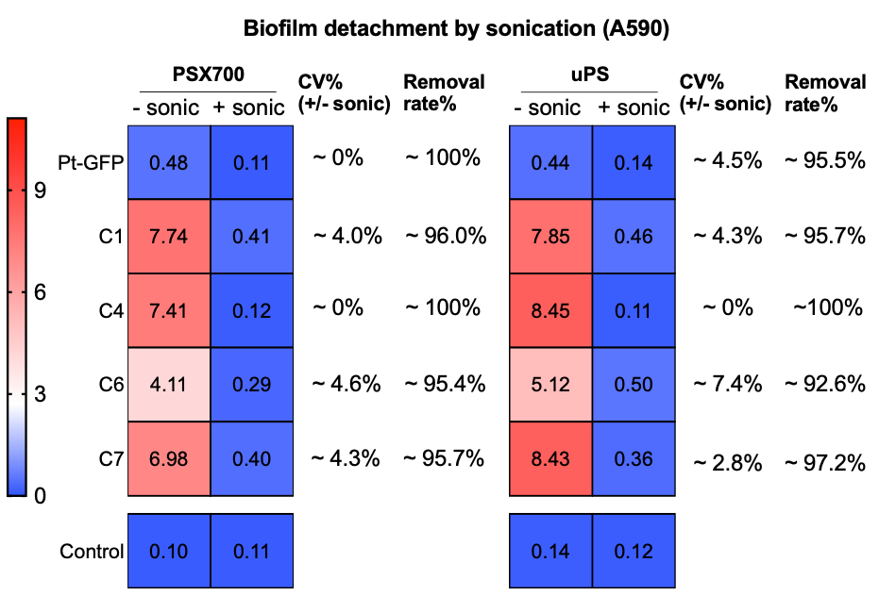
Supplementary Figure 6. Validation of the sonication protocol for biofilm detachment from uPS and PSX700-coated surfaces. The heatmap shows biofilm quantification (A₅₉₀) measured by crystal violet (CV) staining before and after sonication. CV% represents the percentage of biofilm remaining after sonication, relative to that before sonication with total detachment indicated as 100 %.

Supplementary Figure 7. Second independent experiment on invasion tolerance of mono- and multispecies biofilms. Total biofilm cell numbers (left panel) in mono- and multispecies communities with and without P. tunicata invasion. Proportion of P. tunicata invasion (right panel) in mono- and multispecies communities. Non-invaded non-added P. tunicata); Invaded communities (added P. tunicata). Error bars represent mean ± standard deviation (n = 3). The different letters above each bar in right panel indicate statistically significant differences determined by two-way ANOVA (Tukey’s studentized range test, p < 0.05). Data from three biological replicates, each with three technical replicates

Supplementary tables
Supplementary Table 1. List of marine isolates used in this study.
Strain | 16S ID | WGS accession | Reference
ABA4_009 | Halobacillus kuroshimensis |  | This study
ABA4_010 | Priestia abyssalis |  | This study
ABA4_042 | Bacillus sp. |  | This study
ABA4_043 | Bacillus sp. |  | This study
ABA4_053 | Halobacillus sp. |  | This study
ABA4_114 | Anaerobacillus sp. | JBSWUM000000000 | This study¹
ABA4_160 | Bacillus sp. |  | This study
ABA4_161 | Kocuria sp. |  | This study
ABA4_163 | Bacillus sp. |  | This study
ABA4_164 | Bacillus sp. |  | This study
ABA4_165 | Nitratireductor aquimarinus | JBSWYD000000000 | This study¹
ABA4_166 | Bacillus sp. |  | This study
ABA4_169 | NA |  | This study
ABA4_171 | Bacillus sp. |  | This study
ABA4_173 | Dermacoccus sp. |  | This study
ABD3_012 | Staphylococcus sp. |  | This study
ABD4_070 | Staphylococcus sp. |  | This study
ABD4_174 | Muricauda sp. | JBSWWP000000000 | This study¹
ABD4_190 | Alteromonas sp. | JBSWWN000000000 | This study¹
ABD4_191 | Microbulbifer sp. |  | This study
ABD4_192 | Vibrio alginolyticus | JBSWWM000000000 | This study¹
ABD4_316 | Halobacillus sp. | JBSWZA000000000 | This study¹
ABF4_107 | Microbulbifer sp. | JBUBLR000000000 | This study¹
ABF4_108 | Vibrio sp. |  | This study
ABF4_109 | Vibrio sp. |  | This study
ABF4_142 | Pseudoalteromonas sp. |  | This study
ABF4_143 | Microbulbifer sp. | JBSWWT000000000 | This study¹
ABF4_144 | Ruegeria sp. | JBSWWK000000000 | This study¹
ABF4_146 | Salipiger sp. | JBSWYX000000000 | This study¹
ABF4_147 | Micrococcus luteus | JBSWUJ000000000 | This study¹
ABF4_148 | Microbulbifer sp. | JBSWUI000000000 | This study¹
ABH2_001 | Vibrio owensii | JBSWUH000000000 | This study¹
ABH2_002 | Vibrio sp. |  | This study
ABH2_003 | Vibrio sp. |  | This study
ABH2_014 | Vibrio owensii | JBSWWH000000000 | This study¹
ABH2_043 | Vibrio owensii | JBSWWG000000000 | This study¹
ABH3_004 | Staphylococcus sp. |  | This study
ABH3_006 | Ruegeria arenilitoris | JBSWWE000000000 | This study¹
ABH3_013 | Microbulbifer sp. |  | This study
ABH4_017 | Qipengyuania flava | JBUBLO000000000 | This study¹
ABH4_018 | Thalassospira profundimaris |  | This study
ABH4_019 | Halomonas sp. | JBSWWC000000000 | This study¹
ABH4_020 | Ruegeria arenilitoris | JBSWWB000000000 | This study¹
ABH4_046 | Halobacillus litoralis | JBSWUF000000000 | This study¹
ABH4_047 | Tritonibacter mobilis | JBSWWA000000000 | This study¹
ABH4_048 | Marinobacter xestospongiae | JBSWVZ000000000 | This study¹
ABH4_049 | Marinobacter sp. |  | This study
ABH4_050 | Rhodococcus ruber | JBSWVY000000000 | This study¹
ABH4_073 | Cytobacillus kochii | JBSWUE000000000 | This study¹
ABI3_011 | Staphylococcus ureilyticus |  | This study
ABI4_066 | Dermacoccus sp. |  | This study
ABI4_071 | Microbulbifer sp. |  | This study
ABJ2_032 | NA |  | This study
ABJ3_001 | Staphylococcus sp. |  | This study
ABM2_034 | NA |  | This study
ABM2_035 | Vibrio sp. |  | This study
ABM2_037 | NA |  | This study
ABM2_038 | NA |  | This study
ABM3_003 | Staphylococcus sp. |  | This study
ABM3_015 | Ruegeria denitrificans |  | This study
ABM4_006 | Tritonibacter mobilis |  | This study
ABM4_007 | Microbulbifer variabilis | JBSWXF000000000 | This study¹
ABM4_008 | Microbulbifer sp. | JBUBLF000000000 | This study¹
ABM4_026 | Pseudoalteromonas sp. |  | This study
ABM4_027 | Pseudoalteromonas sp. |  | This study
ABM4_029 | Vibrio sp. |  | This study
ABM4_030 | Vibrio sp. |  | This study
ABM4_031 | Vibrio owensii |  | This study
ABM4_032 | Vibrio alginolyticus |  | This study
ABM4_033 | Vibrio alginolyticus |  | This study
ABM4_035 | Pseudoalteromonas sp. |  | This study
ABM4_036 | Pseudoalteromonas ruthenica | JBSWUA000000000 | This study¹
ABM4_037 | Vibrio rotiferianus |  | This study
ABM4_039 | Pseudoalteromonas ruthenica | JBSWTZ000000000 | This study¹
ABM4_040 | NA |  | This study
ABM4_041 | Pseudoalteromonas ruthenica | JBSWTY000000000 | This study¹
ABM4_058 | NA |  | This study
ABM4_059 | Vibrio owensii |  | This study
ABM4_061 | NA |  | This study
ABM4_062 | Microbulbifer sp. |  | This study
ABM4_063 | Pseudoalteromonas ruthenica | JBSWTW000000000 | This study¹
ABM4_064 | NA |  | This study
ABM4_068 | Staphylococcus ureilyticus |  | This study
ABM4_075 | Microbulbifer sp. |  | This study
ABM4_097 | Pseudovibrio sp. |  | This study
ABM4_098 | Dermacoccus sp. |  | This study
ABM4_099 | NA |  | This study
ABM4_100 | Bacillus sp. |  | This study
ABM4_101 | Ruegeria sp. | JBSWTV000000000 | This study¹
ABM4_102 | NA |  | This study
ABM4_103 | Leisingera sp. | JBSWTU000000000 | This study¹
ABM4_104 | Leisingera sp. |  | This study
ABM4_105 | Pseudoalteromonas sp. |  | This study
ABM4_106 | Vibrio sp. |  | This study
ABM4_110 | Staphylococcus sp. |  | This study
ABM4_112 | NA |  | This study
ABM4_193 | Ruegeria sp. | JBSWTT000000000 | This study¹
ABQ3_007 | Staphylococcus ureilyticus |  | This study
ABQ3_014 | Microbulbifer variabilis |  | This study
ABQ4_069 | Microbulbifer variabilis |  | This study
ABR3_010 | Staphylococcus ureilyticus |  | This study
ABR4_001 | Bacillus thuriengensis | JBSWTL000000000 | This study¹
ABR4_002 | Mycoplana sp. | JBSWVO000000000 | This study¹
ABR4_003 | Staphylococcus warneri | JBSWVN000000000 | This study¹
ABR4_004 | Rossellomorea sp. | JBSWVM000000000 | This study¹
ABR4_005 | Bacillus sp. |  | This study
ABR4_011 | Halomonas litopenaei | JBSWVL000000000 | This study¹
ABR4_012 | Rossellomorea sp. | JBSWVK000000000 | This study¹
ABR4_013 | NA |  | This study
ABR4_014 | Metabacillus endolithicus | JBSVEN000000000 | This study¹
ABR4_044 | Anaerobacillus sp. | JBSWVJ000000000 | This study¹
ABR4_065 | Staphylococcus sp. |  | This study
ABR4_154 | NA |  | This study
ABR4_318 | Anaerobacillus sp. | JBSWVG000000000 | This study¹
ABR4_319 | Bacillus sp. |  | This study
ABR4_321 | Anaerobacillus sp. | JBSWTK000000000 | This study¹
ABR4_322 | Alkalihalobacillus |  | This study
ABT3_002 | Staphylococcus ureilyticus |  | This study
ABT4_085 | Staphylococcus sp. |  | This study
ABV2_016 | NA |  | This study
ABV2_017 | NA |  | This study
ABV2_018 | NA |  | This study
ABV2_019 | NA |  | This study
ABV2_021 | NA |  | This study
ABV2_022 | NA |  | This study
ABV2_025 | NA |  | This study
ABV2_033 | NA |  | This study
ABV3_008 | Ruegeria sp. | JBSWYP000000000 | This study¹
ABV3_009 | Ruegeria arenilitoris |  | This study
ABV3_024 | Ruegeria arenilitoris |  | This study
ABV4_021 | Pseudoalteromonas sp. | JBSWVB000000000 | This study¹
ABV4_022 | Epibacterium sp. | JBSWVA000000000 | This study¹
ABV4_023 | Staphylococcus warneri |  | This study
ABV4_024 | Staphylococcus warneri |  | This study
ABV4_025 | Staphylococcus pasteuri |  | This study
ABV4_072 | Ruegeria denitrificans |  | This study
ABV4_149 | Staphylococcus pasteuri | JBSWXA000000000 | This study¹
ABV4_150 | Alteromonas sp. | JBUBLE000000000 | This study¹
ABV4_151 | Alteromonas macleodii | JBSWUZ000000000 | This study¹
ABV4_152 | Salinivibrio sp. |  | This study
ABV4_153 | Bacillus sp. |  | This study
ABV4_155 | Microbulbifer sp. |  | This study
ABV4_156 | Microbulbifer variabilis | JBUBLM000000000 | This study¹
ABV4_157 | Microbulbifer sp. |  | This study
ABV4_159 | Bacillus thuringiensis | JBSWYO000000000 | This study¹
ABV4_178 | Microbacterium testaceum | JBUBLL000000000 | This study¹
ABV4_179 | Brevundimonas sp. | JBUBLK000000000 | This study¹
ABV4_180 | Mesobacillus sp. | JBSWTJ000000000 | This study¹
ABV4_181 | Ruegeria sp. | JBSWTI000000000 | This study¹
ABV4_182 | Pseudomonas luteola | JBSWUY000000000 | This study¹
ABV4_183 | Mesobacillus sp. | JBSWUX000000000 | This study¹
ABV4_184 | Roseibium sp. |  | This study
ABV4_185 | Saccharospirillum sp. | JBSWUW000000000 | This study¹
ABV4_187 | NA |  | This study
ABV4_188 | Pontibacillus sp. | JBUBLJ000000000 | This study¹
ABV4_189 | Brevundimonas sp. |  | This study
ABV4_312 | Halobacillus sp. |  | This study
ABV4_313 | Catenococcus sp. |  | This study
ABV4_314 | Vibrio sp. |  | This study
ABV4_315 | Vibrio sp. |  | This study
ABX4_074 | Priestia sp. | JBSWYN000000000 | This study¹
¹ These strains are currently in review process for a genome announcement manuscript.
Supplementary Table 2. Strains used for chromosomal tagging of Pseudoalteromonas tunicata D2 (P. tunicata).
Strain | Plasmid | Features | Reference
P. tunicata |  | Wild-type strain | (1)
P. tunicata-gfp |  | P. tunicata derivative, miniTn7-Plac-GFP-Chl. Chl^{R}, Tmp^{R} | This study
Escherichia coli GeneHogs | pBK-miniTn7-gfp3 | Delivery plasmid Amp^{R}, Chl^{R} | (2)
E. coli DH5α | pTNS2 | Helper transposase. Amp^{R} | (3)
E. coli S17-1 | pRK2013 | Helper conjugation. Kan^{R} | (4)

References

1. Rao D, Webb JS, Kjelleberg S. Competitive interactions in mixed-species biofilms containing the marine bacterium Pseudoalteromonas tunicata. Appl Environ Microbiol. 2005;71(4):1729-36.
2. Koch B, Jensen LE, Nybroe O. A panel of Tn-based vectors for insertion of the marker gene or for delivery of cloned DNA into Gram-negative bacteria at a neutral chromosomal site. J Microbiol Methods. 2001;45(3):187-95.
3. Choi KH, Gaynor JB, White KG, Lopez C, Bosio CM, Karkhoff-Schweizer RR, et al. A Tn7-based broad-range bacterial cloning and expression system. Nat Methods. 2005;2(6):443-8.
4. Figurski DH, Helinski DR. Replication of an Origin-Containing Derivative of Plasmid Rk2 Dependent on a Plasmid Function Provided in Trans. P Natl Acad Sci USA. 1979;76(4):1648-52.

