Supplementary information

Sediment dispersal of PE and PVC primary microplastics in a coastal archipelago surrounding a plastic production industrial complex

Karin Mattsson¹*, Elisabet Ekstrand¹, Jeongyeon Yun¹, Titouan Palluy¹, Thisal Mandula Sugathapala², Kerstin Magnusson³, Kjell Nordberg¹ and Martin Hassellöv¹

CTD measurements

The synoptic CTD survey showed the typical strong stratification, which in the autumn is governed both by Temperature and Salinity, while salinity is the strongest factor. The seabed bathymetry varies distinctly which has influence on the bottom currents, sediment shear, and resuspension, which can be monitored through turbitity. The turbidity signal show distinct enhancement towards the seabed, and especially for the stations that are deep and in the narrow trenches between the islands.

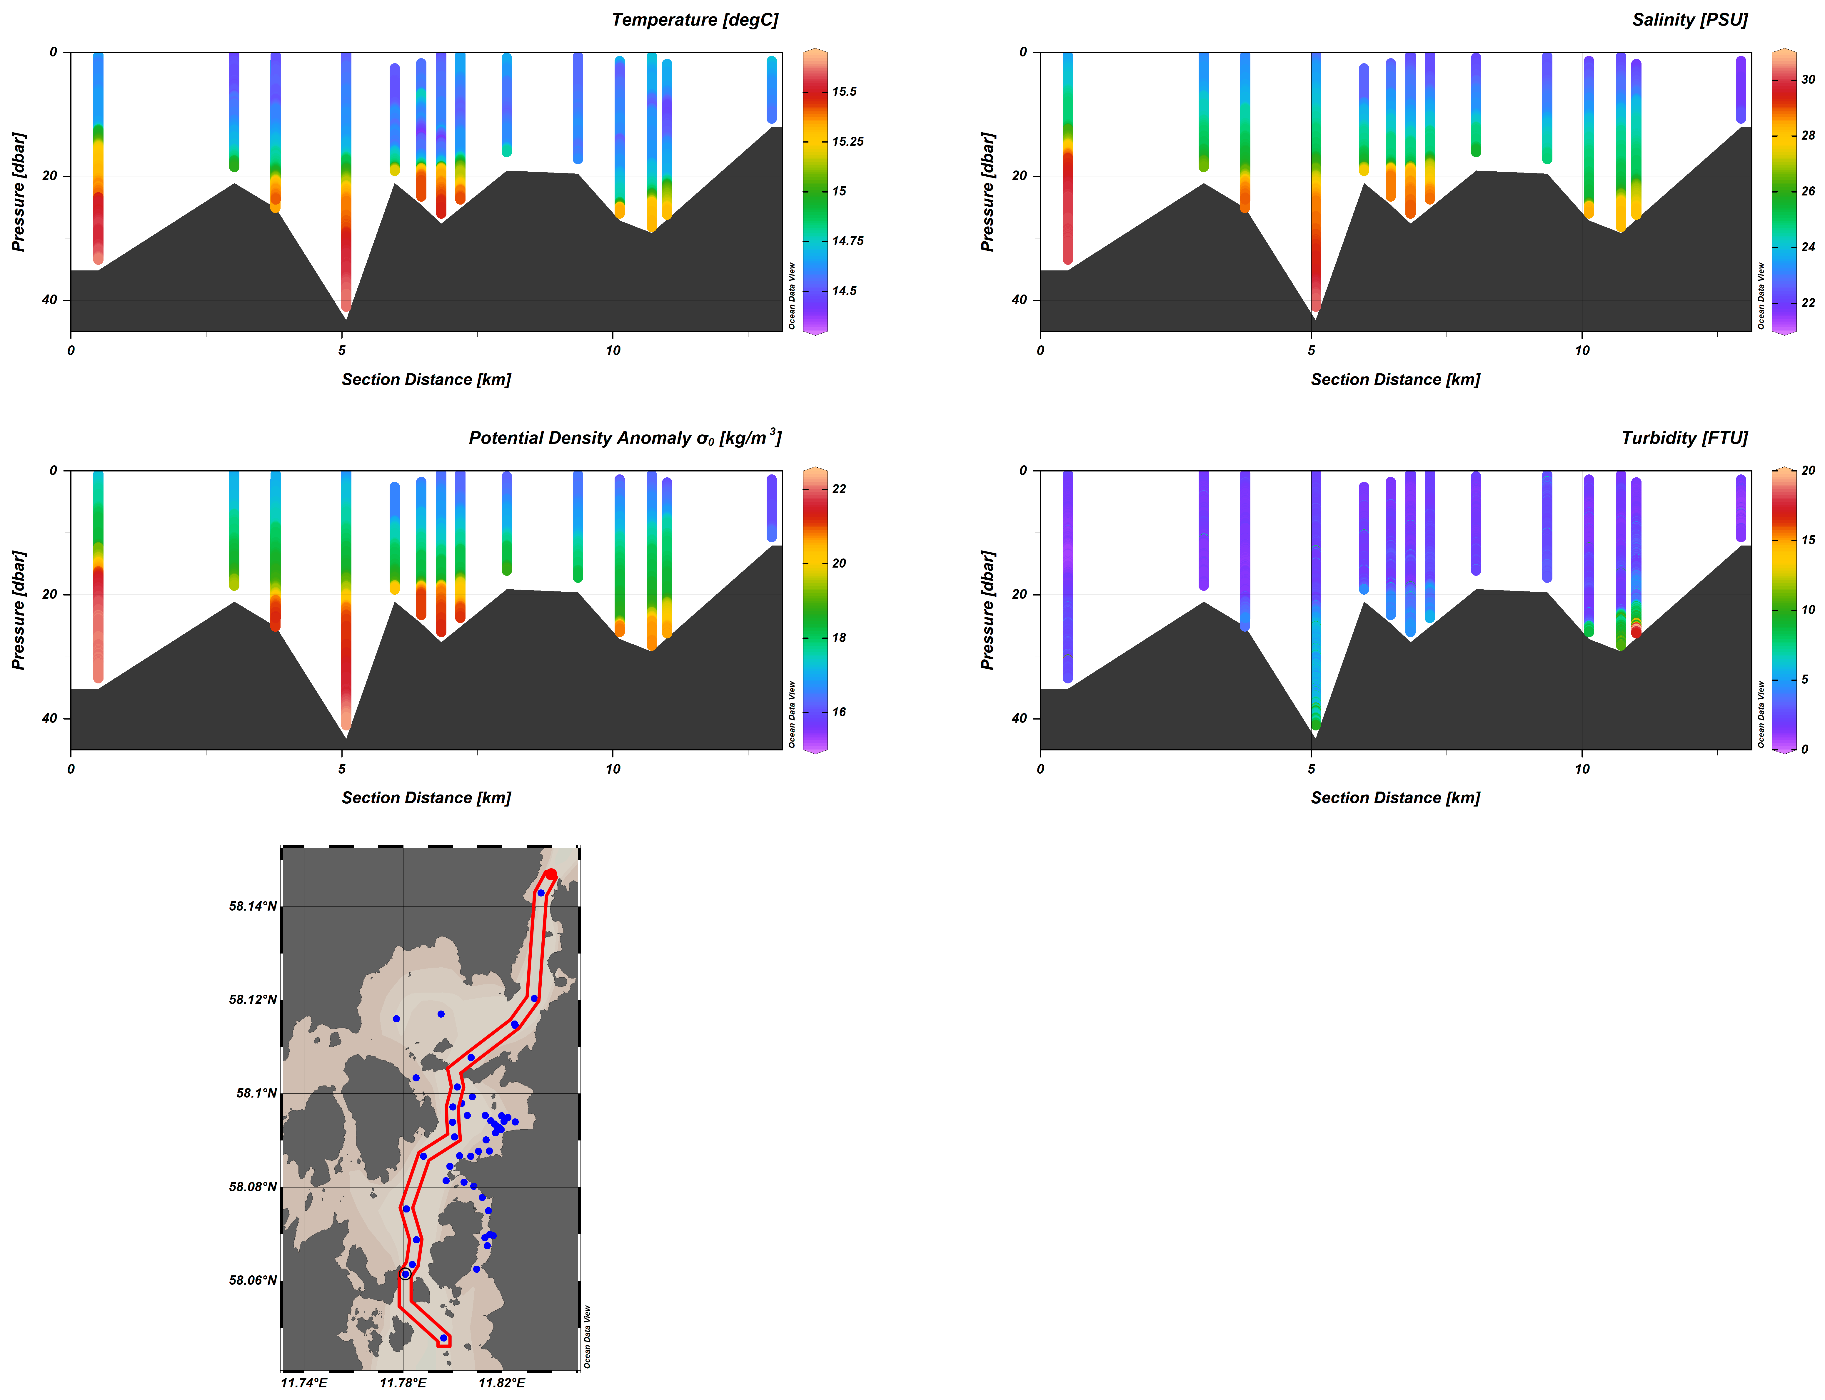
Figure S1: CTD data

Sedimentation rate calculations
For the sedimentation rate calculations, we used the mean radius of the identified PVC particles, which was 72 μm. The volume of the Askeröfjorden and Halsefjorden is 32.02 km².
For the viscosity, a temperature of 7 °C and a salinity of 35g/kg was used.

