Variable | mean | sd |  |  | median | min | max
SDNN (ms) | 45,90573674 | 22,30939933 |  |  | 42,361411 | 15,052073 | 171,372
Mean HR (bpm) | 86,38738544 | 16,52310617 |  |  | 85,989061 | 9,045833333 | 129,855694
RMSSD (ms) | 40,39892064 | 23,92337649 |  |  | 34,1382095 | 7,309181 | 125,209045
VLF power (log) | 4,340311459 | 0,9646162508 |  |  | 4,3841055 | 1,570487 | 6,31
LF power (log) | 6,653794306 | 0,8186475158 |  |  | 6,773177 | 4,6259 | 8,52
HF power (log) | 6,218279724 | 1,207912843 |  |  | 6,332538 | 2,858963 | 8,428717
LF/HF ratio | 2,143508265 | 1,956023199 |  |  | 1,8069985 | 0,104145 | 13,36736
DFA alpha1 | 1,147182918 | 0,2517456339 |  |  | 1,1688765 | 0,454107 | 1,660712
DFA alpha2 | 0,4480790408 | 0,1521014486 |  |  | 0,435872 | 0,112286 | 0,968554
VLF power (ms²) | 113,0510678 | 97,9795517 |  |  | 80,162673 | 4,808992 | 551,9
LF power (ms²) | 1056,481219 | 858,7394395 |  |  | 875,854346 | 102,0897 | 5036,49
HF power (ms²) | 908,1084184 | 959,7525567 |  |  | 561,646174 | 17,443423 | 4576,625057
Age at onset (years) | 6,628571429 | 4,814732545 |  |  | 6 | 0 | 21
Epilepsy duration (years) | 7,973469388 | 5,38992093 |  |  | 7 | 0 | 20
Active epilepsy duration (years) | 6,176530612 | 5,321553161 |  |  | 5 | 0,3 | 20
Age (years) | 14,60204082 | 5,200098722 |  |  | 15 | 3 | 25
Sex | 1,540816327 | 0,500893374 |  |  | 2 | 1 | 2

Supplementary Table 1. Full descriptive statistics

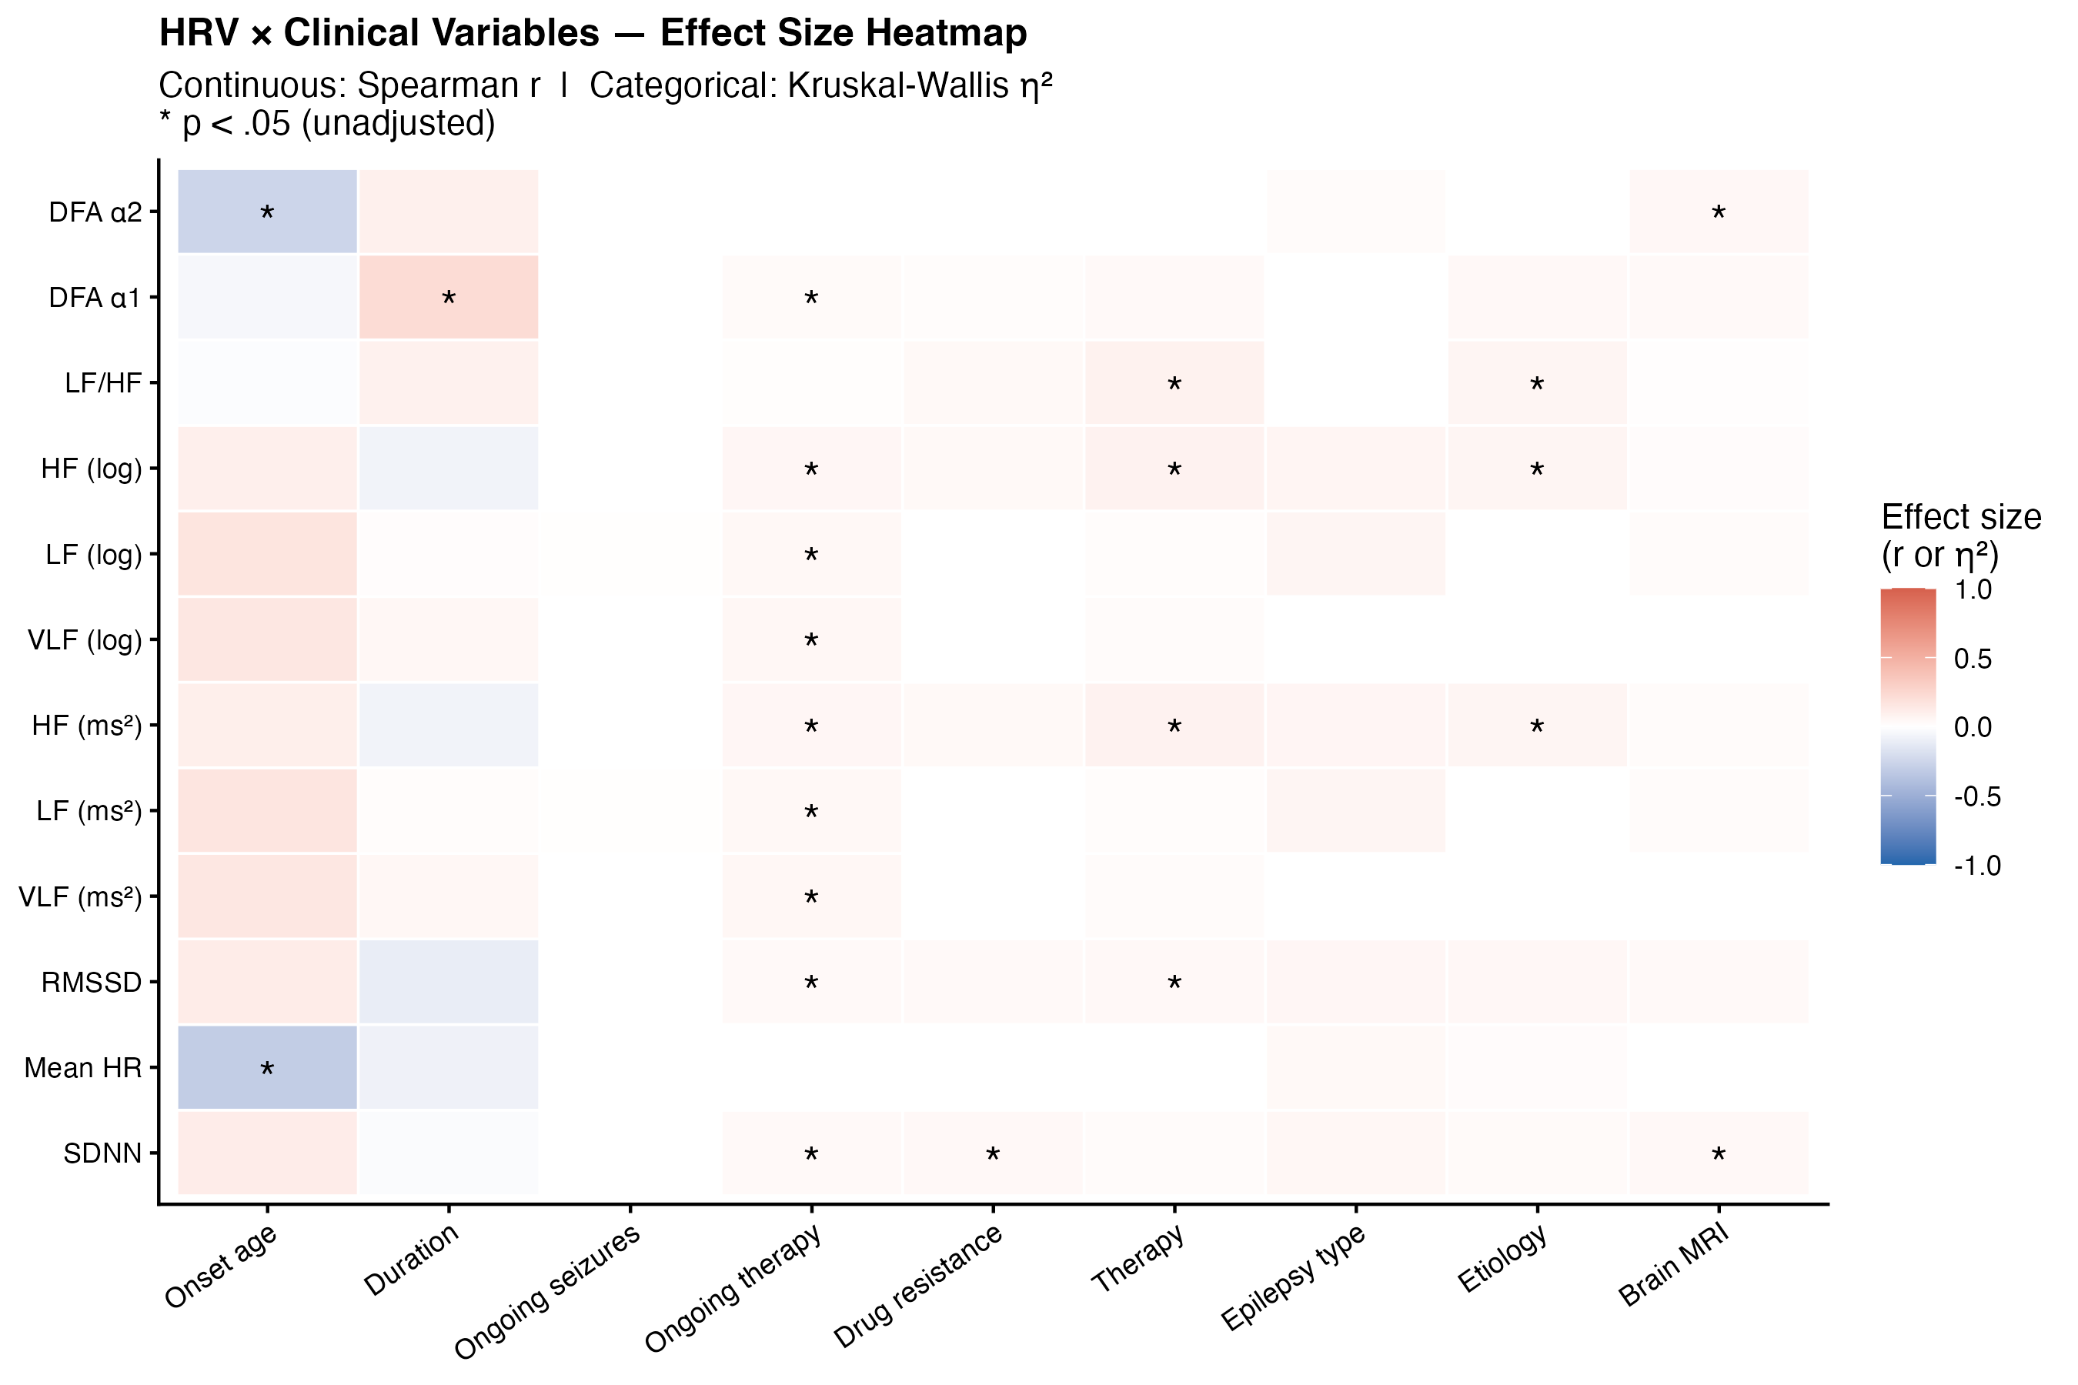

Supplementary Figure 1. Heat map showing the correlation between clinical and HRV parameters with nominal significance

dep | indep | r | P_value | Adjusted_P
S1_SDNN_.ms. | Age_at_epilepsy_onset_years | 0,117248 | 0,250238 | 0,375357
S1_Mean_HR_.bpm. | Age_at_epilepsy_onset_years | -0,30867 | 0,001986 | 0,01787
S1_RMSSD_.ms. | Age_at_epilepsy_onset_years | 0,118935 | 0,243438 | 0,375357
S1_VLFpow_FFT_.log. | Age_at_epilepsy_onset_years | 0,153653 | 0,130902 | 0,294529
S1_LFpow_FFT_.log. | Age_at_epilepsy_onset_years | 0,165623 | 0,103138 | 0,294529
S1_HFpow_FFT_.log. | Age_at_epilepsy_onset_years | 0,101206 | 0,321403 | 0,413232
S1_LF_HF_ratio_FFT | Age_at_epilepsy_onset_years | -0,01784 | 0,861553 | 0,861553
S1_DFA1 | Age_at_epilepsy_onset_years | -0,04664 | 0,648355 | 0,7294
S1_DFA2 | Age_at_epilepsy_onset_years | -0,2578 | 0,010383 | 0,046722
S1_SDNN_.ms. | Epilepsy_duration_years | -0,02364 | 0,817299 | 0,863776
S1_Mean_HR_.bpm. | Epilepsy_duration_years | -0,08219 | 0,421099 | 0,731085
S1_RMSSD_.ms. | Epilepsy_duration_years | -0,10985 | 0,281599 | 0,731085
S1_VLFpow_FFT_.log. | Epilepsy_duration_years | 0,050637 | 0,620483 | 0,797764
S1_LFpow_FFT_.log. | Epilepsy_duration_years | 0,017555 | 0,863776 | 0,863776
S1_HFpow_FFT_.log. | Epilepsy_duration_years | -0,07097 | 0,48739 | 0,731085
S1_LF_HF_ratio_FFT | Epilepsy_duration_years | 0,088414 | 0,386644 | 0,731085
S1_DFA1 | Epilepsy_duration_years | 0,220531 | 0,029104 | 0,261938
S1_DFA2 | Epilepsy_duration_years | 0,095427 | 0,349948 | 0,731085
S1_SDNN_.ms. | Active_epilepsy_duration | -0,10119 | 0,321475 | 0,482213
S1_Mean_HR_.bpm. | Active_epilepsy_duration | -0,04058 | 0,691537 | 0,777979
S1_RMSSD_.ms. | Active_epilepsy_duration | -0,1677 | 0,098823 | 0,185332
S1_VLFpow_FFT_.log. | Active_epilepsy_duration | 0,061968 | 0,544408 | 0,699953
S1_LFpow_FFT_.log. | Active_epilepsy_duration | -0,01929 | 0,850458 | 0,850458
S1_HFpow_FFT_.log. | Active_epilepsy_duration | -0,16571 | 0,102962 | 0,185332
S1_LF_HF_ratio_FFT | Active_epilepsy_duration | 0,209282 | 0,038624 | 0,173809
S1_DFA1 | Active_epilepsy_duration | 0,260762 | 0,009505 | 0,085549
S1_DFA2 | Active_epilepsy_duration | 0,188137 | 0,063573 | 0,185332

Supplementary Table 2. Details of correlation analysis

Dependent | Independent | Std_Beta | CI_low |  | CI_high | P_value | Adjusted_P
S1_SDNN_.ms. | Age_at_epilepsy_onset_years | 0,02070569839 | -0,9544764768 | 1,146359074 |  | 0,856483004 | 0,856483004
S1_SDNN_.ms. | Epilepsy_duration_years | -0,02317928899 | -1,146359074 | 0,9544764768 |  | 0,856483004 | 0,856483004
S1_SDNN_.ms. | Active_epilepsy_duration | -0,1310118179 | -1,495217373 | 0,3967429714 |  | 0,2519167417 | 0,3238929536
S1_Mean_HR_.bpm. | Age_at_epilepsy_onset_years | -0,1455917681 | -1,218562613 | 0,219284577 |  | 0,1708898176 | 0,4566685433
S1_Mean_HR_.bpm. | Epilepsy_duration_years | 0,1629847786 | -0,219284577 | 1,218562613 |  | 0,1708898176 | 0,4566685433
S1_Mean_HR_.bpm. | Active_epilepsy_duration | 0,1681881071 | -0,127503918 | 1,171932064 |  | 0,1138735372 | 0,1708103058
S1_RMSSD_.ms. | Age_at_epilepsy_onset_years | 0,1073675533 | -0,5766700227 | 1,643642851 |  | 0,3424576977 | 0,5136865465
S1_RMSSD_.ms. | Epilepsy_duration_years | -0,1201941369 | -1,643642851 | 0,5766700227 |  | 0,3424576977 | 0,5136865465
S1_RMSSD_.ms. | Active_epilepsy_duration | -0,2021544474 | -1,903037147 | 0,08544111582 |  | 0,07272926062 | 0,1309126691
S1_VLFpow_FFT_.log. | Age_at_epilepsy_onset_years | 0,08586270722 | -0,02755600425 | 0,06196064124 |  | 0,4473076246 | 0,5162164528
S1_VLFpow_FFT_.log. | Epilepsy_duration_years | -0,09612023064 | -0,06196064124 | 0,02755600425 |  | 0,4473076246 | 0,5162164528
S1_VLFpow_FFT_.log. | Active_epilepsy_duration | -0,01857100107 | -0,04407104005 | 0,03733846071 |  | 0,8699238075 | 0,8699238075
S1_LFpow_FFT_.log. | Age_at_epilepsy_onset_years | 0,1276299227 | -0,01581778674 | 0,05921954091 |  | 0,2537047463 | 0,4566685433
S1_LFpow_FFT_.log. | Epilepsy_duration_years | -0,142877135 | -0,05921954091 | 0,01581778674 |  | 0,2537047463 | 0,4566685433
S1_LFpow_FFT_.log. | Active_epilepsy_duration | -0,1046656236 | -0,05020056969 | 0,0179978461 |  | 0,3508796022 | 0,3947395525
S1_HFpow_FFT_.log. | Age_at_epilepsy_onset_years | 0,1305246283 | -0,0236221375 | 0,08911378143 |  | 0,2516503844 | 0,4566685433
S1_HFpow_FFT_.log. | Epilepsy_duration_years | -0,1461176543 | -0,08911378143 | 0,0236221375 |  | 0,2516503844 | 0,4566685433
S1_HFpow_FFT_.log. | Active_epilepsy_duration | -0,2289995413 | -0,102339378 | -0,001619552184 |  | 0,04321157889 | 0,1296347367
S1_LF_HF_ratio_FFT | Age_at_epilepsy_onset_years | -0,08415757518 | -0,1254580083 | 0,05707864649 |  | 0,4588590691 | 0,5162164528
S1_LF_HF_ratio_FFT | Epilepsy_duration_years | 0,09421139629 | -0,05707864649 | 0,1254580083 |  | 0,4588590691 | 0,5162164528
S1_LF_HF_ratio_FFT | Active_epilepsy_duration | 0,2064080954 | -0,005665833245 | 0,1574031215 |  | 0,06781261997 | 0,1309126691
S1_DFA1 | Age_at_epilepsy_onset_years | -0,1355130052 | -0,01856722199 | 0,00439621371 |  | 0,2235272691 | 0,4566685433
S1_DFA1 | Epilepsy_duration_years | 0,1517019639 | -0,00439621371 | 0,01856722199 |  | 0,2235272691 | 0,4566685433
S1_DFA1 | Active_epilepsy_duration | 0,2505507521 | 0,00164336591 | 0,02206214111 |  | 0,02335969606 | 0,1296347367
S1_DFA2 | Age_at_epilepsy_onset_years | -0,1585821549 | -0,01186394914 | 0,001844461972 |  | 0,1500476695 | 0,4566685433
S1_DFA2 | Epilepsy_duration_years | 0,1775270521 | -0,001844461972 | 0,01186394914 |  | 0,1500476695 | 0,4566685433
S1_DFA2 | Active_epilepsy_duration | 0,2316648448 | 0,0004851635187 | 0,01275779673 |  | 0,03473618077 | 0,1296347367

Supplementary Table 3. Details of regression analysis

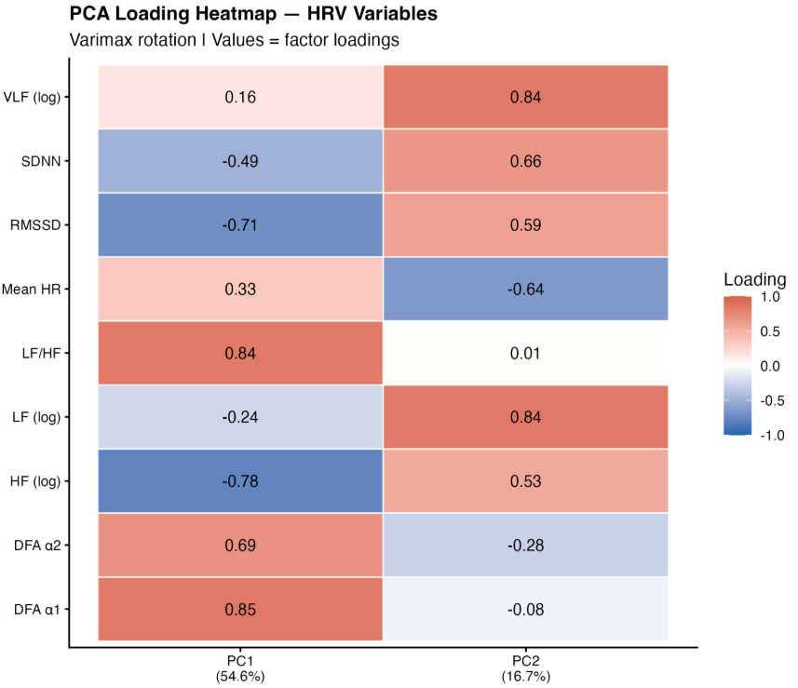

Supplementary Figure 2. Heatmap showing the PCA loadings

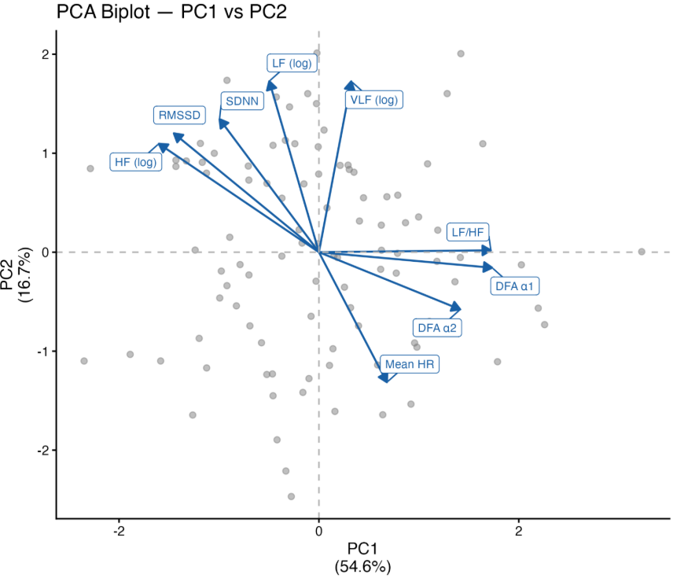

Supplementary Figure 3. Varimax rotation of PC1 and PC2

