Modulating Electronic Structure of Cu-based MOF via Ni Doping for Efficient CO₂ Electroreduction to C₂₊ Products
Aicheng Songª, Zhitao Hanª*, Mengjing Zhangª, Xiao Yangª, Bingqiang Yanª, Dong Liuª, Song Zhou^{b}
a. Marine Engineering College, Dalian Maritime University, Dalian 116026, China;
^{b} College of Power and Energy Engineering, Harbin Engineering University, Harbin 150001, P. R. China.
Correspondence information: Dr. Zhitao Han, Dalian Maritime University, No.1, Linghai Road, Dalian 116026, China, hanzt@dlmu.edu.cn.

Materials
CO₂ (99.999 %) and N₂ (99.999 %) pure gases were obtained from Dalian Special Gases Co., Ltd. Methyl alcohol, KHCO₃, Ni(NO₃)₂·6H₂O and Cu(NO₃)₂·3H₂O were obtained from Sinopharm Chemical Reagent Co., Ltd. H₃BTC was obtained from Shanghai Aladdin Co., Ltd. Nafion was obtained from Dupont, USA. Pure water was prepared using ELGA purification system with a resistance of 15 MΩ. All materials were used directly without further processing.

Catalyst characterization
X-ray diffraction (XRD) tests were conducted using an X-ray diffractometer (Empyrean, PANalytical) with Cu Ka (λ= 0.154 nm) as the radiation source. The XRD diffractograms of the catalyst samples were recorded in the 2θ range of 5º–90º with a scanning speed of 2º/min and a scanning interval of 0.01º.
The morphology of the sample was measured by scanning electron microscopic (SEM, Tescan Mira4). And the acceleration potential was 200 kV, and the surface chemical analysis was conducted by using energy dispersive X-ray spectrometer (EDS).
The X-ray photoelectron spectra (XPS) of the catalysts were measured with a photoelectron spectrometer (AXIS-ULTRA DLD-600W, Shimadzu) using Al Kα as the radiation source. The binding energies of the different elements were calibrated by the C 1s peak at 284.6 eV.
The structural properties of the samples were investigated by N₂ physisorption (ASAP 2020 PLUS, Micromeritics). The samples were required to be degassed under vacuum at 350 °C for 4 h before each test, N₂ adsorption-desorption data were recorded at the temperature of liquid nitrogen (-196 °C). Specific surface areas and pore volumes were calculated using the Brunauer-Emmett-Teller (BET) equation and the Barrett-Joyner-Halenda (BJH) method, respectively.
Sample digestion for ICP-OES analysis was performed in polytetrafluoroethylene vessels using a mixture of nitric acid, hydrochloric acid, and perchloric acid. The sealed vessels were heated on a hotplate through a programmed temperature ramp for complete digestion. After digestion, the solution was evaporated to near dryness, then transferred and diluted to a fixed volume with deionized water for measurement.
The reaction intermediates in the electrolyte were determined by Attenuated Total Reflectance-Fourier Transform Infrared Spectroscopy (ATR-FTIR). The spectra of the catalysts were recorded with a Fourier Transform Infrared Spectrometer (iS50, Thermo Fisher Scientific) in the wavelength range of 400-4000 cm⁻¹.

Catalysts synthesis
Initially, 5 mmol of Ni(NO₃)₂·6H₂O was dissolved in 30 mL of methanol under stirring to form a clear solution. Then, 5 mmol of Cu(NO₃)₂·3H₂O was added, and stirring was continued to obtain a homogeneous mixture, followed by ultrasonication for 10 min. Separately, 5 mmol of 1,3,5-benzenetricarboxylic acid (H₃BTC) was dissolved in 30 mL of methanol. The ligand solution was slowly poured into the metal salt solution, stirred, and further ultrasonicated. The mixture was transferred into a 100 mL Teflon-lined autoclave and heated at 120 °C for 24 h. After cooling, the solid product was collected, washed with methanol via centrifugation, and dried at 65 °C. The precursor was finally calcined in air at 500 °C for 3 h (heating rate: 3 °C/min) to obtain the CuNi-2 catalyst. Other catalysts with different Cu/Ni ratios were synthesized following the same procedure while maintaining the total metal precursor amount.

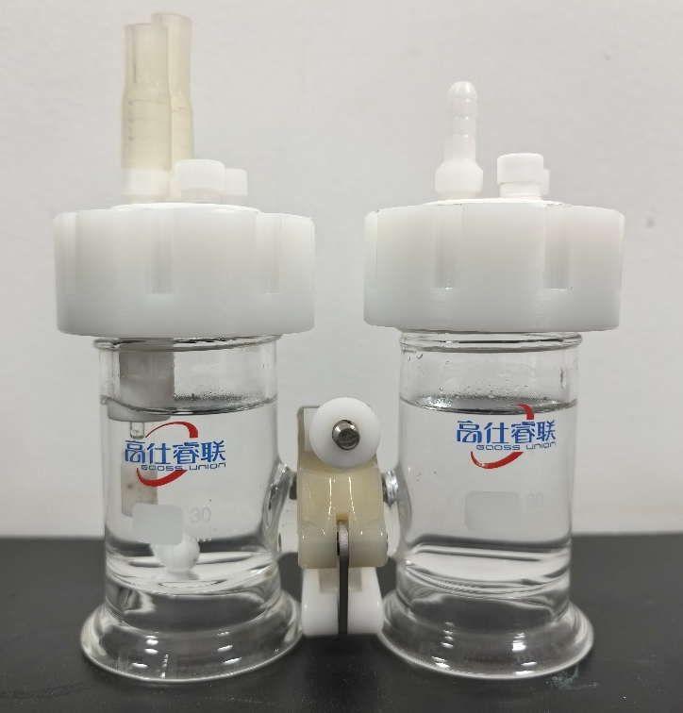
Figure S1. Schematic diagram of H-type electrolytic cell.
Figure S2. XRD patterns of uncalcined catalysts.
Figure S3. SEM images and EDS elemental maps of catalysts. (a) CuNi-0, (b) CuNi-1, (c) CuNi-3.
Figure S4. FE values of products of catalysts. (a) CuNi-0, (b) CuNi-1, (c) CuNi-3.
Figure S5. Cyclic voltammograms of catalysts (a) CuNi-0, (b) CuNi-1, (c) CuNi-2, (d) CuNi-3.
Table S1 XPS results of catalysts (Cu 2p)
Catalysts | The relative molar ratio (%)
Catalysts | Cu²⁺ | Cu⁺
CuNi-0 | 86.46 | 13.54
CuNi-1 | 87.76 | 12.24
CuNi-2 | 81.35 | 18.65
CuNi-3 | 86.92 | 13.08
Table S2 XPS results of catalysts (Ni 2p)
Catalysts | The relative molar ratio (%)
Catalysts | Ni²⁺ | Ni⁰
CuNi-1 | 93.72 | 6.28
CuNi-2 | 96.53 | 3.47
CuNi-3 | 90.97 | 9.03
Table S3 XPS results of catalysts (O 1s)
Catalysts | The relative molar ratio (%)
Catalysts | O_{α} | O_{β}
CuNi-0 | 43.48 | 56.52
CuNi-1 | 61.35 | 38.65
CuNi-2 | 51.89 | 48.11
CuNi-3 | 52.11 | 47.89

Table S4 ICP-OES results of catalysts
Sample | Cu loading (wt.%) | Ni loading (wt.%)
CuNi-0 | 75.6314 | /
CuNi-1 | 70.0945 | 1.1167
CuNi-2 | 76.2857 | 2.5769
CuNi-3 | 72.6838 | 3.1608

Table S5 The comparisons of catalysts in this paper with reported electrocatalysts
Catalysts | Condition | FE of C₂H₄ (%) | Total current density (mA cm⁻²) | Reference
CuNi-0 | 0.5 M KHCO₃  -1.0 V vs RHE | 18.36 | 52 | This work
CuNi-1 | 0.5 M KHCO₃  -1.0 V vs RHE | 27.54 | 83 | This work
CuNi-2 | 0.5 M KHCO₃  -1.0 V vs RHE | 32.35 | 71 | This work
CuNi-3 | 0.5 M KHCO₃  -1.0 V vs RHE | 17.66 | 72 | This work
Cu₉Zn₁ | 0.1 M KHCO₃  –1.1 V vs. RHE | 17 | - | [1]
Cu75Zn25-C | 0.1 M KHCO₃  –1.0 V vs RHE | 15 | 6.7 | [2]
Cu@CeO₂@C | 0.5 M KHCO₃  –1.5V vs RHE | <10 | 136 | [3]
CuBi@Cu-MOF | 0.1 M KOH  –1.6 V vs RHE | <10 | <160 | [4]
Cu/C-450-air | 0.1 M KHCO₃  –1.1 V vs RHE | 34.8 | - | [5]
Fe-TCPP@Cu | 0.5 M KHCO₃  –1.17 V vs RHE | 33.42 | - | [6]
CuZn-500 | 0.5 M KHCO₃  -0.8V vs RHE | 27.78 | 46 | [7]

References:
[1] R. Yang, Z.P. Zeng, Z. Peng, J.F. Xie, Y.Y. Huang, Y.B. Wang. Amorphous urchin-like copper@nanosilica hybrid for efficient CO₂ electroreduction to C₂₊ products, J ENERGY CHEM 61 (2021) 290-296.
[2] S. Juntrapirom, J. Santatiwongchai, A. Watwiangkham, S. Suthirakun, T. Butburee, K. Faungnawakij, P. Chakthranont, P. Hirunsit, B. Rungtaweevoranit, Tuning CuZn interfaces in metal-organic framework-derived electrocatalysts for enhancement of CO₂ conversion to C₂ products, Catal. Sci. Technol. 11 (24) (2021) 8065-8078.
[3] Y. Zhang, X.Y. Zhang, W.Y. Sun, In situ carbon-encapsulated copper-doped cerium oxide derived from MOFs for Boosting CO₂‑to-CH₄ electro-conversion. ACS Catal. 13 (2023) 1545−1553.
[4] F.F. Wang, W.Y. Sun, Cu-MOF and CuBi Double-Perovskite Composites for Selective CO₂ Electroreduction to HCOOH, ACS Sustainable Chem. Eng. 12 (2024) 15651−15658.
[5] Yang Z, Chen Y, Wen X, Guo X, Wei R, Gao L, et al. Modulable Cu(0)/Cu(I)/Cu(II) sites of Cu/C catalysts derived from MOF for highly selective CO₂ electroreduction to hydrocarbons. Vacuum 2023;215:112231.
[6] Xing L, Wei K, Li Y, Fang Z, Li Q, Qi T, et al. TiO₂ Coating Strategy for Robust Catalysis of the Metal–Organic Framework toward Energy-Efficient CO₂ Capture. Environmental Science & Technology 2021;55(16):11216-24.
[7] Liu D, Yang X, Han Z, Wu X, Zhou Z, Zhang M, et al. Influence of calcination temperature on catalytic performance of Cu-Zn bimetallic MOFs derivatives for electroreduction CO₂ to ethylene. Journal of Environmental Chemical Engineering 2025;13(5).

