Supplemental Methods
1.Randomization Method
In this study, eligible patients admitted in a single outpatient session were randomized after signing the surgical consent form. An independent physician conducted the 1:1 randomization using a computer-based method (simple randomization via the SAS system). Patients in the experimental group underwent MB-UKA surgery, while those in the control group received FB-UKA surgery. The surgical assignments were made by another independent physician. If the number of patients admitted in a single outpatient session was even, randomization was completed for that session. If the number was odd, the last patient admitted was scheduled for randomization in the next outpatient session. We employed a stratified randomization method, accumulating multiple outpatient visits to achieve the required minimum sample size, including a 5% follow-up rate. Throughout the process, neither patients nor study personnel were aware of the randomization results to ensure the study's double-blind nature.

2.Preoperative Preparation
(1) Preoperative Assessment: Physicians conduct a thorough review of the patient's medical history, complete a physical examination, and perform ASA classification and airway assessment. They evaluate the patient’s nutritional status, underlying diseases, and the function of key organs such as the cardiovascular and respiratory systems. Risks associated with anesthesia and surgery are rigorously assessed, and contraindications are identified to ensure patient safety and suitability for the procedure.
(2) Preoperative Education: Patients are provided with comprehensive preoperative education. This includes detailed information about the anesthesia techniques, multimodal pain management strategies, potential common issues before discharge, and guidelines for home recovery. The risks associated with the surgery are explained, and patients are repeatedly informed about expected pain levels, postoperative care, and overall surgical safety to align their expectations with the realities of the procedure.
(3) Preoperative Informed Consent: Patients are informed of the risks related to both the surgery and anesthesia, along with the strategies for managing these risks. They are required to sign an informed consent form and any other necessary medical documentation before proceeding with the surgery.
3. Intraoperative Management
(1) Infection Prevention: Prior to anesthesia in the operating room, a prophylactic intravenous infusion of 1.5 g of cefuroxime is administered to prevent surgical site infections.
(2) Anesthesia Technique: Subarachnoid block anesthesia is employed, achieved by injecting a local anesthetic into the lumbar intervertebral space to block the conduction of selected spinal nerves, thereby producing anesthesia in the corresponding areas.
(3) Blood Management: Prior to surgery, it is essential to verify and address any pre-existing anemia. Normal body temperature is maintained throughout the procedure, and strict hemostasis is enforced. In accordance with standard procedures, a pneumatic tourniquet is applied during surgery with a pressure of 300 mmHg (1 mmHg = 0.133 kPa). Thirty minutes before skin incision, 1 g of tranexamic acid is administered intravenously. After closing the joint capsule, 1.5 g of tranexamic acid is injected into the joint cavity, followed by a postoperative intravenous infusion of 1 g to minimize blood loss after UKA surgery.
(4) Intraoperative Local Infiltration Analgesia: Before the implantation of the UKA prosthesis, local infiltration analgesia ("cocktail therapy") is administered using a 19-gauge needle. The anesthetic solution is injected into the surrounding tissues of the knee joint, including the femoral periosteum, posterior joint capsule, anterior and posterior cruciate ligament insertions, Hoffa’s fat pad, and deep tissues around the medial and lateral collateral ligaments, as well as subcutaneous fat tissue. Injection sites are positioned 3 mm from the edge of the incision.

4. Surgical Techniques of Two Types of Medial Unicompartmental Knee Arthroplasty
(1) Medial Fixed-Bearing Unicompartmental Knee Arthroplasty
For anesthesia and positioning, spinal anesthesia or general anesthesia is administered. The patient is placed in a supine position, with a tourniquet applied to the root of the affected thigh. After routine disinfection and draping, the affected knee is flexed at 90° and fixed with a pillow to fully expose the surgical field, facilitating subsequent osteotomy and prosthesis implantation.
A 8-10cm arc incision is made on the medial side of the left knee. The skin, subcutaneous tissue, and deep fascia are dissected layer by layer, the interval between the vastus medialis and sartorius muscles is separated, and the medial joint capsule is incised. The medial soft tissues are appropriately released while preserving necessary stability, and proliferative synovial tissue, osteophytes, and loose bodies within the joint are removed to fully expose the femoral condyle and tibial plateau of the medial compartment.
In terms of core surgical procedures, tibial osteotomy is performed first: an osteotomy thickness mark is made 4-5mm below the lowest point of cartilage wear in the medial tibial compartment; the width is estimated based on the patient's gender and height; an oscillating saw is used to perform osteotomy strictly according to the mark to ensure a flat osteotomy surface and avoid excessive or insufficient osteotomy that may affect prosthesis fit. For femoral prosthesis positioning and preparation, the anterior edge of the femoral prosthesis is positioned 8-12mm in front of the apex of the intercondylar fossa, with positioning points marked by drilling to ensure precise anteroposterior and medial-lateral positioning; a femoral trial prosthesis is installed to check the fit with the tibial side and the coordination during knee joint movement, with timely adjustments if there is jamming or poor stability. Joint space testing is conducted using thickness gauges of specifications such as 55X7mm and 55X9mm; with the knee in a flexed state, the thickness gauge should be inserted without resistance to ensure a uniform space and no jamming, and the osteotomy amount or trial prosthesis size is adjusted if the space is mismatched.
During prosthesis implantation, the tibial prosthesis follows the "three-cortex principle" to ensure complete coverage of the posterior and medial cortices and full adherence to the bone surface, with the posterior tilt angle adjusted to 7°. Bone cement is evenly applied to the fitting surface of the femoral prosthesis before implantation, and the prosthesis is fully seated by tapping to avoid loosening. The amount of bone cement is strictly controlled to ensure fixation effect while preventing overflow that may damage surrounding soft tissues; after the bone cement solidifies, excess cement is removed. Intraoperative bleeding is strictly controlled to maintain a clear surgical field; the medial soft tissues are appropriately released to avoid postoperative joint stiffness while maintaining knee stability; before prosthesis implantation, the joint cavity and osteotomy surface are thoroughly irrigated to remove bone chips, tissue debris, and residual bone cement. Fluoroscopy is performed to confirm that the central lines of the femoral and tibial prostheses are aligned without deviation, the posterior tilt angle of the tibial prosthesis reaches 7°, the prosthesis edges have no overhang, and the prostheses fit tightly with the bone surface without obvious gaps.
Finally, the joint capsule, deep fascia, subcutaneous tissue, and skin are sutured layer by layer to ensure tight closure of the joint capsule and reduce the risk of postoperative infection. The incision is covered with sterile gauze, and moderate compression bandaging is applied with an elastic bandage to reduce postoperative bleeding and swelling.
(2) Mobile-Bearing Unicompartmental Knee Arthroplasty
Spinal anesthesia or general anesthesia is used for this procedure. The patient lies supine, with a tourniquet fastened at the root of the affected thigh. After disinfection and draping, the affected knee is fixed at 90° of flexion to fully expose the medial knee compartment.
A 7-9cm arc incision is made on the medial side of the knee joint. The skin and subcutaneous tissue are dissected layer by layer, the vastus medialis and sartorius muscles are separated, and the medial joint capsule is incised. Proliferative synovial tissue, osteophytes, and loose bodies are removed, and the stability of the knee joint is tested through varus and valgus stress to confirm the integrity of the medial collateral ligament (MCL).
Tibial osteotomy includes vertical and horizontal osteotomy. For vertical osteotomy, the principle of "prefer wider than narrower, prefer internal rotation than external rotation" is adhered to; the width is positioned with reference to 1-2mm medial to the apex of the medial tibial spine (ACL edge); the saw blade is consistent with the sagittal axis of the tibia and perpendicular to the front of the osteotomy guide block, with the anterior cortex sawed through first before flattening the saw blade to complete the osteotomy, ensuring the osteotomy surface does not exceed the apex of the medial tibial spine. For horizontal osteotomy, the MCL is protected by a combination of a Z-shaped retractor (horizontal direction) and a periosteal elevator (inserted longitudinally under the MCL) to avoid injury; an oscillating saw is used to perform osteotomy outside the slot (cancellous bone area), ensuring the saw blade does not touch the MCL and the tibia is fully sawed through (the bone block can be loosened by varus and valgus movements of the saw blade); the use of an osteotome is prohibited to prevent posterior wall fracture; after installing a G-clamp, the horizontal osteotomy saw blade is aligned with the mark line to ensure accurate osteotomy thickness. Osteotomy verification is performed to confirm that the angle between the vertical and horizontal osteotomy surfaces is 90° (no varus/valgus deviation), the osteotomy block is of equal width (no internal/external rotation deviation) and equal thickness (ensuring a 7° posterior tilt after horizontal osteotomy), with the osteotomy surface located 2mm below the lowest wear point.
For femoral side preparation, the osteotomy surface is covered with a tibial module, and a No. 4 thickness gauge is inserted above it; a line perpendicular to the template is drawn on the femoral condyle with an electric knife through the midpoint, which serves as the midline of the femoral condyle prosthesis (based on the tibial prosthesis midline rather than the femoral anatomical midline). With the knee flexed at 45°, the femoral intramedullary entry point is at the junction of 1cm anterior to the apex of the intercondylar fossa and the extension line of the lateral wall of the medial femoral condyle; the insertion direction of the guide rod is prioritized over the entry point position to correct potential entry deviations, and complications such as prosthesis hyperextension (entry too high), hyperflexion (entry too low), varus (entry too medial), or valgus (entry too lateral) are avoided.
Flexion-extension gap measurement and balancing take "restoring MCL tension" as the core (verified by testing with the knee flexed at 110°), following the "three-choice principle" (prefer Class A 3mm thickness gauge with free entry and exit and slight resistance) and the "two-finger principle" (holding the thickness gauge with the thumb and index finger to ensure free entry and exit with slight resistance). For extension gap measurement, after extending the knee joint, it is lowered slightly (close to 20°), mild valgus stress is applied before inserting the thickness gauge, and verification is performed with a 1mm metal shim (smooth insertion) and a 2mm metal shim (failure to insert) to confirm the extension gap is 1mm, with the extension gap ≤ flexion gap under normal conditions. For flexion-extension gap balancing, the flexion gap is measured with the knee flexed at 110°, and the extension gap is measured with the knee flexed at 20°; the thickness gauge inserted during flexion is kept in place while the knee is slowly extended—slight resistance during removal indicates an appropriate thickness, easy removal indicates an excessively large extension gap, and entrapment indicates an excessively small extension gap; a spacer trial is used for verification: with the knee flexed at 110°, the anterior edge of the spacer trial can be lifted 2-3mm up and down; with the knee flexed at 20°, the joint surface opens 1-2mm when the knee is in valgus; a straight preoperative lateral marking line combined with the above conditions confirms an appropriate spacer thickness and equal flexion-extension gaps.
During prosthesis implantation, the tibial prosthesis is attached to the osteotomy surface, adjusted to meet alignment requirements, and fixed with bone cement to ensure tight adherence to the bone surface. The mobile bearing spacer is placed between the tibial and femoral prostheses, and the range of motion and stability are checked to ensure no jamming or displacement. Bone cement is evenly applied to the femoral prosthesis, which is then accurately implanted into the predetermined position by tapping; after the bone cement solidifies, excess cement is cleaned. Fluoroscopy is performed to confirm the normal position, alignment, and joint space recovery of the prosthesis; the joint cavity is thoroughly irrigated to remove bone chips, tissue debris, and residual bone cement, and strict hemostasis is ensured to eliminate active bleeding in the surgical field.
Finally, the joint capsule, deep fascia, subcutaneous tissue, and skin are sutured layer by layer. The incision is covered with sterile gauze, and compression bandaging is applied with an elastic bandage to reduce postoperative swelling and bleeding.

4. Postoperative Management
(1) General Postoperative Care and Infection Prevention: Following surgery, patients are transferred to the anesthesia recovery room, where vital signs are monitored and pain and nausea are managed with minimal use of anesthetics or sedatives. Subsequently, patients are moved to the general ward. Both groups of patients receive drainage via a single-use negative pressure drain for 12 hours, followed by compression bandaging for the next 24 hours. Standard infection prevention includes intravenous cefuroxime (1.5 g, twice daily) for 48 hours postoperatively.
(2) Prevention of Deep Vein Thrombosis (DVT): Early mobilization is encouraged to prevent deep vein thrombosis. Subcutaneous administration of enoxaparin sodium is given within 8-12 hours post-surgery, and patients are prescribed oral apixaban for 3 weeks upon discharge to prevent venous thromboembolism.
(3) Postoperative Rehabilitation: During hospitalization, family and friends are allowed to visit, and patients are encouraged to begin functional training as soon as possible. The rehabilitation exercise program follows the protocol established by Snell et al. and is supervised by a rehabilitation therapist. All patients adhere to the standard clinical pathways and physical therapy protocols for postoperative UKA recovery. Before discharge, patients are informed that early recovery may be rapid, but later stages could be slower. Symptoms such as medial knee pain, lateral knee skin numbness, knee joint swelling, stiffness, and restricted range of motion may persist for up to 3 months.

5. Discharge Evaluation
The criteria for discharge following UKA surgery in this study include:
- Mental and Nutritional Status: The patient’s mental and nutritional conditions must be satisfactory.
- Bowel and Bladder Function: The patient must have normal bowel and bladder function.
- Absence of Nausea and Vomiting: The patient should be free from nausea and vomiting.
- Pain Management: The patient should not experience severe pain.
- Wound Condition: There should be no redness, swelling, or exudate at the surgical site.
- Functional Range of Motion: The patient should demonstrate effective use of various rehabilitation methods to achieve a functional range of motion in the knee, including the ability to flex the knee beyond 90° without flexion contractures.
Upon meeting these discharge criteria, patients must wait for confirmation from the attending physician before leaving the hospital, and an X-ray examination is required. The nurse is responsible for verifying the patient’s medications and follow-up card, informing the patient of follow-up appointments and instructions, and updating contact information for follow-up purposes. Although patients should be able to walk and climb stairs before discharge, they must ensure that they have assistance from friends or family within the first 24 hours post-surgery.

6. Assessment Methods for Knee Joint ROM and Radiographic Data
(1) Measurement of Knee Joint ROM
Knee joint range of motion (ROM) is measured using a goniometer. The standard procedure is as follows:
- Position the subject on a flat surface, ensuring the knee is fully extended.
- Align the baseline of the goniometer parallel to the femur and secure it to the thigh.
- Position the measuring arm of the goniometer parallel to the tibia and secure it to the lower leg.
- Instruct the subject to slowly flex the knee until no further flexion is possible.
- Read and record the maximum flexion angle displayed on the goniometer.
- Instruct the subject to slowly extend the knee until no further extension is possible.
- Read and record the maximum extension angle displayed on the goniometer.
(2) Evaluation of Radiographic Data
Radiographic data is assessed by measuring the femorotibial angle (FTA) on weight-bearing X-rays to evaluate the overall alignment of the lower extremities. The FTA is determined by measuring the angle between the anatomical axes of the femur and tibia (Illustrated in Supplemental Figure 1). The standard procedure is as follows:
- Obtain weight-bearing X-rays, ensuring the patient is standing and bearing normal body weight.
- Using the method described by Xue Huaming et al., identify the anatomical axes of the femur and tibia on the X-ray images.
- Measure the angle between the femoral and tibial axes using computer software and accurately record the FTA.
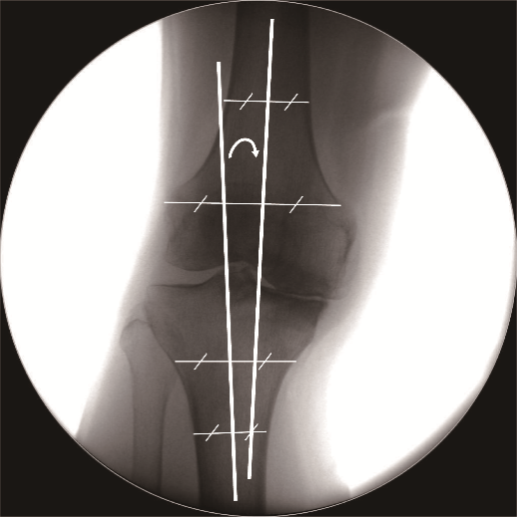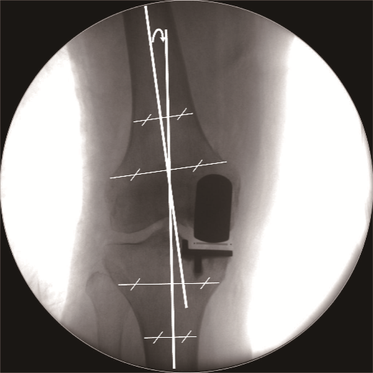

Supplemental Figure 1 | Lower Extremity Alignment Assessment Method.

