Supplementary information
Who becomes replaceable? Generative AI and the discursive stratification of work
This file provides extended documentation for corpus construction, annotation, classification, measures, statistical models, and robustness analyses. All supplementary numbering is independent of the main manuscript.

Supplementary Methods

Corpus retrieval and temporal coverage
The news corpus was retrieved through ProQuest Text and Data Mining on 22 June 2026. Document type was restricted to newspapers and news, with no language restriction. The Boolean query was:
("artificial intelligence" OR "generative AI" OR "generative artificial intelligence" OR "machine learning" OR "deep learning" OR ChatGPT OR "large language model*" OR LLM) AND (job OR jobs OR work OR worker* OR workforce OR employment OR occupation* OR profession* OR career* OR "labor market" OR "labour market" OR automation OR "future of work" OR layoff* OR reskill* OR upskill* OR "replace* worker*").
The raw retrieval contained 446,417 articles. Although raw coverage extended from 1976 to 2026, the analysis used complete years in three theoretically defined periods: EARLY (2010-2017), PRE (2018-2021), and POST (2023-2025). The transition year 2022 was omitted from the primary comparison and included in boundary sensitivity analyses.

Occupation extraction, sense screening, and cluster balancing
The extraction dictionary contained 45 occupation terms assigned to seven sectors. For every hit, the pipeline retained the target term and up to 25 words on each side, producing a maximum 51-word passage. The stored fields included document identifier, date, source title, occupation, sector, target term, left and right context, AI cue, word count, normalised cluster identifier, and screening flags.
The principal analysis excluded passages flagged as likely non-occupational senses. Five terms - author, CEO, executive, manager, and banker - were additionally excluded from aggregate occupation comparisons because recurrent ambiguity or non-comparability made their occupation-level output unstable. The complete dictionary and sector mapping appear in Supplementary Table S2.
Syndication and repeated mentions can cause a single text to contribute many near-identical passages. The analytical unit was therefore balanced within era. Each normalised cluster-occupation combination contributed at most one passage per era. When multiple eligible passages remained, the retained passage was the first in ascending document-identifier order. The rule was deterministic and produced 6,265 EARLY, 13,917 PRE, and 48,850 POST news units.

Annotation protocol and coding specifications
Two coders independently assigned four-way frames to 602 news passages. Coding first established whether the target denoted an occupation and whether the occupation was a target of AI-related change. If activated, coders distinguished augmentation, task automation, and replacement. The operational rules are in Supplementary Table S4. Examples in that table are schematic and are not quotations from the licensed corpora.
The strict reference specification conservatively resolved the 143 coder disagreements by assigning the less activation- or replacement-intensive label. The lenient specification assigned the more intensive label. The strict specification was used for the primary classifier. These rules were selected to preserve disagreement rather than describe the labels as an expert-adjudicated ground truth.
Human agreement was calculated with raw agreement and Cohen's kappa. Four-way agreement captures the most demanding distinction. Gate agreement collapses augmentation, task automation, and replacement into a single activated category. Three-way agreement combines task automation and replacement into a replacement-oriented category. The confusion matrix and label distributions are shown in Supplementary Table S5.

Classifier training and evaluation
The base model was roberta-base with a four-class sequence-classification head. Each input concatenated an occupation token, left context, a marked target term, and right context. Inputs were truncated at 192 word-piece tokens. A single 80/20 split was stratified by strict frame label with random seed 0. The split was not grouped by document or text cluster; near-duplicate passages may therefore make the held-out metrics optimistic.
Within the training split, minority classes were oversampled to the majority-class count. The loss was class-weighted cross-entropy with weights inversely proportional to class frequency. Optimisation used AdamW, a linear learning-rate schedule, learning rate 2 x 10^-5, training batch size 16, evaluation batch size 32, and five epochs. No early stopping or validation-based checkpoint selection was used; the final epoch was retained. A deployment model was then trained on all 602 passages with identical settings.
The reported ranges reflect repeated training under residual non-determinism at fixed seed. Software versions were Transformers 5.12.1, PyTorch 2.12.1, Datasets 5.0.0, Accelerate 1.14.0, scikit-learn 1.9.0, and Python 3.13. No large-language-model-generated labels were retained. Supplementary Table S6 reports held-out performance.

Derived outcomes
Activation equals one when the predicted frame is augmentation, task automation, or replacement. Replacement-oriented framing equals one for task automation or replacement and is defined only among activated passages. Replacement-only framing equals one for replacement and is also defined only among activated passages. The distinction prevents task-level compression from being treated as equivalent to the claimed disappearance of a role.

Career-stage, prestige, task-structure, and generative-AI cues
Career-stage cues were searched within five tokens of the occupation. Core low-stage cues included junior, entry-level, trainee, and intern; core high-stage cues included senior, lead, and principal. Ambiguous descriptors such as assistant, associate, manager, and executive were not used in the formal measure. Exact machine-readable token patterns and inflection rules are included in the replication package. Supplementary Table S3 reports the human-readable cue families.
Prestige was measured independently with low-status descriptors such as aspiring, freelance, and amateur, and high-status descriptors such as acclaimed, elite, and renowned. Task structure used routine descriptors such as routine, repetitive, standardised, and rule-bound, and expert descriptors referring to judgement or expertise. The stage and prestige systems overlapped in 23 passages.
The explicit generative-AI indicator identified POST passages naming ChatGPT, GPT, LLM or large language model, or generative AI. It indicates explicit textual invocation and is not a measure of technological exposure.

Statistical specifications
Linear probability models were used for binary outcomes. Coefficients are reported as proportions in tables and percentage points in prose. Tests were two-sided. Exact P values are reported at or above 0.001; smaller values are reported as P < 0.001. Source-clustered standard errors were used for domain-specific PRE-POST contrasts. Career-stage models used two-way clustering by source and normalised text cluster.
The main stage specification included Junior, Junior x POST, occupation fixed effects, and calendar-year fixed effects. Conditional frame models were estimated only among activated passages. The stronger within-cell model included occupation-by-year fixed effects and retained cells containing both career stages. Routine and prestige models replaced Junior with their respective low-category indicator. Sector tests were adjusted with the Benjamini-Hochberg procedure.
The shift-share decomposition used activated news units. For each occupation and era, s was the occupation's share of activated mentions and r its replacement-oriented rate. Following the accounting identity defined in the Methods, the aggregate change was partitioned into a within-occupation term (PRE shares multiplied by rate changes), a compositional term (PRE rates multiplied by share changes), and their interaction. Occupation-level components are reported in Supplementary Table S8 and visualised in Supplementary Fig. S3.

Cue masking
To test lexical shortcutting, all career-stage and task-structure cue tokens were replaced with [MASK] before inference with the saved deployment classifier. The regressions were then re-estimated using the masked predictions. Masking removes the direct cue while preserving the surrounding representation of AI's relation to the occupation.

Matched human replication
The replication sample contained 204 junior-senior pairs matched on occupation and year. Stage cues, source, and year were masked, and the 408 passages were randomised. Two human coders labelled the passages independently and without the matching key. Strict labels were constructed using the same conservative rule as in the broad validation set. Exact McNemar tests compared discordant pairs for activation, replacement-oriented framing, and replacement-only framing.

Supplementary Tables
Supplementary Table S1. Corpus retrieval, queries, and temporal coverage
Corpus | Retrieval details | Search expression and filters
News | ProQuest Text and Data Mining; retrieved 22 June 2026; document type restricted to newspapers and news; no language restriction; raw n = 446,417. | ("artificial intelligence" OR "generative AI" OR "generative artificial intelligence" OR "machine learning" OR "deep learning" OR ChatGPT OR "large language model*" OR LLM) AND (job OR jobs OR work OR worker* OR workforce OR employment OR occupation* OR profession* OR career* OR "labor market" OR "labour market" OR automation OR "future of work" OR layoff* OR reskill* OR upskill* OR "replace* worker*").

Note: The analytical periods are EARLY (2010-2017), PRE (2018-2021), and POST (2023-2025). The transition year 2022 is omitted from the primary comparison and reassigned in sensitivity analyses. Raw coverage extends beyond the analytical periods.
Supplementary Table S2. Occupation dictionary and sector mapping
Sector | Occupation terms | Main-analysis note
Business/Finance | accountant; auditor; banker; broker; CEO; consultant; executive; manager | banker, CEO, executive, and manager excluded from main aggregate comparisons
Creative/Media | actor; artist; author; designer; editor; journalist; musician; reporter; writer | author excluded from main aggregate comparisons
Education | academic; educator; instructor; lecturer; professor; teacher; tutor | retained
Healthcare | doctor; nurse; physician; surgeon; therapist | retained
Legal | attorney; counsel; judge; lawyer; prosecutor | retained
Service/Manual | driver; electrician; factory worker; mechanic; plumber | retained
Tech/Data | analyst; coder; data scientist; developer; engineer; programmer | retained

Note: The dictionary contains 45 occupation terms. Inflection and matching patterns are supplied in the replication package. Passages flagged as likely non-occupational senses are excluded from principal comparisons.
Supplementary Table S3. Human-readable cue families
Construct | Low/category cues | High/contrast cues | Exclusions and interpretation
Formal career stage | junior; entry-level; trainee; intern | senior; lead; principal | Searched within five tokens of the occupation. assistant, associate, manager, and executive excluded because of ambiguity.
Prestige / market status | aspiring; freelance; amateur | acclaimed; elite; renowned | Measured separately from formal career stage; overlap = 23 mentions.
Task structure | routine; repetitive; standardised; rule-bound; clerical | expert; expertise-intensive; judgement-intensive | Independent predictor axis; terms that directly encode the outcome are not used to define task structure.
Explicit generative AI | ChatGPT; GPT; generative AI; LLM; large language model | General-AI passage without an explicit generative cue | POST only; indicates explicit textual invocation, not causal exposure.

Note: The table reports representative human-readable cues. Exact token patterns, stems, inflections, and matching rules are included in the replication package and should be treated as the executable specification.
Supplementary Table S4. Coding decision rules and schematic examples
Label | Decision rule | Schematic positive example | Schematic exclusion / contrast
Neutral | The passage does not represent the named occupation as a target of AI-related change. | "Researchers discussed AI governance" when researcher is merely a source or actor. | A claim that AI changes how researchers perform their work is activated.
Augmentation | AI assists, complements, increases capacity, or improves performance while retaining the worker or role. | "AI helps nurses detect risks earlier." | AI carrying out a bounded nursing task without an assistance relation is task automation.
Task automation | AI performs identifiable tasks or reduces task demand without explicitly eliminating the occupational role. | "The system drafts routine reports previously prepared by analysts." | A claim that analysts or their positions are no longer needed is replacement.
Replacement | AI substitutes for workers, reduces demand for the role, removes positions, or makes the role unnecessary. | "The tool could eliminate entry-level translator positions." | A claim that translators use the tool to work faster is augmentation.

Note: Examples are schematic and are not quotations from licensed news texts. Coding first established a valid occupational sense and then applied the activation gate before assigning an activated frame.
Supplementary Table S5. Broad validation-set agreement and label distributions (n = 602)
Reliability target | Raw agreement | Cohen's kappa | Interpretation
Four-way frame | 0.762 | 0.561 | Neutral / augmentation / task automation / replacement
Activation gate | 0.852 | 0.680 | Neutral versus any activated frame
Three-way frame | 0.814 | 0.645 | Task automation and replacement combined

Panel B. Label distributions
Specification / coder | Neutral | Augmentation | Task automation | Replacement | Total
Coder 1 | 416 | 80 | 56 | 50 | 602
Coder 2 | 361 | 126 | 40 | 75 | 602
Strict reference | 433 | 79 | 45 | 45 | 602
Lenient reference | 344 | 127 | 51 | 80 | 602

Note: The two coders agreed on 459 passages and disagreed on 143. Strict and lenient labels are alternative conservative and inclusive disagreement specifications, not mathematical lower and upper bounds on population rates.
Supplementary Table S6. Held-out classifier performance against the strict reference specification
Metric | Reported range | Evaluation set | Qualification
Four-way Cohen kappa | 0.48-0.54 | 20% stratified holdout | Most demanding distinction
Activation-gate Cohen kappa | 0.56-0.63 | 20% stratified holdout | Neutral versus activated
Macro-F1 | 0.57-0.61 | 20% stratified holdout | Unweighted mean across four labels

Note: The split used random seed 0 and was stratified by label but not grouped by document or normalised text cluster. Ranges reflect residual training non-determinism at fixed seed. The deployment model was trained on all 602 passages.
Supplementary Table S7. Cluster-balanced news era counts and frame rates
Domain | Era | All units | Activated | Activation (%) | RF | activated (%) | RO | activated (%)
News | EARLY | 6,265 | 1,529 | 24.41 | 40.75 | 32.70
News | PRE | 13,917 | 3,295 | 23.68 | 23.64 | 15.11
News | POST | 48,850 | 13,513 | 27.66 | 26.43 | 13.91

Note: RF = replacement-oriented framing (task automation or replacement). RO = replacement-only framing. Conditional rates use activated mentions as denominators.

Supplementary Table S8. Occupation-level shift-share decomposition of PRE-POST replacement-oriented news framing
Occupation | PRE share (%) | POST share (%) | PRE RF (%) | POST RF (%) | Within (pp) | Composition (pp) | Interaction (pp) | Total (pp)
Academic | 0.61 | 1.33 | 20.00 | 21.79 | +0.011 | +0.144 | +0.013 | +0.167
Accountant | 2.31 | 1.51 | 59.21 | 46.08 | -0.303 | -0.471 | +0.105 | -0.670
Actor | 1.61 | 3.04 | 47.17 | 50.85 | +0.059 | +0.676 | +0.053 | +0.789
Analyst | 2.06 | 2.03 | 30.88 | 27.01 | -0.080 | -0.011 | +0.001 | -0.090
Artist | 3.40 | 6.49 | 21.43 | 29.99 | +0.291 | +0.663 | +0.265 | +1.219
Attorney | 0.46 | 0.40 | 6.67 | 7.41 | +0.003 | -0.004 | -0.000 | -0.001
Auditor | 0.64 | 0.29 | 19.05 | 25.64 | +0.042 | -0.066 | -0.023 | -0.047
Broker | 0.88 | 0.47 | 13.79 | 20.31 | +0.057 | -0.056 | -0.026 | -0.025
Coder | 0.42 | 1.80 | 57.14 | 51.85 | -0.022 | +0.785 | -0.073 | +0.690
Consultant | 1.49 | 1.67 | 28.57 | 32.74 | +0.062 | +0.053 | +0.008 | +0.123
Counsel | 0.18 | 0.16 | 16.67 | 27.27 | +0.019 | -0.003 | -0.002 | +0.014
Data Scientist | 1.18 | 0.38 | 7.69 | 28.85 | +0.250 | -0.061 | -0.169 | +0.020
Designer | 1.76 | 2.62 | 18.97 | 33.05 | +0.248 | +0.163 | +0.121 | +0.532
Developer | 6.13 | 8.97 | 7.92 | 13.28 | +0.329 | +0.225 | +0.152 | +0.706
Doctor | 22.61 | 9.38 | 8.59 | 8.76 | +0.038 | -1.137 | -0.023 | -1.121
Driver | 9.32 | 2.78 | 41.37 | 36.44 | -0.460 | -2.703 | +0.322 | -2.840
Editor | 0.58 | 1.29 | 10.53 | 24.14 | +0.078 | +0.075 | +0.097 | +0.250
Educator | 0.91 | 2.19 | 13.33 | 11.49 | -0.017 | +0.171 | -0.024 | +0.130
Electrician | 0.15 | 0.27 | 100.00 | 80.56 | -0.030 | +0.115 | -0.022 | +0.063
Engineer | 7.04 | 7.47 | 14.66 | 20.02 | +0.378 | +0.063 | +0.023 | +0.464
Factory Worker | 0.91 | 0.30 | 100.00 | 90.00 | -0.091 | -0.614 | +0.061 | -0.644
Instructor | 0.52 | 0.43 | 17.65 | 18.97 | +0.007 | -0.015 | -0.001 | -0.010
Journalist | 2.00 | 10.20 | 42.42 | 8.06 | -0.688 | +3.478 | -2.818 | -0.028
Judge | 2.19 | 1.09 | 12.50 | 17.01 | +0.098 | -0.137 | -0.049 | -0.088
Lawyer | 5.13 | 4.23 | 32.54 | 25.00 | -0.387 | -0.291 | +0.067 | -0.611
Lecturer | 0.18 | 0.14 | 16.67 | 26.32 | +0.018 | -0.007 | -0.004 | +0.007
Mechanic | 0.49 | 0.29 | 56.25 | 51.28 | -0.024 | -0.111 | +0.010 | -0.125
Musician | 0.88 | 1.76 | 20.69 | 36.97 | +0.143 | +0.182 | +0.144 | +0.469
Nurse | 3.40 | 1.70 | 10.71 | 14.85 | +0.140 | -0.183 | -0.070 | -0.112
Physician | 4.28 | 2.07 | 3.55 | 3.58 | +0.002 | -0.079 | -0.001 | -0.078
Plumber | 0.24 | 0.44 | 50.00 | 59.32 | +0.023 | +0.097 | +0.018 | +0.138
Professor | 0.24 | 0.40 | 0.00 | 14.81 | +0.036 | +0.000 | +0.023 | +0.059
Programmer | 1.82 | 2.52 | 45.00 | 35.78 | -0.168 | +0.317 | -0.065 | +0.084
Reporter | 0.64 | 2.75 | 14.29 | 4.84 | -0.060 | +0.302 | -0.200 | +0.042
Surgeon | 3.03 | 0.87 | 18.00 | 5.08 | -0.392 | -0.389 | +0.279 | -0.502
Teacher | 6.80 | 6.78 | 36.61 | 32.64 | -0.270 | -0.006 | +0.001 | -0.275
Therapist | 1.64 | 1.78 | 59.26 | 61.83 | +0.042 | +0.086 | +0.004 | +0.132
Tutor | 0.97 | 2.81 | 75.00 | 82.06 | +0.069 | +1.376 | +0.129 | +1.574
Writer | 0.91 | 4.89 | 46.67 | 57.58 | +0.099 | +1.855 | +0.434 | +2.388

Note: Shares are occupation shares of activated news mentions. RF is the replacement-oriented rate among activated mentions. Summed components are within = -0.448 pp, composition = +4.482 pp, interaction = -1.240 pp, and total = +2.794 pp; minor differences arise from displayed rounding.

Supplementary Table S9. Career-stage, alternative-axis, and robustness estimates
Analysis | Outcome | Focal coefficient | Estimate | SE | P | n / support
Primary | Activation | Junior x POST | +0.200 | 0.094 | 0.032 | 2,971
Primary | RF | activated | Junior level | +0.404 | 0.199 | 0.042 | 399
Primary | RO | activated | Junior level | +0.565 | 0.172 | 0.001 | 399
Cue masking | Activation | Junior x POST | +0.213 | 0.090 | 0.018 | 2,971
Cue masking | RF | activated | Junior level | +0.593 | 0.206 | 0.004 | 399
Cue masking | RO | activated | Junior level | +0.680 | 0.200 | 0.001 | 399
Routine axis | Activation | Routine x POST | -0.208 | - | 0.009 | routine 719; expert 305
Routine axis | RO | activated | Routine level | +0.341 | - | <0.001 | activated subset
Prestige axis | Activation | Low status x POST | +0.011 | - | 0.820 | overlap with stage = 23
Occupation x year FE | Activation | Junior x POST | +0.304 | - | 0.002 | 66 cells; n = 1,799
2022 omitted | Activation | Junior x POST | +0.200 | - | 0.032 | primary boundary
2022 assigned PRE | Activation | Junior x POST | +0.272 | - | 0.003 | boundary sensitivity
2022 assigned POST | Activation | Junior x POST | +0.186 | - | 0.049 | boundary sensitivity

Note: RF = replacement-oriented; RO = replacement-only. Dashes indicate rows where the concise summary table does not display a standard error or exact analytical n because those estimates are used as robustness checks rather than main-text claim estimates. The executable regression outputs in the replication package are the authoritative record. All reported P values and coefficients are preserved from those outputs.
Panel B. Sector heterogeneity in Junior x POST activation
Sector | Estimate | FDR-adjusted P | Interpretation
Business/Finance | +0.558 | <0.001 | Widening supported
Creative/Media | +0.467 | 0.003 | Widening supported
Education | +0.293 | 0.036 | Widening supported
Tech/Data | +0.206 | 0.480 | Not significant after FDR
Legal | +0.076 | 0.724 | Not significant after FDR

Note: Sector estimates are exploratory because some cells are sparse and label-specification sensitivity has not been completed for every sector. They are therefore not used as a central claim in the main text.

Supplementary Table S10. Blinded matched human replication
Reliability target | Raw agreement | Cohen's kappa | n passages
Four-way frame | 0.855 | 0.794 | 408
Activation gate | 0.951 | 0.900 | 408
Three-way frame | 0.887 | 0.822 | 408

Panel B. Frame composition by career stage
Labelling source | Stage | Activated / 204 | Activation (%) | RF | activated (%) | RO | activated (%) | Augment | activated (%)
Human strict | Junior | 161 | 78.9 | 76.4 | 46.0 | 23.6
Human strict | Senior | 59 | 28.9 | 28.8 | 11.9 | 71.2
Classifier | Junior | 105 | 51.5 | 54.3 | 44.8 | 45.7
Classifier | Senior | 46 | 22.5 | 15.2 | 2.2 | 84.8

Panel C. Exact McNemar tests on 204 matched occupation-year pairs
Outcome | Junior = 1 / Senior = 0 | Junior = 0 / Senior = 1 | Exact two-sided P
Activation | 111 | 9 | 1.71e-23
Replacement-oriented | 113 | 7 | 9.53e-26
Replacement-only | 72 | 5 | 2.80e-16

Note: Pairs share occupation and calendar year. Stage cues, source, and year were masked, passages were randomised, and coders were blind to one another and the matching key. RF = task automation or replacement; RO = replacement only.

Supplementary Figures
Supplementary Figure S1. Occupation-level selection and fate in AI news discourse, PRE versus POST. Each point is an occupation. Panel a plots the share of cluster-balanced mentions activated as AI targets in PRE against POST; panel b plots replacement-oriented framing among activated mentions in PRE against POST. The dashed line is equality. Point colour denotes sector and point size is proportional to the POST mention count. These descriptive rates are not rankings of objective exposure.
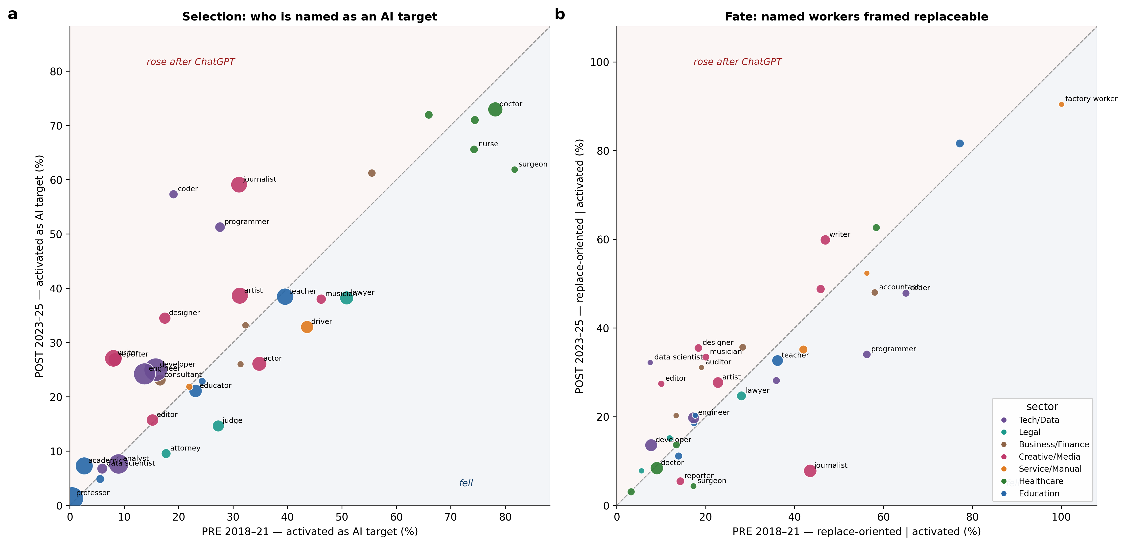

Supplementary Figure S2. Classifier and blind-human evidence for the career-stage hierarchy. Panel a compares replacement-oriented rates among activated junior and senior mentions in the classifier-labelled and blind-human matched samples. Panel b reports discordant matched-pair directions for activation, replacement-oriented framing, and replacement-only framing. Each human-coded pair shares occupation and calendar year.
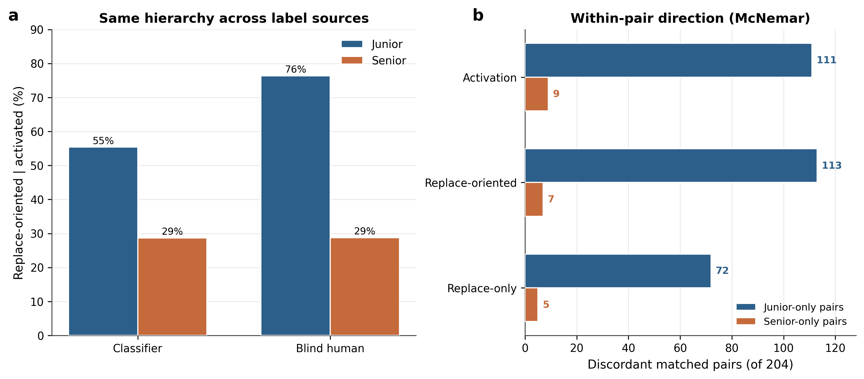

Supplementary Figure S3. Occupation-level components of the aggregate PRE-POST change in replacement-oriented news framing. Bars report within-occupation, compositional, and interaction components in percentage points for all occupations included in the decomposition. The components sum to each occupation's total share of the change.
