Supplementary Note for
High-strength and ductile high-entropy alloy via expert-trajectory-guided processing
Shuya Dong^{1, &}, Bin Cao^{2, &}, Jie Xiong¹*, Haoran Jiang¹, Mengwei He³, Shuai Chen¹*, Tao Yang⁴, Tong-Yi Zhang¹*
¹ Materials Genome Institute, and State Key Laboratory of Materials for Advanced Nuclear Energy, Shanghai University, Shanghai 200444 China.
² Guangzhou Municipal Key Laboratory of Materials Informatics, Hong Kong University of Science and Technology (Guangzhou), Guangzhou 511400, China
³ Australian Centre for Microscopy and Microanalysis, School of Aerospace, Mechanical and Mechatronic Engineering, The University of Sydney, Sydney, New South Wales, 2006, Australia
⁴ Department of Materials Science and Engineering, Hong Kong Institute for Advanced Study, City University of Hong Kong, Hong Kong, China

&These authors contributed equally: Shuya Dong, Bin Cao.
*Correspondence should be addressed to Jie Xiong (xiongjie@shu.edu.cn), Shuai Chen (chens@shu.edu.cn) and Tong-Yi Zhang (zhangty@shu.edu.cn).

Note 1
1.1 ATON Architecture
1.1.1 Multi-Scale Feature Encoding
ATON employs dedicated encoders to process heterogeneous feature modalities, enabling effective representation learning across composition, processing, testing, and trajectory state information.
Composition Encoder. The normalized composition vector $C$, satisfying $\sum_{i=1}^{8}{C_{i}}=1$ , is mapped to a latent representation using a multilayer perceptron:
$$h_{\text{comp}}={MLP}_{\text{comp}}\left(C;θ_{\text{comp}}\right).$$ | (S1)
Processing Encoder. Processing conditions comprise categorical variables $P_{cat}$ (preparation method, processing technique, and as-cast condition) and continuous variables $P_{cont}$ (e.g., temperatures, durations, and reduction ratios). These components are encoded separately and subsequently combined:
$$e_{\text{cat}}=Concat\left[{Emb}_{1}\left(P_{\text{cat},1}\right),…,{Emb}_{K}\left(P_{\text{cat},K}\right)\right],$$ | (S2)
$$h_{\text{proc}}={MLP}_{\text{proc}}\left(\left[e_{\text{cat}}⊕P_{\text{cont}}\right];θ_{\text{proc}}\right).$$ | (S3)
Here, ${Emb}_{k}$ denotes the embedding layer associated with the $k\text{-th}$ categorical variable, and $⊕$ indicatesfeature concatenation.
Testing Condition Encoder. Mechanical testing parameters $T$ , including strain rate, test modality, andtesting temperature, are encoded as
$$h_{\text{test}}={MLP}_{\text{test}}(T;θ_{\text{test}}).$$ | (S4)
State Encoder. The trajectory state vector $s_{t}$ is embedded via
$$h_{\text{state}}={MLP}_{\text{state}}\left(s_{t};θ_{\text{state}}\right).$$ | (S5)
1.1.2 Adaptive Feature Fusion via Gating
To capture the strong dependence of material performance on processing history, ATON incorporates an adaptive gating mechanism that modulates compositional features conditioned on processing parameters and trajectory state.
Gating Network. An element-wise gate vector is computed from the processing and state representations:
$$g=σ\left({MLP}_{\text{gate}}\left(\left[h_{\text{proc}}⊕h_{\text{state}}\right];θ_{\text{g a t e}}\right)\right),$$ | (S6)
where $σ(⋅)$ denotes the sigmoid activation function.
Gated Composition Features. The compositional embedding is modulated through element-wise multiplication:
$${\tilde{h}}_{\text{comp}}=g⊙h_{\text{comp}},$$ | (S7)
where $⊙$ denotes the Hadamard product. This operation enables selective amplification or attenuation of compositional features in response to processing context.
Feature Fusion. The gated composition features are fused with testing condition embeddings through a shared transformation:
$$h_{\text{fused}}={MLP}_{\text{shared}}\left(\left[{\tilde{h}}_{\text{comp}}⊕h_{\text{test}}\right];θ_{\text{shared}}\right).$$ | (S8)
Multi-Task Prediction Heads. Task-specific prediction heads are employed to separately model strength and ductility:
$$\hat{{σ_{t}}_{i}}={MLP}_{{σ_{t}}_{i}}\left(h_{\text{fused}};θ_{{σ_{t}}_{i}}\right)∈R,$$ | (S9)
$$\hat{{}_{i}}={MLP}_{{}_{i}}\left(h_{\text{fused}};θ_{{}_{i}}\right)∈R.$$ | (S10)
The final model output is given by $\hat{y}=[\hat{{σ_{t}}_{i}},\hat{{}_{i}}]^{T}$ .

1.2 Training Objective
1.2.1 Target Standardization
To stabilize optimization and balance task scales, target variables are standardized using statistics computed from the training set:
$$\tilde{y}=\frac{y-μ_{\text{train}}}{σ_{\text{train}}},$$ | (S11)
where $μ_{train}$ and $σ_{train}$ are applied consistently to the validation and test sets to prevent data leakage.
1.2.2 Weighted Multi-Task Loss
Given the disparate numerical scales of strength and elongation, a weighted multi-task mean squared error objective is adopted:
$$L=w_{σ_{t}}MSE\left(\tilde{y}σ_{t},\hat{\tilde{y}}σ_{t}\right)+w_{\text{elong}}MSE\left({\tilde{y}}_{δ},{\hat{\tilde{y}}}_{δ}\right).$$ | (S12)
The objective is further regularized using L2 weight decay and dropout with probability $p=0.1$.

1.3 Self-Consistent Inference for Unlabeled Candidates
Once trained, ATON is intended to predict the mechanical response of novel candidate alloys whose properties have not yet been measured. In this setting, however, the trajectory state $s_{t}$ defined in Eq. (2) cannot be evaluated directly: its construction relies on the energies $E_{i}={σ_{t}}_{i}×{}_{i}$, which in turn require the very strength ${σ_{t}}_{i}$ and elongation ${}_{i}$ that we seek to predict.
We resolve this circular dependency through a self-consistent iterative inference procedure, in which the model’s own predictions serve as pseudo-labels that progressively refine the trajectory state until a fixed point is reached. Let $f_{θ}$($∁, Ρ_{i}$, $s_{t}$) denote the trained ATON model with parameters $θ$, taking as input the composition $∁$, the processing parameters $Ρ_{i}$, and the trajectory state $s_{t}$. For an unlabeled candidate set $\{(C_{i},P_{i})\}_{i=1}^{N}$, the procedure proceeds as follows.
1. Cold start. Initialize the pseudo-labels ${\hat{y}}_{i}^{(0)}=[{\hat{σ_{t}}}_{i}^{\left(0\right)},{\hat{δ}}_{i}^{\left(0\right)}]^{T}=0$, so that the initial pseudo-energies ${\hat{E}}_{i}^{(0)}=0$ and the pseudo-time indices $t_{i}$ are determined solely by the input order within each composition group. Construct the initial state $s_{i}^{(0)}$
from these pseudo-labels following Eq. (2).
2. Iterative refinement. At iteration $k$ = 1, 2, . . ., generate updated predictions
$${\hat{y}}_{i}^{(k)}=f_{θ}\left(C_{i},P_{i},s_{i}^{(k-1)}\right),$$ | (S13)
recompute the pseudo-energies ${\hat{E}}_{i}^{(k)}={\hat{σ_{t}}}_{i}^{(k)}{\hat{δ}}_{i}^{(k)}$, re-order each trajectory $T_{C}$ accordingly, and rebuild $s_{i}^{(k)}$ via Eq. (3).
3. Convergence test. Terminate at iteration $K$ when the mean relative change of the predicted labels falls below a tolerance $τ$,
$$\frac{1}{N}\sum_{i=1}^{N}{\frac{{∥{\hat{y}}_{i}^{(k)}-{\hat{y}}_{i}^{(k-1)}∥}_{1}}{{∥{\hat{y}}_{i}^{(k-1)}∥}_{1}+ϵ}}<τ,$$ | (S14)
or when a maximum iteration budget $K_{max}$ is reached, where $∈$ is a small positive constant preventing division by zero. We adopt $τ$ = 10⁻³ and $K_{max}$ = 50 in all experiments.
All intermediate iterations are deterministic (dropout disabled) to ensure stable fixed-point dynamics. Bayesian uncertainty quantification via Monte Carlo dropout is performed in a single additional pass on the converged state $s_{i}^{(k)}$, yielding predictive means and standard deviations without compounding stochastic noise across iterations.

1.4 Uncertainty Quantification via Monte Carlo Dropout
Predictive uncertainty is quantified using Monte Carlo (MC) dropout¹, which provides an efficient Bayesian approximation for deep neural networks. During inference, dropout layers remain active, and $N$ stochastic forwardpasses are performed to generate an ensemble of predictions:
$$\{{\hat{y}}^{(1)},{\hat{y}}^{(2)},…,{\hat{y}}^{(N)}\}∼p(y∣x,D).$$ | (S15)
The predictive mean and uncertainty are estimated as
$$μ_{\text{pred}}=\frac{1}{N}\sum_{i=1}^{N}{{\hat{y}}^{(i)}},$$ | (S16)
$$σ_{\text{pred}}=\sqrt{\frac{1}{N-1}\sum_{i=1}^{N}{{\left({\hat{y}}^{(i)}-μ_{\text{pred}}\right)}^{2}}}.$$ | (S17)
Assuming approximate normality, the 95 % confidence interval is estimated as $[μ_{pred}-2σ_{pred},μ_{pred}+2σ_{pred}]$ .

1.5 Model Evaluation
Model performance is evaluated using the root mean squared error (RMSE) and the coefficient of determination$(R^{2})$ :
$$RMSE=\sqrt{\frac{1}{n}\sum_{i=1}^{n}{{\left(y_{i}-{\hat{y}}_{i}\right)}^{2}}},$$ | (S18)
$$R^{2}=1-\frac{\sum_{i=1}^{n}{{\left(y_{i}-{\hat{y}}_{i}\right)}^{2}}}{\sum_{i=1}^{n}{{\left(y_{i}-\overset{‾}{y}\right)}^{2}}}.$$ | (S19)
Here, $n$ denotes the number of samples, $y_{i}$ and ${\hat{y}}_{i}$ are the true and predicted values, respectively, and $\overset{‾}{y}$ isthe mean of the true targets.

1.6 Dataset Detail
Using the Al-Co-Cr-Fe-Ni high-entropy alloy system as a baseline, experimental data from diverse high-entropy alloy systems were collected from the literature to construct a dataset. The dataset encompasses chemical compositions, classification of whether the microstructure is eutectic, thermomechanical processing conditions, tensile/compressive testing parameters, tensile/compressive strengths, and engineering tensile/compressive strains. Specifically, the chemical compositions comprise a total of 8 elemental species. For the thermomechanical processing conditions, the cold rolling reduction ranges from 0% to 92%, an annealing temperature of 298 to 1473 K, an annealing time of 0 to 192 h, the aging temperature spans from 298 to 1323 K, and the aging time is between 0 and 144 hours. A strain rate of 1 × 10⁻³ s⁻¹ is the most prevalent, and the testing temperatures range from 77 to 1273 K. The strength values range from 98 to 3705.3 MPa, and the strains range from 0.5% to 96.2%. In total, 577 independent samples were collated.

1.7 Implementation Details
The model is implemented in PyTorch 2.0 and trained using the Adam optimizer² with a learning rate of η =10⁻³ and a batch size of 64. Early stopping is applied with a patience of 5 epochs.

Note 2
2.1 Comparison between the ATON and tabular regression models
To evaluate the effectiveness of ATON, we benchmark ATON against widely used tabular regression models to evaluate its effectiveness, including Random Forest (RF), Gradient Boosting Decision Trees (GBDT), Support Vector Regression (SVR), Ridge Regression, Elastic Net, and K-Nearest Neighbors (KNN). These baseline models rep- resent strong, well-established approaches for learning from structured materials data. All models were evaluated using a 5-fold cross validation setting.
Fig. S1 summarizes the predictive performance of all models on test set for both σ_{t} and δ. Across both target properties, ATON consistently outperforms the baseline methods, achieving the highest R² values under 5-fold cross-validation (0.853 for strength and 0.617 for elongation), exceeding the second-best models by 3.14 % and 6.6 %, respectively, while also yielding the lowest prediction errors. Beyond improved accuracy, ATON exhibits more concentrated error distributions with reduced variance, indicating enhanced robustness and prediction stability. This performance gain arises from ATON’s trajectory-aware representations, which explicitly capture historical performance trends and processing evolution, leading to systematically improved generalization.

Note 3
3.1 Candidate Recommendation
Predictive uncertainty obtained via Monte Carlo dropout enables the estimation of posterior performance distributions for candidate alloy-processing conditions using ATON. Based on these posterior predictions, a structured search space is constructed to identify promising experimental conditions for further optimization.
The alloy composition space is restricted to the AlCoCrFeNi_{2.5}. Processing variables are varied systematically within experimentally feasible ranges. Specifically, the cold reduction ratio (CR %) is varied from its minimum to maximum observed values with a step size of 1 %. The annealing temperature is scanned from the minimum to the maximum value using a step of 5 ℃, while the annealing time is varied with a step size of 0.5 h. The strain rate is fixed at 1 × 10⁻³ s⁻¹, consistent with experimental conditions. The preceding conditions yield a search space comprising 8449980 discrete configurations.
Based on the posterior predictions generated by ATON, candidate conditions are ranked using the noisy Expected Hypervolume Improvement (qNEHVI) acquisition function³. The qNEHVI optimization is performed using the Bgolearn API⁴, enabling efficient multi-objective optimization under predictive uncertainty.

Note 4
The inverse fast Fourier transform (IFFT) image corresponding to the FCC(111)//BCC(110) planes is shown in Fig. S6a. The parallel FCC(111) and BCC(110) planes exhibit an misfit d-spacing of 3.22 % Å. Combined with the high-resolution transmission electron microscope (HRTEM) image in Fig. S6b, it is evident that the FCC matrix and the B2 precipitates maintain a semi-coherent relationship. Their orientation relationship (OR) is determined to be (111)_{FCC}∥(110)_{BCC} and [$\overline{\text{1}}$10]_{FCC}∥[$\overline{\text{1}}$11]_{BCC}, which corresponds to the Kurdjumov-Sachs (K-S) OR.

Note 5
The front of the 9R structure intersects with SFs (Fig. S9d) and subsequently extends to the BCC phase boundary. SFs hinder the motion of dislocations and cause dislocation pile-ups. As deformation progresses, dislocations move toward the hard BCC phase, leading to a significant increase in local stress at the phase boundary, thereby inducing the nucleation and expansion of the 9R phase. The storage and obstruction of dislocations by the 9R structure result in significant strain hardening during the deformation process⁵. In addition, combined with the superlattice spots observed in the SAED pattern and the BF-STEM images, it is evident that the FCC matrix contains L1₂ nanoprecipitates (Fig. S9f, Fig. S9g), while BCC nanoprecipitates are observed in the B2 matrix (Fig. S9h, Fig. S9i). These nanoprecipitates effectively pinned dislocations thereby played a precipitation strengthening role.

Note 6
To elucidate the underlying mechanism governing the remarkable strength-ductility synergy in ATON-Opt, we analyzed the strengthening contributions from both the FLH and FGR. HRTEM image reveals that the lamellar FCC/BCC interfaces in the FLH regions exhibit a K-S OR {111}_{FCC}//{110}_{BCC} and <110>_{FCC}//<111>_{BCC} (Fig. S8(a-c)). Concurrently, a strain-induced FCC-to-BCC phase transformation is observed within the FGR zone of the SFD. During the initial stages of deformation, these nascent phase boundaries serve as barriers against dislocation glide, elevating the strength via back-stress strengthening (HDI effect)^{6, 7}. Furthermore, the heterogeneous lamellae in the FLH and the network-like dual-phase architecture within the FGR regions (Fig. S8d) increases the density of phase boundaries. Those structures contributing to strength via the Hall-Petch effect while also providing space for dislocation multiplication and storage to enable a high work-hardening capacity.
Throughout the entire heating process, the intensity of the B2 diffraction peak increases significantly, which is associated with the transformation of the FCC phase to the B2 phase in both the SFD and FGR, as well as the precipitation of the B2 phase within the SFD regions. Mechanistically, the pre-existing compositional segregation in the SFD regions promotes spinodal decomposition or secondary precipitation of the metastable FCC phase. Whereas the high density of grain boundaries in the FGR provides abundant nucleation sites and fast diffusion pathways, thereby strongly driving the transformation to the B2 phase.

Note 7
As shown in the GND distribution results in Fig. S3d, ATON-Opt exhibits internal residual stress prior to the onset of macroscopic strain, with GNDs distributed within the SFD and lath-like FLH, whereas sparsely distributed within the clustered FLH and FGR. As shown in Fig. S13(e, f), through geometric phase analysis (GPA), the local lattice strain distribution (ε_{xx}) at the interface between the FCC phase in the SFD regions and the BCC phase in the FGR regions was obtained. The strain level within the SFD is higher than that in the FGR, and the area fraction of high-strain regions is also significantly greater. The pronounced strain gradient characteristics indicate that the heterostructure enhances intragranular deformation heterogeneity, thereby promoting extensive multiplication of GNDs to maintain lattice continuity, which intensifies the HDI hardening effect. In the dense localized stress concentrations within SFD, twinning nucleation is facilitated, while the twin growth process is accompanied by local stress relaxation (Fig. S13e). When deformation continues, the twins and the dispersed B2 precipitates within the SFD act synergistically, further enhancing the strength of the SFD through the dynamic Hall-Petch effect.

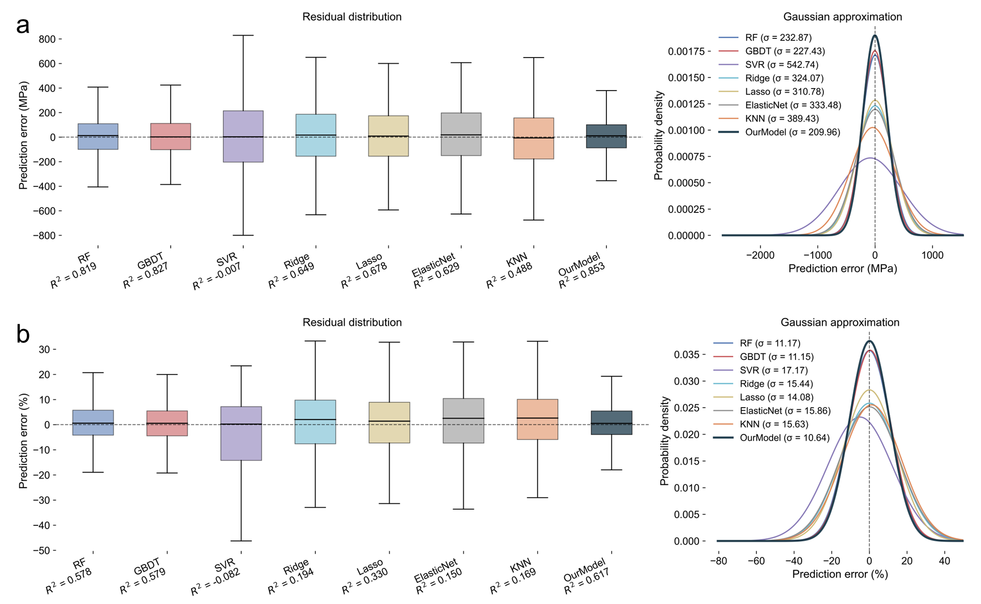
Fig. S1 | Prediction errors on the test dataset. (a) Box plots and Gaussian distributions of tensile strength prediction errors (MPa) for baseline models and the proposed ATON model. (b) Corresponding prediction error distributions for fracture elongation (%). ATON achieves the highest R² values and exhibits the most concentrated error distributions with the lowest variance among all compared methods.

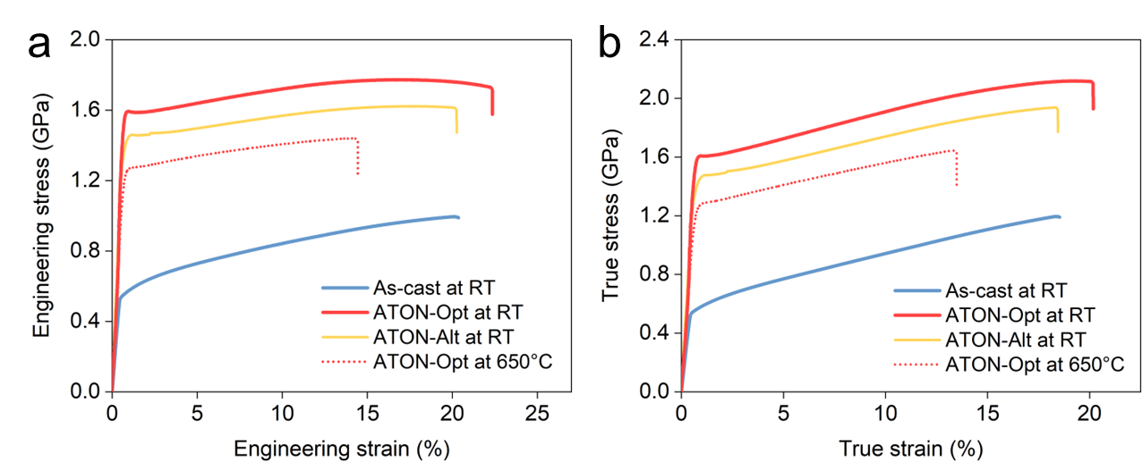
Fig. S2 | Engineering and true stress-strain curves of the investigated alloys. (a) Room temperature (RT) engineering stress-strain curves for the as-cast AlCoCrFeNi_{2.5} alloy, ATON-Opt, and ATON-Alt. The curve for ATON-Opt obtained at 650 °C is also included for comparison. (b) Corresponding true stress-strain curves derived from the data in (a).

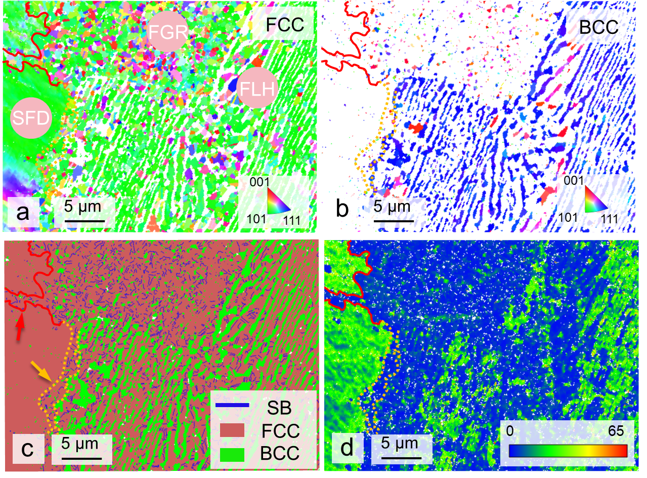
Fig. S3 | EBSD inverse pole figure (IPF) maps of the (a) FCC and (b) BCC phases in ATON-Opt, and (c) Phase map and (d) GND density map. The red curves delineate the boundaries between the SFD and FGR regions, while the orange curves outline the FGR adjacent to the SFD boundaries. SB denotes special boundaries, corresponding to deformation twins.

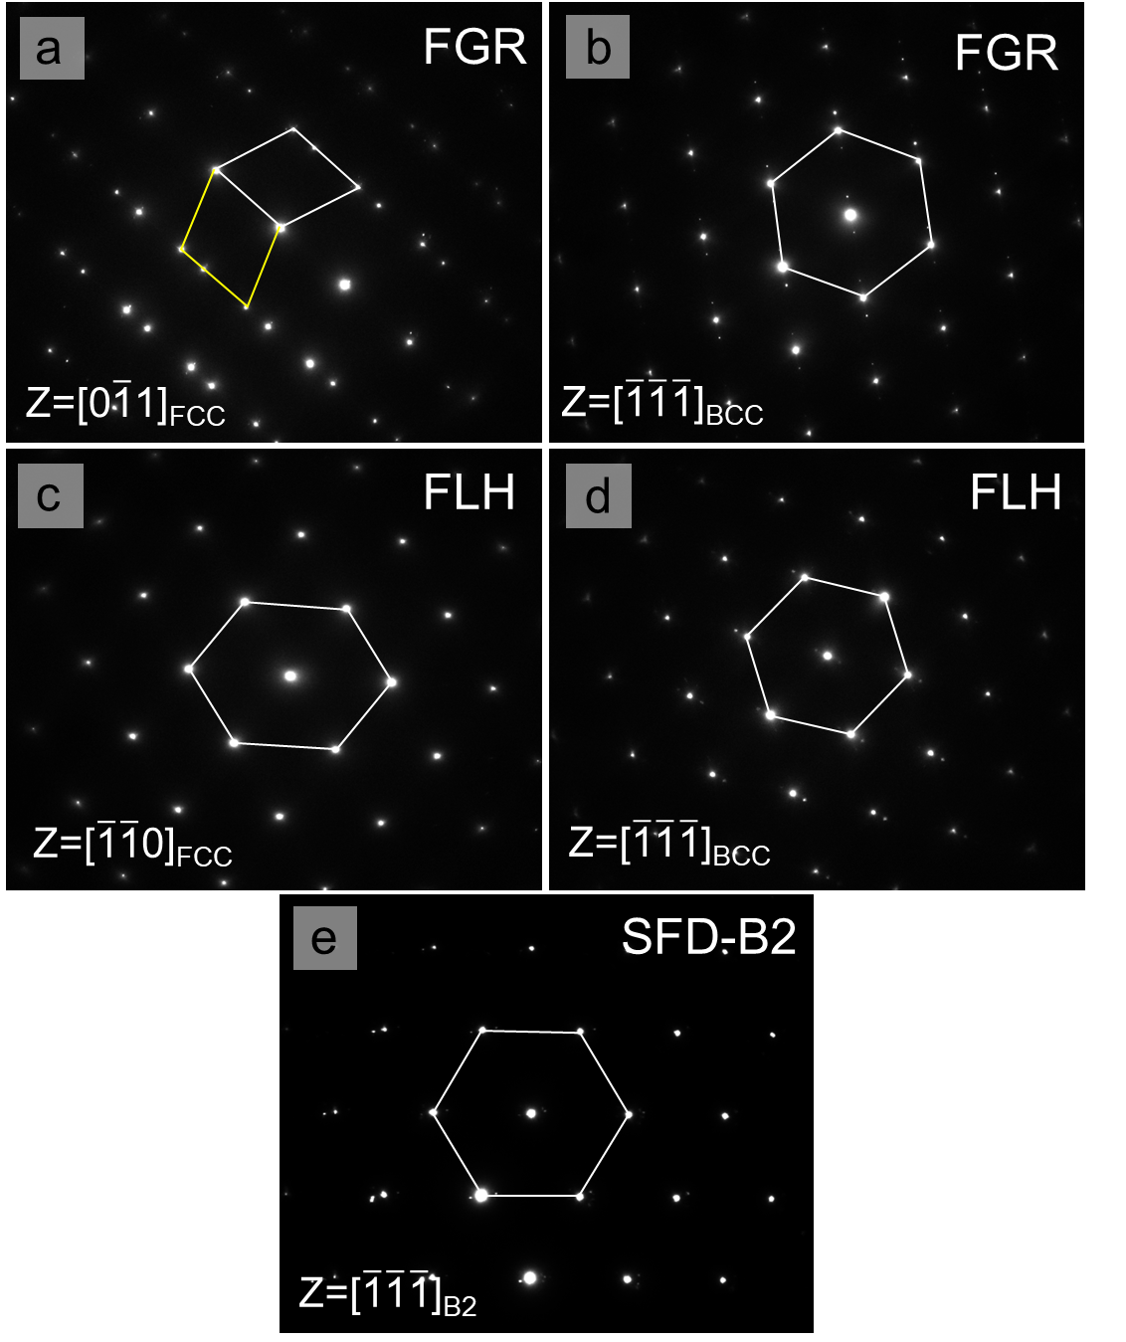
Fig. S4 | The SAED diffraction patterns of the FCC and BCC phases in FLH and FGR, as well as the B2 precipitates in SFD.

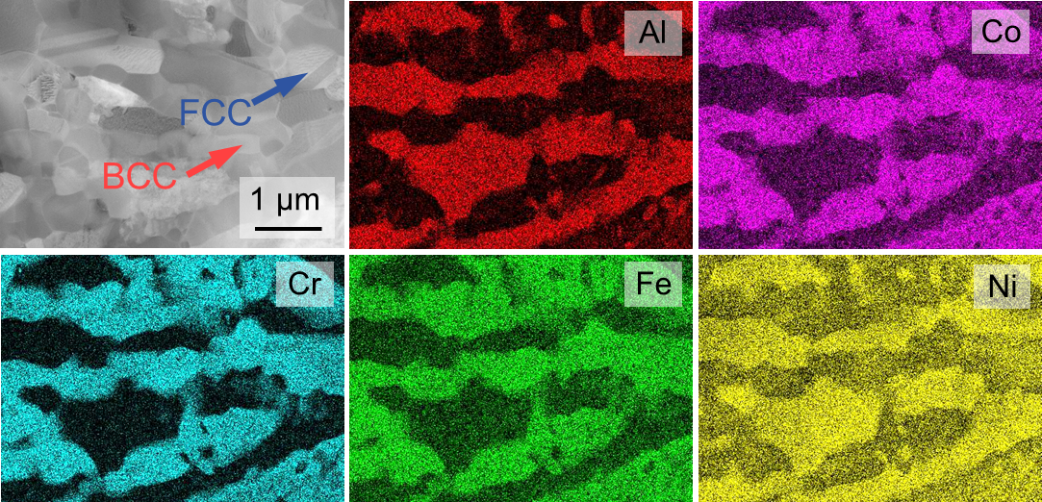
Fig. S5 | HAADF image and elemental distribution map of FGR in FLH.

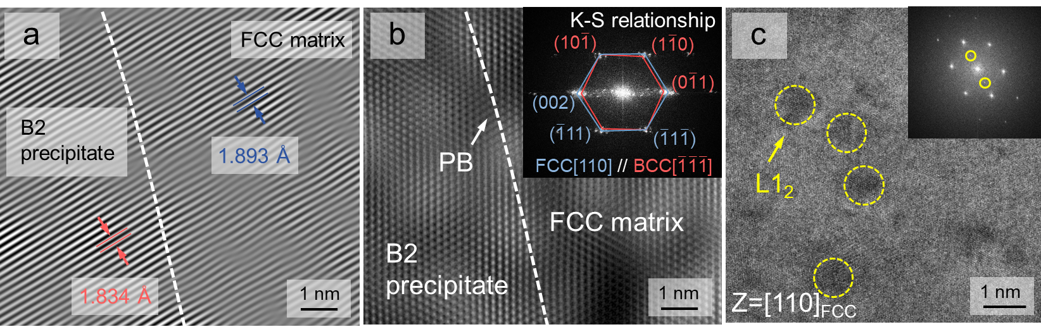
Fig. S6 | (a) IFFT corresponding to the FCC(111)//BCC(110) planes and (b) HRTEM image of the interface between the FCC matrix and the B2 precipitate in the SFD. (c) HRTEM image of the interface between the FCC matrix and the L1₂ precipitate in the SFD.

Fig. S7 | Temperature-dependent intensity evolution of the diffraction peaks exhibiting negligible variations during in-situ HESXRD. Accompanied by the differential scanning calorimeter curve as a calorimetric reference.

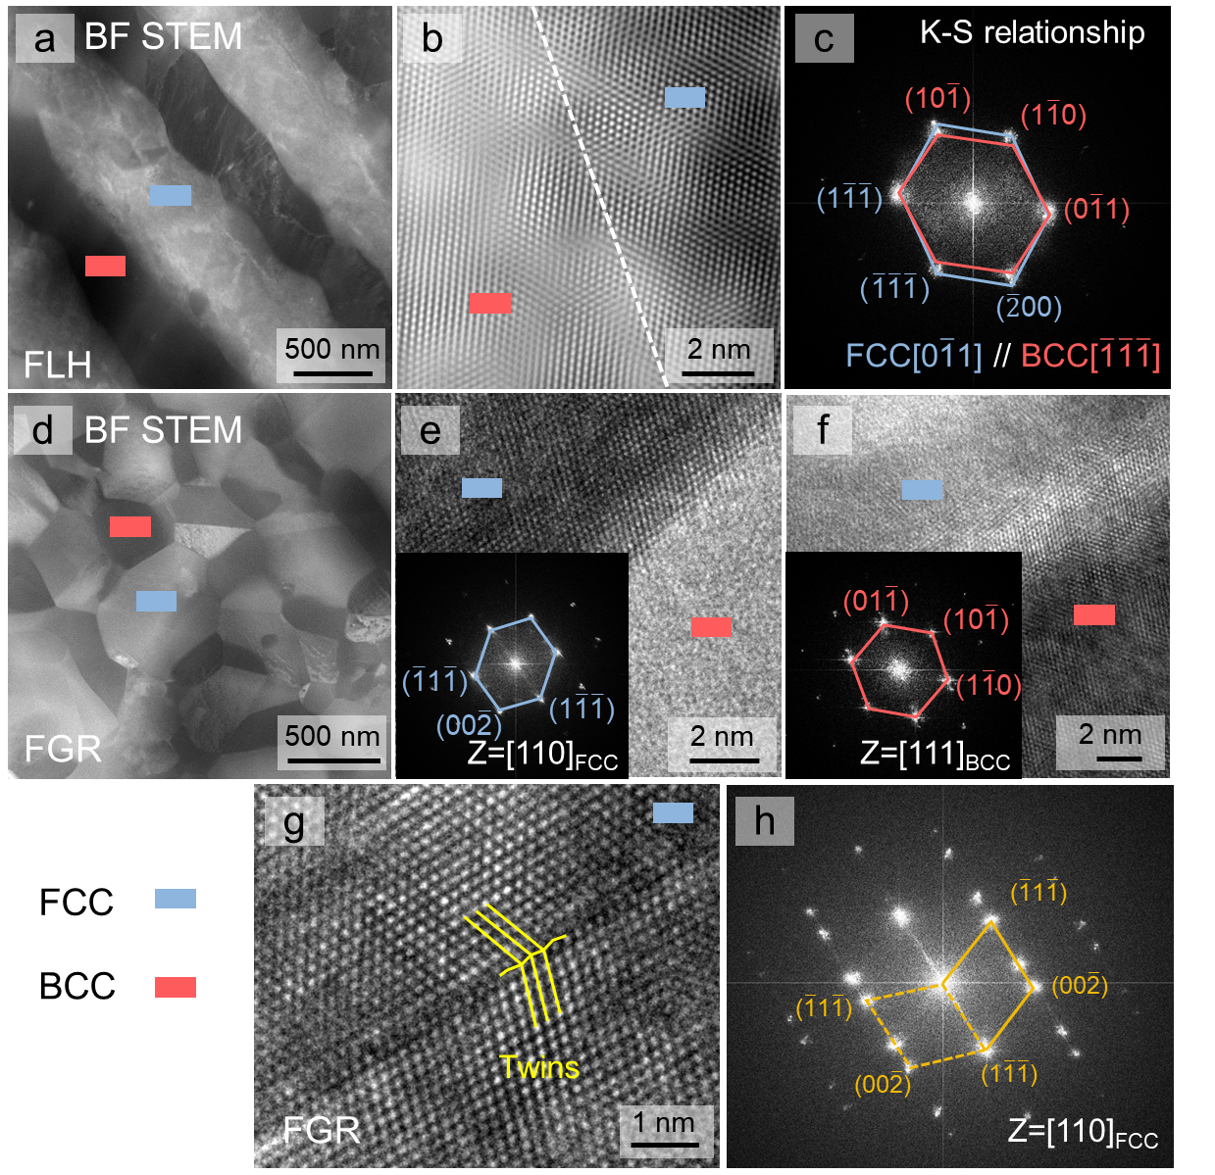
Fig. S8 | Microstructural characterization of ATON-Opt at 0 % strain within the FLH and FGR regions. BF-STEM, HRTEM, and corresponding SAED patterns images of (a-c) FLH and (d-f) FGR in SFD. Additionally, (g) HRTEM and (h) SAED patterns images of twins on FGR in SFD.

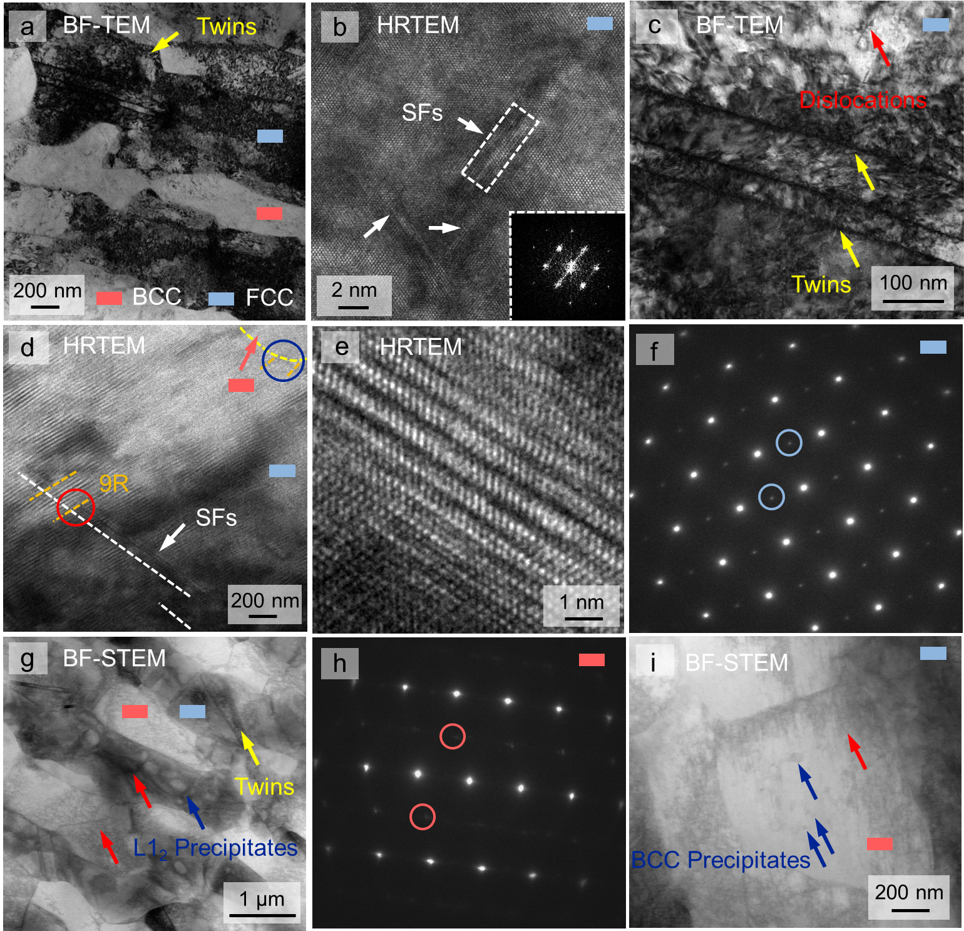
Fig. S9 | Microstructural characterization of ATON-Opt at 20 % strain within the FLH regions. (a) BF-TEM image showing the lamellar heterogeneous structure. (b) HRTEM image of SFs within the FCC matrix, with the inset showing the corresponding SAED pattern of the SFs. (c) BF-TEM image showing deformation twins within the FCC phase. (d, e) HRTEM images of the 9R phase at the FCC/BCC interface; as indicated by the red circles, an intersection between the 9R and SFs is observed within the FCC matrix. (f, h) SAED patterns of the FCC and BCC phases, respectively; the circled superlattice reflections indicate the presence of ordered structures in both phases. (g) BF-TEM images revealing L1₂ nanoprecipitates within the FCC phase and and (i) the morphology of the BCC phase.

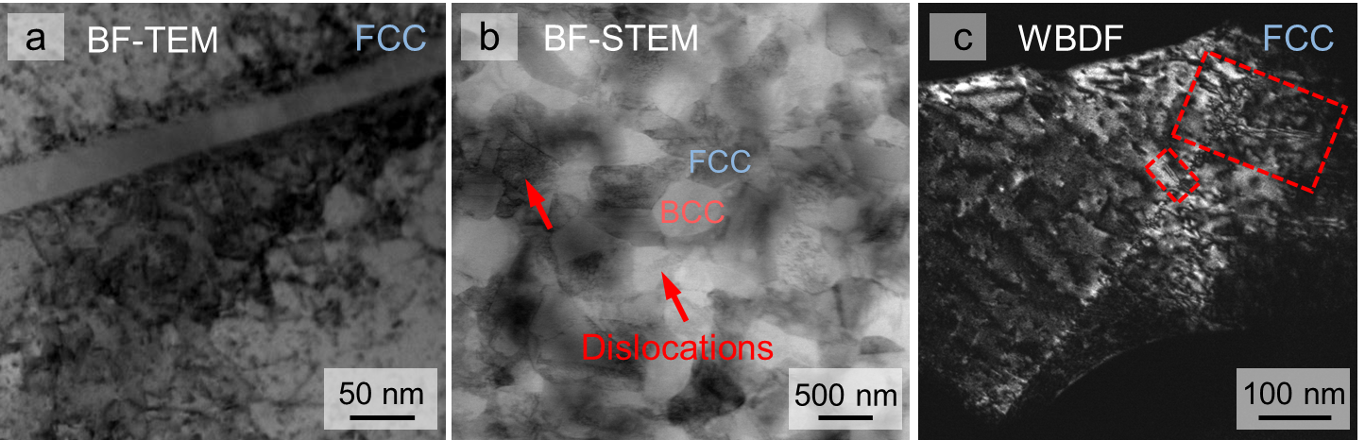
Fig. S10 | Microstructural characterization of ATON-Opt at 20 % strain within the FGR regions at FLH. (a) BF-TEM image of deformation twins in the FCC phase. (b) BF-STEM micrograph illustrating the interconnected dual-phase network structure of the FGR sample, complemented by a (c) WBDF image of the FCC phase.

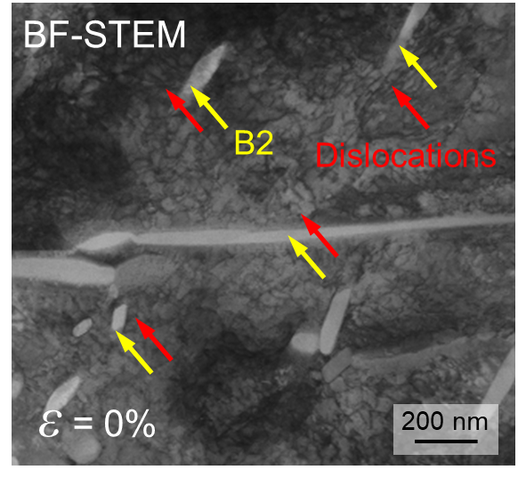
Fig. S11 | (a) BF-TEM image of SFD at 0 % strain.

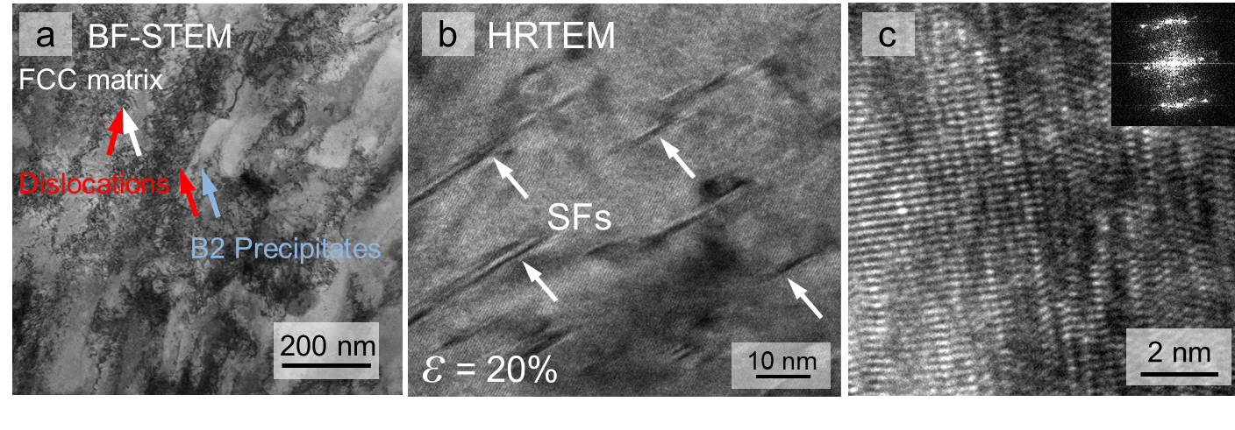
Fig. S12 | Microstructural characterization of ATON-Opt at 20 % strain within the FLH regions. (a) BF-STEM imaging reveals dense dislocation tangles within the FCC matrix and in the vicinity of B2 precipitates. (b) HRTEM image showing dense SFs on the FCC matrix of SFD at 20 % strain. (c) lattice distortion at the interface between the FCC matrix and the B2 precipitates.

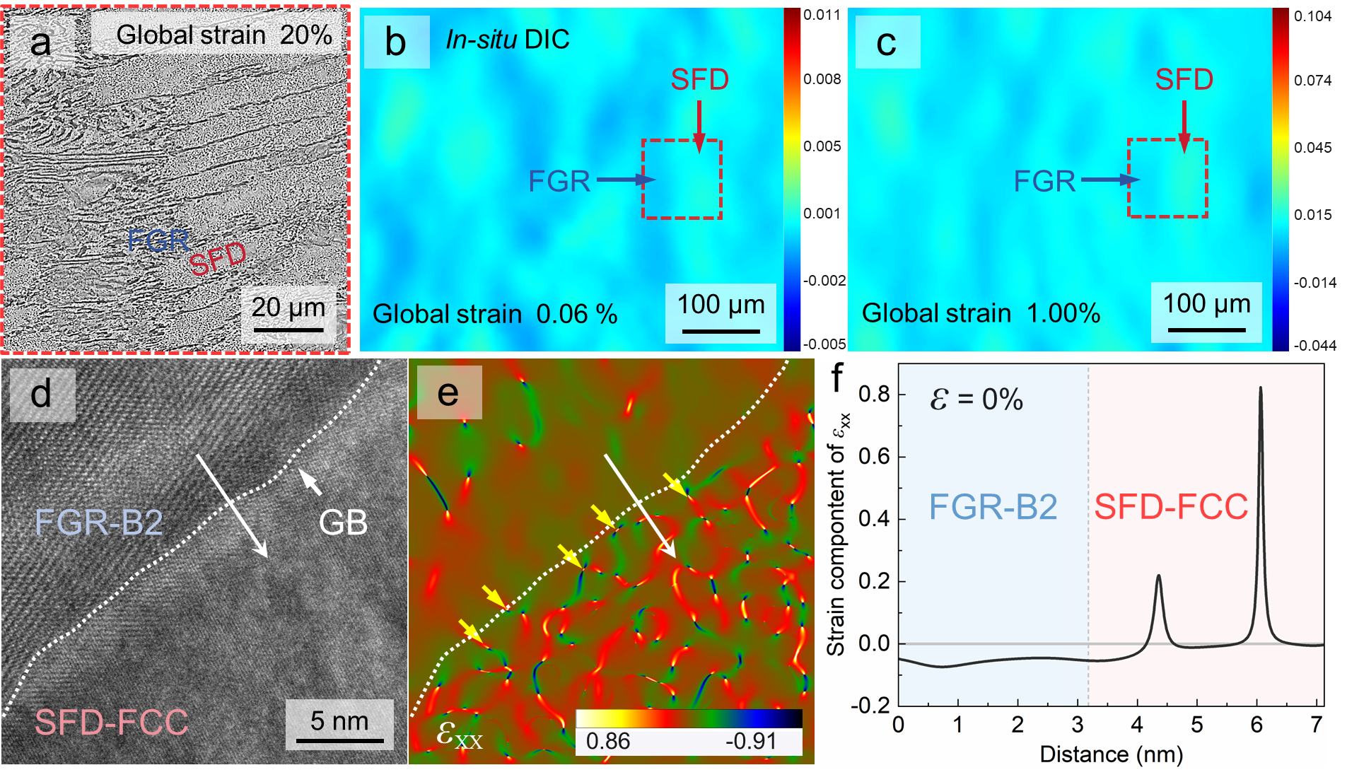
Fig. S13 | (a-c) In-situ DIC results of ATON-Opt during tensile deformation and the corresponding SEM images of the same locations. The tensile direction is horizontal in all images. (d-f) Under unstrained conditions, HRTEM images and corresponding GPA of the interface between the FCC phase in the SFD regions and the BCC phase in the FGR regions, showing the horizontal normal strain (ε_{xx}) of the ATON-Opt alloy. GB denotes the grain boundary, yellow arrows indicate dislocations, and (f) shows the strain distribution along the white arrow direction in (e).

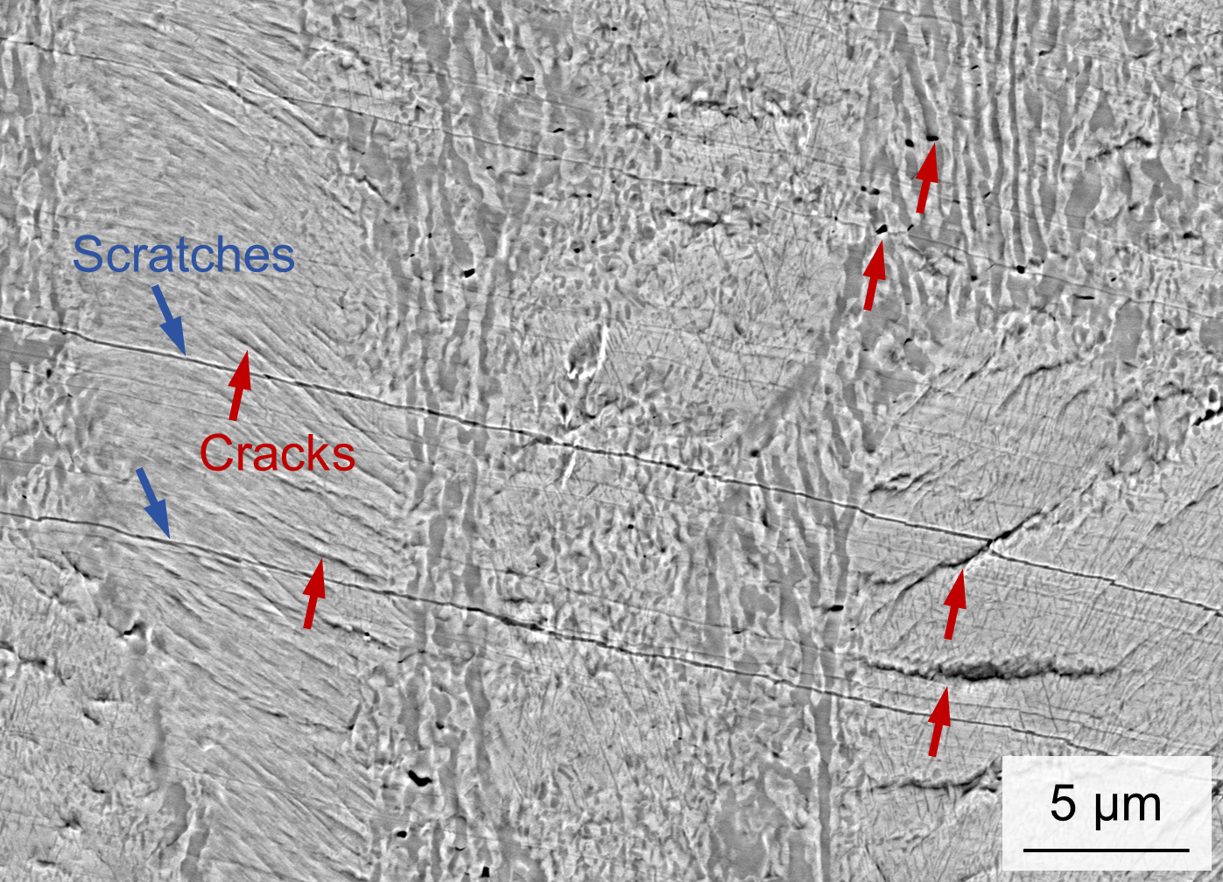
Fig. S14 | SEM image of the fracture surface of ATON-Opt at 20 % strain.

References
1. Gal Y, Ghahramani Z. Dropout as a Bayesian Approximation: Representing Model Uncertainty in Deep Learning. INTERNATIONAL CONFERENCE ON MACHINE LEARNING, VOL 48; 2016.
2. Kingma DP, Ba J. Adam: A method for stochastic optimization. arXiv preprint arXiv:14126980 2014.
3. Daulton S, Balandat M, Bakshy E. Parallel Bayesian Optimization of Multiple Noisy Objectives with Expected Hypervolume Improvement. ADVANCES IN NEURAL INFORMATION PROCESSING SYSTEMS 34 (NEURIPS 2021); 2021.
4. Cao B, Xiong J, Ma J, Tian Y, Hu Y, He M, et al. Bgolearn: a Unified Bayesian Optimization Framework for Accelerating Materials Discovery. arXiv preprint arXiv:260106820 2026.
5. Li Q, Xue S, Wang J, Shao S, Kwong AH, Giwa A, et al. High-Strength Nanotwinned Al Alloys with 9R Phase. ADVANCED MATERIALS 2018, 30(11).
6. Chung H, Choi WS, Jun H, Do H-S, Lee B-J, Choi P-P, et al. Doubled strength and ductility via maraging effect and dynamic precipitate transformation in ultrastrong medium-entropy alloy. Nature Communications 2023, 14(1): 145.
7. Zhou L, Duan F, Zhou Y, Bai X, Jiang Z, Zhou T, et al. Nanotwinned precipitates induced ultra-strong AlCoCrFeNi_{2.1} eutectic high-entropy alloy through additive manufacturing. Materials Today 2025, 88: 99-108.

