Supplementary Figure S1

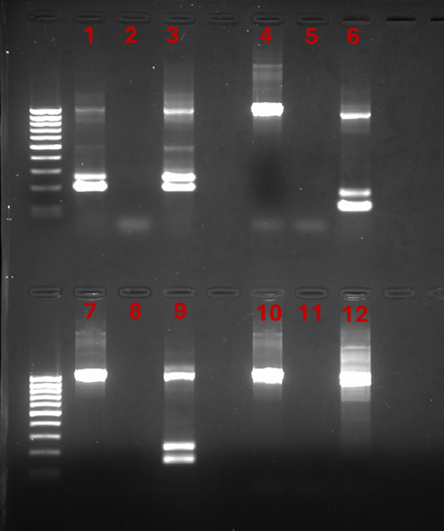
Figure S1: Gel electrophoresis of Nested PCR. Patient blood sample positive both for P. falciparum and P. ovale. Line 1: patient Dna sample with P. falciparum specific primers; Line 2: negative control, Line 3: P. falciparum positive control, Line 4: patient Dna sample with P. vivax specific primers; Line 5: negative control; Line 6: P. vivax positive control; Line 7: patient Dna sample with P. malariae specific primers; Line 8: negative control; Line 9: P. malariae positive control; Line 10 patient Dna sample with P. ovale specific primers; Line 11: negative control; Line 12: P. ovale positive control.

