Sex-specific educational disparities in the odds and progression of depressive symptoms in Northern Sweden: A longitudinal study

Contents
Supplementary figure 1: Directed Acyclic Graph (DAG) for covariates selection 2
Supplementary figure 2: Observed mean CES-D scores across follow-up waves by sex 3
Supplementary table 1: Baseline characteristics and binary depression outcomes by sex 4
Supplementary table 2: Cross-tabulation between education levels and test waves 6

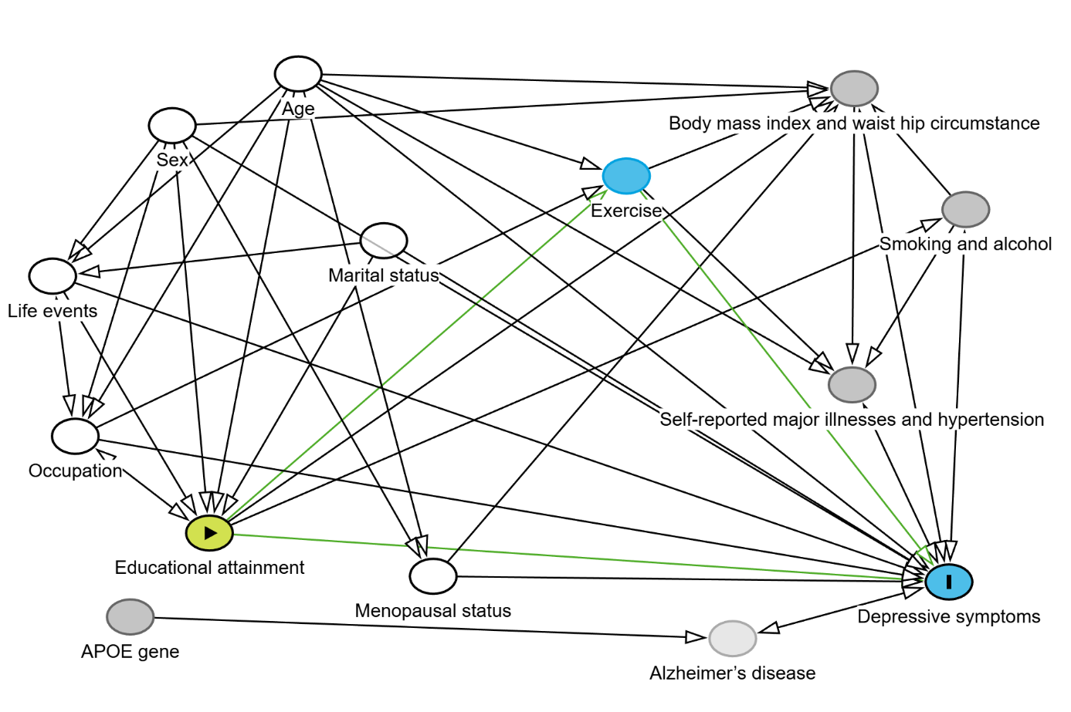

Supplementary figure 1: Directed Acyclic Graph (DAG) for covariates selection
DAG depicting how socioeconomic determinants, genetic factors, lifestyle, anthropometric measures, and other health-related factors are interconnected with depressive symptoms. The graph includes exposure (green), outcome (blue), potential confounders adjusted in model 1 (white), and other key risk/resilience factors of depressive symptoms (grey). DAGitty software by Johannes Textor et al (1) was used for making DAG.

1. Johannes Textor, Benito van der Zander, Mark K. Gilthorpe, Maciej Liskiewicz, George T.H. Ellison. Robust causal inference using directed acyclic graphs: the R package 'dagitty'. International Journal of Epidemiology 45(6):1887-1894, 2016.

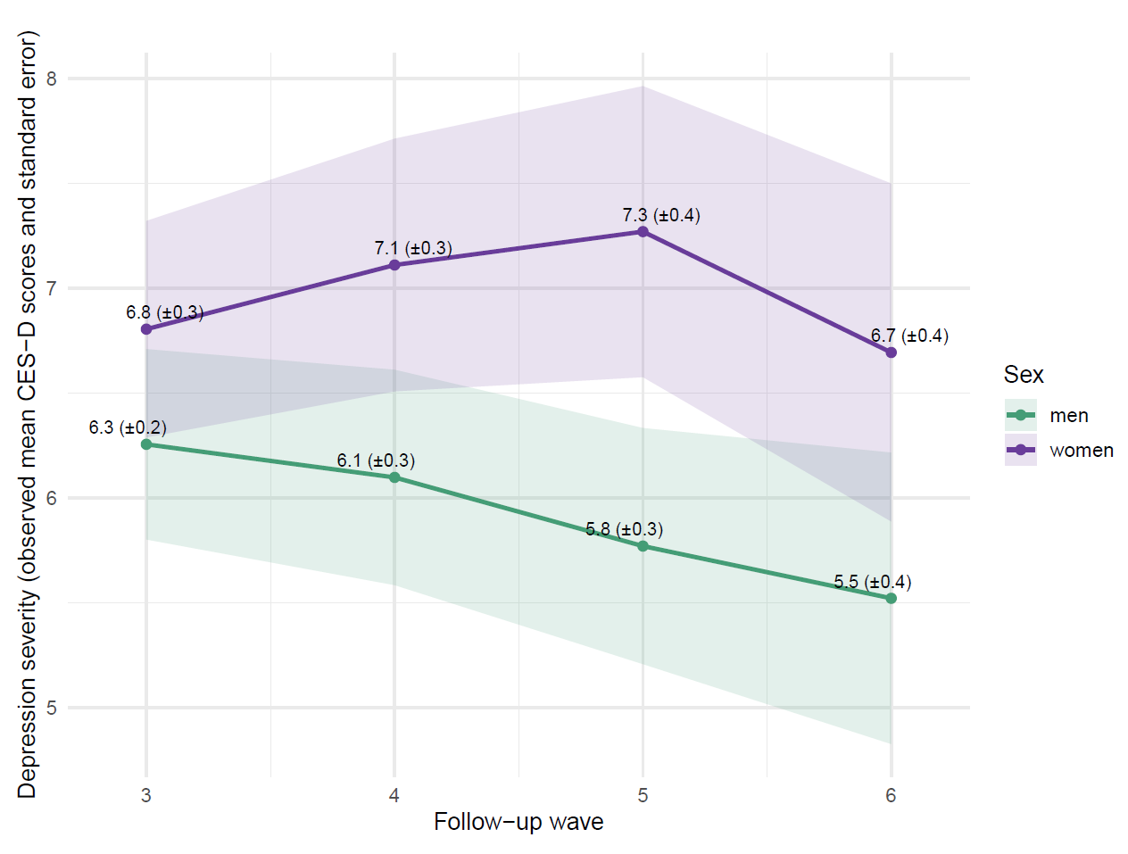

Supplementary figure 2: Observed mean CES-D scores across follow-up waves by sex
CES-D = Center for Epidemiologic Studies Depression scale
Wave 2 is baseline, and CES-D scores were collected from Wave 3 onward in the Betula cohort. In age- and wave-adjusted linear mixed model, men had lower mean scores than women across follow-up (β= -0.82; 95% CI: -1.37 to -0.26; P = 0.004).

Supplementary table 1: Baseline characteristics and binary depression outcomes by sex
Baseline characteristics | Depression outcome  (CES-D >=16) |  | P-value¹ |  | Depression outcome  (CES-D >=16) |  | P-value¹
 | No (N=432) | Yes (N=78) |  |  | No (N=453) | Yes (N=50)
Age at assessment, mean (SD) | 58 (12.56) | 53 (10.54) | <0.001 |  | 57 (12.15) | 58 (12.93) | 0.418
Cohort age, N (%)
40–50 | 168 (38.9) | 44 (56.4) | 0.006 |  | 197 ( 43.5) | 18 ( 36.0) | 0.514
55–65 | 158 (36.6) | 25 (32.1) |  |  | 164 ( 36.2) | 19 ( 38.0)
70–85 | 106 (24.5) | 9 (11.5) |  |  | 92 ( 20.3) | 13 ( 26.0)
Educational attainment, N (%)
primary education (<=9yr) | 195 (45.1) | 18 (23.1) | 0.001 |  | 190 ( 41.9) | 19 ( 38.0) | 0.848
secondary education (10–12yr) | 94 (21.8) | 25 (32.1) |  |  | 97 ( 21.4) | 12 ( 24.0)
postsecondary education (>=13yr) | 143 (33.1) | 35 (44.9) |  |  | 166 ( 36.6) | 19 ( 38.0)
Occupation status, N (%)
employed | 393 (91.0) | 72 (92.3) | 0.868 |  | 352 ( 77.7) | 41 ( 82.0) | 0.605
retired/unemployed/sick-leave | 39 ( 9.0) | 6 ( 7.7) |  |  | 101 ( 22.3) | 9 ( 18.0)
Marital status, N (%)
married | 303 (70.1) | 63 (80.8) | 0.054 |  | 395 ( 87.2) | 38 ( 76.0) | 0.026
not married | 20 ( 4.6) | 5 ( 6.4) |  |  | 26 ( 5.7) | 3 ( 6.0)
divorced/window/er | 109 (25.2) | 10 (12.8) |  |  | 32 ( 7.1) | 9 ( 18.0)
AP0E4 genes, N (%)
no | 316 (73.1) | 54 (69.2) | 0.565 |  | 322 ( 71.1) | 38 ( 76.0) | 0.571
yes | 116 (26.9) | 24 (30.8) |  |  | 131 ( 28.9) | 12 ( 24.0)
Smoking, N (%)
no | 254 (58.8) | 39 (50.0) | 0.186 |  | 210 ( 46.4) | 19 ( 38.0) | 0.329
yes | 178 (41.2) | 39 (50.0) |  |  | 243 ( 53.6) | 31 ( 62.0)
Alcohol, N (%)
no | 90 (20.8) | 15 (19.2) | 0.865 |  | 55 ( 12.1) | 9 ( 18.0) | 0.339
yes | 342 (79.2) | 63 (80.8) |  |  | 398 ( 87.9) | 41 ( 82.0)
Body mass index, N (%)
normal weight (18.5–24.9) | 196 (45.4) | 33 (42.3) | 0.720 |  | 193 ( 42.6) | 17 ( 34.0) | 0.217
overweight (25–29.9) | 162 (37.5) | 33 (42.3) |  |  | 219 ( 48.3) | 25 ( 50.0)
obese (>=30) | 74 (17.1) | 12 (15.4) |  |  | 41 ( 9.1) | 8 ( 16.0)
Waist hip circumstance, N (%)
recommended | 321 (74.3) | 66 (84.6) | 0.070 |  | 183 ( 40.4) | 18 ( 36.0) | 0.652
high risk | 111 (25.7) | 12 (15.4) |  |  | 270 ( 59.6) | 32 ( 64.0)
physical activity, N (%)
never/few times ever | 104 (24.1) | 28 (35.9) | 0.030 |  | 93 ( 20.5) | 15 ( 30.0) | 0.274
few times a month | 54 (12.5) | 13 (16.7) |  |  | 92 ( 20.3) | 7 ( 14.0)
weekly | 182 (42.1) | 29 (37.2) |  |  | 196 ( 43.3) | 23 ( 46.0)
daily | 92 (21.3) | 8 (10.3) |  |  | 72 ( 15.9) | 5 ( 10.0)
Hypertension, N (%)
no | 208 (48.1) | 47 (60.3) | 0.065 |  | 213 ( 47.0) | 18 ( 36.0) | 0.182
yes | 224 (51.9) | 31 (39.7) |  |  | 240 ( 53.0) | 32 ( 64.0)
Any comorbidities, N (%)
no | 105 (24.3) | 20 (25.6) | 0.913 |  | 169 ( 37.3) | 15 ( 30.0) | 0.388
yes | 327 (75.7) | 58 (74.4) |  |  | 284 ( 62.7) | 35 ( 70.0)
Menopausal status, N (%)
no | 260 (60.2) | 54 (69.2) | 0.166 |  | NA | NA
yes | 172 (39.8) | 24 (30.8) |  |  | NA | NA
Number of critical life events, N (%)
None | 29 (6.7) | 2 (2.6) | <0.001 |  | 34 (7.5) | 1 (2.0) | 0.187
1–5 | 236 (54.6) | 24 (30.8) |  |  | 268 (59.2) | 27 (54.0)
6–10 | 123 (28.5) | 38 (48.7) |  |  | 123 (27.2) | 16 (32.0)
11–23 | 44 (10.2) | 14 (17.9) |  |  | 28 (6.2) | 6 (12.0)
¹Pearson’s chi-square test for categorical variables and t-tests for continuous variables

Supplementary table 2: Cross-tabulation between education levels and test waves

Characteristic | Wave 2¹ | Wave 3¹ | Wave 4¹ | Wave 5¹ | Wave 6¹
Education level (Women)
primary(<=9yr) | 213 (41.8%) | 213 (41.8%) | 179 (39.0%) | 114 (34.2%) | 53 (26.6%)
secondary(10-12yr) | 119 (23.3%) | 119 (23.3%) | 110 (24.0%) | 85 (25.5%) | 59 (29.6%)
postsecondary(>=13yr) | 178 (34.9%) | 178 (34.9%) | 170 (37.0%) | 134 (40.2%) | 87 (43.7%)
Education level (Men)
primary(<=9yr) | 209 (41.6%) | 209 (41.6%) | 169 (39.2%) | 99 (31.1%) | 59 (29.8%)
secondary(10-12yr) | 109 (21.7%) | 109 (21.7%) | 97 (22.5%) | 83 (26.1%) | 46 (23.2%)
postsecondary(>=13yr) | 185 (36.8%) | 185 (36.8%) | 165 (38.3%) | 136 (42.8%) | 93 (47.0%)
¹ N (%)

