Vertical Structure and Evolution of Large-Scale Subsurface Marine Heatwaves
Supplementary Figures
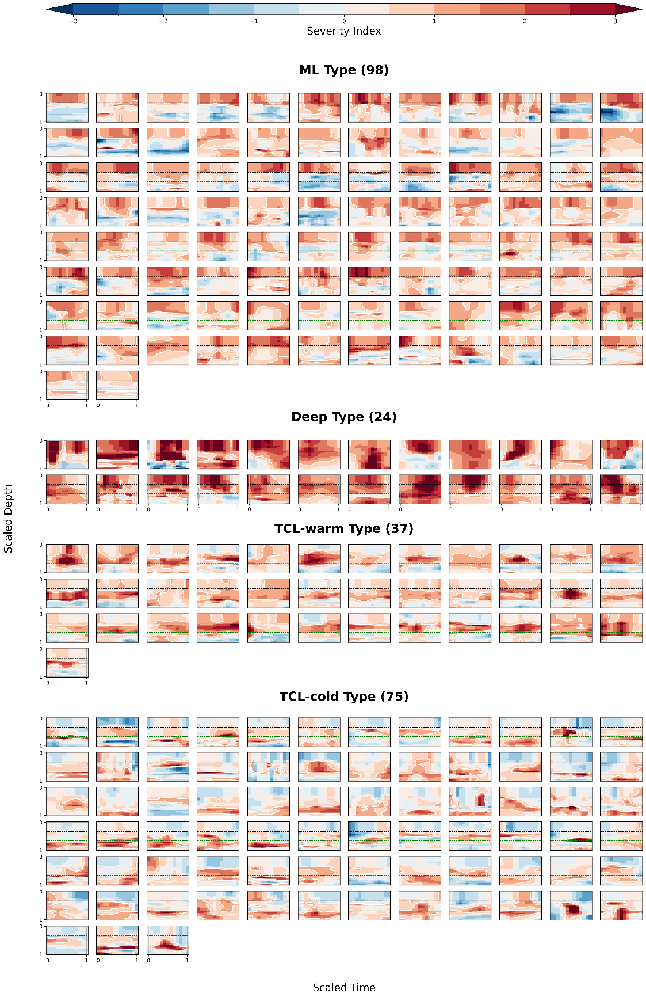
Supple. Fig. 1. Time–depth rescaled MHW severity profiles at the persistence center of each event, grouped by seven distinct vertical evolution types: mixed-layer (ML), deep, thermocline-warm (TCL-warm), thermocline-cold (TCL-cold), submerged-warm (SM-warm), submerged-neutral (SM-neutral), and submerged-cold (SM-cold). The number of events that belong to individual evolution type is shown on the top next to the type name. Color shading indicates the severity index, and white contours delineate the MHW boundary (severity index > 1). The black and green dashed lines represent the base of local mixed layer and thermocline layer.

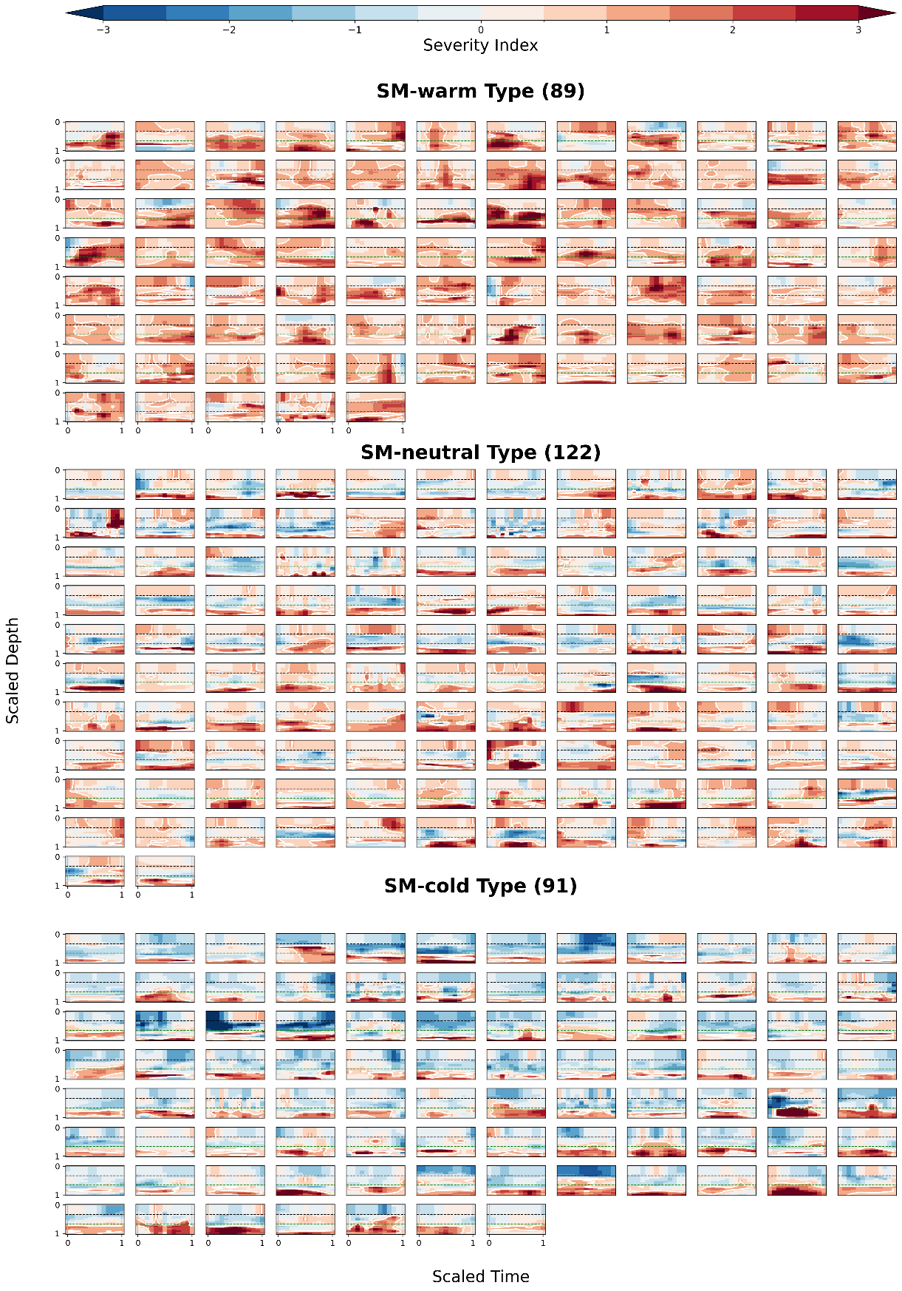
Supple. Fig. 1 (continued)

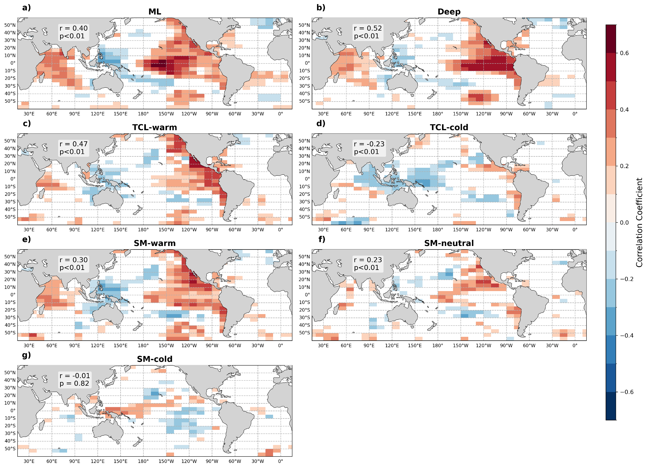

Supple.Fig.2. Spatial maps of correlation coefficient between MHW profile counts and Nino3.4 index, for each MHW vertical structure. White regions represent the p value > 0.01.

Supple. Movies 1–7. Evolution of 536 large-scale subsurface MHW events in the upper 1,000 m of the global ocean (60°S–60°N) during 1993–2020. Each movie shows the spatiotemporal evolution of MHW events for consecutive four-year periods:
Supple. Movie 1 (1993–1996)
Supple. Movie 2 (1997–2000)
Supple. Movie 3 (2001–2004)
Supple. Movie 4 (2005–2008)
Supple. Movie 5 (2009–2012)
Supple. Movie 6 (2013–2016)
Supple. Movie 7 (2017–2020).
Each event is assigned a distinct color, with darker shades indicating higher severity index values. All supplementary movies are available on Github: https://github.com/Jocelynshujing/Vertical-Structure-and-Evolution-of-Large-Scale-Subsurface-Marine-Heatwaves-/blob/main/3Danimation.md

