Supplementary Information
History-Aware Text Representations for Polymer Property Prediction from Literature-Derived Records

Table of contents
Supplementary Note 1. Main Comparison Metrics 1
Supplementary Note 2. LLM Backbone Comparison 3
Supplementary Note 3. Input Strategy Ablation 4
Supplementary Note 4. Cross-Dataset Ranking of Input Strategies 6
Supplementary Note 5. Data Scaling Results 7
Supplementary Note 6. Article-Level Baseline Across Data Scales 8
Supplementary Note 7. Transfer Learning 8
Supplementary Note 8. Domain-Specific Continual Training 11
Supplementary Note 9. Article-Level Sensitivity Diagnostic 12
Supplementary Note 10. Illustrative Examples of Processing-Dependent Property Variation 13
Supplementary Note 11. Article-Level Splitting Analysis 13
Supplementary References 16

This Supplementary Information provides the complete $R^{2}$ and RMSE summaries used in the manuscript, together with normalized RMSE metrics for the main comparison and complementary diagnostics for interpreting the article-level baseline. In the main text, HHT denotes Holistic History-aware Text. The manuscript emphasizes $R^{2}$ trends, selected RMSE summaries, and the interquartile-range normalized RMSE used for cross-property interpretation; here we collect the full tabulated values, auxiliary baseline diagnostics, and supporting comparisons. Unless noted otherwise, all reported standard deviations for learned models are sample standard deviations across the three random seeds.
Numerical Reporting Convention. All numerical values in the following tables are reported as output by the evaluation pipeline, with trailing digits retained for computational transparency. These trailing digits originate from floating-point arithmetic and do not indicate measurement precision; the accompanying standard deviations (where reported) provide the appropriate indication of uncertainty for interpretation.
Supplementary Methods
The Methods section of the main text provides the full description of the PolyBERT and PerioGT baseline adaptations, including the representational-coverage limitations of structure encoders, the treatment of heterogeneous unit annotations, and the rationale for excluding the additives field from the structure-only baselines. Briefly, PolyBERT was applied at the monomer level rather than as a single repeat-unit predictor, and PerioGT was trained in a unified copolymer-style setting with homopolymers treated as special one-component copolymers.
Composition annotations were not forcibly converted to one canonical scale because the source literature reports them in highly heterogeneous forms (e.g., wt%, mol%, molar ratio, phr, parts by weight, equivalents, and many free-text conventions), and many entries do not provide an explicit unit for every reported component. Supplementary Tables 1-6 therefore supplement the conventional metrics with two RMSE-based normalized error measures: ${\text{NRMSE}}_{IQR}=\text{RMSE}/IQR\left(y_{test}\right)$ for intuitive cross-property comparison, and ${\text{NRMSE}}_{within}=\text{RMSE}/σ_{within}^{train}$ for article-aware error interpretation.

Supplementary Note 1. Main Comparison Metrics
Full $R^{2}$ and RMSE values for HHT, PerioGT, PolyBERT, and the article-level baseline on all six polymer properties are reported below as property-specific subtables. Two derived RMSE-based normalized metrics are also reported: ${\text{NRMSE}}_{IQR}$ and ${\text{NRMSE}}_{within}$. Learned model metrics are reported as mean ± standard deviation across three random seeds (42, 62, 82); the normalized columns are computed from the corresponding mean RMSE values. To make within-property comparison easier, rows are grouped by target property.
Supplementary Table 1. Main-comparison metrics for $T_{\text{g}}$ (°C)
Method | $$R^{2}$$ | RMSE | $${\text{NRMSE}}_{IQR}$$ | $${\text{NRMSE}}_{within}$$
Article-level baseline | 0.648 | 43.80 | 0.545 | 1.060
PolyBERT | 0.654 ± 0.011 | 43.44 ± 0.70 | 0.540 | 1.051
PerioGT | 0.682 ± 0.010 | 41.60 ± 0.69 | 0.517 | 1.006
HHT (ChemDFM-v1.5-8B) | 0.865 ± 0.006 | 27.08 ± 0.61 | 0.337 | 0.655
Supplementary Table 2. Main-comparison metrics for $T_{\text{m}}$ (°C)
Method | $$R^{2}$$ | RMSE | $${\text{NRMSE}}_{IQR}$$ | $${\text{NRMSE}}_{within}$$
Article-level baseline | 0.815 | 36.57 | 0.275 | 1.316
PolyBERT | 0.697 ± 0.008 | 46.85 ± 0.65 | 0.352 | 1.686
PerioGT | 0.716 ± 0.007 | 45.34 ± 0.56 | 0.341 | 1.631
HHT (ChemDFM-v1.5-8B) | 0.890 ± 0.014 | 28.14 ± 1.76 | 0.211 | 1.012
Supplementary Table 3. Main-comparison metrics for $E$ (GPa)
Method | $$R^{2}$$ | RMSE | $${\text{NRMSE}}_{IQR}$$ | $${\text{NRMSE}}_{within}$$
Article-level baseline | 0.844 | 15.98 | 4.864 | 1.801
PolyBERT | 0.112 ± 0.004 | 38.11 ± 0.08 | 11.602 | 4.296
PerioGT | 0.068 ± 0.023 | 39.03 ± 0.47 | 11.881 | 4.399
HHT (ChemDFM-v1.5-8B) | 0.905 ± 0.044 | 12.25 ± 2.89 | 3.729 | 1.381
Supplementary Table 4. Main-comparison metrics for UTS (MPa)
Method | $$R^{2}$$ | RMSE | $${\text{NRMSE}}_{IQR}$$ | $${\text{NRMSE}}_{within}$$
Article-level baseline | 0.743 | 425.37 | 7.529 | 1.465
PolyBERT | 0.197 ± 0.024 | 752.57 ± 11.33 | 13.320 | 2.593
PerioGT | 0.187 ± 0.061 | 756.71 ± 28.50 | 13.393 | 2.607
HHT (ChemDFM-v1.5-8B) | 0.744 ± 0.012 | 424.41 ± 10.01 | 7.512 | 1.462
Supplementary Table 5. Main-comparison metrics for $ε$
Method | $$R^{2}$$ | RMSE | $${\text{NRMSE}}_{IQR}$$ | $${\text{NRMSE}}_{within}$$
Article-level baseline | -0.569 | 993.33 | 98.838 | 1.726
PolyBERT | 0.039 ± 0.008 | 777.21 ± 3.43 | 77.335 | 1.350
PerioGT | 0.076 ± 0.026 | 762.19 ± 10.94 | 75.840 | 1.324
HHT (ChemDFM-v1.5-8B) | 0.349 ± 0.031 | 639.83 ± 15.39 | 63.665 | 1.112

Supplementary Table 6. Main-comparison metrics for $n$
Method | $$R^{2}$$ | RMSE | $${\text{NRMSE}}_{IQR}$$ | $${\text{NRMSE}}_{within}$$
Article-level baseline | 0.691 | 0.064 | 0.513 | 0.483
PolyBERT | 0.519 ± 0.014 | 0.080 ± 0.001 | 0.640 | 0.603
PerioGT | 0.483 ± 0.075 | 0.083 ± 0.006 | 0.663 | 0.624
HHT (ChemDFM-v1.5-8B) | 0.712 ± 0.035 | 0.062 ± 0.004 | 0.495 | 0.466

Supplementary Note 2. LLM Backbone Comparison
Full $R^{2}$ and RMSE values for all six LLM backbones evaluated using [2,4]→[2] configuration are reported below as property-specific subtables for direct within-task comparison.
Supplementary Table 7. LLM backbone comparison for $T_{\text{g}}$ (°C)
Model | $$R^{2}$$ | RMSE
Qwen3-0.6B-Base | 0.822 ± 0.005 | 31.10 ± 0.40
Qwen3-4B-Base | 0.834 ± 0.017 | 30.04 ± 1.57
Qwen3-4B-Instruct | 0.851 ± 0.009 | 28.45 ± 0.87
Qwen3-4B-Thinking | 0.848 ± 0.006 | 28.79 ± 0.57
Qwen3-8B-Base | 0.780 ± 0.019 | 34.63 ± 1.45
ChemDFM-v1.5-8B | 0.865 ± 0.006 | 27.08 ± 0.61
Supplementary Table 8. LLM backbone comparison for $T_{\text{m}}$ (°C)
Model | $$R^{2}$$ | RMSE
Qwen3-0.6B-Base | 0.848 ± 0.004 | 33.16 ± 0.47
Qwen3-4B-Base | 0.845 ± 0.025 | 33.50 ± 2.67
Qwen3-4B-Instruct | 0.888 ± 0.013 | 28.41 ± 1.64
Qwen3-4B-Thinking | 0.882 ± 0.008 | 29.30 ± 0.98
Qwen3-8B-Base | 0.831 ± 0.014 | 34.98 ± 1.44
ChemDFM-v1.5-8B | 0.890 ± 0.014 | 28.14 ± 1.76
Supplementary Table 9. LLM backbone comparison for $E$ (GPa)
Model | $$R^{2}$$ | RMSE
Qwen3-0.6B-Base | 0.666 ± 0.017 | 23.38 ± 0.60
Qwen3-4B-Base | 0.652 ± 0.010 | 23.85 ± 0.35
Qwen3-4B-Instruct | 0.864 ± 0.129 | 13.87 ± 6.73
Qwen3-4B-Thinking | 0.838 ± 0.135 | 15.36 ± 6.54
Qwen3-8B-Base | 0.681 ± 0.086 | 22.70 ± 3.19
ChemDFM-v1.5-8B | 0.905 ± 0.044 | 12.25 ± 2.89

Supplementary Table 10. LLM backbone comparison for UTS (MPa)
Model | $$R^{2}$$ | RMSE
Qwen3-0.6B-Base | 0.676 ± 0.061 | 476.74 ± 43.81
Qwen3-4B-Base | 0.687 ± 0.005 | 469.66 ± 3.98
Qwen3-4B-Instruct | 0.665 ± 0.108 | 481.65 ± 82.57
Qwen3-4B-Thinking | 0.702 ± 0.018 | 458.15 ± 14.23
Qwen3-8B-Base | 0.691 ± 0.029 | 466.65 ± 22.22
ChemDFM-v1.5-8B | 0.744 ± 0.012 | 424.41 ± 10.01
Supplementary Table 11. LLM backbone comparison for $ε$
Model | $$R^{2}$$ | RMSE
Qwen3-0.6B-Base | 0.330 ± 0.092 | 647.96 ± 45.10
Qwen3-4B-Base | 0.348 ± 0.059 | 639.86 ± 29.32
Qwen3-4B-Instruct | 0.329 ± 0.064 | 649.24 ± 30.85
Qwen3-4B-Thinking | 0.297 ± 0.081 | 664.34 ± 37.83
Qwen3-8B-Base | -0.127 ± 0.658 | 820.06 ± 233.25
ChemDFM-v1.5-8B | 0.349 ± 0.031 | 639.83 ± 15.39
Supplementary Table 12. LLM backbone comparison for $n$
Model | $$R^{2}$$ | RMSE
Qwen3-0.6B-Base | 0.801 ± 0.020 | 0.052 ± 0.003
Qwen3-4B-Base | 0.822 ± 0.005 | 0.049 ± 0.001
Qwen3-4B-Instruct | 0.819 ± 0.014 | 0.049 ± 0.002
Qwen3-4B-Thinking | 0.796 ± 0.017 | 0.052 ± 0.002
Qwen3-8B-Base | 0.724 ± 0.092 | 0.060 ± 0.010
ChemDFM-v1.5-8B | 0.712 ± 0.035 | 0.062 ± 0.004

Supplementary Note 3. Input Strategy Ablation
All input-type configurations were reevaluated on the final ChemDFM-v1.5-8B backbone with complete test-set $R^{2}$ summaries. The table includes the eight base input types, the matched single-type control [2]→[2], and the dynamic strategy [2,4]→[2]. During training, dynamic input selection can be employed, where multiple input types are randomly sampled across epochs to improve robustness; we denote training--evaluation configurations as [train types]→[eval type], so that [2,4]→[2] indicates dynamic sampling between Types 2 and 4 during training, with evaluation using Type 2.
Type 1. Structured JSON including chemical composition, processing history, and hierarchical structure.
Type 2. Structured JSON including chemical composition and processing history, without hierarchical structure.
Type 3. LLM-generated descriptive summary with hierarchical structure retained.
Type 4. LLM-generated descriptive summary without hierarchical structure.
Type 5. LLM-generated reasoning analysis with hierarchical structure retained.
Type 6. LLM-generated reasoning analysis without hierarchical structure.
Type 7. Combined descriptive summary plus reasoning analysis with hierarchical structure retained.
Type 8. Combined descriptive summary plus reasoning analysis without hierarchical structure.
Types 3-8 were generated only after the structured extraction-and-review pipeline had produced the base JSON record. The generation prompts received restricted subsets of the structured fields only: chemical composition, processing history, and optionally hierarchical structure. They did not receive the target property value or the original paper text, so these auxiliary inputs should be interpreted as alternate representations of the curated record rather than as leakage-prone post hoc summaries. Types 3 and 4 in particular are information-preserving reformulations of Types 1 and 2 and were introduced as a controlled text-level augmentation mechanism.
[2]→[2]. Single-type control strategy: training and evaluation both use Type 2 only. This adds one derived strategy beyond the eight base types.
[2,4]→[2]. Dynamic input strategy: during training, Types 2 and 4 are randomly sampled across epochs, while evaluation uses Type 2 only. This is the tenth evaluated configuration in Supplementary Table 13 and the only explicitly dynamic prompt strategy used in the main experiments.
Supplementary Table 13. Input strategy ablation
Input Config | $$T_{\text{g}}$$ | $$T_{\text{m}}$$ | $$E$$ | UTS | $$ε$$ | $$n$$
[1] | 0.858 ± 0.006 | 0.918 ± 0.008 | 0.905 ± 0.031 | 0.704 ± 0.032 | 0.378 ± 0.027 | 0.810 ± 0.020
[2] | 0.848 ± 0.005 | 0.903 ± 0.013 | 0.800 ± 0.060 | 0.643 ± 0.019 | 0.368 ± 0.028 | 0.763 ± 0.031
[1,3] | 0.857 ± 0.017 | 0.910 ± 0.002 | 0.888 ± 0.052 | 0.707 ± 0.041 | 0.312 ± 0.146 | 0.806 ± 0.005
[2,4] | 0.855 ± 0.007 | 0.898 ± 0.010 | 0.806 ± 0.152 | 0.676 ± 0.066 | 0.399 ± 0.045 | 0.766 ± 0.029
[1,2,3,4] | 0.864 ± 0.006 | 0.915 ± 0.019 | 0.930 ± 0.003 | 0.710 ± 0.031 | 0.180 ± 0.344 | 0.565 ± 0.116
[1,3,5,7] | 0.862 ± 0.009 | 0.906 ± 0.011 | 0.868 ± 0.024 | 0.668 ± 0.060 | 0.184 ± 0.120 | 0.679 ± 0.046
[2,4,6,8] | 0.856 ± 0.008 | 0.886 ± 0.017 | 0.788 ± 0.153 | 0.618 ± 0.115 | 0.068 ± 0.342 | 0.470 ± 0.140
[1-8] | 0.859 ± 0.014 | 0.889 ± 0.018 | 0.836 ± 0.132 | 0.732 ± 0.028 | -0.054 ± 0.210 | 0.511 ± 0.124
[2]→[2] | 0.849 ± 0.015 | 0.905 ± 0.017 | 0.876 ± 0.018 | 0.700 ± 0.060 | 0.341 ± 0.087 | 0.762 ± 0.013
[2,4]→[2] | 0.865 ± 0.006 | 0.890 ± 0.014 | 0.905 ± 0.044 | 0.744 ± 0.012 | 0.349 ± 0.031 | 0.712 ± 0.035

Supplementary Note 4. Cross-Dataset Ranking of Input Strategies
For this post hoc ChemDFM comparison, candidates were descriptively ranked by the same composite score used elsewhere for multi-property summaries
S=d​1rankd-d​Rbest,d2-Rd2Rbest,d2-Rworst,d2,
which rewards high within-property ranks while penalizing large normalized gaps from the property-specific optimum. Supplementary Table 14 applies this formula to the reported test-set mean $R^{2}$ values in Supplementary Table 13, so it should be interpreted as a descriptive re-ranking of the final-backbone ablation rather than as a validation-stage selection record. Under this ChemDFM re-ranking, [1] appears strongest overall, but it depends on hierarchical-structure information that is typically unavailable in a prospective pre-experimental setting. The pre-specified final configuration [2,4]→[2] ranks second overall and is the strongest hierarchy-free dynamic strategy: it preserves a clean Type 2 evaluation input, excludes LLM reasoning-analysis fields, and uses Type 4 only as training-time text augmentation.
Supplementary Table 14. Cross-dataset ranking of input strategies.
Rank | Input Config | Total Score | Rank Score | Gap Penalty | Mean Test $R^{2}$ | $T_{\text{g}}$ Rank | $T_{\text{m}}$ Rank | $E$ Rank | UTS Rank | $ε$ Rank | $n$ Rank
1 | [1] | 2.44 | 3.40 | 0.96 | 0.762 | 5 | 1 | 2 | 5 | 2 | 1
2 | [2,4]→[2] | 1.44 | 2.88 | 1.44 | 0.744 | 1 | 8 | 3 | 1 | 4 | 6
3 | [1,2,3,4] | 0.94 | 2.58 | 1.64 | 0.694 | 2 | 2 | 1 | 3 | 8 | 8
4 | [1,3] | 0.16 | 1.67 | 1.51 | 0.747 | 6 | 3 | 4 | 4 | 6 | 2
5 | [2,4] | -0.86 | 1.87 | 2.73 | 0.734 | 8 | 7 | 8 | 7 | 1 | 3
6 | [2]→[2] | -1.23 | 1.08 | 2.31 | 0.739 | 9 | 5 | 5 | 6 | 5 | 5
7 | [1,3,5,7] | -1.33 | 1.16 | 2.49 | 0.695 | 3 | 4 | 6 | 8 | 7 | 7
8 | [2] | -2.34 | 1.07 | 3.41 | 0.721 | 10 | 6 | 9 | 9 | 3 | 4
9 | [1-8] | -2.69 | 1.22 | 3.91 | 0.629 | 4 | 9 | 7 | 2 | 10 | 9
10 | [2,4,6,8] | -4.61 | 0.65 | 5.26 | 0.614 | 7 | 10 | 10 | 10 | 9 | 10

Supplementary Note 5. Data Scaling Results
Mean ± standard deviation $R^{2}$ values at different training set proportions for all three encoder families are reported below as property-specific subtables so that the scaling behavior of HHT, PerioGT, and PolyBERT can be compared directly within each task.
Supplementary Table 15. Data-scaling results for $T_{\text{g}}$ (°C)
Data % | HHT | PerioGT | PolyBERT
20% | 0.561 ± 0.013 | 0.448 ± 0.006 | 0.306 ± 0.029
40% | 0.711 ± 0.004 | 0.582 ± 0.023 | 0.502 ± 0.009
60% | 0.800 ± 0.006 | 0.617 ± 0.001 | 0.583 ± 0.001
80% | 0.836 ± 0.016 | 0.677 ± 0.006 | 0.640 ± 0.008
100% | 0.865 ± 0.006 | 0.682 ± 0.010 | 0.654 ± 0.011
Supplementary Table 16. Data-scaling results for $T_{\text{m}}$ (°C)
Data % | HHT | PerioGT | PolyBERT
20% | 0.734 ± 0.004 | 0.543 ± 0.006 | 0.525 ± 0.012
40% | 0.779 ± 0.017 | 0.584 ± 0.008 | 0.546 ± 0.011
60% | 0.857 ± 0.024 | 0.639 ± 0.015 | 0.589 ± 0.009
80% | 0.862 ± 0.009 | 0.684 ± 0.009 | 0.629 ± 0.003
100% | 0.890 ± 0.014 | 0.716 ± 0.007 | 0.697 ± 0.008
Supplementary Table 17. Data-scaling results for $E$ (GPa)
Data % | HHT | PerioGT | PolyBERT
20% | 0.669 ± 0.032 | -0.031 ± 0.031 | 0.048 ± 0.030
40% | 0.892 ± 0.037 | 0.043 ± 0.002 | 0.054 ± 0.015
60% | 0.903 ± 0.029 | 0.033 ± 0.035 | 0.088 ± 0.026
80% | 0.908 ± 0.026 | 0.070 ± 0.024 | 0.096 ± 0.015
100% | 0.905 ± 0.044 | 0.068 ± 0.023 | 0.112 ± 0.004

Supplementary Table 18. Data-scaling results for UTS (MPa)
Data % | HHT | PerioGT | PolyBERT
20% | 0.497 ± 0.057 | 0.137 ± 0.101 | 0.179 ± 0.002
40% | 0.649 ± 0.019 | 0.201 ± 0.046 | 0.211 ± 0.017
60% | 0.642 ± 0.018 | 0.172 ± 0.027 | 0.196 ± 0.012
80% | 0.724 ± 0.029 | 0.224 ± 0.031 | 0.219 ± 0.012
100% | 0.744 ± 0.012 | 0.187 ± 0.061 | 0.197 ± 0.024
Supplementary Table 19. Data-scaling results for $ε$
Data % | HHT | PerioGT | PolyBERT
20% | 0.203 ± 0.038 | 0.005 ± 0.014 | 0.003 ± 0.006
40% | 0.191 ± 0.063 | -0.007 ± 0.019 | 0.022 ± 0.004
60% | 0.202 ± 0.085 | 0.006 ± 0.005 | 0.028 ± 0.007
80% | -0.293 ± 0.527 | -0.006 ± 0.014 | 0.003 ± 0.027
100% | 0.349 ± 0.031 | 0.076 ± 0.026 | 0.039 ± 0.008
Supplementary Table 20. Data-scaling results for $n$
Data % | HHT | PerioGT | PolyBERT
20% | 0.652 ± 0.022 | 0.400 ± 0.022 | 0.430 ± 0.005
40% | 0.647 ± 0.084 | 0.362 ± 0.024 | 0.419 ± 0.031
60% | 0.747 ± 0.001 | 0.432 ± 0.010 | 0.388 ± 0.012
80% | 0.759 ± 0.046 | 0.502 ± 0.031 | 0.504 ± 0.011
100% | 0.712 ± 0.035 | 0.483 ± 0.075 | 0.519 ± 0.014

Supplementary Note 6. Article-Level Baseline Across Data Scales
Supplementary Table 21. $R^{2}$ values from the article-level baseline at different training data proportions.
Data % | $$T_{\text{g}}$$ | $$T_{\text{m}}$$ | $$E$$ | UTS | $$ε$$ | $$n$$
20% | 0.279 | 0.515 | 0.554 | 0.574 | -4.381 | 0.471
40% | 0.457 | 0.552 | 0.777 | 0.618 | -0.866 | 0.581
60% | 0.588 | 0.723 | 0.837 | 0.601 | 0.316 | 0.646
80% | 0.629 | 0.758 | 0.839 | 0.713 | -0.722 | 0.661
100% | 0.648 | 0.815 | 0.844 | 0.743 | -0.569 | 0.691

Supplementary Note 7. Transfer Learning
Results are reported below as property-specific subtables so that each transfer strategy can be compared directly against the single-task baseline within the same prediction task.
Supplementary Table 22. Transfer-learning results for $T_{\text{g}}$ (°C)
Experiment | $$R^{2}$$ | RMSE
Single-task | 0.865 ± 0.006 | 27.08 ± 0.61
All-6 Transfer | 0.816 ± 0.009 | 31.66 ± 0.81
Tg+Tm Transfer | 0.840 ± 0.013 | 29.55 ± 1.21
Supplementary Table 23. Transfer-learning results for $T_{\text{m}}$ (°C)
Experiment | $$R^{2}$$ | RMSE
Single-task | 0.890 ± 0.014 | 28.14 ± 1.76
All-6 Transfer | 0.870 ± 0.009 | 30.72 ± 1.11
Tg+Tm Transfer | 0.905 ± 0.013 | 26.13 ± 1.79
Supplementary Table 24. Transfer-learning results for $E$ (GPa)
Experiment | $$R^{2}$$ | RMSE
Single-task | 0.905 ± 0.044 | 12.25 ± 2.89
All-6 Transfer | 0.740 ± 0.134 | 20.18 ± 5.15
E+UTS Transfer | 0.902 ± 0.014 | 12.61 ± 0.89
Supplementary Table 25. Transfer-learning results for UTS (MPa)
Experiment | $$R^{2}$$ | RMSE
Single-task | 0.744 ± 0.012 | 424.41 ± 10.01
All-6 Transfer | 0.759 ± 0.057 | 410.23 ± 49.50
E+UTS Transfer | 0.716 ± 0.012 | 447.53 ± 9.76
Supplementary Table 26. Transfer-learning results for $ε$
Experiment | $$R^{2}$$ | RMSE
Single-task | 0.349 ± 0.031 | 639.83 ± 15.39
All-6 Transfer | -0.035 ± 0.058 | 806.49 ± 22.55
Supplementary Table 27. Transfer-learning results for $n$
Experiment | $$R^{2}$$ | RMSE
Single-task | 0.712 ± 0.035 | 0.062 ± 0.004
All-6 Transfer | 0.762 ± 0.028 | 0.056 ± 0.003
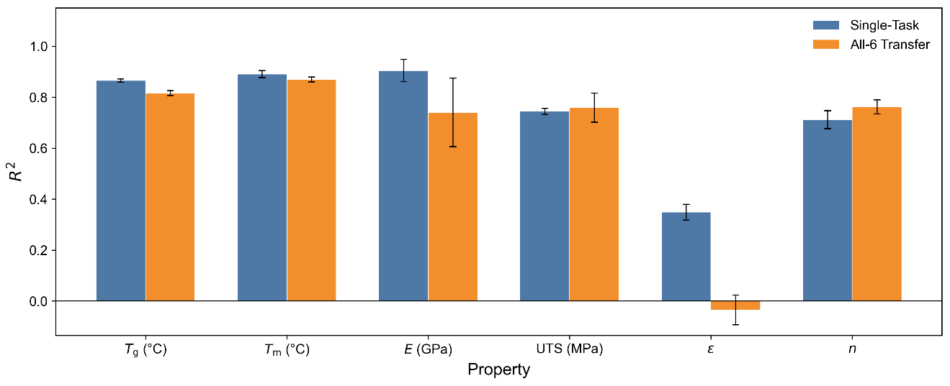
Supplementary Fig. 1. All-six joint transfer compared with the corresponding single-task models across all six properties. Bars show mean test-set $R^{2}$ and error bars denote ± one standard deviation across three random seeds. The all-six transfer setting improves only UTS and $n$ while reducing $T_{\text{g}}$, $T_{\text{m}}$, $E$, and especially $ε$.
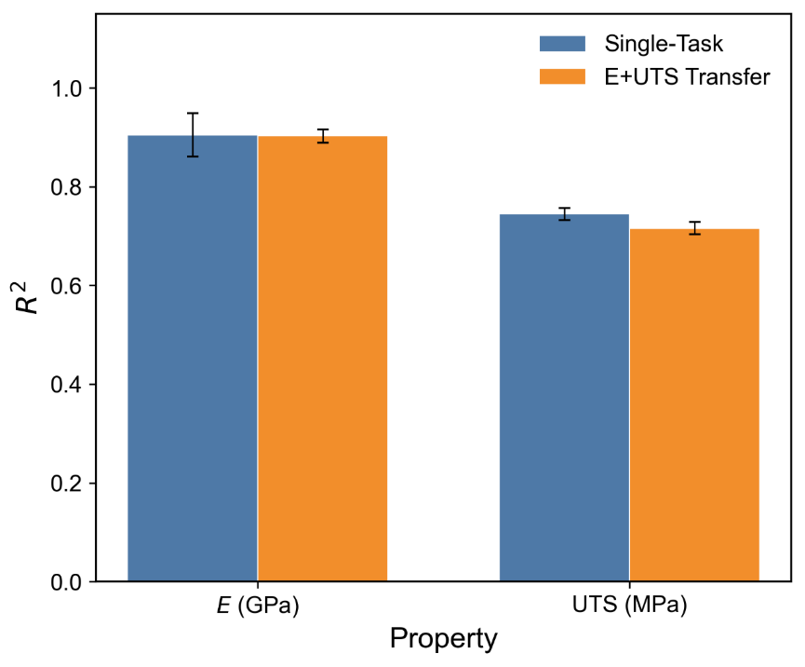
Supplementary Fig. 2. Joint $E$ +UTS transfer compared with the corresponding single-task baselines. The coupled model nearly preserves $E$ performance but still lowers UTS, indicating only limited transfer benefit even between mechanically related targets.
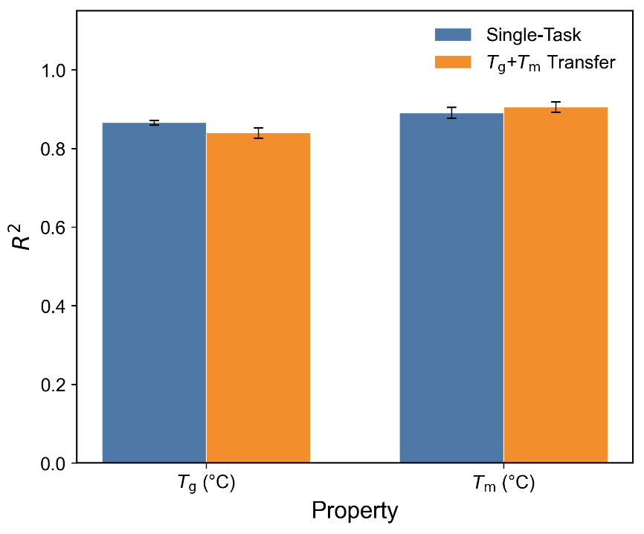
Supplementary Fig. 3. Joint $T_{\text{g}}$+$T_{\text{m}}$ transfer compared with the corresponding single-task baselines. The paired-transfer setting modestly improves $T_{\text{m}}$ while reducing $T_{\text{g}}$, showing that even closely related thermal properties do not consistently benefit from shared training.

Supplementary Note 8. Domain-Specific Continual Training
Before/after continual-training performance is reported below as property-specific subtables so that different initialization and encoder choices can be compared directly within each continual-training task.
For the random-initialization runs, the "before continual training" values correspond to evaluating an untrained regression head before any domain adaptation. The resulting strongly negative $R^{2}$ values should therefore be interpreted only as a starting reference for the subsequent continual-training gains, not as meaningful predictive baselines.
The continual-training benchmarks were collected with the same automated extraction, RDKit-based SMILES screening, and unit-harmonization workflow as the six main-property datasets. The $T_{\text{m}}$ benchmark comes from a single-source 73-sample corpus that was partitioned into a 50-sample continual-training pool and a 23-sample held-out evaluation split. The $E$ benchmark comes from a single 879-sample corpus that was partitioned into a 701-sample continual-training pool and a 178-sample held-out evaluation split; this combined corpus spans 150 unique non-null title-defined articles, with 84 titles appearing in both partitions. Unlike the main six-property datasets, both held-out evaluation splits used for continual training were fully manually reviewed sample by sample.
Supplementary Table 28. Continual-training performance for $E$ (GPa)
Method | Init | Before CT $R^{2}$ | After CT $R^{2}$ | Before CT RMSE | After CT RMSE
HHT | Pretrained | -0.019 | 0.976 | 34.30 | 5.29
HHT | Random | -148.789 | 0.963 | 415.97 | 6.52
PerioGT | Pretrained | -0.071 | 0.070 | 35.17 | 32.77
PerioGT | Random | -0.462 | 0.261 | 41.10 | 29.21
PolyBERT | Pretrained | -0.018 | 0.030 | 34.29 | 33.48
PolyBERT | Random | -0.050 | 0.005 | 34.82 | 33.91
Supplementary Table 29. Continual-training performance for $T_{\text{m}}$ (°C)
Method | Init | Before CT $R^{2}$ | After CT $R^{2}$ | Before CT RMSE | After CT RMSE
HHT | Pretrained | 0.859 | 0.944 | 23.19 | 14.61
HHT | Random | -9.955 | 0.877 | 204.38 | 21.62
PerioGT | Pretrained | 0.141 | 0.903 | 57.22 | 19.22
PerioGT | Random | 0.102 | 0.883 | 58.51 | 21.12
PolyBERT | Pretrained | 0.838 | 0.927 | 24.82 | 16.63
PolyBERT | Random | -0.019 | 0.851 | 62.34 | 23.82
For contextual reference only, and not as values plotted in Figure 4 of the main text, the article-level baseline on the continual-training evaluation sets behaves very differently for the two domains. For $T_{\text{m}}$, the continual-training and evaluation data come from a single source article identified during collection, so the baseline degenerates to predicting one train-article average for all evaluation samples; the best variant is the mean-based rule with $R^{2}=\text{-0.015}$ and RMSE = 62.21, while the median-based rule gives $R^{2}=\text{-0.045}$ and RMSE = 63.13. For $E$, the domain-specific dataset still spans many source articles, so the same null model remains competitive: the best variant is the mean-based rule with $R^{2}=\text{0.797}$ and RMSE = 15.32, while the median-based rule gives $R^{2}=\text{0.784}$ and RMSE = 15.81. These $E$-domain baseline values were computed from the predefined 561-sample continual-training subset rather than the full 701-sample continual-training pool, while evaluation remained on the same 178-sample held-out evaluation split.

Supplementary Note 9. Article-Level Sensitivity Diagnostic
Figure 2a in the main text provides the primary explanation for why the article-level baseline can attain high $R^{2}$ under random splitting: within-article variation is often much smaller than between-article variation. Supplementary Table 30 reports the observed between-article variance fraction together with a permutation-null comparison obtained by keeping article group sizes fixed and shuffling property values among records. The table also retains the compact sensitivity analysis showing how much $R^{2}$ would change if the baseline RMSE were hypothetically reduced by 5%, 10%, or 20% while the evaluation set remained fixed. Formal definitions are given in the Evaluation Metrics and Article-Level Variance Analysis subsection of Methods in the main text. All values were generated from the study split files, permutation diagnostics, and main-comparison outputs using dedicated analysis scripts; all six one-sided empirical permutation $P$ values are below ${\text{10}}^{\text{-4}}$.
Supplementary Table 30. Article-level sensitivity diagnostic and permutation-null comparison.
Property | Observed Variance (%) | Null Mean (%) | Null 95th Percentile (%) | $$σ_{between}/σ_{within}$$ | Expected $ΔR_{5\%}^{2}$ | Expected $ΔR_{10\%}^{2}$ | Expected $ΔR_{20\%}^{2}$
$$T_{\text{g}}$$ | 71.5 | 10.6 | 12.4 | 4.6 | 0.034 | 0.067 | 0.127
$$T_{\text{m}}$$ | 90.9 | 13.9 | 16.1 | 7.9 | 0.018 | 0.035 | 0.066
$$E$$ | 97.0 | 13.3 | 18.7 | 14.6 | 0.015 | 0.030 | 0.056
UTS | 77.5 | 12.5 | 20.3 | 4.9 | 0.025 | 0.049 | 0.092
$$ε$$ | 47.1 | 16.1 | 26.3 | 2.2 | 0.153 | 0.298 | 0.565
$$n$$ | 68.2 | 10.3 | 26.5 | 4.3 | 0.030 | 0.059 | 0.111

Supplementary Note 10. Illustrative Examples of Processing-Dependent Property Variation
The Discussion section of the main text discusses the mechanistic advantages of HHT over structure-only encoders. Here we provide the concrete examples referenced in that discussion, illustrating how synthesis and processing history can dominate polymer properties even when the monomer composition is identical.
Example 1: Polyacrylonitrile (PAN) — Cast Film vs. Electrospinning¹
A polyacrylonitrile sample prepared as a cast film from a 10 wt% PAN/DMF solution exhibits a Young’s modulus of 1.18 GPa, whereas an electrospun nanofiber drawn from the identical solution at 22 kV reaches 47.5 GPa — a roughly 40-fold increase attributable to molecular chain alignment induced during electrospinning.
Example 2: Thiol-Acrylate Network — UV Cure vs. Thermal Post-Cure²
A thiol-acrylate network formulated from 74 mol% 2-hydroxy-3-phenoxypropyl acrylate, 12 mol% bisphenol A-glycidyl methacrylate, and 14 mol% trimethylolpropane tris(3-mercaptopropionate) yields an ultimate tensile strength of 1.6 MPa after UV curing, yet the identical formulation subjected to an additional 180 °C thermal treatment for 5 h reaches 30 MPa.
Example 3: Systems Lacking Repeat-Unit SMILES³
A sulfur-rich inverse-vulcanized copolymer, synthesized from 70 wt% elemental sulfur and 2,5-norbornadiene dimer, exhibits a refractive index of 1.83 at 600 nm. This system lacks both a canonical repeat-unit SMILES and valid monomer SMILES for the sulfur component, yet remains a scientifically meaningful entry whose optical property is controlled by the high sulfur loading and crosslinking chemistry rather than by an isolated repeat unit.

Supplementary Note 11. Article-Level Splitting Analysis
The main experiments described in the Results section of the main text use entry-level random splitting, which allows samples from the same source article to appear in training, validation, and test partitions simultaneously. An alternative is article-level splitting, which assigns all samples from a given article exclusively to one partition. Entry-level splitting aligns our evaluation protocol with prior polymer machine learning studies, which split at the individual-entry level rather than by article, keeping our metrics directly comparable to published baselines.
Article-level splitting, however, imposes a particularly difficult task at the current data scale. Each dataset draws from 170-268 unique source articles; under a 70/10/20 article-level split, the training partition contains at most roughly 120-190 articles. Since each article represents a distinct synthesis protocol or formulation family, the model must generalize to test articles whose monomer combinations, synthesis methods, and processing conditions it has never seen during training—learning, from only one to two hundred documented pathways, a predictive function that transfers to the vastly broader space of possible polymer formulations. Although LLMs carry strong inductive biases from pretraining, ChemDFM-v1.5-8B has not been domain-trained on polymer corpora, and its regression head is trained from scratch on a limited number of examples; robust cross-article generalization is therefore unrealistic at the current data scale.
We nevertheless implemented article-level splitting to provide an empirical reference (Supplementary Fig. 4 and Supplementary Table 31); to prevent degenerate disjoint value ranges, we used stratified assignment that guarantees the training set spans the full observed range of each property. Under this regime, all models show marked performance loss. HHT retains a clear advantage over the structure-only baselines, but its $R^{2}$ stays above 0.5 only for $T_{\text{m}}$ (0.613) while falling to 0.112-0.346 for the remaining properties. The structure-only baselines degrade further, with PerioGT producing strongly negative $R^{2}$ for $E$ (-1.314) and both PolyBERT and PerioGT operating near or below zero on UTS, $ε$, and $n$. The article-level baseline collapses to near-zero $R^{2}$ across all six properties (Supplementary Table 31), confirming that article-level splitting removes the article-level confound but makes the prediction problem nearly intractable at the available data volume. To illustrate how synthesis diversity undermines cross-article generalization, two representative entries from the epoxy corpus are listed below: despite similar base chemistry, they differ by roughly 200-fold in modulus due to divergent processing histories (Entry A, a woven E-glass/epoxy laminate fabricated by hand lay-up, $E$ = 18.8 GPa⁴; Entry B, a PEG-plasticized epoxy/steel-slag composite cast and cured at 40°C/4 h followed by postcuring at 80°C/4 h, $E$ = 0.088 GPa⁵).
These results also contextualize the continual-training experiments reported in the main text. For $T_{\text{m}}$, where a single-source article provided a coherent adaptation benchmark, article-level pretraining followed by continual training decreases performance from $R^{2}=\text{0.944}$ for entry-level pretraining to $R^{2}=\text{0.928}$ for article-level pretraining (Supplementary Fig. 5). For $E$, the degradation is much more severe: article-level pretraining followed by continual training yields a negative $R^{2}$ of -0.542 (Supplementary Fig. 6), substantially worse than both random-initialization ($R^{2}=\text{0.370}$) and entry-level pretrained ($R^{2}=\text{0.}\text{187}$) continual training. This deterioration reflects two compounding effects: disjoint training, validation, and test article sets prevent the validation distribution from tracking the test distribution closely enough to guide effective early stopping; and the reduced number of distinct articles limits the diversity of synthesis methods and processing histories seen during training. Taken together, these analyses support entry-level splitting as the appropriate convention at the current data scale, while underscoring that the article-level baseline and variance decomposition remain essential controls for contextualizing generalization claims.
Supplementary Table 31. Article-level baseline under article-level splitting. Under article-level splitting, test samples cannot draw on training-article averages, so the baseline degenerates to the global mean. All $R^{2}$ values are consequently near zero.
Dataset | $$R^{2}$$ | Strategy
$$T_{\text{g}}$$ | 0.000 | mean
$$T_{\text{m}}$$ | -0.003 | mean
$$E$$ | -0.040 | mean
UTS | -0.018 | mean
$$ε$$ | 0.000 | mean
$$n$$ | 0.000 | mean

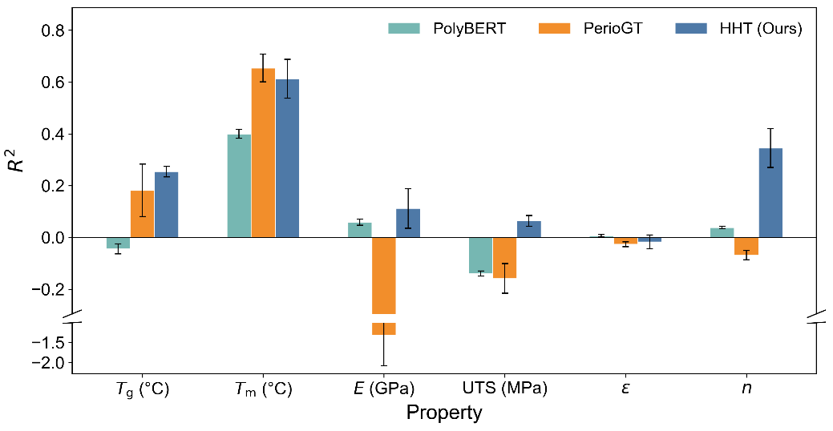
Supplementary Fig. 4. Model comparison under article-level train-test splitting. Test-set $R^{2}$ (mean ± standard deviation across three random seeds) for HHT (ChemDFM-v1.5-8B, [2,4]→[2]), PerioGT, and PolyBERT across all six properties.
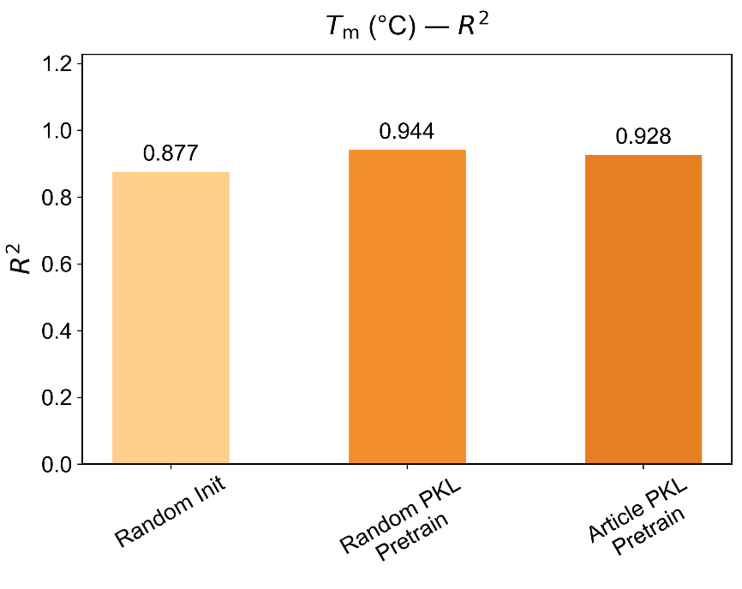
Supplementary Fig. 5. Continual-training $T_{\text{m}}$ performance under article-level splitting. Three initialization strategies (random, entry-level pretrained, article-level pretrained) were continually trained on 50 samples and evaluated on 23 held-out samples.
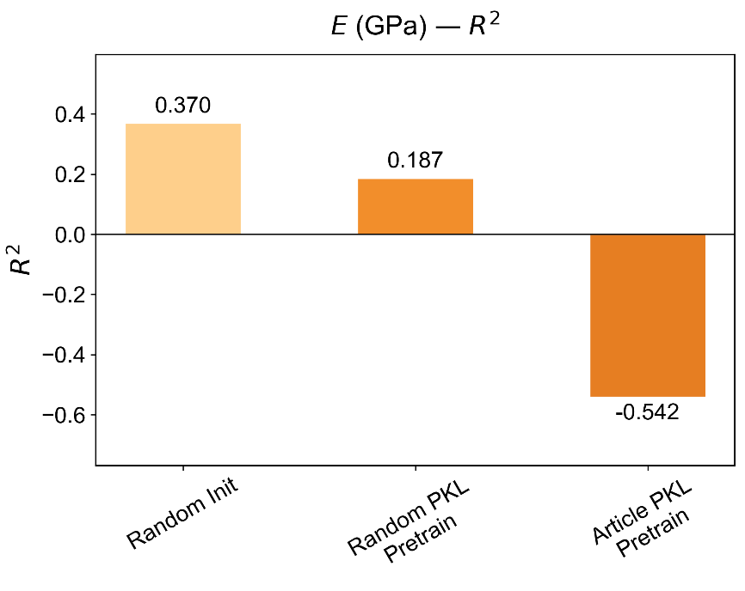
Supplementary Fig. 6. Continual-training $E$ performance under article-level splitting.

Supplementary References
1. Gu, S., Wu, Q., Ren, J. & Vancso, G. J. Mechanical Properties of a Single Electrospun Fiber and Its Structures. Macromol. Rapid Commun. 26, 716–720 (2005).
2. Alabiso, W., Hron, T. M., Reisinger, D., Bautista-Anguís, D. & Schlögl, S. Shape memory-assisted self-healing of dynamic thiol-acrylate networks. Polym. Chem. 12, 5704–5714 (2021).
3. Zhou, Y., Zhu, Z., Zhang, K. & Yang, B. Molecular Structure and Properties of Sulfur‐Containing High Refractive Index Polymer Optical Materials. Macromol. Rapid Commun. 44, 2300411 (2023).
4. Rajaei, M., Kim, N. K., Bickerton, S. & Bhattacharyya, D. A comparative study on effects of natural and synthesised nano-clays on the fire and mechanical properties of epoxy composites. Composites Part B: Engineering 165, 65–74 (2019).
5. Guzel, G. & Deveci, H. Physico‐mechanical, thermal, and coating properties of composite materials prepared with epoxy resin/steel slag. Polymer Composites 38, 1974–1981 (2017).

