SUPPLEMENTARY MATERIAL

Cognitive reserve estimated with a life experience questionnaire outperforms education in predicting performance on MoCA: Italian normative data

Sonia Montemurro¹, Roberta Daini^{2,3}, Chiara Tagliabue⁴, Sabrina Guzzetti⁵, Giulia Gualco⁶, Sara Mondini⁷, and Giorgio Arcara¹

¹IRCCS San Camillo Hospital, Venice (Italy)
² Department of Psychology, University of Milano-Bicocca, Milan, Italy
³NeuroMI - Milan Center for Neuroscience, Milan, Italy
⁴Center for Mind/Brain Sciences (CIMeC), University of Trento, Rovereto, Italy
⁵Memory Clinic, Neurology Service, Humanitas San Pio X, Milan, Italy
⁶RSA sant'Andrea, Monza, Italy
⁷Department of Philosophy, Sociology, Education and Applied Psychology, FISPPA, University of Padova, Padua (Italy)

Distribution of Age, Education, Cognitive Reserve Index and MoCA scores in the normative sample

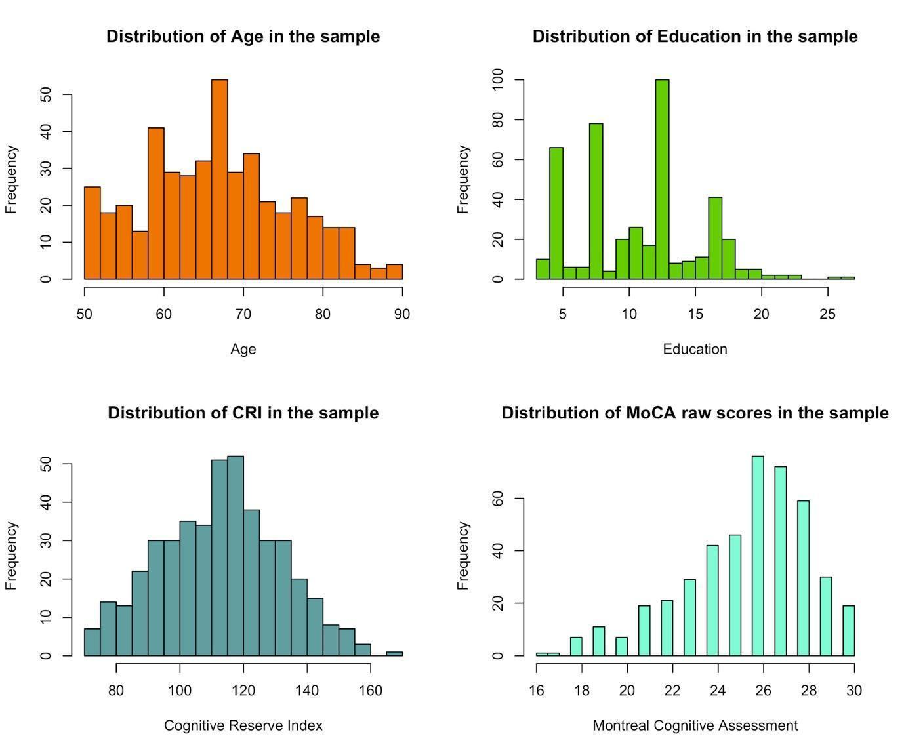
Figure S1. Distribution of variables of interest in the study. This figure shows the distribution of the continuous variables adopted in the present study: Age, Cognitive Reserve Index (CRI, derived from the Cognitive Reserve Index questionnaire, Nucci et al., 2012), Education and the Montreal Cognitive Assessment score (Nasreddine et al., 2005) referred to the Italian normative sample.

Variance Inflation Factors associated with variables of the regression models.

Variance Inflation Factors associated with linear regression models
 | Term | VIF
Model 1 | Age | 1.01
Model 1 | Sex | 1.01
Model 2 | Age | 1.05
Model 2 | Sex | 1.02
Model 2 | CRI | 1.05
Model 3 | Age | 1.04
Model 3 | Sex | 1.18
Model 3 | Education | 1.21
Model 4 | Age | 1.20
Model 4 | Sex | 1.04
Model 4 | CRI | 2.36
Model 4 | Education | 2.71
Model 5 | Age | 1.10
Model 5 | Sex | 1.03
Model 5 | CRI | 100
Model 5 | CRI^2 | 101
Model 6 | Age | 1.22
Model 6 | Sex | 1.04
Model 6 | Education | 21
Model 6 | Education^2 | 20
Model 7 | Age | 1.28
Model 7 | Sex | 1.05
Model 7 | CRI | 128
Model 7 | CRI^2 | 127
Model 7 | Education | 28
Model 7 | Education^2 | 25
Table S1. Variance Inflation Factors associated with linear regression models. The first column reports the names associated with the linear regression models. The second column reports the terms entered in each regression model. The third column reports the Variance Inflation Factor (VIF) associated with each term of the model. VIF values associated with Model 5-7 also include the values of the quadratic terms included in the model (which are naturally collinear with their squared value).

Cut-offs of MoCA accounting for Age, Sex, Cognitive Reserve Index (CRI) and Education

EDUCATION = 5 Years Old
Age | 50 | 55 | 60 | 65 | 70 | 75 | 80 | 85 | 90
 | CRI = 70
Females | 20 | 19 | 19 | 18 | 18 | 18 | 17 | 17 | 16
Males | 19 | 19 | 18 | 18 | 17 | 17 | 17 | 16 | 16
 | CRI = 90
Females | 21 | 21 | 20 | 20 | 20 | 19 | 19 | 18 | 18
Males | 21 | 20 | 20 | 19 | 19 | 19 | 18 | 18 | 17
 | CRI = 110
Females | 22 | 22 | 22 | 21 | 21 | 20 | 20 | 20 | 19
Males | 22 | 21 | 21 | 21 | 20 | 20 | 19 | 19 | 19
 | CRI = 130
Females | 23 | 23 | 22 | 22 | 21 | 21 | 21 | 20 | 20
Males | 23 | 22 | 22 | 21 | 21 | 20 | 20 | 20 | 19
 | CRI = 150
Females | 23 | 23 | 23 | 22 | 22 | 21 | 21 | 20 | 20
Males | 23 | 22 | 22 | 22 | 21 | 21 | 20 | 20 | 19
 | CRI = 170
Females | 23 | 23 | 22 | 22 | 21 | 21 | 21 | 20 | 20
Males | 23 | 22 | 22 | 21 | 21 | 20 | 20 | 20 | 19
Table S2.1 Cut-offs of the Montreal Cognitive Assessment based on Age, Sex, Cognitive Reserve Index (CRI) and Education of 5 years old (Primary School, Italian translation: “Scuole Elementari”). CRI refers to the total score obtained on the Cognitive Reserve Index questionnaire (Nucci et al., 2012).

Montemurro S., Daini R., Tagliabue C., Guzzetti S., Gualco G., Mondini S., and Arcara G. Cognitive reserve estimated with a life experience questionnaire outperforms education in predicting performance on MoCA: Italian normative data
Cut-offs of MoCA accounting for Age, Sex, Cognitive Reserve Index (CRI) and Education

EDUCATION = 8 Years Old
Age | 50 | 55 | 60 | 65 | 70 | 75 | 80 | 85 | 90
 | CRI = 70
Females | 20 | 20 | 20 | 19 | 19 | 18 | 18 | 17 | 17
Males | 20 | 19 | 19 | 19 | 18 | 18 | 17 | 17 | 16
 | CRI = 90
Females | 22 | 22 | 21 | 21 | 20 | 20 | 20 | 19 | 19
Males | 21 | 21 | 21 | 20 | 20 | 19 | 19 | 19 | 18
 | CRI = 110
Females | 23 | 23 | 22 | 22 | 22 | 21 | 21 | 20 | 20
Males | 23 | 22 | 22 | 21 | 21 | 21 | 20 | 20 | 19
 | CRI = 130
Females | 24 | 23 | 23 | 23 | 22 | 22 | 21 | 21 | 21
Males | 23 | 23 | 22 | 22 | 22 | 21 | 21 | 20 | 20
 | CRI = 150
Females | 24 | 24 | 23 | 23 | 22 | 22 | 22 | 21 | 21
Males | 24 | 23 | 23 | 22 | 22 | 21 | 21 | 21 | 20
 | CRI = 170
Females | 24 | 23 | 23 | 23 | 22 | 22 | 21 | 21 | 21
Males | 23 | 23 | 22 | 22 | 22 | 21 | 21 | 20 | 20
Table S2.2 Cut-offs of the Montreal Cognitive Assessment based on Age, Sex, Cognitive Reserve Index (CRI) and Education of 8 years old (Middle School, Italian translation: “Scuole Medie”). CRI refers to the total score obtained on the Cognitive Reserve Index questionnaire (Nucci et al., 2012).

Montemurro S., Daini R., Tagliabue C., Guzzetti S., Gualco G., Mondini S., and Arcara G. Cognitive reserve estimated with a life experience questionnaire outperforms education in predicting performance on MoCA: Italian normative data

Cut-offs of MoCA accounting for Age, Sex, Cognitive Reserve Index (CRI) and Education

EDUCATION = 13 Years Old
Age | 50 | 55 | 60 | 65 | 70 | 75 | 80 | 85 | 90
 | CRI = 70
Females | 21 | 21 | 20 | 20 | 19 | 19 | 18 | 18 | 18
Males | 20 | 20 | 20 | 19 | 19 | 18 | 18 | 17 | 17
 | CRI = 90
Females | 23 | 22 | 22 | 21 | 21 | 20 | 20 | 20 | 19
Males | 22 | 22 | 21 | 21 | 20 | 20 | 19 | 19 | 19
 | CRI = 110
Females | 24 | 23 | 23 | 22 | 22 | 22 | 21 | 21 | 20
Males | 23 | 23 | 22 | 22 | 21 | 21 | 21 | 20 | 20
 | CRI = 130
Females | 24 | 24 | 24 | 23 | 23 | 22 | 22 | 22 | 21
Males | 24 | 23 | 23 | 23 | 22 | 22 | 21 | 21 | 21
 | CRI = 150
Females | 25 | 24 | 24 | 23 | 23 | 23 | 22 | 22 | 21
Males | 24 | 24 | 23 | 23 | 22 | 22 | 22 | 21 | 21
 | CRI = 170
Females | 24 | 24 | 24 | 23 | 23 | 22 | 22 | 22 | 21
Males | 24 | 23 | 23 | 23 | 22 | 22 | 21 | 21 | 21
Table S2.3 Cut-offs of the Montreal Cognitive Assessment based on Age, Sex, Cognitive Reserve Index (CRI) and Education of 13 years old (High School, Italian translation: “Scuole Superiori”). CRI refers to the total score obtained on the Cognitive Reserve Index questionnaire (Nucci et al., 2012).

Montemurro S., Daini R., Tagliabue C., Guzzetti S., Gualco G., Mondini S., and Arcara G. Cognitive reserve estimated with a life experience questionnaire outperforms education in predicting performance on MoCA: Italian normative data.
Cut-offs of MoCA accounting for Age, Sex, Cognitive Reserve Index (CRI) and Education

EDUCATION = 16 Years Old
Age | 50 | 55 | 60 | 65 | 70 | 75 | 80 | 85 | 90
 | CRI = 70
Females | 21 | 20 | 20 | 20 | 19 | 19 | 18 | 18 | 18
Males | 20 | 20 | 19 | 19 | 19 | 18 | 18 | 17 | 17
 | CRI = 90
Females | 23 | 22 | 22 | 21 | 21 | 20 | 20 | 20 | 19
Males | 22 | 22 | 21 | 21 | 20 | 20 | 19 | 19 | 19
 | CRI = 110
Females | 24 | 23 | 23 | 22 | 22 | 22 | 21 | 21 | 20
Males | 23 | 23 | 22 | 22 | 21 | 21 | 21 | 20 | 20
 | CRI = 130
Females | 24 | 24 | 24 | 23 | 23 | 22 | 22 | 21 | 21
Males | 24 | 23 | 23 | 23 | 22 | 22 | 21 | 21 | 20
 | CRI = 150
Females | 25 | 24 | 24 | 23 | 23 | 23 | 22 | 22 | 21
Males | 24 | 24 | 23 | 23 | 22 | 22 | 22 | 21 | 21
 | CRI = 170
Females | 24 | 24 | 24 | 23 | 23 | 22 | 22 | 21 | 21
Males | 24 | 23 | 23 | 23 | 22 | 22 | 21 | 21 | 20
Table S2.4 Cut-offs of the Montreal Cognitive Assessment based on Age, Sex, Cognitive Reserve Index (CRI) and Education of 16 years old (Bachelor’s Degree, Italian translation: “Laurea Universitaria Triennale”). CRI refers to the total score obtained on the Cognitive Reserve Index questionnaire (Nucci et al., 2012).

Montemurro S., Daini R., Tagliabue C., Guzzetti S., Gualco G., Mondini S., and Arcara G. Cognitive reserve estimated with a life experience questionnaire outperforms education in predicting performance on MoCA: Italian normative data.
Cut-offs of MoCA accounting for Age, Sex, Cognitive Reserve Index (CRI) and Education

EDUCATION = 18 Years Old
Age | 50 | 55 | 60 | 65 | 70 | 75 | 80 | 85 | 90
 | CRI = 70
Females | 21 | 20 | 20 | 19 | 19 | 19 | 18 | 18 | 17
Males | 20 | 20 | 19 | 19 | 18 | 18 | 18 | 17 | 17
 | CRI = 90
Females | 22 | 22 | 22 | 21 | 21 | 20 | 20 | 19 | 19
Males | 22 | 21 | 21 | 21 | 20 | 20 | 19 | 19 | 18
 | CRI = 110
Females | 24 | 23 | 23 | 22 | 22 | 21 | 21 | 21 | 20
Males | 23 | 23 | 22 | 22 | 21 | 21 | 20 | 20 | 20
 | CRI = 130
Females | 24 | 24 | 23 | 23 | 23 | 22 | 22 | 21 | 21
Males | 24 | 23 | 23 | 22 | 22 | 22 | 21 | 21 | 20
 | CRI = 150
Females | 24 | 24 | 24 | 23 | 23 | 22 | 22 | 22 | 21
Males | 24 | 23 | 23 | 23 | 22 | 22 | 21 | 21 | 21
 | CRI = 170
Females | 24 | 24 | 23 | 23 | 23 | 22 | 22 | 21 | 21
Males | 24 | 23 | 23 | 22 | 22 | 22 | 21 | 21 | 20
Table S2.5 Cut-offs of the Montreal Cognitive Assessment based on Age, Sex, Cognitive Reserve Index (CRI) and Education of 18 years old (Master’s Degree, Italian translation: “Laurea Universitaria Magistrale”). CRI refers to the total score obtained on the Cognitive Reserve Index questionnaire (Nucci et al., 2012).

Montemurro S., Daini R., Tagliabue C., Guzzetti S., Gualco G., Mondini S., and Arcara G. Cognitive reserve estimated with a life experience questionnaire outperforms education in predicting performance on MoCA: Italian normative data.
Cut-offs of MoCA accounting for Age, Sex, Cognitive Reserve Index (CRI) and Education

EDUCATION > 18 Years Old
Age | 50 | 55 | 60 | 65 | 70 | 75 | 80 | 85 | 90
 | CRI = 70
Females | 20 | 19 | 19 | 18 | 18 | 18 | 17 | 17 | 16
Males | 19 | 19 | 18 | 18 | 17 | 17 | 17 | 16 | 16
 | CRI = 90
Females | 21 | 21 | 20 | 20 | 20 | 19 | 19 | 18 | 18
Males | 21 | 20 | 20 | 19 | 19 | 19 | 18 | 18 | 17
 | CRI = 110
Females | 22 | 22 | 22 | 21 | 21 | 20 | 20 | 20 | 19
Males | 22 | 21 | 21 | 21 | 20 | 20 | 19 | 19 | 19
 | CRI = 130
Females | 23 | 23 | 22 | 22 | 22 | 21 | 21 | 20 | 20
Males | 23 | 22 | 22 | 21 | 21 | 21 | 20 | 20 | 19
 | CRI = 150
Females | 23 | 23 | 23 | 22 | 22 | 21 | 21 | 20 | 20
Males | 23 | 22 | 22 | 22 | 21 | 21 | 20 | 20 | 19
 | CRI = 170
Females | 23 | 23 | 22 | 22 | 22 | 21 | 21 | 20 | 20
Males | 23 | 22 | 22 | 21 | 21 | 21 | 20 | 20 | 19
Table S2.6 Cut-offs of the Montreal Cognitive Assessment based on Age, Sex, Cognitive Reserve Index (CRI) and Education > 18 years old (Specialization, PhD etc., Italian translation: “Dottorato di Ricerca/Specializzazione”). CRI refers to the total score obtained on the Cognitive Reserve Index questionnaire (Nucci et al., 2012).

Montemurro S., Daini R., Tagliabue C., Guzzetti S., Gualco G., Mondini S., and Arcara G. Cognitive reserve estimated with a life experience questionnaire outperforms education in predicting performance on MoCA: Italian normative data.

Generalized Additive Models
Supplementary materials

Contour plots of the Interaction effect between Age and the Cognitive Reserve Index questionnaire in the two sexes

We performed Generalized Additive Model analyses (GAMs; Hastie & Tibshirani, 1986) to investigate the potential interaction between Age and CRI and considering Sex.
A series of diagnostic tests (i.e., through the R function ‘gam.check’, used to check whether the basis dimension choices were adequate) showed appropriate characteristics for the tensor, in the group of females (k’ = 24, p = 0.57) and in the group of males (k’ = 24, p = 0.34). Figure S.2 shows the interaction effect between Age and CRI through a contour plot, which is provided to interpret the GAM interactions among continuous variables. Figure S.2 shows, in both the females and males, that MoCA scores were lower in the participants with higher Age and this age-related effect was modulated by CRI. Similarly, MoCA scores were higher in the participants with lower Age and this age-related effect was modulated by CRI. Higher MoCA scores were observed in the more advantageous condition (i.e., lower Age and higher CRI), while lower MoCA scores were observed in the less advantageous condition (i.e., higher Age and lower CRI). However, the comparison between these two surfaces did not yield any significant effect (see the Figure S.2 for a more detailed explanation).

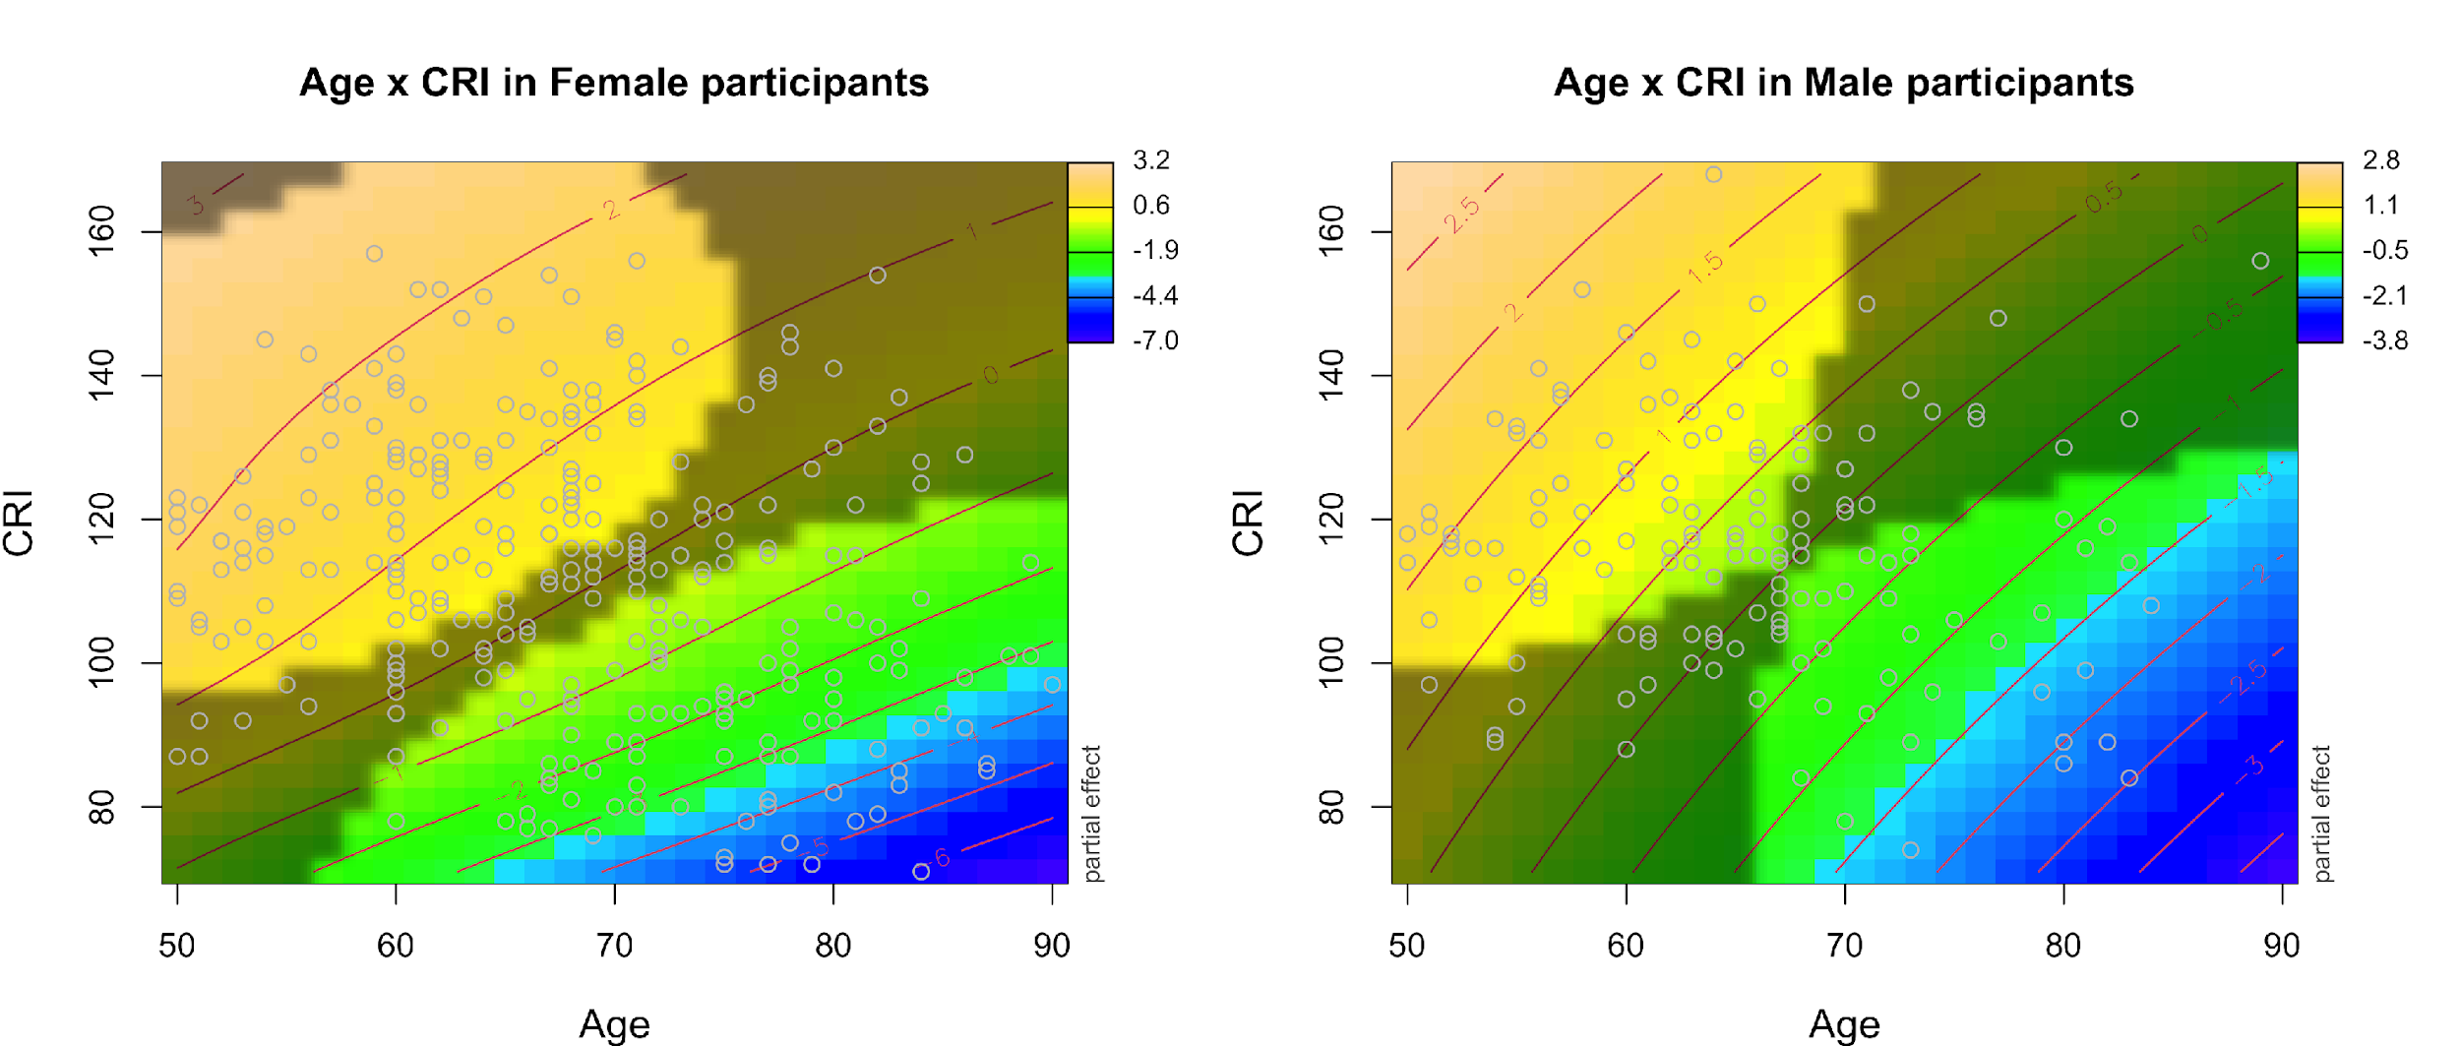
Figure S2. Interaction effect of Age and CRI on the MoCA score in Females and in Males participants. The figure reports the partial effects of the tensor surfaces associated with the interactions between Age and CRI (for Female participants in the left panel, for Male participant in the right panel). Age is on the x-axis in year units, while CRI is on the y-axis. Darker shades of blue in the contour plots show lower predicted scores on MoCA, while darker shades of yellow show higher scores on MoCA. Within each contour plot, grayed out areas show where the confidence interval at 95% included the value zero. The figure shows that persons with higher Age and lower CRI performed significantly worse on MoCA compared to persons with lower Age and higher CRI. Although some qualitative differences between the surfaces can be appreciated, the comparison between these two surfaces did not yield any significant effect (i.e., the confidence interval of the surface obtained by the difference between the two surfaces always included zero).

