Supplementary Information

Table S1. New Zealand Climate-related Disclosure Regulation Timeline
Timeline | Milestones
15 December 2022 | The XRB issued Aotearoa New Zealand Climate Standards
1 January 2023 | The Climate Standard come into effective
1 June 2023 | The IFRS S1 and IFRS S2 officially issued
30 November 2023 | The XRB conducted international alignment of climate reporting –and find that there is a high degree compatibility between NZ CS and the TCFD recommendations and the ISSB standards
1 January 2024 | CREs are required to prepare climate statements and lodge them on this register
27 October 2024 | Mandatory assurance of Greenhouse Gas (GHG) emissions begins for reporting periods ending on or after this date
November 2025 | Amendments made to extend adoption provisions (NZ CS 2), this applied for accounting reports ending before 31 December 2027  - Anticipated financial impacts  - Scope 3 GHG emissions  - Scope 3 GHG assurance
March 2026 | The Government announced major changes to New Zealand's climate-related disclosures regime. The proposed changes include:  - raising the threshold for listed issuers from $60 million to $1 billion;  - removing managers of registered managed investment schemes from the regime entirely; and  - relieving directors of automatic personal liability for non-compliant disclosures.  - There are no changes proposed to the reporting thresholds for registered banks and licensed insurers
June 2026 | The Government announced to remove health and life insurers from mandatory climate reporting regime, citing that health and life insurers are not directly exposed to climate risks like extreme weather events and there are little value in making them report on it.

Table S2. The scenario analysis disclosure requirements from New Zealand Climate Standards (XRB, 2022)
Scenario analysis undertaken
“An entity must describe the scenario analysis it has undertaken to help identify its climate-related risks and opportunities and better understand the resilience of its business model and strategy. This must include a description of how an entity has analysed, at a minimum, a 1.5 degrees Celsius climate-related scenario, a 3 degrees Celsius or greater climate related scenario and a third climate related scenario.”
Page 8, section 13, Aotearoa New Zealand Climate Standard 1

Scenario analysis methods and assumptions
“An entity must disclose the methods and assumptions underlying the climate-related scenarios used, and the scenario analysis process employed. The following information must be included when describing the methods and assumptions underlying the climate-related scenarios used, and the scenario analysis process employed:
a) the climate-related scenarios it has used, including:
(i) a brief description of each scenario narrative;
(ii) the time horizons considered, including endpoints and whether the endpoints are determined by a year or a temperature target;
(iii) a description of the various emissions reduction pathways in each scenario and the assumptions underlying pathway development over time, including the scope of operations covered, policy and socioeconomic assumptions, macroeconomic trends, energy pathways, carbon sequestration from afforestation and nature-based solutions and technology assumptions including negative emissions technology; s(iv) an explanation of why the entity believes the chosen scenarios are relevant and appropriate to assessing the resilience of the entity’s business model and strategy to climate-related risks and opportunities; and s(v) the sources of data used to construct each scenario; sb) how the scenario analysis process has been conducted, including: s(i) whether scenario analysis is a standalone analysis or integrated within the entity’s strategy processes;s (ii) the governance process used to oversee and manage the scenario analysis process, including the role of the governance body and management; s(iii) if modelling has been undertaken, a clear description of what modelling was undertaken and why the model was chosen as the appropriate model; and s(iv) which external partners and stakeholders are involved”.sPage 13, section 51, Aotearoa New Zealand Climate Standard 3

Table S3. Comparing NLP metrics by industries and reporting periods
 | Number of statements |  |  | Number of pages |  |  |  | Number of words |  |  |  | Compound score |  |  |  | Degree of quantification
 | FY23/24 | FY24/25 |  | FY23/24 | FY24/25 | P value |  | FY23/24 | FY24/25 | P value |  | FY23/24 | FY24/25 | P value |  | FY23/24 | FY24/25 | P value
FINANCE | 35 | 38 |  | 38.0 | 50.6 | 0.06 |  | 14,276 | 21,205 | 0.01 |  | -0.21 | -0.41 | 0.36 |  | 1.96% | 2.17% | 0.36
Finance - Banks | 13 | 13 |  | 40.5 | 54.5 | 0.02 |  | 16,677 | 25,487 | 0.01 |  | -0.45 | -0.53 | 0.80 |  | 2.07% | 2.06% | 0.97
Finance - Insurance | 13 | 16 |  | 22.3 | 44.1 | 0.00 |  | 9,087 | 18,146 | 0.01 |  | -0.69 | -0.50 | 0.54 |  | 1.55% | 2.19% | 0.13
Finance - Other | 9 | 9 |  | 56.9 | 56.4 | 0.98 |  | 18,305 | 20,459 | 0.77 |  | 0.84 | -0.06 | 0.02 |  | 2.39% | 2.32% | 0.91
NON-FINANCE | 76 | 78 |  | 41.8 | 54.4 | 0.06 |  | 16,311 | 22,117 | 0.02 |  | 0.11 | 0.39 | 0.07 |  | 2.11% | 2.15% | 0.74
Agriculture | 10 | 12 |  | 28.0 | 53.7 | 0.12 |  | 11,390 | 21,856 | 0.11 |  | 0.11 | 0.67 | 0.16 |  | 1.84% | 2.17% | 0.26
Airport | 4 | 4 |  | 27.3 | 36.5 | 0.42 |  | 15,606 | 19,701 | 0.47 |  | -0.51 | 0.30 | 0.28 |  | 1.88% | 1.83% | 0.65
Constructions | 5 | 5 |  | 25.6 | 41.8 | 0.23 |  | 9,967 | 16,114 | 0.23 |  | -0.21 | -0.60 | 0.55 |  | 1.75% | 1.98% | 0.43
Energy | 7 | 6 |  | 44.9 | 56.7 | 0.31 |  | 20,688 | 26,171 | 0.27 |  | 0.67 | 1.00 | 0.30 |  | 1.97% | 1.93% | 0.90
Healthcare | 4 | 4 |  | 55.3 | 64.0 | 0.88 |  | 19,171 | 23,611 | 0.83 |  | 0.01 | 0.00 | 0.99 |  | 2.30% | 2.11% | 0.83
Infrastructure | 8 | 8 |  | 70.4 | 92.8 | 0.54 |  | 24,839 | 37,513 | 0.28 |  | 0.43 | 0.50 | 0.88 |  | 2.30% | 2.41% | 0.83
Other industries | 18 | 19 |  | 25.7 | 47.7 | 0.01 |  | 12,243 | 19,367 | 0.07 |  | -0.13 | 0.32 | 0.15 |  | 2.23% | 2.30% | 0.84
Pharmaceuticals | 2 | 2 |  | 72.0 | 76.5 | 0.96 |  | 23,459 | 25,827 | 0.93 |  | 0.43 | 1.00 | 0.42 |  | 2.64% | 2.64% | 1.00
Real Estates | 7 | 7 |  | 35.6 | 49.6 | 0.11 |  | 12,753 | 20,019 | 0.09 |  | -0.14 | 0.14 | 0.63 |  | 1.76% | 1.79% | 0.88
Retirement Village | 6 | 6 |  | 49.7 | 42.5 | 0.71 |  | 15,056 | 15,207 | 0.98 |  | 0.66 | 0.67 | 0.99 |  | 2.19% | 1.88% | 0.51
Telecom | 5 | 5 |  | 82.0 | 48.2 | 0.38 |  | 29,279 | 20,187 | 0.51 |  | 0.19 | 0.20 | 0.99 |  | 2.63% | 2.48% | 0.87
ALL INDUSTRIES | 111 | 116 |  | 40.6 | 53.1 | 0.01 |  | 15,670 | 21,819 | 0.00 |  | 0.01 | 0.13 | 0.37 |  | 2.06% | 2.16% | 0.41

Table S4. List of tools provided to the Langgraph agent (Langchain framework) to create a fully autonomous agentic RAG.
Scope | Tool name(parameters) | Description
Retrieval Augmented Generation | search_knowledge_base(query, k) | The agent can run a natural language query against the vector store where the document(s) have been embedded into. The agent decides also how many k text chunks are returned. Each chunk would be link to a page number and a source document.
 | get_page(source, page) | The agent can decide to look at a whole page after retrieving text chunks with the search_knowledge_base tool. It can eventually provide more context around a specific chunk.
Analysis Action | commit_answer(q_id, question, answer, evidence, location_hint, confidence, notes) | The agent is asked to commit each answer when it judges it has enough to answer the question and is ready to provide evidence to support that answer.

Table S5. Example of raw outputs from the agentic RAG
{
"source": "ASB_BANK_LIMITED_2024",
"model_id": "claude-sonnet-4-6",
"token_usage": {
"claude-sonnet-4-6": {
"input_tokens": 1230390,
"output_tokens": 7587,
"total_tokens": 1237977,
"input_token_details": {
"cache_creation": 0,
"cache_read": 1162215,
"ephemeral_5m_input_tokens": 68150,
"ephemeral_1h_input_tokens": 0
}
}
},
"answers": [
{
"q_id": 9,
"question": "List of scenarios",
"answer": [
"Scenario 1 ('1.5°C')",
"Scenario 2 ('2°C')",
"Scenario 3 ('3°C')",
"RBNZ Climate Stress Test 'Too Little, Too Late'"
],
"evidence": "Scenario 1 (\"1.5°C\") ... Scenario 2 (\"2°C\") ... Scenario 3 (\"3°C\") ... External global pathways: IPCC SSP1-1.9 / NGFS Net Zero / IEA Net Zero 2050 / NIWA RCP2.6 / CCC 'Tailwinds' | IPCC SSP2-4.5 / NGFS Nationally Determined Contributions (NDC's) / IEA Announced Pledges / NIWA RCP4.5 / CCC 'Headwinds' | IPCC SSP5-8.5 / NGFS Current Policies / IEA Stated Policies / NIWA RCP8.5 / CCC 'Current Policy reference'. Also: \"In FY24 ASB completed the 2023 RBNZ Climate Stress Test. The scenario was titled 'Too Little, Too Late' and presented severe but plausible climate-related challenges spread over a 28-year period.\"",
"location_hint": "Strategy section, p.44-45 (scenario table); Risk Management section, p.58-59 (RBNZ stress test)",
"confidence": "high",
"notes": "The three main scenarios are ASB's own narratives built on NZBA sector scenarios. The RBNZ stress test is a separate but related scenario used in risk management.",
"verification": null
},
{
"q_id": 10,
"question": "Global temperature outcome by 2100",
"answer": "Three temperature outcomes are described: 1.5°C, >2°C (with a specific mention of 2.7°C above pre-industrial levels by 2100 under Scenario 2), and >3°C. No explicit temperature overshoot language is used, but the 2°C scenario narrative notes temperatures exceeding 2.7° vs pre-industrial level by 2100.",
"evidence": "\"The narratives used below describe the pathways to certain global temperature outcomes (1.5°C, >2°C, >3°C), and the events predicted to occur along the way.\" And under Scenario 2: \"Although national policy targets are met in the long term, global temperatures exceed 2.7° vs pre-industrial level by 2100, causing food security issues and therefore driving demand for low-cost alternatives.\"",
"location_hint": "Strategy section, p.43 (narrative description) and p.44-45 (Scenario 2 narrative)",
"confidence": "high",
"notes": "The 2.7°C figure is specifically mentioned for Scenario 2 (\"2°C\" scenario), indicating a temperature overshoot relative to the scenario label.",
"verification": null
},
{
"q_id": 11,
"question": "Scenario provider",
"answer": "Multiple scenario providers are explicitly named: NZBA (New Zealand Banking Association) as the primary base for ASB's scenarios, with external global pathways from IPCC, NGFS (Network for Greening the Financial System), IEA (International Energy Agency), NIWA (National Institute of Water and Atmospheric Research), and CCC (Climate Change Commission). RBNZ (Reserve Bank of New Zealand) provided the stress test scenario.",
"evidence": "\"The NZBA scenarios were chosen as the baseline because they represent the most relevant downscaling, a process of applying global and national pathways to the New Zealand banking sector in which ASB Banking Group operates in.\" External global pathways listed: \"IPCC SSP1-1.9 / NGFS Net Zero / IEA Net Zero 2050 / NIWA RCP2.6 / CCC 'Tailwinds'\" (Scenario 1); \"IPCC SSP2-4.5 / NGFS Nationally Determined Contributions (NDC's) / IEA Announced Pledges / NIWA RCP4.5 / CCC 'Headwinds'\" (Scenario 2); \"IPCC SSP5-8.5 / NGFS Current Policies / IEA Stated Policies / NIWA RCP8.5 / CCC 'Current Policy reference'\" (Scenario 3).",
"location_hint": "Strategy section, p.43-45",
"confidence": "high",
"notes": "NZBA is the primary scenario provider for ASB's narratives; IPCC, NGFS, IEA, NIWA, and CCC provide the underlying external global pathways.",
"verification": null
},
{
"q_id": 12,
"question": "Pick-and-mix of SSPs and RCPs",
"answer": "Yes",
"evidence": "\"External global pathways: IPCC SSP1-1.9 / NGFS Net Zero / IEA Net Zero 2050 / NIWA RCP2.6 / CCC 'Tailwinds' | IPCC SSP2-4.5 / NGFS Nationally Determined Contributions (NDC's) / IEA Announced Pledges / NIWA RCP4.5 / CCC 'Headwinds' | IPCC SSP5-8.5 / NGFS Current Policies / IEA Stated Policies / NIWA RCP8.5 / CCC 'Current Policy reference'\"",
"location_hint": "Strategy section, p.44-45 (scenario table)",
"confidence": "high",
"notes": "The document explicitly lists both SSP identifiers (SSP1-1.9, SSP2-4.5, SSP5-8.5) and RCP identifiers (RCP2.6, RCP4.5, RCP8.5) within the same scenario framework. SSPs are from IPCC AR6 and RCPs are from NIWA, which are from different scenario families/generations.",
"verification": null
},
{
"q_id": 13,
"question": "Customised scenarios",
"answer": "Yes",
"evidence": "\"The NZBA scenarios were chosen as the baseline because they represent the most relevant downscaling, a process of applying global and national pathways to the New Zealand banking sector in which ASB Banking Group operates in. Through our downscaling process, ASB Banking Group has assessed that the narratives used are relevant to our business model and strategy, challenge our thinking and are plausible to the decision makers in our business.\" Also: \"Using the New Zealand Banking Association (NZBA) sector-level scenarios, we tailored scenarios to focus on climate drivers of material relevance to the Bank.\"",
"location_hint": "Strategy section, p.43 and p.21",
"confidence": "high",
"notes": "The document explicitly uses the words \"tailored\" and \"downscaling\" to describe the adaptation of NZBA sector scenarios to ASB's specific context. ASB also preferred domestic pathway parameters over global ones where relevant.",
"verification": null
},
{
"q_id": 14,
"question": "Co-produced climate scenarios",
"answer": "No",
"evidence": "\"During 2024, integrated within ASB's annual strategy refresh process, we engaged in a process of scenario analysis. Our scenario analysis working group brought together teams from across the business to build and analyse the climate scenarios to derive ASB specific impacts, risks, and opportunities.\" The process involved internal cross-functional teams and governance approval, not external participatory or co-design processes.",
"location_hint": "Strategy section, p.43",
"confidence": "medium",
"notes": "The scenario development was internal (cross-functional team), building on NZBA sector scenarios. While ASB participates in NZBA working groups, there is no explicit language of \"participatory\", \"co-creat\", \"deliberat\", \"co-design\", or \"stakeholder input\" in the scenario development process itself.",
"verification": null
},
{
"q_id": 15,
"question": "Baseline scenarios",
"answer": "Yes. The RBNZ Climate Stress Test scenario ('Too Little, Too Late') is used as a reference/comparison point for ASB's 2°C scenario. Additionally, the CCC Demonstration Path is used as a reference scenario for the Dairy sector Financed Emissions intensity reduction target.",
"evidence": "\"The Reserve Bank of New Zealand (RBNZ) Stress Test scenario is similar to ASB's 2°C scenario narrative. As such it was also a source of information when deriving narratives and impacts.\" And: \"The Climate Change Commission (CCC) Demonstration Path has been used as a reference scenario for our Dairy sector Financed Emissions intensity reduction target.\"",
"location_hint": "Strategy section, p.43 (RBNZ reference); p.15 (CCC Demonstration Path)",
"confidence": "medium",
"notes": "The RBNZ stress test is described as \"similar to\" the 2°C scenario and used as a source, rather than a formal baseline for comparison. The CCC Demonstration Path is explicitly called a \"reference scenario\" for the Dairy target. Neither is described as a \"no climate change\" or \"business as usual\" baseline in the traditional sense.",
"verification": null
},
{
"q_id": 16,
"question": "Model used",
"answer": [
"RMS New Zealand Inland Flood HD Model (Moody's RMS)"
],
"evidence": "\"In FY24 we estimated the present inland flooding risk for the majority of ASB's home lending portfolio, using property-level estimated flood depth and expected building damage, sourced from Moody's RMS, for Average Recurrence Intervals (ARI) 1-in-100, 1-in-200, and 1-in-500, under today's climate conditions.\" And: \"The RMS New Zealand Inland Flood HD Model captures sources of flood risk including pluvial and fluvial flooding, as well as flooding caused or exacerbated by snowmelt. The model simulates over 350,000 inland flood events based on 50,000-year time series of simulated precipitation.\"",
"location_hint": "Strategy section, p.50-51; Other Information, p.90",
"confidence": "high",
"notes": "The only explicitly named model is the RMS New Zealand Inland Flood HD Model (Moody's RMS). No IAMs or macroeconomic models are named. The NZBA sector scenarios and RBNZ stress test are referenced but their underlying models are not named in this document.",
"verification": null
},
{
"q_id": 17,
"question": "Damage from acute physical risk considered",
"answer": "Yes",
"evidence": "\"In FY24 we estimated the present inland flooding risk for the majority of ASB's home lending portfolio, using property-level estimated flood depth and expected building damage, sourced from Moody's RMS, for Average Recurrence Intervals (ARI) 1-in-100, 1-in-200, and 1-in-500, under today's climate conditions.\" And: \"analysis indicates 0.4% (1-in-100) to 5% (1-in-500) of residential properties in our home lending portfolio could be vulnerable to expected damage greater than or equal to 0.5% of building replacement value.\" Also: \"The Damage Ratio (DR) is defined as the ratio of the expected loss from flood damage (before any insurance terms are applied) to the replacement cost of an asset, such as a building and its contents.\"",
"location_hint": "Strategy section, p.50-51; Other Information, p.90",
"confidence": "high",
"notes": "The document explicitly quantifies damage from acute physical risk (inland flooding) using damage ratios and Average Recurrence Intervals. Tropical cyclones and storms are also mentioned qualitatively in scenario narratives.",
"verification": null
},
{
"q_id": 18,
"question": "Non-temperature variables in scenarios",
"answer": [
"sea level rise",
"flooding (inland/fluvial/pluvial)",
"coastal inundation",
"drought",
"heat stress",
"storm frequency and severity",
"precipitation",
"emissions pricing",
"agricultural yield",
"insurance coverage and affordability",
"land use change",
"technology advances",
"policy changes",
"economic trends",
"societal changes"
],
"evidence": "\"Such as economic trends, policy changes, technology advances, environmental shifts, and societal changes under each scenario.\" Physical risks include: \"flooding, coastal inundation and tropical cyclones\"; \"Heat stress and drought: As atmospheric temperatures increase, drought conditions and high temperature events are likely to become more severe and frequent\"; \"Sea level rise: Our Home Lending, Rural and Commercial Property lending portfolios are vulnerable to the impacts of sea level rise\"; \"Further temperature increases in the medium term result in moderate yield losses, compounded by high emissions pricing and high operating costs.\"",
"location_hint": "Strategy section, p.21, p.23, p.44-45",
"confidence": "high",
"notes": "The document describes a wide range of physical and transition variables used to drive the scenarios beyond temperature alone.",
"verification": null
},
{
"q_id": 19,
"question": "Scale of scenarios",
"answer": "both",
"evidence": "\"The NZBA scenarios were chosen as the baseline because they represent the most relevant downscaling, a process of applying global and national pathways to the New Zealand banking sector in which ASB Banking Group operates in. Through our downscaling process, ASB Banking Group has assessed that the narratives used are relevant to our business model and strategy.\" Also: \"The sector scenarios map out different global and domestic climate, socio-economic, policy and technology pathways within the scenarios. The major limitation of this is that there can be differences between the global and domestic pathways for a common temperature outcome, due to calculation and modelling approaches as well as the way New Zealand may react. As such, ASB has preferred the domestic pathway parameters where relevant.\"",
"location_hint": "Strategy section, p.43; Scenario analysis assumptions, p.91",
"confidence": "high",
"notes": "The scenarios incorporate both global pathways (IPCC SSPs, NGFS, IEA) and domestically downscaled pathways (NIWA RCPs, CCC, NZBA sector scenarios). ASB explicitly preferred domestic pathway parameters where relevant.",
"verification": null
},
{
"q_id": 20,
"question": "Time frames",
"answer": "Three time horizons are used: Short-term (<6 years, to ~2030), Medium-term (30 years, to ~2050), Long-term (50+ years, to ~2080+). Rationale is provided: the three periods are chosen because there is \"meaningful differentiation in outcomes\" across them and they \"broadly build on the timeframes considered in our strategy process.\" The strategic planning horizons (Short/Medium 0-5 years; Long 10+ years) differ from the climate scenario horizons, and capital plans are agreed for a 3-year horizon.",
"evidence": "\"Short term: 6 years / 2030; Medium term: 30 years / 2050; Long term: 50+ years / 2080+.\" And: \"ASB has chosen to consider short-, medium- and long-term horizons in analysis as there is meaningful differentiation in outcomes in these three periods and they broadly build on the timeframes considered in our strategy process.\" Also: \"ASB's strategic planning horizons (Short/Medium (0-5 years) and Long (10+ years)) are different than those used for climate scenario analysis (Short (<6 years), Medium (30 years), Long (50+ years)). Capital plans are agreed for a 3 year horizon.\"",
"location_hint": "Strategy section, p.21 (time horizon table); p.43 (rationale); p.46-47 (planning horizons)",
"confidence": "high",
"notes": "Rationale is explicitly provided for the choice of three time horizons. The document also notes that different risk processes use different time horizons (e.g., RCSA uses 12 months, RBNZ stress test uses 28 years).",
"verification": null
},
{
"q_id": 21,
"question": "Justification for scenario/model choice",
"answer": "Yes",
"evidence": "\"The NZBA scenarios were chosen as the baseline because they represent the most relevant downscaling, a process of applying global and national pathways to the New Zealand banking sector in which ASB Banking Group operates in. Through our downscaling process, ASB Banking Group has assessed that the narratives used are relevant to our business model and strategy, challenge our thinking and are plausible to the decision makers in our business.\"",
"location_hint": "Strategy section, p.43",
"confidence": "high",
"notes": "The justification explicitly states three criteria for choosing the NZBA scenarios: (1) most relevant downscaling to the NZ banking sector, (2) relevance to ASB's business model and strategy, (3) ability to challenge thinking and plausibility for decision makers.",
"verification": null
}
]
}

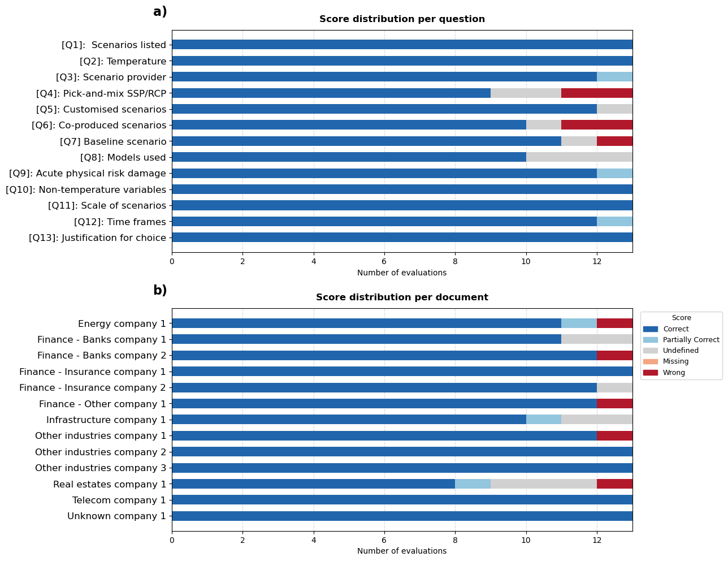

Figure S1. Validation of agentic RAG output. A simple approach of comparing each system-generated response against a gold-standard dataset, our human answers for 13 documents. Five labels were created to qualify the quality of the agentic RAG answers (5: Correct, 4: Partially correct, 3: Undefined, 2: Missing, and 1: Wrong). Panel (a) illustrates the breakdown of validation scores by questions, panel (b) illustrates the breakdown of validation scores by documents.

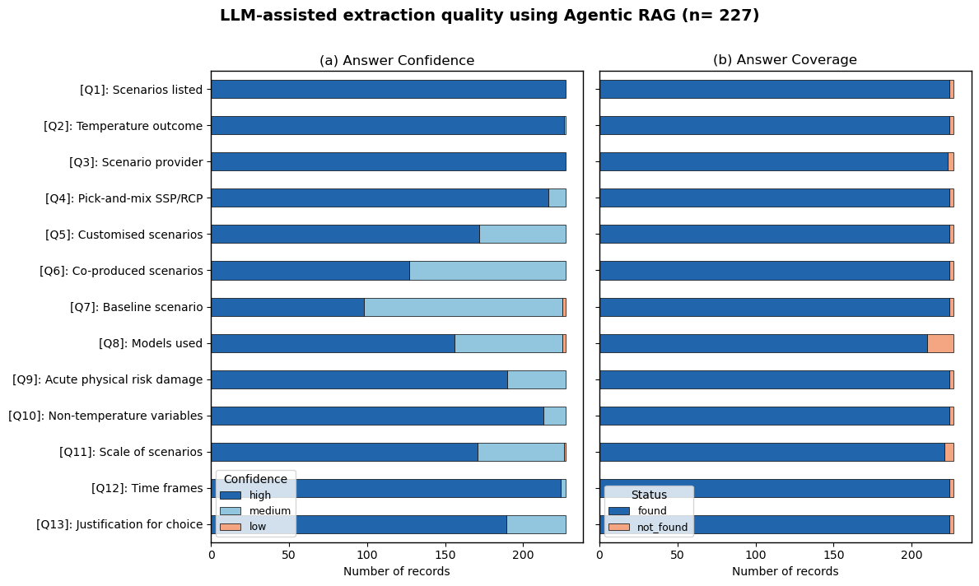

Figure S2. Agentic RAG extraction quality. Panel (a) illustrates the fraction of answers with “high”, “medium”, and “low” confidence score out of 227 climate statements. Panel (b) illustrates the fraction of answers that are “not found”, signifying that the agentic RAG cannot find a direct quote support an answer following the LLM prompt (Table 2

https://www.xrb.govt.nz/dmsdocument/5757/

