Supplementary Figures

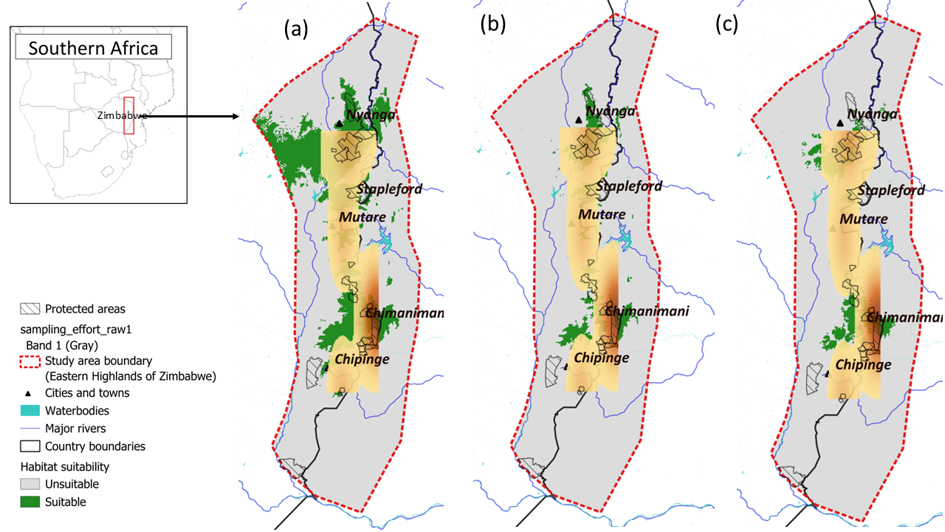
Supplementary Figure S1. Spatial distribution of sampling effort overlaid with species-specific habitat suitability across the Eastern Highlands of Zimbabwe for (a) Chlorolestes elegans, (b) Pseudagrion vumbaense, and (c) Platycypha inyangae. Sampling effort is represented by a kernel density surface derived from historical Odonata records, while coloured areas indicate predicted suitable habitat.

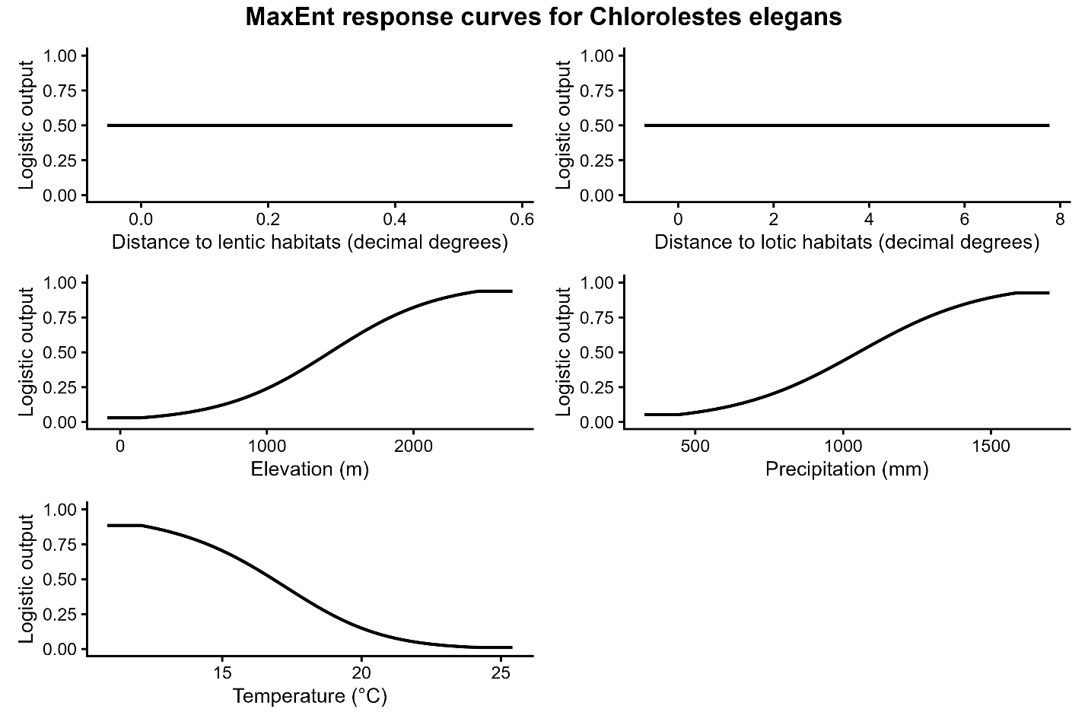
Supplementary Figure S2. MaxEnt response curves for Chlorolestes elegans.

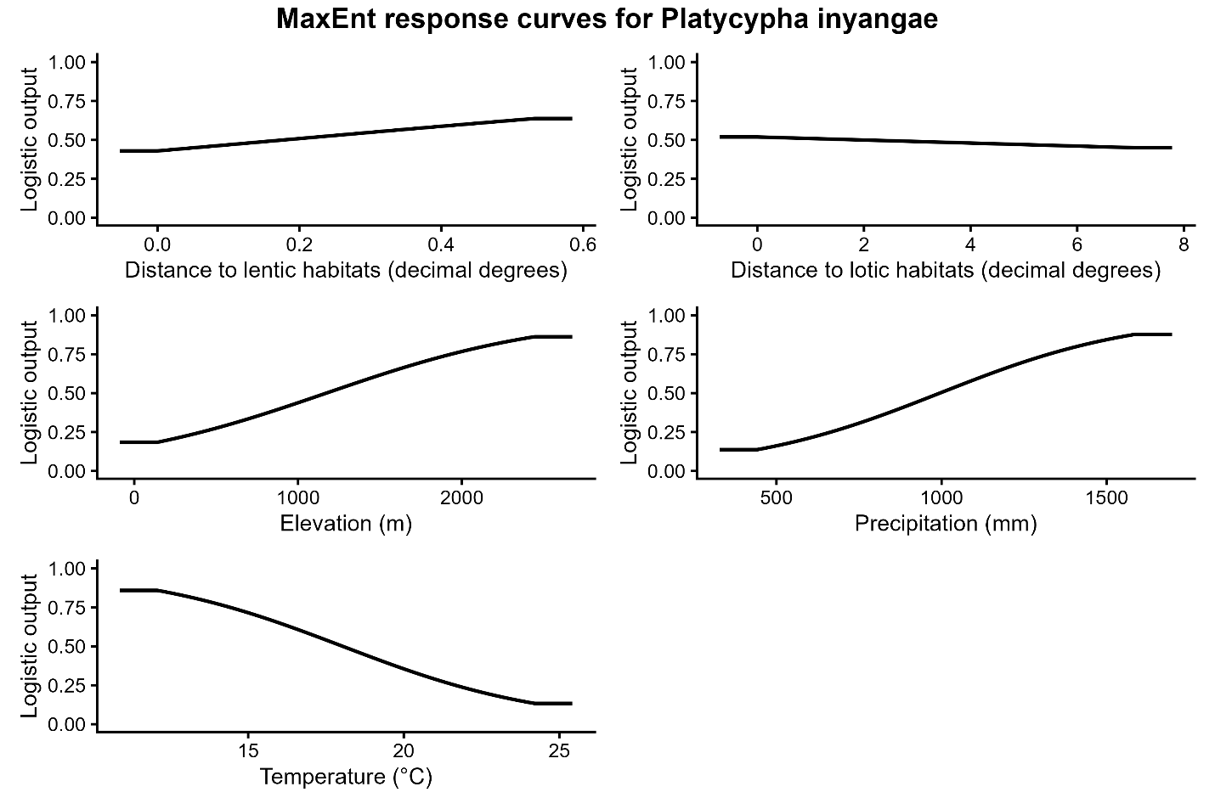
Supplementary Figure S3. MaxEnt response curves for Platycypha inyangae.

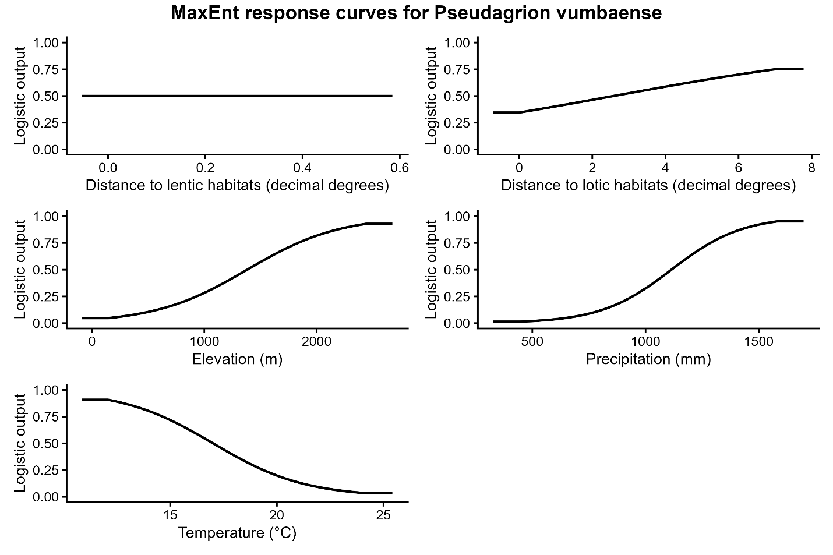
Supplementary Figure S4. MaxEnt response curves for Pseudagrion vumbaense
Supplementary table S1. Interpretation thresholds for these metrics
Metric | Range | Interpretation
AUC | ≥ 0.90 | High discrimination
 | 0.70–0.89 | Moderate to good discrimination
 | ≈ 0.50 | No better than random
Sensitivity | ≥ 0.80 | Strong detection of presences
 | 0.60–0.79 | Moderate detection
 | ≈ 0.50 | Poor detection
Specificity | ≥ 0.80 | Strong identification and rejection of unsuitable areas
 | 0.60–0.79 | Moderate rejection
 | ≈ 0.50 | Weak discrimination
Omission rate | < 0.20 | Low omission (good)
 | 0.20–0.40 | Moderate omission
 | > 0.40 | High omission
Proportion correctly classified | ≥ 0.80 | High overall accuracy
 | 0.65–0.79 | Moderate accuracy
 | ≈ 0.50 | Random expectation
Cohen’s Kappa | < 0.20 | Slight agreement
 | 0.21–0.40 | Fair agreement
 | 0.41–0.60 | Moderate agreement
 | 0.61–0.80 | Substantial agreement
 | > 0.80 | Near-perfect agreement
Calibration | ≥ 0.80 | Well calibrated
 | 0.50–0.79 | Moderate calibration
 | < 0.50 | Poor calibration
Threshold | ≥ threshold value | Suitable
 | < threshold value | Unsuitable
kept.model | 1 | Retained in ensemble
 | 0 | Excluded from ensemble

Supplementary Table S2.
ensemble name | species name | threshold | AUC | omission.rate | sensitivity | specificity | prop.correct | Kappa | calibration | kept.model
GLM.SDM.ensemble | Chlorolestes elegans | 0.048895 | 0.888325 | 0.149253731 | 1 | 0.847715736 | 0.850746 | 0.181374 | 0.892148 | 1
RF.SDM.ensemble | Chlorolestes elegans | 0.529093 | 0.833333 | 0.285714286 | 0.75 | 0.666666667 | 0.714286 | 0.416667 | 0.761209 | 1
MAXENT.SDM.ensemble | Chlorolestes elegans | 0.525834 | 0.921501 | 0.497137788 | 0.918241 | 0.502611871 | 0.502862 | 0.002821 | 0.342938 | 1
GLM.SDM.ensemble | Platycypha inyangae | 0.024924 | 0.778912 | 0.331658291 | 0.666667 | 0.668367347 | 0.668342 | 0.029125 | 0.924532 | 1
RF.SDM.ensemble | Platycypha inyangae | 0.838873 | 1 | 0 | 1 | 1 | 1 | 1 | 0.48022 | 1
MAXENT.SDM.ensemble | Platycypha inyangae | 0.853662 | 0.949816 | 0.49766625 | 0.946653 | 0.502129183 | 0.502334 | 0.001967 | 0.247771 | 1
GLM.SDM.ensemble | Pseudagrion vumbaense | 0.029766 | 0.952736 | 0.093596059 | 1 | 0.905472637 | 0.906404 | 0.158779 | 0.897969 | 1
RF.SDM.ensemble | Pseudagrion vumbaense | 0.6495 | 1 | 0 | 1 | 1 | 1 | 1 | 0.620707 | 1
MAXENT.SDM.ensemble | Pseudagrion vumbaense | 0.918017 | 0.981346 | 0.498141353 | 0.978607 | 0.501713452 | 0.501859 | 0.00205 | 0.393094 | 1

