Supplementary Materials
Section S1: Cancer type-specific mutation prediction reveals widespread genotype–phenotype encoding across solid tumors
We evaluated GenoGlyph in a cancer-specific setting, training independent models for each mutation within each tumor type using five-fold patient-level cross-validation. Across 14 cancer types and 34 mutation prediction tasks, GenoGlyph demonstrated consistent performance, supporting the hypothesis that mutation-associated morphological signals are detectable within individual tumor contexts (Table S5).
Overall, predictive performance varied across cancer types and genes. In PAAD, GenoGlyph achieved an AUC of 0.71 ± 0.07 for KRAS and 0.66 ± 0.11 for TP53. In CRC, the model achieved an AUC of 0.75 ± 0.06 for TP53, 0.71 ± 0.02 for APC, 0.63 ± 0.08 for KRAS, 0.63 ± 0.05 for PIK3CA, 0.63 ± 0.05 for TTN, 0.84 ± 0.07 for BRAF and 0.63 ± 0.05 for COX2. In BRCA, GenoGlyph achieved an AUC of 0.84 ± 0.04 for TP53 and 0.65 ± 0.03 for PIK3CA.
Across additional tumor types, GenoGlyph achieved an AUC of 0.70 ± 0.04 for TP53 in LUAD. In kidney cancers (KICH + KIRC + KIRP), PBRM1 mutation prediction achieved an AUC of 0.78 ± 0.08. In LIHC, CTNNB1 achieved an AUC of 0.78 ± 0.06 and TP53 achieved an AUC of 0.69 ± 0.06.
In squamous malignancies, HNSC achieved an AUC of 0.72 ± 0.10 for TP53 prediction, while LUSC achieved an AUC of 0.61 ± 0.02. In STAD, ARID1A achieved an AUC of 0.73 ± 0.05, TP53 achieved an AUC of 0.68 ± 0.06, and TTN achieved an AUC of 0.61 ± 0.07.
Section S2: Prognostic Survival Analysis
Survival analyses were performed to evaluate whether GenoGlyph's predicted mutation probability scores carry independent prognostic information, separate from the mutation classification task itself. For each of the six pan-cancer gene models (APC, BRAF, KRAS, KMT2D, PIK3CA, TP53, TTN), we assessed prognostic utility across four independent, multi-institutional external cohorts including, invasive lung adenocarcinoma (LUAD; n = 189), colorectal adenocarcinoma (CRC; n = 422), pancreatic ductal adenocarcinoma (PDAC; n = 275), and metastatic hormone receptor-positive, HER2-negative breast carcinoma (BRCA; n = 94), comprising 982 patients in total.
Survival Endpoints
Survival endpoints varied by cohort and clinical setting. For LUAD, overall survival (OS), disease-free survival (DFS), and recurrence-free survival (RFS) were evaluated. For CRC, OS, DFS, and RFS were evaluated. For PDAC, OS was the sole available endpoint given the aggressive natural history of pancreatic cancer and short follow-up. For BRCA, OS and progression-free survival (PFS) were evaluated, reflecting the metastatic setting. Time was measured in days from enrollment to event or last follow-up. The censoring indicator was coded 1 for the event occurred and 0 for censored.
Analytical Framework
Three complementary analytical approaches were applied for each gene–cohort–endpoint combination. First, univariable Cox proportional hazards regression with the raw continuous predicted probability score (0–1) as the covariate was performed to assess whether the continuous probability gradient carries prognostic information. A penalizer of 0.01 was applied for numerical stability. Second, binary Cox regression using a median probability split was performed, categorizing patients into High (probability ≥ cohort median) and Low (probability < cohort median) groups. Third, concordance index (C-index) was computed using the continuous predicted probability negated (such that higher probability corresponds to higher risk), providing a threshold-free discrimination metric. Cells with fewer than 10 total events or fewer than 5 events per arm were flagged and excluded from analysis to ensure model stability. Multiple testing correction was applied using the Benjamini-Hochberg false discovery rate (FDR) procedure per outcome group.
Landmark Analysis
To characterize the temporal dynamics of prognostic separation, landmark log-rank tests were performed at 1, 2, 3, 4, and 5 years post-enrollment. At each landmark, patients were censored at the respective timepoint, and the log-rank test evaluated whether survival curves in the High and Low predicted probability groups differed significantly up to that point. Landmark analyses provide complementary information to the overall log-rank statistic, particularly for detecting early divergence (which may appear ns in the global test if curves reconverge) or late divergence (which may be missed if censoring is heavy at later timepoints). Landmark years extending beyond the maximum observed follow-up in a cohort were coded N/A.
For all analyses, significance thresholds were defined as: **** p < 0.0001, *** p < 0.001, ** p < 0.01, * p < 0.05. Statistical analyses were performed in Python 3 using the lifelines library (v0.28) for survival modeling and the statsmodels library for FDR correction.
Lung Adenocarcinoma (LUAD; n = 189)
The LUAD cohort comprised 189 patients with 44 OS events, 72 DFS events, and 71 RFS events. Median survival was not reached (NR) for either High or Low probability groups across all genes and endpoints, reflecting early-stage disease composition and adequate follow-up relative to event rates.
KRAS mutation probability was the dominant prognostic predictor in this cohort, yielding significant stratification across all three survival endpoints. By median split, KRAS-High patients demonstrated significantly inferior OS (HR = 1.83, 95% CI 1.01–3.34, p = 0.047), DFS (HR = 1.83, 95% CI 1.15–2.92, p = 0.011), and RFS (HR = 1.78, 95% CI 1.11–2.84, p = 0.016). The concordance index for KRAS was the highest in this cohort: 0.616 for OS, 0.636 for DFS, and 0.631 for RFS. Importantly, the landmark analysis confirmed that this prognostic separation is sustained over time rather than driven by early events: for OS, significant landmark tests were observed at 1, 4, and 5 years; for DFS and RFS, landmark tests reached significance at 1, 2, 3, 4, and 5 years, with 5-year DFS rates of 53.7% (High) versus 70.2% (Low).
TP53 mutation probability provided secondary prognostic information. Overall log-rank was significant for DFS (p = 0.015) and RFS (p = 0.022), with HRs of 1.76 and 1.71, respectively, by median split. The continuous Cox model also identified TP53 as a significant DFS predictor (HR = 4.00, 95% CI 1.14–14.00, p = 0.030). Landmark analysis revealed a distinct temporal pattern: OS differences were concentrated in the early period (1yr: 95.8% vs 100.0%, p = 0.033; 2yr: 90.5% vs 98.9%, p = 0.044), whereas DFS and RFS differences emerged at 2 years and persisted through year 5 (5yr DFS: 53.7% High vs 70.2% Low, p = 0.049).
TTN reached nominal significance for OS by median split (HR = 1.85, p = 0.043), with significant OS landmark tests at 1, 3, 4, and 5 years (5yr: 70.5% vs 83.0%). However, DFS and RFS log-rank tests were non-significant, and the wide confidence intervals in continuous Cox models indicate that TTN probability does not provide a stable prognostic signal in this cohort beyond OS. PIK3CA demonstrated a nominally significant continuous DFS association (HR = 10.09, p = 0.044), which did not survive FDR correction and was accompanied by wide confidence intervals reflecting limited separation. APC and KMT2D showed no prognostic utility in LUAD.
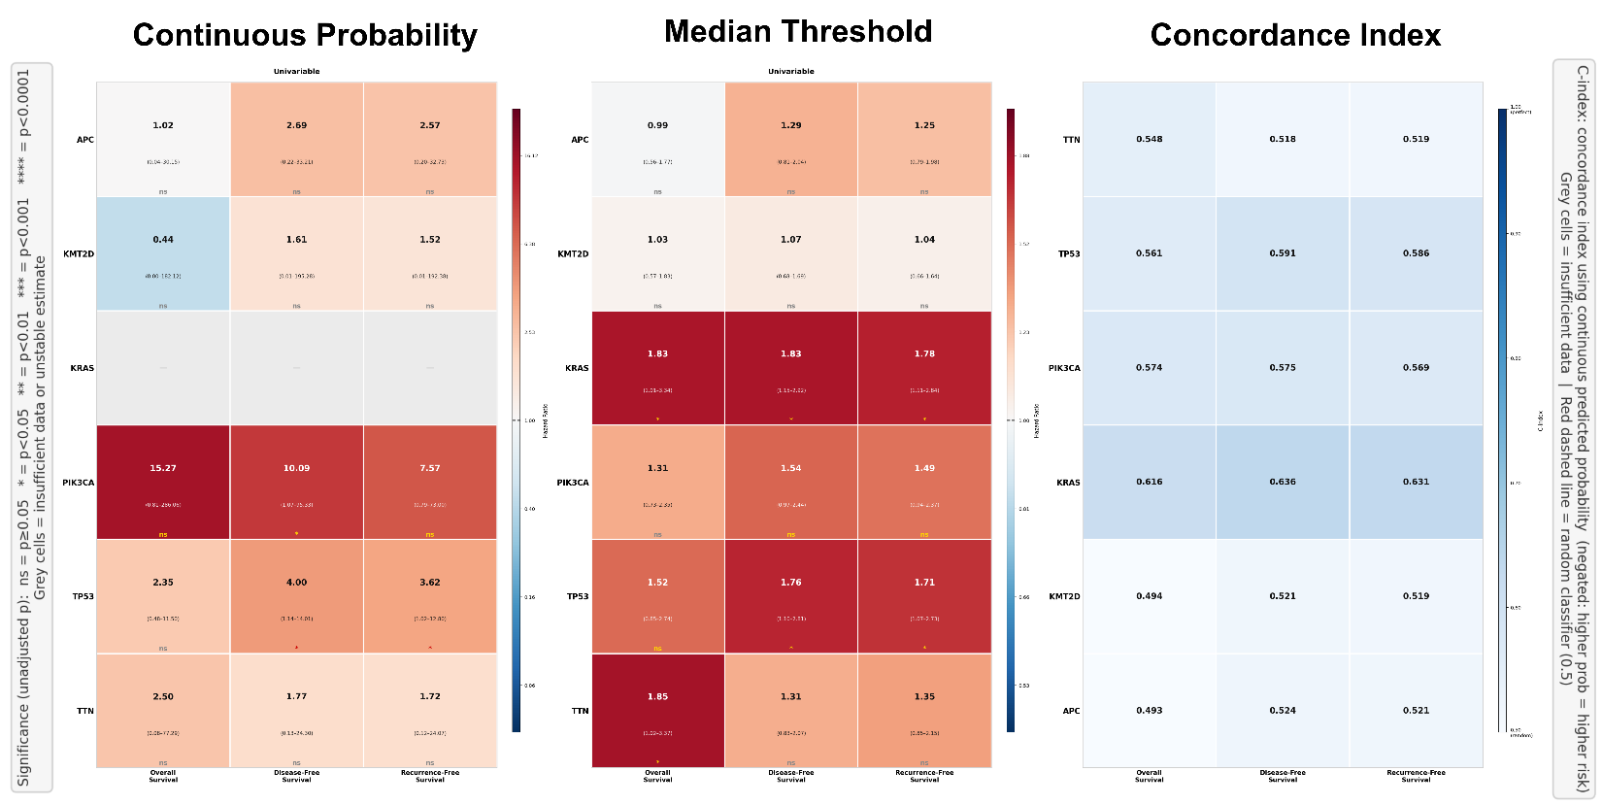
Figure S1 | Summary of univariable Cox regression hazard ratios and concordance indices for all gene mutation probability scores in invasive lung adenocarcinoma (LUAD). Three-panel visualization of prognostic utility across OS and PFS. Left: Hazard ratio heatmap from univariable Cox regression using the continuous predicted probability as covariate. Cell color encodes HR magnitude on a red (adverse; HR > 1) to blue (protective; HR < 1) scale. HR point estimates and 95% confidence intervals are shown within each cell. Grey cells indicate insufficient events or unstable estimates. Centre: Hazard ratio heatmap from univariable Cox regression using median-split binary classification. Right: Concordance index (C-index) heatmap for the continuous predicted probability score (negated, such that higher probability corresponds to higher predicted risk), with a blue color scale ranging from 0.50 (random classifier) to 1.00 (perfect discrimination). Significance designations reflect unadjusted P values: ns P ≥ 0.05; *P < 0.05; **P < 0.01; ***P < 0.001; ****P < 0.0001. Grey cells indicate insufficient data or unstable estimates.
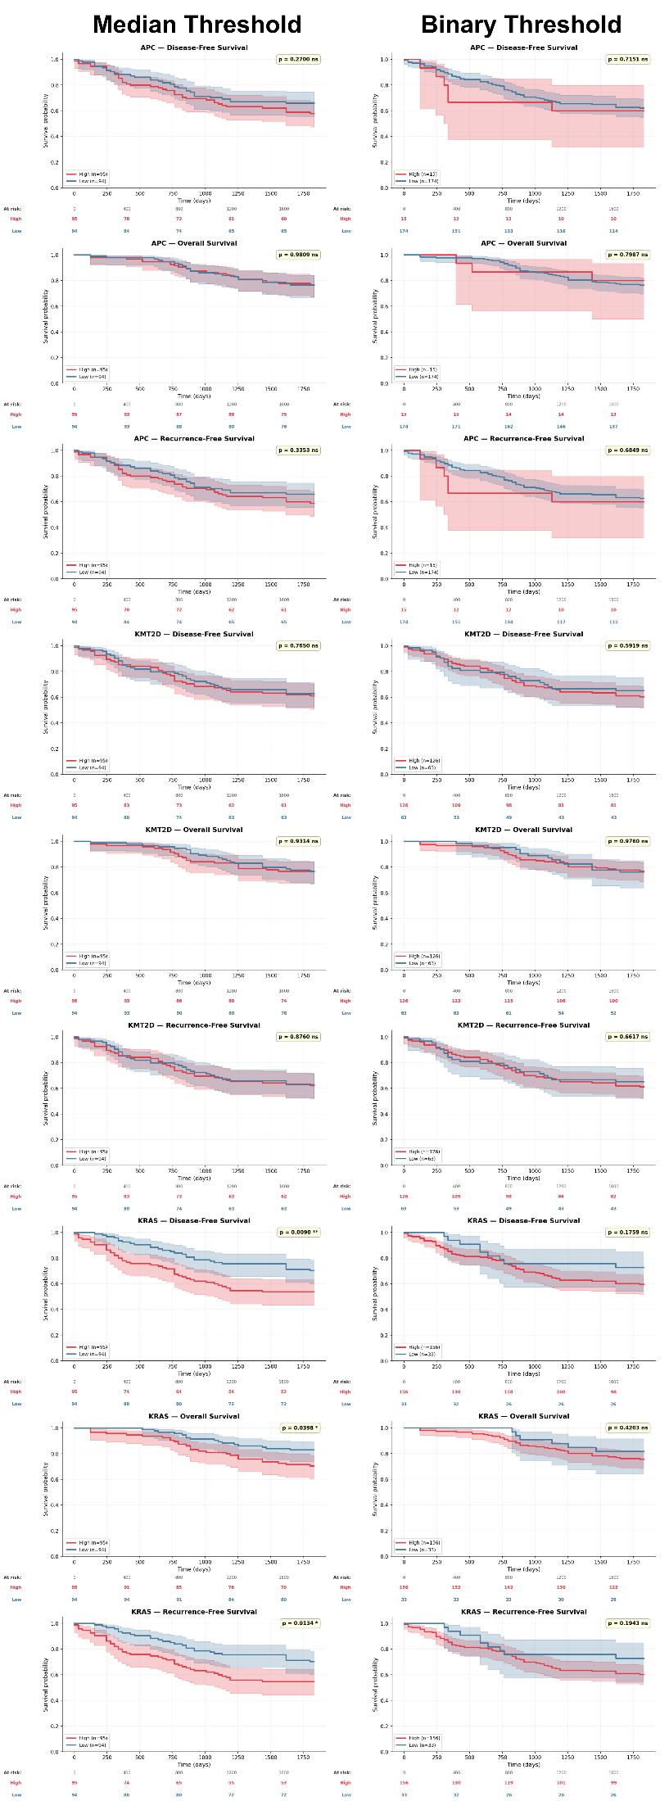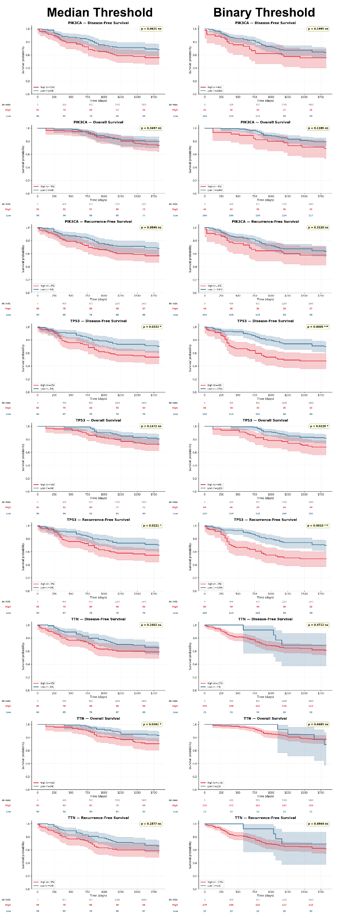
Figure S2 | Kaplan–Meier survival analysis for APC, PIK3CA, KMT2D, KRAS, TTN, and TP53 mutation probability scores across DFS, OS, and RFS in invasive lung adenocarcinoma (LUAD; n = 189). Kaplan–Meier curves for disease-free survival (DFS), overall survival (OS) and progression-free survival (PFS) stratified by GenoGlyph-predicted mutation probability using two thresholding strategies: median split (left) and binary threshold at 0.5 (right). Red curves indicate the High-probability group; blue curves indicate the Low-probability group. Shaded regions represent 95% confidence intervals. Number-at-risk tables are shown below each panel. P values from log-rank tests are displayed in the upper right of each panel; ns, not significant (P ≥ 0.05); *P < 0.05.
Colorectal Adenocarcinoma (CRC; n = 422)
The CRC cohort was the largest in this study, comprising 422 patients with 144 OS events, 144 DFS events, and 137 RFS events, with follow-up sufficient to evaluate all five landmark timepoints.
BRAF mutation probability yielded the strongest and most statistically robust continuous Cox associations in the entire dataset. Continuous Cox regression demonstrated significant adverse associations with OS (HR = 2.01, 95% CI 1.28–3.16, p = 0.003, FDR q = 0.018), DFS (HR = 2.17, 95% CI 1.39–3.40, p = 0.001, FDR q = 0.005), and RFS (HR = 2.28, 95% CI 1.45–3.59, p < 0.001, FDR q = 0.003). These FDR-adjusted associations confirm that BRAF probability carries robust prognostic information independent of multiple testing. The binary median split did not reach significance (p = 0.09–0.15), indicating that the prognostic information is encoded in the continuous probability gradient and is partially lost upon dichotomization. Consistently with this, landmark analyses revealed significant differences at all five timepoints for OS (1yr p < 0.05 through 4yr), with BRAF-High patients showing notably lower 2-year OS (83.9% vs 92.4%). These findings are consistent with the well-established adverse prognostic role of BRAF mutation in CRC, particularly in microsatellite-stable tumors.
KRAS mutation probability provided the most stable, temporally consistent prognostic stratification across all survival endpoints. Binary median split yielded HRs of 1.68 (OS, p = 0.002), 1.60 (DFS, p = 0.005), and 1.55 (RFS, p = 0.011), demonstrating that patients with high predicted KRAS mutation probability have uniformly inferior outcomes across recurrence and survival metrics. Landmark analyses were remarkable for their consistency: OS differences reached significance at 1, 2, 3, 4, and 5 years (2yr OS: 82.9% vs 93.4%, p < 0.001; 5yr OS: 69.7% vs 82.0%, p < 0.01), as did DFS and RFS across all five timepoints. This landmark-persistent signal represents the most temporally sustained prognostic stratification observed across all cohorts and genes in this study.
KMT2D mutation probability demonstrated consistent prognostic significance across all three endpoints by binary median split (OS HR = 1.40, p = 0.042; DFS HR = 1.43, p = 0.031; RFS HR = 1.47, p = 0.024). Landmark analyses were particularly compelling, with 2-year and beyond landmark tests reaching ** or *** across OS, DFS, and RFS (5yr OS: 69.2% High vs 82.5% Low, p < 0.001). Notably, KMT2D's landmark profile was among the strongest in the cohort at the 3–5 year timepoints, with OS differences of approximately 13 percentage points persisting at year 5. These findings implicate KMT2D-associated chromatin remodeling phenotypes as a durable histomorphological marker of CRC prognosis.
APC and TP53 probability scores did not reach overall log-rank significance in CRC. However, both showed isolated significant landmark tests, APC at the 1-year DFS landmark (**) and TP53 at OS landmarks at 3 and 4 years (*). Notably, both APC and TP53 were associated with better early survival in their High probability groups (e.g., 1yr OS: TP53-High 98.6% vs Low 95.3%), suggesting a paradoxical protective directionality of these probability scores in CRC, possibly reflecting that histomorphological features associated with high TP53/APC mutation probability in this cohort encode differentiation states with favorable early outcomes. PIK3CA showed a nominally protective continuous Cox association (HR ≈ 0.36–0.43, p ≈ 0.04–0.10) with poor survival, but this did not survive FDR correction. TTN showed an isolated significant 5-year OS landmark (*), without broader prognostic significance.
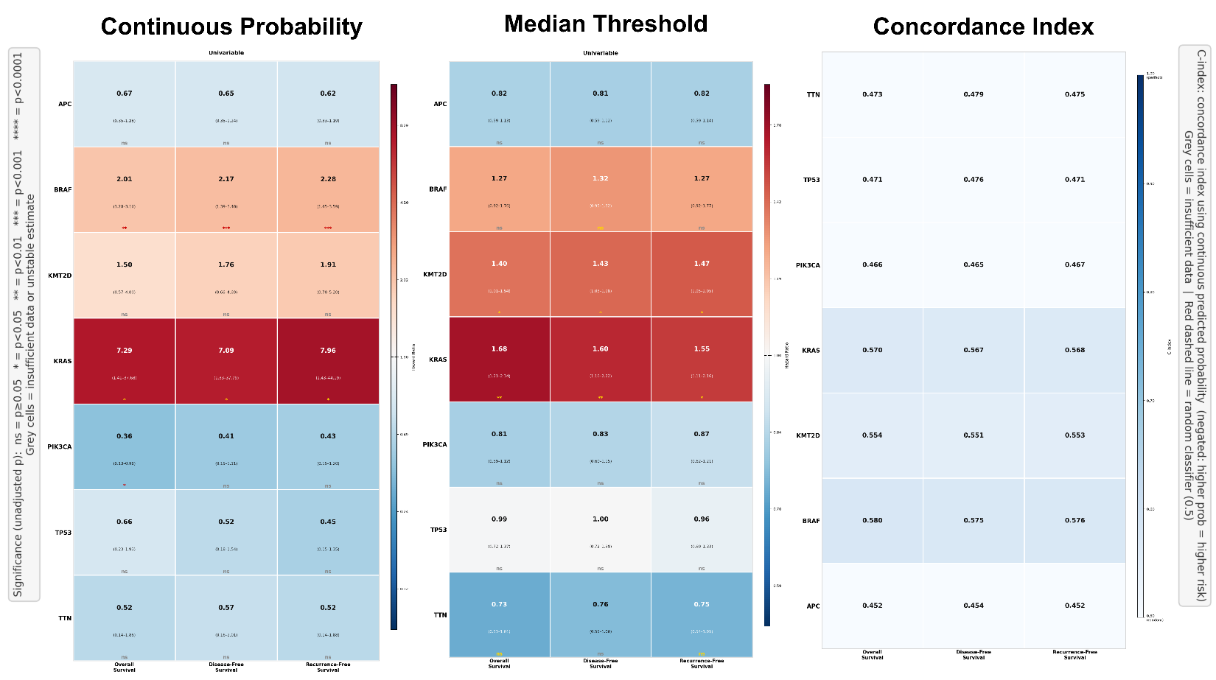

Figure S3 | Summary of univariable Cox regression hazard ratios and concordance indices for all gene mutation probability scores in colorectal adenocarcinoma (CRC). Three-panel visualization of prognostic utility across OS, DFS, and RFS. Left: Hazard ratio heatmap from univariable Cox regression using the continuous predicted probability as covariate. Centre: Hazard ratio heatmap from median-split binary Cox regression. Right: C-index heatmap. Panel layout, color scheme, and significance designations as in Supplementary Figure 1.
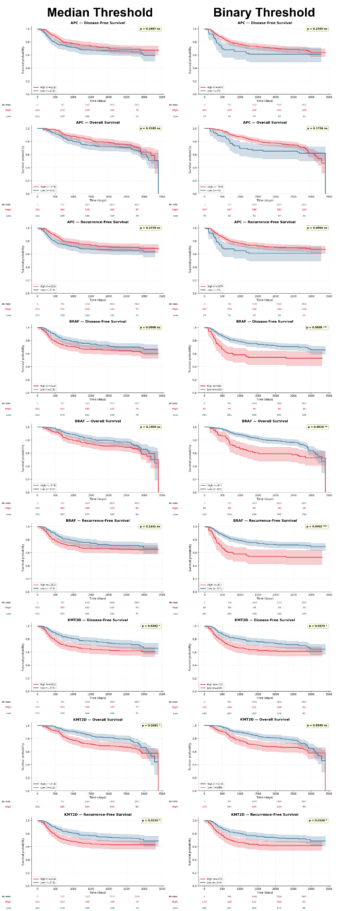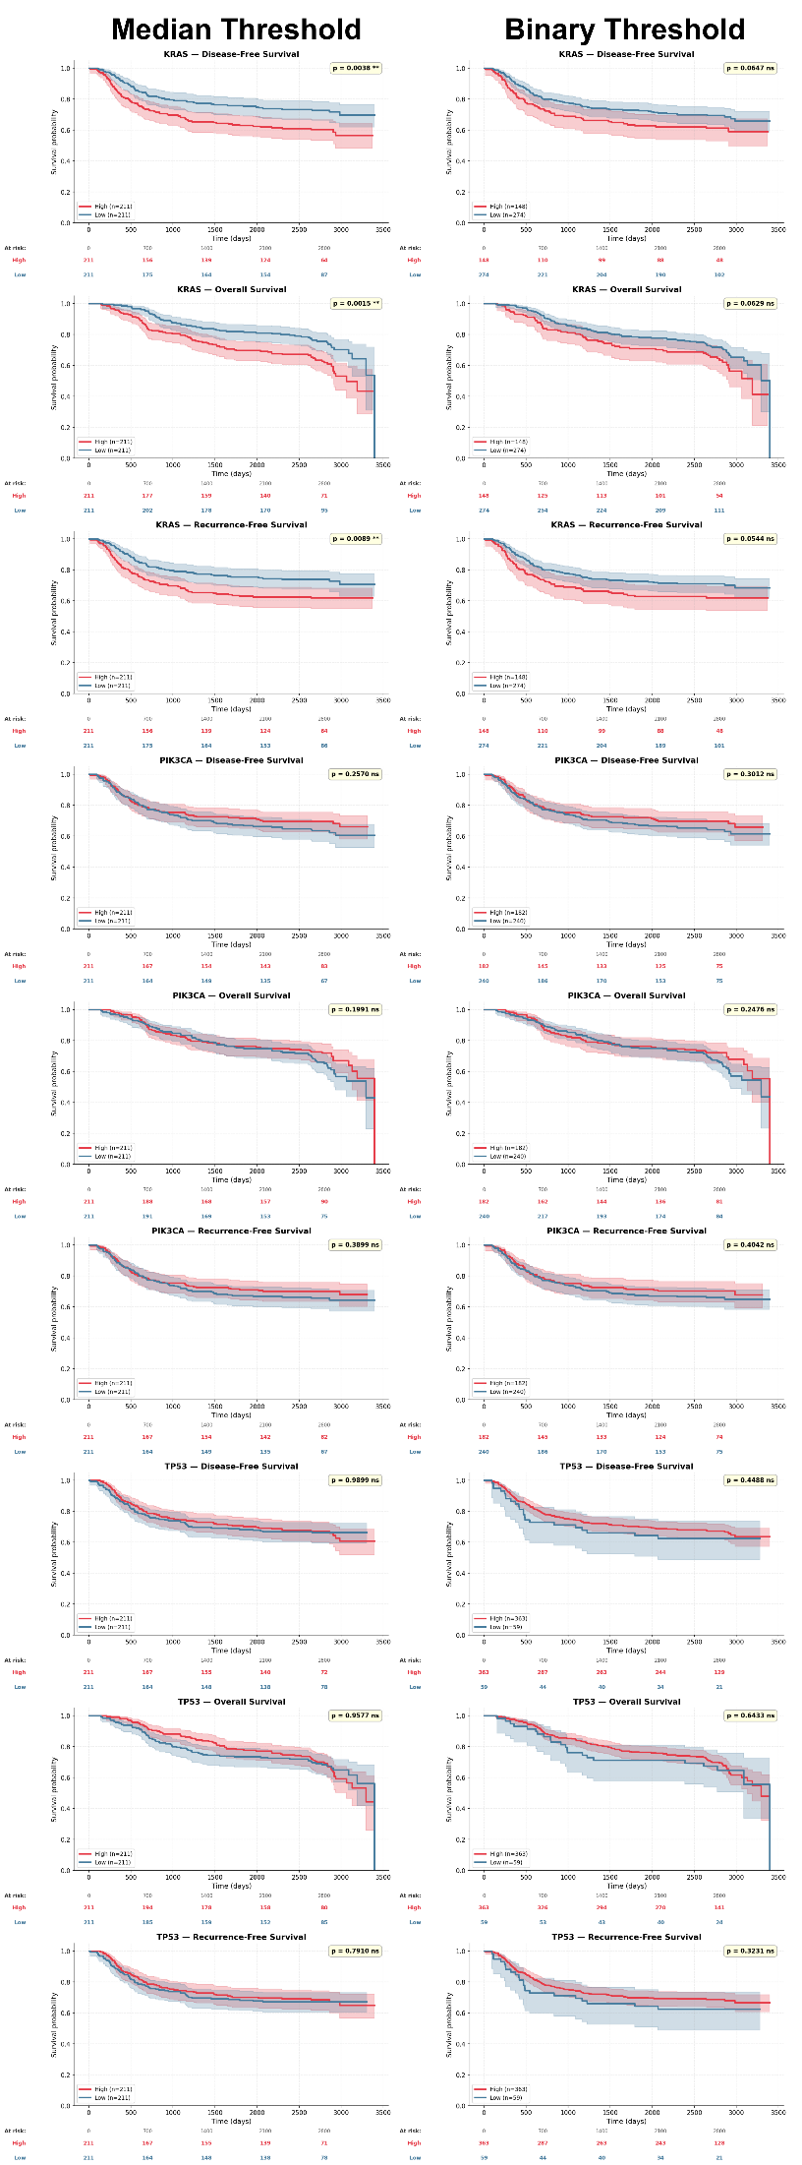
Figure S4 | Kaplan–Meier survival analysis for APC, BRAF, KMT2D, KRAS, PIK3CA, and TP53 mutation probability scores across OS, DFS, and RFS in colorectal adenocarcinoma (CRC; n = 422). Kaplan–Meier curves for three survival endpoints stratified by predicted mutation probability using median split (left) and binary threshold at 0.5 (right). Red curves indicate High-probability group; blue curves indicate Low-probability group. Shaded regions represent 95% confidence intervals. Number-at-risk tables are shown below each panel. ns, not significant; *P < 0.05; **P < 0.01; ***P < 0.001.
Pancreatic Ductal Adenocarcinoma (PDAC; n = 275)
The PDAC cohort comprised 275 patients with 203 OS events (74% event rate), reflecting the aggressive clinical course of pancreatic cancer and justifying the use of OS as the sole survival endpoint.
KRAS mutation probability demonstrated the most statistically dominant prognostic signal across the entire study. Continuous Cox regression yielded HR = 0.09 (95% CI 0.03–0.26, p < 0.0001, FDR q < 0.0001), indicating a highly significant protective association, patients with higher predicted KRAS mutation probability had substantially better OS. This directionality is reflected in the C-index of 0.391, confirming that higher KRAS probability scores correspond to lower hazard (i.e., the protective direction). Binary median split confirmed this relationship: KRAS-High patients had a median OS of 898 days versus 560 days in the Low group (HR = 0.60, 95% CI 0.46–0.80, p = 0.0003). Landmark analyses demonstrated significant survival differences at every timepoint: 1yr OS (81.9% vs 65.0%, p < 0.01), 2yr (53.8% vs 37.2%, p < 0.01), 3yr (37.6% vs 19.0%, p < 0.001), 4yr (29.5% vs 12.5%, p < 0.0001), and 5yr (15.8% vs 10.4%, p < 0.001). The 4-year landmark (p < 0.0001) represents the strongest single landmark test in the dataset.
Biological interpretation of this inverse relationship warrants consideration. KRAS mutation is near-universal in PDAC (~90% overall prevalence), and the GenoGlyph model trained across multiple cancer types may be learning histomorphological features associated with classical glandular KRAS-driven differentiation. In PDAC, more differentiated tumors, which express stronger classical glandular architecture, may carry higher KRAS-associated morphological scores while simultaneously exhibiting better prognosis than poorly differentiated or basal-like subtypes. This interpretation is consistent with established PDAC molecular subtyping: the Moffitt classical subtype, characterized by well-differentiated glandular morphology, is associated with superior outcomes compared to the basal-like subtype, and we initially hypothesized that KRAS probability scores might align with this classical-versus-basal morphological axis. To test this directly, we leveraged Moffitt subtype labels available for a subset of this cohort and examined whether KRAS probability discriminated classical from basal-like cases. Contrary to this expectation, KRAS probability scores did not meaningfully separate the two subtypes, with accuracy near chance and no consistent directional signal. This suggests that while the model's prognostic behavior is consistent with a classical morphology hypothesis, the learned features do not map cleanly onto the Moffitt classification, and the survival signal likely reflects a more nuanced morphological gradient than a strict binary subtype distinction.
BRAF mutation probability demonstrated a significant adverse continuous Cox association (HR = 7.42, 95% CI 1.95–28.23, p = 0.003, FDR q = 0.011) in PDAC. Although binary median split was not significant (p = 0.071), the continuous score carries an independent prognostic signal. A significant landmark difference was observed at 4 years (15.1% High vs 28.3% Low, p < 0.05), representing late adverse divergence in survival in the BRAF-High group.
APC probability showed a modest but significant protective binary median Cox association (HR = 0.74, 95% CI 0.56–0.97, p = 0.032), with significant 3-year (34.8% vs 22.4%, p < 0.05) and 5-year (18.0% vs 7.3%, p < 0.05) OS landmark differences. The remaining genes (KMT2D, PIK3CA, TP53, TTN) demonstrated no significant prognostic associations in PDAC.
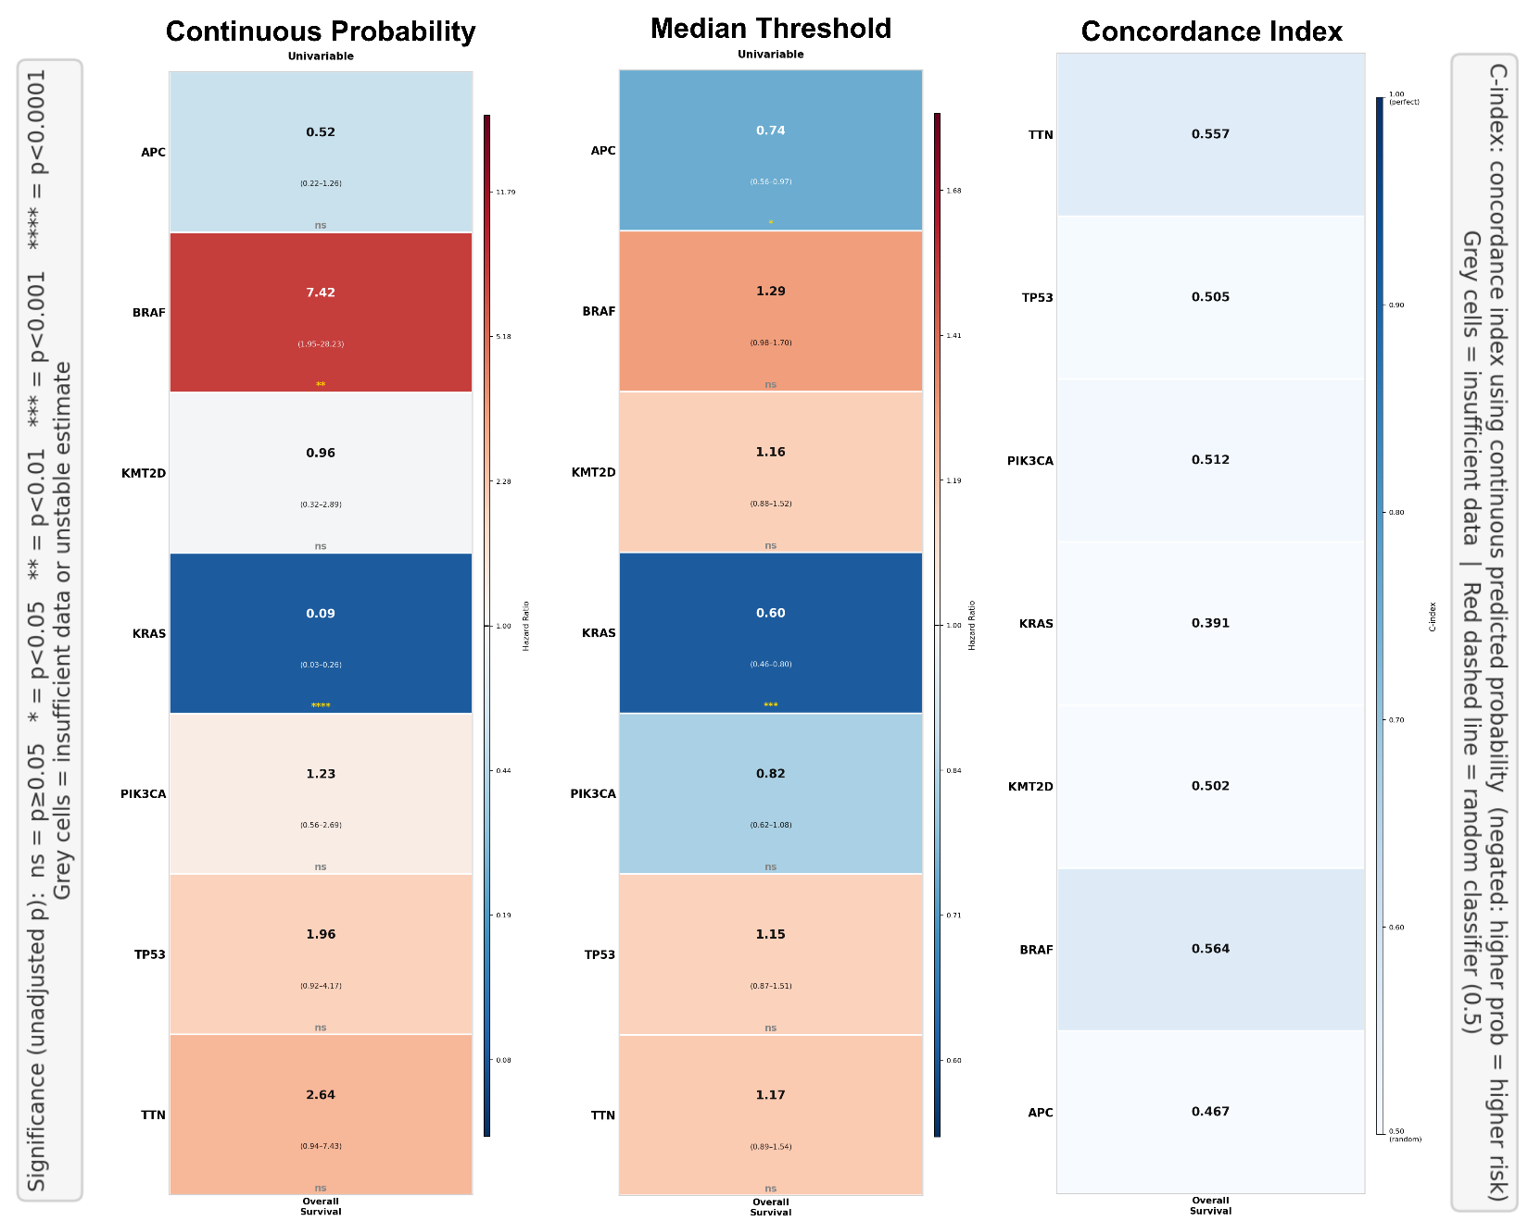
Figure S5 | Summary of univariable Cox regression hazard ratios and concordance indices for all gene mutation probability scores in pancreatic ductal adenocarcinoma (PDAC). Three-panel visualization of prognostic utility across OS. Left: Hazard ratio heatmap from univariable Cox regression using the continuous predicted probability as covariate. Centre: Hazard ratio heatmap from median-split binary Cox regression. Right: C-index heatmap. Panel layout, color scheme, and significance designations as in Supplementary Figure 1.
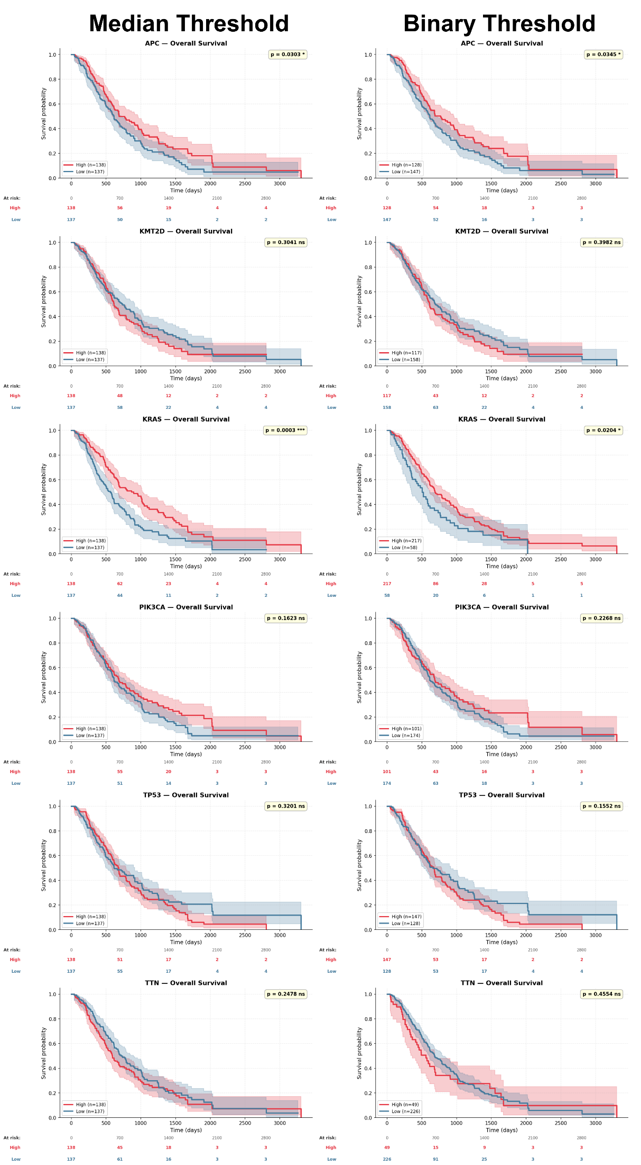
Figure S6 | Kaplan–Meier survival analysis for APC, KMT2D, KRAS, PIK3CA, TP53, and TTN mutation probability scores in pancreatic ductal adenocarcinoma (PDAC; n = 275). Kaplan–Meier curves for overall survival (OS) stratified by predicted mutation probability using median split (left) and binary threshold at 0.5 (right). Red curves indicate High-probability group; blue curves indicate Low-probability group. Shaded regions represent 95% confidence intervals. Number-at-risk tables are shown below each panel. ns, not significant; *P < 0.05; ***P < 0.001.
Metastatic HR+/HER2− Breast Carcinoma (BRCA; n = 94)
The BRCA cohort comprised 94 patients with metastatic hormone receptor-positive, HER2-negative breast cancer. With 68 OS events and 94 PFS events (all patients experienced disease progression), this was the smallest cohort in the study and the only metastatic setting represented. The small sample size necessitates appropriate caution in interpreting individual findings, and confidence intervals throughout are correspondingly wide.
TP53 mutation probability was the primary prognostic feature in this cohort, with its most striking effect on PFS. Binary median split yielded HR = 1.90 (95% CI 1.21–2.96, p = 0.005), indicating that patients with high predicted TP53 mutation probability experienced significantly more rapid disease progression. The landmark analysis revealed a compelling late-divergence pattern: no significant difference was observed at 1 or 2 years (1yr: 46.8% High vs 55.3% Low, ns), but dramatic separation emerged by year 3 (4.3% vs 25.5%, p < 0.05), year 4 (0.0% vs 25.5%, p < 0.01), and year 5 (0.0% vs 19.1%, p < 0.01). This pattern, early convergence followed by late catastrophic failure, is consistent with TP53-mutated HR+ breast cancers exhibiting endocrine resistance that manifests primarily in the 2-4 year range, after initial response to therapy. By year 4, all patients in the TP53-High group had progressed, while approximately one-quarter of TP53-Low patients remained progression-free.
PIK3CA mutation probability demonstrated a nominally significant protective OS association in this cohort. Continuous Cox regression yielded an HR of approximately 0.00 with the observed effect driven by the extreme end of the probability distribution (p = 0.009, FDR q = 0.043), while binary median split gave HR = 0.61 (95% CI 0.38–0.99, p = 0.044). The PIK3CA-High group had a median OS of 2,124 days versus 1,442 days in the Low group. Although landmark tests did not individually achieve significance, the numerically widening separation over time (5yr OS: 59.6% High vs 38.0% Low) suggests a real, if underpowered, protective association. This finding is biologically plausible, as PIK3CA mutations in HR+ breast cancer are associated with PI3K pathway-driven tumors that retain sensitivity to CDK4/6 inhibitors and endocrine therapy combinations.
KRAS probability showed a late-divergence PFS signal, with significant landmark tests at years 3, 4, and 5 (* each), where KRAS-High patients maintained higher progression-free rates (19.1% vs 6.4% at 4 years). The overall log-rank was non-significant (p = 0.069), suggesting that this represents a late-emerging difference rather than a sustained separation. Given the small cohort size, this finding should be considered hypothesis-generating. APC, KMT2D, and TTN showed no meaningful prognostic associations in this cohort.
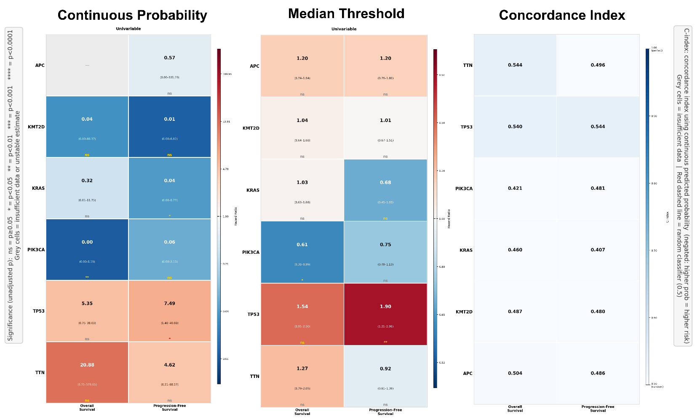
Figure S7 | Summary of univariable Cox regression hazard ratios and concordance indices for all gene mutation probability scores in metastatic HR+/HER2− breast carcinoma (BRCA). Three-panel visualization of prognostic utility across OS and PFS. Left: Hazard ratio heatmap from univariable Cox regression using the continuous predicted probability as covariate. Cell color encodes HR magnitude on a red (adverse; HR > 1) to blue (protective; HR < 1) scale; cell area is proportional to HR magnitude. HR point estimates and 95% confidence intervals are shown within each cell. Grey cells indicate insufficient events or unstable estimates. Centre: Hazard ratio heatmap from univariable Cox regression using median-split binary classification. Right: Concordance index (C-index) heatmap for the continuous predicted probability score (negated, such that higher probability corresponds to higher predicted risk), with a blue color scale ranging from 0.50 (random classifier) to 1.00 (perfect discrimination). Significance designations reflect unadjusted P values: ns P ≥ 0.05; *P < 0.05; **P < 0.01; ***P < 0.001; ****P < 0.0001. Grey cells indicate insufficient data or unstable estimates.
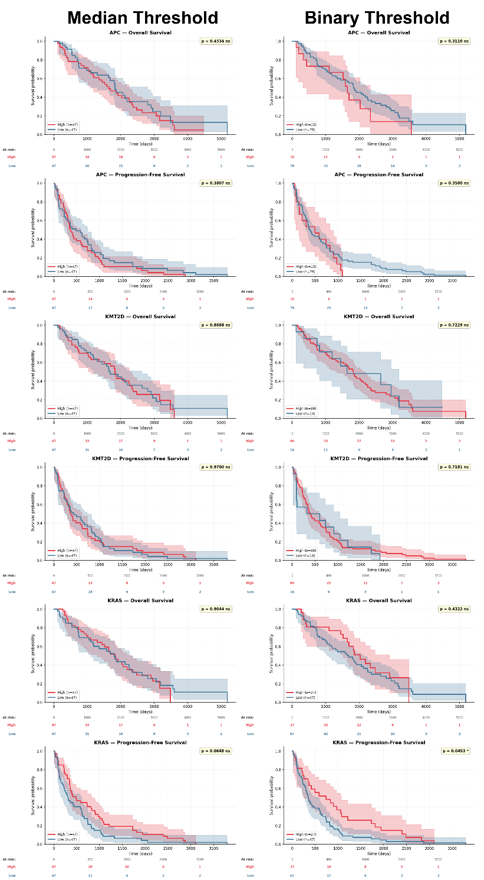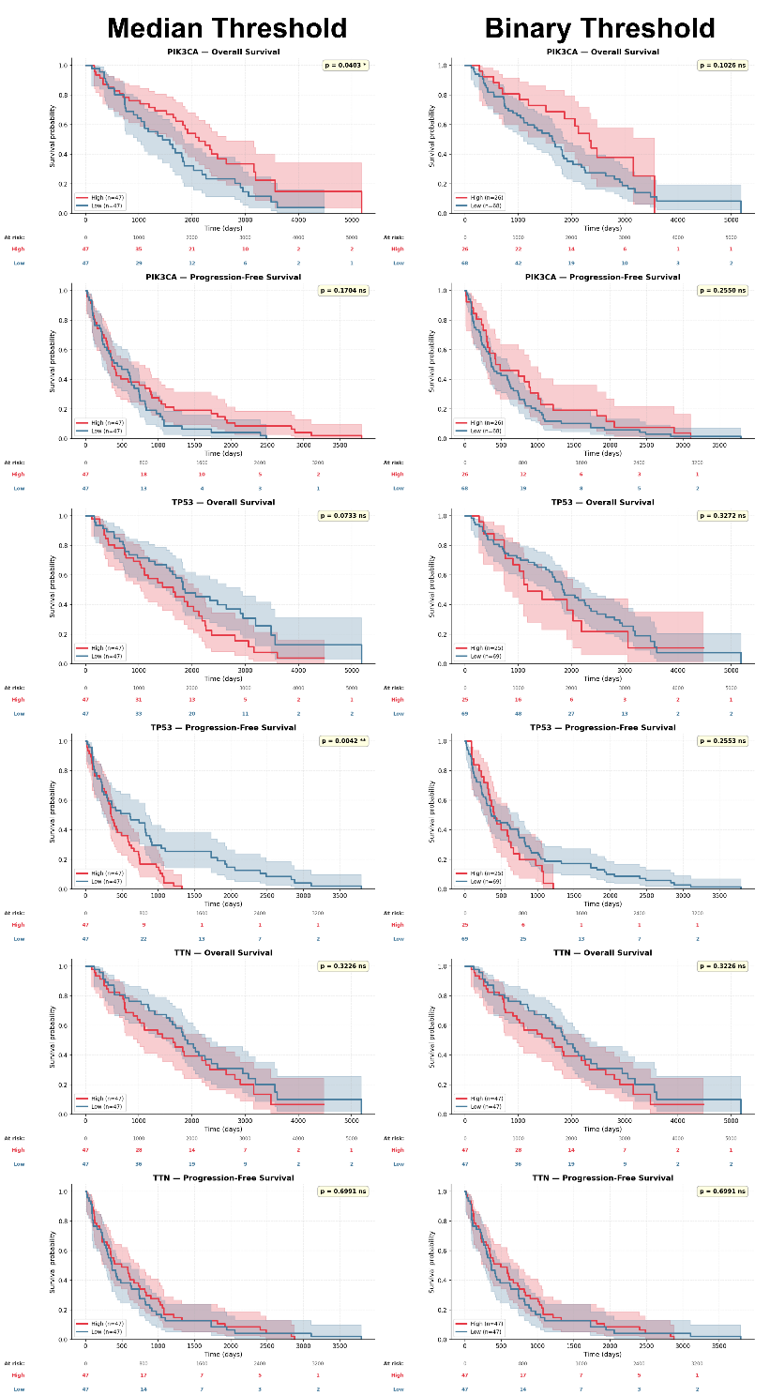
Figure S8 | Kaplan–Meier survival analysis for APC, KMT2D, KRAS, PIK3CA, TP53, and TTN mutation probability scores in metastatic HR+/HER2− breast carcinoma (BRCA; n = 94). Kaplan–Meier curves for overall survival (OS) and progression-free survival (PFS) stratified by GenoGlyph-predicted mutation probability using two thresholding strategies: median split (left) and binary threshold at 0.5 (right). Red curves indicate the High-probability group; blue curves indicate the Low-probability group. Shaded regions represent 95% confidence intervals. Number-at-risk tables are shown below each panel. P values from log-rank tests are displayed in the upper right of each panel; ns, not significant (P ≥ 0.05); *P < 0.05.
Section S5: Cross-Cohort Observations and Biological Interpretation
KRAS Probability as a Versatile but Directionally Variable Prognostic Feature
Across three of four cohorts, KRAS mutation probability derived from H&E WSIs carried significant prognostic information. In LUAD, high KRAS probability identified patients at elevated risk of recurrence and death (HR 1.78–1.83 across endpoints). In CRC, KRAS probability stratified patients with consistent landmark-stable separation across OS, DFS, and RFS over five years, representing the most temporally sustained prognostic signal in the study. In PDAC, however, higher KRAS probability was strongly associated with better OS (HR = 0.09, p < 0.0001), reflecting an inverted prognostic direction that we attribute to the GenoGlyph model capturing classical glandular differentiation morphology in the context of this pancreas-specific cancer biology. This directional inversion across cancer types underscores the importance of cohort-specific biological contextualization when interpreting pan-cancer model outputs in prognostic settings, and motivates future work integrating subtype-specific morphological annotations.
BRAF Probability and the Continuous-versus-Binary Discordance
BRAF mutation probability in CRC demonstrated a notable methodological observation: significant FDR-robust associations were observed with the continuous Cox model (p = 0.001–0.003, FDR q = 0.003–0.018), while binary median split failed to reach significance. This discordance reflects the known limitation of median dichotomization in survival analysis, when the prognostic signal is encoded as a continuous gradient without a natural biological threshold, median splitting reduces statistical power. The landmark analysis confirmed that BRAF-High patients accumulate excess events continuously from year 1 through year 4, consistent with a graded dose-response relationship between the BRAF morphological probability score and adverse outcome. This is clinically consistent with BRAF-mutated CRC having a well-recognized adverse prognosis driven by resistance to EGFR-targeted therapies and enrichment in aggressive histological subtypes.
TP53 Probability: Early Signal in Lung, Late Divergence in Breast
TP53 mutation probability demonstrated distinct temporal patterns across cohorts. In LUAD, TP53-associated OS differences were concentrated in the early follow-up period (1–2 years), consistent with TP53 mutations driving aggressive early tumor behavior. In BRCA, by contrast, TP53-associated PFS differences emerged only at years 3–4, with the TP53-High group reaching 0% progression-free survival by year 4 while the Low group maintained approximately 25% PFS. This late-divergence pattern in metastatic HR+ breast cancer is clinically interpretable: TP53-mutated tumors may exhibit initial responses to endocrine and CDK4/6 inhibitor therapy before acquiring resistance mechanisms that ultimately drive progression. The histopathological probability score may therefore be capturing morphological correlates of this resistance biology.
KMT2D as an Emerging Prognostic Marker in CRC
KMT2D mutation probability demonstrated consistent and landmark-stable prognostic utility in the CRC cohort, with OS landmark tests maintaining ** or *** significance from year 2 through year 5. KMT2D encodes a lysine methyltransferase involved in H3K4 methylation and chromatin remodeling, and its mutations are associated with dysregulation of enhancer landscapes and transcriptional programs relevant to tumor progression. That GenoGlyph's KMT2D probability, derived from H&E morphology alone, captures information predictive of long-term CRC survival suggests that KMT2D mutation drives recognizable histomorphological changes, potentially including nuclear architecture alterations, stromal remodeling patterns, or immune microenvironmental features that are encoded in tissue organization. This finding warrants prospective validation and suggests KMT2D probability as a candidate H&E-derived prognostic biomarker for CRC.
Supplementary Tables
Table S1 | Univariable Cox proportional hazards regression using continuous predicted mutation probability scores. Results of univariable Cox regression in which the raw GenoGlyph-predicted mutation probability (range 0–1) for each gene model was used as a continuous covariate to assess prognostic utility across four independent external cohorts: invasive lung adenocarcinoma (LUAD; n = 189), colorectal adenocarcinoma (CRC; n = 422), pancreatic ductal adenocarcinoma (PDAC; n = 275), and metastatic HR+/HER2− breast carcinoma (BRCA; n = 94). For each gene–cohort–endpoint combination, the table reports the number of patients (N), number of events, hazard ratio (HR) with 95% confidence interval, unadjusted P value, significance designation, Benjamini–Hochberg false discovery rate (FDR)-adjusted q value, and FDR significance. Entries marked '—' indicate that the minimum event threshold (≥10 total events; ≥5 events per arm) was not met and the model was excluded. HR < 1 indicates a protective association (higher predicted probability associated with lower hazard); HR > 1 indicates an adverse association. FDR correction was applied independently within each cohort-outcome group. Significance thresholds: ****P < 0.0001, ***P < 0.001, **P < 0.01, *P < 0.05; ns, not significant. Color coding: dark red = p < 0.0001; orange = p < 0.001; yellow = p < 0.01; green = p < 0.05.
Gene | Outcome | N | Events | HR (95% CI) | p-value | Sig. | FDR q | FDR Sig.
Lung Adenocarcinoma (LUAD) — OS, DFS, RFS
APC | OS | 189 | 44 | 1.02 (0.03–30.15) | 0.990 | ns | 0.990 | ns
KMT2D | OS | 189 | 44 | 0.44 (0.00–182.12) | 0.791 | ns | 0.989 | ns
KRAS | OS | — | — | — | — | — | — | —
PIK3CA | OS | 189 | 44 | 15.27 (0.82–286.06) | 0.068 | ns | 0.341 | ns
TP53 | OS | 189 | 44 | 2.35 (0.48–11.50) | 0.293 | ns | 0.732 | ns
TTN | OS | 189 | 44 | 2.50 (0.08–77.29) | 0.601 | ns | 0.989 | ns
APC | DFS | 189 | 72 | 2.68 (0.22–33.21) | 0.442 | ns | 0.736 | ns
KMT2D | DFS | 189 | 72 | 1.61 (0.01–195.29) | 0.847 | ns | 0.847 | ns
KRAS | DFS | — | — | — | — | — | — | —
PIK3CA | DFS | 189 | 72 | 10.09 (1.07–95.33) | 0.044 | * | 0.109 | ns
TP53 | DFS | 189 | 72 | 4.00 (1.14–14.00) | 0.030 | * | 0.109 | ns
TTN | DFS | 189 | 72 | 1.77 (0.13–24.30) | 0.670 | ns | 0.838 | ns
APC | RFS | 189 | 71 | 2.57 (0.20–32.74) | 0.466 | ns | 0.777 | ns
KMT2D | RFS | 189 | 71 | 1.52 (0.01–192.38) | 0.865 | ns | 0.865 | ns
KRAS | RFS | — | — | — | — | — | — | —
PIK3CA | RFS | 189 | 71 | 7.57 (0.79–73.00) | 0.080 | ns | 0.200 | ns
TP53 | RFS | 189 | 71 | 3.62 (1.02–12.80) | 0.046 | * | 0.200 | ns
TTN | RFS | 189 | 71 | 1.72 (0.12–24.07) | 0.688 | ns | 0.860 | ns
Colorectal Adenocarcinoma (CRC) — OS, DFS, RFS
APC | OS | 422 | 144 | 0.67 (0.35–1.28) | 0.226 | ns | 0.395 | ns
BRAF | OS | 422 | 144 | 2.01 (1.28–3.16) | 0.003 | ** | 0.018 | *
KMT2D | OS | 422 | 144 | 1.50 (0.57–4.00) | 0.413 | ns | 0.452 | ns
KRAS | OS | 422 | 144 | 7.29 (1.41–37.68) | 0.018 | * | 0.062 | ns
PIK3CA | OS | 422 | 144 | 0.36 (0.13–0.99) | 0.047 | * | 0.109 | ns
TP53 | OS | 422 | 144 | 0.66 (0.23–1.93) | 0.452 | ns | 0.452 | ns
TTN | OS | 422 | 144 | 0.52 (0.14–1.86) | 0.312 | ns | 0.437 | ns
APC | DFS | 422 | 144 | 0.65 (0.35–1.24) | 0.193 | ns | 0.303 | ns
BRAF | DFS | 422 | 144 | 2.17 (1.39–3.40) | 0.001 | *** | 0.005 | **
KMT2D | DFS | 422 | 144 | 1.76 (0.66–4.69) | 0.259 | ns | 0.303 | ns
KRAS | DFS | 422 | 144 | 7.10 (1.33–37.79) | 0.022 | * | 0.076 | ns
PIK3CA | DFS | 422 | 144 | 0.40 (0.15–1.11) | 0.079 | ns | 0.183 | ns
TP53 | DFS | 422 | 144 | 0.52 (0.18–1.54) | 0.240 | ns | 0.303 | ns
TTN | DFS | 422 | 144 | 0.57 (0.16–2.01) | 0.379 | ns | 0.379 | ns
APC | RFS | 422 | 137 | 0.62 (0.33–1.19) | 0.151 | ns | 0.214 | ns
BRAF | RFS | 422 | 137 | 2.28 (1.45–3.59) | <0.001 | *** | 0.003 | **
KMT2D | RFS | 422 | 137 | 1.91 (0.70–5.20) | 0.208 | ns | 0.243 | ns
KRAS | RFS | 422 | 137 | 7.96 (1.43–44.19) | 0.018 | * | 0.062 | ns
PIK3CA | RFS | 422 | 137 | 0.43 (0.15–1.20) | 0.105 | ns | 0.214 | ns
TP53 | RFS | 422 | 137 | 0.45 (0.15–1.35) | 0.153 | ns | 0.214 | ns
TTN | RFS | 422 | 137 | 0.51 (0.14–1.88) | 0.315 | ns | 0.315 | ns
Pancreatic Ductal Adenocarcinoma (PDAC) — OS only
APC | OS | 275 | 203 | 0.52 (0.22–1.26) | 0.149 | ns | 0.209 | ns
BRAF | OS | 275 | 203 | 7.42 (1.95–28.23) | 0.003 | ** | 0.011 | *
KMT2D | OS | 275 | 203 | 0.96 (0.32–2.89) | 0.946 | ns | 0.946 | ns
KRAS | OS | 275 | 203 | 0.09 (0.03–0.26) | <0.0001 | **** | <0.0001 | ****
PIK3CA | OS | 275 | 203 | 1.23 (0.56–2.69) | 0.609 | ns | 0.710 | ns
TP53 | OS | 275 | 203 | 1.96 (0.92–4.17) | 0.082 | ns | 0.143 | ns
TTN | OS | 275 | 203 | 2.64 (0.94–7.43) | 0.065 | ns | 0.143 | ns
Metastatic HR+/HER2− Breast Carcinoma (BRCA) — OS, PFS
APC | OS | — | — | — | — | — | — | —
KMT2D | OS | 94 | 68 | 0.03 (0.00–80.37) | 0.395 | ns | 0.494 | ns
KRAS | OS | 94 | 68 | 0.32 (0.01–11.75) | 0.532 | ns | 0.532 | ns
PIK3CA | OS | 94 | 68 | 0.00 (0.00–0.19) | 0.009 | ** | 0.043 | *
TP53 | OS | 94 | 68 | 5.35 (0.75–38.03) | 0.094 | ns | 0.157 | ns
TTN | OS | 94 | 68 | 20.87 (0.75–579.05) | 0.073 | ns | 0.157 | ns
APC | PFS | 94 | 94 | 0.57 (0.00–101.19) | 0.830 | ns | 0.830 | ns
KMT2D | PFS | 94 | 94 | 0.01 (0.00–6.82) | 0.168 | ns | 0.253 | ns
KRAS | PFS | 94 | 94 | 0.04 (0.00–0.77) | 0.032 | * | 0.096 | ns
PIK3CA | PFS | 94 | 94 | 0.06 (0.00–2.15) | 0.125 | ns | 0.251 | ns
TP53 | PFS | 94 | 94 | 7.49 (1.40–40.08) | 0.019 | * | 0.096 | ns
TTN | PFS | 94 | 94 | 4.62 (0.31–68.57) | 0.266 | ns | 0.319 | ns

Table S2 | Concordance index (C-index) for continuous predicted mutation probability scores across cohorts and endpoints. C-index values computed using the negated continuous GenoGlyph-predicted mutation probability as the prognostic risk score, such that a C-index > 0.5 indicates higher predicted mutation probability is associated with worse survival (adverse direction), and C-index < 0.5 indicates a protective association. A C-index of 0.5 reflects no discriminative ability. Results are reported for all gene–cohort–endpoint combinations with sufficient events. OS, overall survival; DFS, disease-free survival; RFS, recurrence-free survival; PFS, progression-free survival. Color coding: deep red ≥ 0.65; orange ≥ 0.60; light green ≥ 0.55; light blue < 0.50 (below-chance performance, indicating protective directionality).
Cohort | Gene | Outcome | C-index | N
LUAD | APC | OS | 0.493 | 189
LUAD | APC | DFS | 0.525 | 189
LUAD | APC | RFS | 0.521 | 189
LUAD | KMT2D | OS | 0.494 | 189
LUAD | KMT2D | DFS | 0.521 | 189
LUAD | KMT2D | RFS | 0.520 | 189
LUAD | KRAS | OS | 0.616 | 189
LUAD | KRAS | DFS | 0.636 | 189
LUAD | KRAS | RFS | 0.631 | 189
LUAD | PIK3CA | OS | 0.574 | 189
LUAD | PIK3CA | DFS | 0.575 | 189
LUAD | PIK3CA | RFS | 0.569 | 189
LUAD | TP53 | OS | 0.561 | 189
LUAD | TP53 | DFS | 0.591 | 189
LUAD | TP53 | RFS | 0.586 | 189
LUAD | TTN | OS | 0.548 | 189
LUAD | TTN | DFS | 0.518 | 189
LUAD | TTN | RFS | 0.519 | 189
CRC | APC | OS | 0.452 | 422
CRC | APC | DFS | 0.454 | 422
CRC | APC | RFS | 0.452 | 422
CRC | BRAF | OS | 0.580 | 422
CRC | BRAF | DFS | 0.575 | 422
CRC | BRAF | RFS | 0.576 | 422
CRC | KMT2D | OS | 0.554 | 422
CRC | KMT2D | DFS | 0.551 | 422
CRC | KMT2D | RFS | 0.553 | 422
CRC | KRAS | OS | 0.570 | 422
CRC | KRAS | DFS | 0.567 | 422
CRC | KRAS | RFS | 0.568 | 422
CRC | PIK3CA | OS | 0.466 | 422
CRC | PIK3CA | DFS | 0.465 | 422
CRC | PIK3CA | RFS | 0.467 | 422
CRC | TP53 | OS | 0.471 | 422
CRC | TP53 | DFS | 0.476 | 422
CRC | TP53 | RFS | 0.472 | 422
CRC | TTN | OS | 0.473 | 422
CRC | TTN | DFS | 0.479 | 422
CRC | TTN | RFS | 0.475 | 422
PDAC | APC | OS | 0.467 | 275
PDAC | BRAF | OS | 0.564 | 275
PDAC | KMT2D | OS | 0.502 | 275
PDAC | KRAS | OS | 0.391 | 275
PDAC | PIK3CA | OS | 0.512 | 275
PDAC | TP53 | OS | 0.505 | 275
PDAC | TTN | OS | 0.557 | 275
BRCA | APC | OS | 0.504 | 94
BRCA | APC | PFS | 0.486 | 94
BRCA | KMT2D | OS | 0.487 | 94
BRCA | KMT2D | PFS | 0.480 | 94
BRCA | KRAS | OS | 0.461 | 94
BRCA | KRAS | PFS | 0.407 | 94
BRCA | PIK3CA | OS | 0.421 | 94
BRCA | PIK3CA | PFS | 0.481 | 94
BRCA | TP53 | OS | 0.540 | 94
BRCA | TP53 | PFS | 0.544 | 94
BRCA | TTN | OS | 0.544 | 94
BRCA | TTN | PFS | 0.496 | 94

Table S3 | Landmark survival analysis: year-by-year survival rates and log-rank significance. Kaplan–Meier survival rates and landmark log-rank test results at 1, 2, 3, 4, and 5 years post-enrollment for gene–cohort–endpoint combinations with at least one nominally significant overall or landmark finding. At each landmark timepoint, patients were censored and survival curves in the High (predicted mutation probability ≥ cohort median) and Low (probability < cohort median) groups were compared using the log-rank test. Landmark analyses detect both early-divergence signals that may resolve before the study endpoint and late-divergence signals not captured by the overall log-rank test. Entries not reaching the maximum observed follow-up within a cohort are omitted. Survival rates are expressed as percentages. Overall LR sig., overall log-rank significance across full follow-up. Significance thresholds: ****P < 0.0001, ***P < 0.001, **P < 0.01, *P < 0.05; ns, not significant. Shading reflects landmark test significance at each timepoint: dark red = p < 0.0001; orange = p < 0.001; yellow = p < 0.01; green = p < 0.05.
Cohort | Gene | Outcome | Overall | 1-Year |  |  | 2-Year |  |  | 3-Year |  |  | 4-Year |  |  | 5-Year
 |  |  | LR sig. | High% | Low% | p | High% | Low% | p | High% | Low% | p | High% | Low% | p | High% | Low% | p
LUAD | KRAS | OS | * | 95.8% | 100.0% | * | 92.6% | 96.8% | ns | 81.1% | 90.4% | ns | 73.7% | 85.1% | * | 70.5% | 83.0% | *
LUAD | KRAS | DFS | ** | 80.0% | 93.6% | ** | 71.6% | 86.2% | * | 60.0% | 76.6% | ** | 53.7% | 75.5% | ** | 53.7% | 70.2% | **
LUAD | KRAS | RFS | * | 80.0% | 93.6% | ** | 71.6% | 86.2% | * | 61.1% | 76.6% | * | 54.7% | 75.5% | ** | 54.7% | 70.2% | *
LUAD | TP53 | OS | ns | 95.8% | 100.0% | * | 90.5% | 98.9% | * | 81.1% | 90.4% | ns | 75.8% | 83.0% | ns | 72.6% | 80.9% | ns
LUAD | TP53 | DFS | * | 82.1% | 91.5% | ns | 72.6% | 85.1% | * | 60.0% | 76.6% | * | 55.8% | 73.4% | * | 53.7% | 70.2% | *
LUAD | TP53 | RFS | * | 82.1% | 91.5% | ns | 72.6% | 85.1% | * | 61.1% | 76.6% | * | 56.8% | 73.4% | * | 54.7% | 70.2% | *
LUAD | TTN | OS | * | 95.8% | 100.0% | * | 91.6% | 97.9% | ns | 80.0% | 91.5% | * | 73.7% | 85.1% | * | 70.5% | 83.0% | *
CRC | KRAS | OS | ** | 94.8% | 99.1% | * | 82.9% | 93.4% | *** | 79.6% | 86.3% | * | 73.9% | 83.9% | ** | 69.7% | 82.0% | **
CRC | KRAS | DFS | ** | 83.4% | 92.9% | ** | 72.5% | 82.0% | * | 68.2% | 79.1% | ** | 65.4% | 76.8% | ** | 63.0% | 75.8% | **
CRC | KRAS | RFS | ** | 83.4% | 92.9% | ** | 72.5% | 82.0% | * | 68.2% | 79.1% | ** | 65.4% | 76.8% | ** | 63.0% | 75.4% | **
CRC | KMT2D | OS | * | 94.3% | 99.5% | ** | 82.9% | 93.4% | *** | 76.3% | 89.6% | *** | 72.0% | 85.8% | *** | 69.2% | 82.5% | ***
CRC | KMT2D | DFS | * | 83.9% | 92.4% | ** | 71.1% | 83.4% | ** | 67.3% | 80.1% | ** | 65.4% | 76.8% | ** | 63.5% | 75.4% | **
CRC | KMT2D | RFS | * | 83.9% | 92.4% | ** | 71.1% | 83.4% | ** | 67.3% | 80.1% | ** | 65.4% | 76.8% | ** | 63.5% | 74.9% | **
CRC | BRAF | OS | ns | 94.8% | 99.1% | * | 83.9% | 92.4% | ** | 78.7% | 87.2% | * | 74.9% | 82.9% | * | 71.6% | 80.1% | *
CRC | BRAF | DFS | ns | 84.4% | 91.9% | * | 73.0% | 81.5% | * | 69.7% | 77.7% | * | 66.8% | 75.4% | * | 65.9% | 73.0% | ns
CRC | BRAF | RFS | ns | 84.4% | 91.9% | * | 73.0% | 81.5% | * | 69.7% | 77.7% | * | 66.8% | 75.4% | * | 65.9% | 72.5% | ns
CRC | APC | DFS | ns | 92.4% | 83.9% | ** | 79.6% | 74.9% | ns | 76.8% | 70.6% | ns | 74.4% | 67.8% | ns | 72.0% | 66.8% | ns
CRC | TP53 | OS | ns | 98.6% | 95.3% | * | 91.0% | 85.3% | ns | 86.7% | 79.1% | * | 83.4% | 74.4% | * | 78.2% | 73.5% | ns
PDAC | KRAS | OS | *** | 81.9% | 65.0% | ** | 53.8% | 37.2% | ** | 37.6% | 19.0% | *** | 29.5% | 12.5% | **** | 15.8% | 10.4% | ***
PDAC | APC | OS | * | 76.8% | 70.1% | ns | 49.8% | 41.2% | ns | 34.8% | 22.4% | * | 25.1% | 17.2% | ns | 18.0% | 7.3% | *
PDAC | BRAF | OS | ns | 68.8% | 78.1% | ns | 44.6% | 46.4% | ns | 24.3% | 32.9% | ns | 15.1% | 28.3% | * | 11.1% | 14.2% | ns
BRCA | TP53 | PFS | ** | 46.8% | 55.3% | ns | 23.4% | 46.8% | ns | 4.3% | 25.5% | * | 0.0% | 25.5% | ** | 0.0% | 19.1% | **
BRCA | PIK3CA | OS | * | 87.2% | 91.2% | ns | 78.5% | 77.9% | ns | 74.0% | 62.2% | ns | 69.4% | 49.6% | ns | 59.6% | 38.0% | ns
BRCA | KRAS | PFS | ns | 57.4% | 44.7% | ns | 42.6% | 27.7% | ns | 21.3% | 8.5% | * | 19.1% | 6.4% | * | 12.8% | 6.4% | *

Table S4 | Univariable Cox proportional hazards regression using binary median-split predicted mutation probability. Results of univariable Cox regression in which patients were stratified into High (predicted probability ≥ cohort median) and Low (probability < cohort median) groups. For each gene–cohort–endpoint combination, the table reports the number of patients and events in each arm, the estimated HR with 95% confidence interval, unadjusted P value, and significance designation. HR > 1 indicates that the High-probability group has elevated hazard relative to the Low-probability group; HR < 1 indicates reduced hazard in the High-probability group (protective direction). Selected significant and representative non-significant associations are shown; complete results are provided in Supplementary Figures. Significance thresholds: ***P < 0.001, **P < 0.01, *P < 0.05; ns, not significant.
Cohort | Gene | Outcome | N High | N Low | Ev. High | Ev. Low | HR (95% CI) | p-value | Sig.
LUAD | KRAS | OS | 95 | 94 | 28 | 16 | 1.83 (1.01–3.34) | 0.047 | *
 | KRAS | DFS | 95 | 94 | 44 | 28 | 1.83 (1.15–2.92) | 0.011 | *
 | KRAS | RFS | 95 | 94 | 43 | 28 | 1.78 (1.11–2.84) | 0.016 | *
 | TP53 | DFS | 95 | 94 | 44 | 28 | 1.76 (1.10–2.81) | 0.018 | *
 | TP53 | RFS | 95 | 94 | 43 | 28 | 1.71 (1.07–2.73) | 0.025 | *
 | TTN | OS | 95 | 94 | 28 | 16 | 1.85 (1.02–3.37) | 0.043 | *
 | PIK3CA | OS | 95 | 94 | 25 | 19 | 1.31 (0.73–2.35) | 0.359 | ns
 | APC | OS | 95 | 94 | 22 | 22 | 0.99 (0.56–1.77) | 0.982 | ns
CRC | KRAS | OS | 211 | 211 | 85 | 59 | 1.68 (1.21–2.34) | 0.002 | **
 | KRAS | DFS | 211 | 211 | 85 | 59 | 1.60 (1.16–2.22) | 0.005 | **
 | KRAS | RFS | 211 | 211 | 80 | 57 | 1.55 (1.11–2.16) | 0.011 | *
 | KMT2D | OS | 211 | 211 | 81 | 63 | 1.40 (1.01–1.94) | 0.042 | *
 | KMT2D | DFS | 211 | 211 | 81 | 63 | 1.43 (1.03–1.97) | 0.031 | *
 | KMT2D | RFS | 211 | 211 | 78 | 59 | 1.47 (1.05–2.05) | 0.024 | *
 | BRAF | OS | 211 | 211 | 79 | 65 | 1.27 (0.92–1.76) | 0.147 | ns
 | BRAF | DFS | 211 | 211 | 79 | 65 | 1.32 (0.95–1.82) | 0.096 | ns
 | APC | OS | 211 | 211 | 67 | 77 | 0.82 (0.59–1.13) | 0.226 | ns
 | TP53 | OS | 211 | 211 | 73 | 71 | 0.99 (0.72–1.37) | 0.959 | ns
PDAC | KRAS | OS | 138 | 137 | 94 | 109 | 0.60 (0.46–0.80) | <0.001 | ***
 | APC | OS | 138 | 137 | 95 | 108 | 0.74 (0.56–0.97) | 0.032 | *
 | BRAF | OS | 138 | 137 | 110 | 93 | 1.29 (0.98–1.70) | 0.071 | ns
 | KMT2D | OS | 138 | 137 | 101 | 102 | 1.16 (0.88–1.53) | 0.308 | ns
BRCA | TP53 | PFS | 47 | 47 | 47 | 47 | 1.90 (1.21–2.96) | 0.005 | **
 | PIK3CA | OS | 47 | 47 | 31 | 37 | 0.61 (0.38–0.99) | 0.044 | *
 | KRAS | PFS | 47 | 47 | 47 | 47 | 0.68 (0.45–1.03) | 0.069 | ns
 | TP53 | OS | 47 | 47 | 35 | 33 | 1.54 (0.95–2.50) | 0.078 | ns

Table S5 | Cancer type-specific mutation prediction performance. Cross-validated classification performance of GenoGlyph cancer type-specific models for predicting individual somatic mutations from H&E whole-slide images within the TCGA dataset. Each model was evaluated under five-fold patient-stratified cross-validation. Metrics reported are mean ± standard deviation of area under the receiver operating characteristic curve (AUC), accuracy, balanced accuracy, sensitivity, and specificity across folds. Cancer types shown include PAAD (pancreatic ductal adenocarcinoma), CRC (colorectal adenocarcinoma; TCGA-COAD and TCGA-READ combined), BRCA (breast invasive carcinoma), LUAD (lung adenocarcinoma), KIXX (kidney cancers; KICH, KIRC, and KIRP combined), LIHC (liver hepatocellular carcinoma), LUSC (lung squamous cell carcinoma), STAD (stomach adenocarcinoma), and HNSC (head and neck squamous cell carcinoma). All metrics are expressed as percentages.
Dataset | Mutation | AUC | Accuracy | Bal. Acc. | Sensitivity | Specificity
PAAD | TP53 | 65.544 ± 10.591 | 64.062 ± 3.819 | 64.936 ± 4.135 | 63.981 ± 9.630 | 65.890 ± 13.590
PAAD | KRAS | 70.675 ± 7.008 | 65.169 ± 7.481 | 63.674 ± 5.749 | 67.383 ± 12.558 | 59.965 ± 7.997
CRC (READ + COAD) | PIK3CA | 63.485 ± 5.582 | 61.857 ± 3.430 | 60.888 ± 3.690 | 58.923 ± 6.893 | 62.853 ± 4.234
CRC (READ + COAD) | KRAS | 63.132 ± 7.557 | 59.998 ± 6.120 | 60.241 ± 6.115 | 61.039 ± 7.806 | 59.444 ± 7.089
CRC (READ + COAD) | TP53 | 75.112 ± 5.824 | 69.965 ± 3.755 | 70.026 ± 3.860 | 71.243 ± 8.049 | 68.808 ± 10.316
CRC (READ + COAD) | APC | 70.890 ± 1.798 | 65.721 ± 4.496 | 65.140 ± 4.166 | 66.783 ± 6.941 | 63.497 ± 7.507
CRC (READ + COAD) | TTN | 63.270 ± 5.060 | 57.103 ± 4.107 | 57.507 ± 4.340 | 60.548 ± 7.253 | 54.467 ± 1.878
CRC (READ + COAD) | COX2 | 63.056 ± 4.929 | 61.980 ± 4.903 | 61.069 ± 3.862 | 57.926 ± 4.300 | 64.212 ± 8.039
CRC (READ + COAD) | BRAF | 83.528 ± 6.515 | 83.323 ± 7.395 | 78.042 ± 5.646 | 70.606 ± 5.177 | 85.477 ± 8.227
BRCA | PIK3CA | 65.406 ± 3.469 | 61.232 ± 4.222 | 61.049 ± 2.792 | 60.439 ± 4.927 | 61.660 ± 7.649
BRCA | TP53 | 83.620 ± 3.729 | 79.049 ± 3.658 | 77.003 ± 3.999 | 70.987 ± 5.678 | 83.020 ± 3.464
LUAD | TP53 | 70.372 ± 3.656 | 67.044 ± 1.777 | 66.858 ± 1.138 | 68.910 ± 11.010 | 64.806 ± 9.555
KIXX (KICH + KIRC + KIRP) | PBRM1 | 78.022 ± 8.167 | 70.561 ± 5.920 | 71.017 ± 6.494 | 72.214 ± 12.754 | 69.820 ± 8.193
LIHC | CTNNB1 | 78.328 ± 6.024 | 69.508 ± 5.670 | 70.159 ± 5.199 | 71.591 ± 11.966 | 68.726 ± 9.286
LIHC | TP53 | 69.283 ± 5.962 | 64.396 ± 6.874 | 64.083 ± 7.363 | 63.212 ± 9.282 | 64.954 ± 6.462
LUSC | TP53 | 61.250 ± 1.807 | 63.946 ± 5.878 | 61.554 ± 3.253 | 65.154 ± 7.828 | 57.953 ± 6.976
STAD | ARID1A | 72.849 ± 4.839 | 70.154 ± 3.755 | 67.809 ± 6.432 | 63.296 ± 11.741 | 72.321 ± 2.246
STAD | TP53 | 67.829 ± 6.005 | 64.974 ± 4.760 | 64.816 ± 4.747 | 60.837 ± 9.022 | 68.794 ± 5.309
STAD | TTN | 60.783 ± 7.022 | 59.669 ± 4.622 | 59.557 ± 4.572 | 62.539 ± 5.316 | 56.574 ± 6.373
HNSC | TP53 | 72.394 ± 9.816 | 69.956 ± 8.465 | 67.876 ± 8.888 | 73.049 ± 8.539 | 62.703 ± 11.172

Table S6 | Pan-cancer mutation prediction performance. Cross-validated classification performance of GenoGlyph pan-cancer organ-agnostic models trained jointly across all cancer types within the TCGA dataset. For each of six genes — KRAS, APC, TP53, PIK3CA, KMT2D, and TTN — a single model was trained on the full multi-cancer training set and evaluated under five-fold patient-stratified cross-validation. Metrics reported are mean ± standard deviation of AUC, accuracy, balanced accuracy, sensitivity, and specificity across folds. All metrics are expressed as percentages.
Mutation | AUC | Accuracy | Bal. Acc. | Sensitivity | Specificity
KRAS | 79.497 ± 7.868 | 74.350 ± 4.350 | 74.294 ± 4.593 | 71.927 ± 7.406 | 76.662 ± 2.782
APC | 84.511 ± 2.222 | 78.442 ± 1.709 | 78.440 ± 1.642 | 78.589 ± 4.347 | 78.291 ± 3.590
TP53 | 79.894 ± 1.817 | 73.257 ± 1.778 | 73.240 ± 1.796 | 73.924 ± 2.928 | 72.556 ± 3.377
PIK3CA | 65.282 ± 1.210 | 62.269 ± 3.308 | 61.218 ± 1.721 | 59.280 ± 3.167 | 63.156 ± 5.036
KMT2D | 68.594 ± 2.507 | 64.025 ± 2.394 | 63.122 ± 3.303 | 61.906 ± 7.402 | 64.339 ± 3.229
TTN | 72.740 ± 0.854 | 67.362 ± 0.972 | 67.385 ± 1.433 | 67.382 ± 4.984 | 67.388 ± 2.940

Table S7 | Pan-cancer training improves cancer type-specific mutation prediction performance. Direct comparison of cancer type-specific model performance (above value) versus pan-cancer model performance (below value) for each gene–cancer type combination. Upward arrows (↑) indicate improvement with pan-cancer training; downward arrows (↓) indicate performance decrease. Metrics reported are AUC, accuracy, balanced accuracy, sensitivity, and specificity (mean ± standard deviation across five cross-validation folds). All metrics are expressed as percentages.
Organ | AUC | Accuracy | Bal. Acc. | Sensitivity | Specificity
KRAS Mutation
PAAD (202) | 70.675 ± 7.008  89.613 ± 9.357 ↑ | 65.169 ± 7.481  88.316 ± 3.682 ↑ | 63.674 ± 5.749  78.742 ± 1.431 ↑ | 67.383 ± 12.558  96.723 ± 1.847 ↑ | 59.965 ± 7.997  60.761 ± 3.525 ↑
CRC (540) | 63.132 ± 7.557  73.863 ± 6.869 ↑ | 59.998 ± 6.120  72.127 ± 3.139 ↑ | 60.241 ± 6.115  67.884 ± 2.729 ↑ | 61.039 ± 7.806  57.065 ± 2.754 ↓ | 59.444 ± 7.089  78.704 ± 3.346 ↑
APC Mutation
CRC (557) | 70.890 ± 1.798  90.539 ± 8.466 ↑ | 65.721 ± 4.496  84.669 ± 5.599 ↑ | 65.140 ± 4.166  74.256 ± 3.039 ↑ | 66.783 ± 6.941  91.473 ± 4.734 ↑ | 63.497 ± 7.507  57.039 ± 1.748 ↓
TP53 Mutation
PAAD (202) | 65.544 ± 10.591  70.258 ± 6.538 ↑ | 64.062 ± 3.819  66.101 ± 10.446 ↑ | 64.936 ± 4.135  64.387 ± 8.009 ↓ | 63.981 ± 9.630  71.139 ± 1.651 ↑ | 65.890 ± 13.590  57.634 ± 1.649 ↓
CRC (540) | 75.112 ± 5.824  74.673 ± 3.121 ↓ | 69.965 ± 3.755  67.007 ± 3.054 ↓ | 70.026 ± 3.860  66.507 ± 2.860 ↓ | 71.243 ± 8.049  73.784 ± 8.738 ↑ | 68.808 ± 10.316  59.231 ± 5.304 ↓
BRCA (1102) | 83.620 ± 3.729  85.631 ± 4.283 ↑ | 79.049 ± 3.658  80.048 ± 4.158 ↑ | 77.003 ± 3.999  75.077 ± 4.553 ↓ | 70.987 ± 5.678  61.720 ± 6.687 ↓ | 83.020 ± 3.464  88.435 ± 3.886 ↑
LUAD (513) | 70.372 ± 3.656  75.984 ± 5.394 ↑ | 67.044 ± 1.777  68.824 ± 4.113 ↑ | 66.858 ± 1.138  68.926 ± 4.817 ↑ | 68.910 ± 11.010  74.428 ± 9.289 ↑ | 64.806 ± 9.555  63.425 ± 11.413 ↓
LIHC (359) | 69.283 ± 5.962  89.931 ± 4.027 ↑ | 64.396 ± 6.874  83.667 ± 3.707 ↑ | 64.083 ± 7.363  73.331 ± 1.906 ↑ | 63.212 ± 9.282  57.773 ± 1.448 ↓ | 64.954 ± 6.462  88.864 ± 2.943 ↑
LUSC (482) | 61.250 ± 1.807  98.104 ± 3.148 ↑ | 63.946 ± 5.878  98.625 ± 0.910 ↑ | 61.554 ± 3.253  86.191 ± 21.787 ↑ | 65.154 ± 7.828  99.049 ± 0.537 ↑ | 57.953 ± 6.976  73.333 ± 23.461 ↑
STAD (392) | 67.829 ± 6.005  68.483 ± 3.732 ↑ | 64.974 ± 4.760  64.778 ± 2.816 ↓ | 64.816 ± 4.747  64.515 ± 2.828 ↓ | 60.837 ± 9.022  58.287 ± 3.250 ↓ | 68.794 ± 5.309  70.744 ± 4.894 ↑
HNSC (307) | 72.394 ± 9.816  96.620 ± 2.977 ↑ | 69.956 ± 8.465  94.318 ± 4.171 ↑ | 67.876 ± 8.888  86.653 ± 11.436 ↑ | 73.049 ± 8.539  96.862 ± 2.440 ↑ | 62.703 ± 11.172  76.444 ± 21.863 ↑
PIK3CA Mutation
CRC (540) | 63.485 ± 5.582  61.459 ± 4.616 ↓ | 61.857 ± 3.430  56.360 ± 0.898 ↓ | 60.888 ± 3.690  56.645 ± 0.903 ↓ | 58.923 ± 6.893  57.372 ± 1.596 ↓ | 62.853 ± 4.234  56.052 ± 1.113 ↓
BRCA (1102) | 65.406 ± 3.469  83.031 ± 6.903 ↑ | 61.232 ± 4.222  69.440 ± 5.872 ↑ | 61.049 ± 2.792  69.597 ± 2.728 ↑ | 60.439 ± 4.927  83.389 ± 5.341 ↑ | 61.660 ± 7.649  55.304 ± 0.190 ↓
TTN Mutation
CRC (557) | 63.270 ± 5.060  64.045 ± 4.442 ↑ | 57.103 ± 4.107  59.467 ± 3.864 ↑ | 57.507 ± 4.340  59.517 ± 4.002 ↑ | 60.548 ± 7.253  62.978 ± 8.250 ↑ | 54.467 ± 1.878  56.057 ± 0.480 ↑
STAD (392) | 60.783 ± 7.022  63.270 ± 9.393 ↑ | 59.669 ± 4.622  71.549 ± 7.220 ↑ | 59.557 ± 4.572  67.725 ± 4.938 ↑ | 62.539 ± 5.316  78.348 ± 10.124 ↑ | 56.574 ± 6.373  57.102 ± 1.281 ↑

Table S8 | Leave-one-cancer-out (LOCO) mutation prediction performance. Performance of GenoGlyph LOCO models, in which each model was trained on all available cancer types except the one being evaluated and then tested on the held-out cancer type without any exposure to that cancer's histology during training. Results demonstrate the degree to which GenoGlyph's learned morphological features are tissue-invariant and transferable across cancer types. For each gene–cancer type combination, the table reports AUC, accuracy, sensitivity, and specificity. Mean ± standard deviation values across held-out cancer types are reported for each gene. Higher LOCO performance indicates stronger cross-tissue generalizability of the mutation-associated morphological signature.
Gene | Dataset | AUC | ACC | SEN | SPE
APC | CRC | 0.887031 | 0.820796 | 0.914286 | 0.5
APC | SKCM | 0.535135 | 0.962567 | 0.5 | 0.967568
APC | STAD | 0.530899 | 0.958333 | 0.5 | 0.963483
APC | MEAN ± STD | 0.6510 ± 0.2044 | 0.9139 ± 0.0807 | 0.6381 ± 0.2392 | 0.8104 ± 0.2688
KRAS | CRC | 0.684805 | 0.715152 | 0.552632 | 0.787172
KRAS | PAAD | 0.864724 | 0.874214 | 0.966942 | 0.578947
KRAS | MEAN ± STD | 0.7748 ± 0.1272 | 0.7947 ± 0.1125 | 0.7598 ± 0.2930 | 0.6831 ± 0.1472
KMT2D | CESC | 0.645736 | 0.617886 | 0.59375 | 0.621495
KMT2D | CRC | 0.845204 | 0.851301 | 0.692308 | 0.868313
KMT2D | HNSC | 0.568174 | 0.593443 | 0.5625 | 0.599222
KMT2D | LUSC | 0.633322 | 0.565445 | 0.7 | 0.511029
KMT2D | SKCM | 0.60453 | 0.538922 | 0.658537 | 0.5
KMT2D | STAD | 0.713593 | 0.785166 | 0.589286 | 0.81791
KMT2D | MEAN ± STD | 0.6684 ± 0.0992 | 0.6587 ± 0.1281 | 0.6327 ± 0.0584 | 0.6530 ± 0.1556
PIK3CA | BRCA | 0.780973 | 0.653753 | 0.839335 | 0.509677
PIK3CA | CESC | 0.617145 | 0.705628 | 0.5625 | 0.743169
PIK3CA | CRC | 0.519186 | 0.518939 | 0.51938 | 0.518797
PIK3CA | HNSC | 0.530233 | 0.86194 | 0.5 | 0.875969
PIK3CA | LUSC | 0.60325 | 0.889908 | 0.5 | 0.902844
PIK3CA | STAD | 0.723893 | 0.864721 | 0.543478 | 0.909366
PIK3CA | MEAN ± STD | 0.6291 ± 0.1046 | 0.7491 ± 0.1482 | 0.5774 ± 0.1306 | 0.7433 ± 0.1874
TTN | BRCA | 0.51631 | 0.97306 | 0.5 | 0.98136
TTN | CESC | 0.628743 | 0.558376 | 0.653333 | 0.5
TTN | CRC | 0.572537 | 0.562249 | 0.61991 | 0.516245
TTN | HNSC | 0.68264 | 0.590551 | 0.694915 | 0.5
TTN | KIXX | 0.654596 | 0.980822 | 0.5 | 0.988858
TTN | LIHC | 0.546191 | 0.816667 | 0.5 | 0.859848
TTN | LUAD | 0.934483 | 0.863777 | 0.943396 | 0.5
TTN | LUSC | 0.986919 | 0.985549 | 0.988372 | 0.5
TTN | PAAD | 0.593023 | 0.965517 | 0.5 | 0.97093
TTN | SKCM | 0.915909 | 0.903226 | 0.926136 | 0.5
TTN | STAD | 0.73613 | 0.686154 | 0.783251 | 0.52459
TTN | MEAN ± STD | 0.7061 ± 0.1665 | 0.8078 ± 0.1762 | 0.6918 ± 0.1919 | 0.6674 ± 0.2268
TP53 | BRCA | 0.831074 | 0.792007 | 0.596639 | 0.885753
TP53 | CRC | 0.730611 | 0.663569 | 0.735192 | 0.581673
TP53 | HNSC | 0.959869 | 0.921162 | 0.967742 | 0.5
TP53 | LIHC | 0.652964 | 0.814696 | 0.5 | 0.889328
TP53 | LUAD | 0.729091 | 0.678501 | 0.741313 | 0.612903
TP53 | LUSC | 0.974083 | 0.97852 | 0.99022 | 0.5
TP53 | PAAD | 0.667454 | 0.647668 | 0.709402 | 0.552632
TP53 | SKCM | 0.619075 | 0.88601 | 0.5 | 0.930636
TP53 | STAD | 0.682973 | 0.645408 | 0.581152 | 0.706468
TP53 | MEAN ± STD | 0.7608 ± 0.1316 | 0.7808 ± 0.1282 | 0.7024 ± 0.1816 | 0.6844 ± 0.1749

Table S9 | Comparison with previously reported methods in literature. Performance of GenoGlyph compared with previously published approaches. Performance metrics were extracted directly from the original publications and are reported here without modification. Although we attempted to align the evaluation settings as closely as possible across studies, certain methodological differences could not be reconciled; these are explicitly noted in the Notes column. Because most prior studies reported only the area under the receiver operating characteristic curve (AUC), our comparison is limited to this metric. However, it is important to note that GenoGlyph was optimized to achieve a clinically meaningful balance between sensitivity and specificity rather than to maximize AUC alone. This design choice may result in slightly lower reported AUC values compared with methods optimized solely for discrimination performance. Consequently, direct AUC comparisons should be interpreted with caution. If GenoGlyph were optimized and reported using AUC as the primary objective, its AUC performance would likely be higher than the values presented here.
Cancer | Gene | AUC (Kather et al. [13]) | AUC (GenoGlyph) | Notes
BRCA | PIK3CA | 0.63 | 0.83 | To ensure a fair comparison, we evaluated our per-cancer, per-gene models against the corresponding models reported in the comparison study. Both methods were trained and evaluated using the same ground-truth labels released by the authors, maintaining consistency with the published literature. Because the comparison study reported pooled AUCs with bootstrapped 95% confidence intervals, we adopted the same evaluation protocol for this comparison, although our primary results throughout the manuscript are reported as mean ± standard deviation across folds. The only methodological difference is that the comparison study employed 3-fold cross-validation, whereas our models were trained using 5-fold cross-validation.
BRCA | TP53 | 0.78 | 0.84
CRC | TP53 | 0.68 | 0.74
CRC | BRAF | 0.67 | 0.84
CRC | KRAS | 0.60 | 0.74
CRC | PIK3CA | 0.62 | 0.64
CRC | APC | 0.65 | 0.91
HNSC | TP53 | 0.70 | 0.96
KIXX | PBRM1 | 0.63 | 0.78
LIHC | CTNNB1 | 0.71 | 0.78
LIHC | TP53 | 0.61 | 0.90
LUAD | TP53 | 0.72 | 0.76
PAAD | KRAS | 0.67 | 0.89
STAD | TP53 | 0.60 | 0.68
Cancer | Gene | AUC (Saldanha et al. [38]) | AUC (GenoGlyph) | Notes
BRCA | PIK3CA | 0.5868 ± 0.1023 | 0.8303 ± 0.0690 | The training data used for both methods is identical. The authors also report 5-fold cross-validation results in terms of mean ± standard deviation, which is consistent with the evaluation protocol we use for our method. Although the exact fold splits are not guaranteed to be the same, this is unlikely to substantially affect the overall performance trends.
BRCA | TP53 | 0.7833 ± 0.1123 | 0.8563 ± 0.0428
CRC | APC | 0.6029 ± 0.0766 | 0.9054 ± 0.0846
CRC | BRAF | 0.7556 ± 0.0783 | 0.8353 ± 0.0651
CRC | KRAS | 0.562 ± 0.093 | 0.7386 ± 0.0686
CRC | PIK3CA | 0.5778 ± 0.0582 | 0.6349 ± 0.0558
CRC | TP53 | 0.6318 ± 0.0516 | 0.7511 ± 0.0582
LUAD | TP53 | 0.6628 ± 0.0453 | 0.7598 ± 0.0539
LUSC | TP53 | 0.4369 ± 0.0788 | 0.9810 ± 0.0314
PAAD | KRAS | 0.5656 ± 0.0424 | 0.8961 ± 0.0935
PAAD | TP53 | 0.5543 ± 0.0879 | 0.7026 ± 0.0653
Cancer | Gene | AUC (Chen et al. [39]) | AUC (GenoGlyph) | Notes
LUAD | TP53 | 0.679 ± 0.084 | 0.760 ± 0.053 | The training data used for both methods is identical. The authors also report 5-fold cross-validation results in terms of mean ± standard deviation, which is consistent with the evaluation protocol we use for our method. Although the exact fold splits are not guaranteed to be the same, this is unlikely to substantially affect the overall performance trends.
HNSC | TP53 | 0.700 ± 0.093 | 0.966 ± 0.029
CRC | TP53 | 0.660 ± 0.021 | 0.751 ± 0.058
CRC | PIK3CA | 0.757 ± 0.085 | 0.635 ± 0.055
CRC | BRAF | 0.695 ± 0.067 | 0.835 ± 0.065

Table S10 | Mutation prediction performance per cancer type. Cross-validated classification performance of GenoGlyph for predicting individual somatic mutations from H&E whole-slide images across different cancer types. These are the best results of either per-cancer or pan-cancer models. All metrics are expressed as percentages.
Dataset | Mutation | AUC | Accuracy | Bal. Acc. | Sensitivity | Specificity
PAAD | TP53 | 70.258 ± 6.538 | 66.101 ± 10.446 | 64.387 ± 8.009 | 71.139 ± 1.651 | 57.634 ± 1.649
PAAD | KRAS | 89.613 ± 9.357 | 88.316 ± 3.682 | 78.742 ± 1.431 | 96.723 ± 1.847 | 60.761 ± 3.525
CRC (READ + COAD) | PIK3CA | 63.485 ± 5.582 | 61.857 ± 3.430 | 60.888 ± 3.690 | 58.923 ± 6.893 | 62.853 ± 4.234
CRC (READ + COAD) | KRAS | 73.863 ± 6.869 | 72.127 ± 3.139 | 67.884 ± 2.729 | 57.065 ± 2.754 | 78.704 ± 3.346
CRC (READ + COAD) | TP53 | 75.112 ± 5.824 | 69.965 ± 3.755 | 70.026 ± 3.860 | 71.243 ± 8.049 | 68.808 ± 10.316
CRC (READ + COAD) | APC | 90.539 ± 8.466 | 84.669 ± 5.599 | 74.256 ± 3.039 | 91.473 ± 4.734 | 57.039 ± 1.748
CRC (READ + COAD) | TTN | 64.045 ± 4.442 | 59.467 ± 3.864 | 59.517 ± 4.002 | 62.978 ± 8.250 | 56.057 ± 0.480
CRC (READ + COAD) | COX2 | 63.056 ± 4.929 | 61.980 ± 4.903 | 61.069 ± 3.862 | 57.926 ± 4.300 | 64.212 ± 8.039
CRC (READ + COAD) | BRAF | 83.528 ± 6.515 | 83.323 ± 7.395 | 78.042 ± 5.646 | 70.606 ± 5.177 | 85.477 ± 8.227
BRCA | PIK3CA | 83.031 ± 6.903 | 69.440 ± 5.872 | 69.597 ± 2.728 | 83.389 ± 5.341 | 55.304 ± 0.190
BRCA | TP53 | 85.631 ± 4.283 | 80.048 ± 4.158 | 75.077 ± 4.553 | 61.720 ± 6.687 | 88.435 ± 3.886
LUAD | TP53 | 75.984 ± 5.394 | 68.824 ± 4.113 | 68.926 ± 4.817 | 74.428 ± 9.289 | 63.425 ± 11.413
KIXX (KICH + KIRC + KIRP) | PBRM1 | 78.022 ± 8.167 | 70.561 ± 5.920 | 71.017 ± 6.494 | 72.214 ± 12.754 | 69.820 ± 8.193
LIHC | CTNNB1 | 78.328 ± 6.024 | 69.508 ± 5.670 | 70.159 ± 5.199 | 71.591 ± 11.966 | 68.726 ± 9.286
LIHC | TP53 | 89.931 ± 4.027 | 83.667 ± 3.707 | 73.331 ± 1.906 | 57.773 ± 1.448 | 88.864 ± 2.943
LUSC | TP53 | 98.104 ± 3.148 | 98.625 ± 0.910 | 86.191 ± 21.787 | 99.049 ± 0.537 | 73.333 ± 23.461
STAD | ARID1A | 72.849 ± 4.839 | 70.154 ± 3.755 | 67.809 ± 6.432 | 63.296 ± 11.741 | 72.321 ± 2.246
STAD | TP53 | 67.829 ± 6.005 | 64.974 ± 4.760 | 64.816 ± 4.747 | 60.837 ± 9.022 | 68.794 ± 5.309
STAD | TTN | 63.270 ± 9.393 | 71.549 ± 7.220 | 67.725 ± 4.938 | 78.348 ± 10.124 | 57.102 ± 1.281
HNSC | TP53 | 96.620 ± 2.977 | 94.318 ± 4.171 | 86.653 ± 11.436 | 96.862 ± 2.440 | 76.444 ± 21.863

