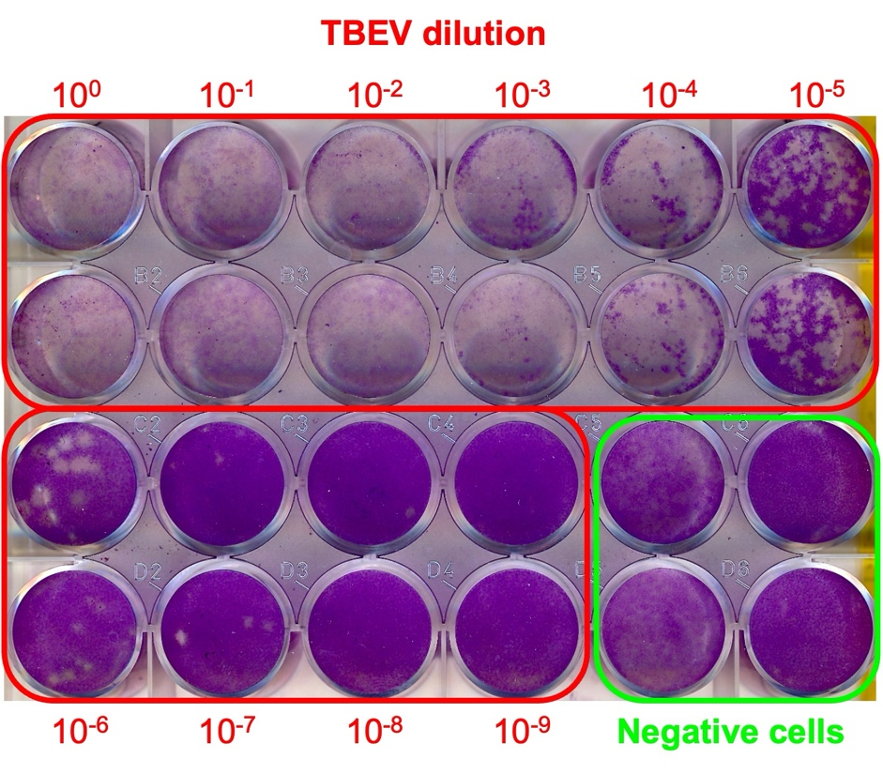
Fig. S1. Plaque titration assay of TBEV Hypr strain used in this study. 10-fold dilution series (from 10⁰ to 10⁻⁹) of the virus were used to infect BHK-21 cells in technical duplicates.

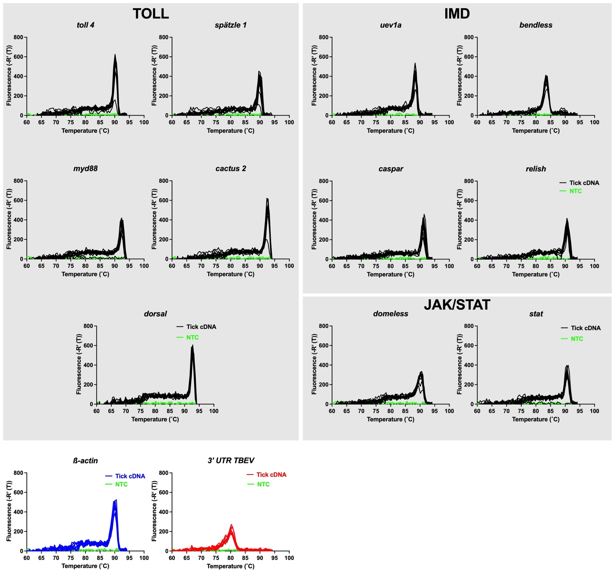
Fig. S2. Melting curve analysis. To demonstrate the specificity of the amplicons, black, blue, or red lines denote several coinfected tick cDNA samples used in qPCR, while the green lines are no template controls (NTC), showing the absence of primer-dimer formation.

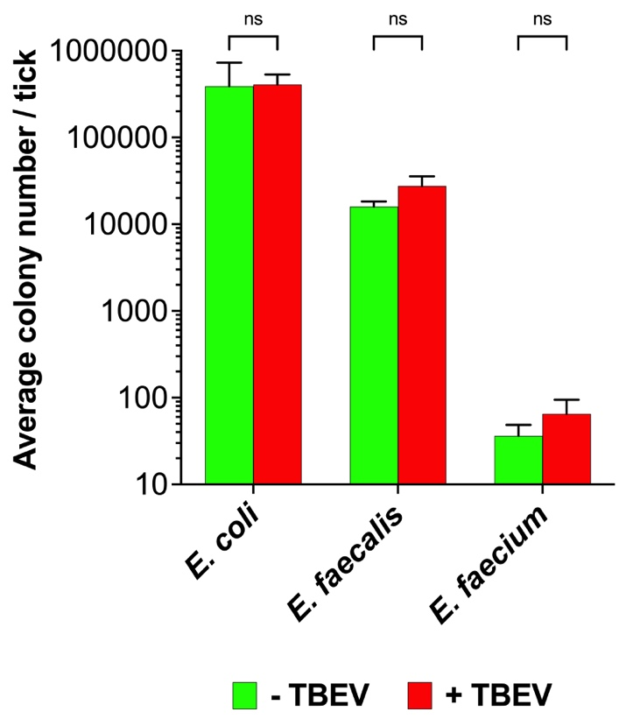
Fig. S3. Bacterial load in unfed Ixodes ricinus nymphal ticks. Bars represent the average colony numbers of tick pool samples (n = 10 ticks/pool) from 2 (Hypr-infected ticks) and 3 (naïve ticks) independent experiments, with standard error of the mean (SEM). ns = statistically insignificant difference.

Tab. S1. List of the primers used in this study. Numbers in brackets denote gene accession numbers in the VectorBase database.
Gene name | Primer sequence | Size | Reference
β-actin | F:5′-AGAGGGAAATCGTGCGTGAC-3′  R:5′-CAATAGTGATGACCTGGCCGT-3′ | 122 bp | Smith et al., 2017
Toll 4 _{(ISCW020989)} | F:5‘-AACTTCAGCCTCATCCAGCC-3‘  R:5‘-TGTGACCCAAGTCTAACCGC-3‘ | 295 bp | This study
Spatzle 1 _{(ISCW022569)} | F:5‘-ATCGAGGTCTGCAGGAACGA-3‘  R:5‘-TGGGAAAGAGAACCTGGACG-3‘ | 165 bp | This study
Myd88 _{(ISCW008802)} | F:5‘-ATGGATCTCGCGTCGCC-3‘  R:5‘-CTCCTTTCTGCTCTGCGCCA-3‘ | 261 bp | This study
Cactus 2 _{(ISCW007030)} | F:5‘-GTCGGCGCGAAGAGGACAAC-3‘  R:5‘-GCTGCTTCCGGATGAGTAGT-3‘ | 266 bp | This study
Dorsal _{(ISCW000140)} | F:5‘-ACGACATTGAGGTGTGGTTT-3‘  R:5‘-GTTGGGGTGCAGGGTGAAG-3‘ | 224 bp | This study
Uev1a _{(ISCW019147)} | F:5‘-ATGTGTACTCTTGCGTCGCC-3‘  R:5‘-CAGGATACTGCTGCCCGCAT-3‘ | 238 bp | This study
Bendless _{(ISCW006743)} | F:5‘-CATCGACAAGCTGGGACGTA-3‘  R:5‘-AGCCTGGATCGAGAGTAGCA-3‘ | 94 bp | This study
Caspar _{(ISCW015648)} | F:5‘-CAGCTGGTGCCCGAGGAA-3‘  R:5‘-CTGGCCAGGACCTTGTACTC-3‘ | 176 bp | This study
Relish _{(ISCW018935)} | F:5‘-AGGAGGGAGCAAAGTGGGCC-3‘  R:5‘-CCAGCCTTGGAATTTGCCAC-3‘ | 186 bp | This study
Domless _{(ISCW016699)} | F:5‘-GGACTACGGGAGCTTCAAGG-3‘  R:5‘-GGGTCGACTGCAGGATGAAG-3‘ | 131 bp | This study
STAT _{(ISCW016158)} | F:5‘-ATGGTTTCTTCGGTGGGGAT-3‘  R:5‘-AAAACCGGTACCTCAGACCC-3‘ | 221 bp | This study
TBEV | F:5‘-GGGCGGTTCTTGTTCTCC-3‘  R:5‘-TCCTTGTCAGACTRTCTGTGTCT-3‘ | 58 bp | Schwaiger & Cassinotti 2003  Ličková et al., 2020

