Supplemental Table S1. Within-Group Regression: Brain Score Predicting Mean Memory Accuracy

LV | Outcome | Group | b | SE | t | df | p | p (fdr) | 95% CI | R²
LV1 | Correct Source Rate | Pre-Meno | 0.02 | 0.03 | 0.60 | 39 | = .552 | = .631 | [-0.04, 0.07] | 0.01
LV1 | Correct Source Rate | Post-Meno | -0.04 | 0.02 | -1.70 | 36 | = .097 | = .447 | [-0.09, 0.01] | 0.07
LV1 | Correct Rejection Rate | Pre-Meno | 0.02 | 0.02 | 0.85 | 39 | = .398 | = .530 | [-0.03, 0.07] | 0.02
LV1 | Correct Rejection Rate | Post-Meno | 0.04 | 0.03 | 1.41 | 36 | = .166 | = .447 | [-0.02, 0.10] | 0.05
LV2 | Correct Source Rate | Pre-Meno | 0.01 | 0.03 | 0.43 | 39 | = .668 | = .668 | [-0.04, 0.07] | 0.00
LV2 | Correct Source Rate | Post-Meno | -0.03 | 0.02 | -1.24 | 36 | = .223 | = .447 | [-0.08, 0.02] | 0.04
LV2 | Correct Rejection Rate | Pre-Meno | -0.02 | 0.02 | -0.88 | 39 | = .382 | = .530 | [-0.07, 0.03] | 0.02
LV2 | Correct Rejection Rate | Post-Meno | 0.04 | 0.03 | 1.36 | 36 | = .183 | = .447 | [-0.02, 0.10] | 0.05
Note. N = 79 after memory-performance exclusion (Pre-Meno = 41, Post-Meno = 38). Brain score z-scored within each group. Outcome = mean accuracy averaged across easy and hard conditions.
p values corrected using FDR (Benjamini & Hochberg, 1995) across 8 within-group regression tests.
b = unstandardized regression coefficient; CI = 95% confidence interval; R² = variance explained.

Supplemental Figure S1: Imputation Method Comparison for Systolic Blood Pressure and Total Cholesterol

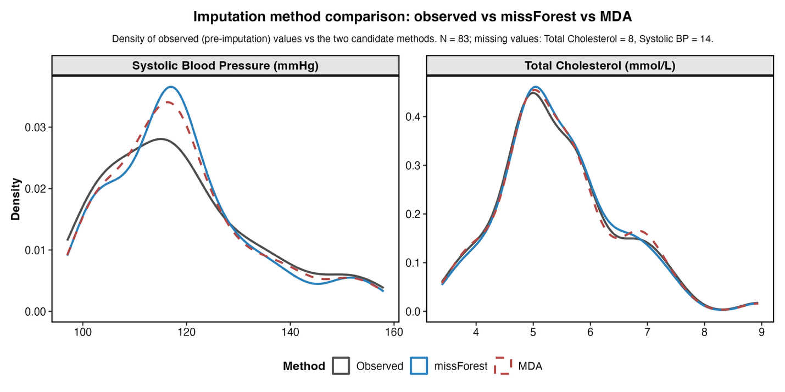

Note. Kernel density estimates of observed (pre-imputation) values for systolic blood pressure (left) and total cholesterol (right), overlaid with values produced by two candidate imputation methods (missForest random-forest imputation; mean difference adjustment, MDA). N = 83; missing values: total cholesterol = 8, systolic blood pressure = 14. missForest preserved the observed distributions more closely and was retained for the primary analysis.

Supplemental Figure S2. LV1 and LV2 Brain Scores Versus Mean Memory Accuracy by Reproductive-Stage Group

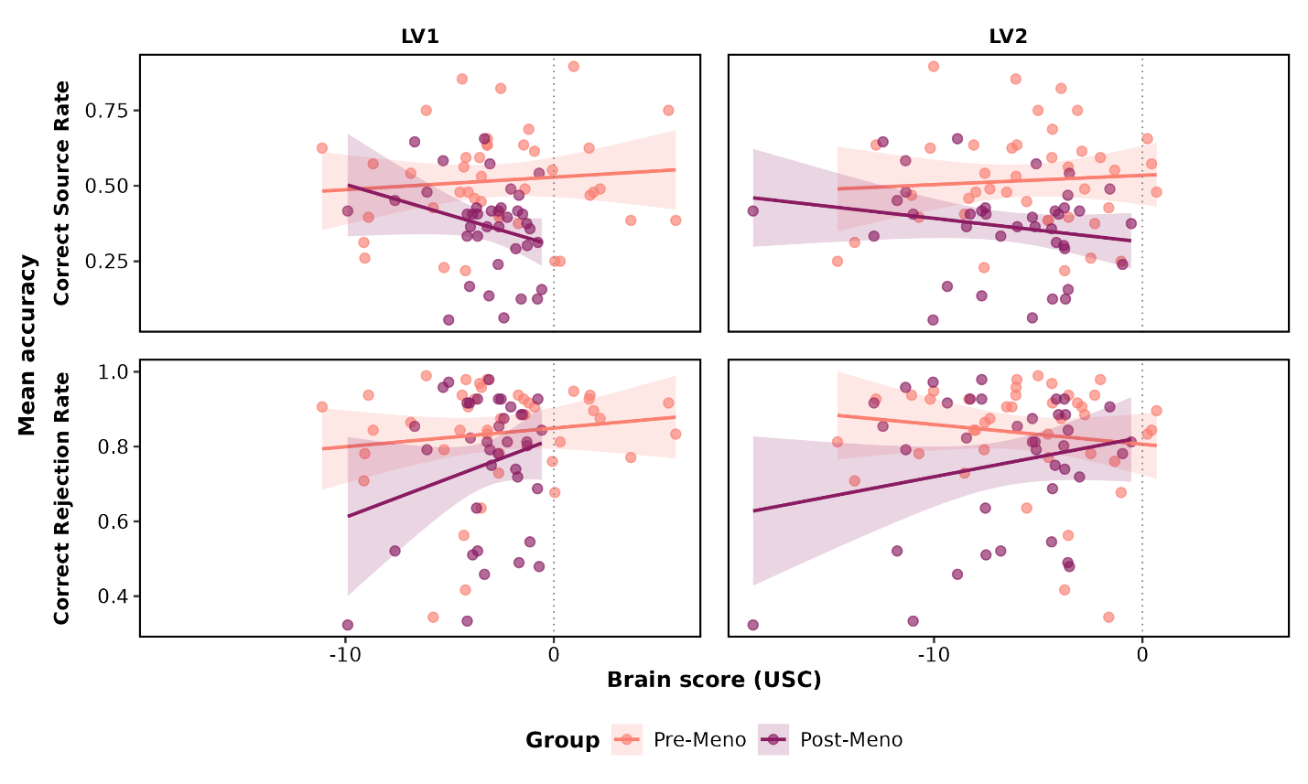

Note. Per-group scatter plots of LV1 and LV2 brain scores (x-axis) against mean memory accuracy (y-axis) for correct source rate (top) and correct rejection rate (bottom), with within-group linear fits (line) and 95% confidence bands (shaded). Premenopausal (salmon) and postmenopausal (maroon) participants are plotted separately. Companion figure to the within-group regression results reported in Supplemental Table S1; N = 79 after memory-performance exclusion.

Supplemental Figure S3.

S3A – Reduced PLS for SBP variable Alone
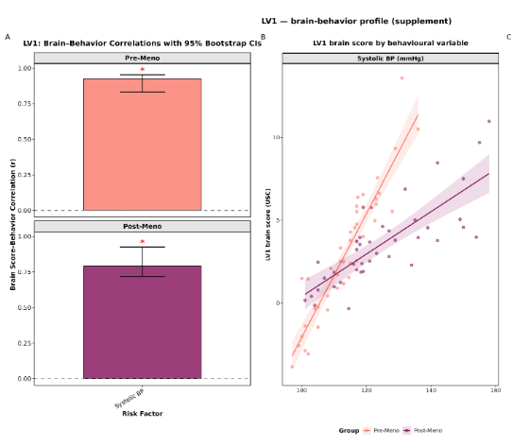

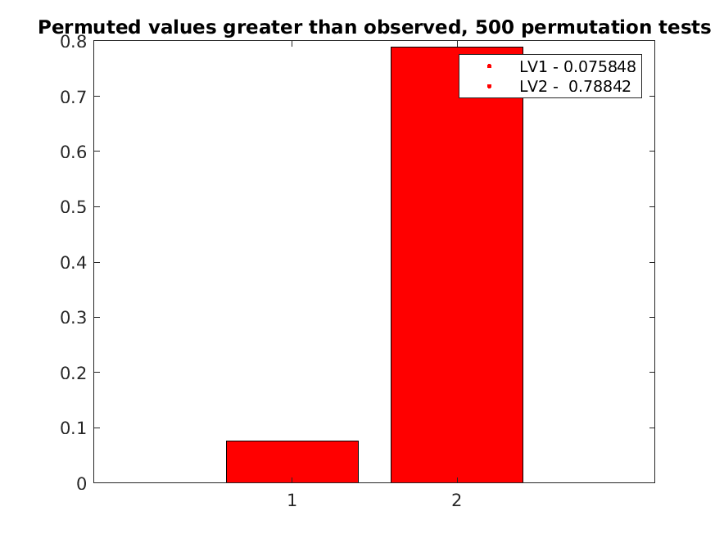

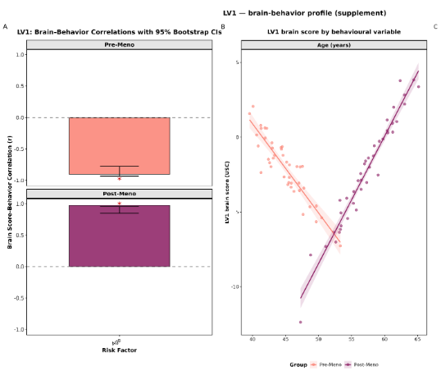
S3B – Reduced PLS for Age variable Alone

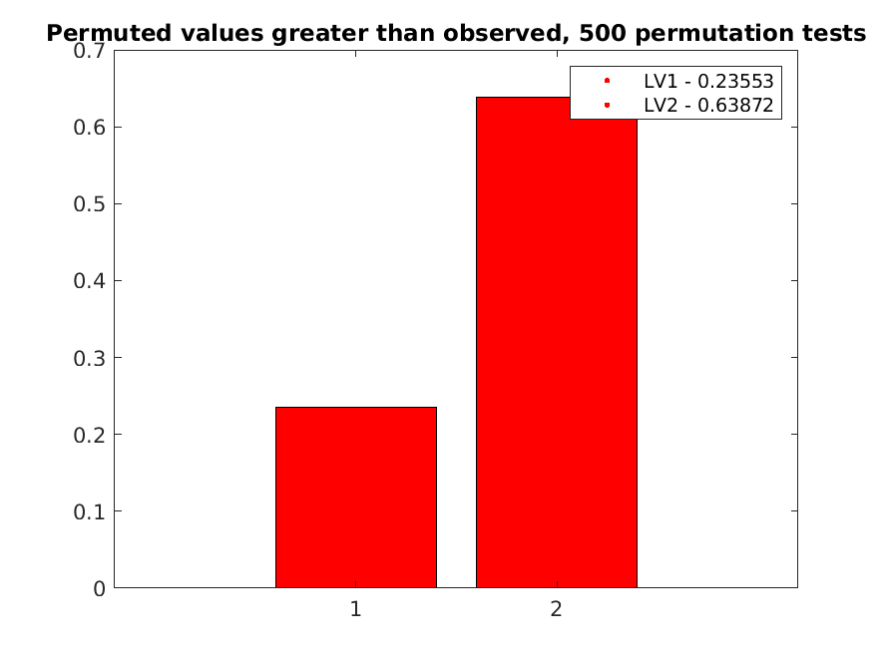

S3C – Reduced PLS for TC variable Alone
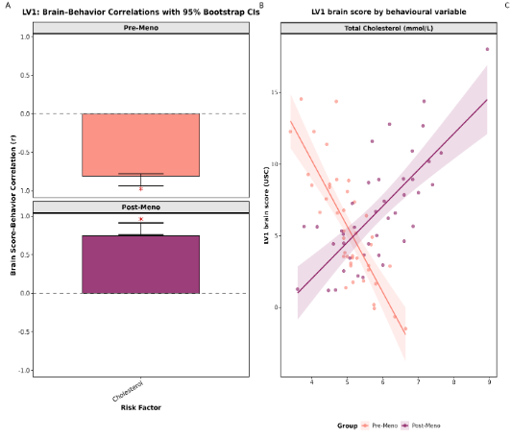
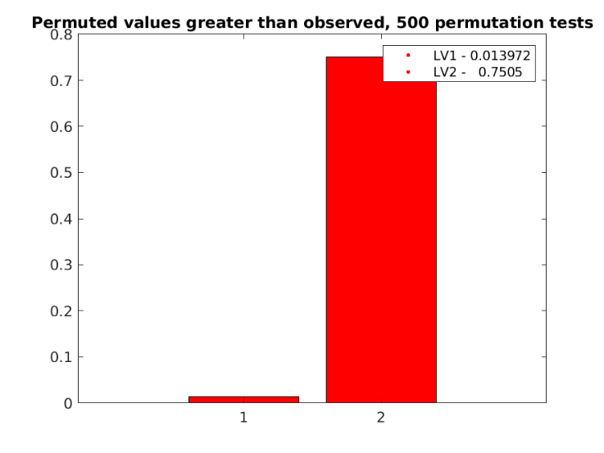

S3B – Reduced PLS for Education variable Alone
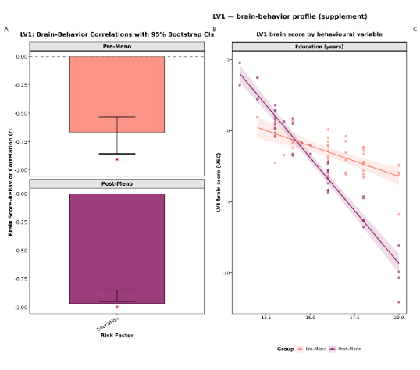

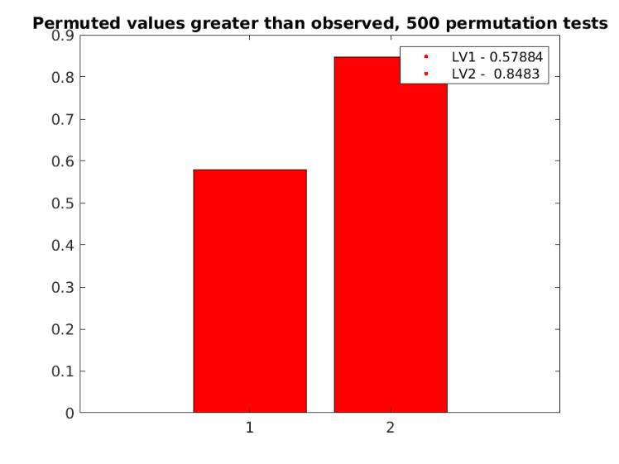

Note. Reduced-block B-PLS results for SBP (3A), Age (3B), TC (3C) and Education (3D) analyses. Each analysis used the same brain block and group structure as the primary B-PLS but with a single-variable behavioural block. Foe each Sub-LV (A) Brain–behaviour correlation profile, plotted separately for premenopausal (salmon) and postmenopausal (maroon) groups. Bars reflect within-group Pearson correlations between reduced-block brain scores and the single behavioural variable. Error bars show 95% bootstrap confidence intervals; asterisks indicate correlations whose CIs do not include zero. (B) The same within-group brain–behaviour relationship shown in (A), displayed as a scatter plot of reduced-block brain scores against the single behavioural variable, with within-group linear fits (line) and 95% confidence bands (shaded). Panel A summarises each within-group association as a single Pearson r; panel B shows the participant-level data underlying that correlation, with the slope of each within-group fit corresponding directly to the height of the matching bar in (A). Within-group Pearson r values with 95% bootstrap CIs are annotated. (C) Presents the permutation results for each analysis. Sub-LV1 for SBP had p = 0.08. Sub-LV1 for Age had a p = 0.24. Only Sub-LV1 for TC was significant, p = 0.014. The other variables and Sub-LVs had p-values > 0.5 and therefore were not significantly weighted in the interpretations of Main LV1 and LV2.

