Eco-Friendly Antimicrobial Food Packaging Films Based on PVA/Starch/Glycerol Blended with Frankincense Ethanolic Extract
(Supplementary information)

Table S-1: Quantities of starch, and PVA used in the preparation of PVA/starch blends
 | PVA | Starch
1 | 100% | -
2 | - | 100%
3 | 70% | 30%
4 | 50% | 50%
5 | 30% | 70%

Table S-2: Composition of biodegradable films (Quantities of starch, PVA, Plant extract and glycerol used in the preparation of formulated film).
Sr.  No. | (PVA/ Starch)  (70%:30%) | Glycerol | Plant extract (Frankincense)
AR-01 | 50.0 g | 5.0 g | ___
AR-02 | 50.0 g | 5.0 g | 0.1 g
AR-03 | 50.0 g | 5.0 g | 0.2 g
AR-04 | 50.0 g | 5.0 g | 0.3 g
AR-05 | 50.0 g | 5.0 g | 0.4 g
AR-06 | 50.0 g | 5.0 g | 0.5 g

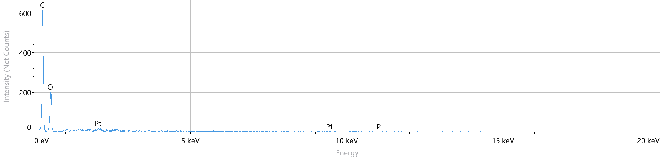
Figure S-1: EDX spectra of sample AR-01 film

Table S-3: Elemental composition of AR-01 film
Element | Weight %
Pt | 0.0
C | 48.8
O | 51.2

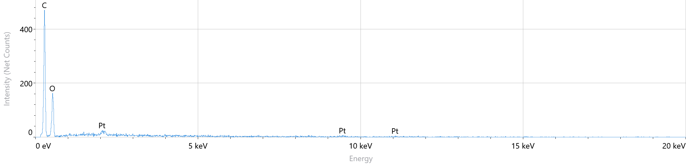
Figure S-2: EDX spectra of sample AR-02 film

Table S-4: Elemental composition of AR-02 film
Element | Weight %
C | 48.8
O | 51.2

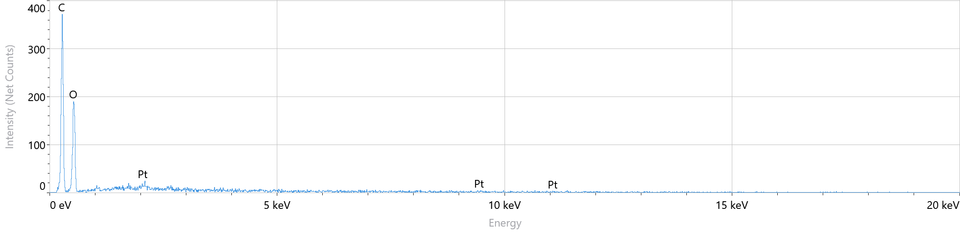
Figure S-3: EDX spectra of sample AR-04 film

Table S-5: Elemental composition of AR-04 film
Element | Weight %
C | 43.4
O | 56.6

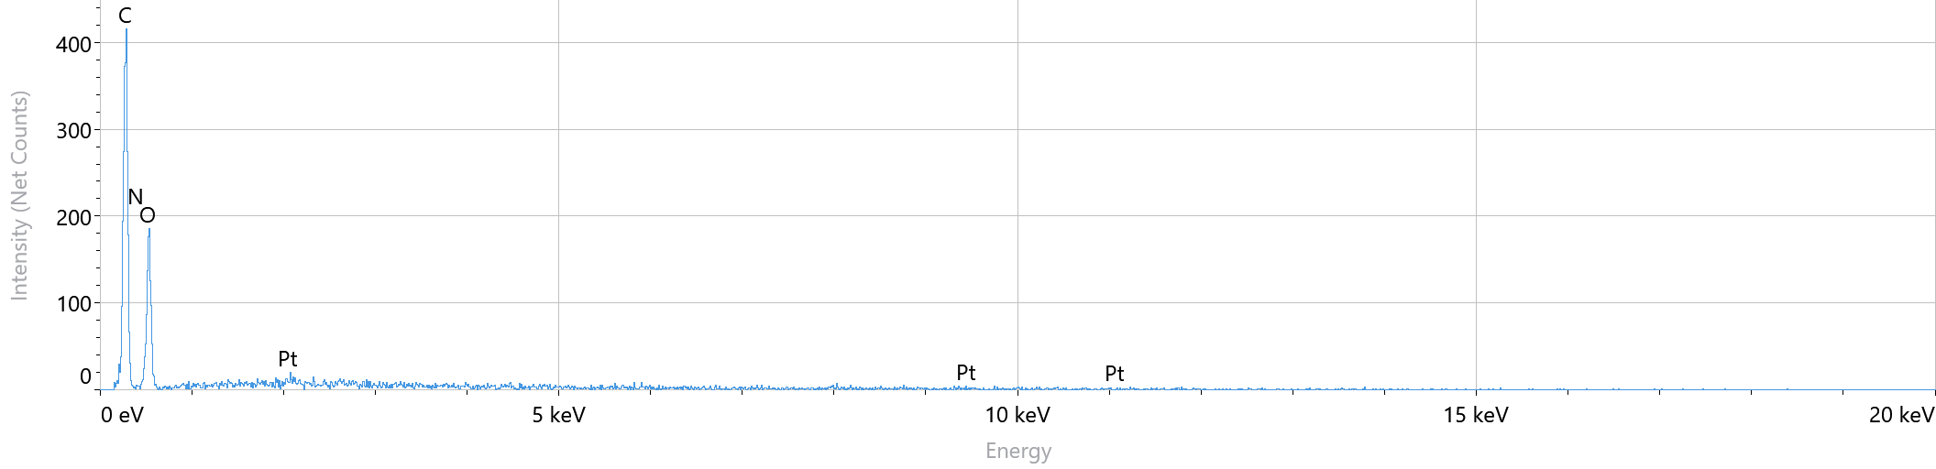
Figure S-4: EDX spectra of sample AR-05 film

Table S-6: Elemental composition of AR-05 film
Element | Weight %
N | 4.5
C | 44.1
O | 51.4

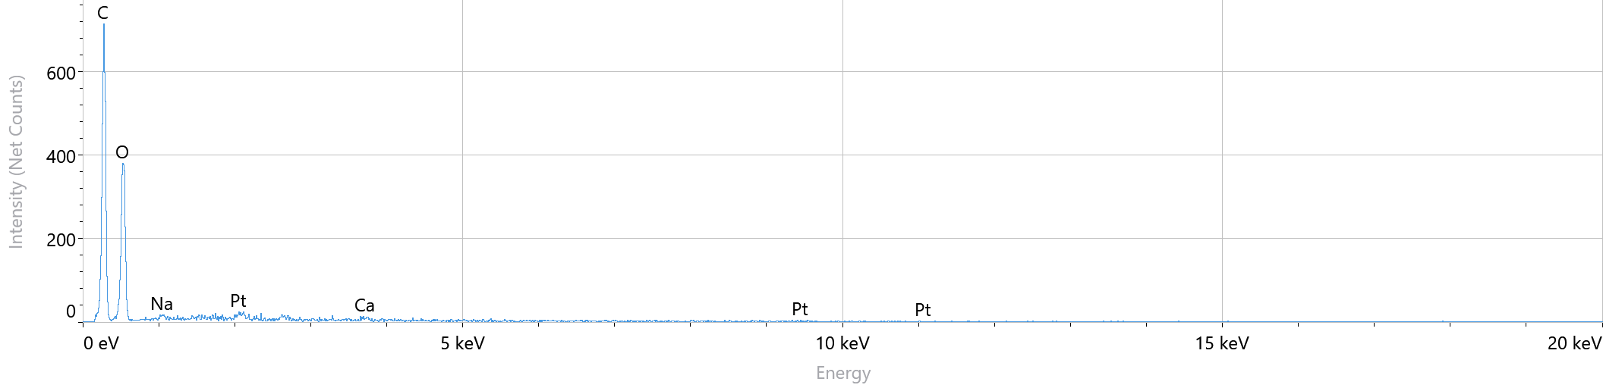
Figure S-5: EDX spectra of sample AR-06 film

Element | Weight %
C | 41.7
O | 58.3
Table S-7: Elemental composition of AR-06 film

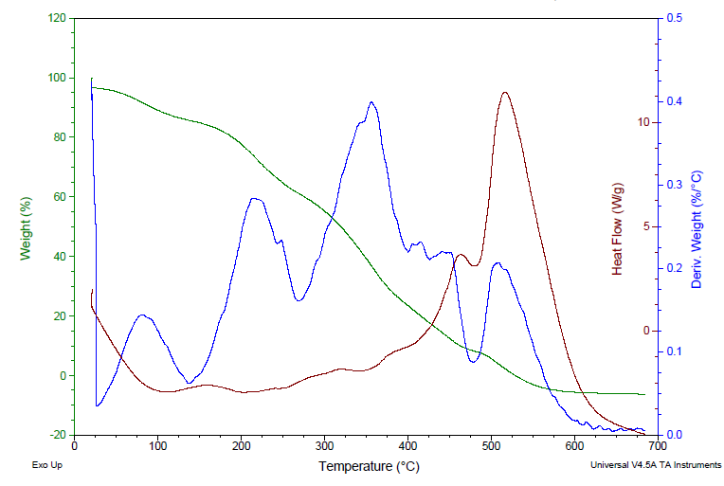
Figure S-6: DSC/DTA spectra (coupled with TGA) of AR-01 film

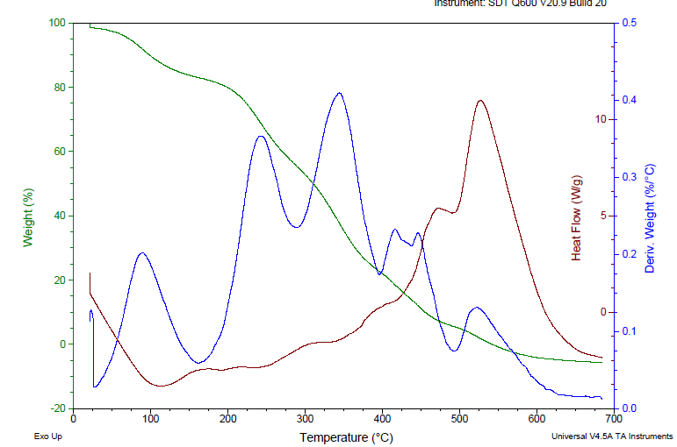
Figure S-7: DSC/DTA spectra (coupled with TGA) of AR-02 film

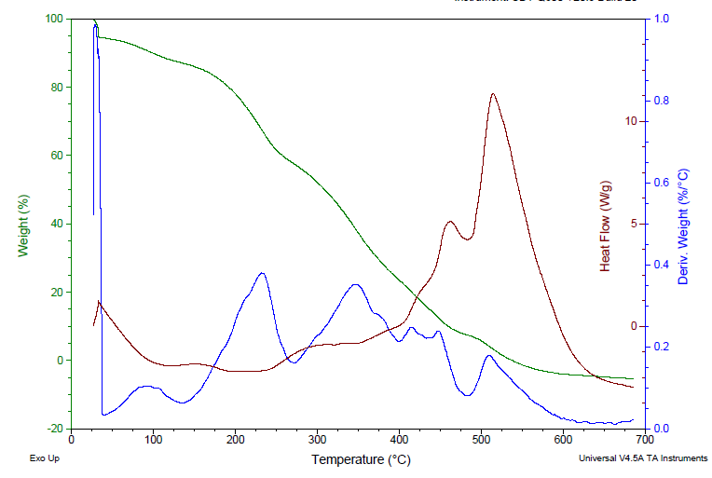
Figure S-8: DSC/DTA spectra (coupled with TGA) of AR-03 film.

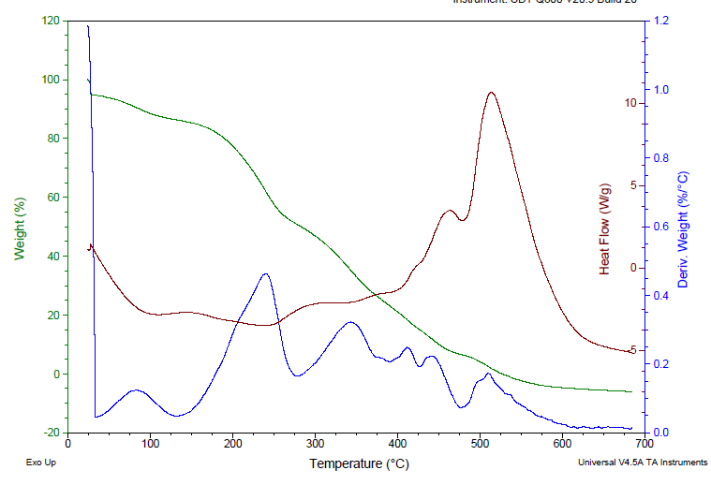
Figure S-9: DSC/DTA spectra (coupled with TGA) of AR-04 film

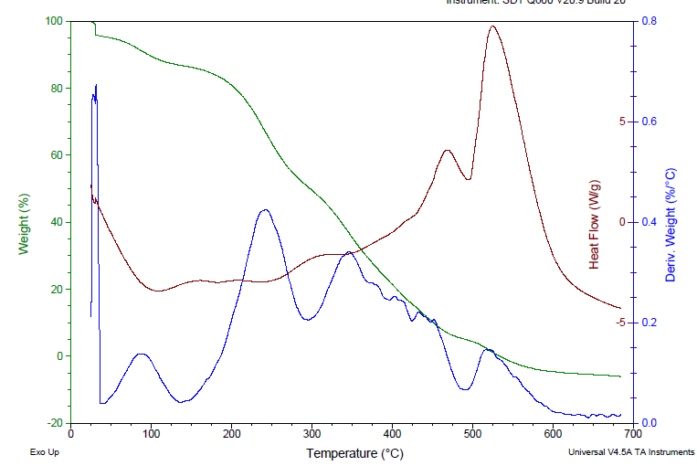
Figure S-10: DSC/DTA spectra (coupled with TGA) of AR-05 film

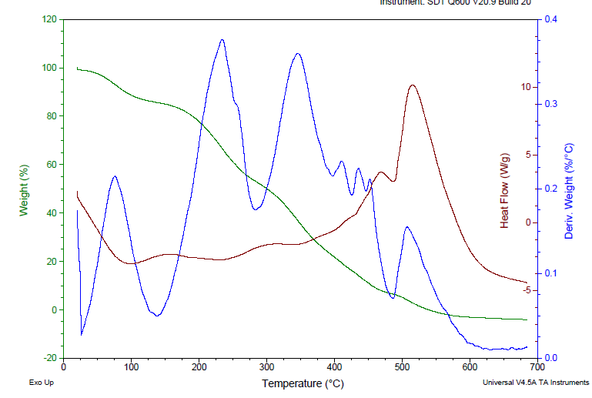
Figure S-11: DSC/DTA spectra (coupled with TGA) of AR-06 film

Sample | before | after | %
AR-01 | 0.1018 | 0.5545 | 81.64
AR-02 | 0.1283 | 0.6445 | 80.09
AR-03 | 0.1757 | 0.5540 | 68.29
AR-04 | 0.1746 | 0.5355 | 67.39
AR-05 | 0.0985 | 0.2918 | 66.24
AR-06 | 0.1791 | 0.4206 | 57.42

Table S-8: Water absorption capacity test of Starch/PVA Films Before and After immersion

Table S-9: Tensile strength/elongation test of formulated films (AR-01 to AR-06)
Sample | Tensile Strength | Elongation
Sample | [MPa] | %
AR-01 | 2.752 | 6.241
AR-02 | 2.852 | 7.356
AR-04 | 3.025 | 8.325
AR-05 | 3.45 | 9.574
AR-06 | 3.941 | 10.235

Table S-10: Soil Degradation of Starch/PVA Films Before and After Soil Burial
Sample | Before | After
AR-01 | 0.2804 | 0.2130
AR-02 | 0.2187 | 0.1627
AR-03 | 0.2074 | 0.1483
AR-04 | 0.1812 | 0.1137
AR-05 | 0.1768 | 0.1097
AR-06 | 0.1709 | 0.1056

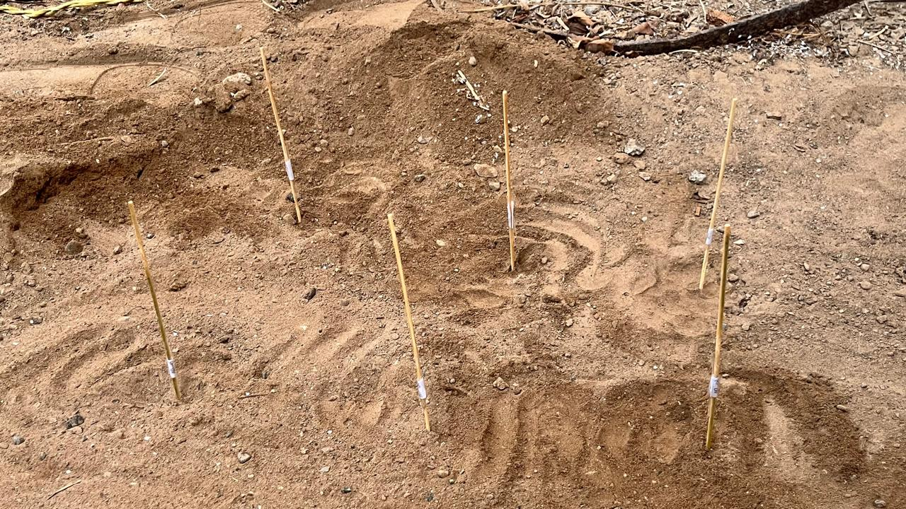
Figure S-12. A setup for the testing the formulated film by soil burial test.

