Supporting Information
The remediation strategy and mechanism of combined passivation and foliar inhibition for safe rice production in red paddy soil contaminated with heavy metals
Fengsong Zhang^{1,2}, Lixia He³, Guixiang Zhang^{3*}, Zhuo Wei⁴, Jiaqi Wang¹, Hongfang Liu³, Siyang Wu⁵
1. Key Laboratory of Land Surface Pattern and Simulation, Institute of Geographic Sciences and Natural Resources Research, Chinese Academy of Sciences, Beijing 100101, China
2. Zhongke-Ji’an Institute for Eco-Environmental Sciences, Ji’an 343000, China
3. College of Environment and Safety, Taiyuan University of Science and Technology, Taiyuan 030024, Shanxi Province, China
4. School of Plant, Environmental and soil Sciences, Louisiana State University, Baton Rouge, LA 70803, USA
5. Research Center of Heavy Metal Pollution Control, Chinese Academy of Environmental Planning

Corresponding author:
E-mail addresses: zhanggx@tyust.edu.cn (Guixiang Zhang)

S1 Screening of passivators
Fig. S1 illustrates the results of available heavy metals in soil after the addition of passivators. Among organic passivation agents, polyacrylamide effectively significantly decreased the content of available Cd, Pb and Cu in soil (p < 0.05). Among the mineral passivators, zeolite did not significantly decrease the available Cd and Pb in soil as compared with the control (p > 0.05), while sepiolite and goetite significantly decreased the available Cd and Pb in soil (p < 0.05). However, goethite significantly increased the content of available Cu in soil as compared with sepiolite (p < 0.05). Among the mineral passivators studied in the present experiment, sepiolite had a better effect on the decrease in the content of available heavy metals in soil. Therefore, according to the results of laboratory experiments, we chosed polyacrylamide, sepiolite and quicklime as original materials of combined passivation for the remediation of heavy metals-contaminated acid soil.

Table S1 The laboratory screening experiment consisted of ten treatments with different passivators added.

Abbreviation | passivators | Dosage of reagents（g) | Dosage of soil (g)
CK |  | 0 | 100
P5 | peat | 5 | 100
A5 | polyacrylamide | 5 | 100
S5 | sepiolite | 5 | 100
Z5 | zeolite | 5 | 100
T5 | geothit | 5 | 100
Q5 | quicklime | 5 | 100
C5 | calcium hydroxide | 5 | 100
G5 | calcium silicate | 5 | 100
N5 | sodium silicate | 5 | 100
F5 | ferrous sulfide | 5 | 100

Table S2 The field experiment consisted of twelve treatments with different amounts of combined passivation and foliar inhibition added.

 | Combined passivation and foliar inhibition addition
 | Quicklime | Polyacrylamide | Sepiolite | siliceous fertilizer | selenium fertilizer
 | （kg·ha⁻¹） |  |  | （mL·mu⁻¹）
CK | 0 | 0 | 0 | 0 | 0
Q1 | 1500 | 0 | 0 | 0 | 0
Q2 | 1875 | 0 | 0 | 0 | 0
QA1 | 1500 | 375 | 0 | 0 | 0
QA2 | 1875 | 750 | 0 | 0 | 0
QS1 | 1500 | 0 | 975 | 0 | 0
QS2 | 1875 | 0 | 2025 | 0 | 0
QAS1 | 1500 | 150 | 750 | 0 | 0
QAS2 | 1875 | 300 | 1500 | 0 | 0
QSi1 | 1500 | 0 | 0 | 50 | 0
QSi2 | 1875 | 0 | 0 | 100 | 0
QSe1 | 1500 | 0 | 0 | 0 | 125
QSe2 | 1875 | 0 | 0 | 0 | 250

Table S3 Bioconcentration factor (BCF) of heavy metals.

 | Cd–BCF (%) | Pb–BCF (%) | Cu–BCF (%)
CK | 87.39 ± 3.42 e | 0.09 ± 0.04 bc | 6.22 ± 0.66 cd
Q1 | 8.65 ± 0.00 a | 0.12 ± 0.04 c | 5.94 ± 0.82 cd
Q2 | 20.18 ± 4.68 b | 0.10 ± 0.01 bc | 7.94 ± 0.15 ef
QA1 | 6.01 ± 0.55 a | 0.00 ± 0.00 a | 3.66 ± 0.25 a
QA2 | 35.68 ± 2.16 c | 0.11 ± 0.00 bc | 7.06 ± 0.99 de
QS1 | 63.42 ± 8.29 d | 0.12 ± 0.01 c | 8.58 ± 0.92 fg
QS2 | 94.59 ± 7.03 f | 0.07 ± 0.02 b | 7.99 ± 0.64 ef
QAS1 | 67.75 ± 6.87 d | 0.12 ± 0.01 c | 8.64 ± 1.20 fg
QAS2 | 21.08 ± 0.90 b | 0.12 ± 0.02 c | 8.82 ± 0.36 fg
QSi1 | 25.05 ± 0.18 b | 0.12 ± 0.02 c | 5.19 ± 0.33 bc
QSi2 | 13.33 ± 1.08 a | 0.10 ± 0.01 bc | 4.07 ± 0.12 ab
QSe1 | 67.57 ± 2.70 d | 0.13 ± 0.02 c | 9.29 ± 0.92 g
QSe2 | 12.61 ± 1.44 a | 0.00 ± 0.00 a | 4.21 ± 0.30 ab

Table S4 The total amount of heavy metals in the passivators and foliar inhibition

passivators | Cd | Pb | Cu
peat | ND | ND | 24.17 mg/kg
polyacrylamide | ND | ND | ND
sepiolite | ND | ND | 7.56 mg/kg
zeolite | ND | ND | 6.10 mg/kg
geothit | ND | ND | 30.23 mg/kg
quicklime | ND | ND | 7.73 mg/kg
calcium hydroxide | ND | ND | 6.73 mg/kg
calcium silicate | ND | ND | 10.72 mg/kg
sodium silicate | ND | ND | ND
ferrous sulfide | ND | ND | 58.17 mg/kg
foliar Si inhibitors | ND | ND | 0.21 mg/L
foliar Se inhibitors | ND | ND | ND
Note: ND means not detected

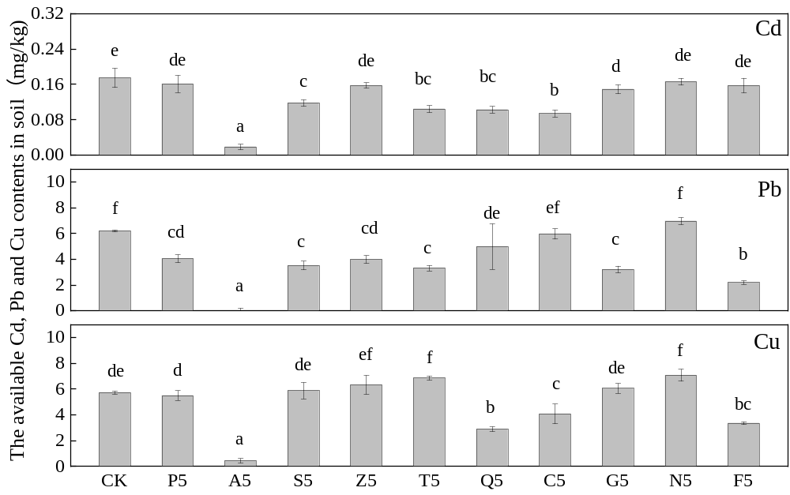Fig. S1. The availabilities of Cd, Pb and Cu contents in soil. (peat (P), polyacrylamide (A), quicklime (Q), calcium hydroxide (C), calcium silicate (G), sodium silicate (N), ferrous sulfide (F), sepiolite (S), zeolite (Z) and geothite (T). Different letters above columns indicate significant difference at p < 0.05 between treatments at the stage (Tukey, replicate N=3).)

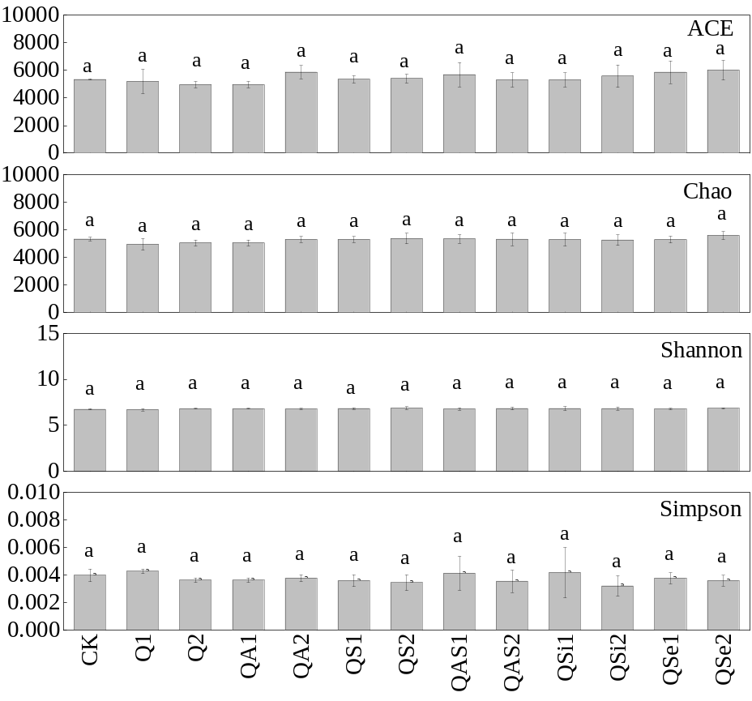
Fig. S2. Bacterial abundance and diversity in different treatments. (Different letters above columns indicate significant difference at p < 0.05 between treatments at the stage (Tukey, replicate N=3).)

