SUPPLEMENTARY MATERIAL

Supplementary Table S1. Detailed Search Strategy
Date of Search: June 15, 2025 Language: English Reference Lists: Reference lists of all included studies and relevant systematic reviews were manually screened.

Database | Search Strategy | Results
PubMed | ("HER2-positive breast cancer") AND ("neoadjuvant therapy"[MeSH] OR "neoadjuvant") AND ("taxane" OR "docetaxel") AND ("pertuzumab" AND "trastuzumab") AND ("carboplatin") | 46
Embase | ('her2-positive breast cancer'/exp OR 'her2-positive breast cancer') AND ('neoadjuvant therapy'/exp OR neoadjuvant) AND ('taxane'/exp OR taxane OR 'docetaxel'/exp) AND (('pertuzumab'/exp) AND ('trastuzumab'/exp)) AND ('carboplatin'/exp) | 451
Cochrane Central | ("HER2-positive breast cancer") AND (neoadjuvant) AND (taxane OR docetaxel) AND (pertuzumab AND trastuzumab) AND (carboplatin) | 44
ClinicalTrials.gov | HER2-positive breast cancer AND neoadjuvant AND pertuzumab AND carboplatin | 36
TOTAL before de-duplication |  | 577
After de-duplication |  | 453
Conference abstracts: Search terms included "HER2 breast cancer," "neoadjuvant," "pertuzumab," and "carboplatin" in ASCO, ESMO, and SABCS proceedings (2018–2025).
Supplementary Table S2. Risk of Bias Assessment
Part A: Randomized Controlled Trials (Cochrane RoB 2 Tool)
Study | D1: Randomization | D2: Deviations | D3: Missing Data | D4: Measurement | D5: Reporting | Overall
Chen et al., 2025 (HELEN-006) [11] | Low | Low | Low | Low | Low | Low
Gao et al., 2026 (neoCARHP) [12] | Low | Low | Low | Low | Low | Low
Both RCTs were multicenter phase 3 trials with centralized randomization (IWRS), concealed allocation, and intention-to-treat analysis.

Part B: Observational Studies (ROBINS-I Tool)
Study | D1: Confounding | D2: Selection | D3: Classification | D4: Deviations | D5: Missing | D6: Measurement | D7: Reporting | Overall
Lin et al., 2023 [13] | Serious | Moderate | Low | Moderate | Low | Low | Moderate | Serious
Lv et al., 2020 [23] | Moderate | Moderate | Low | Low | Low | Low | Low | Moderate
Ma et al., 2022 [24] | Moderate | Moderate | Low | Low | Low | Low | Low | Moderate
Spring et al., 2018 [25] | Serious | Serious | Low | Moderate | Moderate | Low | Moderate | Serious
Wu et al., 2024 [26] | Moderate | Moderate | Low | Low | Low | Low | Low | Moderate
Risk of bias was assessed per ROBINS-I guidelines [18]. Primary sources of bias were confounding by indication and patient selection.

Supplementary Table S3. Publication Bias Assessment
Method | N Studies | Result | Interpretation
Visual Inspection | 7 | Reasonably symmetrical | No strong evidence of bias
Egger's Test | 7 | p = 0.31 | No significant asymmetry
Trim-and-Fill | 7 | 0 studies imputed | No adjustment needed
Conclusion: Multiple assessment methods did not detect significant publication bias for the primary outcome of pCR. With fewer than 10 studies, these tests are underpowered and cannot exclude a small-study effect.

Supplementary Table S4. PRISMA 2020 Checklist
Section/Topic | Item | Checklist Item | Location Where Addressed
TITLE
Title | 1 | Identify the report as a systematic review, meta-analysis, or both. | Title
ABSTRACT
Abstract | 2 | See PRISMA 2020 for Abstracts checklist. | Abstract
INTRODUCTION
Rationale | 3 | Describe the rationale for the review in the context of what is already known. | Introduction, Paragraphs 2-4
Objectives | 4 | Provide an explicit statement of the questions being addressed with reference to participants, interventions, comparisons, and outcomes (PICO). | Introduction, Paragraph 5
METHODS
Eligibility criteria | 5 | Specify the inclusion and exclusion criteria for the review and how studies were grouped for the syntheses. | Methods, Eligibility Criteria
Information sources | 6 | Specify all databases, registers, websites, organizations, citation searching, and other sources searched or consulted to identify studies. | Methods, Search Strategy
Search strategy | 7 | Present the full search strategies for all databases, registers, and websites, including any filters and limits used. | Supplementary Table S1
Selection process | 8 | Specify the methods used to decide whether a study met the inclusion criteria of the review, including how many reviewers screened each record and each report retrieved, whether they worked independently, and if applicable, details of automation tools used in the process. | Methods, Study Selection
Data collection process | 9 | Specify the methods used to collect data from reports, including how many reviewers collected data from each report, whether they worked independently, any processes for obtaining or confirming data from study investigators, and if applicable, details of automation tools used in the process. | Methods, Data Extraction
Data items | 10a | List and define all outcomes for which data were sought. | Methods, Eligibility Criteria
 | 10b | List and define all other variables for which data were sought (e.g., participant and intervention characteristics, funding sources). | Methods, Data Extraction
Risk of bias assessment | 11 | Specify the methods used to assess risk of bias in the included studies, including details of the tool(s) used, how many reviewers assessed each study and whether they worked independently, and if applicable, details of automation tools used in the process. | Methods, Risk of Bias Assessment
Effect measures | 12 | Specify for each outcome the effect measure(s) (e.g., risk ratio, mean difference) used in the synthesis or presentation of results. | Methods, Statistical Analysis
Synthesis methods | 13a | Describe the processes used to decide which studies were eligible for each synthesis (e.g., tabulating the intervention characteristics and comparing against the planned groups for each synthesis). | Methods, Statistical Analysis
 | 13b | Describe any methods required to prepare the data for synthesis, such as handling of missing summary statistics, or data conversions. | Methods, Statistical Analysis (0.5 continuity correction for zero-cell studies)
 | 13c | Describe any methods used to tabulate or visually display results of individual studies and syntheses. | Methods, Statistical Analysis
 | 13d | Describe any methods used to synthesize results and provide a rationale for the choice(s). If meta-analysis was performed, describe the model(s), method(s) to identify the presence and extent of statistical heterogeneity, and software used. | Methods, Statistical Analysis
 | 13e | Describe any methods used to explore possible causes of heterogeneity among study results (e.g., subgroup analysis, meta-regression). | Methods, Statistical Analysis
 | 13f | Describe any sensitivity analyses conducted to assess robustness of the synthesized results. | Methods, Statistical Analysis
Reporting bias assessment | 14 | Describe any methods used to assess risk of bias due to missing results in a synthesis (arising from reporting biases). | Methods, Statistical Analysis
Certainty assessment | 15 | Describe any methods used to assess certainty (or confidence) in the body of evidence for an outcome. | Methods, Certainty of Evidence; Results, Certainty of Evidence; Supplementary Table S5
RESULTS
Study selection | 16a | Describe the results of the search and selection process, from the number of records identified in the search to the number of studies included in the review, ideally using a flow diagram. | Results, Study Selection; Figure 1
 | 16b | Cite studies that might appear to meet the inclusion criteria, but which were excluded, and explain why they were excluded. | Results, Study Selection
Study characteristics | 17 | Cite each included study and present its characteristics. | Table 1
Risk of bias in studies | 18 | Present assessments of risk of bias for each included study. | Supplementary Table S2
Results of individual studies | 19 | For all outcomes, present, for each study: (a) summary statistics for each group (where appropriate) and (b) an effect estimate and its precision (e.g., confidence/credible interval), ideally using structured tables or plots. | Table 2; Figures 2 and 4; Supplementary Figures S7-S10 (per-study events, totals, and effect estimates shown in forest plots)
Results of syntheses | 20a | For each synthesis, present results for all outcomes, including summary statistics for each group (where appropriate), and the calculated effect estimate and its precision (e.g., confidence/credible interval). | Results, Primary Outcome; Results, Safety and Tolerability
 | 20b | Present results of all investigations of possible causes of heterogeneity among study results. | Results, Subgroup and Sensitivity Analyses; Supplementary Figures S3 and S5
 | 20c | Present results of all sensitivity analyses conducted to assess the robustness of the synthesized results. | Results, Subgroup and Sensitivity Analyses; Supplementary Figure S2
Reporting biases | 21 | Present assessments of risk of bias due to missing results (arising from reporting biases) for each synthesis assessed. | Results, Publication Bias; Supplementary Table S3 and Supplementary Figure S1
Certainty of evidence | 22 | Present assessments of certainty (or confidence) in the body of evidence for each outcome assessed. | Methods, Certainty of Evidence; Results, Certainty of Evidence; Supplementary Table S5
DISCUSSION
Discussion | 23a | Provide a general interpretation of the results in the context of other evidence. | Discussion, Paragraphs 1-3
 | 23b | Discuss any limitations of the evidence included in the review. | Discussion, Paragraph 5
 | 23c | Discuss any limitations of the review processes used. | Discussion, Paragraph 5
 | 23d | Discuss the implications of the results for practice, policy, and future research. | Discussion, Paragraphs 4, 6
OTHER INFORMATION
Registration and protocol | 24a | Provide registration information for the review, including register name and registration number, or state that the review was not registered. | Methods, Protocol and Registration
 | 24b | Indicate where the review protocol can be accessed, or state that a protocol was not prepared. | Methods, Protocol and Registration
 | 24c | Describe and explain any amendments to information provided at registration or in the protocol. | Methods, Protocol and Registration
Support | 25 | Specify the sources of financial or non-financial support for the review, and the role of the funders or sponsors in the review. | Statements and Declarations, Funding
Competing interests | 26 | Declare any competing interests of review authors. | Statements and Declarations, Competing Interests
Availability of data, code, and other materials | 27 | Report which of the following are publicly available and where they can be found: template data collection forms; data extracted from included studies; data used for all analyses; analytic code; any other materials used in the review. | Statements and Declarations, Data Availability

SUPPLEMENTARY FIGURES
Supplementary Figure S1. Funnel Plot for Publication Bias Assessment (pCR)
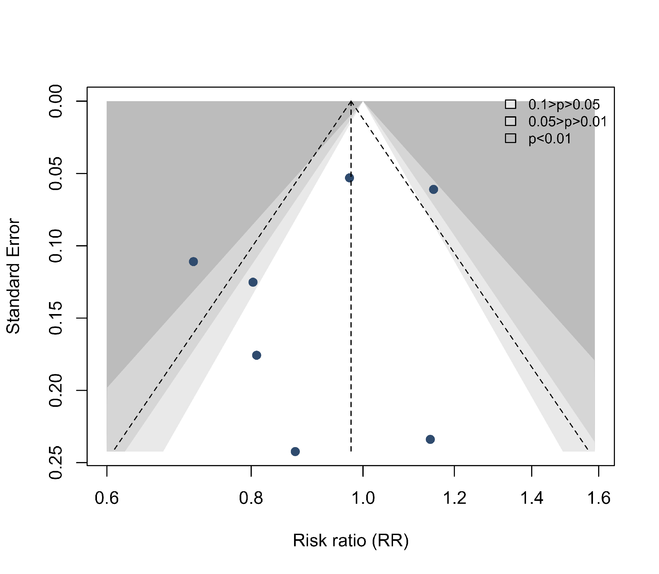

Legend: Funnel plot of the seven included studies examining pCR rates with THP versus TCbHP. The x-axis represents the log risk ratio and the y-axis the standard error (inverted). The vertical dashed line indicates the fixed-effect estimate (RR=0.98); shaded regions denote conventional significance contours. A reasonably symmetrical distribution and a non-significant Egger test (p=0.31) suggest no substantial publication bias, although this test is underpowered with seven studies.
Supplementary Figure S2. Leave-One-Out Sensitivity Analysis for pCR
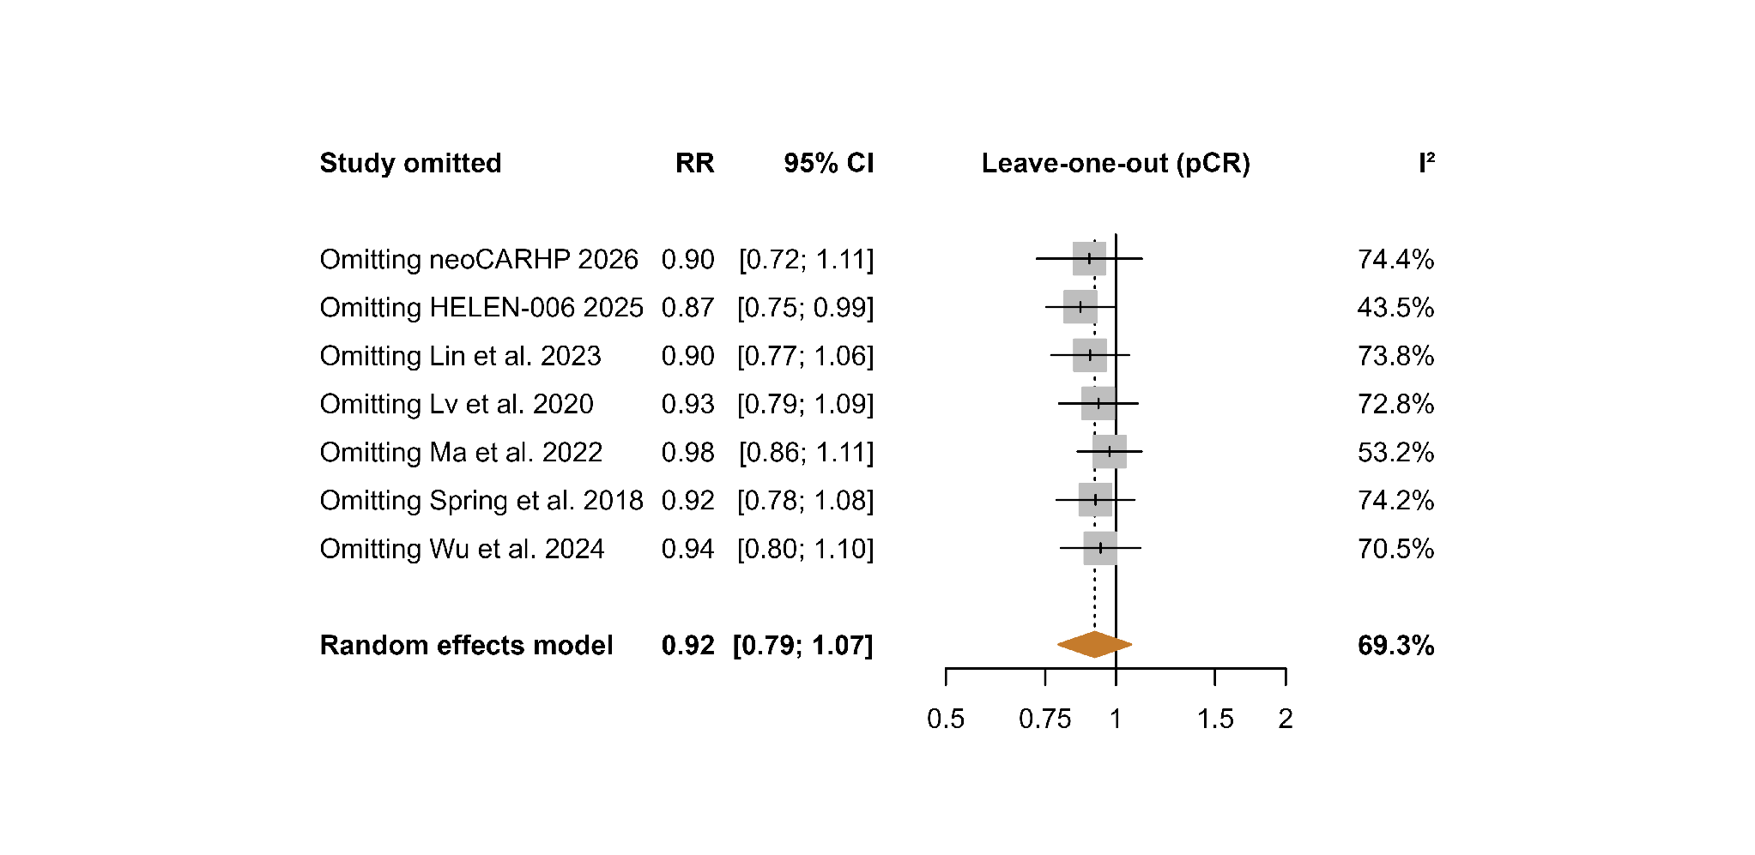
Legend: Leave-one-out sensitivity analysis for the primary outcome of pCR. Each row shows the pooled RR when the named study is excluded. The pooled RR ranged from 0.87 (excluding HELEN-006) to 0.97 (excluding Ma et al.), with the 95% CI including 1.0 in all iterations except the exclusion of HELEN-006 (RR 0.87, 95% CI 0.75–0.99). Excluding HELEN-006 reduced heterogeneity from I²=69% to I²=43%.

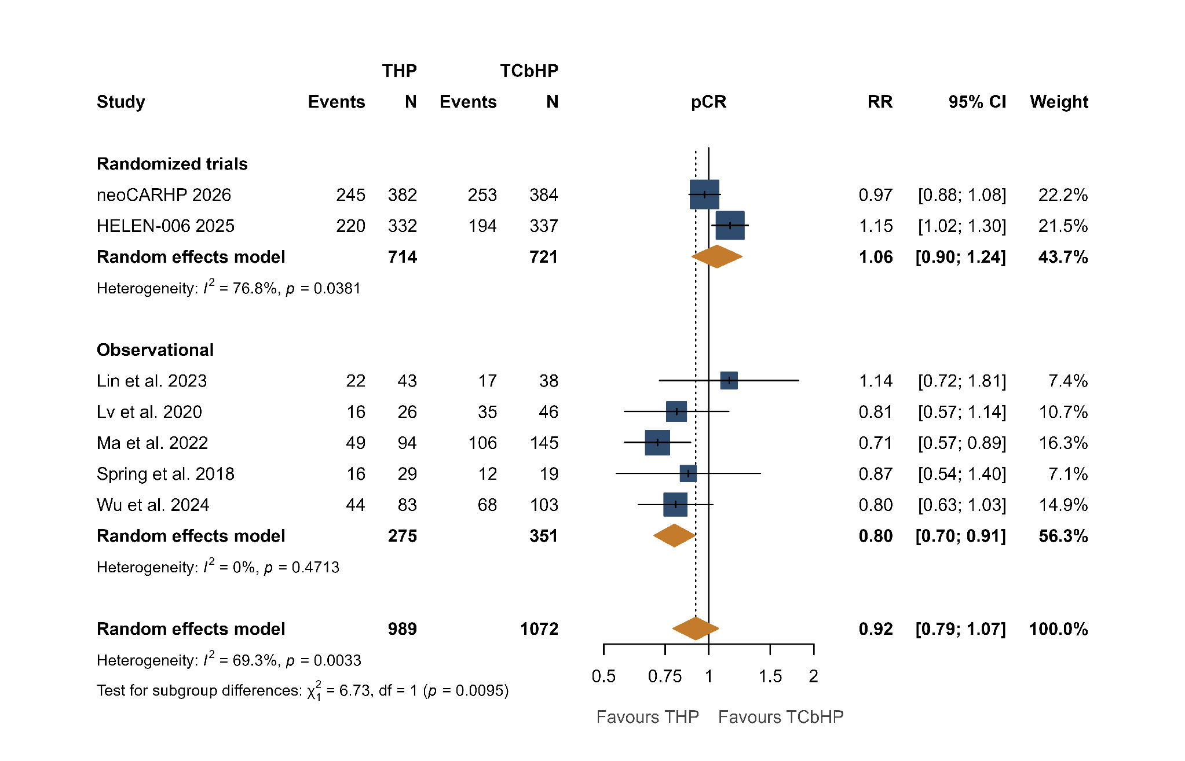
Supplementary Figure S3. pCR Subgroup Analysis by Study Design

Legend: Forest plot showing pCR subgroup analysis by study design. For RCTs (n=2; 1,435 patients), the pooled RR was 1.06 (95% CI 0.90–1.24; I²=77%), indicating equivalent efficacy. For observational studies (n=5; 626 patients), the pooled RR was 0.80 (95% CI 0.70–0.91; I²=0%), favoring TCbHP, likely reflecting confounding by indication.
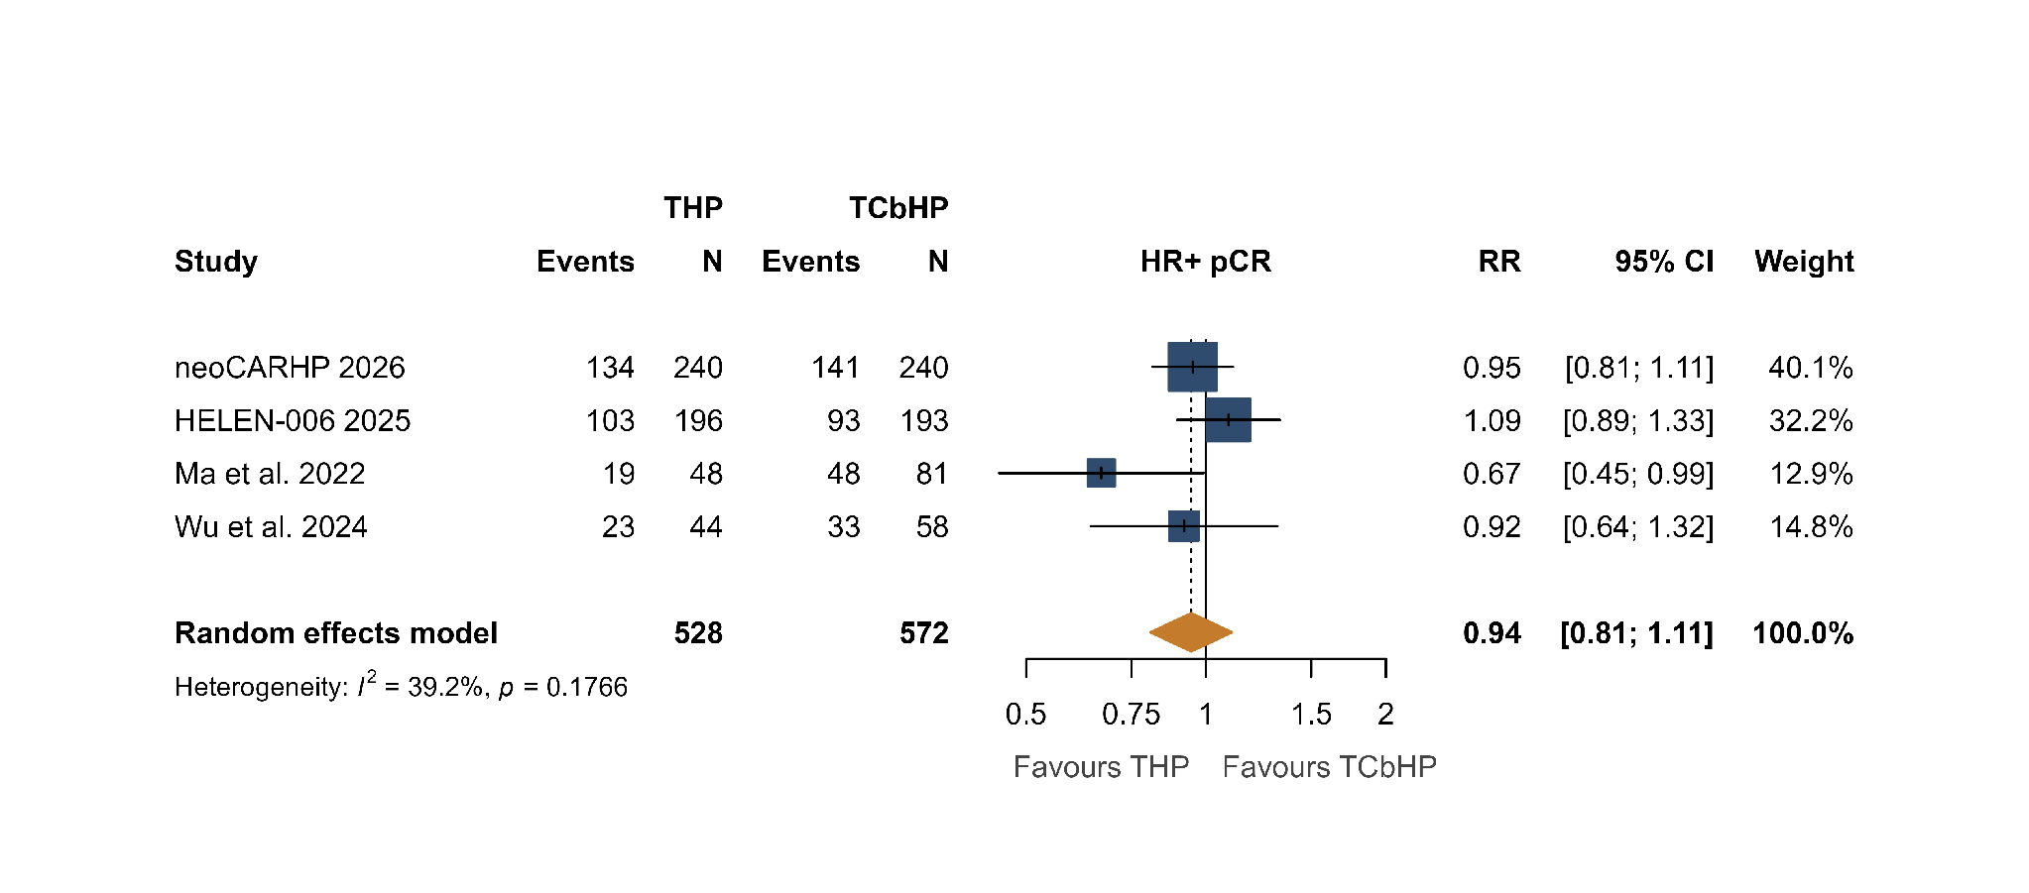
Supplementary Figure S4. HR-Positive pCR Forest Plot

Legend: Forest plot of pCR for HR-positive patients comparing THP versus TCbHP across the four studies reporting hormone-receptor–stratified results (neoCARHP, HELEN-006, Ma, and Wu). The pooled RR was 0.94 (95% CI 0.81–1.11; I²=39%); a leave-one-out analysis yielded pooled RRs ranging from 0.89 to 0.99. RR<1 favours TCbHP.

Supplementary Figure S5. HR-Positive pCR Subgroup Analysis by Study Design

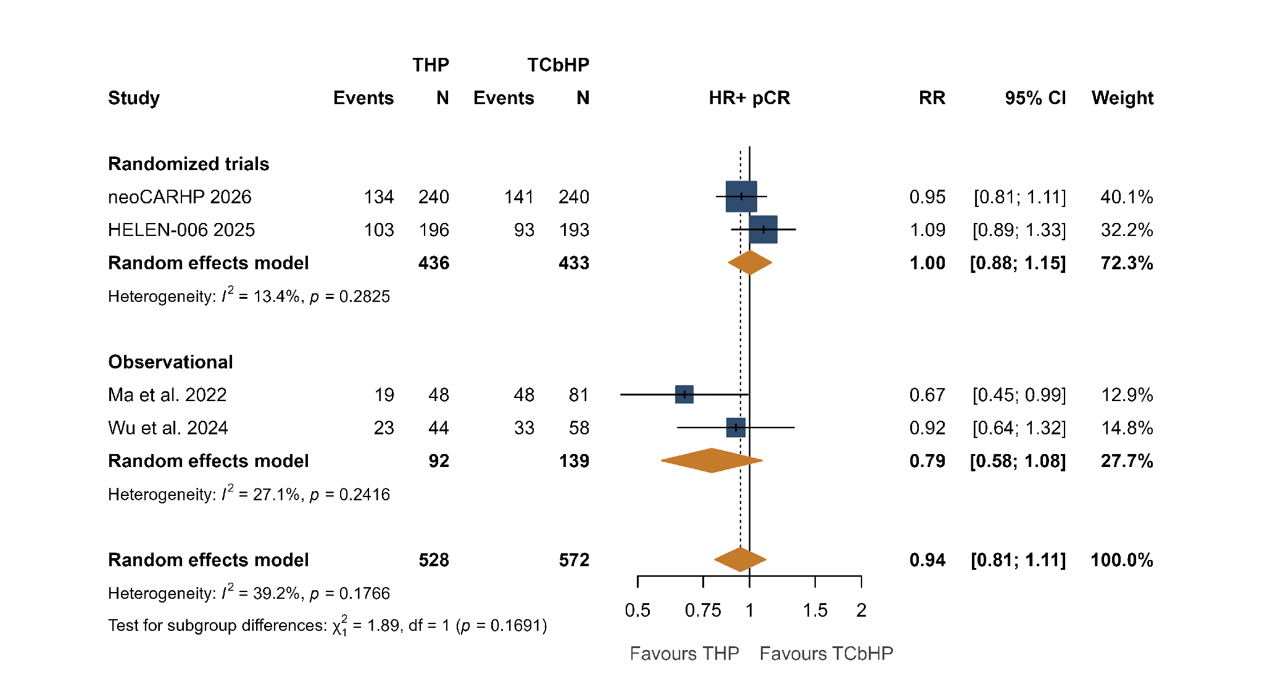
Legend: Subgroup analysis of HR-positive pCR by study design. Among the two randomized trials (n=869 patients), the regimens were equivalent (RR 1.00, 95% CI 0.88–1.15; I²=13%). The two observational studies reporting hormone-receptor–stratified data (Ma and Wu; n=231 patients) showed a comparable, non-significant result (RR 0.79, 95% CI 0.58–1.08; I²=27%); the test for subgroup differences was non-significant (p=0.17). RR<1 favours TCbHP.
Supplementary Figure S6. HR-Negative pCR Forest Plot and Subgroup Analysis by Study Design
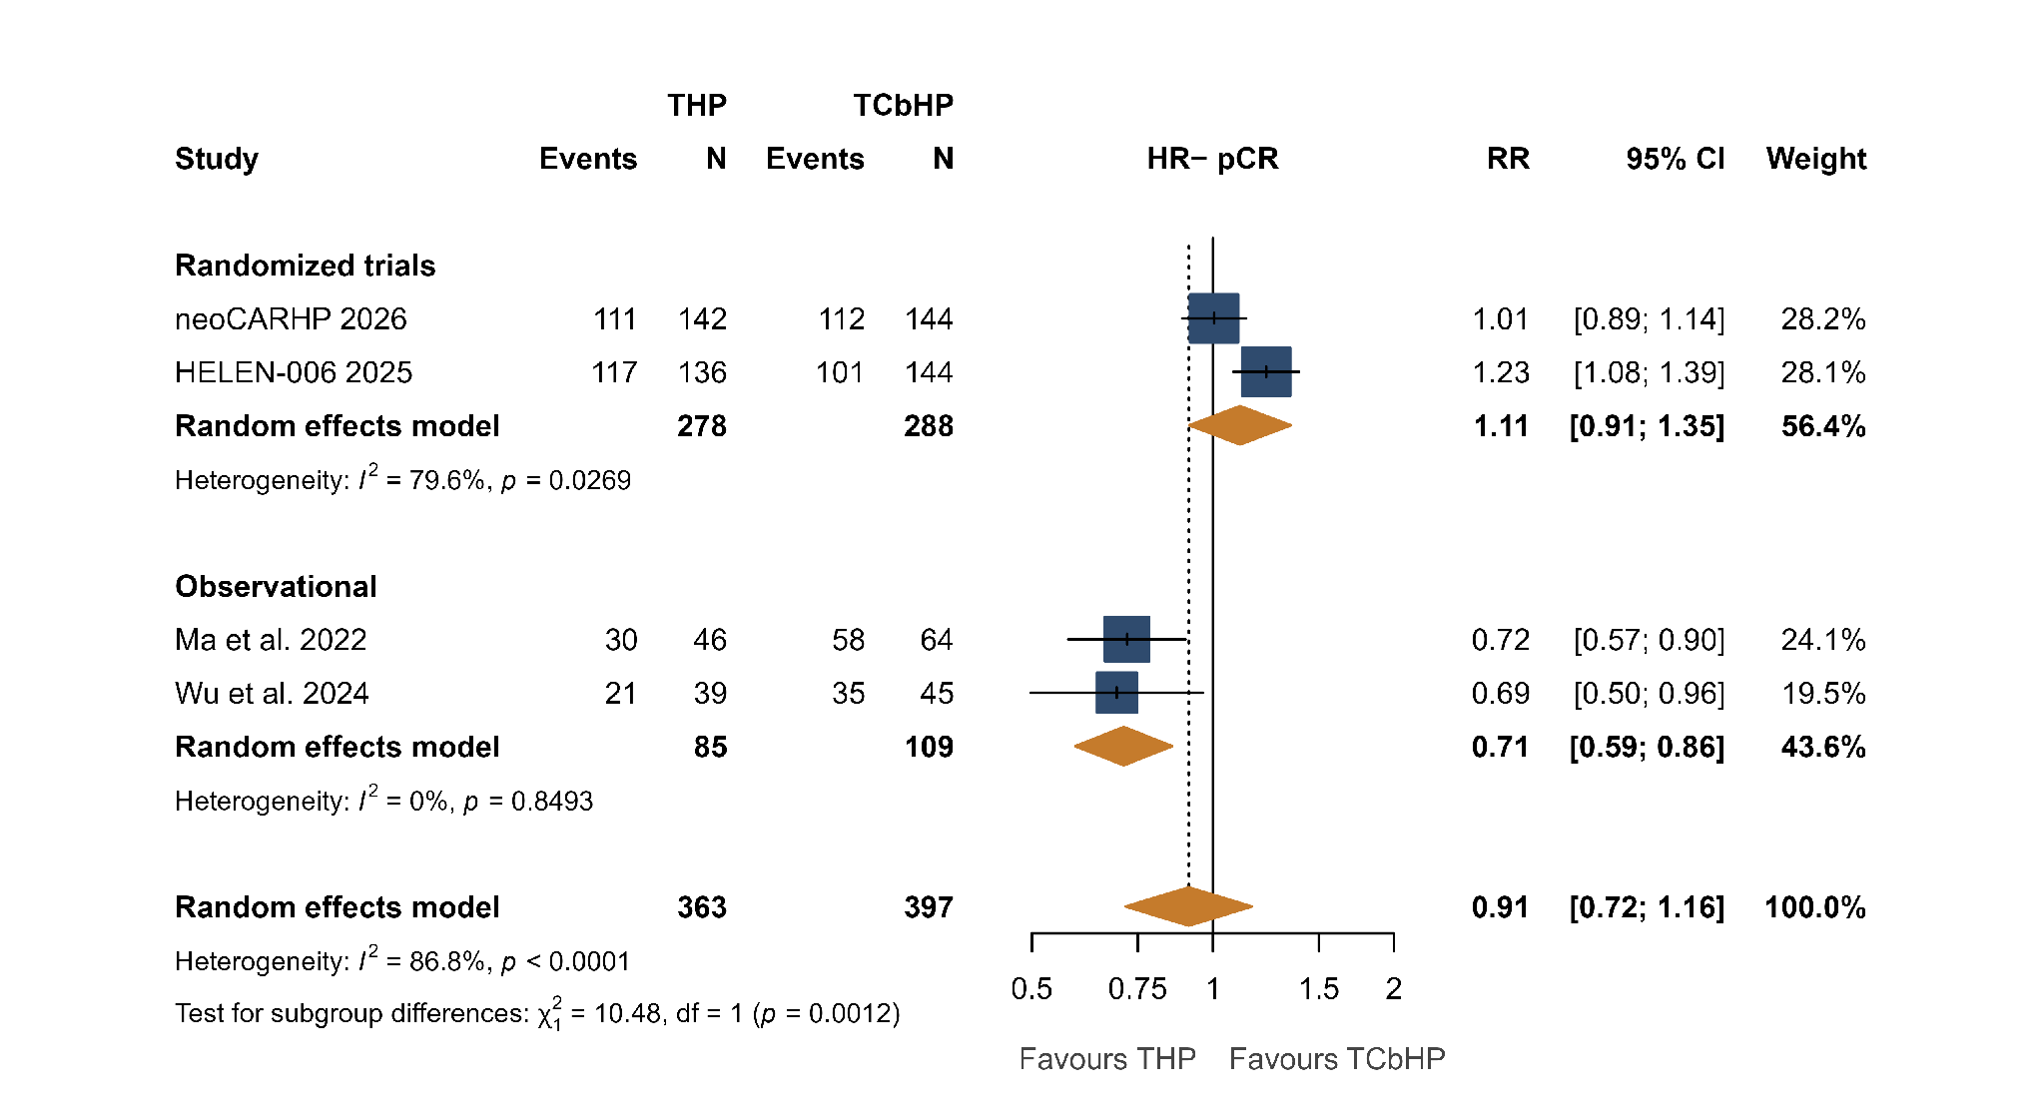
Legend: Forest plot of pCR for HR-negative patients, stratified by study design (four studies reporting hormone-receptor–stratified results: neoCARHP, HELEN-006, Ma, and Wu). The overall pooled RR was 0.91 (95% CI 0.72–1.16; I²=87%). The effect differed by design (test for interaction p=0.001): the two randomized trials were neutral-to-favorable for THP (RR 1.11, 95% CI 0.91–1.35; I²=80%), whereas the two observational studies favored TCbHP (RR 0.71, 95% CI 0.59–0.86; I²=0%). In a leave-one-out analysis, excluding HELEN-006 yielded RR 0.81 (95% CI 0.62–1.07), which remained non-significant. RR<1 favours TCbHP.

Supplementary Figure S7. Thrombocytopenia Forest Plot

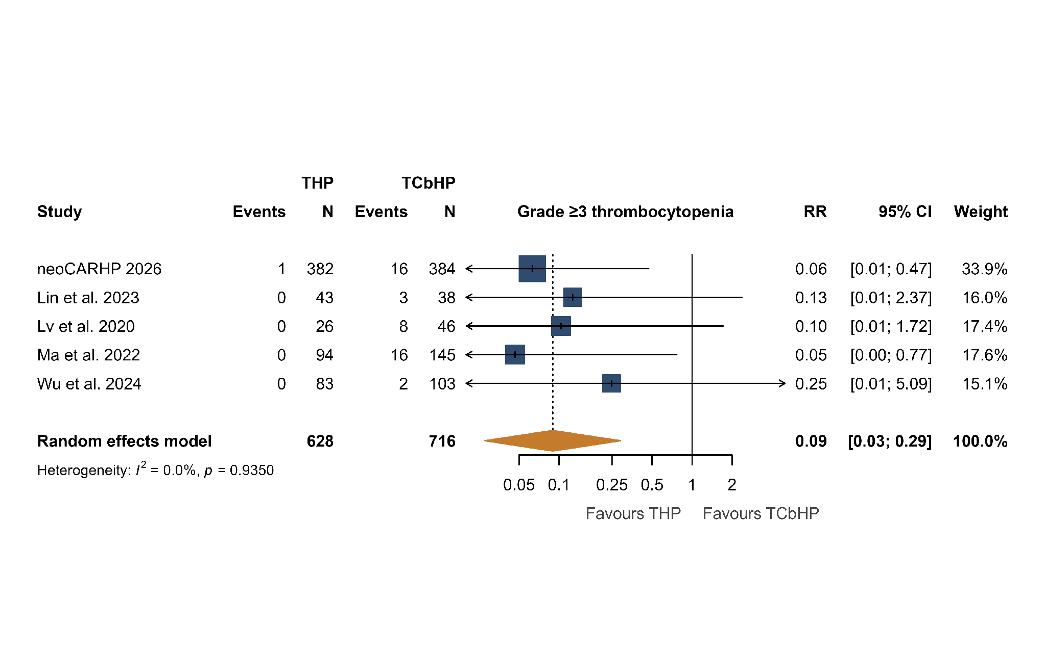

Legend: Forest plot of grade 3-4 thrombocytopenia comparing THP versus TCbHP (n=5; 1,344 patients). The pooled RR was 0.09 (95% CI 0.03-0.29), indicating a 91% reduction with THP. An I² of 0% indicates no detectable heterogeneity.

Supplementary Figure S8. Anemia Forest Plot

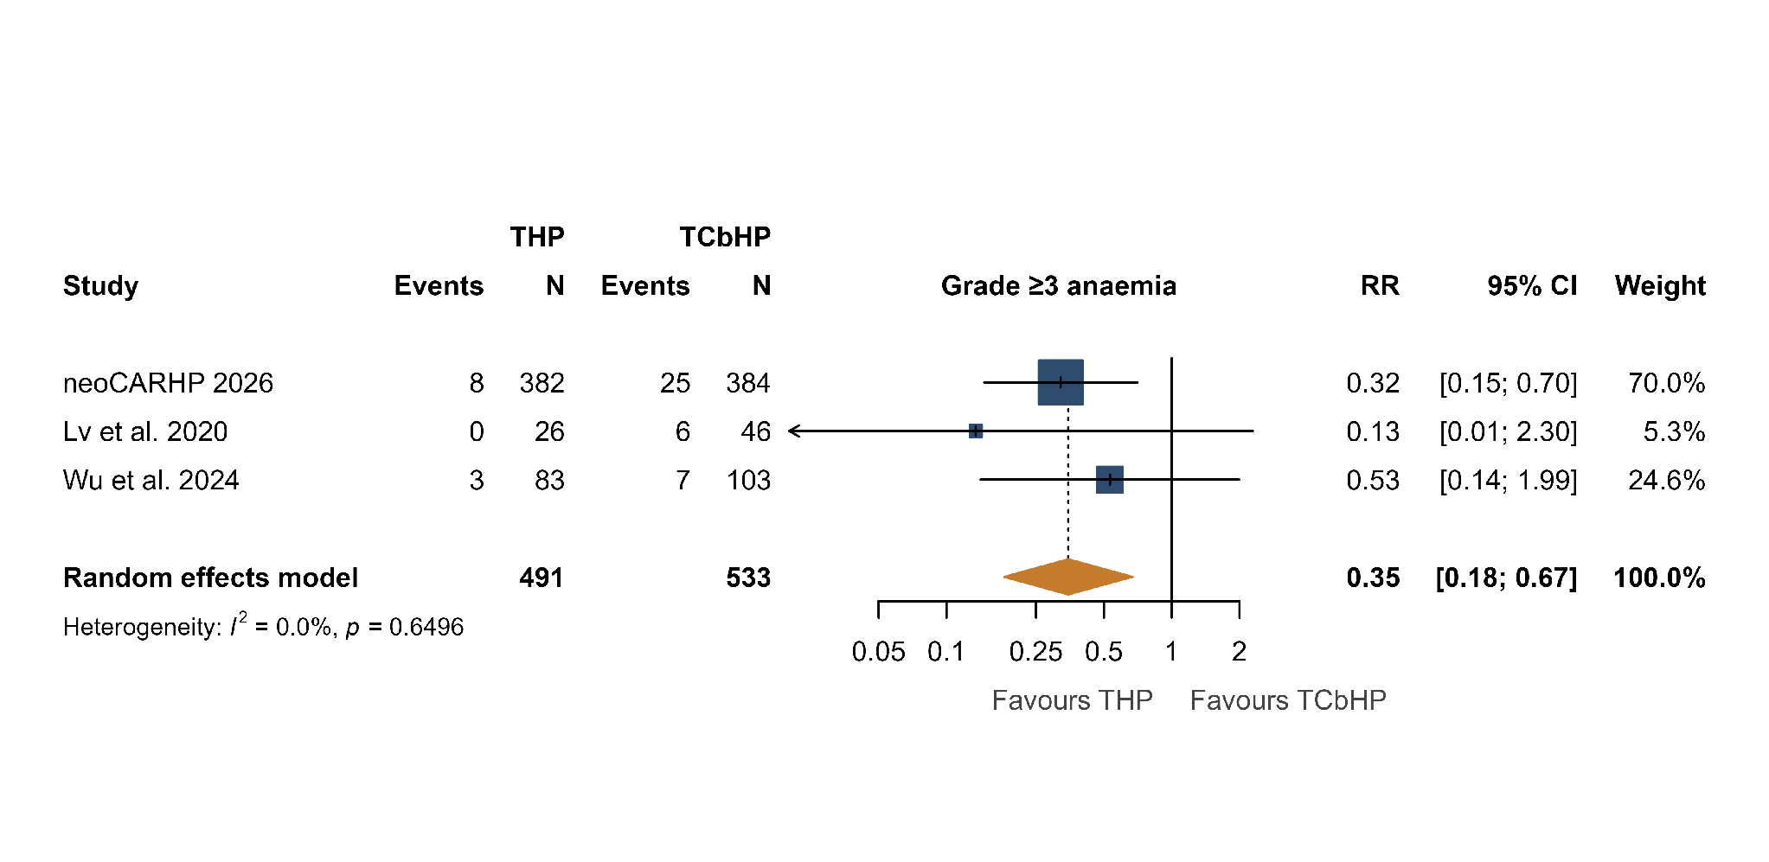

Legend: Forest plot of grade 3-4 anemia comparing THP versus TCbHP (n=3; 1,024 patients). The pooled RR was 0.35 (95% CI 0.18-0.67), indicating a 65% reduction with THP. An I² of 0% confirms a consistent safety benefit across studies.

Supplementary Figure S9. Dose Reduction Forest Plot
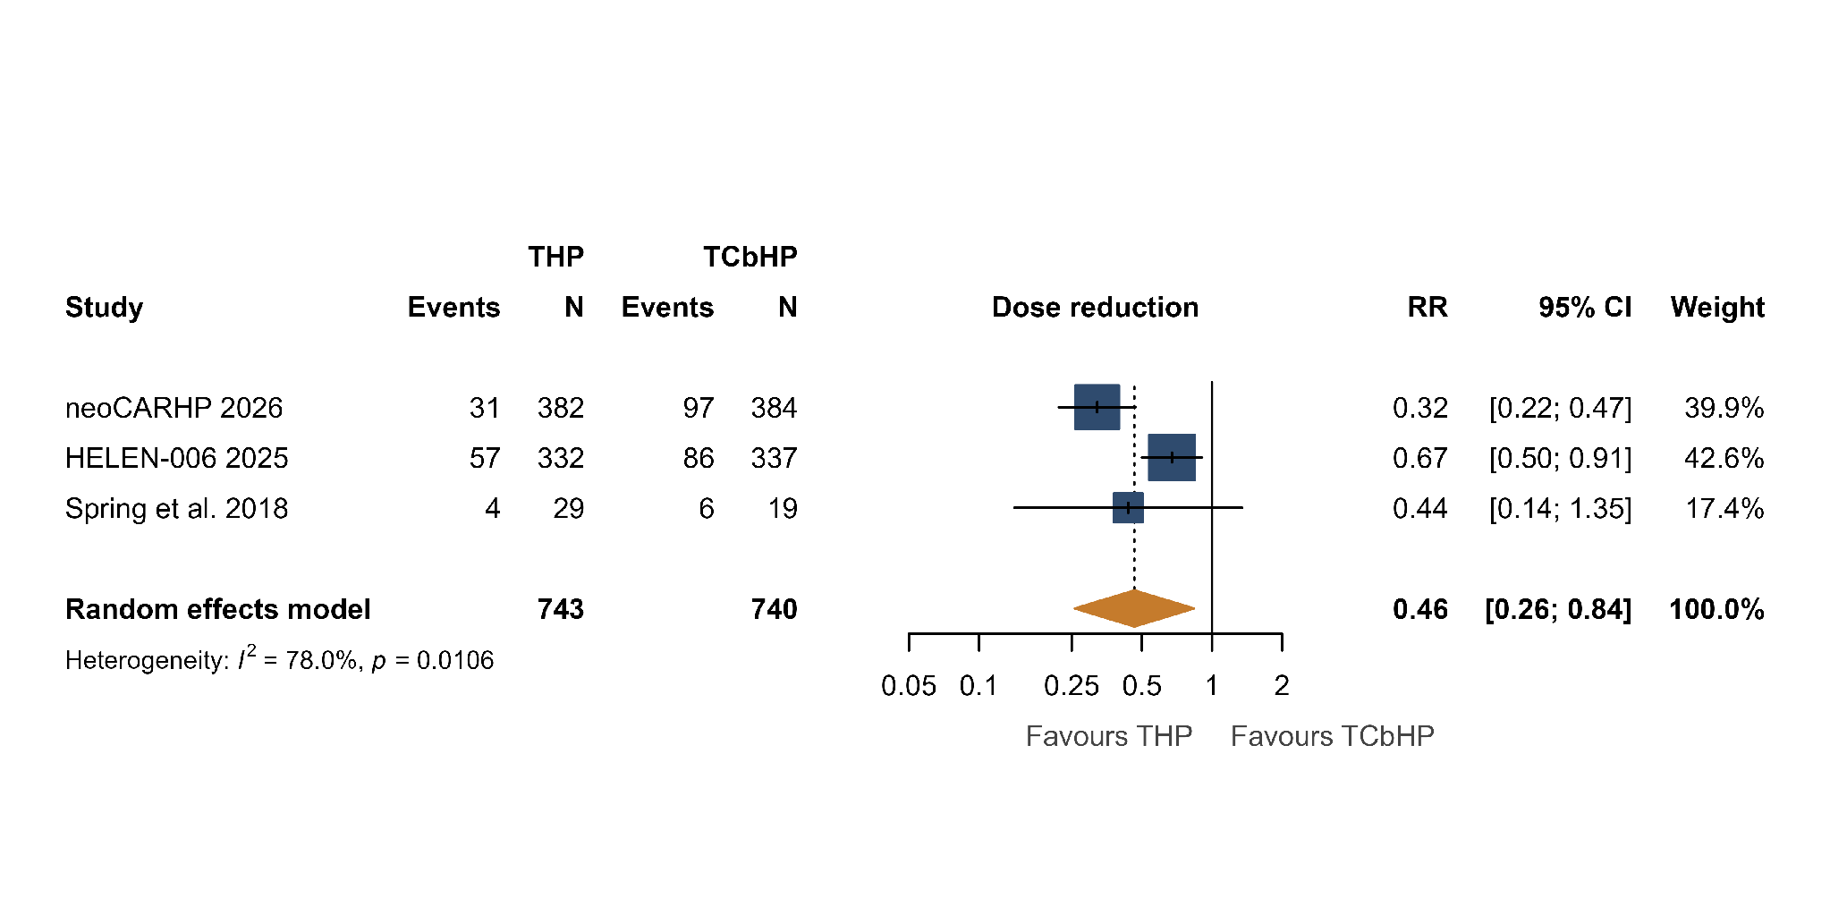
Legend: Forest plot of treatment dose reduction (regimen level) comparing THP versus TCbHP (n=3 studies; 1,483 patients). The pooled risk ratio from a random-effects (DerSimonian-Laird) model was 0.46 (95% CI 0.26–0.84; I²=78%), indicating significantly fewer dose reductions with THP. RR<1 favours THP.
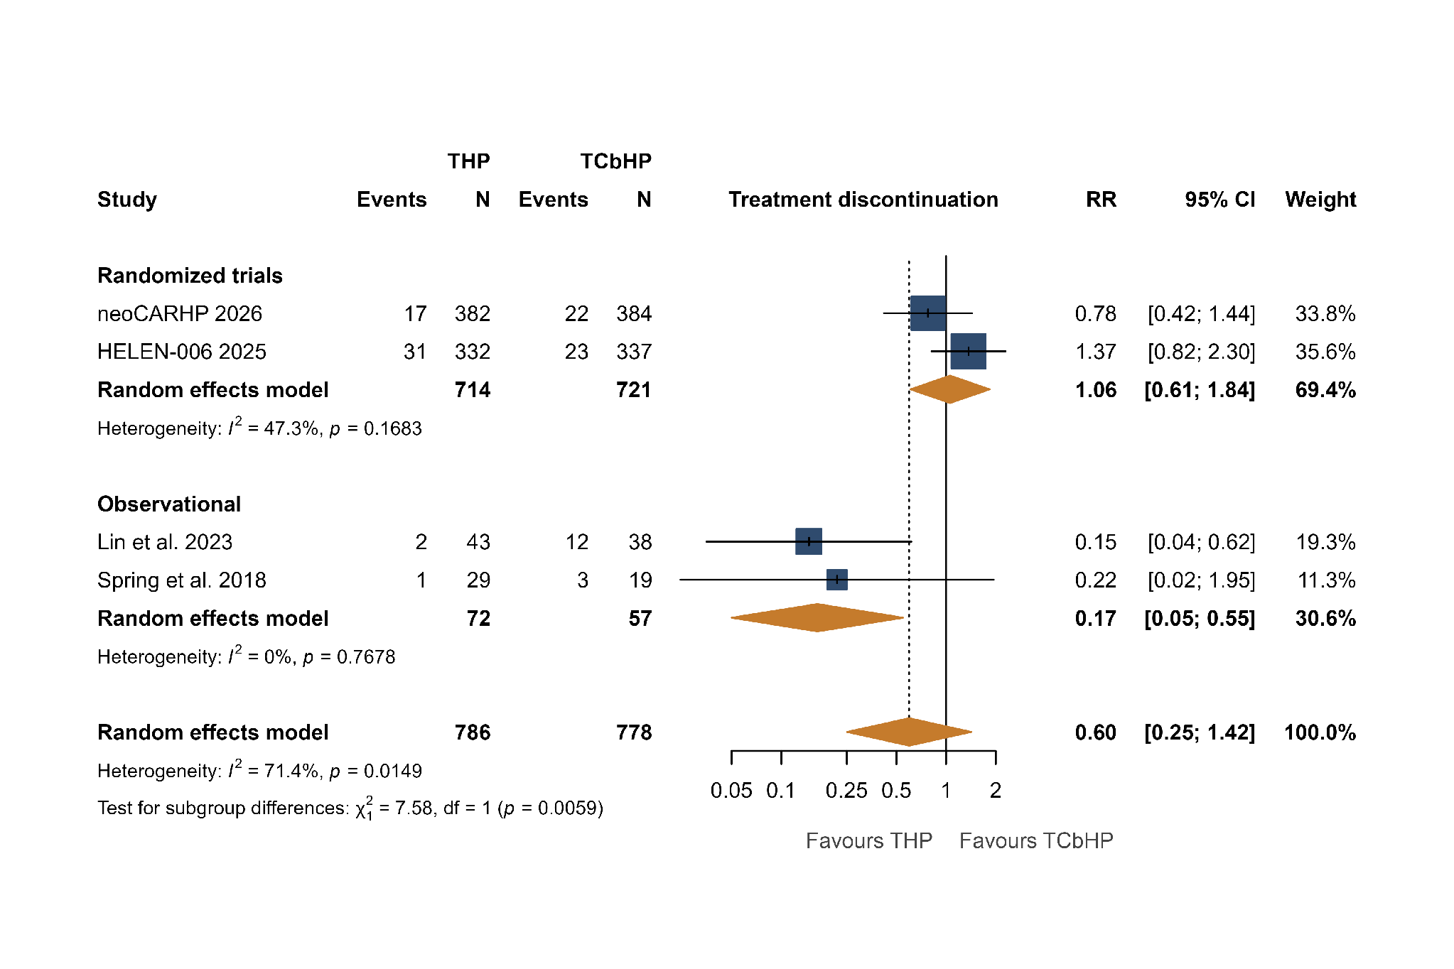
Supplementary Figure S10. Treatment Discontinuation Forest Plot and Subgroup Analysis by Study Design

Legend: Forest plot of all-cause treatment discontinuation comparing THP versus TCbHP, stratified by study design (n=4 studies; 1,564 patients). The overall pooled risk ratio from a random-effects (DerSimonian-Laird) model was 0.60 (95% CI 0.25–1.42; I²=71%) and was not statistically significant. In the subgroup analysis (test for interaction p=0.006), the two randomized trials were neutral (RR 1.06, 95% CI 0.61–1.84; I²=47%), whereas observational studies favoured THP (RR 0.17, 95% CI 0.05–0.55; I²=0%), consistent with confounding by indication. RR<1 favours THP.

Supplementary Table S5. GRADE Summary of Findings (SoF)
Outcome | Participants (studies) | Relative effect, RR (95% CI) | Certainty (GRADE) | Reasons for certainty rating
Pathologic complete response (pCR) | 2,061 (7) | 0.92 (0.79-1.07) | Low (++OO) | Downgraded for risk of bias (non-randomized studies at serious risk of confounding by indication) and for inconsistency (I-squared=69%; randomized and observational studies in opposite directions).
Grade 3-4 neutropenia | 1,344 (5) | 0.45 (0.32-0.63) | Moderate (+++O) | Downgraded for risk of bias (non-randomized studies); upgraded for large magnitude of effect (RR<0.5); low heterogeneity (I-squared=16%).
Grade 3-4 thrombocytopenia | 1,344 (5) | 0.09 (0.03-0.29) | Moderate (+++O) | Downgraded for risk of bias; upgraded for very large magnitude of effect (RR<0.2); no heterogeneity (I-squared=0%).
Grade 3-4 anemia | 1,024 (3) | 0.35 (0.18-0.67) | Moderate (+++O) | Downgraded for risk of bias; upgraded for large magnitude of effect (RR<0.5); no heterogeneity (I-squared=0%).
Dose reduction | 1,483 (3) | 0.46 (0.26-0.84) | Low (++OO) | Downgraded for risk of bias (one non-randomized study) and serious inconsistency (I-squared=78%). Only regimen-level rates were pooled; carboplatin-specific dose modifications were excluded because the carboplatin-free arm cannot undergo them.
Treatment discontinuation (all-cause) | 1,564 (4) | 0.60 (0.25-1.42) | Very low (+OOO) | Downgraded for risk of bias, serious inconsistency (I-squared=71%; randomized and observational studies in opposite directions), and serious imprecision (95% CI crosses 1.0).
Abbreviations: CI, confidence interval; RR, risk ratio. GRADE certainty: ++++ high, +++O moderate, ++OO low, +OOO very low. Effect estimates are pooled risk ratios from random-effects (DerSimonian-Laird) models; RR<1 favors THP for toxicity outcomes. For the hematologic toxicity outcomes, the observed advantage of THP reflects the direct myelosuppressive pharmacology of carboplatin rather than channeling of higher-risk patients to either arm; any confounding by indication would be expected to bias the toxicity comparison conservatively and is therefore an unlikely explanation for the large, consistent reductions, supporting the upgrade for large magnitude of effect.

