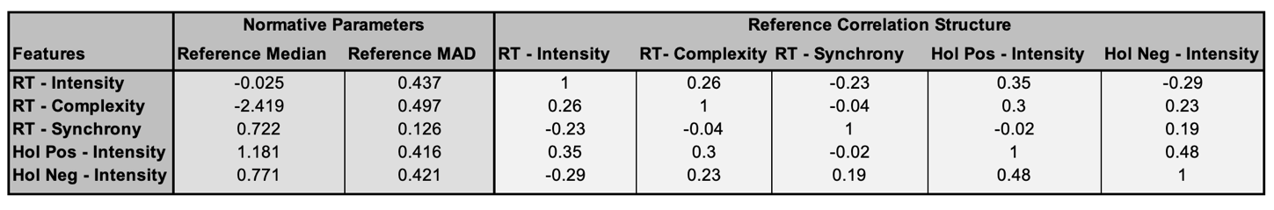
Table 1: The normative parameters, including median and MAD, and the multivariate covariance structure, of the real-time and holistic emotional reactivity features in the “valid” subset of participants (i.e., excluding the outliers). RT=Real-Time, Hol=Holistic, Pos=Positive, Neg=Negative.

