Supplementary Information
Aging reprograms the functional, epigenetic, and metabolic landscape of macrophages.
Manasa Suresh¹*, Francisco Tapia Belmonte^{2,3}, Bryan T. Weselman¹, Xintang Li¹, Marie Durr¹, Isabella Duchovny¹, Yanitza Gutierrez-Monsalve⁴, Matias I. Hepp^{3,4}, Satish Kumar R. Noonepalle¹, Alexis Salas-Burgos^{2,3}*, Alejandro Villagra^{1,3,4}*
Affiliations: ¹Department of Oncology, Georgetown University, Lombardi Comprehensive Cancer Center, Washington DC, USA; ²Pharmacology Department, Concepcion University, Concepcion, Chile; ³Centro Territorial de Investigación Oncológica Integrativa (CTIOi), Concepción, Chile; ⁴Laboratoria de Investiagacion en Ciencias Biomedicas, Departamento de Ciencias Básicas y Morfología, Universidad Católica de la Santisima Concepción, Chile.
Supplementary Table 1: Gating strategy for flow cytometry analysis of bone marrow-derived macrophages
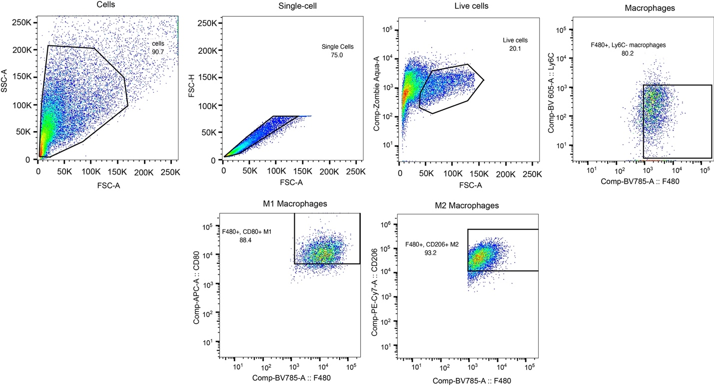
Top panel: Cell, single-cell, live cells, and macrophages
Bottom panel: M1 macrophages and M2 macrophages

Supplementary Table 2: List of primers used for qPCR assay
Gene | Primer | Primer sequence
Cdkn2a | F | TGTTGAGGCTAGAGAGGATCTTG
 | R | CGAATCTGCACCGTAGTTGAGC
p21 | F | TCGCTGTCTTGCACTCTGGTGT
 | R | CCAATCTGCGCTTGGAGTGATAG
Myc | F | AGAGTTTCATCTGCGACCCG
 | R | GAAGCCGCTCCACATACAGT
Usf1 | F | GCTCTATGGAGAGCACCAAGTC
 | R | AGACAAGCGGTGGTTACTCTGC
Nos2 | F | GAGACAGGGAAGTCTGAAGCAC
 | R | CAGCAGTAGTTGCTCCTCTTC
Il1β | Primer mix | Primer mix was obtained from Qiagen – QT01048355 – Mm_Il1b_2_SG Catalog # 249900
Arg1 | Primer mix | Primer mix was obtained from Qiagen – PPM31770C-200 – RT2 qPCR Primer Assay for Mouse Arg1 Catalog # 330001
Fizz1 | F | TCCAGCTAACTATCCCTCCACTGT
Fizz1 | R | GGCCCATCTGTTCATAGTCTTGA
Actb | F | CATTGCTGACAGGATGCAGAAGG
Actb | R | TGCTGGAAGGTGGACAGTGAGG
CD80 | F | CCAACCACAGCTTCATGTGT
CD80 | R | TAAGGTAATGGCCCAGGATG
MRC1  (CD206) | F | GGGTTGCTATCACTCTCTATGC
MRC1  (CD206) | R | TTTCTTGTCTGTTGCCGTAGTT
ACTB | F | CACCATTGGCAATGAGCGGTTC
ACTB | R | AGGTCTTTGCGGATGTCCACGT

Supplementary Table 3: List of antibodies used in flow cytometry assays.
Antibody | Source | Identifier / Catalog no
Brilliant Violet 421™ anti-mouse/human CD11b | BioLegend | 101251
Brilliant Violet 785™ anti-mouse F4/80 | BioLegend | 123141
APC anti-mouse CD80 | BioLegend | 104714
PE/Cyanine7 anti-mouse CD206 (MMR) | BioLegend | 141720
Brilliant Violet 570™ anti-mouse Ly-6C | BioLegend | 128030
APC/Fire™ 750 anti-mouse CD45.2 | BioLegend | 109852
Purified anti-mouse CD16/32 | BioLegend | 101302
PE anti-mouse H-2Kb | BioLegend | 116508
APC anti-mouse H-2Kb bound to SIINFEKL | BioLegend | 141606
PE anti-mouse CD80 Antibody | BioLegend | 104708
Biotin anti-mouse CD119 (IFN-γ-R α chain) | BioLegend | 112803
PE/Cyanine7 anti-mouse TLR4 (CD284)/MD2 complex | BioLegend | 117609
APC anti-mouse CS124 (IL4Rα) | BioLegend | 144807
Anti-mouse CD213a1 (IL13Ra1) | Invitrogen | 12-2130-80
Anti-Biotin antibody | Invitrogen | 53-9895-82
Biotin American Hamster IgG Isotype | BioLegend | 400903

