Figures S8
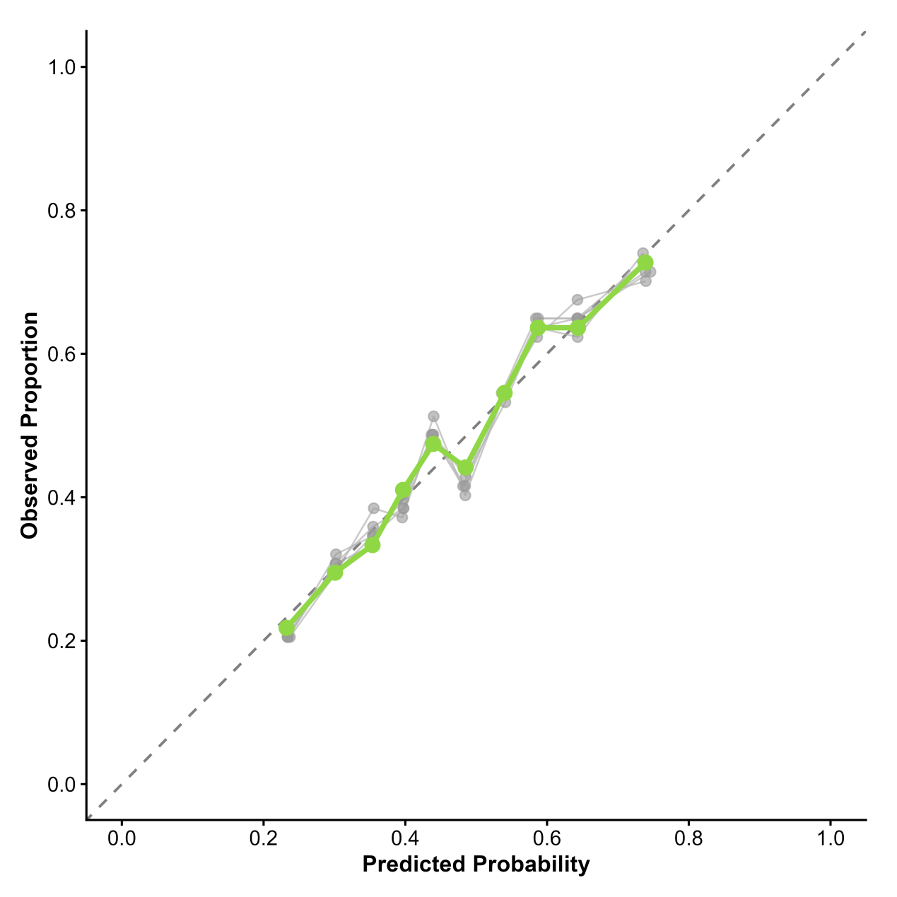

Figures S9
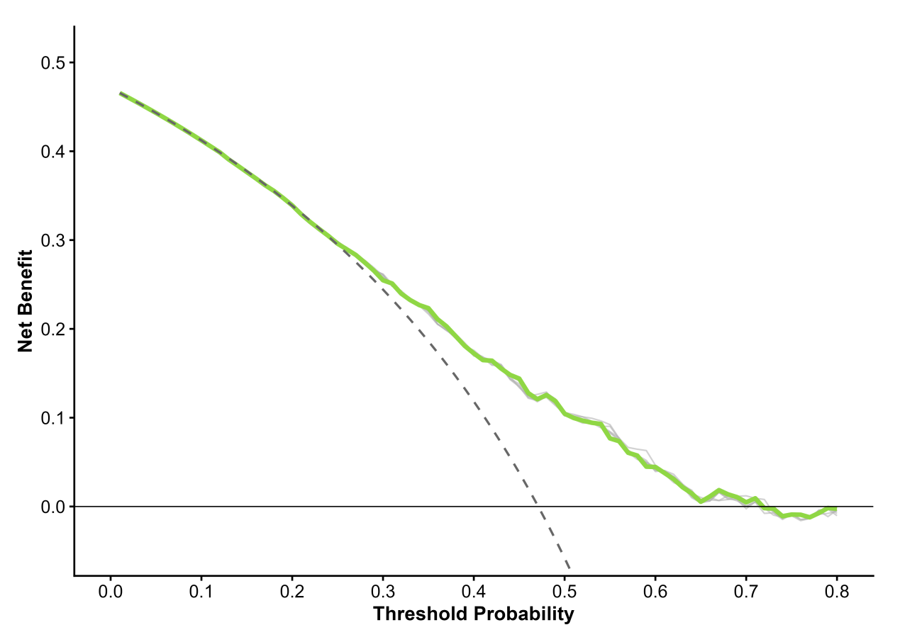

Figure S7
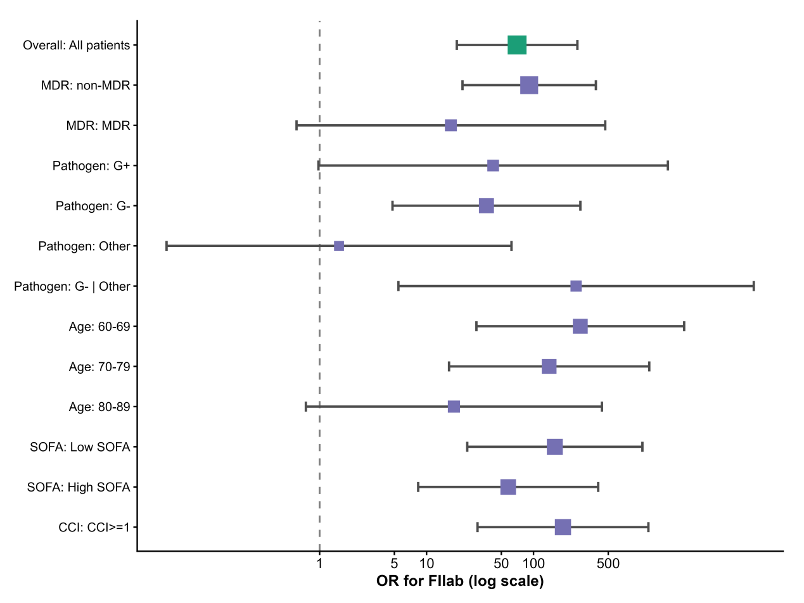
Table S4
Table S4. Interaction tests between FIlab and key covariates
Interaction term | LR χ² | df | P
FIlab × MDR | 0.0790612881 | 1 | 0.779
FIlab × Age≥75 | 0.9165761650 | 1 | 0.338
FIlab × High SOFA | 1.2719825035 | 1 | 0.259
FIlab × CCI≥1 | 0.0000192285 | 1 | 0.997
Likelihood ratio test comparing models with and without the interaction term.

