Supporting Information

The Multi-layer Methylcellulose Substrate based Flexible Printed Circuit Board for Wearable Touch sensor and Display

Yunsu Kim1, Sungpil Chang1* and Youngjun Song2*,

1 Department of electronic engineering at Inha University, 100 Inharo, Nam-gu Incheon,
Korea, 22212
2 Department of nano-bioengineering at Incheon National University, Academy-to 119 Incheon, Korea, 22012

Author Information
Corresponding author
* E-mail: Y. Song (yjunsong@inu.ac.kr), S. Jang (spchang@inha.ac.kr)

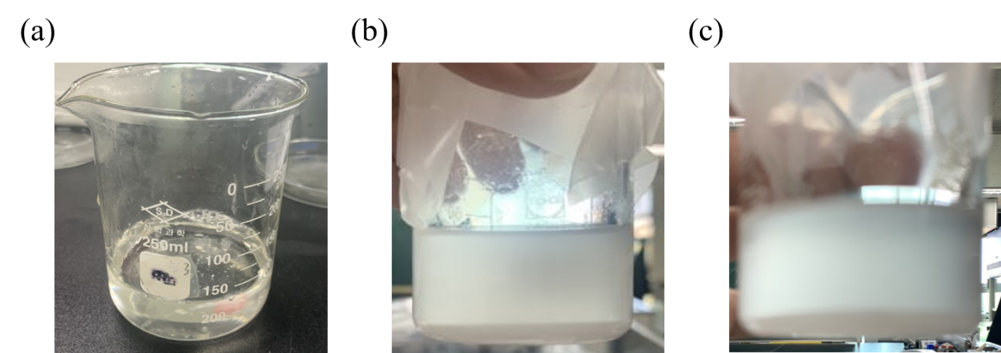

Figure S1. Optical images of MC with other solvents by sonicator (a) DMSO, (b) EtOH and (c) IPA.

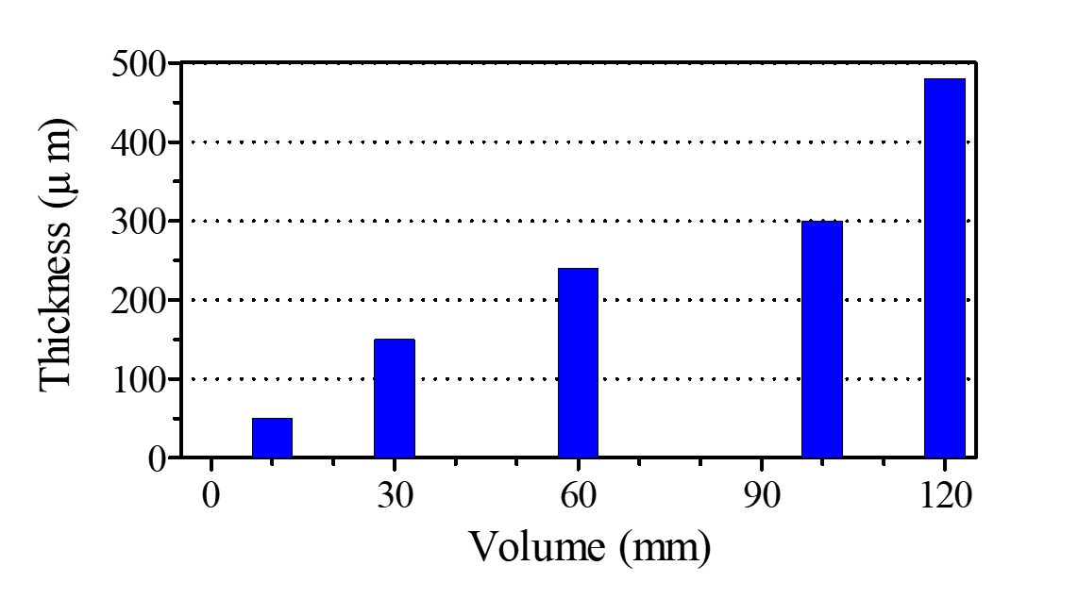

Figure S2. Total thickness of MC substrate fabricated by diverse volume of solutions with evaporation process.

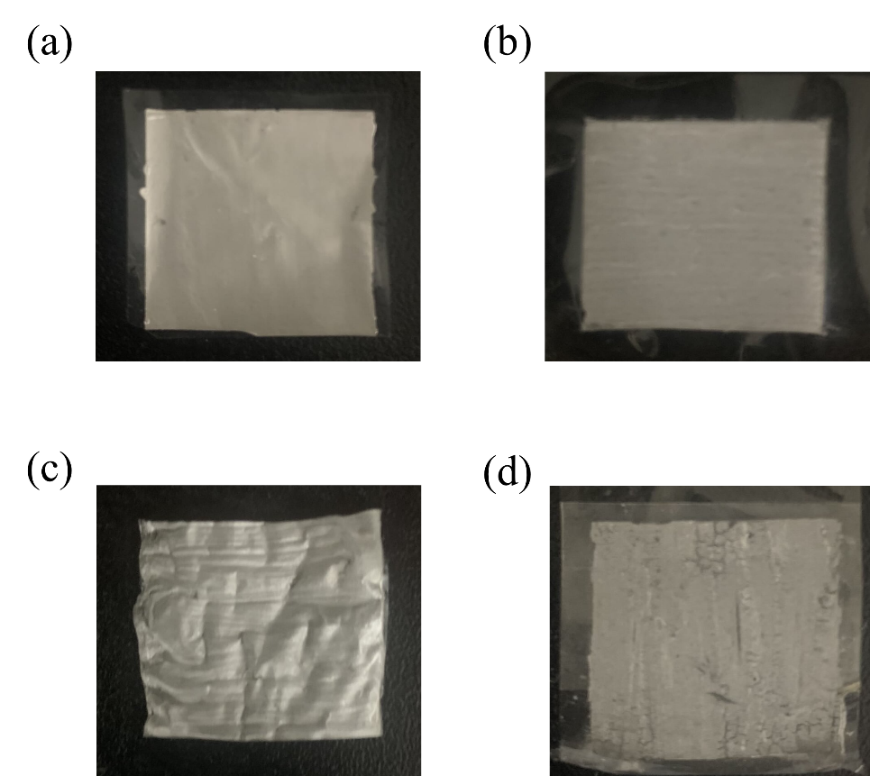

Figure S3. Optical images of Ag/CNT composites by four difference CNT concentration (a) 0 wt. %, (b) 4.3 wt. %, (c) 9.9 wt. %, and (d) 16.7 wt. %

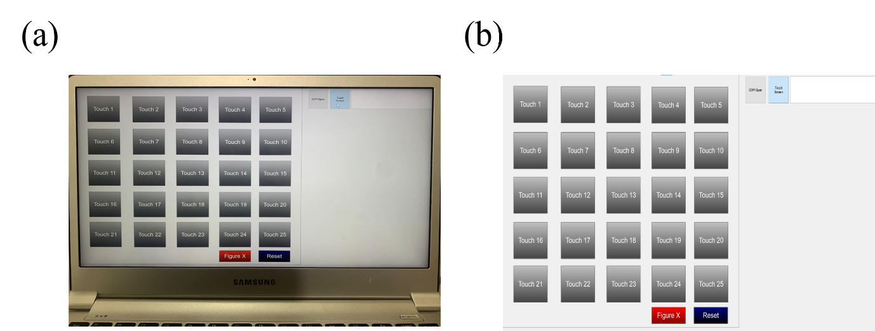

Figure S4. (a) Optical images and (b) screen capture images of customized MFC program for control the FPCB.

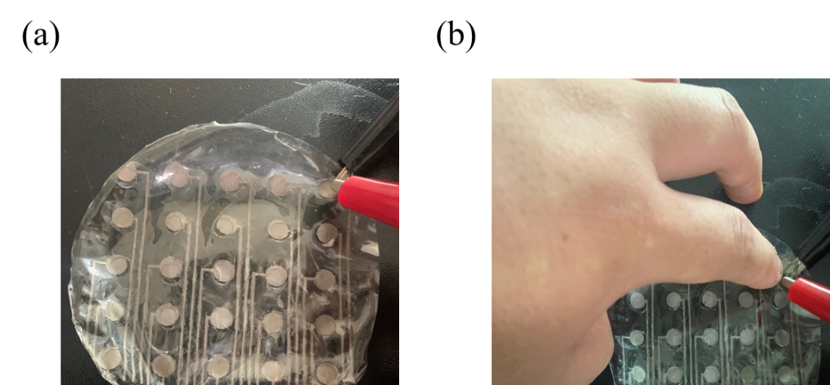

Figure S5. Optical images of capacitance measurement in 5x5 MC touch panel when (a) non-touch, (b) touch with hands.

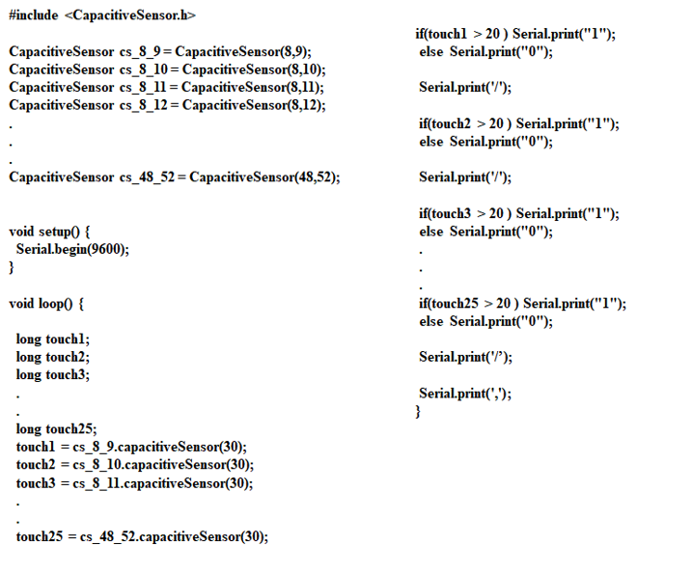

Figure S6. Text images of the Arduino coding contents used in the 5x5 touchpanel.

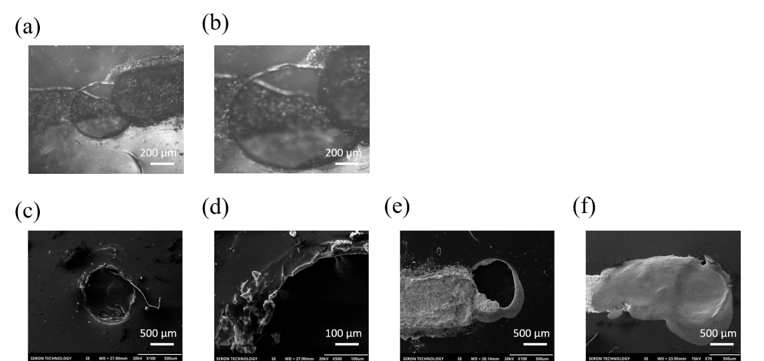

Figure S7. (a-f) SEM images of diverse multi-layer in MC substrate with Ag/CNT composite.

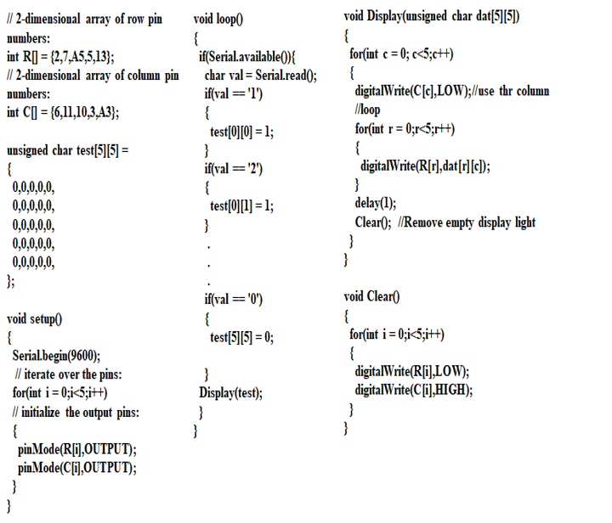

Figure S8. Text images of the MFC program coding contents used in the 5x5 LED circuit and MC touch panel.

